Research Methods I

ECPS4003

Personality and memory

T—test to explore differences

Abstract

This study examined the relationship between extraversion and introversion on performing a memory task using the words taken from Affective Norms of English words. It was predicted that there was no relationship between personal and memory recall. 35 undergraduate students from UWTSD participated in the study. The results confirmed the hypothesis of researcher. The literature has shown that the study that was conducted needed several other important points, such as adding numbers and emotional words to the memory recall task. a questionnaire from the Big five Inventory was also used. SPSS software and a t-test to explore differences.
Results shown no significant differences between groups.

Introduction

Memory is an information processing system, so we often compare its operation with that of a computer. Memory is a set of processes used to encode, store, and retrieve information. Short term memory (STM) is an information temporal location within which short term memory is one element of memory. It takes 15 to 30 seconds to store the data in memory. (Sumrall et al. 2016)
The most interesting for psychologists is memory and personality One of the most common ways of measuring personality is the personality of the Big Five. is considered the gold standard in science. It is the most widely used personality test in scientific research and is sometimes referred to as the "only truly scientific personality test". Scientists generally see the Big Five as more accurate and comprehensive than other tests, but the model may also appear more specialized. Schurer (2011) For memory recall test researcher used words taken from Affective Norms of English words. Words have no emotions. Bradley, Lang, (1999)
The first theory that may be useful for this report is the theory that extroverts remember the words better and introverts remember better a numbers - comes from Carlson and Levy (1973) where they tested STM 'representations of the stimulus under investigation for a short period of time and were then asked to: recognize or recreate the content of the stimuli. STM testing required banks in cognitive orientation, thus testing introversion and extraversion. '
In a study by Fink and the rest of the group on the relationship between extraversion- introversion and memory task, the results showed that there were no significant differences between personalities. only differences were found in the activation of areas of the brain during a task. introverts and extroverts focus differently, and the active area of ​​the brain is the frontal cortex. (Fink. et al.,2004).
Hypothesis for this study is there is no significant differences between introverts and extraverts and memory recall.

Methods

Participants

Participants were recruit by EMS system. They were undergraduate students from UWTSD in Swansea. They were recruit by independent sampling. The study includes 35 participants: 20 females,13 males and 2 non-binaries between 18- and 69-years old (M=28.97 SD=11.30).
Among to total participants 57.14 % are women, 37.14 % are men and 5,21% are non-binary.

Design

T-test was used to determine whether there is a significant difference between means of two groups- low group and high group. Design of this study is between-subject.
Independent variable is memory recall (continuous variable) scored with help of Memory task by Superlab.
Dependent variable is groups score (categorical variable) scored with help of Qualtrics survey system Questionnaire.

Material

Qualtrics survey system Questionnaire- The Big Five Inventory (BFI; John & Srivastava, 1999).
Standard Superlab memory recall test.

Questionnaire
The questionnaire contained 8 items in which the participant writes a number next to each statement to indicate the extent to which you agree or disagree with that statement. The questionnaire examined whether the participant was more introverted or extroverted. The questionnaire can be found at the end of the paperwork in the appendices.

Memory task collect data by Superlab
Words were selected from Affective Norms for English Words (ANEW; Bradley & Lang, 1999), Words were chosen to contain two syllables and to have a valence value between 5 and 5.5 (i.e., a neutral value). The numbers at the end of each word are the valence points associated with the word. Words have neutral valence score with no emotions because if they are emotional is more likely to recognise and remember them better than neutral words- for example beautiful. Words were taken from trusted source, and they were used before, and they can be replicated. Colour of words is black because is good see to screen- not red or green because it can be bad with vision or not able to see. Size of the words is 72 (Microsoft Word size). All the words are shown every two seconds and they were visible for 400 milliseconds. At the end the participant must write the words they have memorised within 30 seconds. Scoring – out of 20 for memory recall. A list of 10 words is included in appendices.

Procedure

Participants were recruited on-line by EMS system for students. Date and time are chosen by the participant. When the day came, the participant came at the appointed time in the laboratory. The examination was carried out using a laptop and computer. Study consent form informed participants that the data was needed for the group of 1st year Psychology Students for the purpose of a module assessment. They were informed that study will involve providing details about age and gender, completing a personality questionnaire, and a memory recall task and study will take 20 minutes. also, they were informed that study is voluntary free to withdraw participation at any time during or before the end of the study by closing the browser and they do not need to give reason why. Next form informed them that study is anonymous and when study is complete is not able to withdraw the data. Another information was an e-mail that participants can contact researcher supervisor. Later they were informed that information will be held confidentially with a code assigned and will be stored indefinitely in accordance with the Data Protection Act.
Then they were shown a study information sheet with key information about what will be expected from participant. to fill the demographic information of age and gender and complete the Extraversion sub-scale of the Big Five Inventory (John et al., 1991). Questionnaire with eight items designed to assess the personality trait of extraversion and each item is five-point response with options from Disagree to Agree strongly. Participants were asked to choose response that the best describe them. Then it was information about that the next step is a standard memory recall via Superlab. At the end of this sheet was information that participants can download a copy of this information. When the participant finished filling in the questionnaire on the laptop, they were shown information about the second part of the study -standard memory recall via Superlab. They were asked to do next step on the computer. They were informed that they will be shown a series of words and that will be displayed individually on the screen for two seconds each. To start the task participants, need to space bar to begin. Every two second in order on the screen they were shown words - fabric, patent, basket, column, paper, butter, engine, doctor, table, and machine. When all the words were shown on the screen, a message was displayed to participant to type in the box as many of the words as they can remember from words they have just seen. Time for this step was 30 seconds. Then participants were thanks to take part in the study. Next step was to select YES on the laptop to the questions shown on the screen to progress with the study. At the end they were shown a study debrief sheet with information like purpose of the study information’s about withdraw and contact to supervisor was included.
To confirm the data of participants to be included they needed to click arrow below. Participants were thanks again.

Results

Results shows not significant difference between extraverts and introverts in their memory recall.
t (33) =. 52, p < .05

Calculation sheet is in appendices end of the research paper.

Discussion

The literature and conclusions of other researchers show that the theory is consistent with the results of these studies.
The words for the memory recall task were taken from ANEW that have no emotions in them. Emotional words may be better remembered by one group for whom these personality words may be better remembered. The study could be accompanied by another two-memory task with words that evoke emotions - happiness or sadness. Where possible that extroverts might have better memorization of words with positive emotions.
The results of Big Five Inventory may be inaccurate since the participants were afraid to answer honestly that they would not be assessed badly, although the date was anonymous.
For the results of the memory recall studies to be more accurate, each participant should participate at the same time of the day - if everyone has a different time, e.g., in the morning or evening, other factors may interfere with the concentration of the participant, e.g., in the evening - tiredness, which gives unclear results.
More participants could have provided better data - 35 participants are not enough.
When it comes to Carlson and Levy (1973) theories, you could add another task in which there will only be numbers to check if any of the groups have significant differences.
As for the findings of Fink (2004) and the group, it can be stated that extroverts and introverts use the brain differently, so maybe not personality, but brain work plays a role in remembering.
Conclusions on literature and this research result could be as follows: to really check whether there is a relationship to the study of several point-honest answers in the questionnaire, the same study time for each participant more participants, the memory task increased by emotional words and numbers, and brain examination.

References

Carlson, R. & Levy, N. (1973). Studies of Jungian typology: I. Memory, social perception, and
social action. Journal of Personality. 41(4), 559-576.
Fink, Andreas, & Neubauer Aljoscha, (2004). Extraversion and Cortical Activation:
Effects of Task Complexity. Personality and Individual Differences, 36- 333

Sumrall W., Sumrall R., Doss D. A., (2016) A Review of Memory Theory Project:
https://www.researchgate.net/publication/323430288_A_Review_of_Memory_Theory

Schurer Stefanie, Deborah Cobb-Clark (2011) The Stability of Big-Five Personality Traits
https://papers.ssrn.com/sol3/papers.cfm?abstract_id=1919414

Appendices

Appendix 1- Information sheet

Appendix 2- Study Consent Form

Appendix 3-Study Debrief Sheet


Centre for Psychology and Counselling
SA1 Campus
Swansea

Study Debrief Sheet
An exploration into the potential differences between individuals high and low in extraversion and memory recall performance

Thank you for taking part in this study.

The purpose of this study is to investigate whether the personality trait of extraversion has an influence on memory recall performance. Specifically, the aim of the study is to examine whether those who report higher levels of extraversion on a self-report personality assessment (the Big Five Inventory, John et al., 1991) will be able to recall more words and therefore have better memory recall.

If you wish to withdraw your data from the study you must close your computer browser now. After this point, your data will become anonymous and it will not be possible to trace it back to you. The data you submit will remain confidential.

If taking part in this study has raised any concerns or if you have any questions about the study, please contact the academic supervisor Stacey Coleman: stacey.coleman@uwtsd.ac.uk

You can download a copy of this debrief sheet for your records by clicking here: Debrief

If you are happy for your data to be included in this study, please click the arrow below to confirm.

Thank you once again for taking time to participate in this study.

BSc Psychology
BSc Psychology and Counselling

University of Wales Trinity Saint David, Swansea

Appendix 4- Questionnaire

Appendix 5 Big Five Inventory

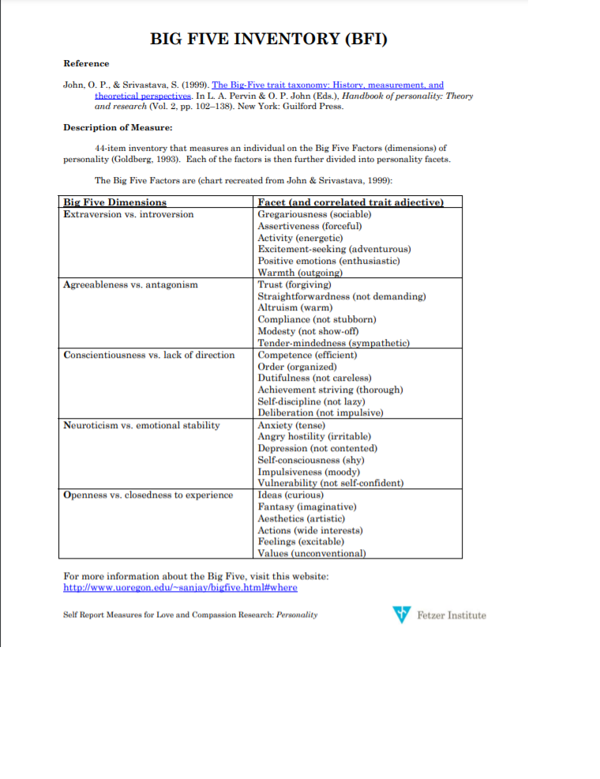

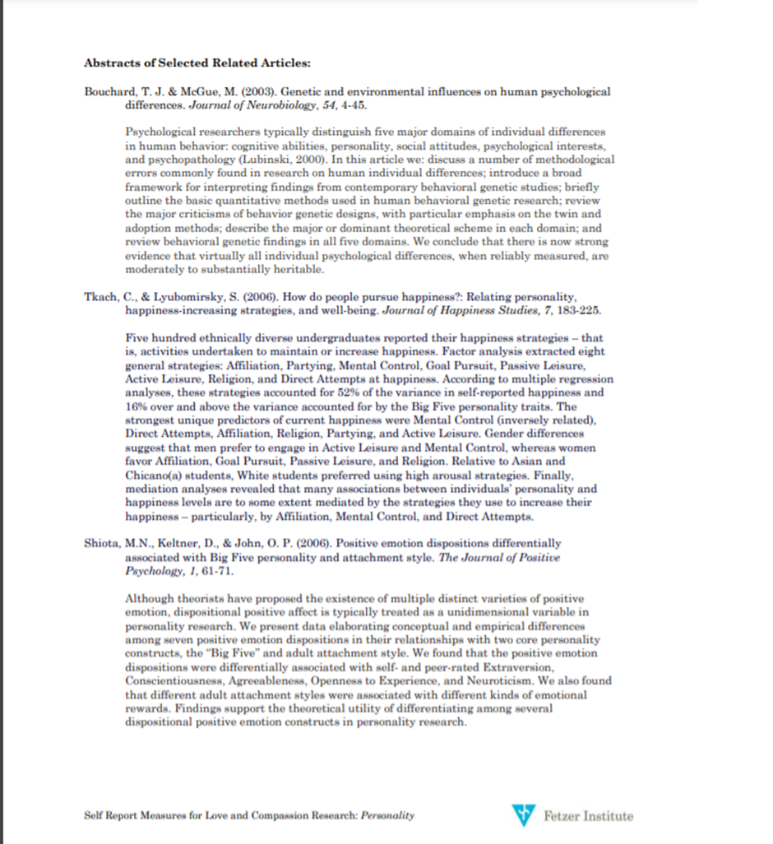

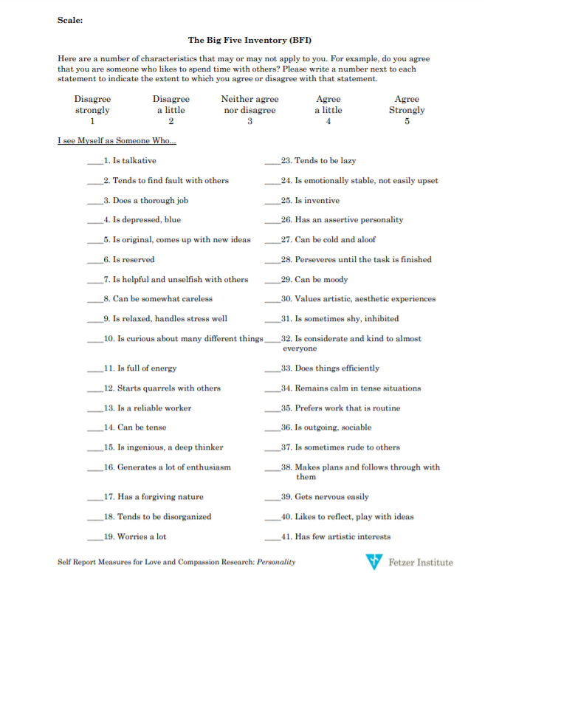

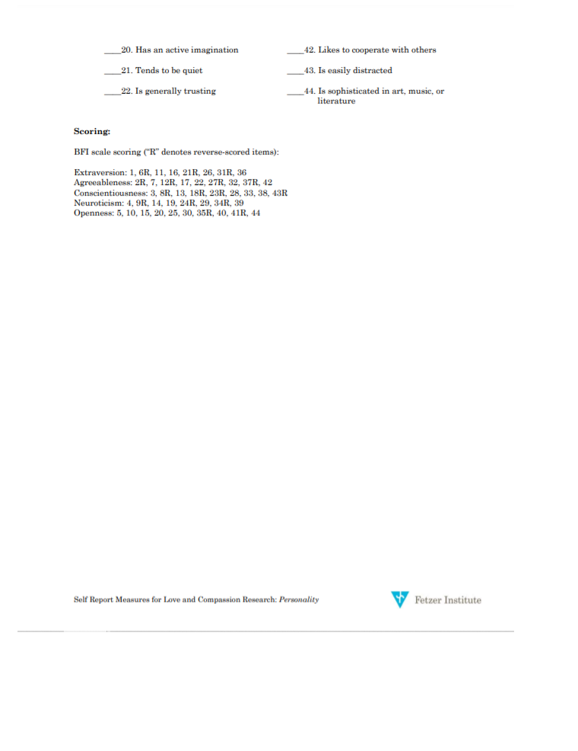

Appendix 6- List of Words for Memory Task

Appendix 7- SPSS Output



