

ACADEMIC AND EMPLOYABILITY SKILLS
BMSW4001_LON
LECTURER: Lizeta Demetriou
STUDENT NAME: Selenne Sangucho
STUDENT ID: 2124256
SUBMISSION DATE:

Contents
1. INTRODUCTION 3
2. DRISCOLL’S REFLECTIVE MODEL 4
3. REFERENCING 5
4. REFLECTION 6
5. CV WRITING 7
6. PUBLIC SPEAKING AND PRESENTATION 8
7. CONCLUSION 9
8. APENDIX 10
9. REFRENCES 13

INTRODUCTION
This is a reflective report with the main aim to provide a reflection on various topics we have covered during Academic and Employability skills modules. Reflection is a valuable skill and it is a written account of some experience in your life, what it has done to you and what you are going to do with what you have learned. (University of Wolverhampton, n.d)
Inn this report I will reflect on the following skills I have learned in class: referencing, reflection, CV writing and public speaking and giving presentations . To reflect on the above skills, I will apply Driscoll’s model of reflection.

DRISCOLL’S REFLECTIVE MODEL
Driscoll’s model is one of the reflective writing models created by Driscoll, who based it on the three questions, that Terry Boston asked in 1970, which are: what? so what? now what? These were developed in 1994, 2000 and 2007.
From each of the questions will derive other questions, but these key questions must be answered for the Driscoll’s model to be done well. Compared to other models, this one is the simplest. (All answers, 2018)

REFERENCING

What?: This topic is used to give credit to the person or organisation from which you are using the information on your assignments. (The Open University, 2020)
The class when I learned this topic, I thought it would be difficult to understand and use, on my reports or presentations, then this made it a bad experience. I have listened about it, but I had not paid attention to it, thinking it was irrelevant. So, the first thing I did is try to understand, ask questions, and do exercises to practice.
However, I was not the only one that did not understand, my partners did not understand either and this made me felt a bit more comfortable with this topic.
So what?: I felt interested on this, because there are many ways to reference and if you do not do it, you will have some legal problems.
Before knowing what referencing is, I used to do my homework taking the information from someone on internet, I put it on the paper and my homework was already to mark. I did not care from who was the information, I just wanted to finish my homework but now, I know is not right use someone’s work on your benefit.
In comparison with my colleagues, I understand it very quickly. I liked the class as we did exercises to practice and the teacher “gave us” a Harvard book, where you can find examples of the diverse types of references, and it was very useful.
Now what?: I have learned that is important to acknowledge someone’s work and is wrong use it whit not reference. I am going to use this skill on mi academic life, and I must improve it as well.
On occasion, I only want to finish my homework and I did not reference or bad reference. But I have many tools, such as Harvard book, and I should use them more, because it does not take much time to do it, and to keep learning about it as well.
Besides that, my feelings cannot depend on no one. I should always feel comfortable with my feelings, and not be afraid of being the only one who does not understand something. Therefore, I should be more confident and believe in my abilities.

REFLECTION
What?: A reflection writing is a way to write about one of your experiences, analysing and knowing what you learnt from it. (University of Wolverhampton, n.d)
This topic was one of the first topics I have learned. It was a bad experience because I didn't understand. At that moment my English was not very good, it was new and is one of the most complicated subjects to understand and to apply. The first thing I did is pay all my attention to the teacher because if I did not, I would be very lost in the module, as reflective writing is one of the most important and most used topics in this module.
So what?: I felt scared that I could not understand it at the first time, and because of that I could fail the module. In addition, I could not see myself being able to write much in English. I was afraid of making more mistakes than my classmates because I saw that many of them were able to do it easily, which made me insecure.
Despite this, the class was good because the teacher encouraged us that we could do it and that helped me to keep trying.
I did not know about the existence of this type of writing, so my past academic influenced me to think that this was useless. However, I now know that reflective writing is easier and more useful than it seems, as it is about writing about myself.
Now what?: I am going to use it more than I thought, because it is a good way to introspect on myself, as I can realise, in a more visual way, what my mistakes were in that experience and what I have learned from it. I always thought that things that have happened stay in the past, but with this I have seen that I can learn a lot more about myself than I believed I could.
Moreover, I am improving my English and learning more every day. Also, a reflection writing is a tool to improve my English and the prove of that is that I am writing a reflection.
Along with improving my English, I also need improve my confidence, understand that it is ok not to understand something, and not compare myself with others, because everyone has a different ability to understand, and just because it is a little harder for me than for other people, does not mean it is a bad thing.

CV WRITING
What?: A CV is a promotion document in which you have to highlight your most relevant skills and experience. In the first sentences the recruiter must be able to see them, because he will not spend more than 20 seconds on the CV. (The Careers Group University of London, 2019)
This one was the second last I have learned, and it was a good experience as I had already done a CV before, so I already had a little bit of information about it, but there are still things I still need learn. Unlike the other topics, this is a quite common one and most people know what it is, so I found it easy, but I still paid attention to the class because there were things I did not know.
So what?: I felt more comfortable than with the other topics, but I was surprised that in England they do not put a photo. Is something good because they do not judge you by your appearance, but they look as you as a person.
In addition, the class was relaxed, in other words there was no stress in the air as on other days.
Although everything went well, compared to before I gave this topic, I did not give the necessary importance to writing a good CV, because I did not know how to do it well and I was not interested in it, as I had no experience or anything remarkable about me, it was not important.
However, I know now that it is important because it depends on it to be able to get the job you like, and it is not important if you do not have experience because there are different ways to do a good CV.
Now what?: Now that I have learned how to make a good CV, I am going to put it into practice and continue learning how to do it. Also, to give it the importance it deserves, because although I thought that not having experience was a bad thing, there are always opportunities.

PUBLIC SPEAKING AND PRESENTATION
What?: It was the last class of this module which made it stressful because I only had one chance, plus the fact that I was going to make a presentation in person and in English made it a bit difficult. It was only five minutes of presentation, but it was intense.
I was one of the last people to present, so I did not pay much attention to my colleagues' presentations, because I was mentally rehearsing my own.
Nevertheless, it was a good experience, as my classmates and the teacher encouraged me to do it, and it is also good practice for future presentations.
So what?: I was very nervous because I had to speak in English and in front of all my colleagues, so I was afraid of making mistakes.
I had experience giving presentations, but it is not the same at school as at university, plus the English factor, which makes it a bit more complicated.
Although I felt nervous, I was quite calm, but when it was time to get up and go to the front of the class, it was horrible. I was slurred in my speech; I had forgotten things I wanted to say.... From my perspective, I had done worse than I had imagined, so I felt like I had failed because I know I could have done better.
Adding to the fact that I am shy, I am also embarrassed to speak in English, because I think that I will not be understood because of my pronunciation or that I will make a lot of grammar mistakes when I speak. All of this stops me from being myself and giving my all in a presentation.
However, the teacher was very kind during the presentation during the presentation and that made me relax a little bit.
Now what?: From now on, I am going to try to be less shy and have more confidence in myself, because if I keep thinking about what people are going to think of me, I am not going to progress in my academic life.
In my future presentations, I will stop being afraid for my English because I am not perfect and the most important thing is to try and if I do not do it, I will never know if I do it right or wrong.

CONCLUSION
All things considered, I have learned a lot in this module and specifically from these four topics. I have learned something from each of them. From all of them I have learnt that I should be more self-confident, that I should not care about the opinions of others and that I should not be afraid to make mistakes. In addition to that, I take a lot of knowledge with me, which is to value the work of others, to learn from my experiences, to know how to get the job you want starting with a CV and to learn how to speak in public.

APENDIX

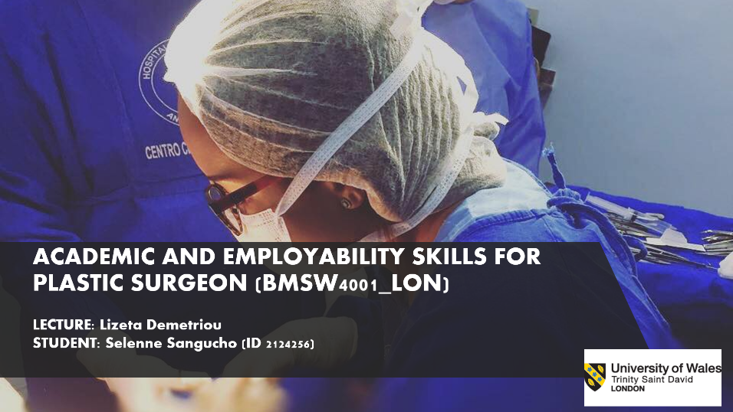

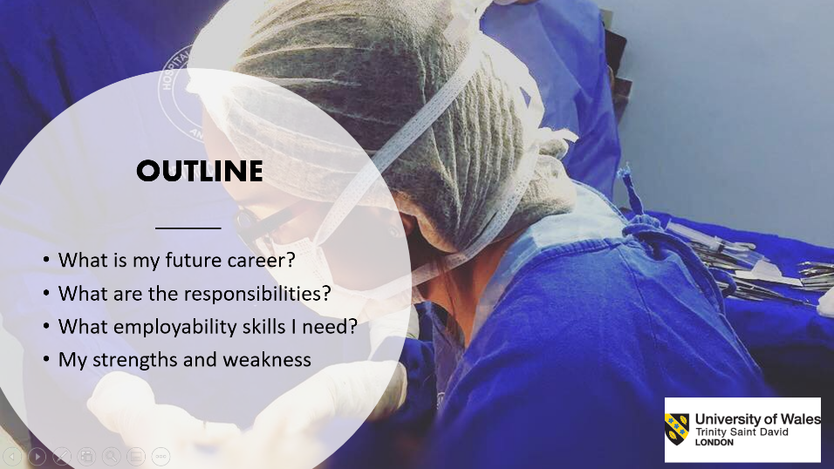

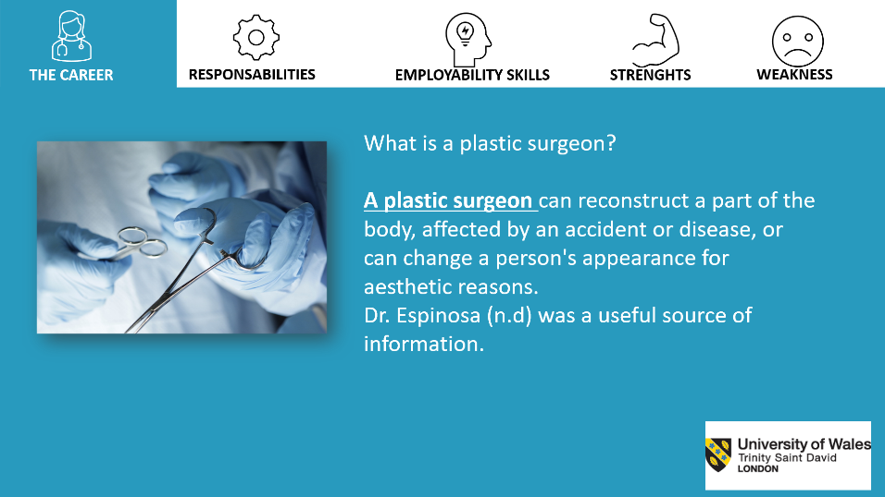

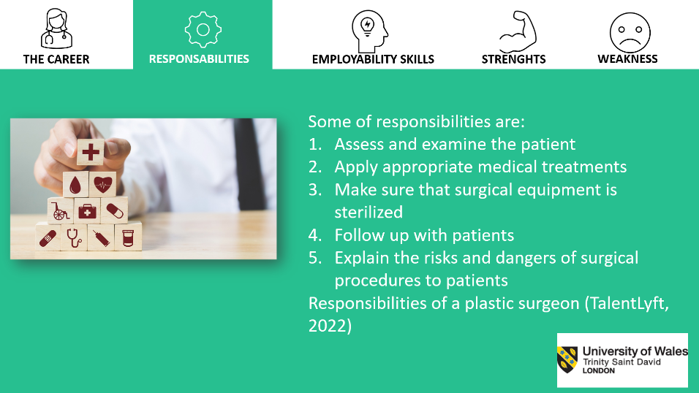

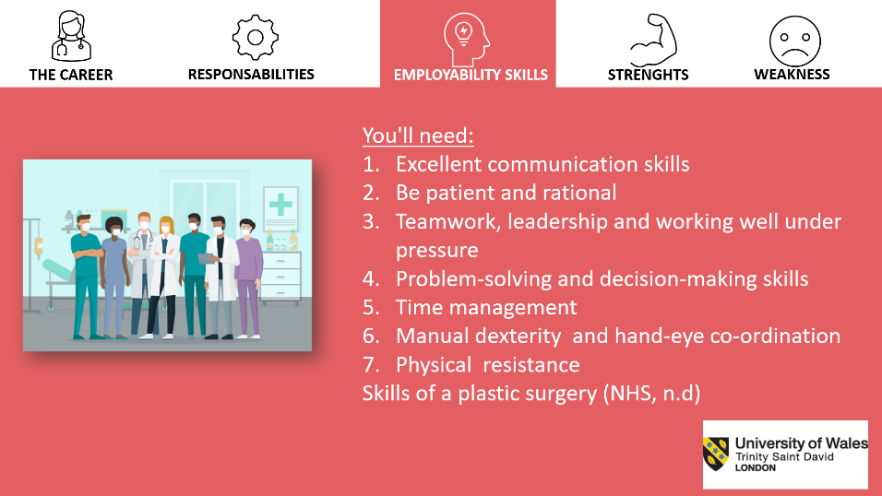

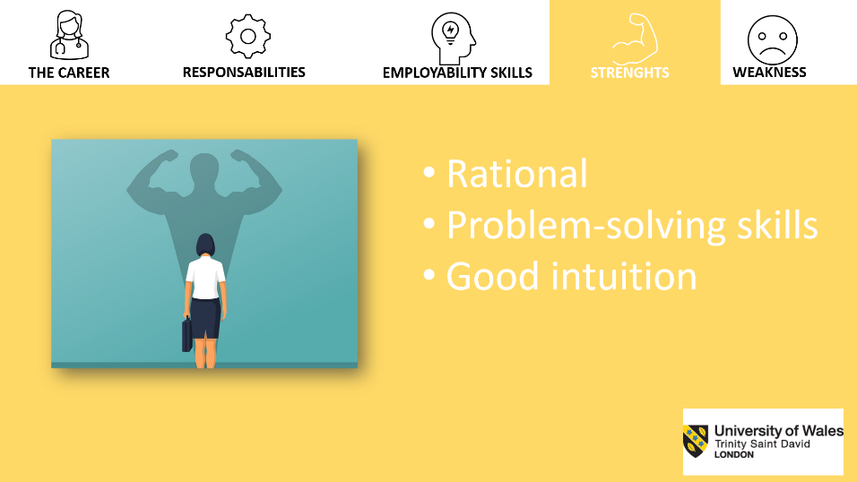

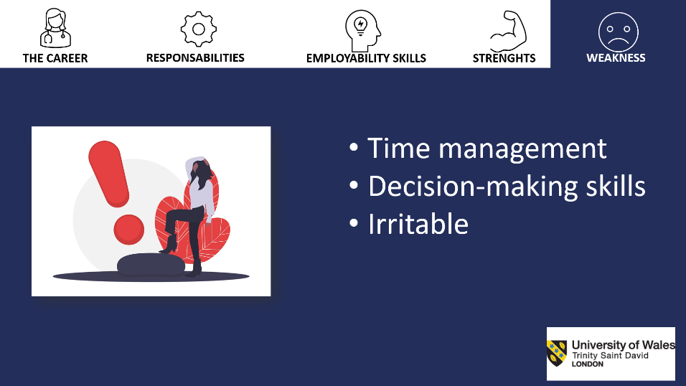

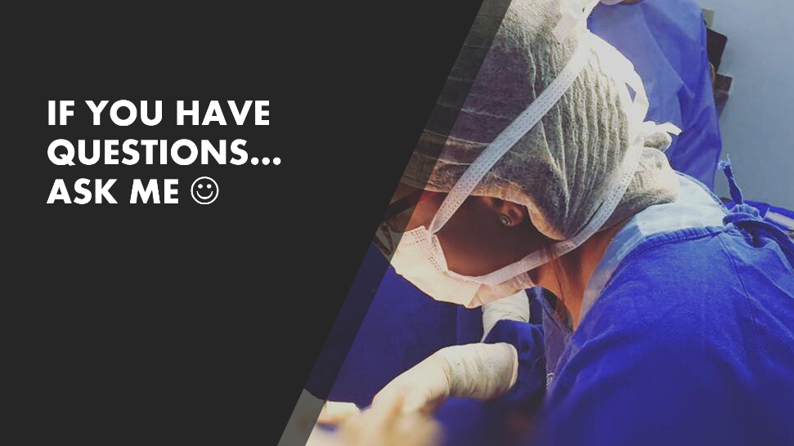

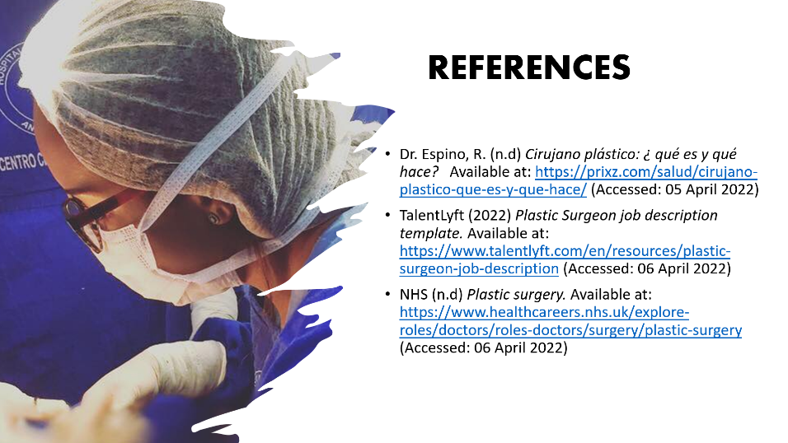

REFRENCES
University of Wolverhampton (n.d) Guide to Reflective Writing Available at: https://www.wlv.ac.uk/lib/media/departments/lis/skills/study-guides/LS006---Guide-to-Reflective-Writing.pdf (Accessed at: 14 April2022)
All answers (2018) Driscoll’s model of reflection. Available at: https://nursinganswers.net/reflective-guides/driscoll-model-of-reflection.php
(Accessed: 14 April 2022)
The Open University (2020) Introduction to referencing Available at: https://www.open.ac.uk/libraryservices/beingdigital/accessible/accessible-pdf-120-introduction-to-referencing.pdfN (Accessed: 15 April 2022)
The Careers Group University of London (2019) How to write a CV. Available at: https://www.ucl.ac.uk/careers/sites/careers/files/how_to_write_a_cv.pdf (Accessed: 20 April 2022)

