Targets | How you have worked on this | An example can be found on
Target 1  ‘It’s difficult to set targets for you as you achieve such high standards in your assignments! The wisest offering is that you continue with this level of excellence when writing your final assignments’ | I have tried to continue this throughout this assignment, although I am probably not the best judge of it! | Across the complete assignment.

ECAD6009-C

Part B – How a school develops one aspect of its SDP: a report that critically reflects on the actions, impact and evidence base.

Student Number: 1903950 CM Maudie Hughes

Word Count: 2559

Assignment Title
How a school develops one aspect of its SDP: a report that critically reflects on the actions, impact and evidence base.

Table of Contents
Introduction 4
School Improvement Plans 4
School X 6
Evaluation 8
Conclusion 9
Reference List 10
Appendix 13
Figure 1 – Screen Shot of a page of the SIP from School X 13
Figure 2 – School X SIP – Priority Area 1 14
Figure 3 – School X Four Purposes Tracker 16

Introduction
This report will examine one element of the School Improvement Plan (SIP) from a Welsh primary school. The school will be referred to as School X in order to protect the anonymity of its staff, learners and community in line with BERA guidance (BERA, 2018).

School X is a rural village primary school that currently has 234 pupils on roll (mylocalschool, 2022). Around 5.7% of learners in the school are eligible for Free School Meals, significantly lower than the national average of 21.3%, whilst around 22.3% of learners are considered to have an additional learning need (ALN), marginally above the national average of 20.6% (StatsWales, 2021). The school has developed a School Improvement Plan (SIP) covering the academic year from September 2021 to July 2022 that has four Priority Areas. In this report one area has been chosen as the focus, relating to the implementation of the curriculum for Wales (Welsh Government, 2022).

School Improvement Plans
School improvement plans (SIP), also known as school development plans (SDP) are strategic planning documents drawn up by every school to outline what and how over a three year period they will be focusing on in order to improve outcomes for learners (Welsh Government, 2014). Often containing targets linked to improving and maintaining standards in literacy and numeracy, the plans may also include targets relating to reducing the variation of attainment believed to be linked to poverty, and or other targets that have been influenced by local or national policy priorities (Reeves, McCall and MacGilchrist, 2001; Welsh Government, 2014). In the case of School X, there are 4 Priority Areas outlined on the plan with a number of targets detailed under each heading, with then a list of actions to be achieved to meet these targets. The plan also details which member or members of staff will lead on the plan, what costs may be associated with the action points, how the activity will be monitored and by when, and further details relating to the expected outcomes and success criteria. Finally there is a column allowing for ‘RAG’ rating (Law, 2016) where progress is shown using the colours of a traffic light. An example of the layout and typical content can be seen in the Appendix, Figure 1. It is worth noting that this particular plan has been drawn up to cover a single academic year, rather than a three year period which is considered to be a more typical length of time for a strategic plan (Davies and Ellison, 2003). As such the plan under review here could be considered to be a short term rather than medium term document, and this will be discussed further in due course.

The focus area under consideration here relates to priority area 1 of the plan, which is concerned with implementation of the curriculum for Wales (see Appendix, Figure 2). As can be seen on the document, there are two targets within this priority, each supported by a number of proposed actions and tasks. Of these targets, consideration is being given to the first, which aims to ‘further embed the Vision for the New Curriculum, ensuring that all stakeholders have a thorough and enhanced grasp of the future for our federation of schools’ (School X, 2022 – Appendix, Figure 2), looking specifically at action points relating to the four purposes of the curriculum (Welsh Government, 2022a).

Following the publication of the Successful Futures report (Donaldson, 2015) and subsequent consultations with stakeholders, the Welsh Government produced a new curriculum for use in Wales that will become statutory for maintained primary schools in September 2022 (Welsh Government, 2021). As such the inclusion of this particular target on the SIP will have been significantly influenced by this national policy. Nonetheless, along with many other schools, School X has already begun to adopt a significant majority of the curriculum and apply it in daily practice and activity (Deputy Head Teacher, School X, 2022) and so inclusion of this target area has also been determined through the school’s own self-evaluation process.

Self-evaluation is a process that schools are expected to undertake on a regular basis in order to inform and develop strategic plans such as the SIP, and also identify other areas beyond the plan where improvement is required (Welsh Government, 2021a). When done effectively it will involve the whole school community and draw on evidence and data supplied by a range of stakeholders, which in turn helps to promote effective engagement with the plan improvement plan that is then created. In this instance key stakeholders in the target area are predominantly staff, however the views of parents and learners will also have been considered, having been collected through consultations, general meetings and discussions and through monitoring of the learners’ work (Deputy Head Teacher, School X, 2022).

The four purposes have been placed firmly at the centre of the curriculum as the “starting point and aspiration for every child and young person in Wales” (Welsh Government, 2022b). Designed to develop “ambitious capable learners, ethical informed citizens, healthy confident individuals and enterprising and creative contributors” (Welsh Government, 2022a) the four purposes statements describe a range of skills and attitudes that schools are expected to develop in the learners as they progress through their education. This approach has been taken by the Welsh Government to promote the development of children and young people as responsible and active citizens who will become key in developing a better Wales, and therefore able to support the seven goals of the Well-being of Future Generations (Wales) Act 2015 (Welsh Government, 2022c). Many of the statements within the four purposes can be linked to these seven goals (Welsh Government, 2022a; Welsh Government, 2021a) which include aims such as “a healthier Wales, a prosperous Wales and a Wales of cohesive communities” (Welsh Government, 2021a).

School X
It is clear from the SIP that School X has created that the school leadership have noted the importance Welsh Government have placed on the four purposes (Welsh Government, 2022a). Furthermore there is evidence in the statement given for Priority Area 1 that the school are aware of and engaged with the wider education and policy communities that can influence their activity as they refer to the ‘our national mission’ document created by Welsh Government as part of the education transformation activity (2017) (see Appendix, Figure 2). Not clear from the document is how the school’s own self-evaluation activity influenced the inclusion of this priority area, however discussion with the Deputy Head Teacher did suggest that ongoing feedback from work scrutiny activity and staff meetings had been used to formulate the action points identified (Welsh Government, 2014; Deputy Head Teacher, School X, 2022).

Also clear from the document is the intention to involve a range of stakeholders, namely staff, learners, and the governing body (referred to as GB) (see Appendix, Figure 2), and again this is something considered to be good practice, if not essential, in creating and delivering the SIP successfully (Woods and Brighouse, 2013; Welsh Government, 2014). The monitoring and review column makes reference to the various parties that will be involved in and what form that involvement will take. Mention is also made of the proposed use of learning walks as a means by which monitoring will take place. Learning walks allow the observer to see a range of activity whilst it is happening in real time against a specific focus that will have been predetermined (Woods and Brighouse, 2013; Estyn, 2021). Evidence will be gathered through observation of both the teacher and the approaches being used, and the progress the learners are making at that given time (Estyn, 2021); this can then be further explored through examination of the learners work and through discussion with the teacher. When used effectively, learning walks can be a supportive development tool, allowing for the sharing of good practice between classes and reducing possible feelings of isolation for practitioners as they are able to engage with other staff as they discuss different approaches being used and also allow for sharing of best practice with other schools (Woods and Brighouse, 2013; Allen and Topolka-Jorissen, 2014). In discussion with the Deputy Head Teacher (2022) a query was raised as to how staff felt about having others in their classroom conducting a learning walk, and although it was acknowledged that it could be possible for the class teacher to feel uncomfortable or under scrutiny, the culture within the school meant that the activity was seen as a positive and supportive one.

Further clarification is provided in the SIP as to what evidence is expected to be found by activities such as learning walks and pupil feedback (See Appendix, Figure 2). Having a clear indication of what successful achievement of the targets will be is important both to drive forward delivery of the plan, and to be able to effectively monitor progress against it (Welsh Government, 2014; Page and Hale, 2016). Furthermore stakeholders across the school community will be more likely to engage and support the plan if they are clear on what the expected outcomes of it are and are supported and encouraged by the senior leadership team (Reeves, McCall and MacGilchrist, 2001).

What is less clear from the SIP document is what the starting point for the various actions is. The target states ‘to further embed…’ (See Appendix, Figure 2) which suggests that some measurement has been taken to determine where the activity is starting from, but this is not shared on this particular document. It is possible that such information may have been captured by review and evaluation of previous plans but knowing what that starting point is and being able to share that with others further informs the development of the plan (Smith, 2008). Again, discussion with the Deputy Head Teacher (2022) suggested that all staff and other stakeholders such as the governing body were aware of the starting point in terms of this particular plan, whilst also acknowledging that it was also an ongoing development area.

The final action point relating to the four purposes however does provide an opportunity for a more responsive and immediate monitoring of the plan’s progress. This point states that “All staff to further embed, trial and practice with the four purpose trackers on a daily, weekly and termly basis. All planning documents will be aligned and can be used by visiting schools as examples of best practice.” (See Appendix, Figure 2). The school has designed and created a shared document containing details of the four purposes statements and the various descriptions of learning under each of the Areas of Learning and Experience (AoLE) within the curriculum for Wales (Welsh Government, 2022) as can be seen in Appendix, Figure 3. This document allows for whole school tracking of teaching and learning opportunities that are being delivered in the classes and shows at a glance through colour coding where the learners have covered particular aspects of the curriculum framework. The SIP indicates that this particular document will be regularly reviewed and discussed in staff meetings, alongside the associated planning documents. Through observation of a staff meeting and further discussion with the Deputy Head Teacher (2022), it was clear that this tracker document is widely used by the staff as an effective tool to record learner progress against the descriptions of learning within the various AoLE with various statements being colour-coded when appropriate. However, what was less clear was how it was being used to specifically track the four purposes; the statements for each of the purposes are shown at the top of the spreadsheet with their respective character icons, but there is no colour coding in use to record development of these particular skills, something that was discussed during a placement review meeting with the Class and Senior Mentors at School X (2022).

Evaluation
As noted earlier, the SIP produced by School X covers a period of one academic year. The guidance produced by Welsh Government (2014) indicates that SIP or SDP are intended to cover a period of three years, with the plan showing detailed targets and actions for the first year of the plan, with higher level targets and priorities shown in the second and third years, However, it also states that the plans are a rolling document, and as such revision will occur regularly as the school leadership team carries out ongoing self-evaluation activity leading to strategic planning, implementation of improvements and review of the impact these have had. Improvements within a school context take time, and so a longer term approach is often needed when planning for this (Middlewood and Lumby, 1998), yet the influence of policy and political agendas may demand a shorter-term approach in order to secure evidence of faster improvement. In the case of School X, it may be argued that whilst the SIP is dated to cover a one year period, the attitudes and approaches of the leadership team indicate that they have a clearly defined programme of evaluation, planning, implementation and review that ensures targets are relevant to the needs of the learners and the school, and that staff in particular are aware of their role in both the creation and delivery of the various action points (Deputy Head Teacher, School X, 2022), with this being a longer term strategic view. The school has previously been commended for its strong leadership team and approaches, something that again works to ensure effective development and progression of the SIP activity (Marzano, Waters and McNulty, 2005; Estyn, 2016).

In terms of the monitoring of the plan and assessment of outcomes, it appears to be a regular and robust process. Nonetheless, there could be scope for further consideration around how coverage of the four purposes of the curriculum (Welsh Government, 2022a) is tracked; the document shown in Appendix Figure 3 could be modified to allow for a RAG style (Law, 2016) coding to be applied against the various statements to indicate how often learners have been given the opportunity to engage with them as part of their learning, and allow staff to see at a glance any statements which are not being discussed with appropriate frequency.

Conclusion
The information shared by School X provided an in-depth and comprehensive overview of the process followed to create the SIP and monitor it. Seeing it from the practitioner perspective as opposed to the view of a parent governor also provided insight into the role of staff stakeholders in collecting and analysing data as part of the ongoing self-evaluation process the school engages in. Appreciation has also been gained on how there is a need to be responsive to a range of influences and data when creating a SIP; sometimes as in the case of the Priority Area considered here it will be driven by a national policy agenda, whereas on other occasions it will be in response to trends in school reporting data generated by assessments carried out in the classroom (Deputy Head Teacher, School X, 2022). It has become clear however that effective delivery of a SIP requires support from all stakeholders, and the classroom practitioner has a significant role to play in this as well, which can also be seen in the professional standards all teachers must evidence (Welsh Government, 2019), especially those relating to collaboration and leadership and this is something that I will seek to demonstrate more fully in the future.

Reference List
Allen, A. S., and Topolka-Jorissen, K., (2014) ‘Using teacher learning walks to build capacity in a rural elementary school: repurposing a supervisory tool’, Professional development in education, 40(5), pp. 822-837 Available at: https://www-tandfonline-com.ezproxy.uwtsd.ac.uk/doi/full/10.1080/19415257.2013.851104 (Accessed: 22 May 2022)

BERA (2018) Ethical Guidelines for Educational Research 4th edn. Available at: https://www.bera.ac.uk/publication/ethical-guidelines-for-educational-research-2018 (Accessed: 16 May 2022)

Class Mentor and Senior Mentor, School X (2022) Placement review conversation with CM Maudie Hughes during Professional Teaching Experience 3, 10 March.

Davies, B., and Ellison, L., (2003) The New Strategic Direction and Development of the School: Key Frameworks for School Improvement Planning. 2nd edn. London: Routledge

Deputy Head Teacher, School X (2022) Conversation with CM Maudie Hughes during Professional Teaching Experience 3, 8 March.

Donaldson, G., (2015) Successful Futures: Independent Review of Curriculum and Assessment Arrangements in Wales Available at: https://gov.wales/sites/default/files/publications/2018-03/successful-futures.pdf (Accessed: 15 May 2022)

Estyn (2016) Leadership and primary school improvement September 2016 Available at: https://www.estyn.gov.wales/system/files/2020-07/Leadership%2520and%2520primary%2520improvement%2520-%2520new%2520links_0.pdf (Accessed: 14 May 2022)

Estyn, (2021) Supplementary guidance: Lesson observation and learning walks – September 2021: Lesson observation: General principles Available at: https://www.estyn.gov.wales/document-page/20555/contents/guidance/lesson-observation-general-principles (Accessed: 22 May 2022)

Law, J., (2016) A Dictionary of Accounting. 5th edn. Oxford: Oxford University Press
Marzano, R. J., Waters, T., and McNulty, B. A., (2005) School leadership that works from research to results Colorado: Mid-continent Research for Education and Learning

Middlewood, D. and Lumby, J., (1998) Strategic Management in Schools and Colleges London: Sage Publications Ltd.

Mylocalschool (2022), Tavernspite CP School Available at: https://mylocalschool.gov.wales/School/6682266?lang=en#0 (Accessed: 16 May 2022)

Page, D., and Hale, J. A., (2016) The School Improvement Specialist Field Guide California: Corwin Press

Reeves, J., McCall, J. and MacGilchrist, B., (2001) ‘Change leadership: planning, conceptualization and perception’, in MacBeath, J., and Mortimore, P. (ed.) Improving School Effectiveness Maidenhead: Open University Press

Smith, L., (2008) Schools That Change: Evidence-Based Improvement and Effective Change Leadership California: Corwin Press

StatsWales (2021), Pupil Level Annual School Census summary data by local authority (pupils aged 5 to 15 in primary, middle or secondary schools) Available at: https://statswales.gov.wales/Catalogue/Education-and-Skills/Schools-and-Teachers/Schools-Census/Pupil-Level-Annual-School-Census/pupillevelannualschoolcensussummarydata-by-localauthority (Accessed: 16 May 2022)

Welsh Government (2014), School Development Plans: Guidance Available at: https://gov.wales/sites/default/files/publications/2018-03/school-development-plans.pdf (Accessed: 16 May 2022)

Welsh Government (2019) Professional standards for teaching and leadership Available at: https://hwb.gov.wales/api/storage/19bc948b-8a3f-41e0-944a-7bf2cadf7d18/professional-standards-for-teaching-and-leadership-interactive-pdf-for-pc.pdf (Accessed: 14 May 2022)

Welsh Government (2022a) Developing a vision for curriculum design Available at: https://hwb.gov.wales/curriculum-for-wales/designing-your-curriculum/developing-a-vision-for-curriculum-design/#curriculum-design-and-the-four-purposes (Accessed: 16 May 2022)
Welsh Government, (2017) Education in Wales: Our national mission: Action plan 2017 – 2021 Avaialble at: https://gov.wales/sites/default/files/publications/2018-03/education-in-wales-our-national-mission.pdf (Accessed: 22 May 2022)

Welsh Government, (2021) Curriculum for Wales: the journey to curriculum roll-out Available at: https://hwb.gov.wales/curriculum-for-wales/curriculum-for-wales-the-journey-to-curriculum-roll-out#page-wrapper (Accessed: 19 May 2022)

Welsh Government, (2021a) School improvement guidance: framework for evaluation, improvement and accountability Available at: https://gov.wales/sites/default/files/consultations/2021-01/210126-school-improvement-guidance-framework-for-evaluation-improvement-accountability.pdf (Accessed: 19 May 2022)

Welsh Government, (2021a) Well-being of Future Generations (Wales) Act 2015: Essentials Guide Available at https://gov.wales/sites/default/files/publications/2021-10/well-being-future-generations-wales-act-2015-the-essentials-2021.pdf (Accessed: 22 May 2022)

Welsh Government, (2022) Curriculum for Wales Available at: https://hwb.gov.wales/curriculum-for-wales/ (Accessed: 16 May 2022)

Welsh Government, (2022b) Introduction to Curriculum for Wales guidance Available at: https://hwb.gov.wales/curriculum-for-wales/introduction/ (Accessed: 20 May 2022)

Welsh Government, (2022c) Well-being of Future Generations (Wales) Act 2015 Available at: https://www.futuregenerations.wales/about-us/future-generations-act/ (Accessed: 22 May 2022)

Woods, D., and Brighouse, T., (2013) The A-Z of School Improvement: Principles and Practice London: Bloomsbury Education

Appendix
Figure 1 – Screen Shot of a page of the SIP from School X
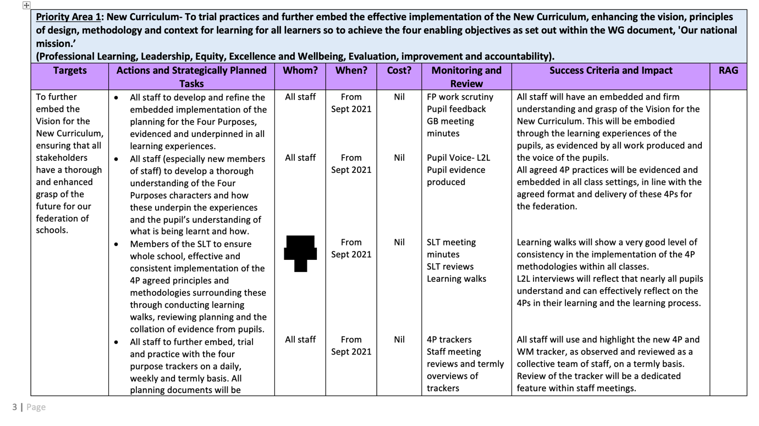
Source: School X SIP Document – Anonymised.

Figure 2 – School X SIP – Priority Area 1
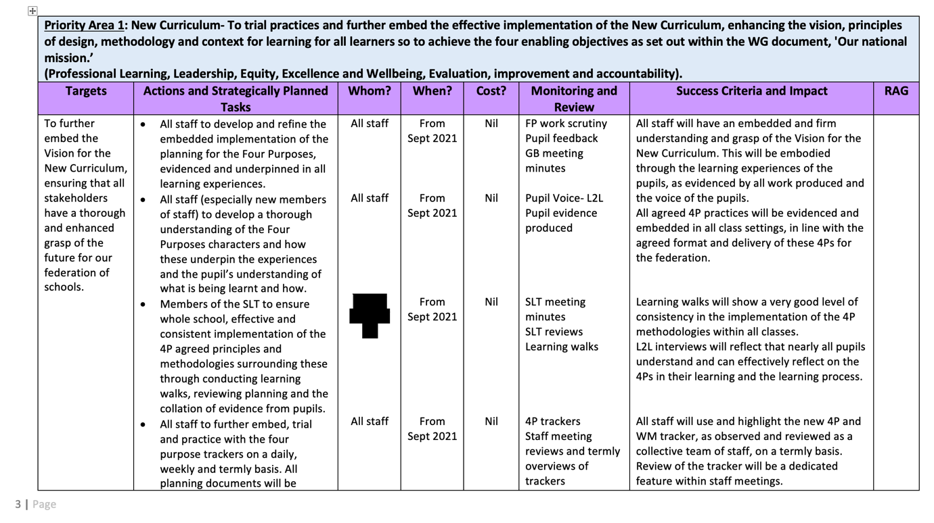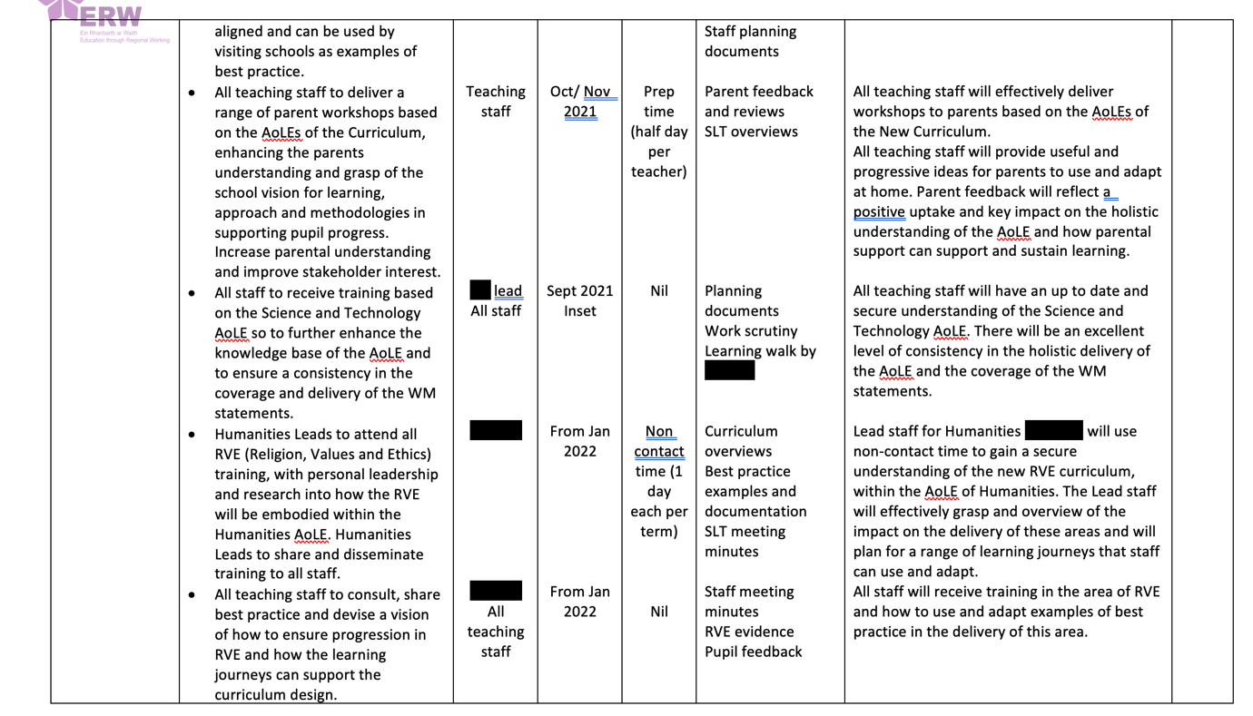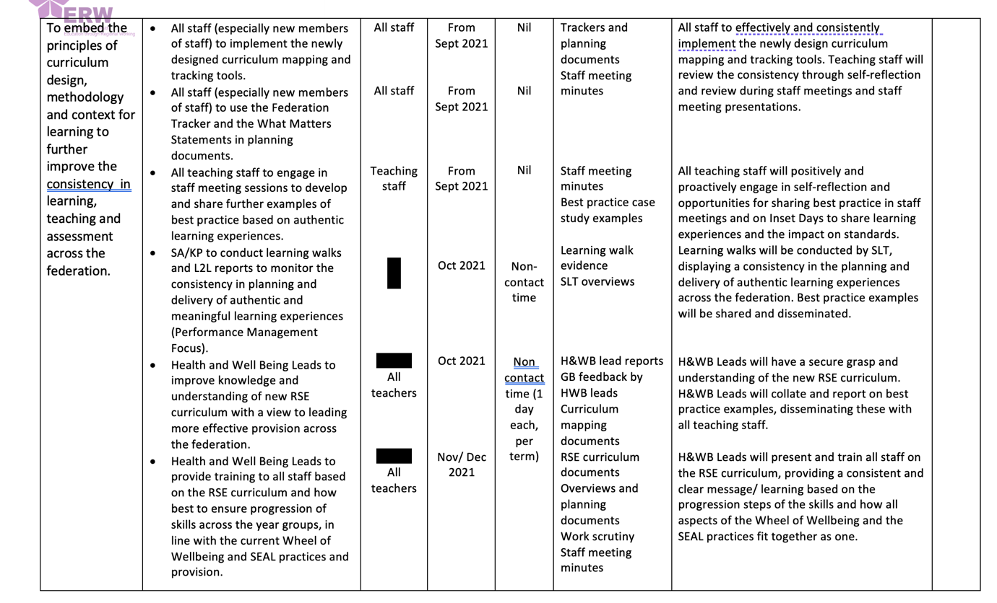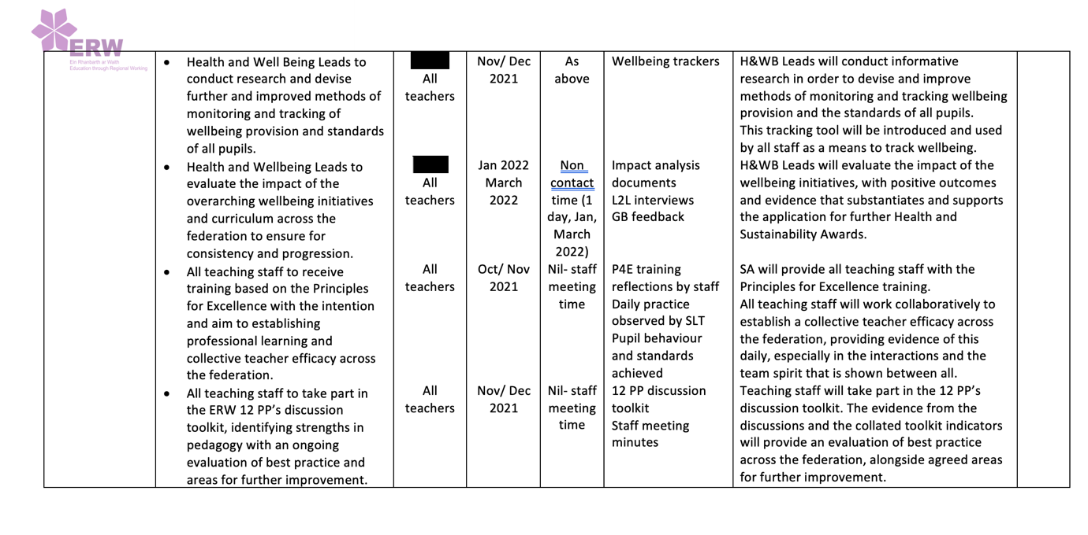

Source: School X SIP Document – Anonymised.

Figure 3 – School X Four Purposes Tracker
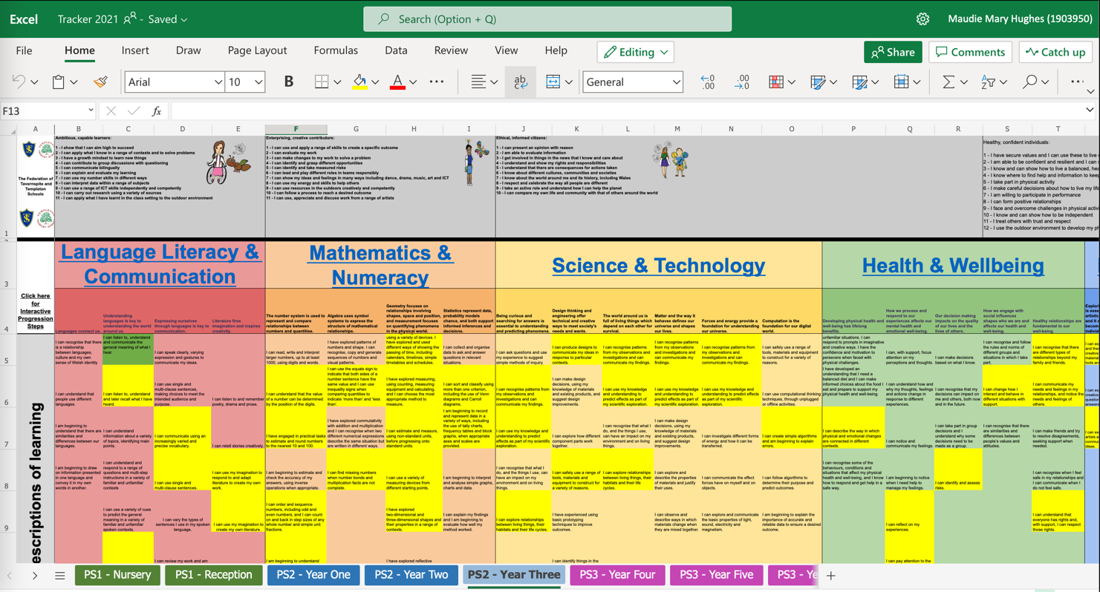

Source: School X Tracker Document – Anonymised.

