Giuseppe Palumbo
University of Wales St Trinity David
Student ID: 2335642

Module: ACCA4023
Lecture: Suneth Fernando
IDW: Database design and deVELOPMENT
Assessment 1

Table of content
Introduction………………………………….2
Entity Relationship Diagram…………….3
Relationship between entities………….4
Entities Interact within the database…4
Logical Design………………………….5-8
Relationship between tables………….9-10
Testing and Validation………………….11
3rd Normal form from MS-Excel………12
Form Creation……………………………12-14
Queries Creation…………………………15-19
Report Creation……………………………20-22
Calculation………………………………….22
Dashboard………………………………….23

Introduction case study
EcoRide is a new electric bike rental service. People can take a bike from one place and return it to another. Right now, the team writes everything on paper and basic spreadsheets, which makes work difficult. They cannot easily see which bikes are free, rented, or need fixing.
For this reason, we need to make a proper database to store rider details, bike information, rentals, and staff work. This project shows how the new database can help EcoRide work better and stay organised.

Entity Relationship Diagram (ERD)
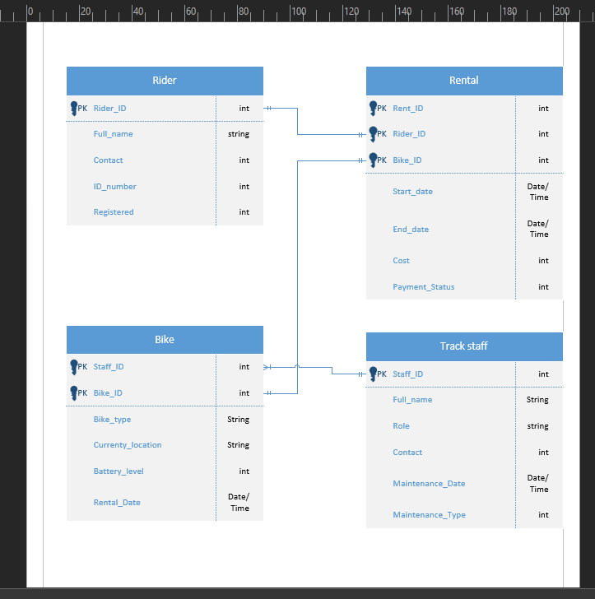
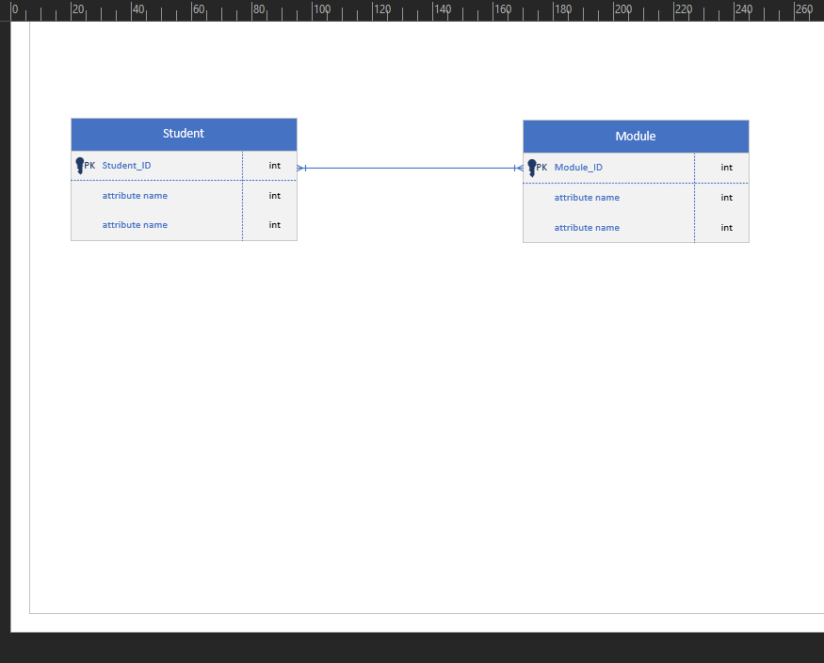

Type of the relationship between Entities

One to one

One rider can rent one bike

One to many

One bike can be rented by multiply riders

Many to many

One student can follow to many modules

One module can have too many students

Entities Interact within the database

How ER modelling helps when developing the database

ER modelling helps me understand the connections and relationships between all parts of the system.
It shows the main entities, like Riders, Bikes, Rentals, and Staff, and how they relate to each other.
This makes it easier to design the database correctly, avoid mistakes, and make sure the data is stored in the right place.
With an ER diagram, I can clearly see which table needs, which information and how the system works.
Logical Design
Table Creation in Access
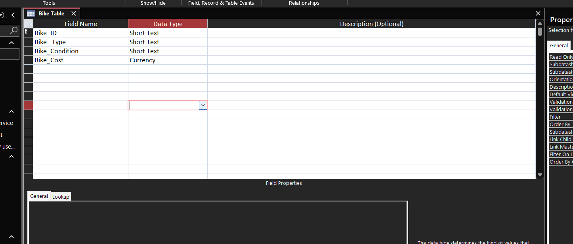
This table stores information about each bike in the system.
It helps identify the bike and keep track of its type, condition, and cost.

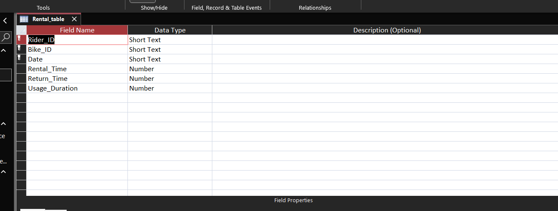

This table stores information about each rental transaction.

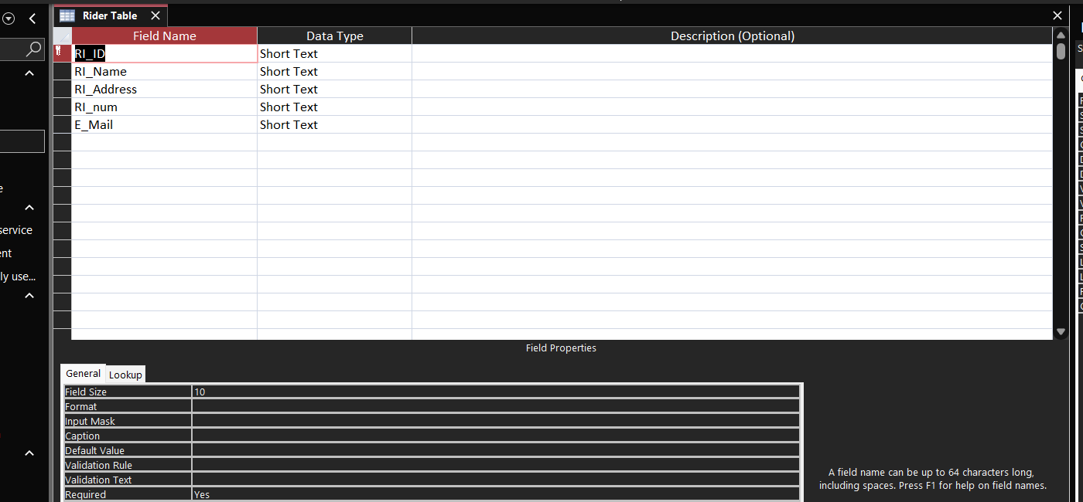
This table stores basic information about each rider registered in the system.
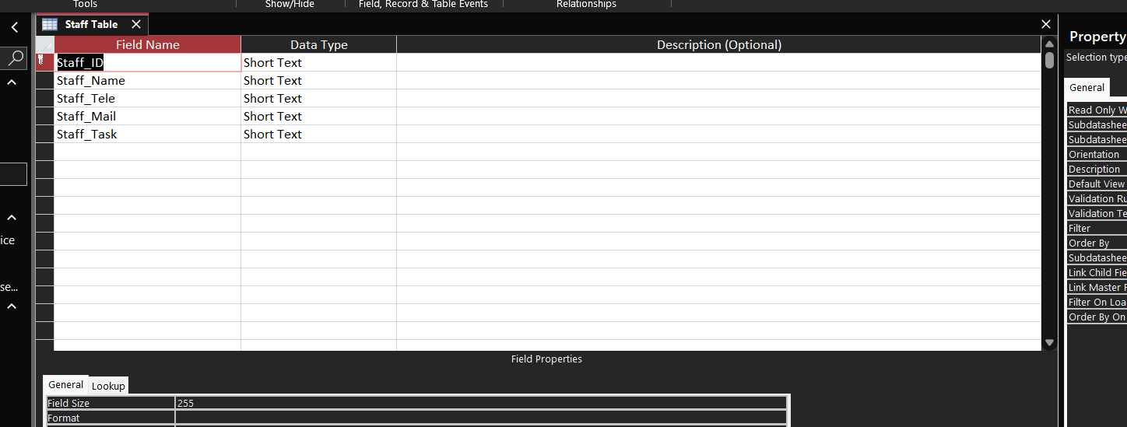
This table stores information about the staff working in the EcoRide system.
Each field keeps a basic detail about each staff member.
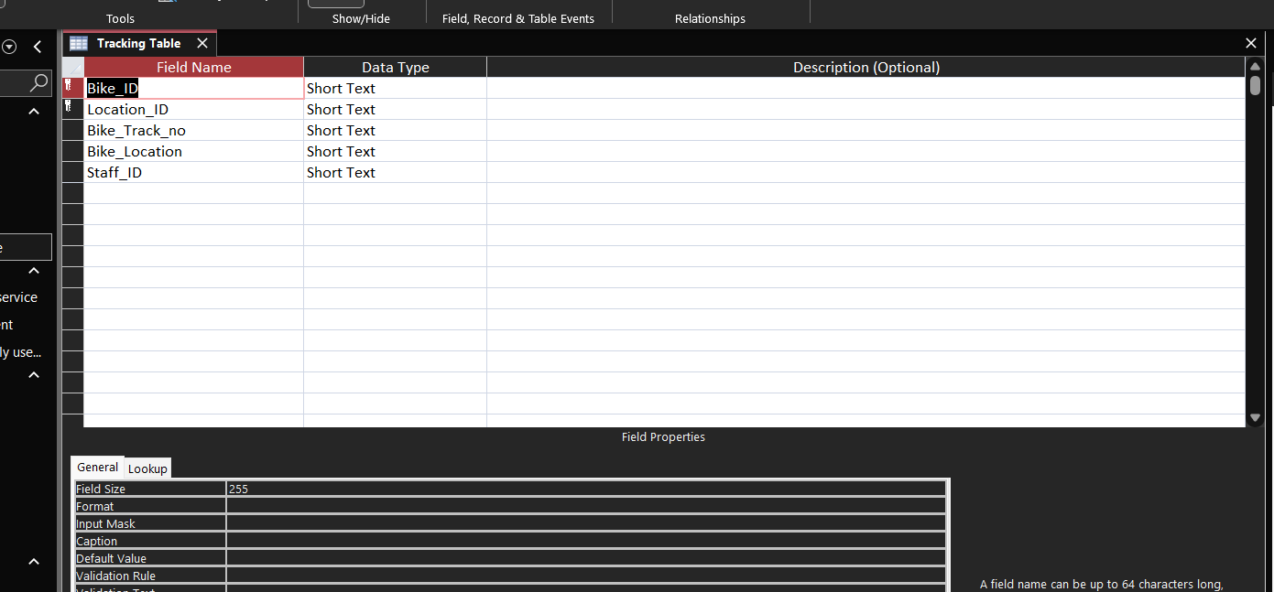
This table is used to track where each bike is and who has worked on it.
It links bikes, locations, and staff members.
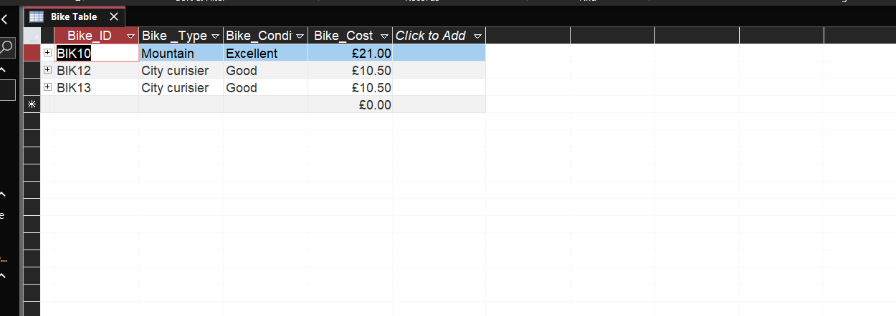
This view shows the Bike Table displayed in datasheet mode, where all the stored bike records are visible as rows of data.
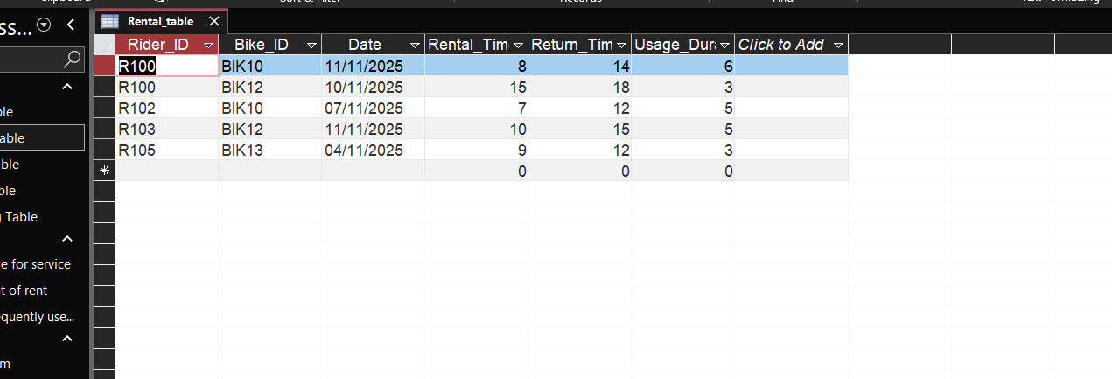
This table shows all the bike rentals. It records which rider took which bike, the rental date, return time, and how long the bike was used.
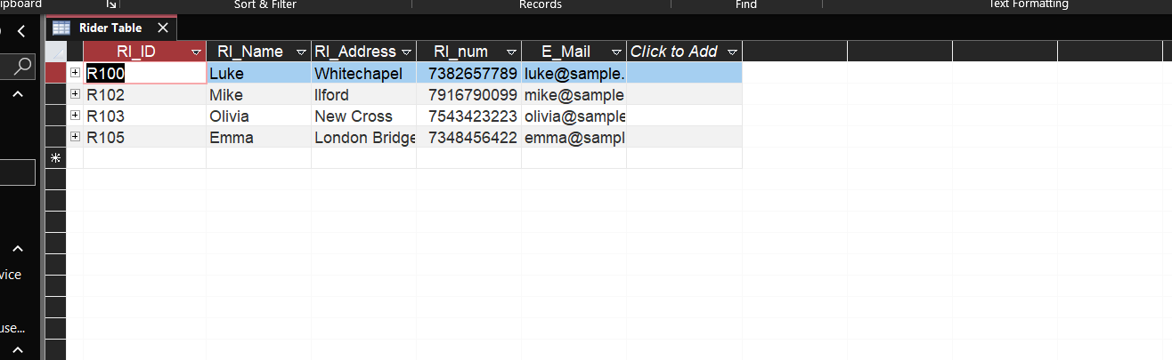
This table stores information about each rider, such as their name, address, phone number and email.

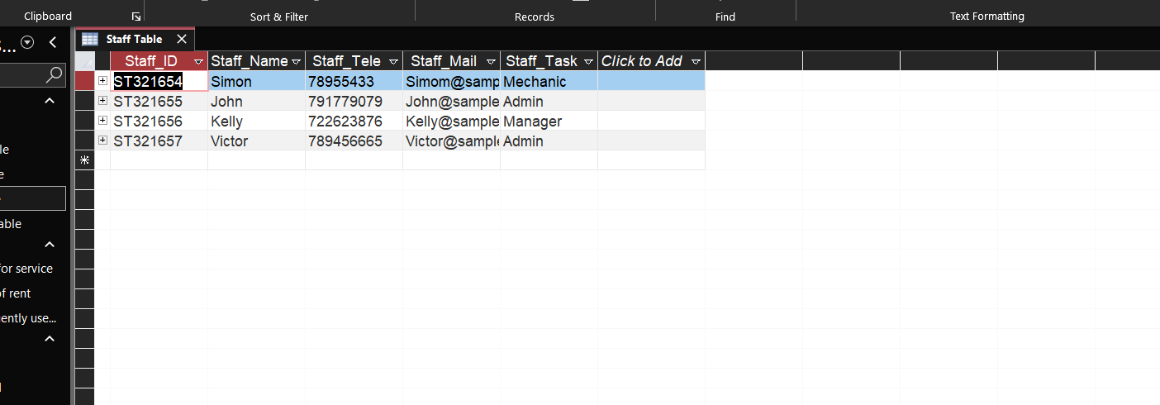
This table stores information about each rider, such as their name, address, phone number and email.

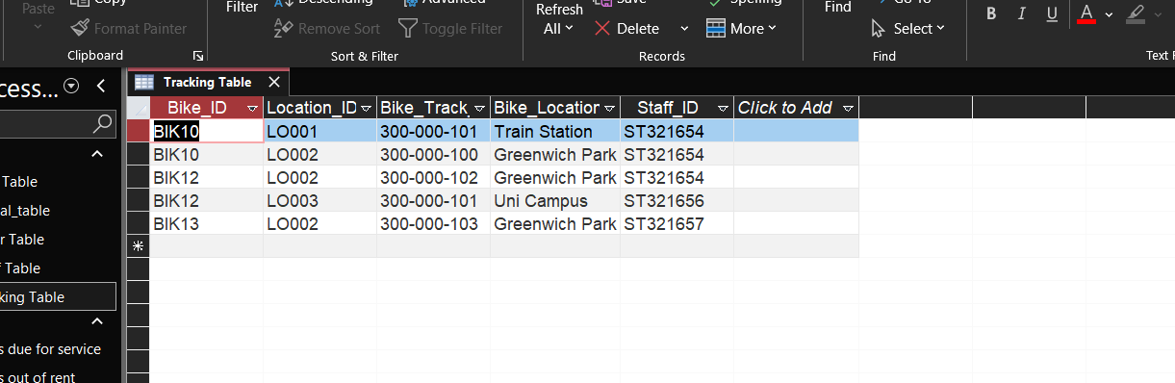
This table tracks where each bike is located and links it to a staff member who checked or managed it.

Relationship between tables
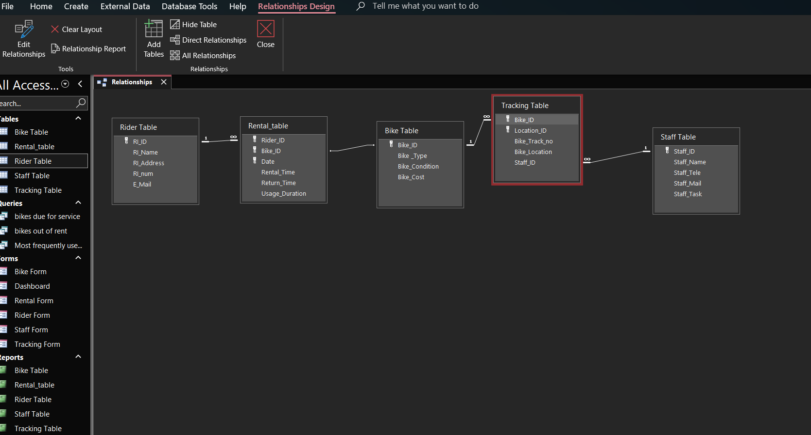
Rider Table:

Primary Key: Rider_ID
This key uniquely identifies each rider and connects to the Rental Table, allowing the system to link each rental to a specific rider.

Rental Table:

Foreign Keys: Rider_ID Bike_ID
These keys tell the database which rider rented which bike, and this table uses other fields (date, time, duration) but only the two keys create relationships.

Bike Table:

Primary key: Bike_ID
This key uniquely identifies each bike and connects to both the Rental Table and the Tracking Table, so the system knows:
- Which bike was rented
- Where each bike is located and maintained

Staff Table:

Primary key: Staff_ID
This key uniquely identifies each staff member and It is used by the Tracking Table to record which staff member checked or managed a bike.

Tracking Table:

Foreign key: Bike_ID Staff_ID
These keys show which staff member handled each bike and where the bike is located.

Testing and Validation

TEST CASE | EXPECTED RESULT | ACTUAL RESULT | ANY ISSUES?
Add a new Rider | A new rider should be correctly in the rider table. | Rider saved successfully and appears in the Rider Table | No
Add new bike | The bike should be saved in with ID, type, cost and condition | Bike saved correctly and visible in the Bike Table | No
Add a new rental | Rental should link Rider_ID and Bike_ID and show rental and return times | Rental saved correctly and linked to rider and bike | No
Track bike location | Bike should show correct location and staff member in the Tracking Table | Location updated and saved correctly | No
Query: Bikes out on rent | The query should show only the bikes that are currently rented | Query works and shows the correct bikes | No
Query: Most used bikes | The query should calculate usage and show the most used bike | Query runs correctly and shows usage | No
Query: Bikes due for service | The query should show bikes that need service based on condition | Query displays the correct bikes | No

3rd Normal form from MS-Excel
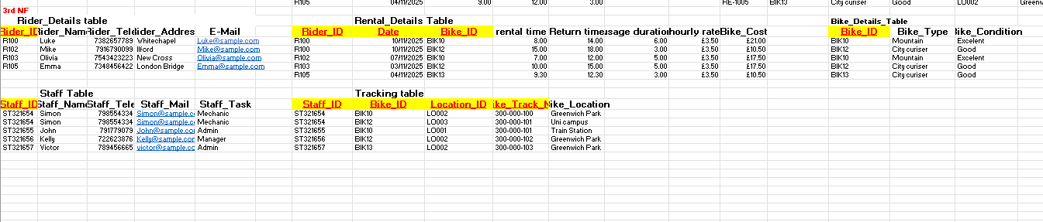

MS-Access
Form Creation
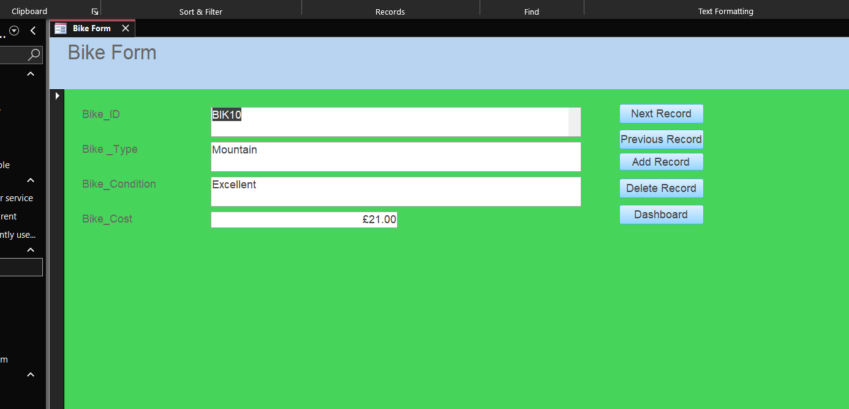
This form is used to show and update the details of each bike in the EcoRide system.
It displays the bike’s ID, type, condition, and rental cost. The form makes it easy to check bike information and keep the records up to date
The bottoms on the right allow the user to go on the next and previous record, add and delete record, and dashboard.
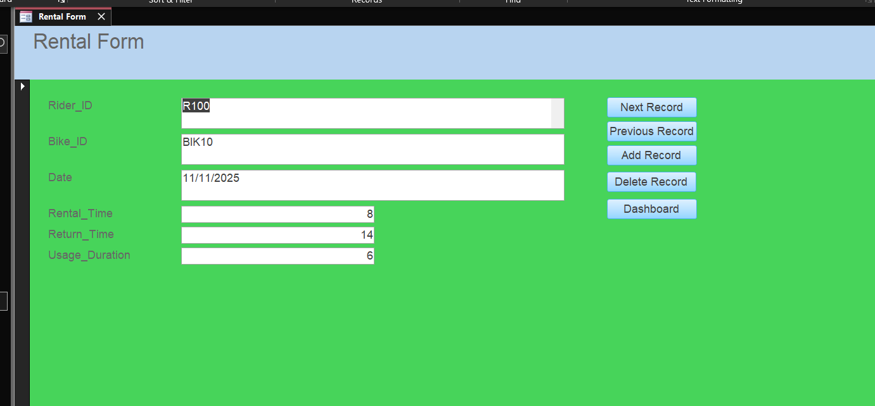
This form is used to record and view each bike rental.
It shows the rider ID, the bike used, the rental date, the start time, the return time, and the total duration. It helps the system track who rented a bike, when it was taken, and when it was returned.
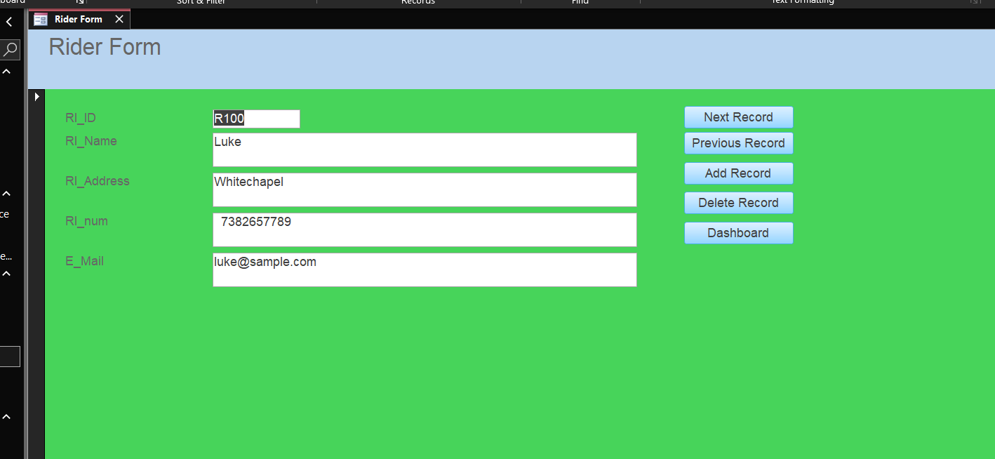
This form stores the personal details of each rider.
It includes the rider’s ID, name, address, phone number, and email. Its purpose is to keep all rider information organised so the system can link each rental to the correct person.
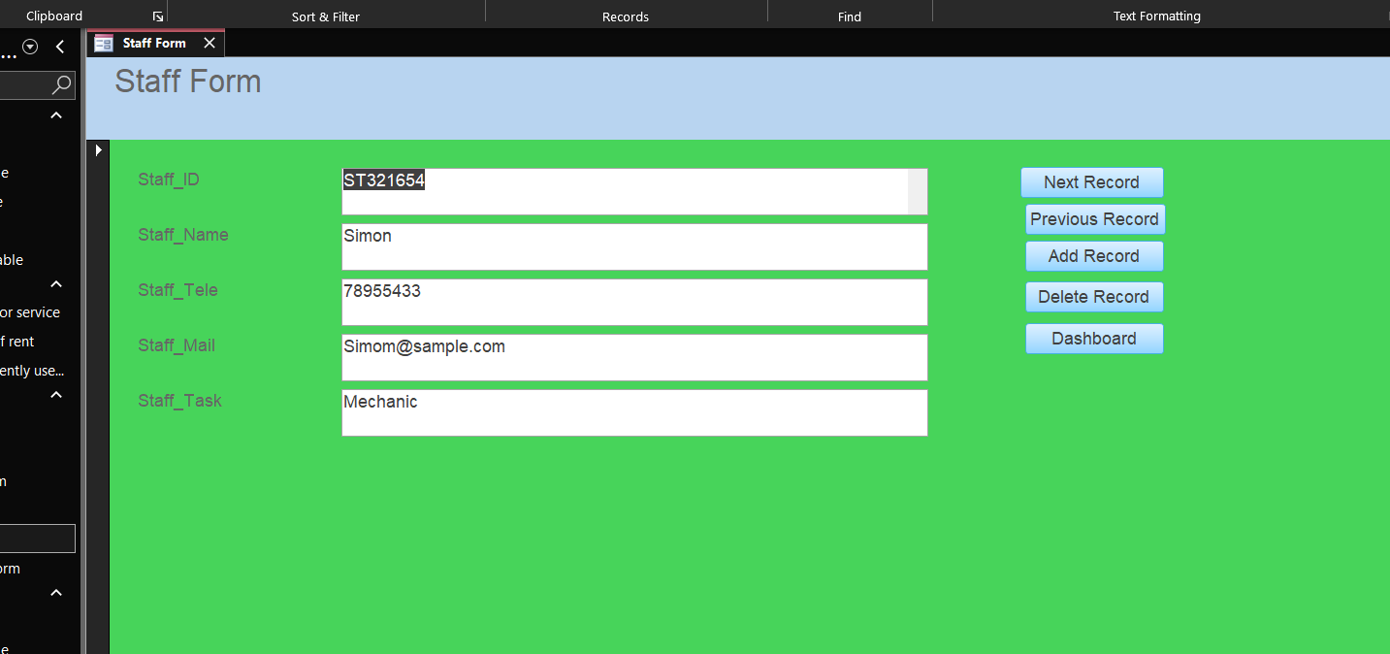
This form stores information about the staff members who work in the EcoRide service.
It includes their staff ID, name, phone number, email, and the task they are responsible for. The form helps keep track of who maintains or checks each bike in the system.
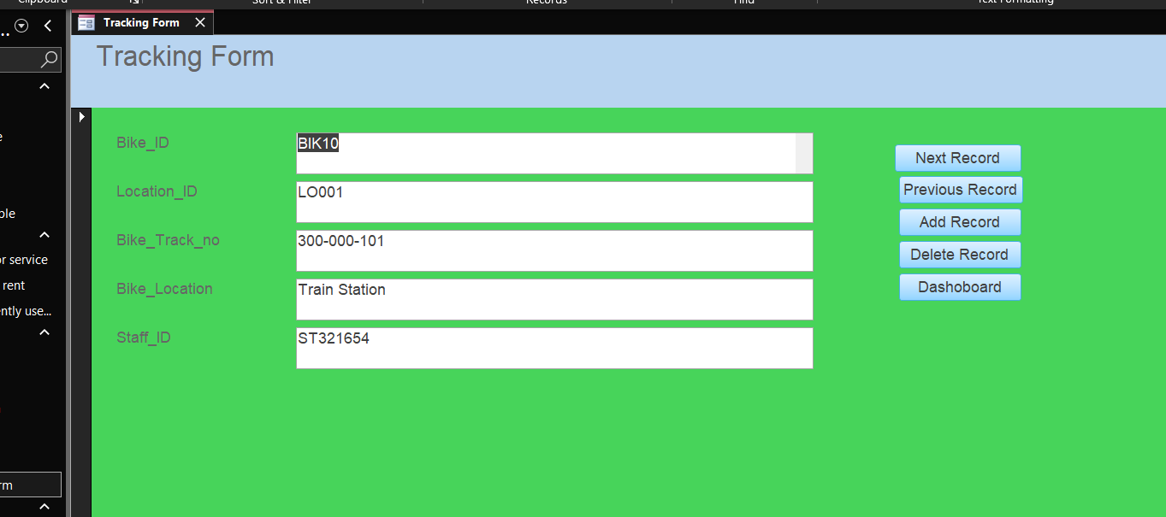
This form records where each bike is located and who last handled it.
It shows the bike ID, the location ID, the tracking number, the exact place of the bike, and the staff member responsible for checking or moving it. This helps the team keep track of bike movements and ensures bikes are always easy to find.

Queries Creation
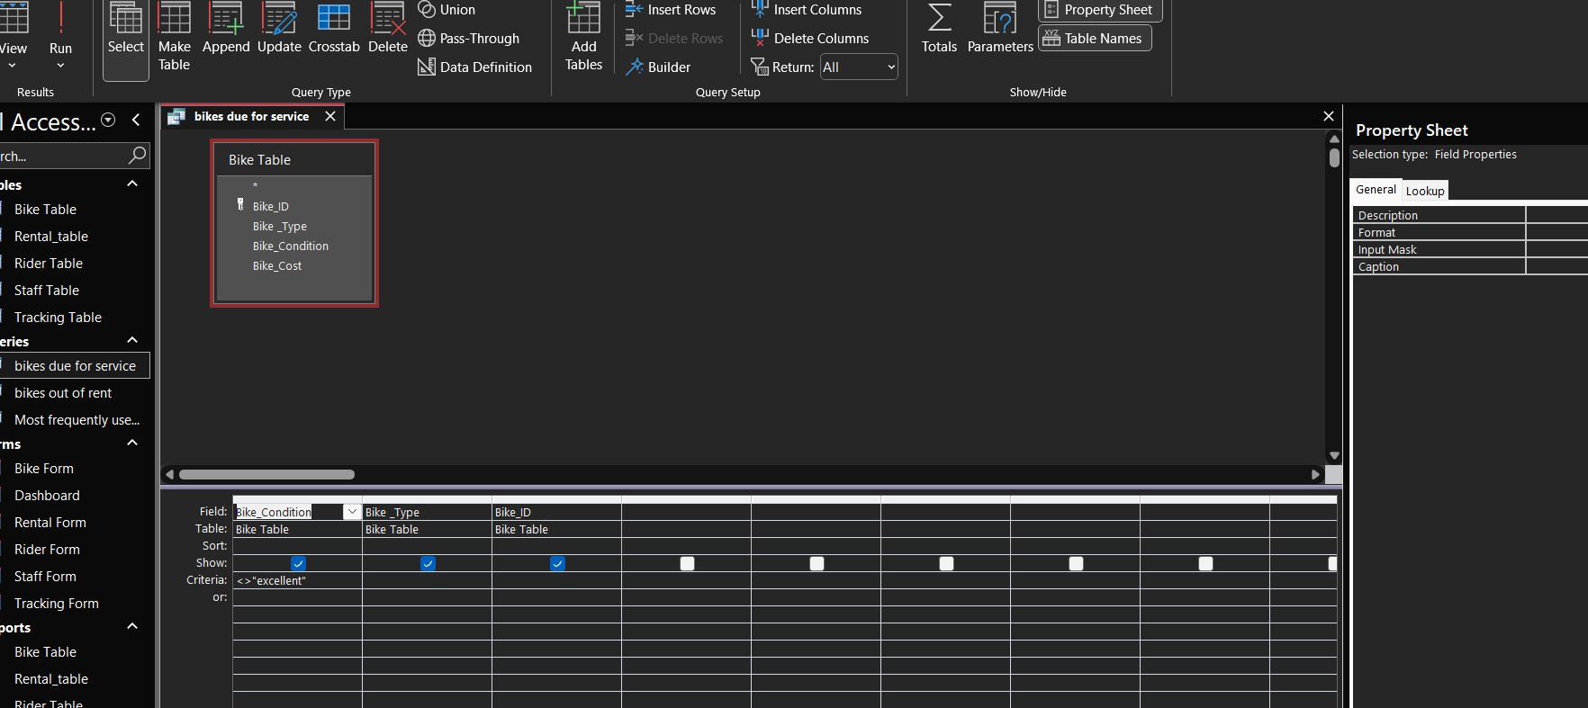
This query finds bikes that need service.
The query finds all bikes that are not in excellent condition.

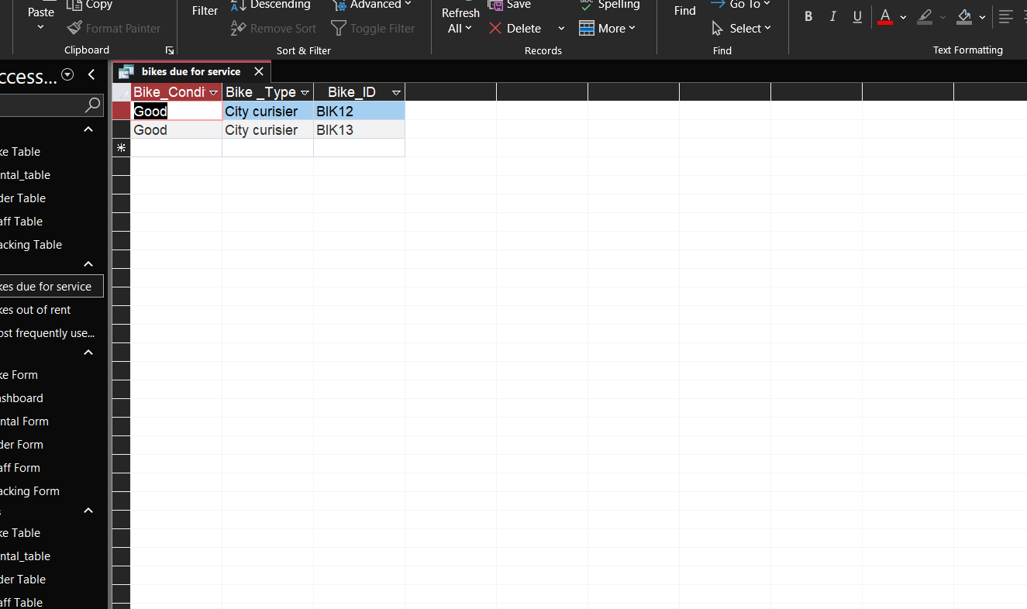
This view shows the results of the query.
The system has found bikes that are not in excellent condition that is why these bikes appear here because they need service, based on the condition rule.
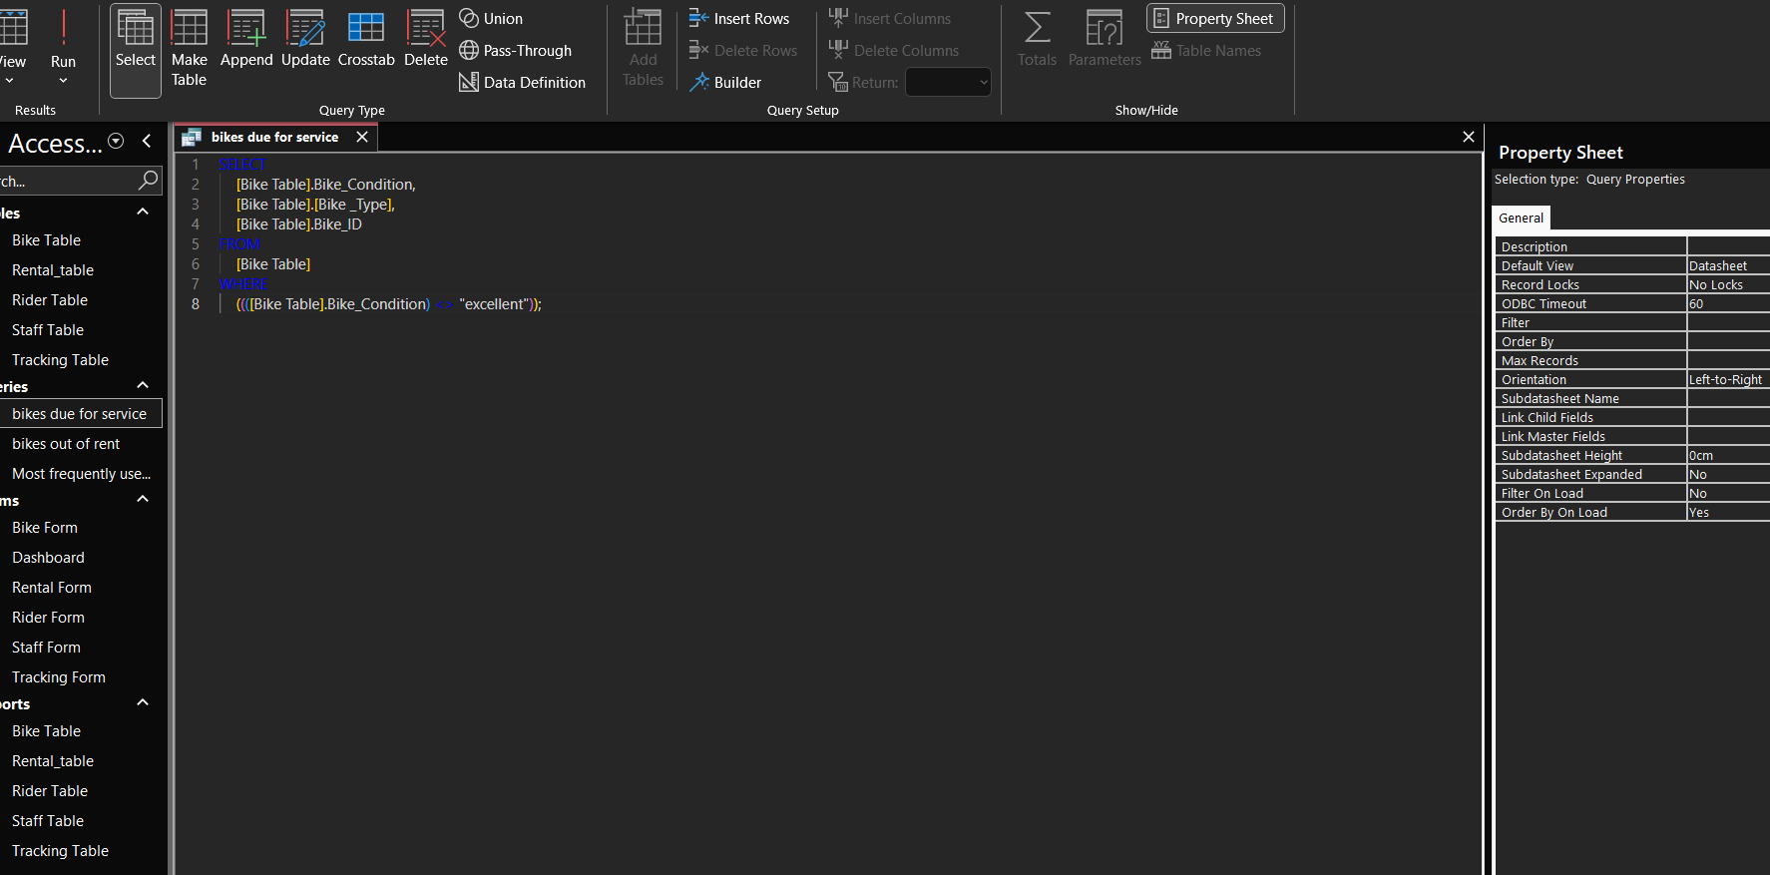
The SQL view shows the code that Access uses to run the query
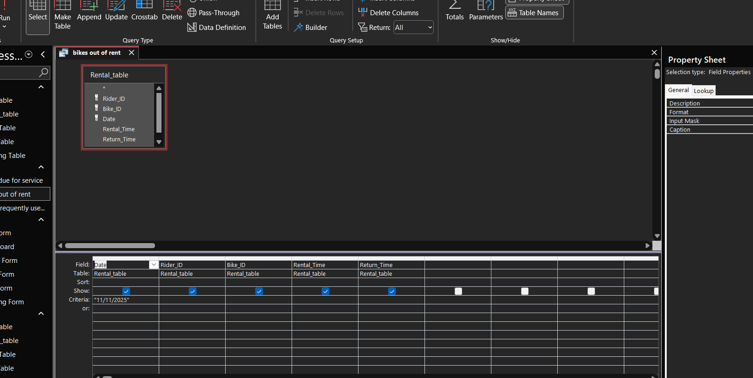
This query checks which bikes are currently out on rent
The criteria are set on the Date field to show rentals for 11/11/2025. Only records from that day are displayed. This helps identify which bikes were rented and not yet returned on that date.

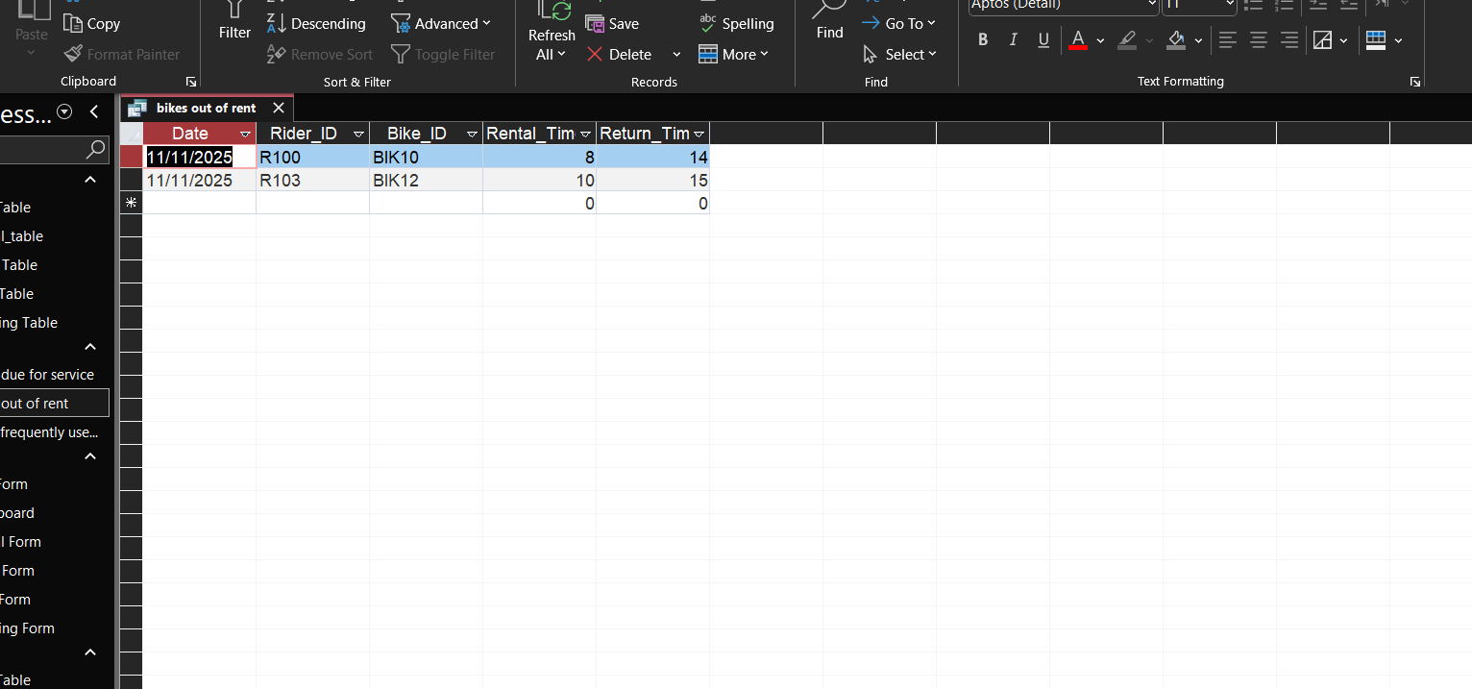
This view shows the results returned by the query
The system displays all bikes that were rented on 11/11/2025, This confirms which bikes were out on rent during that day.

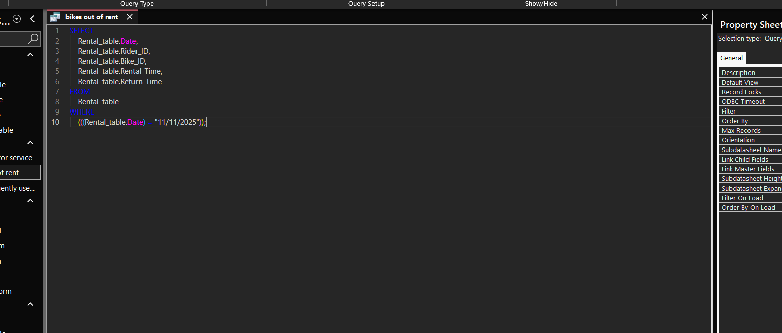
This SQL code shows how the query works behind the scenes

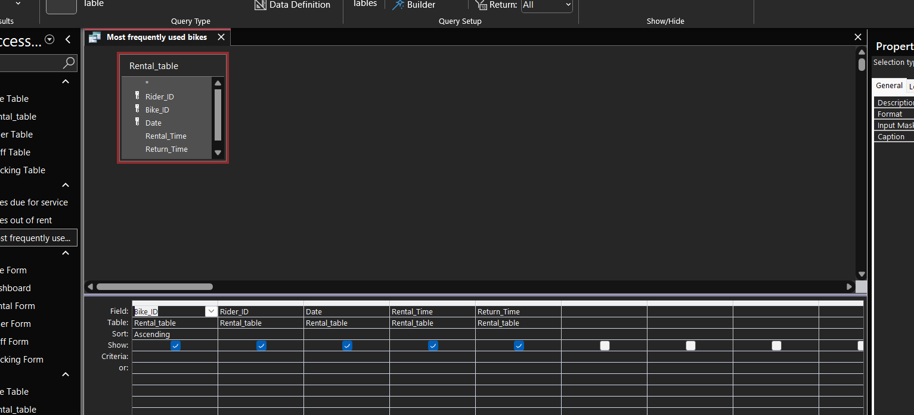
This query uses the Rental_table to check which bikes are used and the view is used to count or review how often each bike has been rented.
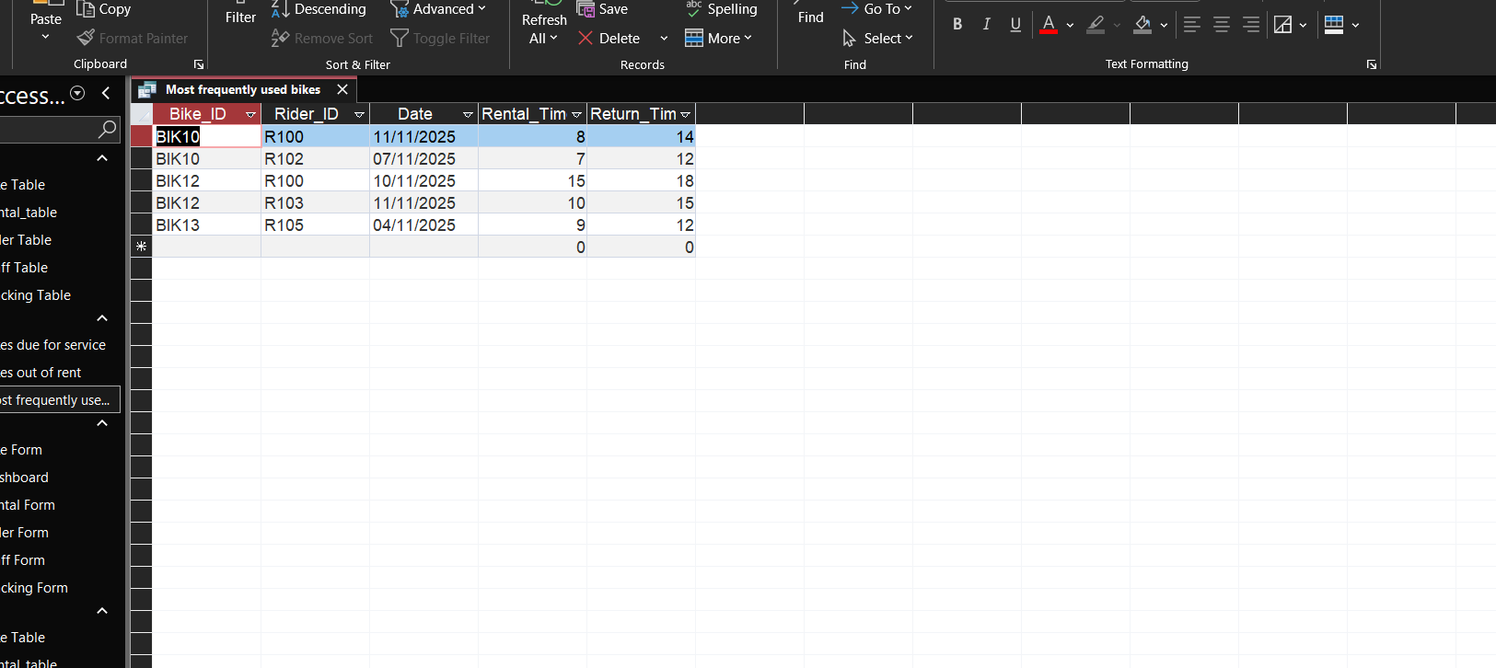
From this table, we can easily see which bikes have been rented more often. For example, BIK10 appears several times, meaning it is one of the most frequently used bikes.

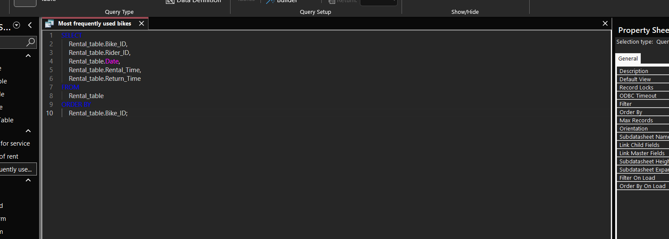
This SQL code selects all rental records from the Rental_table. The results are sorted by Bike_ID and you can see which bikes are used the most.

Report Creation
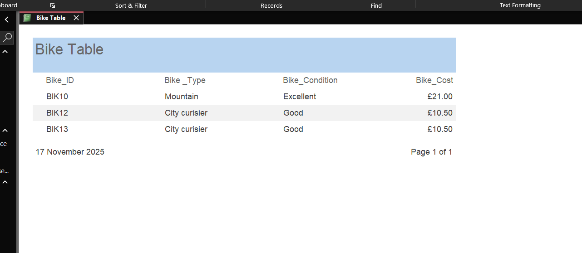
The report displays the bikes clearly in a list format and helps staff quickly see what bikes are available and their status.
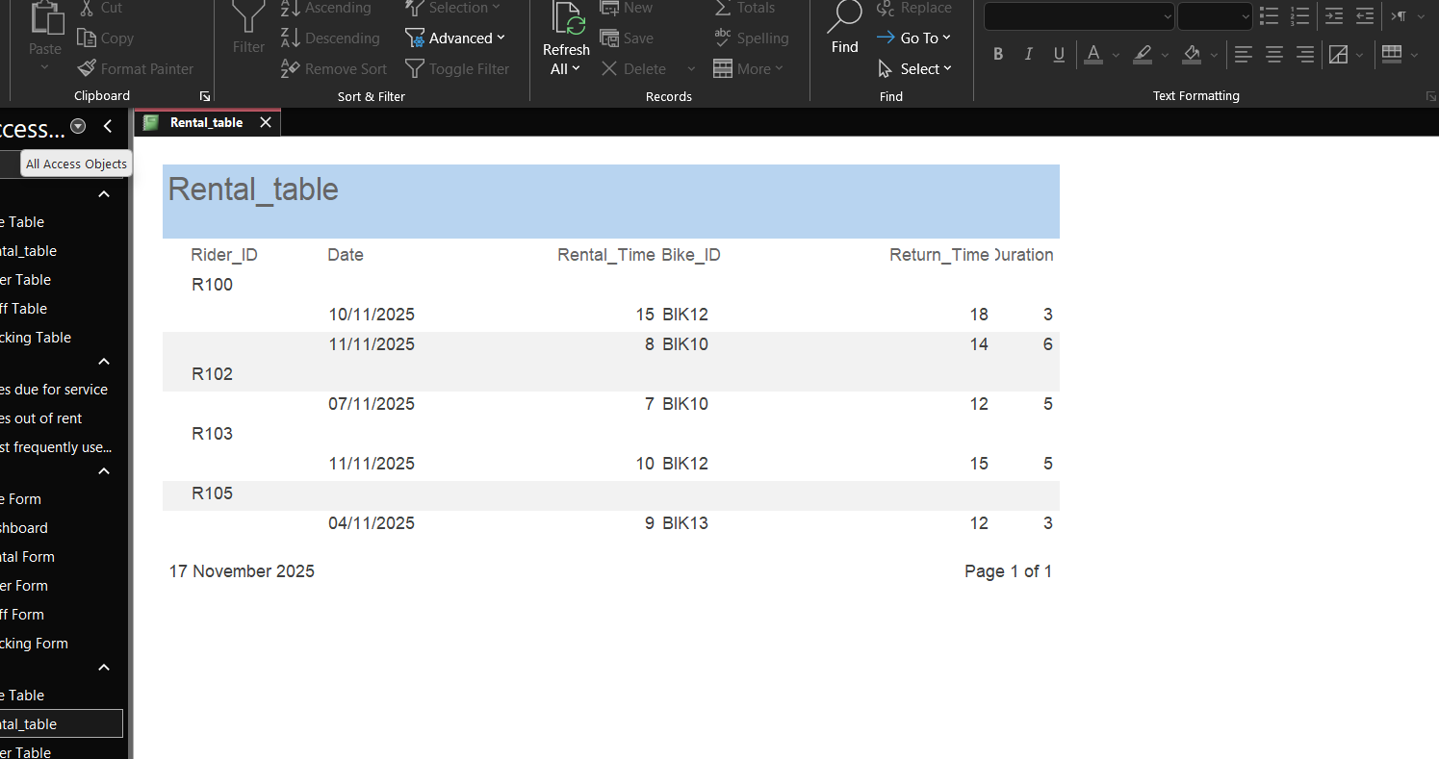
The report gives a clear summary of all rentals, making it easy to see who rented each bike, when it was used, and for how long.

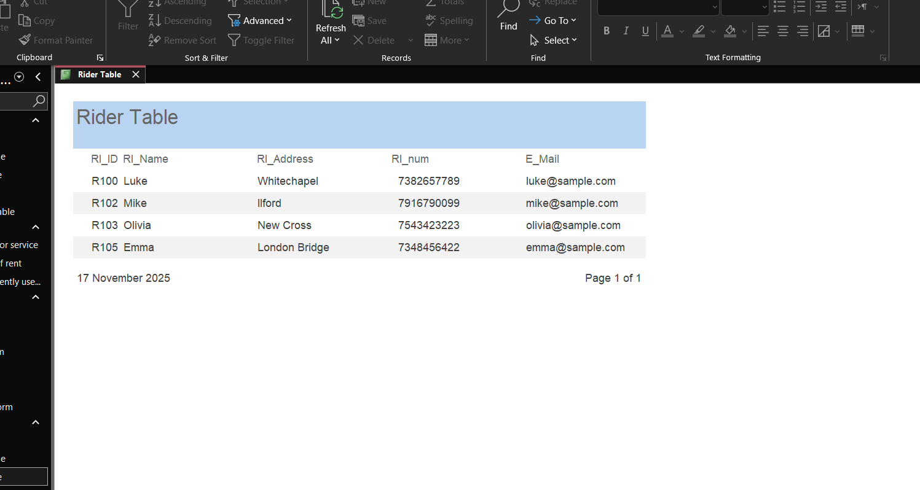
The report provides a clear overview of all riders currently registered in the EcoRide database.
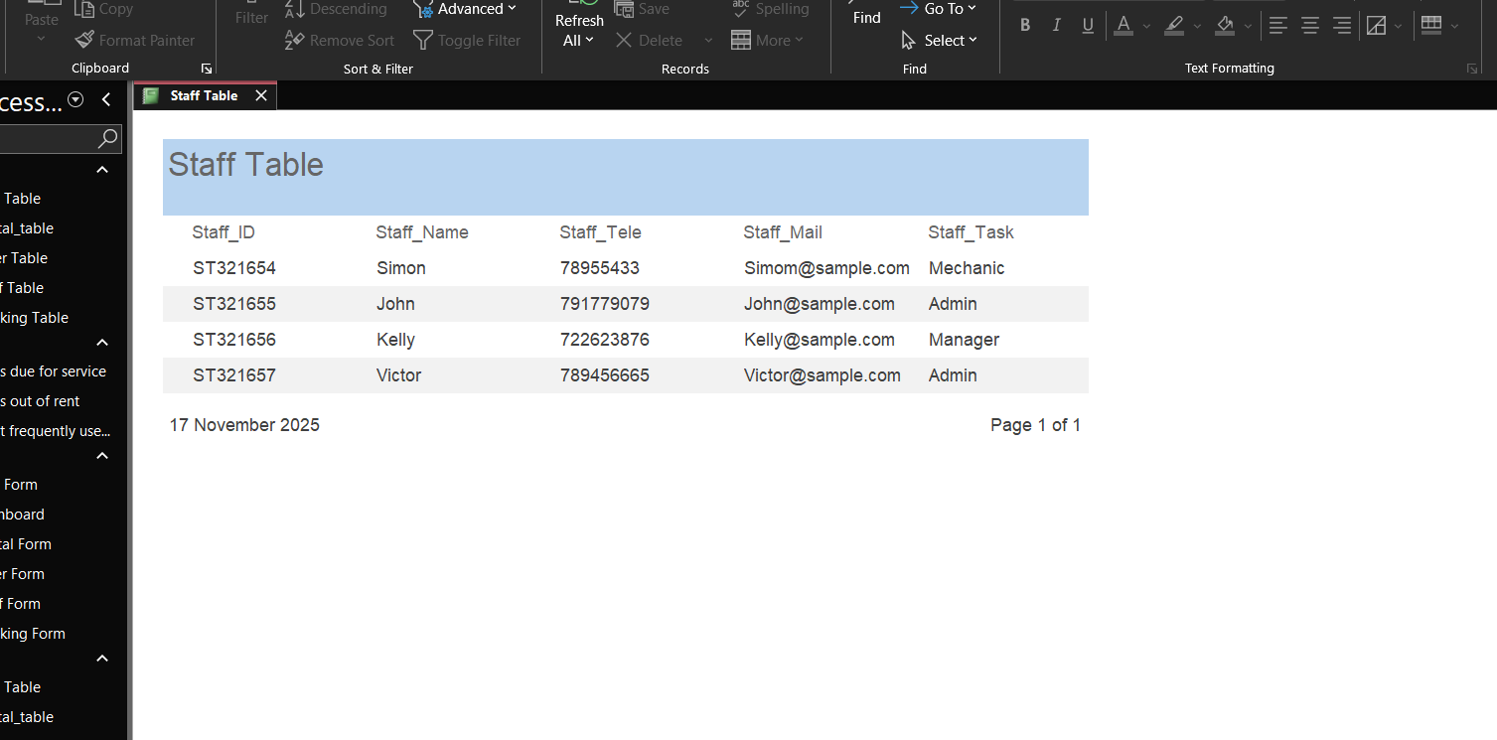
The report provides a clear overview of the staff team and their responsibilities within EcoRide.
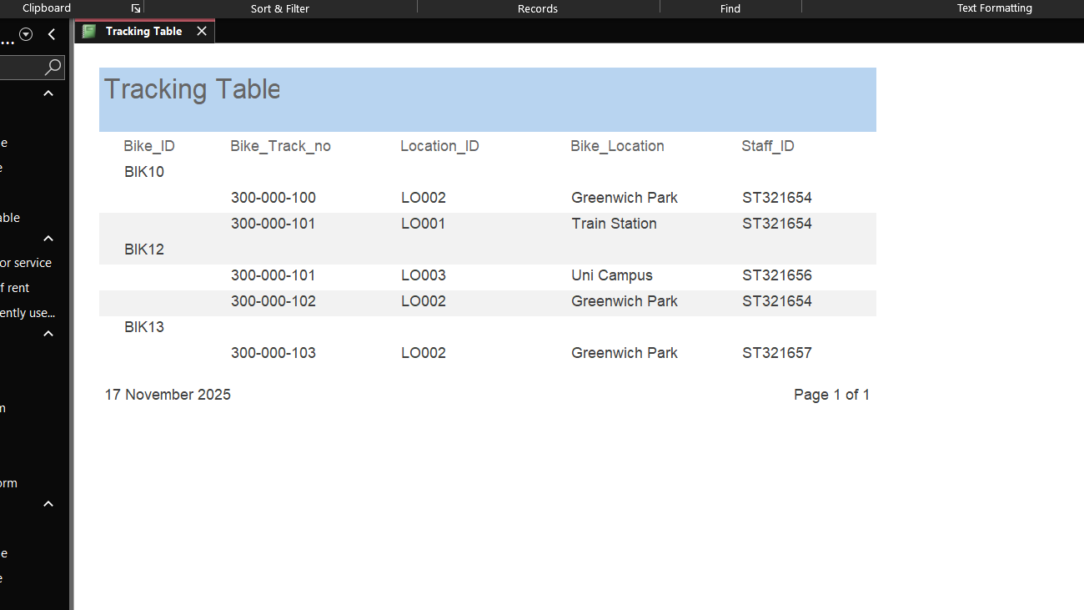
This report shows the current location of each bike and which staff member handled it.

Calculations
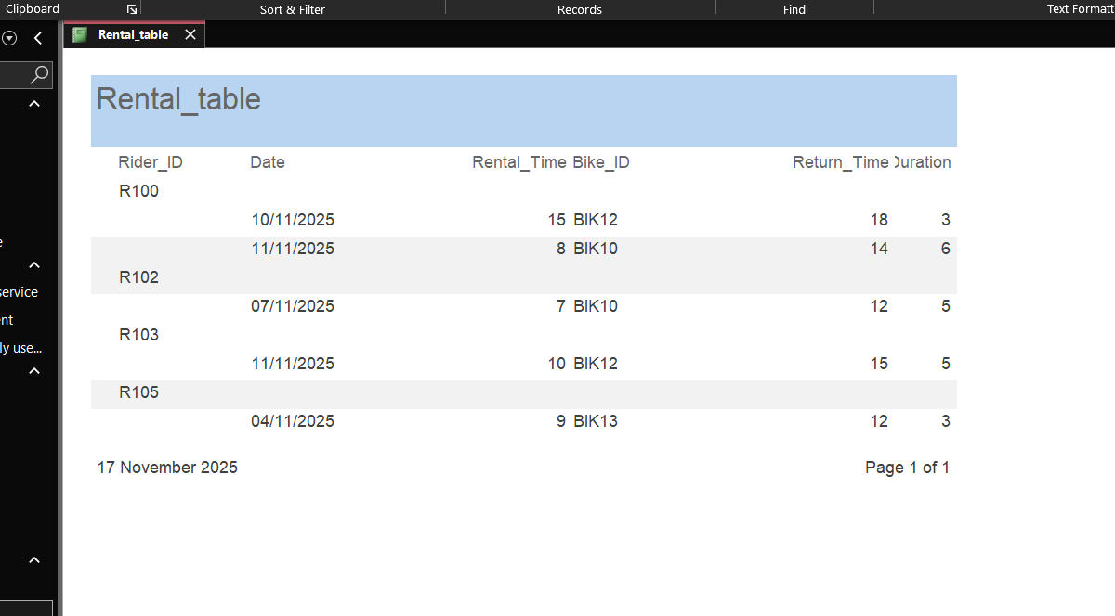
In my database, I implemented a calculation to work out how long each bike rental lasted. The duration is calculated by subtracting the Rental_Time from the Return_Time.
Dashboard Creation
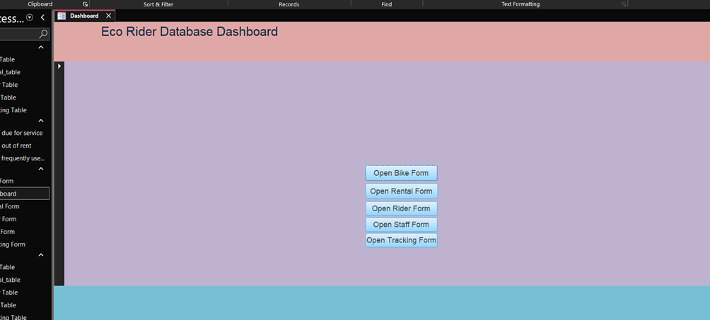
The dashboard is the home screen of the EcoRide database. It helps the user move quickly to different parts of the system.
In the centre, there are buttons that open each form:
- Open bike form – to view and manage bike information
- Open rental form – to check rental records
- Open rider form – to see rider details
- Open staff form – to view staff information
- Open tracking form – to check bike location and tracking

