Title of the Assignment: Component 1 – Coursework: Portfolio

Student full name: Prince Derick Yeboah

Student ID: 2523170

Program of Study: CertHE Computing Skills for Workplace

Module Name: Software Solutions for Business

Module Code : ACCA4026_BIRM

Lecturer’s Name: Osman Elgawi

Date of Submission: March 25, 2026

Name of the University: University of Wales Trinity Saint David

Campus Name: Birmingham Quay Place
Software Solution for Business
PRINCE DERICK YEBOAH (2523170)
ACCA4026
3/25/26

Table of Contents
Task 1: e-Commerce Website builders/software solutions 3
Shopify 3
Wix e-Commerce 3
Task 2: Mind-map of contemporary software applications 4
Task 2a. Describe mind mapping and explain the benefits of using mind mapping in business operations 4
Task 2b. A mind map of modern software programs that help businesses and organisations run their day-to-day operations. 5
Task 3. Office Applications for creating, storing, presenting, and analysing information/data 6
Task 3a. Explain four office software solutions for business operations (MS Word, MS PowerPoint, MS Excel, and MS Access), highlighting their major features, benefits, and limitations (if there are any). You can use some images in addition to text 6
Microsoft Word 6
MS PowerPoint 7
MS Excel 8
MS Access 9
Task 3b - Test Mail merge, IF Function, VLOOKUP, Pivot Table, Goal Seek in MS Excel, and document several screenshots with accompanying description to provide evidence of practical use 10
IF Function 10
Pivot Table 14
Task 4. Communication and Collaboration applications 17
Task 4a. Analyse at least two contemporary Communication (Email and others) and Online Collaboration (SharePoint, MS Teams etc.) applications/tools used frequently in modern business world and document a summary of their key features using written text with some images and relevant citations. 17
Microsoft Teams 17
Google Docs 17
Task 4b. Test at least two features of a freely available Communication (1) and Collaboration (1) application and document several screenshots with brief accompanying description to provide evidence of practical use. 18
Microsoft Teams 18
Google Docs 22
Conclusion 24
References 25

Introduction
In today’s business world, digital tools play a big role in how organisations run their daily activities. Businesses use different software to manage information, communicate, and make better decisions. According to Turban et al. [1], these tools help organisations save time and reduce errors. This assignment examines different types of software used in modern business environments, focusing on their functions, benefits, and limitations in improving organisational efficiency [1].

Task 1: e-Commerce Website builders/software solutions
E-commerce website builders are online platforms that allow businesses to create and manage online stores without needing advanced coding skills. These systems provide ready-made templates, payment integration, and product management features, which make it easier for businesses to sell products online. They are important because they support digital marketing, customer interaction, and global reach for businesses [2].

Shopify
Shopify is one of the most popular ways to develop websites for online retailers all around the world. It is a fully specialist e-commerce platform that helps clients run their own businesses online, keep track of orders, manage inventory, and process payments all in one location. The site is largely for selling products, this makes it particularly suitable for businesses that want to grow and manage their operations efficiently. It provides built-in features like payment gateways, inventory management, and marketing tools that make it easy for people who don’t know advanced coding to sell online. It works with a lot of third-party apps that add to what it can do. It can be used by both small and big business that sells a lot of things. Shopify is widely recognised as an effective solution for businesses that primarily focus on e-commerce operations. It is also expensive to smaller businesses who want to sell online [3].

Wix e-Commerce
Wix is another popular website builder that enables users to sell products online. Wix is a website builder that can be used for more than online stores. You may also use it to create company websites, portfolios, and blogs. One of the best things about Wix is the drag-and-drop editor. Wix also includes many e-commerce features, such as payment processing, product listings, and marketing tools. There are a variety of themes and design options that help users construct websites that seem excellent. On the other hand, Wix doesn’t have as many advanced e-commerce options as Shopify and isn’t as good for huge businesses with intricate needs. It is generally recommended for small businesses. [4].

Task 2: Mind-map of contemporary software applications

Task 2a. Describe mind mapping and explain the benefits of using mind mapping in business operations
Mind mapping is a visual technique used to organise and represent ideas by connecting related concepts around a central topic. There is normally one big thought in the middle, and then lesser ideas that are related to it come out from there. To make the information easier to interpret, these branches can have words, colours, and pictures on them. In business and school, mind maps are widely used to rapidly and clearly organise thoughts. Instead of merely putting everything down in a large list, they show viewers how different concepts are connected [5].
Benefits of Mind Mapping in Business Operations
One of the best things about mind mapping for business is that it helps you organise your thoughts. A business can use a mind map to divide down tasks, timelines, and responsibilities while they are planning a project. This makes it easier to keep track of work and not get confused. It also lets teams see the whole picture of a project, which can help them make better choices. It's easier to find flaws or missing information when everything is shown clearly [6].
Mind mapping also helps people work together and be creative, which is another great thing. During meetings or brainstorming sessions, employees can freely discuss their ideas and add them to the mind map. This gets more people involved and helps come up with new ideas. It also saves time because it gives information in a clear and simple method instead of extensive written materials. Mind mapping is a great tool for running a business since it helps with planning, communication, and getting things done [7].

Task 2b. A mind map of modern software programs that help businesses and organisations run their day-to-day operations.

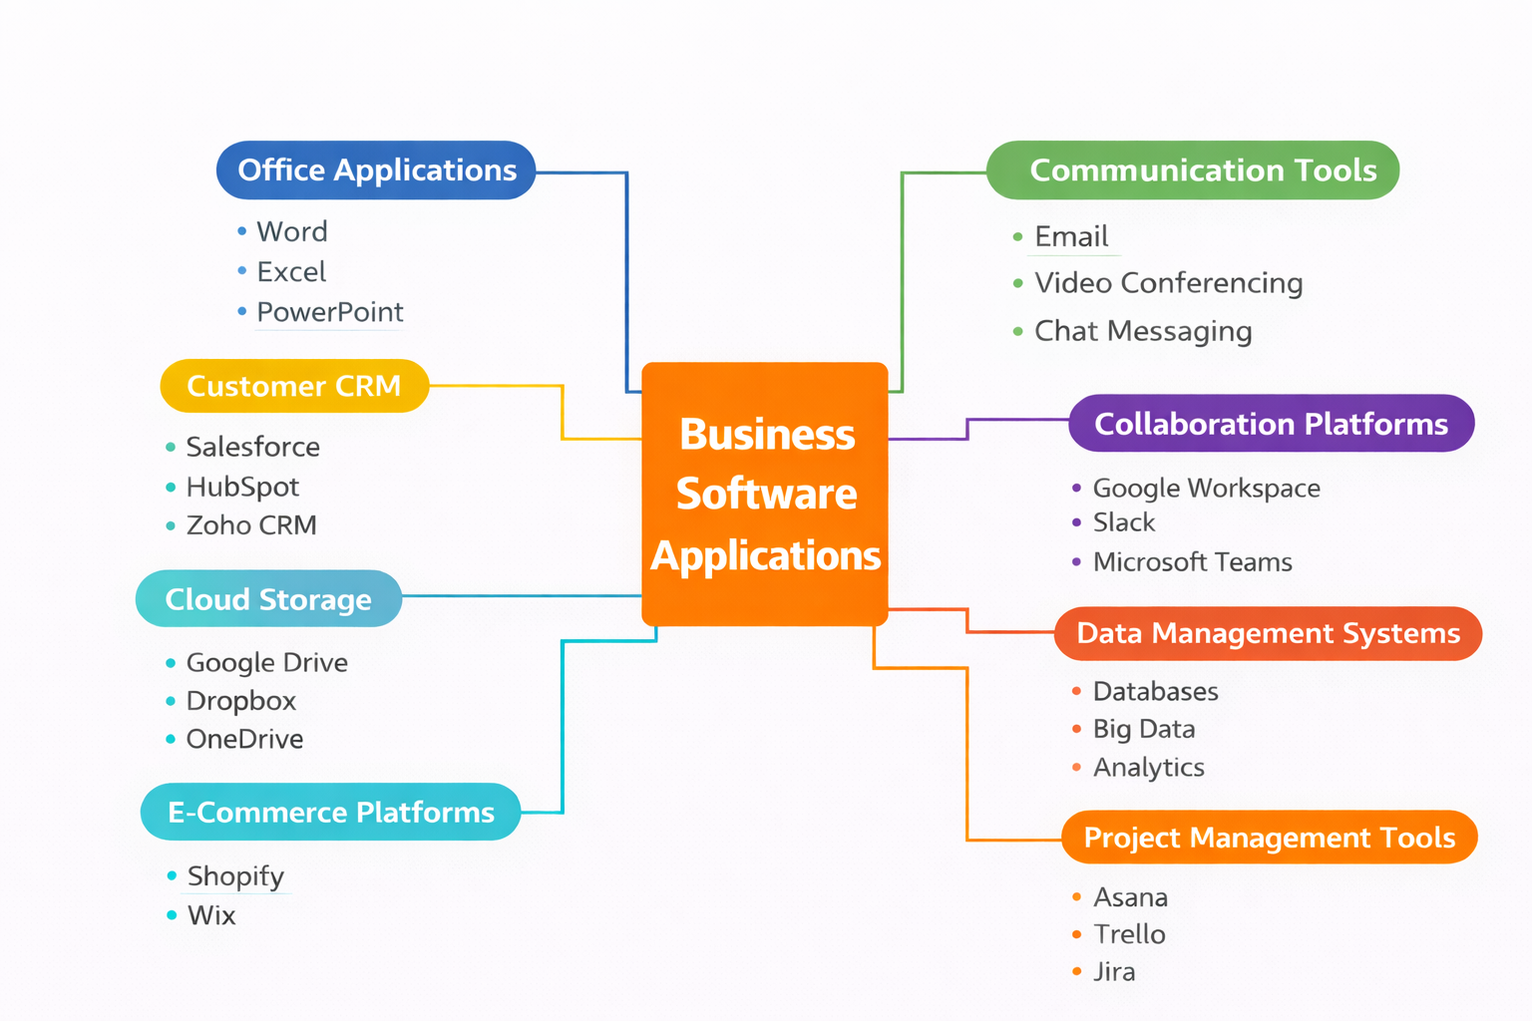

Task 3. Office Applications for creating, storing, presenting, and analysing information/data

Task 3a. Explain four office software solutions for business operations (MS Word, MS PowerPoint, MS Excel, and MS Access), highlighting their major features, benefits, and limitations (if there are any). You can use some images in addition to text
Businesses need office apps to make documents, look at data, show information, and keep records. These apps help businesses stay organised, get things done faster, and talk to each other clearly. Microsoft Word, Microsoft PowerPoint, Microsoft Excel, and Microsoft Access are some of the most used office programs. Businesses use each of these tools for different things [8].

Microsoft Word
Microsoft Word is a well-known word processor that allows individuals to create, edit, and format documents. It helps people type, add images, build tables, and write letters, reports, and assignments that look professional. Some of the most useful things that MS Word can accomplish include spell check, grammar check, and formatting tools like font size, colour, and alignment. It also contains complex capabilities like mail merge, several page layout options, and collaboration tools that let more than one person work on the same document at the same time. One of the best things about MS Word is that it's easy to learn how to use, even for folks who have never used it before. It also helps users write documents that look neat and professional. It also saves you time because it comes with templates and tools that remedy problems on their own. You may also store documents in multiple ways and send them to others simply. There are some difficulties with MS Word, though. You need to pay for a subscription to have full access, and some of the more advanced functions can be hard for beginning users to understand. If you don't pay close attention to the formatting or settings, they can potentially modify the final product. [9].
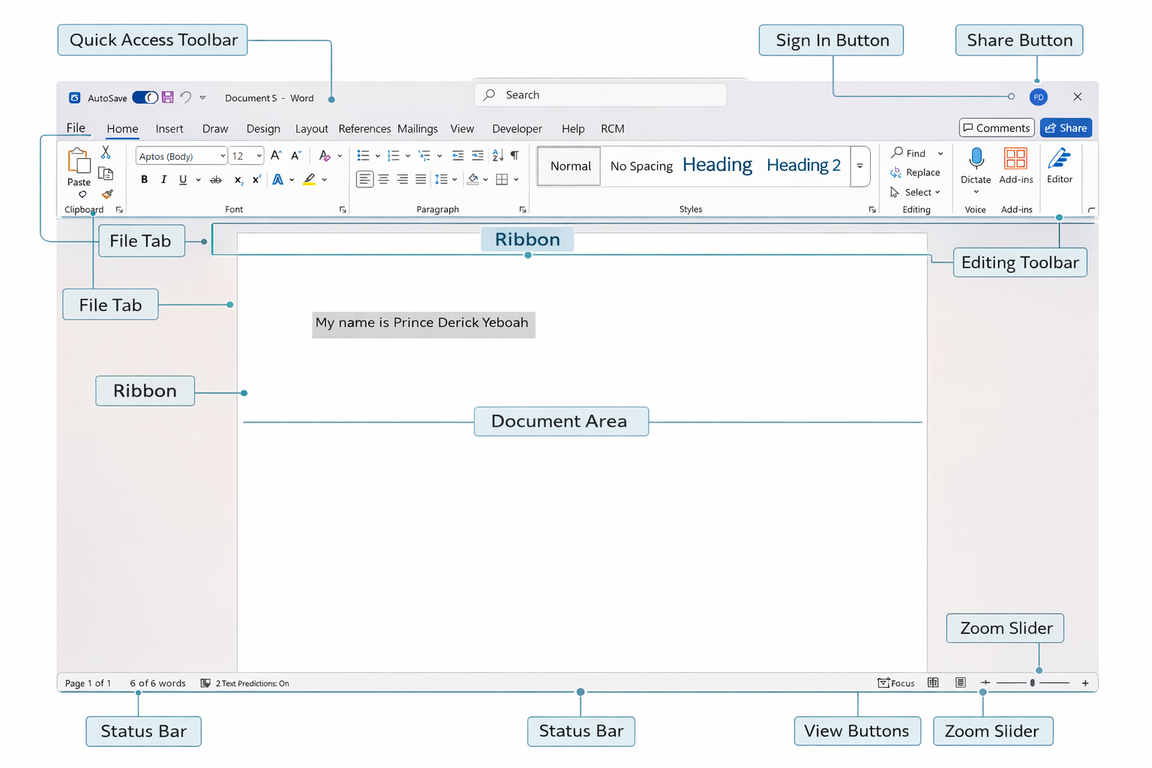
Figure 1. Labelled diagram of Microsoft Word interface.

MS PowerPoint
Microsoft PowerPoint is used to create slideshows for presenting information in a clear and structured format. It allows users to include text, images, charts, videos, and animations. Some of its best features are a wide range of themes, slide layouts, transitions, and design tools that help make presentations look more professional and interesting. People regularly use it in schools, at business, and at parties to get their message across.
One of the best things about PowerPoint is that it helps me convey information clearly and organised, which makes it easier for the audience to understand. It also lets me edit the slides to fit the topic and add multimedia to make the presentation more fun. One concern is that a presentation with too many animations or too much text could be hard to follow. Making a good presentation could potentially take a long time, especially if you want to do it well. [10].
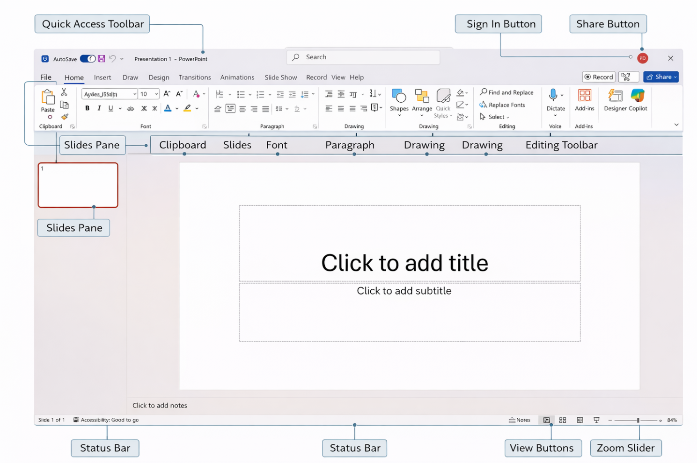
Figure 2. Labelled diagram of Microsoft PowerPoint interface.

MS Excel
Microsoft Excel is used to organise and analyse data in a spreadsheet. Data can be entered into rows and columns and use formulas to do maths. Some of the main features are charts, graphs, and pivot tables, as well as functions like SUM and AVERAGE. These tools help me make sense of data and show it in a way that is easy to see. People often use Excel to make budgets, keep track of their spending, and look at business data. One of the best things about Excel is that it can quickly and accurately handle a lot of data. It also helps you make better choices because the information can be organised and shown clearly. It is widely used in both professional and personal contexts due to its ability to process and analyse large amounts of data efficiently. But Excel can be hard to use at first, especially when you must deal with complicated formulas and functions. If you don't check your work carefully, even small mistakes in formulas can give you wrong answers. [11]
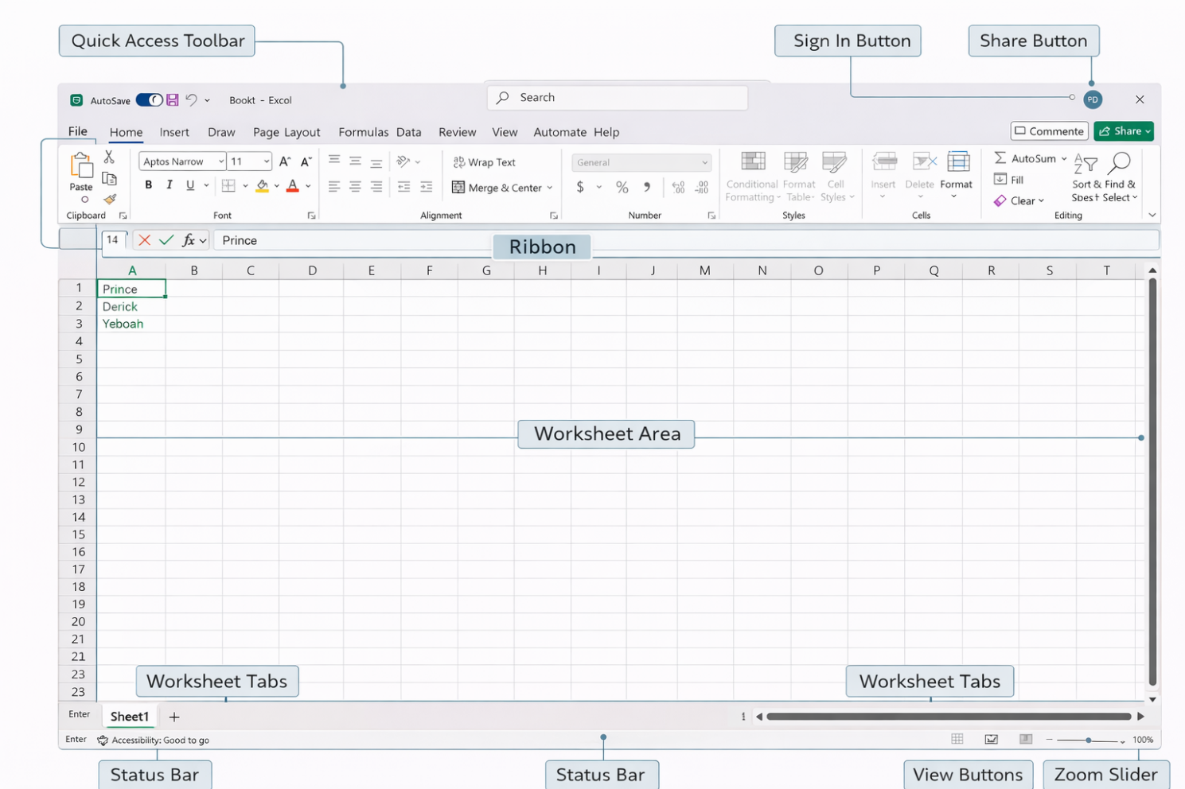
Figure 3. Labelled diagram of Microsoft Excel interface

MS Access
Microsoft Access is a database software that It is used to store and organise vast quantities of data in a structured manner. It is distinct from Excel in that it is specifically designed for database management. I can generate tables in Access to store data, and each table is structured into columns and rows. Queries, forms, and reports comprise several of the primary capabilities. Queries facilitate the rapid discovery of specific information, forms facilitate the entry of data, and reports enable me to present the data in a structured and comprehensible manner.
One of the benefits of Microsoft Access is its ability to facilitate the management of data more effectively, particularly when dealing with a large amount of information. This also mitigates errors by allowing data to be linked between various datasets rather than being repeated. This renders it advantageous for applications such as business data or customer records. Nevertheless, it may be challenging to comprehend at the outset, particularly when learning how to establish relationships between tables. Additionally, it is not the optimal choice for systems that are exceedingly large and are employed by substantial organisations [12].
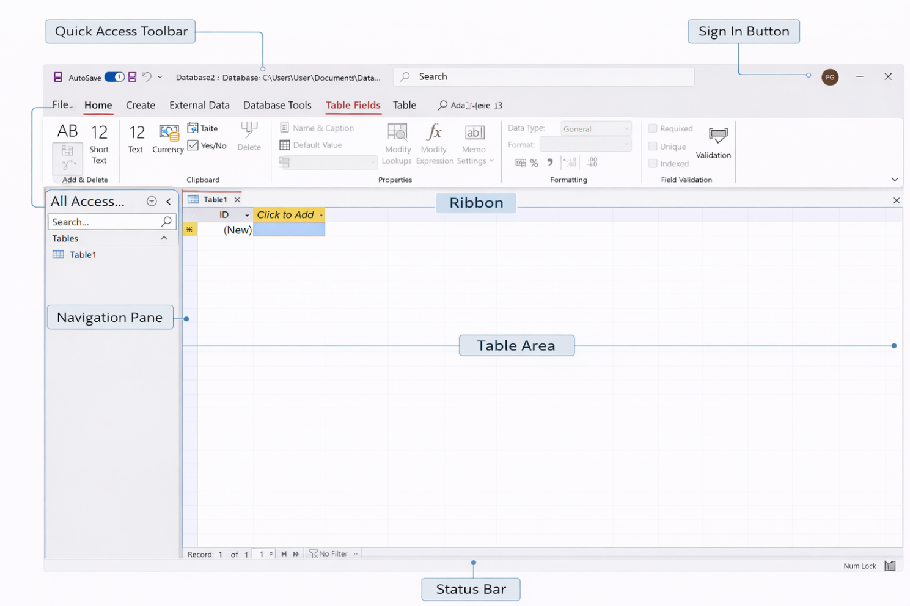
Figure 4. Labelled diagram of Microsoft Access interface.

Task 3b - Test Mail merge, IF Function, VLOOKUP, Pivot Table, Goal Seek in MS Excel, and document several screenshots with accompanying description to provide evidence of practical use
I used Microsoft Excel to carry out some practical tasks to test the IF Function and the Pivot Table. Here are the steps I took, with full explanations so they can be used as proof.

IF Function
Step 1. I created a basic table in Excel which included the names of the students, student’s numbers, course Fees, paid amount, discount, balance, Total paid, average paid, minimum paid, maximum paid and count. After that, I used the IF function to calculate the results.
Below is what I did:
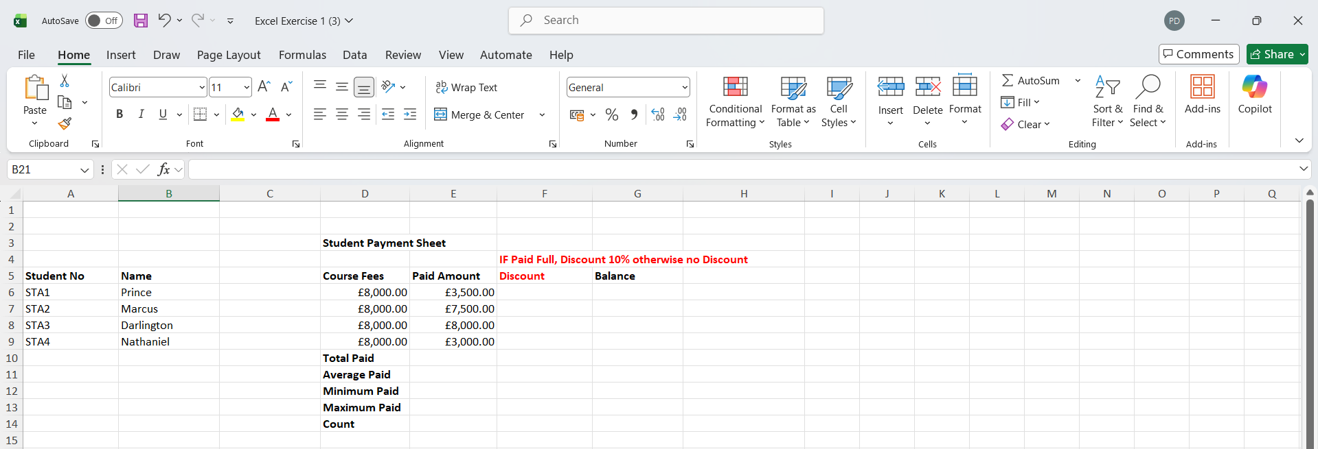
Step 2. Formula to calculate Discount: =IF(E6=D6,D6*0.1,0)
E = Paid amount
D = Course Fees
If they are equal ⇒ give 10% of course fee, if not equal ⇒ give 0.
I clicked on F6 and typed the formula above and pressed enter. ↴
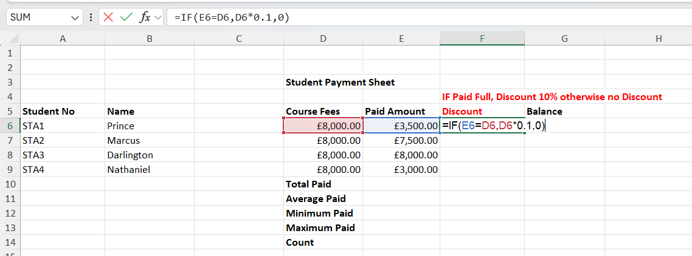
Step 3. A discount amount if fully paid or 0 if not fully paid. ↴
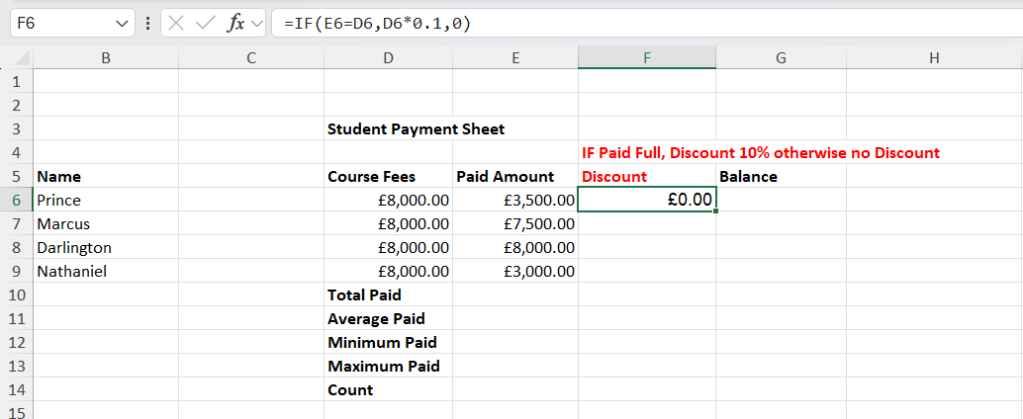
Step 4. Next, I clicked the small square (bottom-right corner of the cell) and drag it down for all the students. ↴
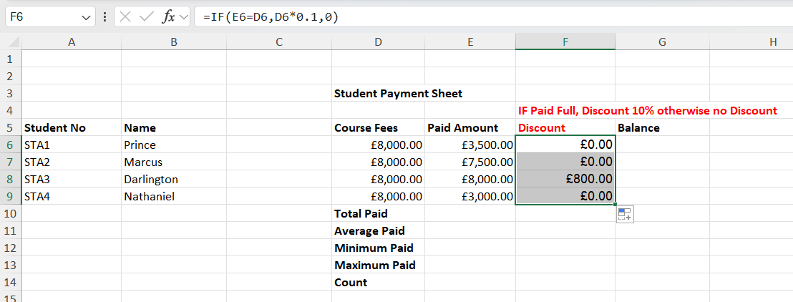
Only Darlington paid in full and had £800 Discount, the rest had 0.

Step 5. Formula to calculate Balance: =D6-E6
Course Fees (D) – Paid Amount (E)
I clicked on G6 and typed the formula above and pressed enter. ↴

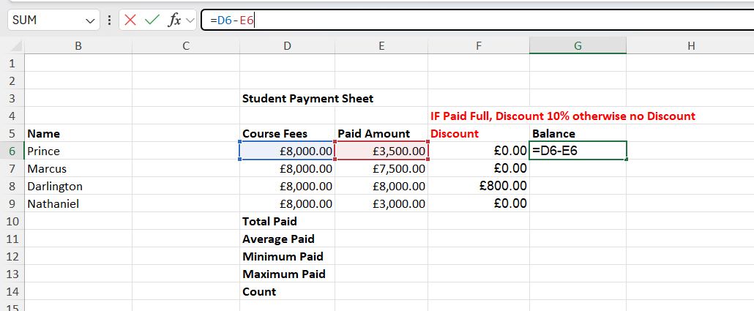
Step 6. I clicked the small square (bottom-right corner of the cell) and drag it down for all the students ↴
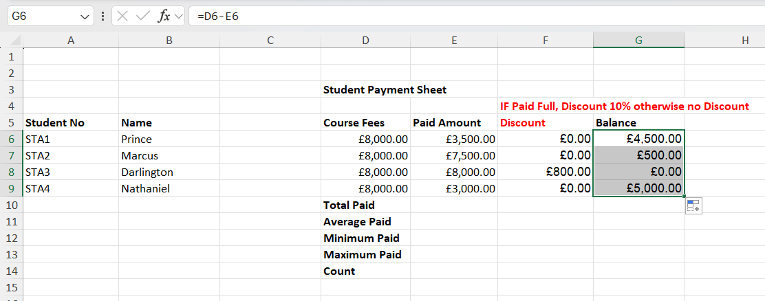
Step 7. I used these formulas to calculate the:
Total Paid: =SUM(E6:E9)
Average Paid: =AVERAGE(E6:E9)
Minimum Paid: =MIN(E6:E9)
Maximum Paid: =MAX(E6:E9)
Count: =COUNT(E6:E9)
And got these final results ↴
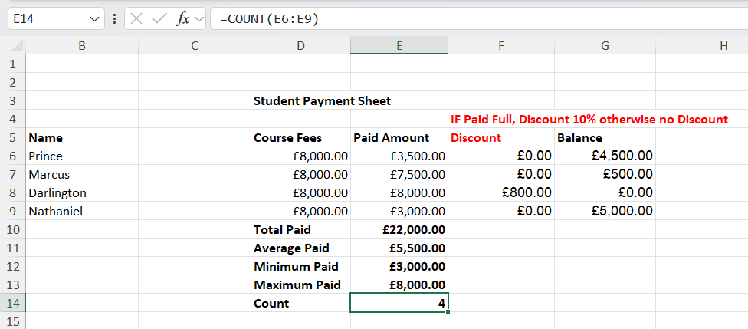

Pivot Table
I used a Pivot Table to look at sales data and see how much money I made in each category.
Step 1. I created this Sales Data ↴
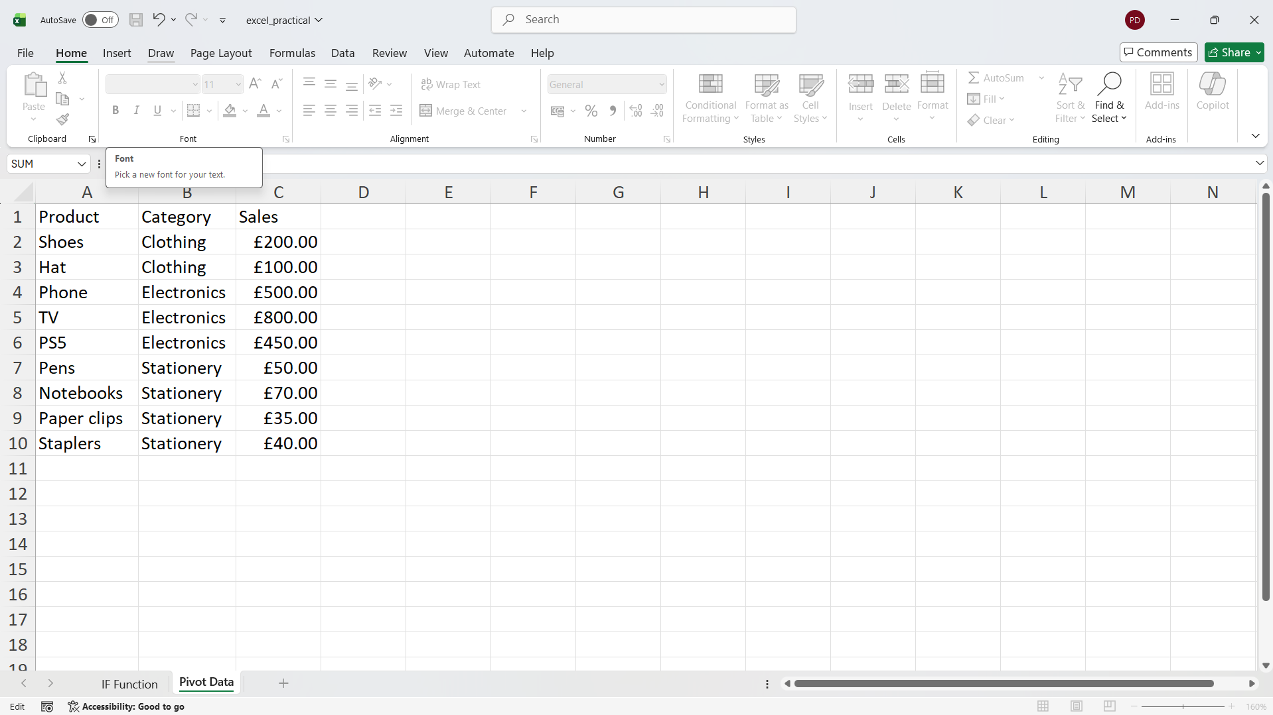
Step 2. I selected all the data (highlighted) ↴
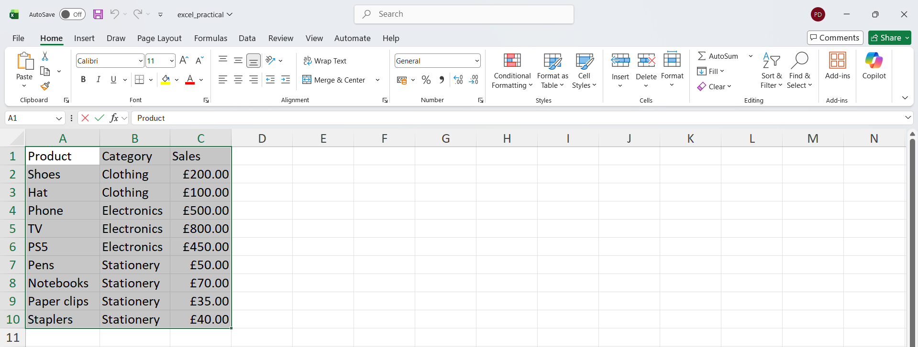
Step 3. I clicked Insert (top menu) → Pivot Table → From Table/Range and I clicked OK ↴
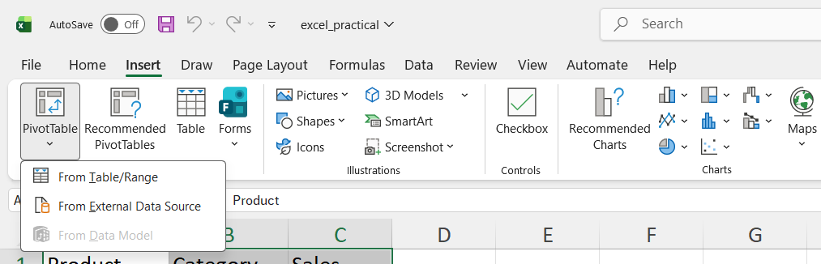
Step 4. Next, I chose “New Worksheet” and clicked OK ↴
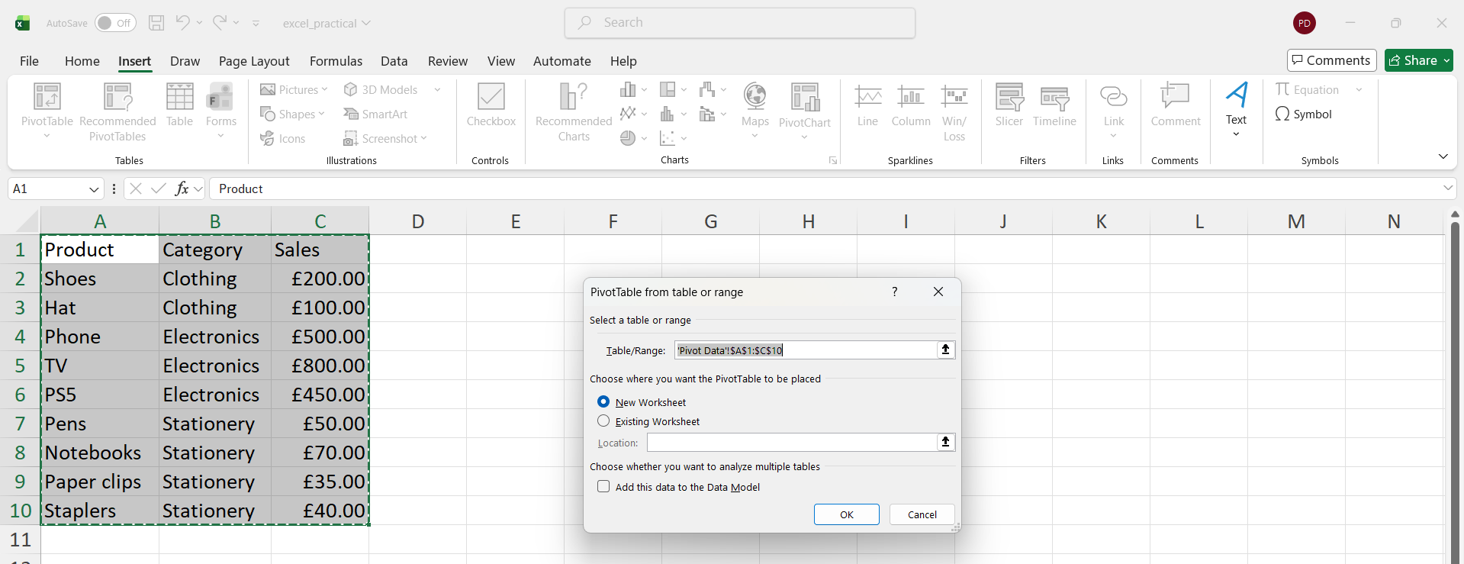
Step 5. Now I see a Pivot Table panel on the right. ↴
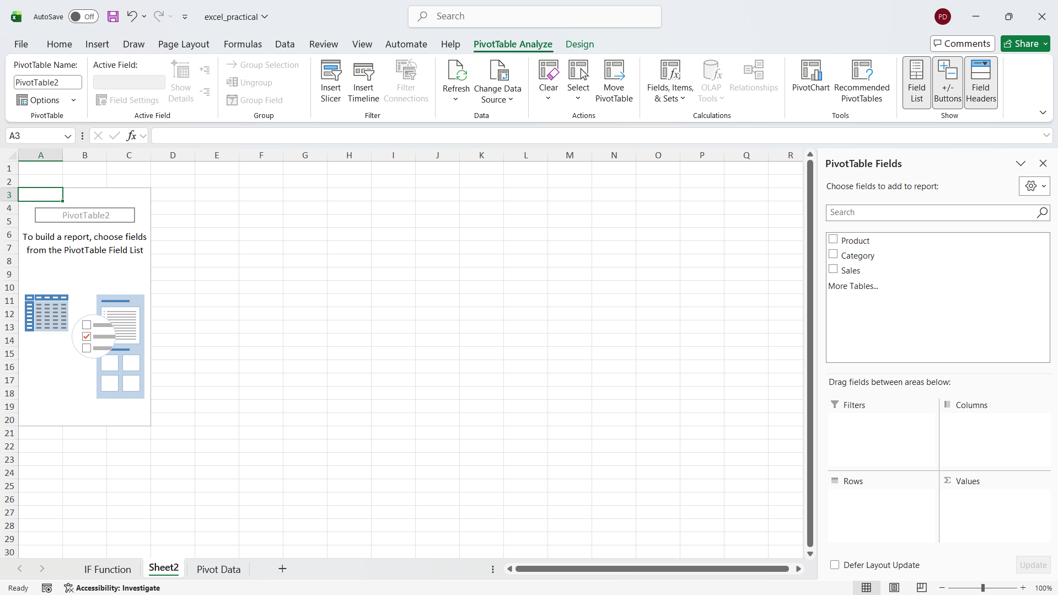
Step 6. I dragged Category → Rows and Dragged Sales → Values
Excel will automatically show the total sales for each category. ↴
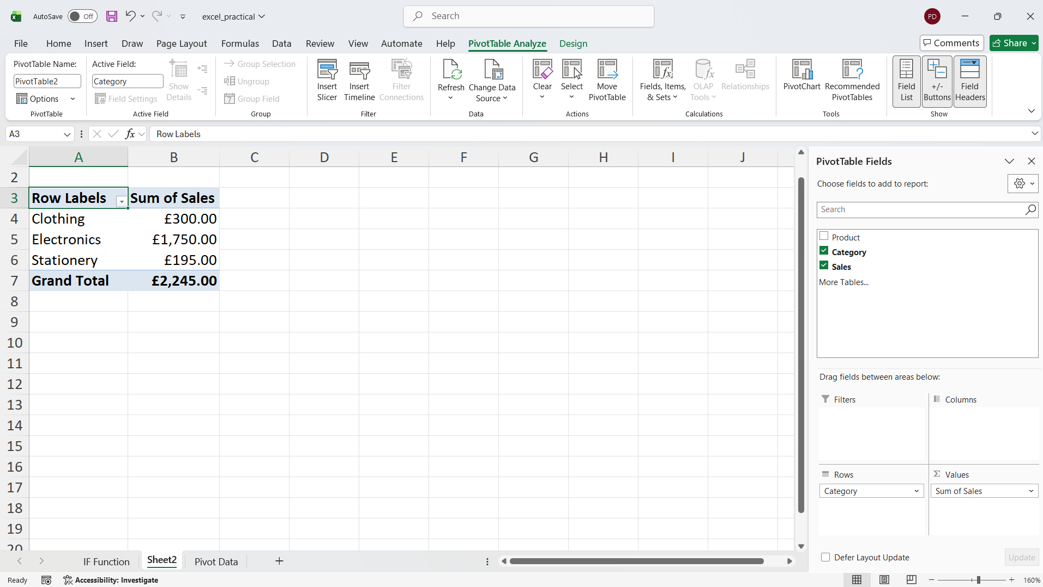

Task 4. Communication and Collaboration applications
Communication and collaboration technologies are very important for businesses today because they help workers share information, work together, and get things done quickly. As more people work from home or in a hybrid setting, businesses depend on digital platforms to keep productivity and teamwork going [10].

Task 4a. Analyse at least two contemporary Communication (Email and others) and Online Collaboration (SharePoint, MS Teams etc.) applications/tools used frequently in modern business world and document a summary of their key features using written text with some images and relevant citations.

Microsoft Teams
Microsoft Teams is a communication tool that is widely used in modern businesses for communication and collaboration. It is part of Microsoft 365 and is mainly used for messaging, video calls, and teamwork in one place. Teams allows users to send instant messages, create group chats, and organise conversations into channels based on different projects or departments. It also supports video meetings where people can share screens, record sessions, and communicate in real time [13].
One of the key advantages of Microsoft Teams is that it integrates multiple functions into a single platform. Instead of using different apps for communication and file sharing, Teams brings everything together. It also connects well with other Microsoft tools like Word, Excel, and OneDrive, which makes it easier to share and edit files during meetings. Another helpful feature is scheduling meetings and managing calendars, which helps teams stay organised and work more efficiently [14].
In terms of benefits, Microsoft Teams improves communication, especially for remote work. It allows employees to stay connected from different locations and reduces the need for emails because conversations can happen instantly. It also supports teamwork by allowing multiple users to collaborate on tasks and share updates quickly. However, it can be difficult for beginners due to its many features, and too many notifications can sometimes be distracting if not managed properly [15].
Overall, Microsoft Teams is a powerful communication tool that helps organisations improve collaboration and stay connected in a digital working environment. It supports both communication and teamwork, making it very useful in modern businesses.

Google Docs
Google Docs is widely used in both schools and businesses. It is an online tool for working together. It is a cloud-based app that lets anyone make, change, and share documents in real time. You don't have to install anything as you do with regular software. Everything works through a web browser, so you can get to your documents from any device at any time [14].

One of the main advantages of Google Docs is its ability to support real-time collaboration. Multiple users can work on the same document simultaneously, and all changes are saved right away. There are also options for comments and ideas that make it easier to give input and keep track of improvements. Automatic saving is another helpful feature because it means I don't have to worry about losing my work. Google Drive stores files, which makes them easy to get to and share [15].

A key advantage of Google Docs is that it makes people work together better and get more done. Everyone may work on the same file, so you don't have to transmit documents back and forth through email. You may also control who can see, comment on, or edit your files by setting permissions. But it needs internet access and doesn't have as many advanced formatting options as Microsoft Word [16].

In conclusion, Google Docs is a great tool for working together because it lets you work together, edit in real time, and easily share. It is especially helpful for group work and teams that work from different places when communication and coordination are crucial.

Task 4b. Test at least two features of a freely available Communication (1) and Collaboration (1) application and document several screenshots with brief accompanying description to provide evidence of practical use.

Microsoft Teams
Feature 1. Chat
Step 1. I Opened Microsoft Teams.
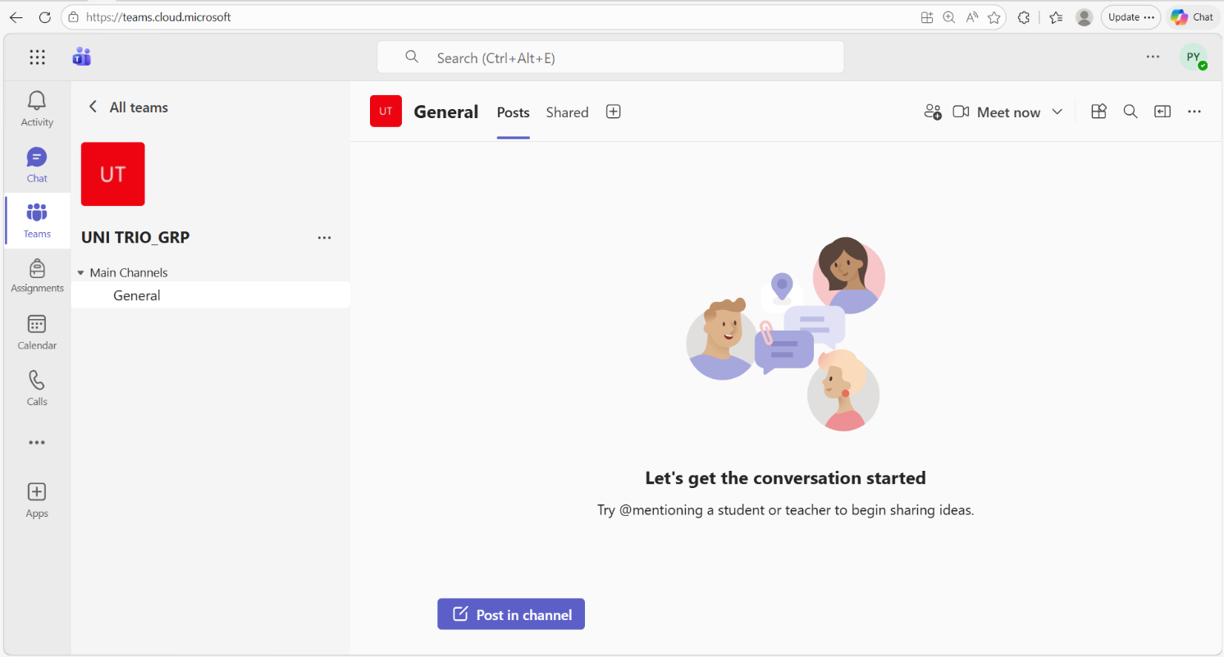
Step 2. I Clicked on the Chat from the sidebar. ↴
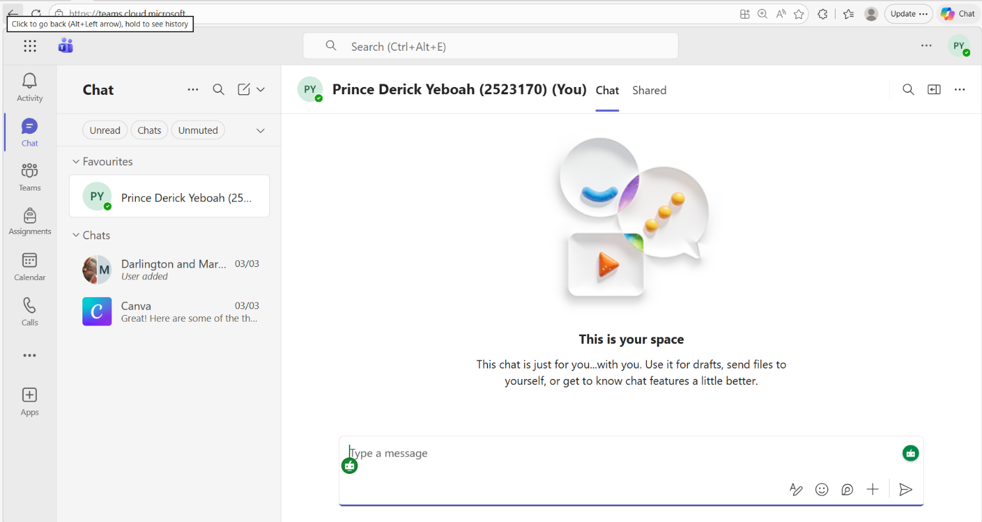

step 3. Select a contact or start a new chat, type a message in the message box and click send. ↴
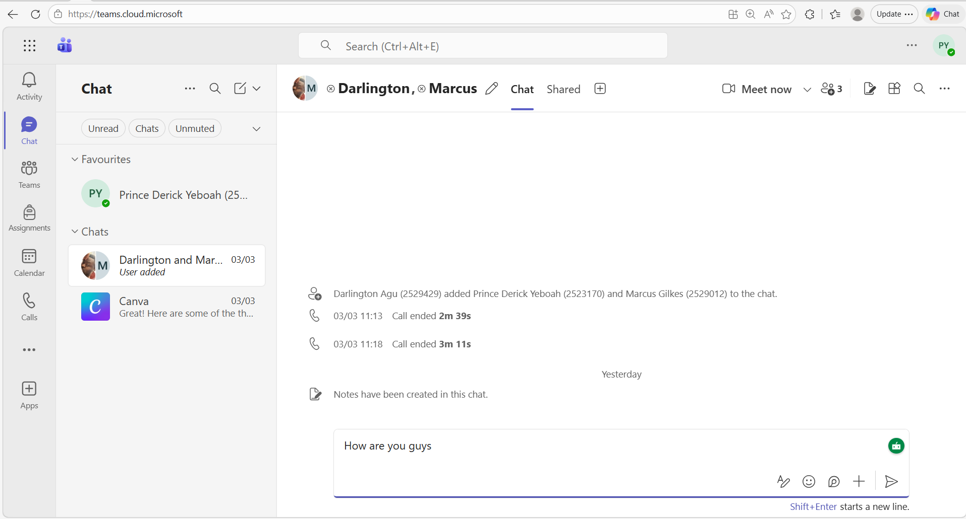

Feature 2. Calls
Step 1. Click on the Calls from the sidebar in Microsoft Teams
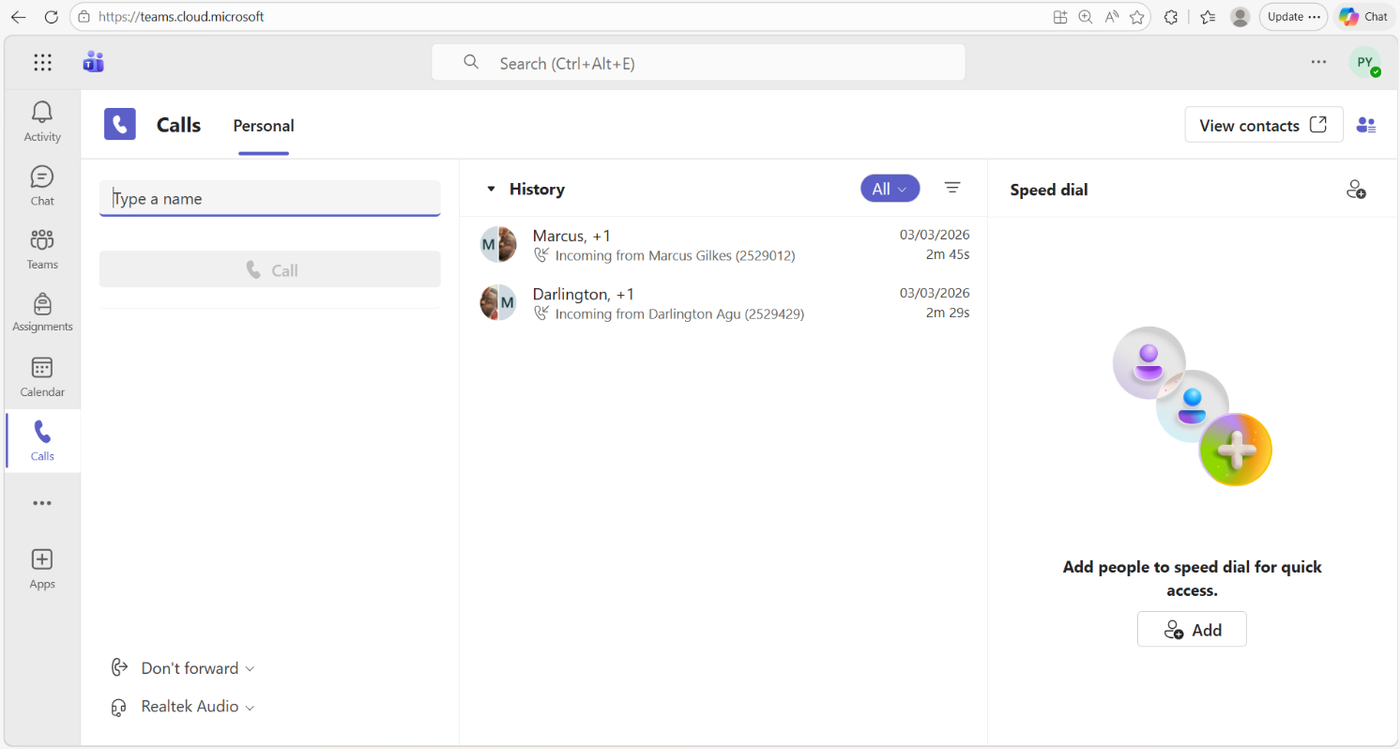

step 2. Select a contact, on the right display panel, click on call or video call button to make a call.
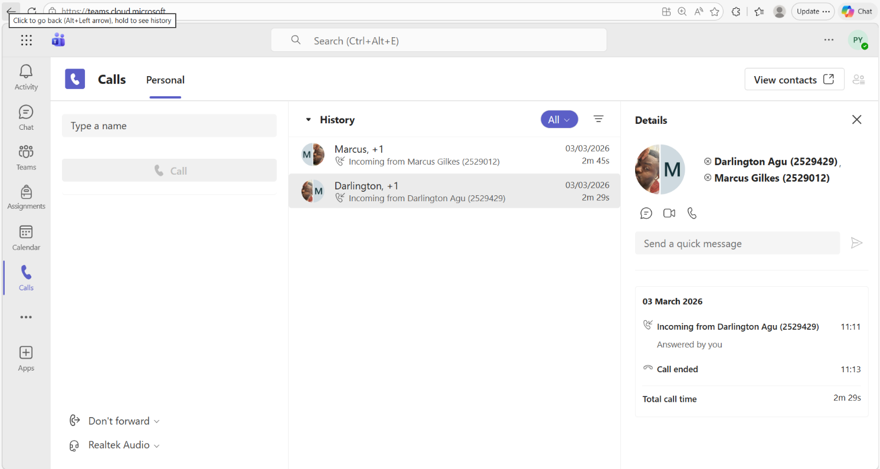

Google Docs
Feature 1.
Step 1. I opened Google Docs and created a new blank document. ↴
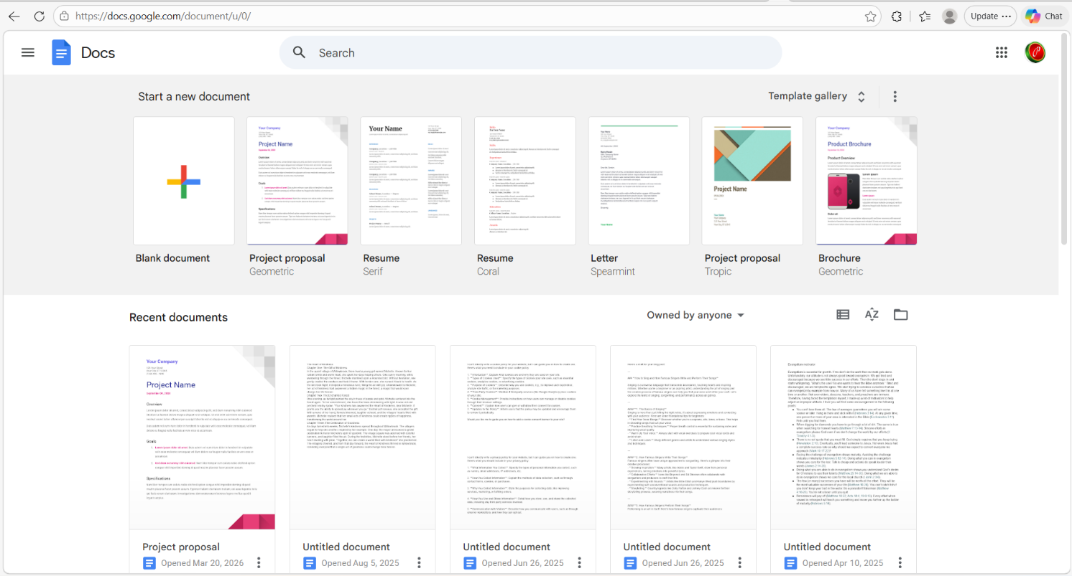

Step 2. I clicked the “Share” button at the top right corner on the Untitled document. ↴
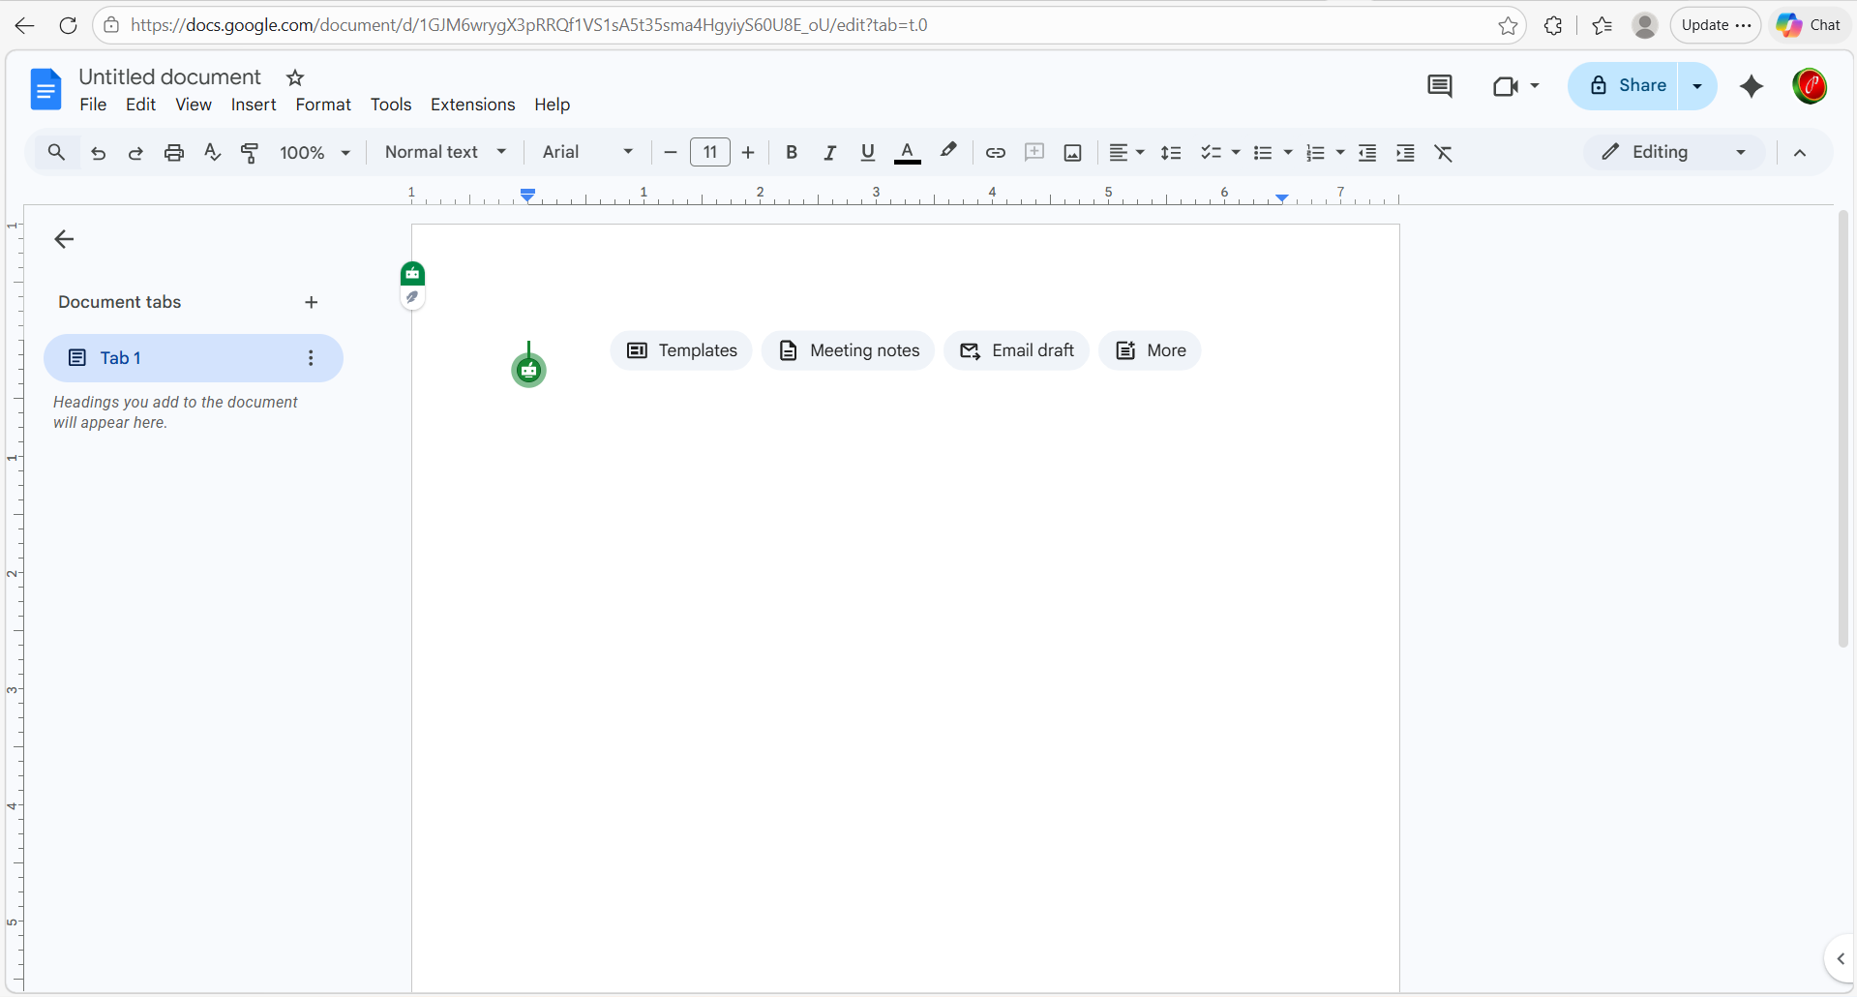
Step 3. I entered the email address of the person I wanted to share with. And after clicked on the settings to select the permission as Editor so they could edit the document. ↴
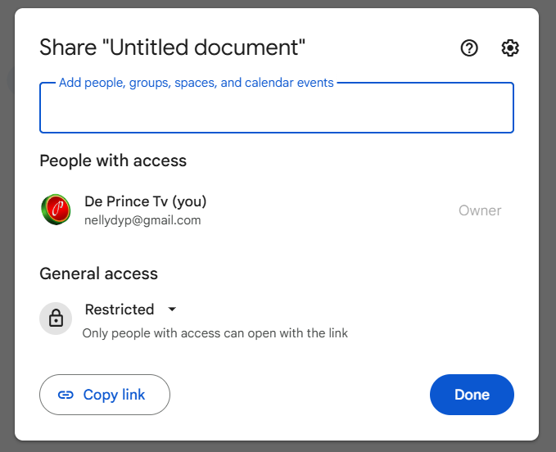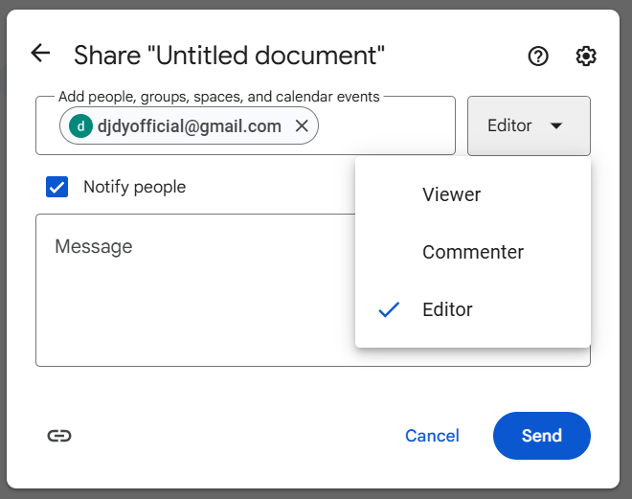
Step 4. I checked the General access and left it as Restricted (only selected people can access). Finally, I clicked “Done” to complete the sharing. This allowed the other person to open and edit the document in real time. ↴

Conclusion
In conclusion, this assignment helped me understand how important different software tools are in modern business environments. From what I explored, e-commerce platforms like Shopify and Wix make it easier for businesses to operate online, even without advanced technical skills. I also learned that mind mapping is a useful way to organise ideas and improve planning and teamwork. Looking at office applications such as Microsoft Word, Excel, PowerPoint, and Access showed me how businesses create documents, analyse data, and manage information effectively.
The practical tasks I completed, especially using Excel functions and Pivot Tables, helped me gain real experience and made it easier to understand how these tools work in real situations. I also found that communication and collaboration tools like Microsoft Teams and Google Docs play a big role in improving teamwork, especially when people are working remotely.
Overall, I can say that these software solutions help businesses save time, reduce errors, and improve productivity. This assignment has improved my knowledge and confidence in using these tools, and I now better understand how they are applied in real business environments.

References
[1] E. Turban, E. Pollard, and G. Wood, Information Technology for Management: Driving Digital Transformation to Increase Local and Global Performance, Growth and Sustainability, 11th ed. Hoboken, NJ, USA: Wiley, 2021.
[2] A. Manzoor, E-commerce: An Introduction. Saarbrücken, Germany: LAP Lambert Academic Publishing, 2010.
[3] D. Chaffey, Digital Business and E-Commerce Management, 7th ed. Harlow, UK: Pearson, 2019.
[4] E. Turban et al., Electronic Commerce: A Managerial and Social Networks Perspective, 8th ed. Cham, Switzerland: Springer, 2015.
[5] T. Buzan, Use Your Head. London, UK: BBC Books, 1974.
[6] T. Buzan and B. Buzan, The Mind Map Book. Harlow, UK: Pearson Education, 2006.
[7] M. Davies, “Concept mapping, mind mapping and argument mapping: what are the differences and do they matter?” Higher Education, vol. 62, no. 3, pp. 279–301, 2011.
[8] J. Walkenbach, Excel 2019 Bible. Indianapolis, IN, USA: Wiley, 2018.
[9] L. A. Bucki, Word 2013 Bible. Hoboken, NJ, USA: Wiley, 2013.
[10] J. Lambert, Microsoft PowerPoint 2016 Step by Step. Redmond, WA, USA: Microsoft Press, 2015.
[11] J. Walkenbach, Excel 2019 Bible. Hoboken, NJ, USA: Wiley, 2018.
[12] M. Alexander and R. Kusleika, Access 2019 Bible. Hoboken, NJ, USA: Wiley, 2018.
[13] A. G. Picard, The Digital Transformation of Communication in Organizations. Cham, Switzerland: Springer, 2020.
[14] K. Laudon and J. Laudon, Management Information Systems: Managing the Digital Firm, 16th ed. Harlow, UK: Pearson, 2020.
[15] D. Chaffey, Digital Business and E-Commerce Management, 7th ed. Harlow, UK: Pearson, 2019.
[16] T. Berners-Lee and M. Fischetti, Weaving the Web. New York, NY, USA: HarperCollins, 2000.

