

Assignment 2
Subject Name: Marketing Management
Subject Code: LCMB7024
Lecturer: Dr Laila Maazouz
Course: MBA
Term : February 2025

Student Name: Dhruvin Nitinbhai Anghan
Student Number: 2429348
Word Count: 2719
Submission Deadline: 28th April 14:00 (2PM)

Table of Contents
1. Introduction 2
1.1 Concept and Rationale 2
1.2 Overview of JPMorgan Chase 4
2. Segmentation, Targeting, and Positioning 5
2.1 Segmentation 5
2.2 Targeting 8
2.3 Positioning 9
3. Customer Persona 11
3.1 Demographic Profile 11
3.2 Psychographic Profile 12
3.3 Customer Preferences, Needs, and Pain Points 13
4. Marketing Mix 14
4.1 Product 14
4.2 Price 15
4.3 Place 15
4.4 Promotion 17
4.5 People 17
4.6 Process 17
4.7 Physical Evidence 19
5. Conclusion 19
References 20

1. Introduction

1.1 Concept and Rationale
The threat of fraud that banks and payments firms face has increased significantly in recent years. By 2018, fraud losses to banks alone surpassed a conservative estimate of $31 billion globally, and the situation has only deteriorated since then (Hasham, Hayden and Wavra, 2018). The acceleration of digital and mobile payment platforms is the primary factor driving this alarming trend, which is resulting in shorter transaction times and a narrower window for fraud detection. In addition, fraudsters have become increasingly sophisticated, employing collaboration networks on the dark web to exchange stolen data and fraudulent techniques.
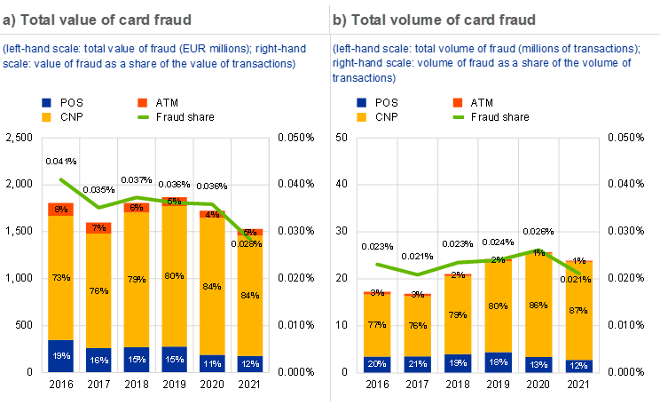
Source: https://www.ecb.europa.eu/press/pr/date/2023/html/ecb.pr230526~f09bc3c664.en.html
Conventional fraud prevention strategies have encountered significant challenges in maintaining their effectiveness. The fragmentation of critical anti-fraud resources within institutions, which encompasses cyber security, compliance, legal, IT, and fraud teams, frequently leads to inadequate coordination and data sharing. The outcome is a defensive stance that is unable to identify and mitigate newly emerging fraud types, such as account takeovers (ATO), synthetic identities, and business email compromise (BEC) (Hasham, Hayden and Wavra, 2018).
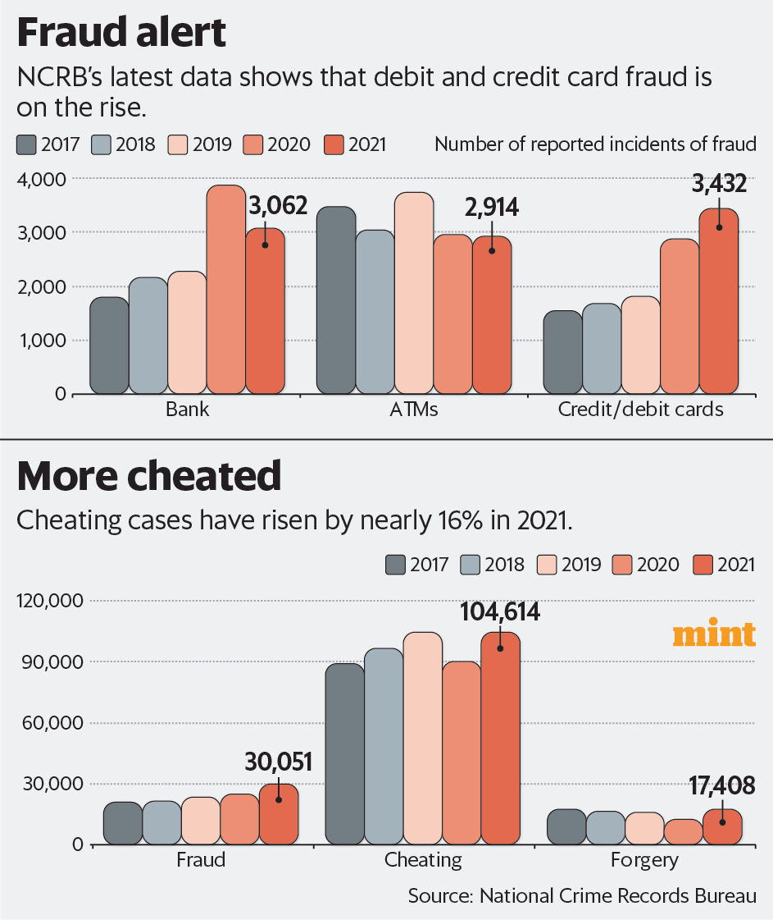
Source: https://www.livemint.com/industry/banking/debit-credit-card-frauds-on-rise-atm-scams-down-ncrb-11661885877307.html
Identity Armour+ was developed to proactively confront these obstacles. It is a real-time service that utilises the most recent developments in artificial intelligence and biometrics to detect deception and recover identities. Identity Armour+ endeavours to offer users comprehensive protection throughout their entire digital footprint by monitoring all user accounts, including those that are not affiliated with Chase. This innovation signifies a transition from the isolation of transactional fraud detection to the assurance of customer identity across the ecosystem, which is crucial for the establishment of enduring trust in a financial environment that is rapidly digitising (Hasham, Hayden and Wavra, 2018).
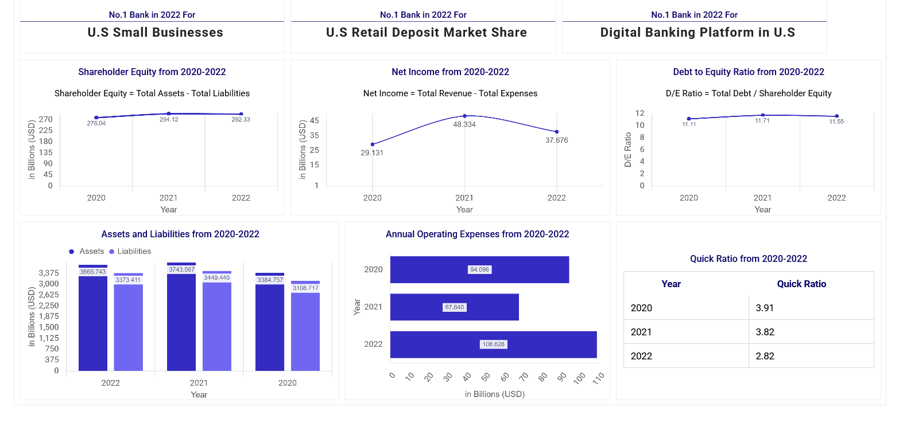
Source: https://app.mokkup.ai/embed/7e5ef489-e03c-4032-a9d5-6337d94b1ae2
The Identity Armour+ platform is significantly influenced by advanced analytics. JPMorgan Chase has adopted a risk-based customer segmentation model, which transcends conventional models that concentrate exclusively on false positives. This enables low-risk users to enjoy lower-friction experiences, while security interventions are only intensified when they are required. The implementation of analytics-driven fraud prevention can reduce fraud losses by 3–5% in mature banking environments and by over 30% in evolving contexts when executed effectively (Hasham, Hayden and Wavra, 2018).

1.2 Overview of JPMorgan Chase
JPMorgan Chase & Co. (JPMC) is a global leader in financial services, operating through four primary business segments: Corporate and Investment Bank, Commercial Banking, Consumer and Community Banking, and Asset and Wealth Management. In FY2023, the company generated $278,906 million in revenue, with Consumer and Community Banking accounting for $70,148 million, or 43.2% of the total (MarketLine, 2024). JPMC provides services to a diverse clientele, which includes consumers, small businesses, corporations, institutions, and government entities in North America, Europe, Asia-Pacific, Latin America, and the Middle East.
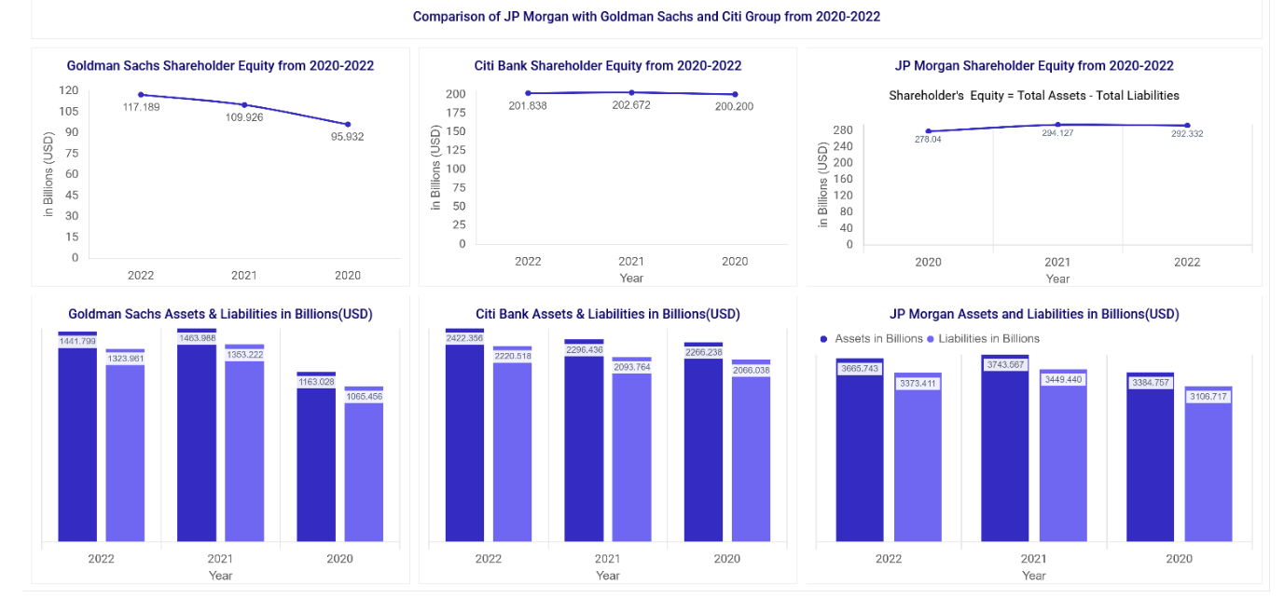
Source: https://app.mokkup.ai/embed/7e5ef489-e03c-4032-a9d5-6337d94b1ae2
Cash management, wealth management, investment banking, residential mortgages, auto loans, student loans, and a diverse selection of credit and debit card products comprise JPMC's service portfolio. It functions under the Chase and J.P. Morgan brands. Morgan has a robust geographic presence and a variety of brands, with North America accounting for 77.9% of its total revenue (MarketLine, 2024). JPMC is well-positioned to introduce innovative services such as Identity Armour+ that complement its robust digital and payment infrastructures, having over 318,000 employees and extensive global operations.

2. Segmentation, Targeting, and Positioning

2.1 Segmentation
Identity Armour+ is engineered to satisfy the expanding need for real-time fraud detection and identity protection in a diverse array of financial threats. The segmentation of this service is determined by the unique fraud vulnerabilities that have emerged across a variety of consumer profiles. Over 60% of global respondents reported an increase in fraud volume, with fraud varieties such as account takeovers, identity theft, cyberattacks, and scams becoming more prevalent, according to KPMG's Global Banking Fraud Survey (KPMG, 2019).
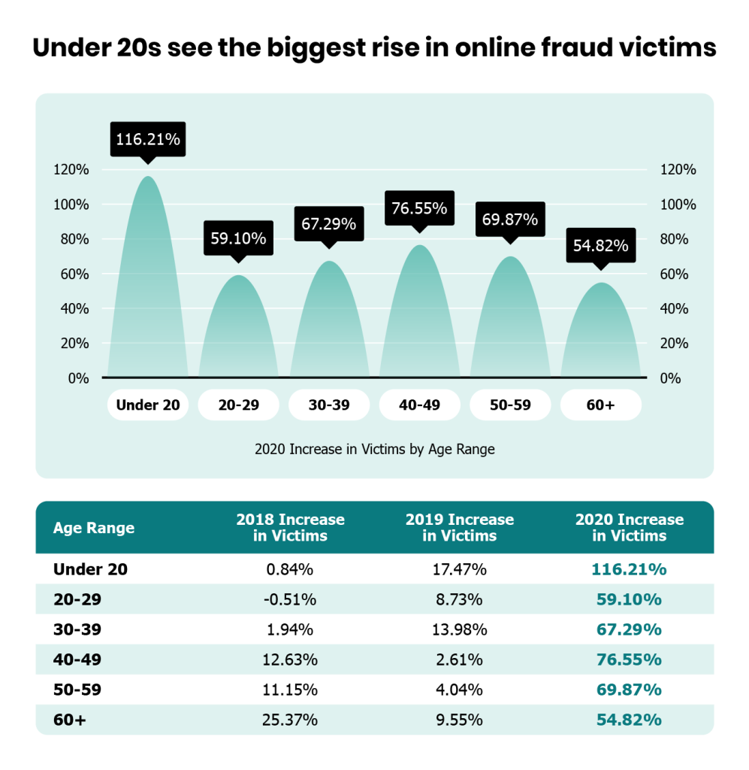
Source: https://seon.io/resources/gen-z-report-online-fraud/
Demographic, behavioural, and technographic factors comprise the primary segmentation criteria. Younger consumers, aged 18–45, who prefer digital and mobile banking, are at a higher risk, particularly due to the proliferation of faster payments and the decrease in physical banking interactions (KPMG, 2019). Behavioural segmentation emphasises the significant increase in fraud concerns, including card-not-present (CNP) fraud, among consumers who engage in online transactions, e-commerce, and mobile app use (KPMG, 2019).
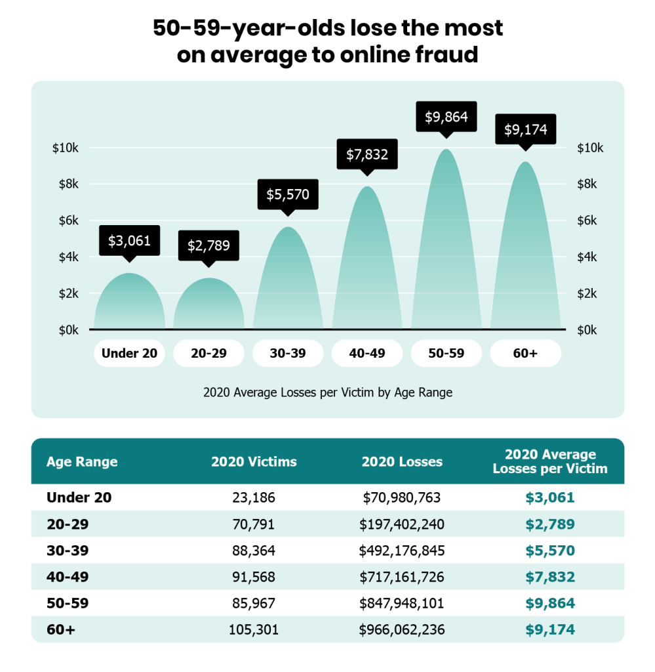
Source: https://seon.io/resources/gen-z-report-online-fraud/
Furthermore, vulnerability-based segmentation is targeted at customers who are at a higher risk of falling victim to scams, including the elderly, socially isolated individuals, and businesses that are susceptible to business email compromise (BEC). According to FBI, global losses exceeded $12 billion between 2013 and 2018 (KPMG, 2019). These segments are critical audiences for Identity Armour+, as scams, authorised push payment fraud, and identity intrusions are on the rise.

2.2 Targeting
Initially, digital banking services are primarily used by tech-savvy millennials and Gen Z consumers (ages 18–35). Over 25% of the products and services offered by 78% of institutions are delivered through digital channels (KPMG, 2019). This demographic prioritises secure, seamless digital experiences and is acutely aware of the potential dangers associated with their identity as a result of high-profile breaches that have affected companies such as Facebook, Equifax, and Yahoo.
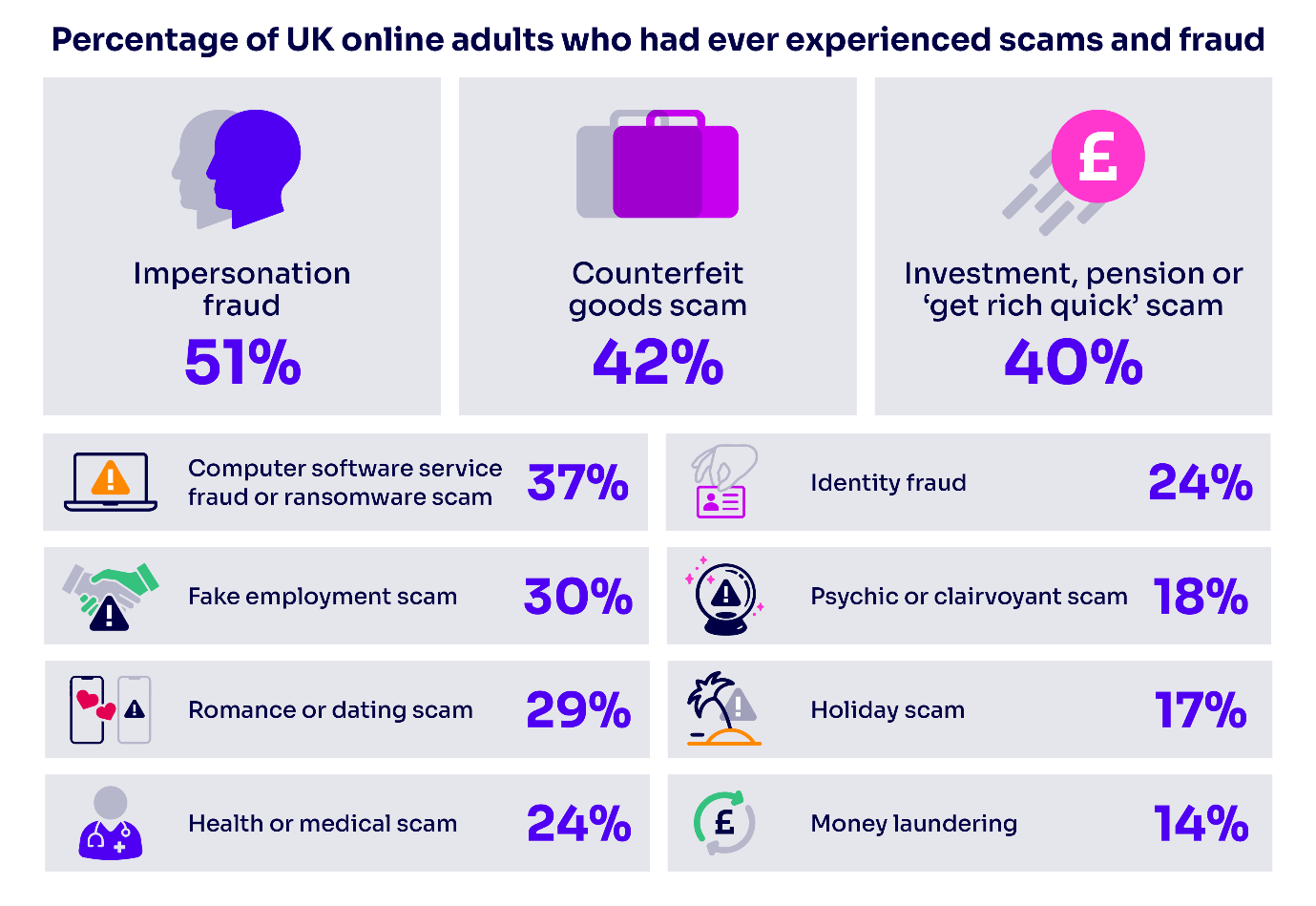
Source: https://www.ofcom.org.uk/online-safety/online-fraud/scale-and-impact-of-online-fraud-revealed
Secondly, individuals between the ages of 36 and 55 who are financially active and are responsible for administering multiple accounts, investments, and mobile transactions are another significant demographic (KPMG, 2019). Particularly in light of the global spread of open banking, they necessitate increased assurance regarding cross-platform account security.
Third, the audience that is most critical is composed of small business proprietors and corporate finance officers. The annual losses in the United States alone are $1.5 billion, and business email compromise continues to be a grievous threat (KPMG, 2019). When onboarding clients or vendors, these consumers are targeted due to their vulnerability to payment redirection scams, invoice fraud, and synthetic identity threats.
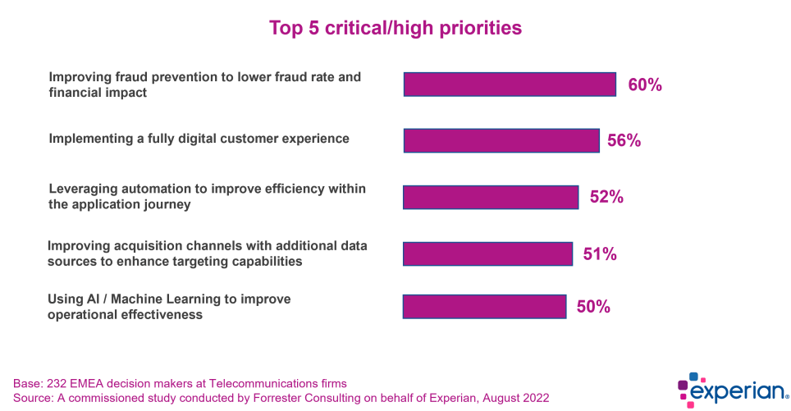
Source: https://experianacademy.com/blog/2023/07/03/how-ai-combats-telco-subscription-fraud/
Cyberattacks, quicker payments, and open banking regulations have simultaneously increased fraud risks in North America, Europe, and the Asia-Pacific regions (KPMG, 2019). North American institutions are particularly challenged by the shorter timeframes that traditional fraud detection systems have to intervene due to the faster payment infrastructures.

2.3 Positioning
Identity Armour+ is a cutting-edge fraud defence platform that is based on AI and biometric technologies. It offers real-time, comprehensive identity protection across all digital and financial channels, including non-Chase accounts. Identity Armour+ provides customers with a comprehensive security framework, as it expands monitoring to external accounts and open banking-linked platforms, in contrast to conventional fraud detection systems that concentrate primarily on in-bank transactions (Kalsoom et al., 2025).
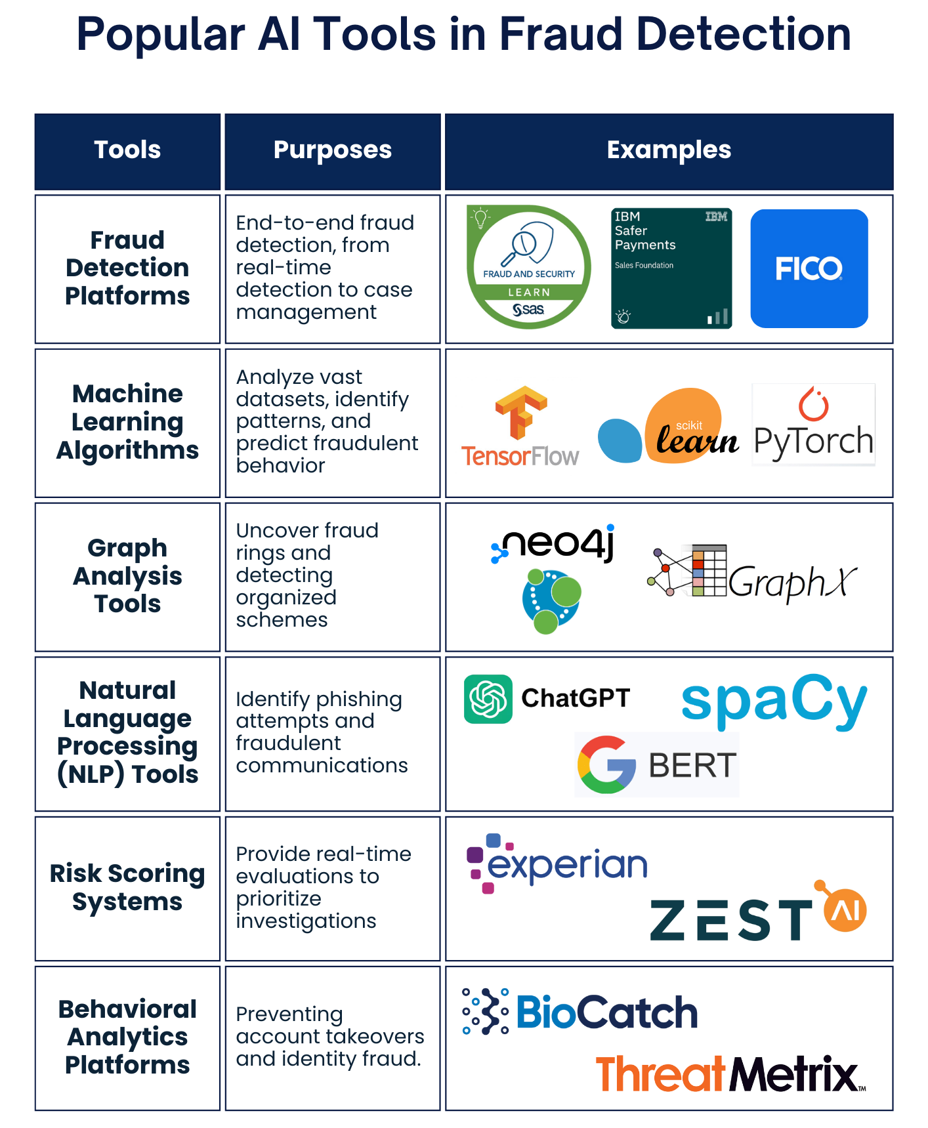
Source: https://smartdev.com/ai-driven-fraud-detection/
The product's positioning capitalises on the pressing consumer demand for proactive protection, trust, and control over personal data. It utilises Chase's robust brand credibility—which is ranked among the world's leading financial institutions with over $3.9 trillion in assets—to reassure customers of the security and reliability of its fraud management ecosystem (MarketLine, 2024).
Additionally, Identity Armour+ distinguishes itself by integrating machine learning-driven predictive analytics, seamless customer experience mechanisms, and behavioural biometrics (which profile customer-device interactions) (Lott, 2015). Banks that implement behavioural biometrics and machine learning achieve superior fraud detection rates; however, they continue to encounter false positives (KPMG, 2019). Identity Armour+ prioritises the reduction of friction for legitimate users while simultaneously improving the accuracy of fraud detection.

3. Customer Persona

3.1 Demographic Profile
The optimal customer persona for Identity Armour+ is characterised by a diverse array of demographic characteristics, with a primary focus on digitally engaged individuals between the ages of 25 and 55. These clients are typically middle- to upper-income earners who are active users of online and mobile banking platforms. 78% of banks provide over 25% of their products and services through digital channels, and there is a growing trend of consumers abandoning traditional branch banking (KPMG, 2019).
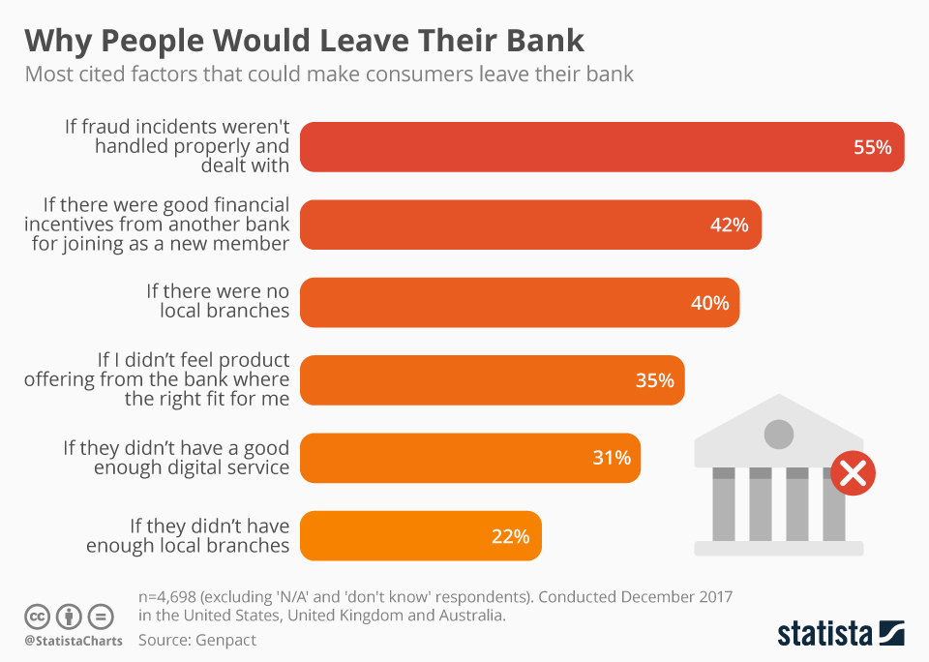
Source: https://www.statista.com/chart/14032/why-people-would-leave-their-bank/
The persona includes both small business proprietors and individual consumers who require robust financial security tools to manage their diversified financial portfolios. Cyberattacks, open banking, and quicker payment platforms are increasing fraud exposure in regions such as North America, Europe, and Asia-Pacific (KPMG, 2019). Geographically, they are concentrated in these regions.
Furthermore, the persona includes individuals with advanced education, particularly those who are proficient in digital platforms and emerging fintech applications. The demographic also includes financially active users who utilise online investment platforms, digital wallets, and real-time peer-to-peer payment services. These areas have been identified as experiencing an expanding prevalence of fraud typologies, including identity theft and scams (KPMG, 2019).

3.2 Psychographic Profile
According to psychographic profiles, these consumers prioritise transparency, control, and trust in their financial transactions. Their expectations for financial services that are instantaneous, secure, and seamless have increased significantly as digital transformation continues to accelerate. Consumers hold banks accountable for safeguarding them from social engineering schemes, regardless of the presence of external factors such as hacking or dark web activities (KPMG, 2019). This is indicative of a critical psychographic characteristic: the necessity for proactive protection without undue customer effort.
Additionally, these customers exhibited a strong preference for the early adoption of technology-based solutions, including biometric authentication and real-time fraud alerts, as well as innovation. Over 67% of banks have implemented physical biometrics, including voice, fingerprint, and facial recognition, to improve security (KPMG, 2019). Customers anticipate that financial institutions will allocate resources to innovative fraud prevention technologies rather than conventional, reactive strategies.
Another substantial psychographic characteristic is risk aversion. Comprehensive security coverage is sought by customers, particularly those who have encountered or are cognisant of the increasing threats, such as business email compromise schemes, which resulted in losses of $12 billion globally between 2013 and 2018 (KPMG, 2019). They favour solutions that reduce the necessity for continuous manual account monitoring, instead placing their trust in intelligent, AI-driven systems to protect their identities.

3.3 Customer Preferences, Needs, and Pain Points
Customers require a digital banking experience that is both highly secure and frictionless. Real-time transaction monitoring, proactive threat alerts, seamless identity verification across platforms, and straightforward recovery mechanisms in the event of fraud are essential requirements. The burden of managing security settings individually, the fragmented fraud protection across multiple banks and platforms, and the distrust that has arisen from significant data breaches such as those at Yahoo and Equifax, which compromised billions of accounts, are all examples of pain points (KPMG, 2019).
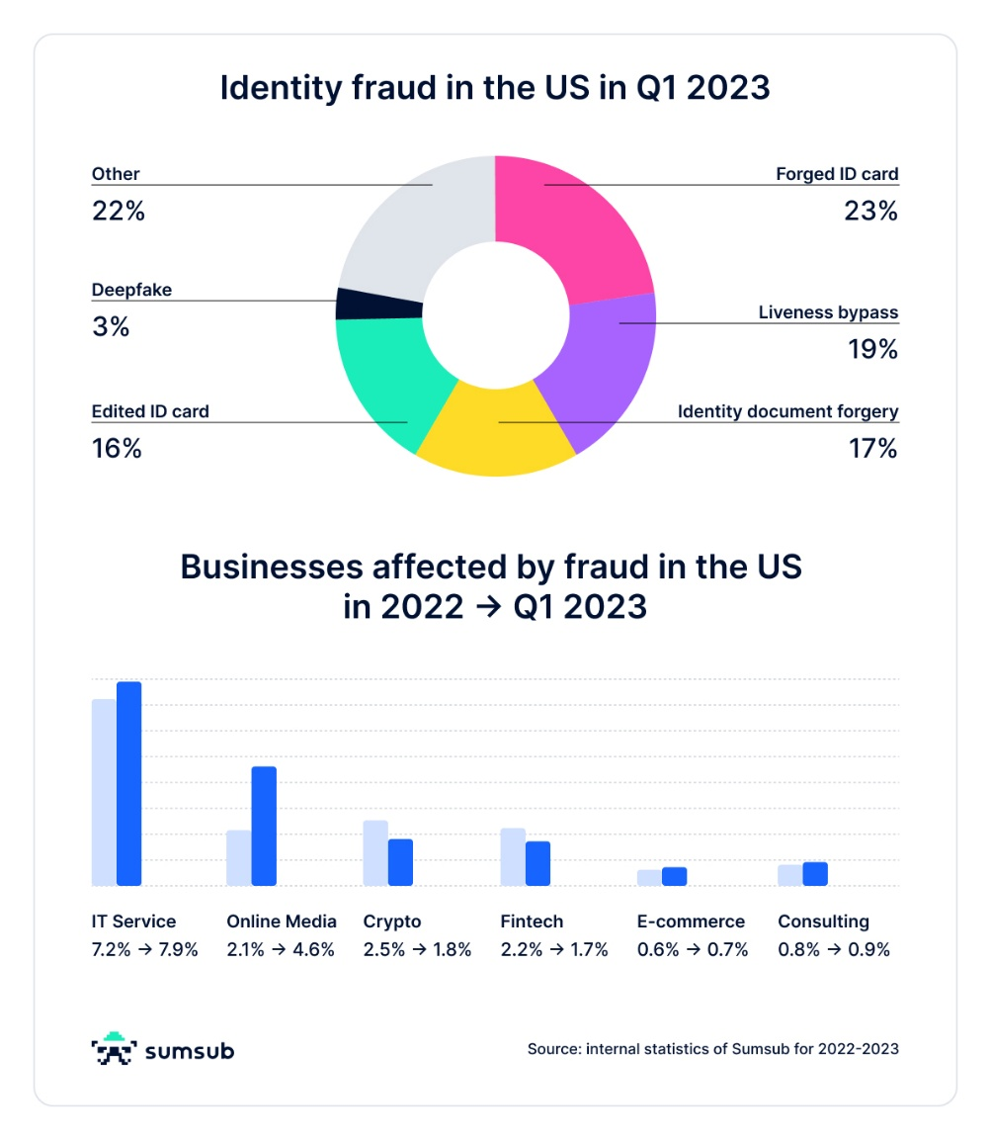
Source: https://tinyurl.com/wbzmzn5d
Furthermore, fraud recovery rates that are inadequate are a substantial issue. The fact that over half of the institutions surveyed recover less than 25% of their fraud losses underscores the importance of prevention over remediation (KPMG, 2019). Therefore, customers favour systems that identify and prevent fraud prior to the occurrence of financial harm.
Identity Armour+ fulfils these requirements by providing comprehensive, real-time protection that extends beyond Chase's internal systems to all externally linked accounts. It seamlessly integrates into the digital lifestyles of contemporary banking customers by utilising AI, behavioural biometrics, and a customer-centric design to provide protection that is both intuitive and proactive.

4. Marketing Mix

4.1 Product
Identity Armour+ is a comprehensive fraud detection and identity recovery service that incorporates advanced biometrics and artificial intelligence to protect user accounts beyond JPMorgan Chase's ecosystem. This solution addresses the increasing global demand for safeguarding against the emergence of new fraud patterns, such as synthetic identity fraud and account usurpation.
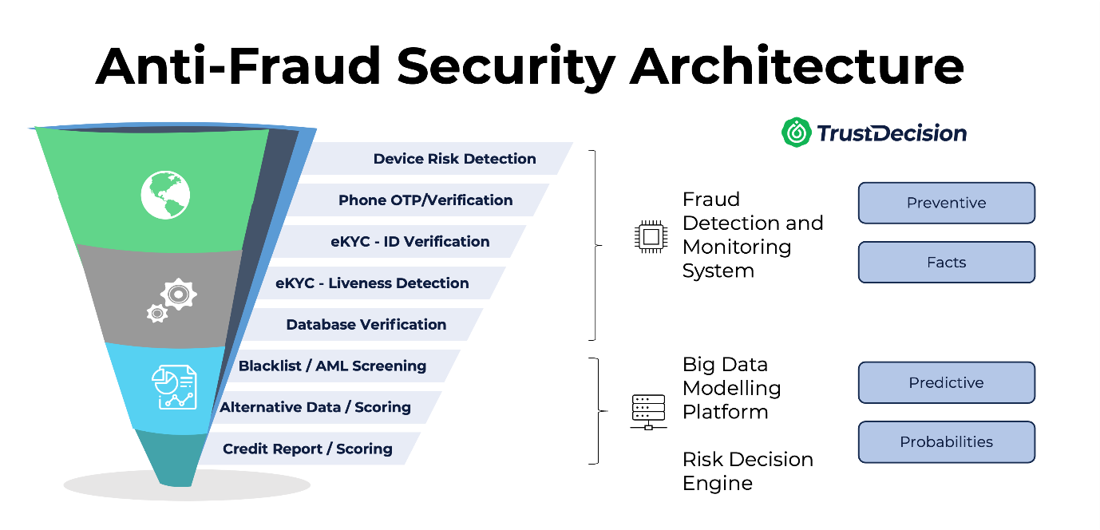
Source: https://trustdecision.com/resources/blog/fraud-prevention-framework-a-guide-for-fintech-architects
The scope and sophistication required in their fraud prevention services were underscored by JPMorgan Chase's report in 2024 that they were safeguarding over $35 trillion in client assets daily and executing transactions across more than 160 countries (JPMorgan Chase, 2024). Chase's market leadership in digital banking, which currently serves over 71 million active digital clients, including 58 million mobile banking users, is further enhanced by Identity Armour+.

4.2 Price
Identity Armor+'s pricing strategy is founded on a value-based model that is designed to optimise customer security at a competitive price. The service will be priced to reflect high value while remaining accessible, as evidenced by Chase's premium positioning, which is demonstrated by a tangible book value per share increase to $97.30 in 2024 (JPMorgan Chase, 2024).
To provide context, Chase increased the cash dividends declared per share from $4.10 in 2023 to $4.80 in 2024, indicating a strong financial resilience and a customer-centric reward focus (JPMorgan Chase, 2024). Identity Armour+ could be integrated with Chase's current premium account services or offered as a subscription model priced (Bala, 2012) to compete with standalone identity protection services in the $10–$20 per month range.

4.3 Place
Chase's extensive digital and physical network will be utilised to distribute Identity Armour+. Chase has 84 million U.S. consumers, seven million small businesses, and over 4,900 branches throughout the United States, which presents a plethora of cross-selling opportunities (JPMorgan Chase, 2024).
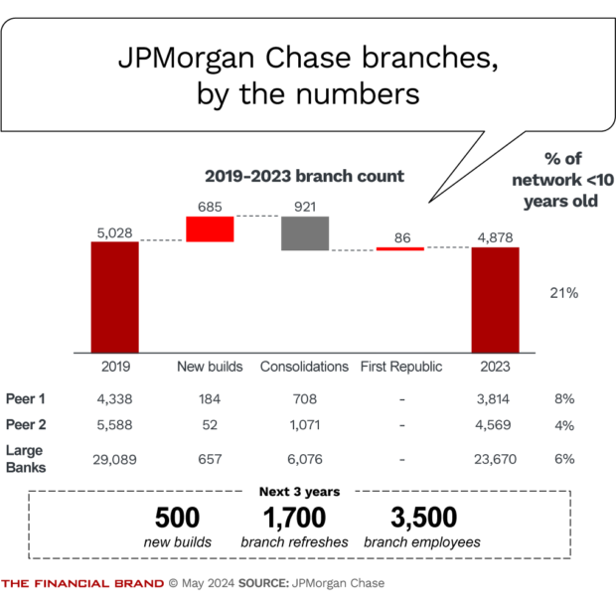
Source: https://thefinancialbrand.com/news/banking-trends-strategies/5-key-points-from-jpmorgan-chase-2024-investor-day-178422
Additionally, Chase's leadership in digital adoption—which includes an 81% penetration of digital non-card payments—designates the mobile and online platforms as the primary channels for service acquisition and management (JPMorgan Chase, 2024). Chase's comprehensive national reach is guaranteed by its dominance in the U.S. retail banking landscape, which includes being the dominant deposit market share holder in four of the five major banking markets.

4.4 Promotion
A multi-channel approach will be employed to promote Identity Armour+, with an emphasis on education, trust, and urgency. Chase's marketing capabilities are well-documented, as they have consistently maintained a high level of brand recognition in both the retail and commercial banking sectors. In the 2024 J.D. Power survey, the organisation placed first in terms of customer satisfaction among self-directed investors (JPMorgan Chase, 2024).
The promotion will underscore the increasing risks of fraud, real-world case studies, and the safeguards that Identity Armour+ offers. Chase's demonstrated ability to engage with customers across a variety of touchpoints will be reflected in the campaigns, which will utilise email marketing, app notifications, in-branch promotions, and strategic partnerships (JPMorgan Chase, 2024).

4.5 People
Chase's workforce of more than 317,000 employees is a critical asset in the provision of exceptional customer service for Identity Armour+. The company's ranking as the top company on LinkedIn's 2024 Top Companies list was significantly influenced by its commitment to employee training and development (JPMorgan Chase, 2024).
Branch staff, digital service agents, and specialised fraud support units, which are customer-facing teams, will receive comprehensive training on the features, benefits, and value propositions of Identity Armour+.

4.6 Process
The process dimension is essential for a frictionless Identity Armour+ experience. AI-driven predictive detection and behavioural biometrics will be employed to incorporate identity verification, onboarding, and monitoring into Chase's current digital infrastructure (Venigandla and Vemuri, 2022; Kalsoom et al., 2025).
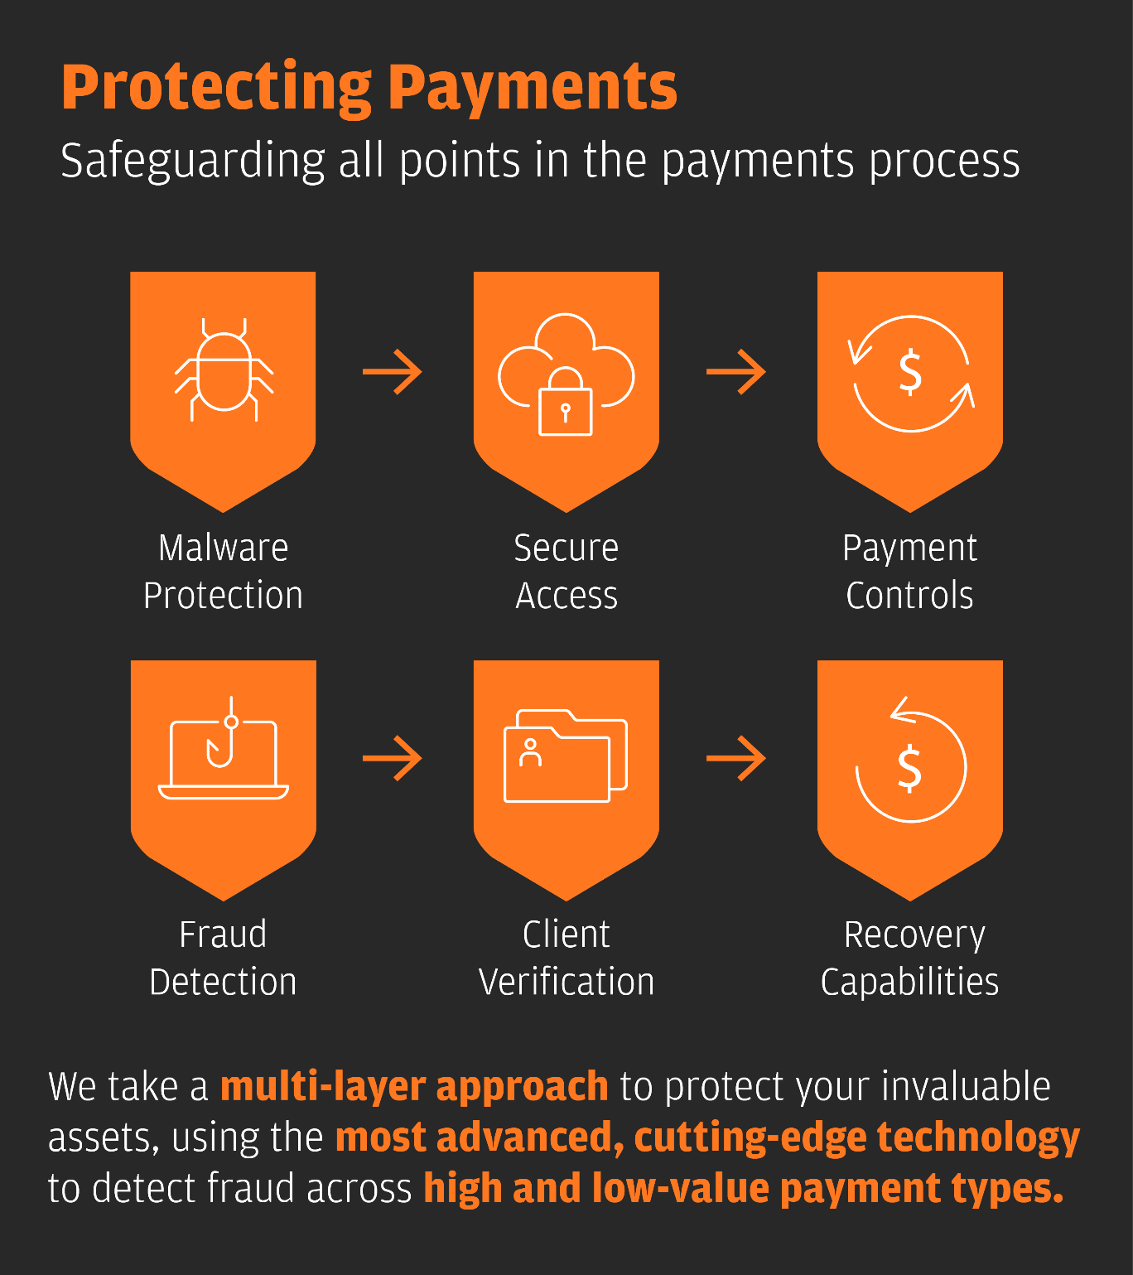
Source: https://datalemur.com/blog/jp-morgan-data-science
In 2024, JPMorgan Chase processed over $10 trillion in payments daily across 120+ currencies, illustrating a highly sophisticated transaction infrastructure that is capable of supporting real-time fraud detection (JPMorgan Chase, 2024). Automated alerts, self-service recovery tools, and seamless escalation paths will be implemented to expedite processes and minimise customer effort. This will guarantee high customer satisfaction and a prompt resolution of suspected fraud cases.

4.7 Physical Evidence
Physical evidence for Identity Armour+ is provided by Chase's well-established digital and physical presence. The service will be accessible to customers through Chase's award-winning mobile app and website interfaces, which have both been acknowledged for their exceptional digital banking experiences. Real-time fraud alerts, detailed monthly security reports, and digital dashboards that are readily accessible and illustrate account health are tangible indicators of protection (Adepoju et al., 2022; Asimiyu, 2024).
In addition, the service offering will be further enhanced by in-branch terminals and advisor consultations for customers who prefer face-to-face reassurance. The credibility of the Identity Armour+ experience is bolstered by Chase's ongoing investment in technology and digital platforms, which includes being ranked #1 in artificial intelligence capabilities for three consecutive years (JPMorgan Chase, 2024).

5. Conclusion
Identity Armour+ is JPMorgan Chase's strategic response to the growing fraud landscape. It integrates state-of-the-art biometrics, artificial intelligence (AI), and risk-based analytics to provide real-time protection for all user accounts. The service is in perfect alignment with the changing requirements of customers for proactive and seamless fraud defence, as it capitalises on Chase's digital leadership, dominant market position, and trust among 84 million U.S. consumers.
Identity Armour+ is poised to establish new industry standards in fraud prevention, thanks to its award-winning digital experience, streamlined onboarding processes, and well-trained workforce. By employing a comprehensive 7P marketing strategy, precise targeting, and deliberate segmentation, JPMorgan Chase guarantees that Identity Armour+ will not only meet but surpass customer expectations, thereby enabling the company to sustain its leadership in an era in which trust and security are of the utmost importance.

References
Adepoju, H., A. et al. (2022) Advancing Monitoring and Alert Systems: a proactive approach to improving reliability in complex data ecosystems, IRE Journals. journal-article, pp. 281–282.
Asimiyu, Z. (2024) Visualizing Cyber Threats: The role of data analytics in building actionable dashboards.
Bala, R. (2012) 'Pricing online subscription services under competition,' Journal of Revenue and Pricing Management, 11(3), pp. 258–273. https://doi.org/10.1057/rpm.2012.14.
Hasham, S., Hayden, R. and Wavra, R. (2018) Combating payments fraud and enhancing customer experience. https://www.mckinsey.com/industries/financial-services/our-insights/combating-payments-fraud-and-enhancing-customer-experience.
JPMorgan Chase (2024) Annual Report 2024. [pdf] JPMorgan Chase & Co. Available at: https://www.jpmorganchase.com/ir/annual-report [Accessed 28 April 2025].
Kalsoom, T. et al. (2025) 'Socio-Organisational challenges and Impacts of IoT: A review in Healthcare and Banking,' Journal of Sensor and Actuator Networks, 14(3), p. 46. https://doi.org/10.3390/jsan14030046.
KPMG (2019) Global Banking Fraud Survey: Fighting fraud in the digital age. [pdf] KPMG International. Available at: https://kpmg.com/ua/en/home/insights/2019/12/fraud-banking.html [Accessed 28 April 2025].
Lott, D. (2015) Improving customer authentication, Retail Payments Risk Forum Working Paper. Federal Reserve Bank of Atlanta.
MarketLine (2024) JPMorgan Chase & Co. Company Profile. [pdf] MarketLine. Available at: https://advantage.marketline.com [Accessed 28 April 2025].
Venigandla, K. and Vemuri, N. (2022) 'RPA and AI-Driven Predictive Analytics in Banking for Fraud Detection,' Tuijin Jishu/Journal of Propulsion Technology [Preprint]. https://doi.org/10.52783/tjjpt.v43.i4.5531.

