2117150
Learning In The Digital Era
ECGE4005P
Assignment Two

Video Link:
New channel meeting-20221106_111909-Meeting Recording.mp4

Slides:

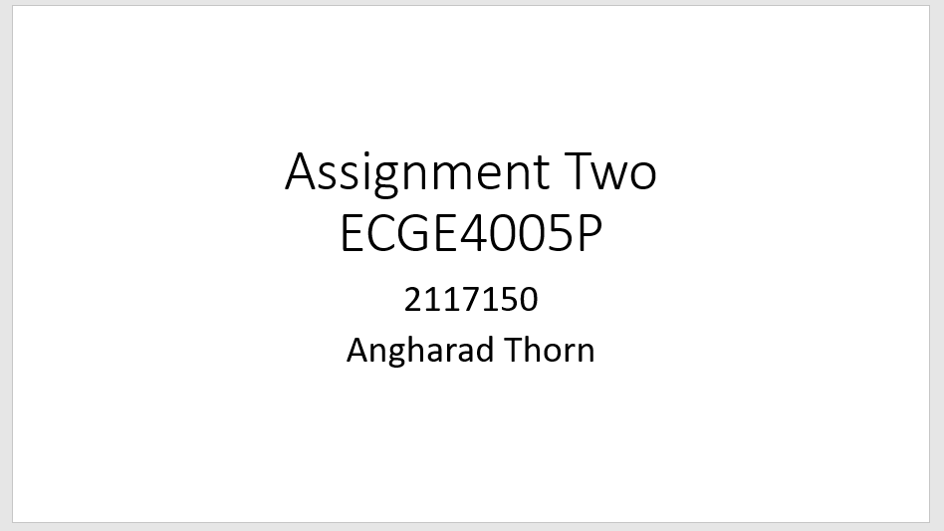
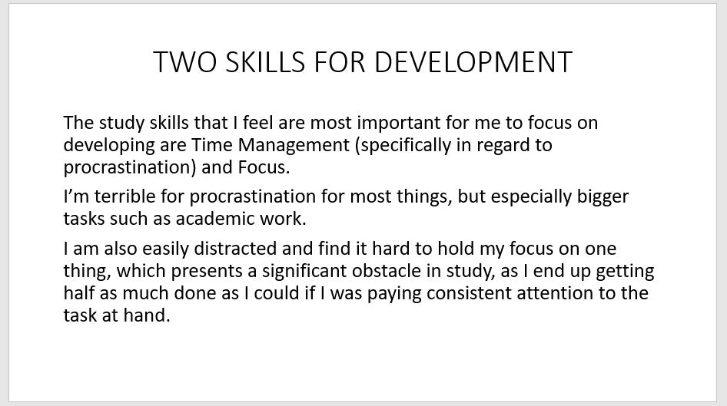
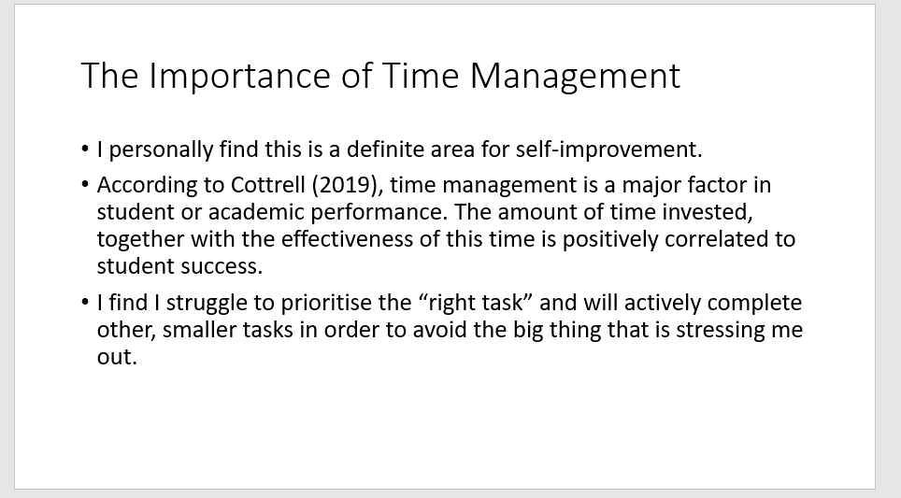
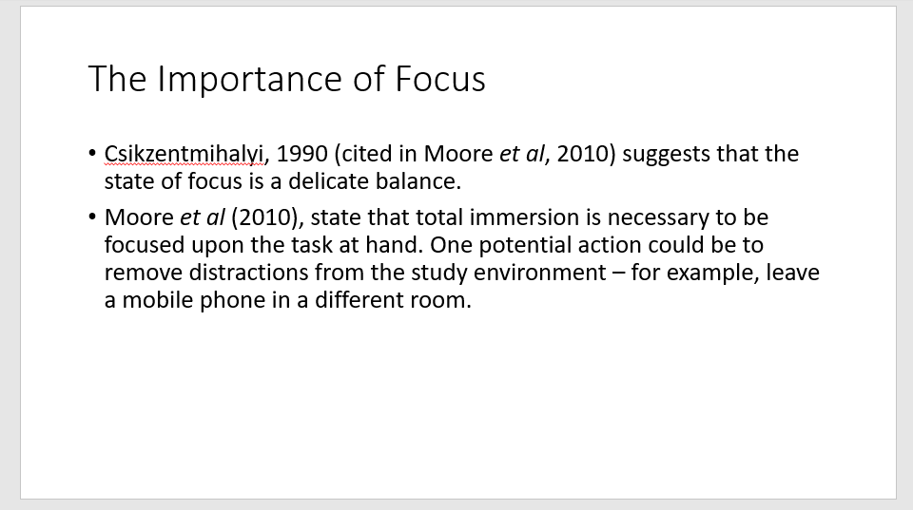
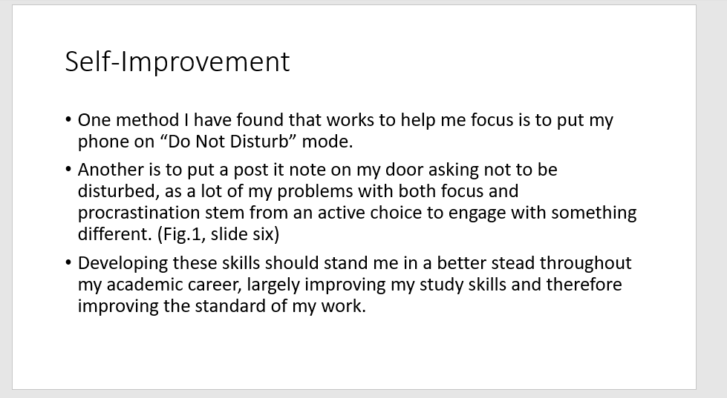
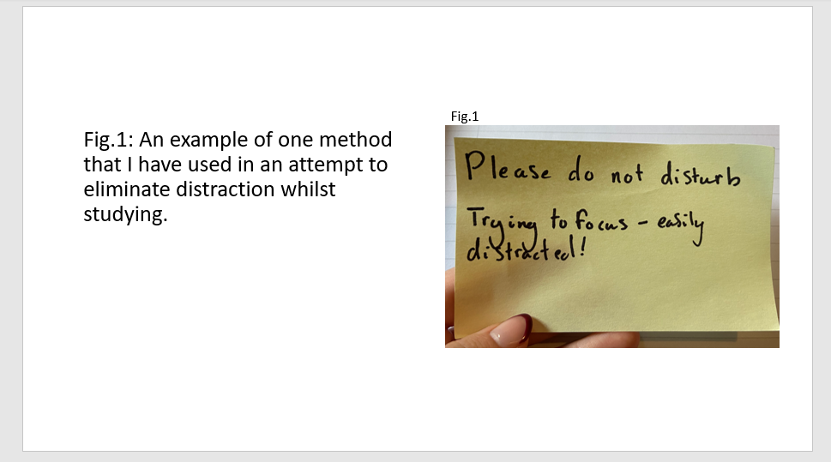
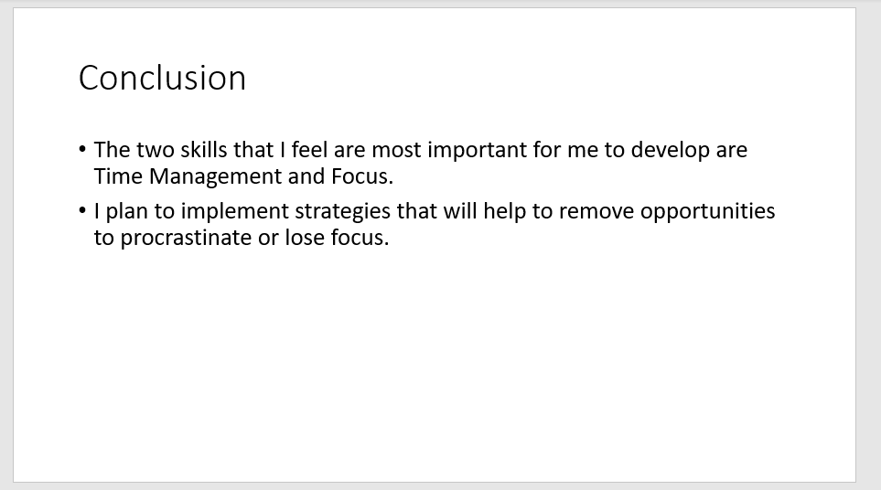
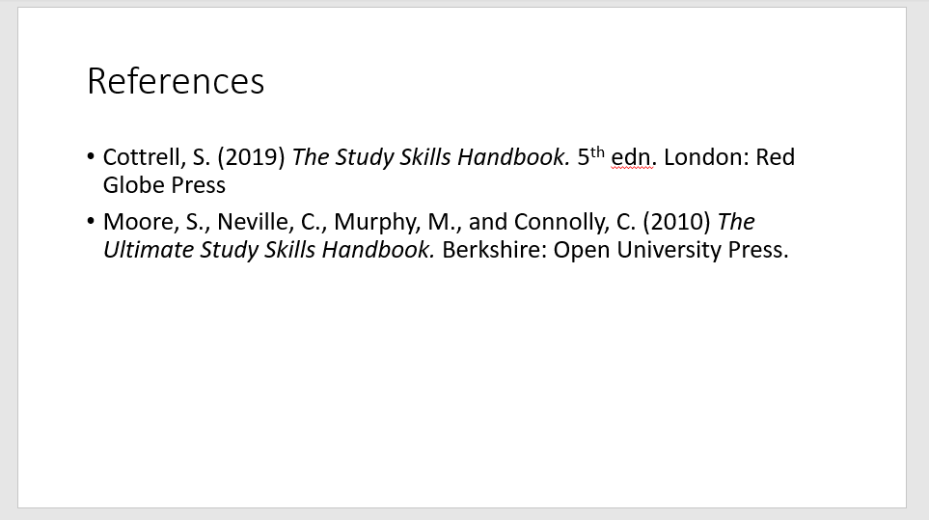

References:

Cottrell, S. (2019) The Study Skills Handbook. 5th edn. London: Red Globe Press.
Moore, S., Neville, C., Murphy, M., and Connolly, C. (2010) The Ultimate Study Skills Handbook. Berkshire: Open University Press.

