Information Engineering Practical Test

Student Name: Jason Byron Hopkins

Student number: 1805507

1. Celtic Caterers Context level diagram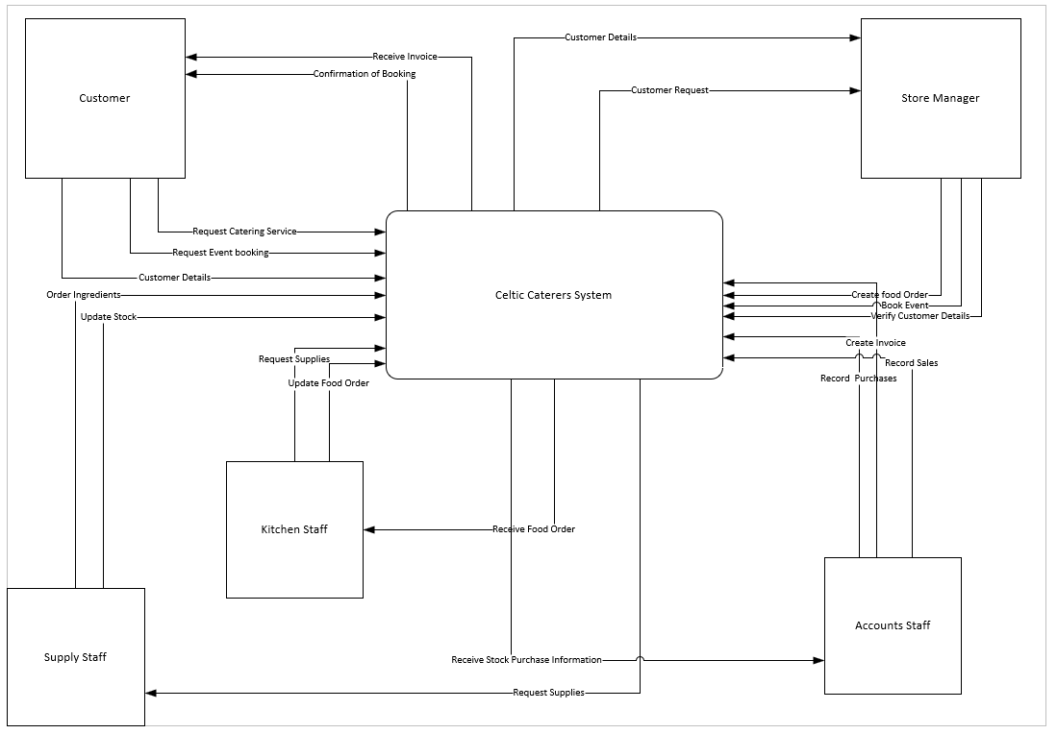

2. Level 0 DFD (2 Images)
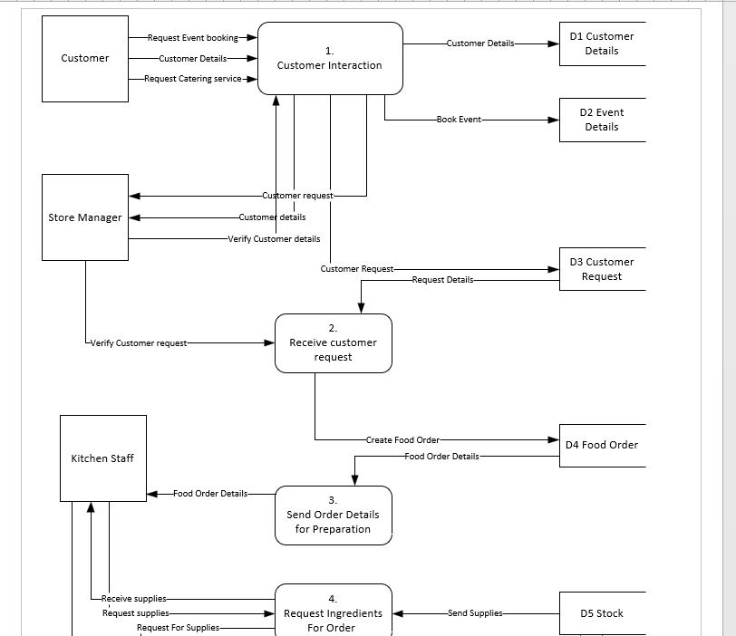
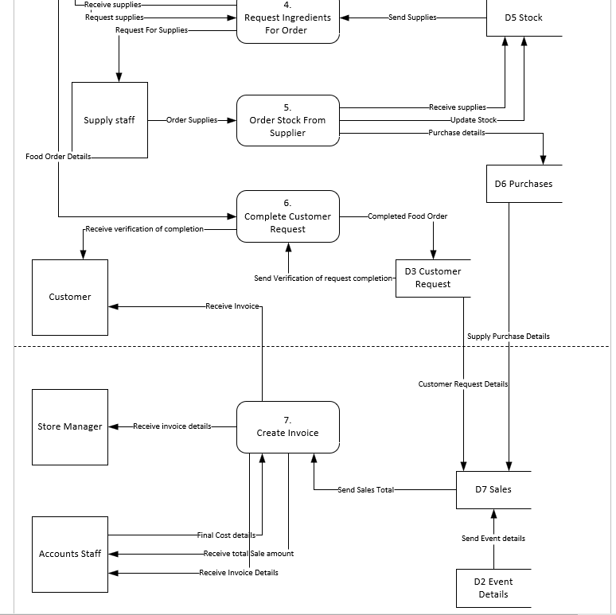

3. Level 1 DFD Diagram
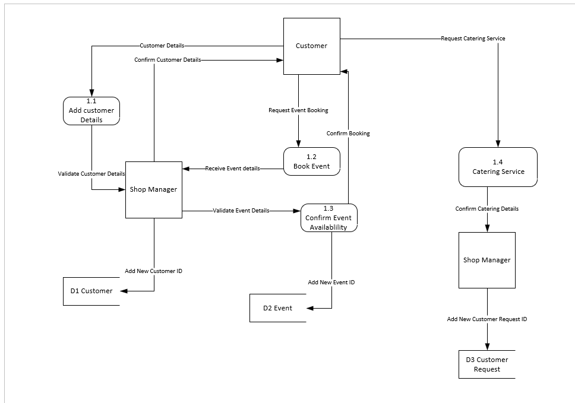

4. Entity Relationship Diagram


