University of Wales Trinity Saint David
School of Engineering
Undertaking a Green Belt Project
Michael Corish
2115171
Advanced Manufacturing Operations
28/04/2024
L5 – Six Sigma Green Belt ACMA5005



Table of Contents
1 Introduction 1
2 Define 2
2.1 Problem Statement 2
2.2 Voice of the Customer 2
2.3 Project Charter 3
3 Measure 4
3.1 Identifying Data Type and Data Collection Plan 4
3.2 Process Capability 4
4 Analysis 6
4.1 Graphical Tools 6
4.1.1 Pareto Analysis 6
4.2 Cause and Effect Diagram (Ishikawa) 8
4.3 5 Why’s Diagram 8
4.4 FMEA 10
5 Improve 11
5.1 Current Design of Coiler Guides 11
5.2 Improvement Alternative 12
5.3 Improved FMEA Diagram 13
5.4 Updated Process Capability 14
5.5 Cost Analysis 14
6 Control 15
6.1 Continuation of Statistical Analysis 15
6.2 Standardising the Process 15
6.3 Project Closure 16
7 Bibliography 17

Table of Figures
Figure 1 - Voice of the Customer Feedback 2
Figure 2 - Project Charter for Coiler area production maintenance delays. 3
Figure 3 - Data collection of Coiler production maintenance task delays over a 4 week period. 4
Figure 4 - Pareto Analysis of Production Maintenance Tasks. 6
Figure 5 - C4 and C5 average weekly delays by task. 7
Figure 6 - Pie chart of weekly average delay total by individual task percentages. 7
Figure 7 - Cause and Effect (Ishikawa) Diagram for the Guide Change Delay. 8
Figure 8 - 5 Why's Analysis of Guide Change Delays. 9
Figure 9 - FMEA of Coiler guide wear plate design. 10
Figure 10 - Complete design of current coiler guides including frame and wear plates. 11
Figure 11 - Batches of wear plates for coiler guides. 11
Figure 12 - Coiler guide after being in process displaying wear pattern. 12
Figure 13 - Drawing of potential design improvement to Coiler guides. *Add ref* 12
Figure 14 - Wear pattern to potential new design of guide rotating disks. 13
Figure 15 - Improved FMEA with potential actions to be taken and improved scoring. 13
Figure 16 - Comparison of current cost breakdown of guide design vs potential cost of guide improvement. 14
Figure 17 - An example of a Statistical Process Control chart displaying reduced variation through process improvements (Anderson, 2023) 15
Figure 18 - Tata Steel Standard Work Procedure Database. 16

Introduction

Tata Steel is a primary steelmaking company that produces steel coil from raw materials. There are multiple processes involved within the steelmaking process from ironmaking to cold rolling. The area being highlighted for this project will be Hot Rolled Products. This is otherwise known as the Hot Mill; the main objective of this area is to manufacture steel slab into coil through thickness reduction. The coil produced must meet customer demands such as profile, gauge, width and expected mechanical properties. To achieve optimal performance, large volumes of high quality coil must be produced to achieve an annual target of 3.5 million tonnes. The current annual average output is between 3.1 – 3.3 million tonnes, this deficit of approximately 200,000 tonnes is why this project is being undertaken. The project will identify where unplanned downtime is being taken and to identify tasks or equipment that are costing the company valuable production time. Through the implementation of the DMAIC process, the main benefit will be an increase in production time ultimately increasing company profits. Also, other key benefits include reduction in operational hazards and waste, providing improvements to the safety and environmental sectors. An application of certain tools and techniques will define the problem, measure data collection, analyse findings, review potential improvements and control methods.

Define

Problem Statement

The first technique used during the define phase was to develop a brief but specific description of the problem, otherwise known as a problem statement. It was essential to analyse the definition against Specific, Measurable, Achievable, Relevant and Time Bound (SMART) objectives, to ensure all relevant data was captured to continue with the project. The problem statement for this project is as follows;
“ During 2023, production maintenance delays in the Hot Mill accounted for 50% of overall delays to steel production. The Coiler department contributes to 75% of the production maintenance periods at 4 hours per week. The price of hot rolled coil is approximately £600 per tonne with the Hot Mill average output at 380 tonnes per hour. This resulting in £900,000 worth of potential sales being lost through Coiler production maintenance delays per week.”

Voice of the Customer

Voice of the customer (VOC) is a critical analysis procedure that provides precise information regarding customer input requirements for a product/service output (Aguwa, et al., 2012). Before implementing change it was important to understand the opinions of individuals this project could directly or indirectly affect. Through carrying out open conversations with area personnel, opinions on the idea of reducing production maintenance delays were captured. Also, collecting opinions from a multi-disciplined group provides a wider outlook on project deliverables (Fig.1).
“ Limiting the amount of occasions employees are carrying out front line tasks, will ultimately reduce risk of injury and improve overall workplace safety.”

Hot Mill Safety Facilitator
“ From an engineering outlook, we want plant to be running consistently. These delays are causing a discontinuous flow, which could possibly be a result of increased breakdowns. The project must be achievable and within area budgets.”

Coiler Area Lead Engineer
“ The reduction of production maintenance delays will improve the flow of material through the process. This will have positive impacts on tonnage and quality control of material.”

Hot Mill Production Manager
Figure 1 - Voice of the Customer Feedback

Project Charter

To initiate the start of the project, a project charter was created to highlight key information and create a one page document that states the intentions of the project (Fig.2). The initial details of the Project Charter captures basic information such as Project Name, Project Description, Company and the date the document was produced. The key details of the project were then captured to highlight the problem, goals, risks, scope and key stakeholders associated with the project.
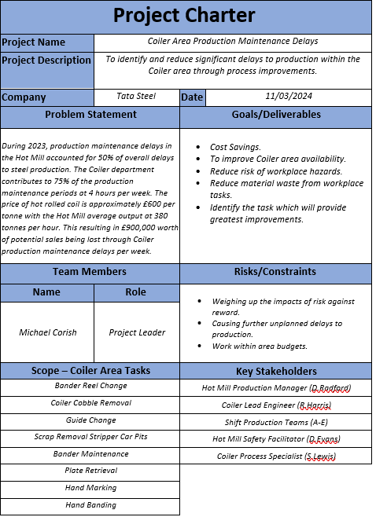

Figure 2 - Project Charter for Coiler area production maintenance delays.

Measure

The Measure phase objective is to collect data and identify a baseline for process performance through the utilisation of clear and meaningful measurement systems (Brook, 2017). The first objective during this phase of the project was to identify the measurement required and highlight potential areas where variation could be accounted for. Once completed, a data collection plan can be introduced and Measurement System Analysis performed.

Identifying Data Type and Data Collection Plan

This project will be mainly focusing on continuous data, through the recording of Coiler production maintenance delays by time lost in minutes. The data collection plan was to sample data over a four week period, allowing each shift to be captured within this time period. By doing this, each shift can be accounted for when carrying out these tasks, therefore capturing any cause for variation. This data can be collected 24 hours of the day, due to the Hot Mill delay computer system which tracks and highlights each issue throughout a shift. The plan was to collect the delay data from this computer system and transfer into an excel check sheet for the recording of specific delay data to selected tasks. The main areas to be captured were weekly delay totals, totals by Coiler, overall total for each task and average weekly total over the 4 week sample period.
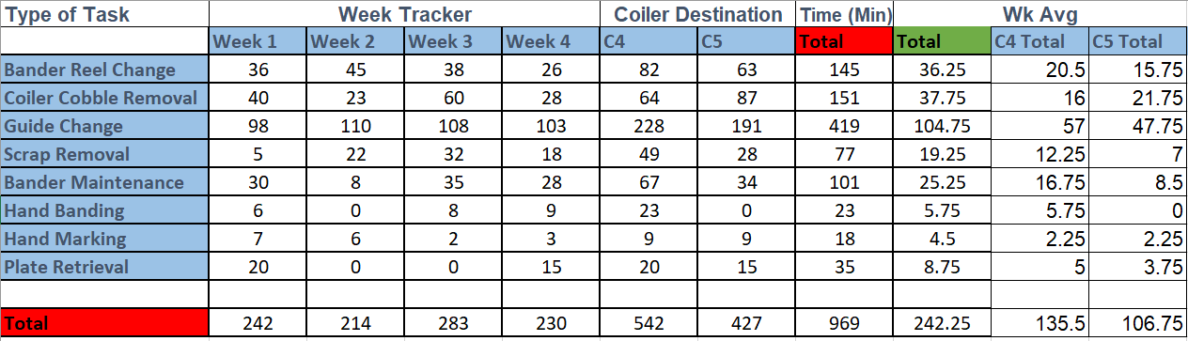
Figure 3 - Data collection of Coiler production maintenance task delays over a 4 week period.

Process Capability

Process Capability refers to the evaluation of how well a process meets specifications or the ability of the process to produce parts that conform to engineering specifications (Wooluru, et al., 2014). This project will attempt to reduce weekly production delay durations, to identify if the process is capable, the following calculations were carried out;
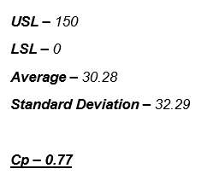

To assess current process capability, customer specifications were set at an upper limit of 150 minutes per week and a lower limit of 0 minutes. Also, the average delay length and standard deviation of all data collected was calculated to identify Cp. As can be seen from previous calculations, Cp is <1 meaning that in this current state the process is not capable of meeting these customer demands from the data collected. Additional calculations for Cpk were not carried out, as data results being centred were not applicable to reducing delay times below the Upper Specification Limit (USL). These findings will be evaluated further once the improvement idea has been identified.

Analysis

Graphical Tools

After data had been collected and recorded, graphical tools were created from measured data to identify areas requiring improvements. The visual aspect of using these tools and techniques, allows the process to be viewed as a whole with greater ease than analysing data points. Through techniques such as Ishikawa diagrams and 5 Whys, root causes of issues can be identified and improvements applied during the next phase of the project.

Pareto Analysis

Pareto principle is a theory where the vital few can be separated from the trivial many by using the 80/20 rule. (Baudin, et al., 2012) explains that if a quantity is partitioned among categories, then the top 20% of the categories hold 80% of the quantity in question. From analysing the Pareto chart in (Fig.4), the vital few tasks accounting for 80% of the cumulative percentage of time lost through production maintenance tasks include Guide Changes, Coiler Cobble Removal and Bander Reel Changes. To identify a singular task for root cause analysis required further investigation.
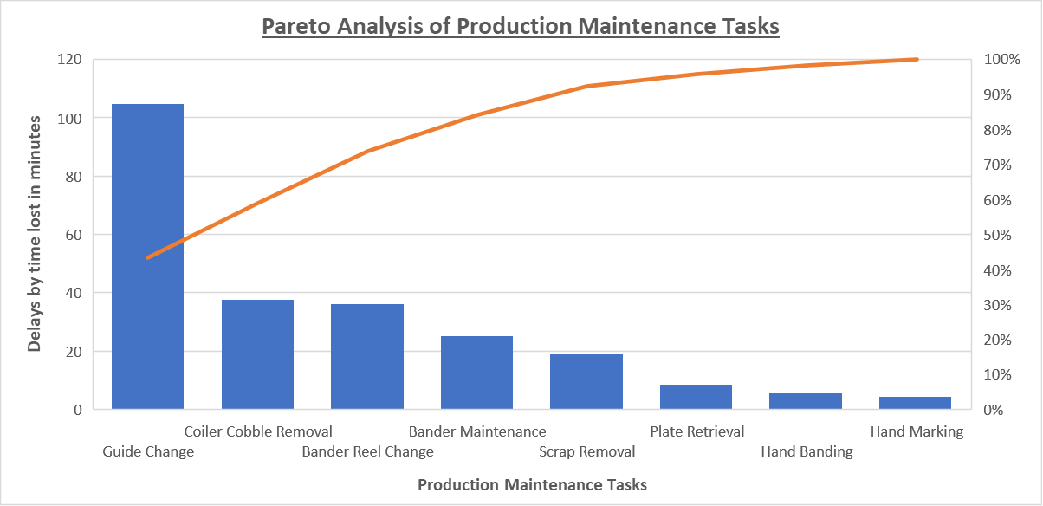
Figure 4 - Pareto Analysis of Production Maintenance Tasks.

The next area for analysis required weekly averages of each task to be visually represented against the weekly average for the combined production maintenance tasks (Fig.5). Also, the weekly averages were calculated for each individual coiler, to display any potential variances between the location, task and the average weekly delay times associated. As can be seen in (Fig.5), the Guide Change is the singular task above the weekly average of 30.28 minutes per week, with Coiler 4 weekly average at 57 minutes per week and Coiler 5 slightly lower at 47.75 minutes per week. Also, in (Fig.6) the pie chart indicates the individual percentages of each task against the overall production maintenance delays weekly average. This information also verifies that the Guide Change is the most valuable task for improvement, by effecting 43% of the weekly delays while the second highest delay percentage is 16% for Coiler Cobble removal. This information clearly shows that by performing root cause analysis techniques and providing improvements for the Guide Change process, has the most potential benefits for this project.
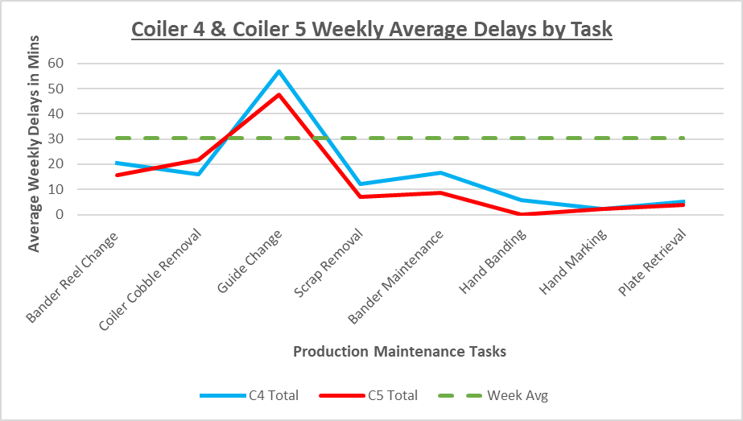
Figure 5 - C4 and C5 average weekly delays by task.
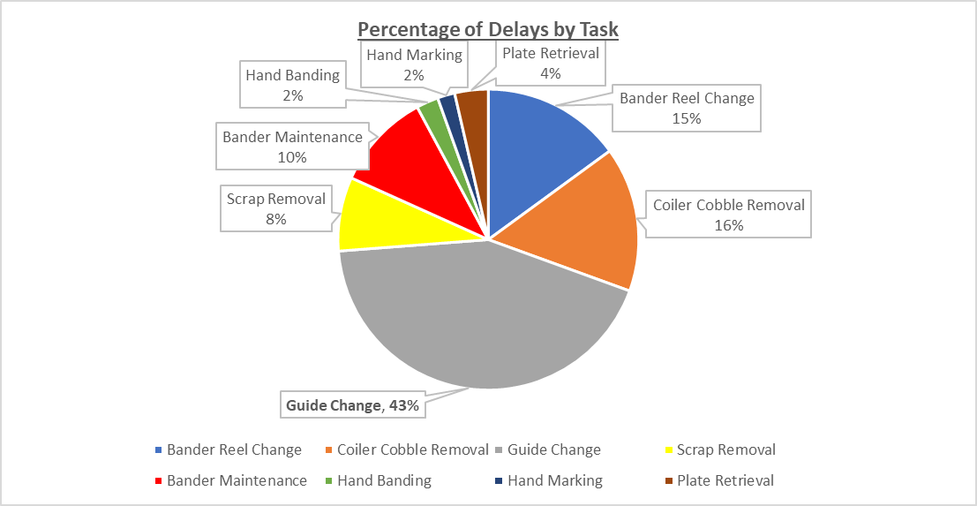
Figure 6 - Pie chart of weekly average delay total by individual task percentages.

Cause and Effect Diagram (Ishikawa)

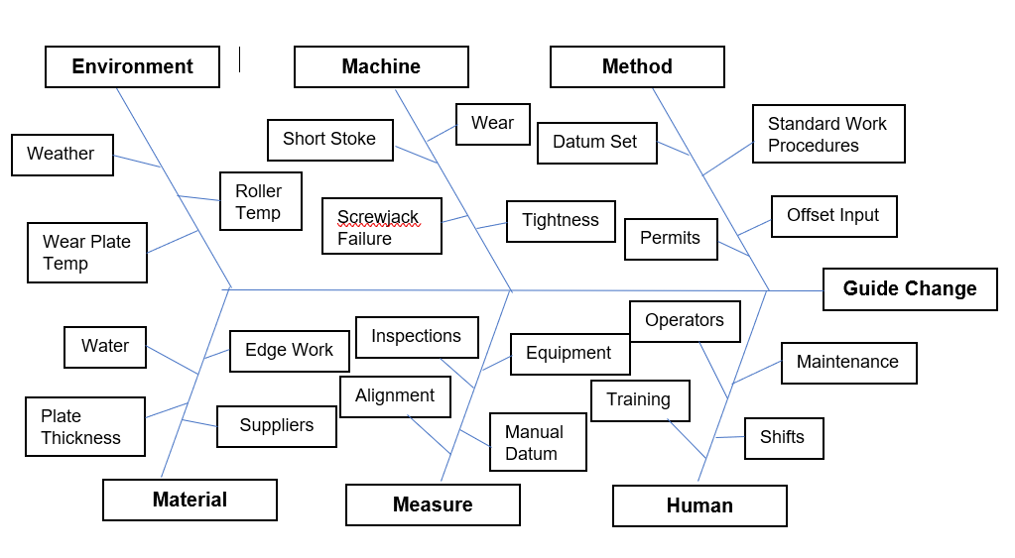
From statistical analysis it was clear that the Guide Change delay was causing significant delays to production. Therefore, to understand the different sources of variation that could contribute to this delay, a Cause and Effect diagram was produced. (Radziwill, 2017) summarises that a Cause and Effect or Ishikawa diagram is a visualisation tool commonly used for root cause analysis of a problem that has been identified through statistical process control . The causes were broken down by splitting them into manageable sub-sections – Method, Machine, Environment, Material, Measure and Human. By carrying out this brainstorming session, the diagram below (Fig.7) provided a uniformed view of identifying the potential root cause. The next stage of analysis, required a more in-depth investigation of the potential root cause through implementing the 5 Why’s technique.
Figure 7 - Cause and Effect (Ishikawa) Diagram for the Guide Change Delay.

5 Why’s Diagram

To have the ability to solve a problem then the root cause of that problem needs to be found. The 5 Why’s technique is a simple but effective tool, (Pojasek, 2000) refers to it as a “short cut” to identify the root cause of a problem as “Why?” is such a common question used in everyday life. The process involves asking the question “Why?” to a generic question, in this case “Why are the guide changes causing significant delays?” and asking follow up questions to the answers given to create a more in-depth view into identifying the real root cause of the problem and not treating the symptoms that the problem has created. The technique was used on Coiler area employees from both production and engineering to capture perspectives from different environments, which can be seen below in (Fig.8).
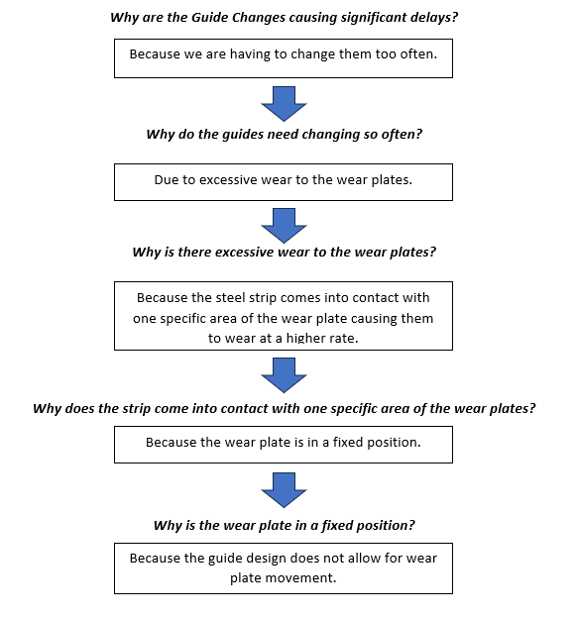
Figure 8 - 5 Why's Analysis of Guide Change Delays.
The diagram above (Fig.8), was the final evaluation of identifying the root cause of the time lost through Guide Change delays. Through asking the question “Why?”, the guide design has become the real root cause of the problem due to it not allowing wear plate movement. This ultimately is causing excessive wear and increasing the number of guide changes in the area. By now having an understanding of the root cause, potential improvement ideas can be developed to reduce time lost through these highlighted delays.

FMEA

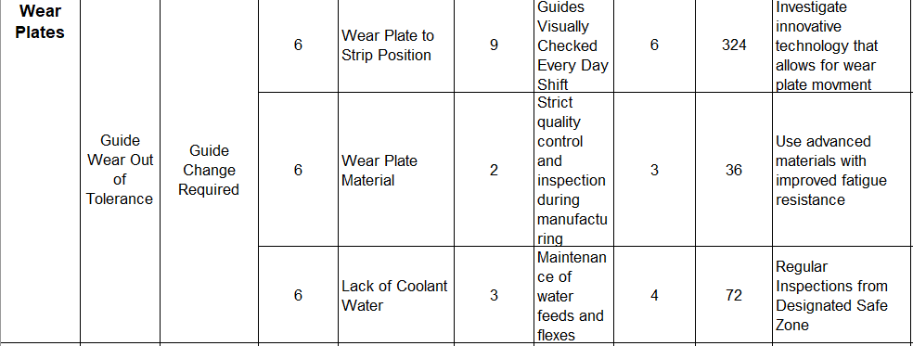
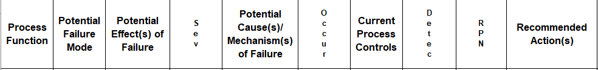
A successful FMEA activity enables a team to identify potential failure modes based on past experience with similar products or processes, enabling the team to design those failures out of the system with the minimum of effort and resource expenditure, thereby reducing development time and costs (Sharma & Srivastava, 2018). The FMEA carried out on Coiler guide wear plates investigated the effects, causes and controls of guide wear and these were scored to highlight priority actions to be taken. In (Fig.9), the analysis highlights the wear plate to strip position as an area that requires action, to reduce the occurrence category score.

Figure 9 - FMEA of Coiler guide wear plate design.

Improve

Current Design of Coiler Guides

The current design for the Coiler guides contains a specified frame to fit within tolerance of the run out table rollers (Fig.10). The wear plates are separate to the guide frame and are bolted on to the rear surface of the guide, this allows plates to be changed when the wear becomes excessive. These plates have a thickness of 20mm and are pre-manufactured in batches (Fig.11). The final picture (Fig.12) displays the wear pattern on the plate after being used within the process. It clearly indicates the minimal amount of surface area in contact with steel product causing guide changes and highlights the unnecessary waste of wear plates. Therefore, the importance of finding a wear plate design that improves wear rate is essential to reducing guide change production delays.
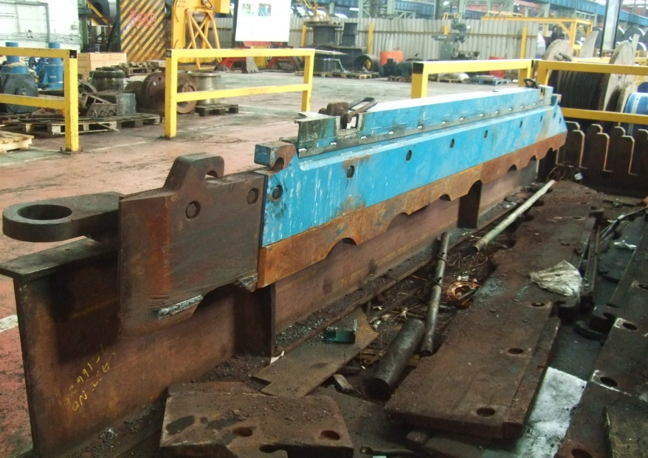

Figure 10 - Complete design of current coiler guides including frame and wear plates.
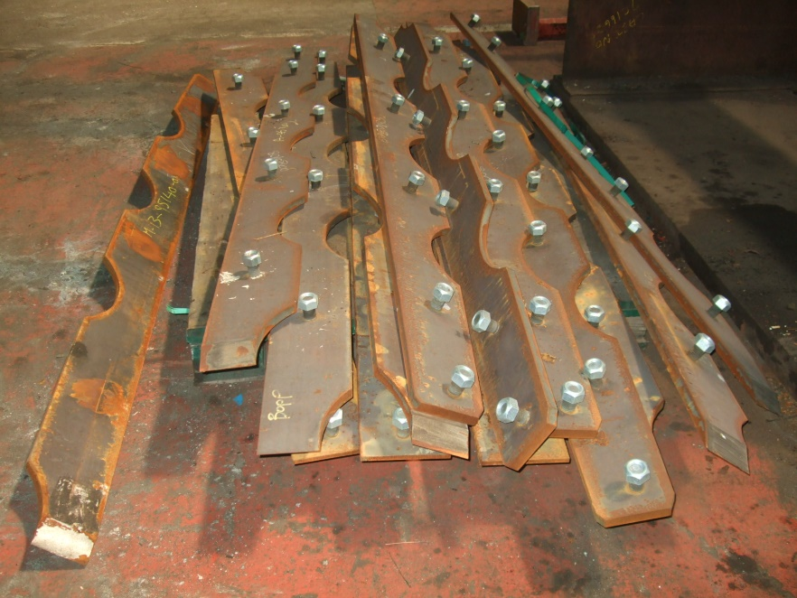

Figure 11 - Batches of wear plates for coiler guides.
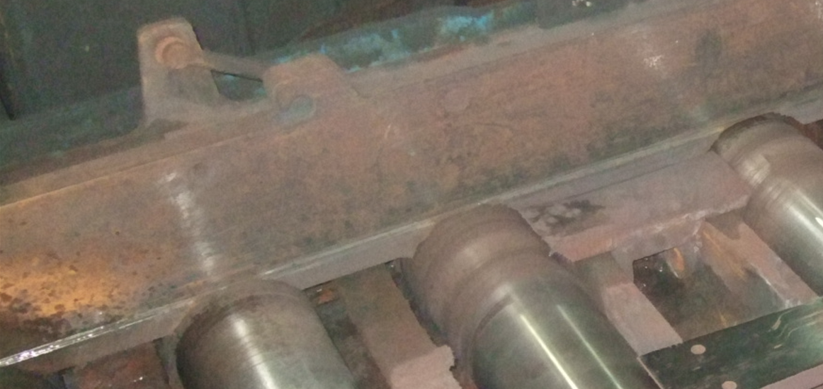
Figure 12 - Coiler guide after being in process displaying wear pattern.

Improvement Alternative

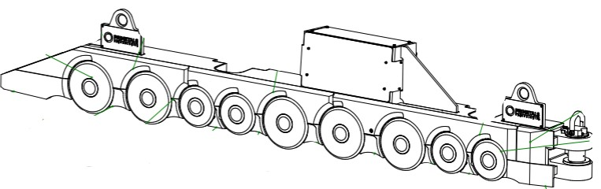
The main aim of this project was to find an alternative guide design that would reduce lost production time through production maintenance tasks. To achieve this, a new wear plate system would need to be introduced to improve the rate of wear. The drawing below (Fig.13), shows the potential design improvement of change from wear plates to discs.
Figure 13 - Drawing of potential design improvement to Coiler guides (Primetals Technology , 2021).
This design idea from an external company allows wear plate movement by disk rotation. The disks will rotate several degrees every two bars, allowing the whole surface area of the disk to be used. By introducing a larger wear pattern would ultimately lead to reduced wear rates. Also, when required the disks are changeable so there is potential to integrate changes into planned maintenance periods. The guide is manufactured to customer specifications, so major structural changes to the base would not be required. The proposed wear pattern to the rotating disks can be seen below in (Fig.14).

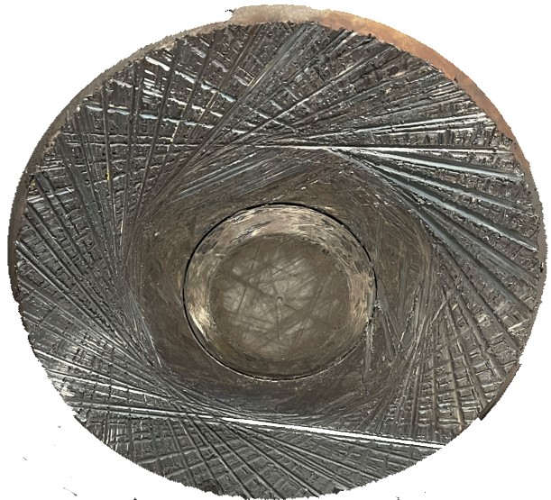

Figure 14 - Wear pattern to potential new design of guide rotating disks (Primetals Technology , 2021).

Improved FMEA Diagram

The diagram below (Fig.15), displays the potential of using the new wear plate design in the Coiler process. The severity score has dropped on all due to the possibility of carrying out guide change tasks during planned maintenance delays compared to interrupting line production. The main reduction from the potential change is the occurrence score from introducing the rotating disk design. This resulting in an original RPN score of 324 to an impressive RPN score of 24, revealing the promising capability of the wear plate design change. The next stage of validation required comparing the cost of change, through the use of Cost Analysis.
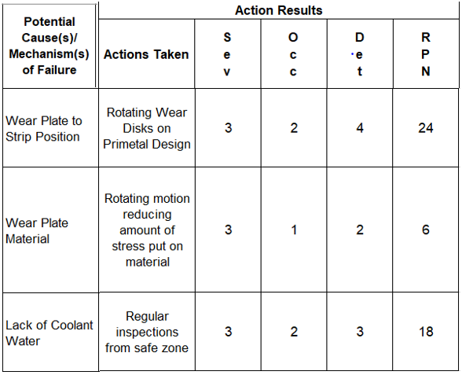

Figure 15 - Improved FMEA with potential actions to be taken and improved scoring.

Updated Process Capability

As previously mentioned during the measure phase, process capability calculations are required to interpret if the process can meet customer specifications. An updated version of these calculations have been made through eliminating guide change delays to production.
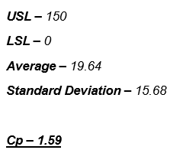

By removing guide delays to production through the guide improvements identified, the calculations show that Cp is now >1. Also, standard deviation and the average of the data results has dropped. These calculations provide an insight into the effect the new guide design can potentially have on the process’ capability to meet customer specifications.

Cost Analysis

The aim of carrying out this technique was to understand if the cost of implementing the project idea would be outweighed by the benefits of implementation. A costing table was created (Fig.16), to compare spending on the current guide process to the potential costs of the improvement alternative. As can be seen below, by introducing the new guide design could have an extremely positive effect on annual costing, with a reduction estimated of 55% from the current system. This is achievable by increasing wear plate life cycles which result in a reduction in delays and potential sales loss. The annual cost has the ability to reduce year on year, after completing payments for the 3 new sets of guides and letting the design settle within the process, resulting in reduced breakdowns and longer periods between planned maintenance schedules. Although, the savings calculated from delays are not guaranteed, due to the possibility of production lost time arising in other areas.
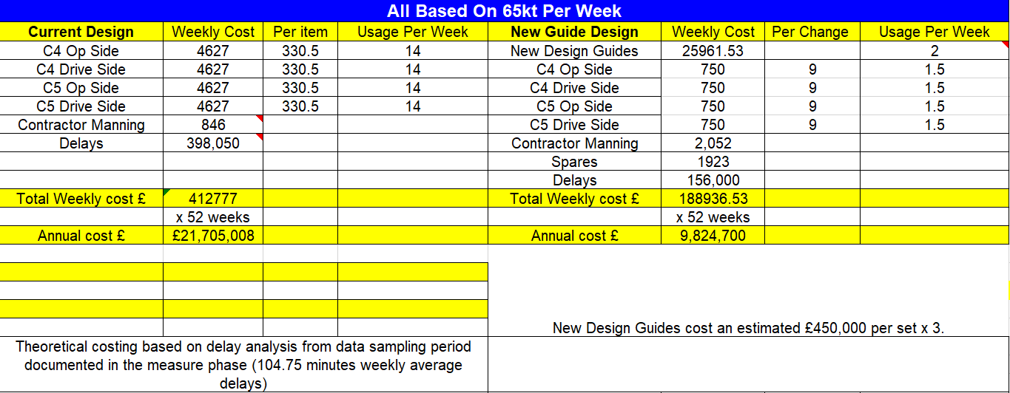

Figure 16 - Comparison of current cost breakdown of guide design vs potential cost of guide improvement.

Control

Continuation of Statistical Analysis

To monitor the process in real-time once the improvement has been implemented, Statistical Process Control (SPC) charts can be used. SPC charts are typically a time series plot that monitors the stability of the process and allows variation in measurements to be evaluated (Brook, 2017). The patterns recorded in the control phase of this project can also be compared to historical data captured in the Measure and Analysis stages. By continuously analysing the improvement during this phase, process improvements can be characterised by change in averages, variations and special cause measurement points. An example of a typical SPC chart can be seen below in (Fig.17).
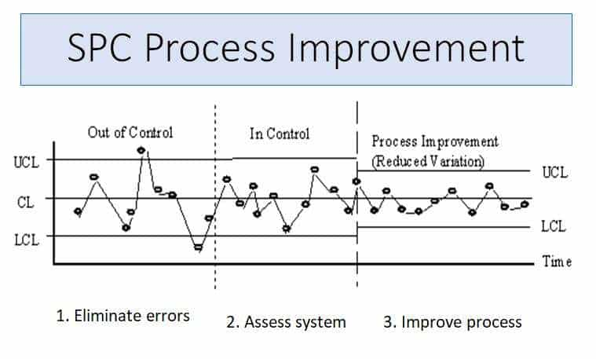

Figure 17 - An example of a Statistical Process Control chart displaying reduced variation through process improvements (Anderson, 2023)
An additional measure that could be integrated during this phase is the control plan. The control plan is used to record data for each process step highlighting areas such as specification, historical process capability and a response plan for containment and adjustments when certain specifications are not met. This measurement process can remain in place after project closure to ensure the continuation of data records so improvements are under control. Also, during the control phase, Key Performance Indicators (KPI) can be updated to reflect the improvements made to key areas of the process. An example of KPI’s involving this project include guide wear rates, length of guide changes, amount of waste/spares and duration of production lost time due to Coiler guide delays.

Standardising the Process

Tata Steel employ a Standard Work Procedure (SWP) database that incorporates each task and the procedure required to meet company standards (Fig.18), ensuring the safety of employees whilst carrying out the task in an efficient manner. It would be essential to set out a new process standard for the proposed guide design, to ensure the same procedure is followed by all company and contractor personnel. The SWP would include a detailed risk assessment, Personal Protective Equipment requirements, permit systems and access/egress diagrams to meet Health and Safety obligations. Also, a step-by-step procedure from start to finish will provide personnel with a clear vision on how to complete the given task. Ownership of the new process will be given to the area lead to ensure standards are within compliance. There are also Lean toolkits that can be used to improve standards such as 5S, Kanban and Andon. These all contribute to the visual management and process flow of the newly proposed guide design.
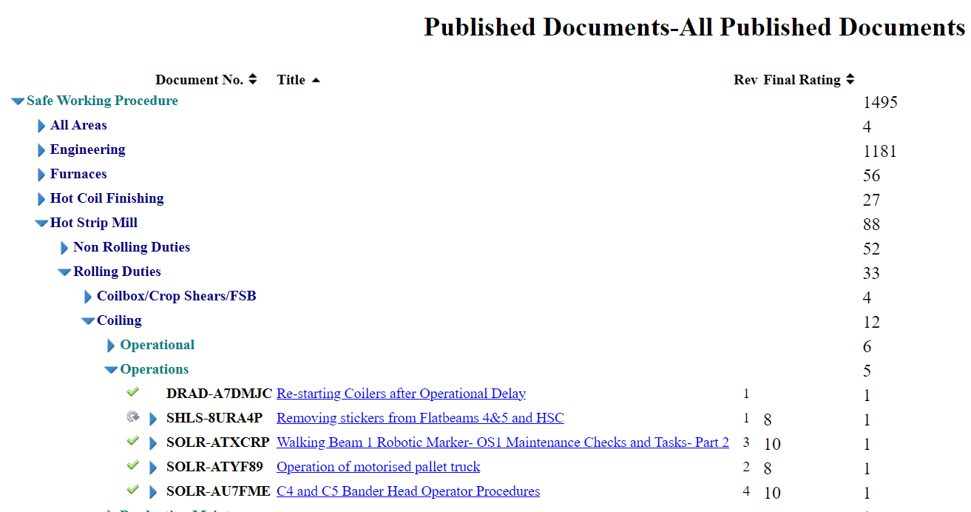
Figure 18 - Tata Steel Standard Work Procedure database.

Project Closure

To ensure that the projects end is successful, it is important to identify a clear controlled timeline for closure. Once all created tasks have been completed, (Brook, 2017) explains that the emphasis on transferring lessons learnt from previous projects will provide gains elsewhere in the organisation, otherwise known as ‘leveraging’. To summarise, the project report and closure action log would be required to ensure the handover of the process to key stakeholders, detailing outstanding actions and responsibilities of each. Typically, the action log would be reviewed after 3-6 months to identify any outstanding actions.

Bibliography
Aguwa, C. C., Monplaisir, L. & Turgut, O., 2012. Voice of the customer: Customer satisfaction ratio based analysis. Expert Systems with Applications, 39(11), pp. 10112-10119.
Anderson, C., 2023. How to Use Control Charts for Continuous Improvement. [Online]
Available at: https://www.bizmanualz.com/improve-business-processes/how-to-use-control-charts-for-continuous-improvement.html
[Accessed 22 04 2024].
Baudin, M., Walsh, L., Brown Jr, G. F. & Parke, C., 2012. Revisiting Pareto in Manufacturing. Industrial Engineer, 44(1), pp. 28-33.
Brook, Q., 2017. Lean Six Sigma & Minitab - The complete toolbox guide for business improvement. 5th ed. s.l.:OPEX Resources.
Brook, Q., 2017. Lean Six Sigma Minitab - The Complete Toolbox Guide for Business Improvement. 5th ed. s.l.:Opex Resources.
Pojasek, R. B., 2000. Asking "Why?" five times. Environmental Quality Management , 10(1), p. 79.
Primetals Technology , 2021. Eco Slide Disc Beams, Austria: Primetals Technology.
Radziwill, N., 2017. Creating Ishikawa (Fishbone) Diagrams with R. Quality Nugget, 20(1), pp. 47-48.
Sharma, K. D. & Srivastava, S., 2018. Failure Mode and Effect Analysis (FMEA) Implementation: A Literature Review. Journal of Advanced Research in Aerodynamics and Space Science, 5(1), pp. 1-17.
Summers, D. C. S., 2010. Lean Six Sigma Process Improvement Tools and Techniques. s.l.:Pearson.
Wooluru, Y., Swamy, D. R. & P, N., 2014. The Process Capability Analysis - A Tool for Process Performance Measures and Metrics - A Case Study. International Journal for Quality Research, 8(3), p. 399.

