



Report: Assessment 1

Name: Crystal Hall
Student ID: 2237516
Module: Human Resource Management – Assessment 1
Code: LCMB7000
Lecturer: Gladius Kulothungan/ Mushfiqur Rahman

The current state of the labour market and the changes in HR Post Brexit and Covid in the UK
2023

Table of Contents
1. Introduction 3
1.1. What is the Labour market 3
1.2. Labour Market in Developed countries 4
1.3. Labour Market in Developing countries. 5
1.4. The UK labour market 6
2. Current state of labour market in the UK 6
1.1. Employment Rates/Unemployment/inactivity 6
1.2. Inactivity 7
3. Factors affecting the labour market in the UK. 8
3.1. Skills gap 8
3.2. High inflation 9
4. Tools and Theories PESTEL analysis in HR department 9
5. Emerging changes in Human resources post Covid 11
6. Emerging changes in Human resources Post Brexit 11
7. Conclusions 12
8. References 13

Introduction
This critical report analysis will examine the current state of the labour market in the UK, it will also discuss the emerging changes in human resourcing strategies in the post-Covid, post-Brexit external environment. The research will investigate the important trends and issues facing UK firms, as well as the consequences for human resource management. In addition, the paper will look at the PESTEL analysis as a tool for firms to use in identifying growth possibilities and developing successful strategies to accomplish their goals.

What is the Labour market
Payroll employment growth Jan 2020 – Jan 2023, UK and ITL1 regions
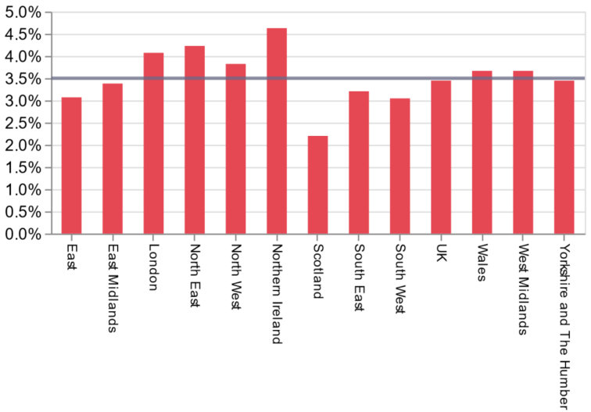
(Source: ONS)

As of 2023, the labour market in the UK is experiencing a period of recovery following the disruptions caused by the COVID-19 pandemic and Brexit. Considering the challenges of recent years, the current state of the British labour market shows resilience. A more thorough examination reveals, however, that the previously mentioned challenges have indeed had an impact on the market, particularly in terms of economic diversity within the marketplace. During the period spanning from January 2020 to January 2023, there was a notable increase of 3.5% in payroll employment across the United Kingdom. This growth rate was observed in most UK regions, which experienced similar levels of growth ranging from 3% to 4%. However, it is worth noting that Scotland stood out as an exception, with its payroll employment growing at a slightly lower rate, closer to 2%. (Economics Observatory, 2023). The labour market in the United Kingdom remains restricted. The unemployment rate remained low from September to November 2022, at 3.7%, despite a minor increase of 0.2% compared to the previous three-month period. This change in unemployment rates is now beginning to affect the economy as a whole. (UK labour market remains historically tight, 2023)

Labour Market in Developed countries
GDP levels for each G7 country, Quarter 4 2019 to Quarter 1 2022
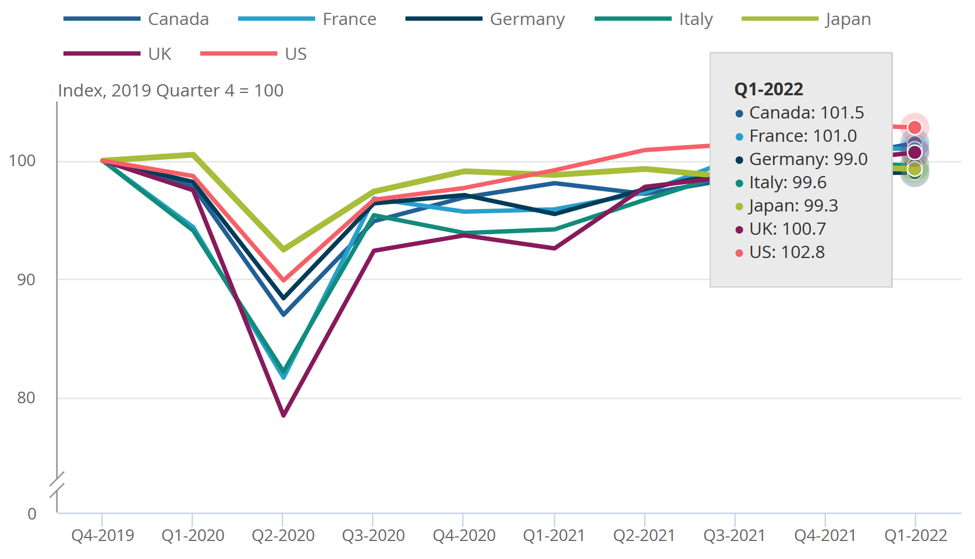 (Source: Roberts, 2022)
After experiencing a substantial decline in 2020 because of the COVID-19 pandemic, labour productivity recovered in 2021 with a 2.4% growth rate. In 2022, however, the rate of productivity growth declined, registering a modest increase of only 0.5%. (Sodergren, 2023) This decline in productivity growth is not restricted to developed nations alone. The current state of labour markets in the G7 nations, which include Canada, France, Germany, Italy, Japan, the United Kingdom, and the United States, is influenced by economic conditions, technological advancements, globalisation, demographic changes, this also includes education and skills, industry-specific factors, and social and cultural factors. Additionally, the article emphasises the impact of technological shifts that favour skills on European labour markets over the past years. (Pologeorgis, 2022; Technology in Developing Economies, 2018).
In developed nations, international trade and competition have impact job prospects and industries, globalisation this has created new opportunities and challenges. Demographic shifts, such as ageing populations and migration patterns, affect labour supply and talent disparities. Such as Immigration tends to have a greater impact on the earnings of low-wage workers, resulting in potential losses for them, while medium and high-paid workers are more likely to benefit, although the overall effects are minimal. (The Labour Market Effects of Immigration - Migration Observatory, 2023). Individuals must have access to education and skills training to adapt to a changing job market. In addition, industry-specific factors, such as technological advances and evolving industries, influence employment opportunities.
Social and cultural factors, has a positive influence on labour productivity, leading to increased efficiency and effectiveness in the workplace. This influences the dynamics of the labour market, including attitudes toward work, gender equality, and workforce diversity. To nurture a robust and inclusive labour market in developed countries, policymakers and stakeholders must navigate these factors considering their complexity. Developed countries can create an environment that empowers individuals and promotes equal opportunities for all by promoting positive work attitudes, striving for gender equality, and embracing workforce diversity, resulting in a more productive and harmonious labour market.

Labour Market in Developing countries.
The present status of the labour market in developing nations varies substantially based on variables such as economic conditions, social policies, and government interventions. Commonly mentioned measures of development, such as gross domestic product (GDP) per capita, the Human Development Index (HDI), and the World Bank's income group classifications (Hamadeh, Van Rompaey and Metreau, 2023) (Overview, 2022), provide valuable insight into the general growth of these nations.
Economic progress in certain developing nations has enhanced the labour market with increased employment, wage growth, and reduced poverty rates. Development indicators alone do not fully represent the labour market. In many developing nations, issues such as income inequality, informality, and unstable employment persist. In addition, demographic factors have a more significant effect on the labour market dynamics of developing nations. Rapid growth in population, growing cities, and young people can present all opportunities and challenges. For inclusive and sustainable economic growth, the capacity to effectively leverage the potential of the working-age population through skill development, education, and targeted employment policies is essential. By investing in these areas, nations can empower individuals, reduce inequality, promote innovation, and develop a resilient labour force able to meet the demands of an evolving economy.

1.4. The UK labour market
The UK has experienced a mix of positive and negative trends over the past few months. Although employment rates in the nation have increased, there are still worries regarding the standard of the jobs that are available and the skills gap in the labour force. While the UK’s recession reduced in part because of the GDP growth of 4% last year, although it is expected to grow by -0.3% due to the tightening of household incomes and the affects of previous rise in interest rates (KPMG, 2018). The impact of Brexit and the ongoing COVID-19 epidemic have created a continually changing external environment, which has resulted in considerable changes and problems for the UK employment market. Businesses and policymakers are still navigating these difficulties as of 2023 and adjusting their plans to the brand-new

Current state of labour market in the UK
The UK labour market in 2023 sees rising employment rates (Leaker, 2023), but declining pay rates (Powell and Francis-Devine, 2023) and vacancies (Brisinger). As the public and private sectors face challenges, it remains crucial to strike a balance between the effects of inflation and the need to pay workers a fair wage. The Office for National Statistics (ONS) highlights increased job options and a low unemployment rate, but real average incomes have decreased. UK government priorities include reducing long-term sickness rates and encouraging older workers to return. The labour market struggles with the skills gap, hindering employers' ability to find suitable candidates. The pandemic has reshaped work patterns and industries, with remote and flexible arrangements becoming more common, while healthcare and logistics experience increased demand.

Employment Rates/Unemployment/inactivity
Employment, unemployment, and inactivity rates are vital indicators of labour market activity, offering insights into an economy's health and guiding policies for inclusive growth. The employment rate gauges the employed portion of the working-age population, while the unemployment rate reflects the jobless proportion in the labour force. The inactivity rate shows the share of working-age individuals not working or actively seeking employment. Understanding these rates informs strategies for economic development and social well-being.
Recent data reveals an increase of 49,000 unemployed individuals in the UK for up to six months, leading to a slight rise in the unemployment rate to 3.8% (TRADING ECONOMICS, 2023). However, employment levels rose by 169,000, driven by part-time and independent contractor positions. Factors like the freelance economy's expansion, evolving work roles, and employer preferences for flexible labour arrangements contribute to this trend. While more job opportunities offer flexibility, concerns about job security, income stability, and benefits arise. The government and businesses must address these implications and strive for sustainable and inclusive employment opportunities.
Total pay increased by 5.9% year on year, but in real terms, earnings declined by 3.0%, marking the sharpest drop since February to April 2009 (TRADING ECONOMICS, 2023). This underscores the challenge of maintaining income levels despite nominal increases. It is essential for policymakers and businesses to address this issue and ensure fair compensation for workers.
By closely monitoring these labour market indicators, policymakers and businesses can adapt strategies to foster a resilient and inclusive economy that supports the well-being of all employees.

Inactivity
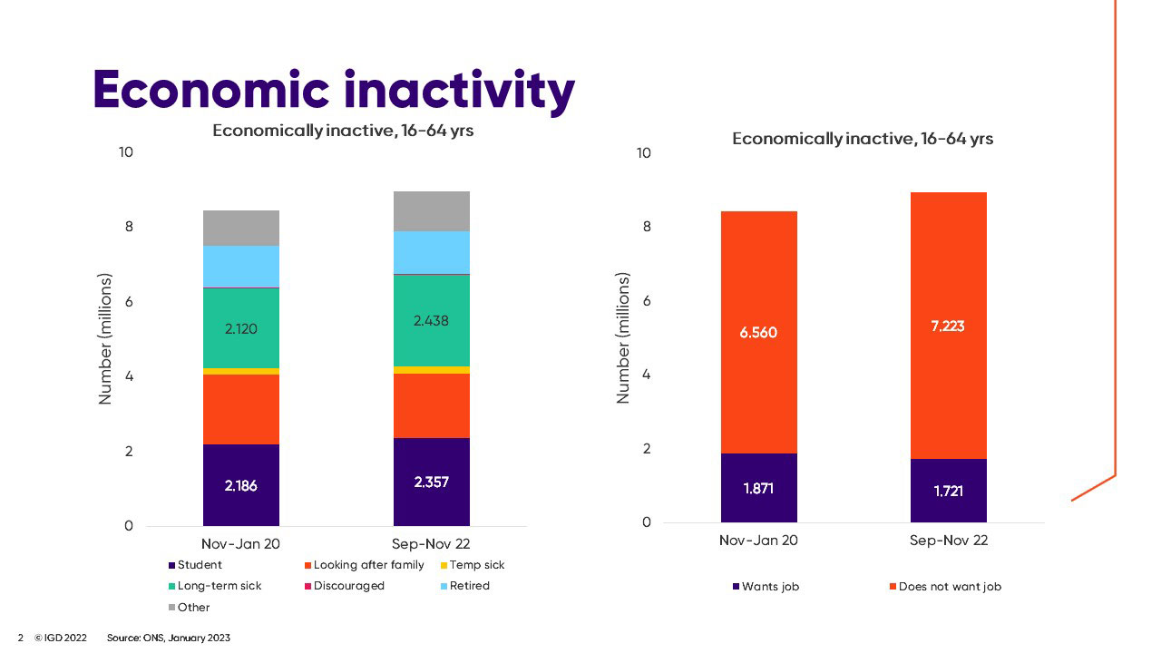

In 2023, the UK labour market saw a slight decrease in economic inactivity, primarily among the 16 to 24 age group (Watson, 2023). However, the overall economic inactivity rate remained high at 21.3%, posing a significant challenge (Watson, 2023). The number of economically inactive young individuals aged 16 to 24 rose by 2.61 million from November 2022 to January 2023 (Buchanan, 2023). Nevertheless, the number of economically inactive individuals decreased by 77,000 compared to the previous quarter (Ali-Hassan, 2023). Balancing inflation and ensuring reasonable compensation for employees is a key priority for businesses and government officials. Encouraging older workers to re-join the workforce can increase labour supply, alleviate wage pressures, and promote a diverse and experienced workforce. The UK government prioritizes addressing long-term sickness rates to support fair pay and employment opportunities (Watson, 2023).
Despite a modest decline in economic inactivity among those aged 16 to 24 on the British labour market, the overall rate remains high. Priorities for businesses and government officials are balancing inflation and equitable compensation. Encouragement of older employees' re-entry into the workforce can reduce wage challenges, increase labour supply, and increase workforce diversity. The government of the United Kingdom is focusing on addressing long-term sickness rates in order to promote equitable pay and employment opportunities.

Factors affecting the labour market in the UK.
The UK labour market is influenced by macroeconomic conditions, demographics, government policies, and technological advancements, which impact employment opportunities, wages, and working conditions. Economic changes like GDP growth affect labour demand, individuals looking for employment offer their labour in exchange for payment, while companies that require labour pay workers for their time and experience. While demographic shifts, such as an ageing population, shape the labour force. Government policies, including immigration and labour laws, shape the business environment. Technological advancements like automation alter work dynamics and the required skills. Understanding these factors is crucial for policymakers, businesses, and individuals navigating the evolving labour market.

In today's UK labour market, individuals must possess sought-after skills to stay competitive. Technology, data analysis, healthcare, renewable energy, and soft skills like communication and problem-solving are in high demand. Specialised knowledge or industry experience may also be necessary. Recognising the importance of a skilled workforce for economic growth, the government and businesses emphasise education, training, and upskilling initiatives. Efforts to develop and maintain a skilled workforce are ongoing to support competitiveness and foster economic growth.

Skills gap

Nine in ten recruiters (88%) say that labour shortages are their biggest concern for
the remainder of 2021, while skill shortages are a major concern for two in three (65%). 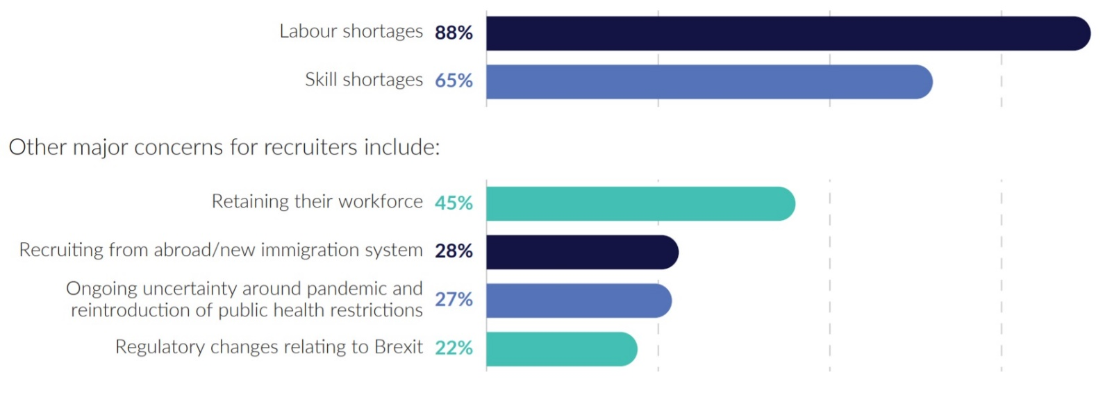
(Source: CIPD)
The UK labour market in 2023 faces a notable skills gap, leading to decreased job postings in certain industries. New immigration rules are identified by 65% of recruiters as the main cause of skill shortages, while 57% cite uncompetitive salaries as a contributing factor. The COVID-19 pandemic has significantly impacted the British economy, with approximately 7.6 million jobs at risk due to unemployment, furloughs, reduced hours, and pay (COVID-19 in the United Kingdom: Assessing jobs at risk and the impact on people and places, 2020). The retail and wholesale sectors are particularly affected. Financial uncertainty has limited growth in the travel and hospitality industries, resulting in a decline in job postings (2023 Travel industry outlook, 2023).
Despite these challenges, the hospitality sector has shown resilience amid declining consumer spending due to inflation and the post-Brexit economic recession (Riaz, 2023). The implementation of the new points-based immigration system offers potential access to a larger pool of skilled employees, potentially alleviating the current skills imbalance.

High inflation
High inflation can have a significant impact on the labour market in the UK. In 2023, as inflation rates rise, the cost-of-living increases, making it difficult for employees to maintain their standard of living. This can lead to demands for higher wages, which can increase labour costs for employers. As a result, employers may become more selective in their hiring process, leading to a decline in job vacancies.

Tools and Theories PESTEL analysis in HR department

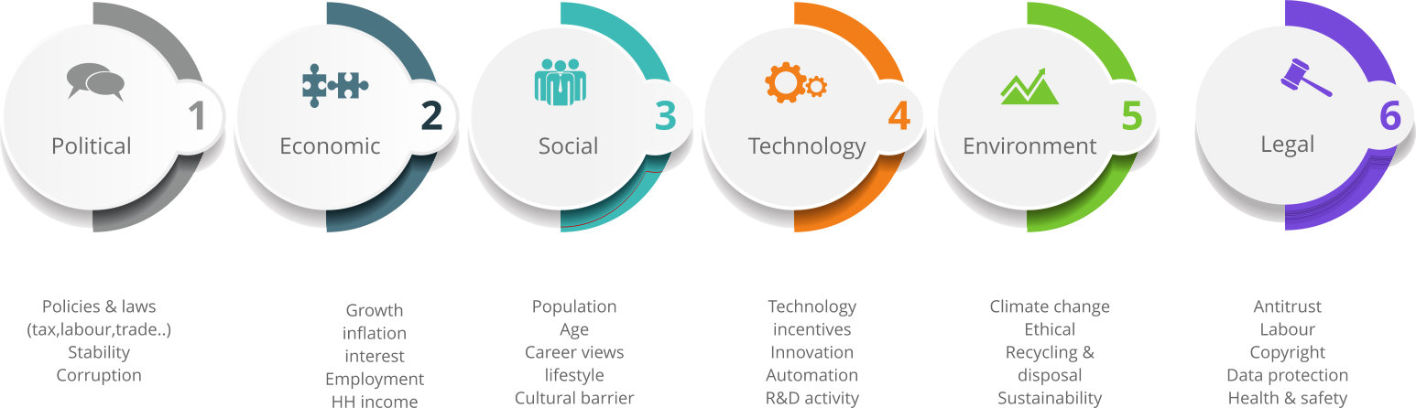
(Source: CA Hall)
- Political
HR practices are affected by changes to government policies, regulations, and labour laws. HR professionals must remain current on political developments, such as Brexit and immigration policies, to ensure compliance and effectively manage workforce planning. Political stability and favourable policies can promote company growth, while political instability may result in cautious hiring and workforce restructuring.
- Economic
The state of the economy affects recruitment, jobs, and workforce planning. Employees must navigate economic fluctuations, market demands, and financial constraints. Adapting HR strategies to economic realities involves important actions like enhancing recruitment channels and implementing cost-effective talent management practices. A robust economy generates more employment opportunities, whereas economic recessions may necessitate strategic workforce adjustments and cost-cutting measures.
- Social
Changing demographics, evolving attitudes, and diversity influence the dynamics of the workforce. Human resources must address social issues, campaign for equal chances, and promote inclusive methodologies. Understanding societal transformations, adapting HR strategies, and creating a diverse and inclusive workplace has a positive effect on employee satisfaction, engagement, and organisational performance as a whole.
- Technological
Artificial intelligence and automation will streamline HR processes, but there are concerns about job displacement and data privacy. Working from a distance requires new policies and instruments. HR professionals must embrace technology, adapt strategies, upskill employees, and create a balance between employee efficiency and overall happiness.
- Environmental
Companies must implement sustainability practises, reduce their carbon footprint, and recruit people who are environmentally conscious. Human Resources play an essential role in promoting green initiatives, implementing sustainable policies, and nurturing an eco-friendly culture. This transition necessitates the adaptation of HR strategies, the promotion of sustainability awareness, and the procurement of sustainable materials in order to have a positive environmental impact.
- Legal
Compliance with employment laws, worker protection guidelines, and equal opportunity regulations is essential. HR professionals ensure equitable employment practises, manage legal risks, and maintain positive employer-employee relationships. To create a legally compliant and inclusive workplace in the United Kingdom, HR strategies must be modified to meet latest legal requirements.

Emerging changes in Human resources post Covid
The COVID-19 pandemic has brought significant changes to human resource management. HR professionals have adapted strategies, invested in education and training, and faced challenges with remote work and filling vacancies. Prioritising employee well-being and fostering an inclusive workplace culture are crucial for retention. The ageing workforce and difficult-to-fill vacancies require modern solutions. In the post-Covid era, HR executives must remain innovative, nurturing a resilient and adaptable workforce. The pandemic has elevated the role of HR, emphasising employees as individuals. HR professionals must continue prioritising employee well-being and aligning with organisational needs. The post-Covid external environment offers an opportunity for HR executives to establish strategic workforce objectives that support well-being, productivity, and efficiency.

Emerging changes in Human resources Post Brexit
Brexit has created economic instability and transformed business operations and talent recruitment, adding complexity to the situation. HR leaders must navigate these changes while supporting employees and planning for the future. Government investment in education and training programmes can prepare workers for future employment, while employers can enhance retention by offering appealing benefits and fostering an inclusive workplace culture.
Post-Brexit, substantial changes to UK immigration policy pose challenges for businesses and HR managers. (CIPD | Employment Law UK, EU and Brexit | Factsheets) The EU Settlement Scheme's eligibility requirements are updated, and the Graduate Route allows international students to work in the UK for two years after graduating. HR practitioners must address practical issues like compensation, pensions, funding gaps, administrative costs, and recruitment considerations such as documentation, credential recognition, and pay disparities. (Lattice, 2022) Upskilling, reskilling, and creating a supportive culture are vital for HR professionals. In addition, they must consider the effects of Brexit on recruitment, such as the need for appropriate documentation, formal recognition of credentials, and differences in pay between countries. (The impact of Brexit: top 10 HR issues, 2021)
Despite these obstacles, the UK labour market shows signs of recovery as businesses adapt HR strategies to meet shifting demands. Remote and flexible work arrangements offer new opportunities, and the government invests in training and apprenticeship programmes to bridge the skills gap.

Conclusions
In conclusion, the UK labour market has experienced an increase in employment rates in recent years, but this has been accompanied by a decline in pay rates. Demographic trends, macroeconomic conditions, government policies, and technological developments have all contributed to the changing landscape of the labour market. One of the key challenges facing the labour market is the skills gap, particularly in industries such as technology, healthcare, and renewable energy. This has resulted in hard-to-fill vacancies and a growing demand for education and training programs that equip workers with the necessary skills to meet the demands of the changing job market. Additionally, policymakers and businesses must balance the need for fair wages for workers while addressing inflation. Addressing these challenges is critical for creating sustainable and inclusive employment opportunities and promoting economic growth and social mobility in the UK. Overall, the British labour market is complex and ever-changing, businesses and policymakers must remain vigilant, adapting strategies to the evolving external environment for future success.

References
“ADDRESSING SKILLS AND LABOUR SHORTAGES POST-BREXIT” (2021) CIPD [Preprint]. Available at: https://www.cipd.org/globalassets/media/knowledge/knowledge-hub/reports/addressing-skills-labour-shortages-post-brexit_tcm18-102313.pdf. (Accessed 14 May 2023)
“The path to the next normal” (2020) McKinsey & Company [Preprint]. Available at: https://www.mckinsey.com/~/media/McKinsey/Featured%20Insights/Navigating%20the%20coronavirus%20crisis%20collected%20works/Path-to-the-next-normal-collection.pdf. (Accessed 14 April 2023)
“UK unemployment rate by region 2023 | Statista” (2023) Statista [Preprint]. Available at: https://www.statista.com/statistics/297167/uk-regional-unemployment-rate/#:~:text=London%20and%20the%20West%20Midlands,unemployment%20rate%20was%203.7%20percent. (Accessed 24 April 2023)
“World Employment and Social Outlook Trends 2022” (2023) ILO Flagship Report [Preprint]. Available at: https://www.ilo.org/wcmsp5/groups/public/---dgreports/---dcomm/---publ/documents/publication/wcms_834081.pdf. (Accessed 16 April 2023)
2023 Travel industry outlook (2023). Available at: https://www2.deloitte.com/us/en/pages/consumer-business/articles/travel-hospitality-industry-outlook.html. (Accessed 24 April 2023)
Ali-Hassan, Y. (2023) “Economic inactivity falls but long-term sickness reaches record high,” CBI [Preprint]. Available at: https://www.cbi.org.uk/media/bm0aiob5/14032023-cbi-pertemps-labour-market-update-mar_2023.pdf. (Accessed 22 April 2023)
Azizi, M. et al. (2021) “Innovative human resource management strategies during the COVID-19 pandemic: A systematic narrative review approach,” Heliyon, 7(6), p. e07233. Available at: https://doi.org/10.1016/j.heliyon.2021.e07233. (Accessed 14 April 2023)
Buchanan, I. (2023) Why are young people leaving the labour market? Available at: https://commonslibrary.parliament.uk/why-are-young-people-leaving-the-labour-market/.(Accessed 24 April 2023)
CIPD | Employment Law UK, EU and Brexit | Factsheets (2021). Available at: https://www.cipd.org/uk/knowledge/factsheets/eu-impact-factsheet/ n(Accessed 22 April 2023)
CIPD | Understanding Economy & Labour Market | Factsheets (no date). Available at: https://www.cipd.org/uk/knowledge/factsheets/economy-labour-market-factsheet/.(Accessed 16 April 2023)
Coaching, A. (2023) “How to Create a Sense of Belonging in the Workplace to Promote Inclusion,” Aduro [Preprint]. Available at: https://adurolife.com/blog/employee-well-being/how-to-create-a-sense-of-belonging-in-the-workplace/.(Accessed 14 April 2023)
Commission on the Future of Employment Support | abrdn (2022). Available at: https://www.financialfairness.org.uk/en/our-work/publications/commission-on-the-future-of-employment-support?gclid=CjwKCAjw6IiiBhAOEiwALNqncSMOGHEFqOZQjNw9b5Ci6pAfT863eQ4-9bMQ12csV_Fjf7rqrozpFRoC6_QQAvD_BwE.(Accessed 24 April 2023)
COVID-19 in the United Kingdom: Assessing jobs at risk and the impact on people and places (2020). Available at: https://www.mckinsey.com/industries/public-and-social-sector/our-insights/covid-19-in-the-united-kingdom-assessing-jobs-at-risk-and-the-impact-on-people-and-places. (Accessed 22 April 2023)
Crosby, M. and Faludi, Julianna. (2022) “Whole Person Promotion, Women, and the Post-Pandemic Era: Impact and Future Outlooks,” Information Science Reference [Preprint]. Available at: https://www-igi-global-com.ezproxy.uwtsd.ac.uk/gateway/book/282095. (Accessed 14 April 2023)
Economics Observatory (2023) What’s happening in the UK labour market? - Economics Observatory. Available at: https://www.economicsobservatory.com/whats-happening-in-the-uk-labour-market. (Accessed 16 April 2023)
Francis-Devine, B. (2023) “UK labour market statistics,” Library of the House of Commons [Preprint]. Available at: https://researchbriefings.files.parliament.uk/documents/CBP-9366/CBP-9366.pdf. (Accessed 24 April 2023)
Hamadeh, N., Van Rompaey, C. and Metreau, E. (2023) “New World Bank country classifications by income level: 2021-2022,” World Bank Blogs, 16 May. Available at: https://blogs.worldbank.org/opendata/new-world-bank-country-classifications-income-level-2021-2022. (Accessed 14 April 2023)
Hampson, F.O. and Penny, C.J. (2008) “Human Security,” in Oxford University Press eBooks, pp. 539–558. Available at: https://doi.org/10.1093/oxfordhb/9780199560103.003.0031. (Accessed 14 April 2023)
Harbert, T. (2021) “The Pandemic Has Expanded the Role of HR,” SHRM, 2 September. Available at: https://www.shrm.org/hr-today/news/hr-magazine/fall2021/pages/pandemic-expands-role-of-hr.aspx. (Accessed 14 April 2023)
Husic, J.B. et al. (2020) “Aging at Work: A Review of Recent Trends and Future Directions,” International Journal of Environmental Research and Public Health, 17(20), p. 7659. Available at: https://www.mdpi.com/1660-4601/17/20/7659 (Accessed 14 April 2023)
KPMG (2018) “Global Economic Outlook,” 7 September. Available at: https://kpmg.com/uk/en/home/insights/2018/09/uk-economic-outlook.html. (Accessed 14 May 2023)
Labour and skills shortages :: The REC (no date). Available at: https://www.rec.uk.com/our-view/research/industry-analysis/labour-and-skills-shortages-1. (Accessed 14 May 2023)
Lattice (2022) 4 Ways HR Can Navigate Brexit’s Impact on UK Business | Lattice. Available at: https://lattice.com/library/4-ways-hr-can-navigate-brexits-impact-on-uk-business. (Accessed 22 April 2023)
Leaker, D. (2022) “Labour market overview, UK - Office for National Statistics,” www.ons.gov.uk [Preprint]. Available at: https://www.ons.gov.uk/employmentandlabourmarket/peopleinwork/employmentandemployeetypes/bulletins/uklabourmarket/november2022. (Accessed 16 April 2023)
Leaker, D. (2023) “Labour market overview, UK - Office for National Statistics,” www.ons.gov.uk [Preprint]. Available at: https://www.ons.gov.uk/employmentandlabourmarket/peopleinwork/employmentandemployeetypes/bulletins/uklabourmarket/march2023 (Accessed 24 April 2023)
Leaker, D. (2023) “Labour market overview, UK - Office for National Statistics,” www.ons.gov.uk [Preprint]. Available at: https://www.ons.gov.uk/employmentandlabourmarket/peopleinwork/employmentandemployeetypes/bulletins/uklabourmarket/april2023. (Accessed 16 April 2023)
Overview (2022). Available at: https://www.worldbank.org/en/country/mic/overview (Accessed 16 April 2023)
Pologeorgis, N.A. (2022) “Employability, the Labor Force, and the Economy,” Investopedia [Preprint]. Available at: https://www.investopedia.com/articles/economics/12/employability-labor-force-economy.asp. (Accessed 14 May 2023)
Powell, A. and Francis-Devine, B. (2023) UK Labour Market Statistics. Available at: https://commonslibrary.parliament.uk/research-briefings/cbp-9366/ (Accessed 24 April 2023)
Ralston, K. et al. (2021) “Economic Inactivity, Not in Employment, Education or Training (NEET) and Scarring: The Importance of NEET as a Marker of Long-Term Disadvantage,” Work, Employment & Society, 36(1), pp. 59–79. Available at: https://journals.sagepub.com/doi/10.1177/0950017020973882(Accessed 24 April 2023)
Riaz, U. (2023) “Hospitality industry looks strong for 2023 – despite recession fears,” www.ey.com [Preprint]. Available at: https://www.ey.com/en_us/real-estate-hospitality-construction/hospitality-industry-looks-strong-for-2023-despite-recession-fears. (Accessed 22 April 2023)
Roberts, S.D.-C.A.B. and E. (2022) “International comparisons of labour markets over the coronavirus (COVID-19) pandemic - Office for National Statistics,” www.ons.gov.uk [Preprint]. Available at: https://www.ons.gov.uk/employmentandlabourmarket/peopleinwork/employmentandemployeetypes/articles/internationalcomparisonsoflabourmarketsoverthecoronaviruscovid19pandemic/2022-06-06. (Accessed 16 April 2023)
Rosales, R., León, I.A. and León-Fuentes, A.L. (2022) “Recommendations for Recruitment and Retention of a Diverse Workforce: A Report from the Field,” Behavior Analysis in Practice [Preprint]. Available at: https://doi.org/10.1007/s40617-022-00747-z. (Accessed 14 April 2023)
Santos, I. (2023) “Labor market polarization in developing countries: challenges ahead,” World Bank Blogs, 17 May. Available at: https://blogs.worldbank.org/developmenttalk/labor-market-polarization-developing-countries-challenges-ahead. (Accessed 14 May 2023)
Shin, Y. (2023) Is the Tight Labor Market Due to Fewer Workers — or Fewer Hours Worked? Available at: https://hbr.org/2023/02/is-the-tight-labor-market-due-to-fewer-workers-or-fewer-hours-worked. (Accessed 16 April 2023)
Sodergren, M.-C. (2023) Assessing the current state of the global labour market: Implications for achieving the Global Goals - ILOSTAT. Available at: https://ilostat.ilo.org/assessing-the-current-state-of-the-global-labour-market-implications-for-achieving-the-global-goals/. (Accessed 14 May 2023)
Technology in Developing Economies (2018). Available at: https://cs.stanford.edu/people/eroberts/cs181/projects/2007-08/developing-economies/. (Accessed 14 May 2023)
The impact of Brexit: top 10 HR issues (2021). Available at: https://www.ashurst.com/en/news-and-insights/insights/the-impact-of-brexit---top-10-hr-issues/ (Accessed 22 April 2023)
The Labour Market Effects of Immigration - Migration Observatory (2023). Available at: https://migrationobservatory.ox.ac.uk/resources/briefings/the-labour-market-effects-of-immigration/. (Accessed 16 May 2023)
TRADING ECONOMICS (2023) United Kingdom Unemployment Rate - April 2023 Data - 1971-2022 Historical. Available at: https://tradingeconomics.com/united-kingdom/unemployment-rate (Accessed 24 April 2023)
Transport Policy | Journal | ScienceDirect.com by Elsevier (no date). Available at: https://www.sciencedirect.com/journal/transport-policy. (Accessed 24 April 2023)
UK labour market remains historically tight (no date). Available at: https://www.igd.com/articles/article-viewer/t/uk-labour-market-remains-historically-tight/i/30454. (Accessed 16 April 2023)
UK LABOUR MARKET REMAINS RESILIENT HEADING INTO 2023 DESPITE ECONOMIC DOWNTURN | Startups Magazine (2023). Available at: https://startupsmagazine.co.uk/article-uk-labour-market-remains-resilient-heading-2023-despite-economic-downturn.(Accessed 24 April 2023)
Watson, B. (2023) “Employment in the UK - Office for National Statistics,” www.ons.gov.uk [Preprint]. Available at: https://www.ons.gov.uk/employmentandlabourmarket/peopleinwork/employmentandemployeetypes/bulletins/employmentintheuk/march2023. (Accessed 24 April 2023)

