Liam Blunt (P149891)
Lblunt.149891@student.uwtsd.ac.uk
Development of Network Security in a Small Enterprise Environment
Project Proposal

Table of Contents
I. Introduction 3
I. Research Background 4
II. Aims & Objectives 6
II. Research and Development 7
I. Philosophy 7
II. Strategy 8
III. Methodology 8
IV. Risks 9
V. Limitations 10
VI. Data Evaluation 11
III. Resource Requirements & Planning 11
IV. Bibliography 15

Introduction

In recent years, the threat of cybersecurity attacks have become both more numerous and effective, and as such the requirement of sufficient computer security has become more apparent to nearly every sector of industry, be it computing or otherwise. Having said this, whilst the need is more apparent, it does not mean that all companies are responding in kind, for one reason or another. Whilst all businesses are at threat here, the ones who are most at threat are smaller businesses, as they often don’t have the capital or knowledge to secure their data to the same extent as larger businesses. This makes them easy targets for potential attackers, and while they do not hold as valuable or numerous information as larger businesses, there are a lot of more small businesses to take advantage of. The trend today for hackers is to throw a wide net, attacking multiple less-secure businesses than rather attacking the secure and prepared bigger businesses, this isn’t to say no one attacks larger businesses, only not to the same extent of smaller businesses.[1]
As of 2019, the estimated number small to micro companies that have suffered at least one data breach, according to the UK government, is 31%[2]. Whilst this is an alarming number in of itself, small and micro businesses make up ~99% of UK total businesses or 5.6 million, resulting in ~1.7million businesses having suffered at least a single reported data breach. [3] To make things worse, Insurance companies think of the actual number to more around 50-60%[4], [5]. Factor in the unreported breaches, and you start to see just how big a problem this is for small businesses and the UK economy.
This project will aim to analyse the current status of network security within the average small business in the UK, as well as researching what security measures can be implemented as well as implementing them into a test environment and seeing how well they stand up to common network security attacks.

Research Background

As mentioned in the introduction, Information Technology is nigh central to nearly every sort of business in 2020, be it for ordering, selling, communications, customer interaction, etc. Yet, while it is critical to all forms of business, in many companies the level of IT security is insufficient, especially so if they are storing any sort of personal information, which is quite probable due to employee records and/or online business transactions.
For the purpose of this project, this writer will be using the UK government definition of a small business with 10-49 employees.[3]

Figure 1- Statistics of breached SME vs Those with a formal incident response
(UK Government Statistics)[6]–[9]

Above in figure 1, you can see a graph detailing the percentage of small companies breached compared against those who had some sort of incident response in case of a breach from 2016-19. Worth noting, in 2014-15 it wasn’t that companies had no incident response but rather the UK government did not ask of it in their annual business cybersecurity survey of which the statistics are sourced, and as such there are no Small-Medium Enterprise (SME) statistics of that kind, and those that are available are only of larger companies that obviously have plans in place, which if put here would heavily skew the results. As you may see, 2015 was an alarming year for small businesses as 75% of them suffered a breach, and companies quickly scrambled to better defend themselves. As you can see, once SMEs started to act and set plans in place, the number of breaches went down significantly, and continues to do so as more small business copy suit, although not as such a significant rate. Using figure 1 as evidence, we can show that the number of breaches is related, if not directly, to the defences SMEs put in place, which makes sense, seeing as a company with a formal incident response is going to be much more aware of their security weaknesses than a business with no incident response.

The main problems of small business IT ‘departments’, can often stem from either lack of knowledge, finances or overconfidence, usually a mixture of these factors.[1] To expand upon those points, due to the limited amount of employees, of whom would be employed for a specific reason, it would be likely that a company with less than 49 employees would not have sufficient knowledgeable dedicated IT employee{s} who would run the IT-related section of the company, and as such there is often little investment in the IT ‘department’ as long as it ‘works’[10]. Ideally speaking it is recommended for a company to have separate personnel for IT and cyber security, but it is not uncommon to find one person or team doing both jobs[11]. The problem with this attitude is that in terms of cyber security, everything works without security, until said lack of security is taken advantage of and then it’s too late.
Whilst on the topic of employees, according to UK government statistics 2019 for small businesses; 77% of small businesses “believe the staff dealing with their cyber security have the necessary skills and knowledge.”[2], and yet only 25% of said companies sent employees for training. Using the data from the 2018 version of the same survey, the owners are just as confident in their employee’s abilities in 2018 compared to 2019 despite, again, no formal training courses for improvement.[12] This overconfidence or complacency in their IT ability quite often results in their undoing, in this case it is falling victim to cybersecurity-related attacks.
Next, looking at the financial aspects, as you can imagine small businesses do not have the capital of a large business and as such have nowhere near the IT budget of larger companies. Therefore it stands to reason that security is of lower priority compared to network and service maintenance, not to mention the other costs associated with IT departments. According to Gallagher, a large UK insurance consultancy, the average annual budget for IT in Small-Medium-Enterprises (SME) was £6,400[13], which is certainly not an insignificant sum, especially for smaller enterprise. Now, compare this to the average annual cost of a cyber-attack being £3650[2] and over half of the annual budget is gone. In addition it is highly unlikely for the damages resulting from certain types of attack to be ‘cleaned up’ in a matter of days, often taking from a few days to upwards of a month depending on the companies’ incident response planning and significance of the attack, resulting in even more damage costs due to loss of business. This doesn’t even factor in the fines that can be levied against the company should sensitive data on customers or employees be compromised and the reputational damage should it become public.[14] Combining these factors it is easy to see how devastating a significant cybersecurity threat can potentially be to businesses. Luckily most forms of attack on small businesses won’t aim to debilitate the business, as long as there is no financial incentive, of which is the driving force behind most attackers. This is why most attacks by good hackers will not disrupt any service the business is running but rather steal information from the company, which as you can guess, is still very damaging to the company, but does so in a way that does not arise suspicion or detection.
Worth noting that these statistics work on averages so, of course, there will be outliers and therefore these figures may not be applicable to certain high-value targets.

These attacks on small enterprises are not only limited to the attacked companies, larger companies often work in collaboration or contracting to smaller companies and as such often have a ‘link’ to said larger company, be it a tunnel or simply communications. Either way, this means that there is a significant chance that a hacker can use the security vulnerabilities present in a system in an attempt to gain access to the larger company. Large companies know this, and this is why there is often stringent security requirements for contracted or collaborated companies and limited access to company resources, but these requirements minimise the risk rather eliminate it, so there is still a chance of them being attacked. According to the ‘Hiscox Cyber Readiness Report 2019’, of UK businesses, 60% of them had experienced some sort of cyber-attack resulting from a part of their supplier network[5].
Additionally small businesses often are part of supply chains involving other businesses, so should they be hit by a cyber-attack, it can have a ‘ripple’ effect, disrupting the supply chain and causing additional financial problems for not only the business attacked but also the businesses that rely on said attacked business.
In conclusion, this section shows that whilst this is a significant problem for small companies, it is not just them affected, and failure to act against the ever growing cybersecurity threats can and will have long lasting economical complications for UK businesses as a whole.

Aims & Objectives

The aim of this proposed project is to analysis the current state of the average small business network security implementation and if possible, improve it. The official aim of the project is;
“To Develop Network Security in a Small Enterprise Environment.”
Of course, like any project there will be steps that must be completed as to reach said aim, these tasks are summarised below;
- Research into the average small business network design and security implementation
- Research of the most common threats to businesses and how to defend against them.
- Designing and implementation of subsequent security into a test network environment
- Use of penetration testing tools against the test network and evaluation of the results.
For the majority of the project, the designed network will be isolated from any other network, except in cases where either services and tools need to downloaded onto devices or if an attack originates from the internet. Z While technically, having a completely isolated network is the best avoidance technique, for obvious reasons it is unsuitable for business usage. It has yet to be decided whether or not the test network will be isolated physically (unplugged) or virtually (Virtual Local Area Network(VLAN)). All in all the total aim here to develop network security without minimising the understanding to the extent of an executive summary which is often found in cybersecurity guides, as doing so tends to take away from the actual documentation.

Research and Development

Philosophy

This section of this documentation will discuss the methodology of the project, and as such will be using the Sanders Research Onion model as a basis, as seen below in figure 2, on a layer by layer basis from outwards-in. Whilst there are alternatives, this is none the less the most standardly used.
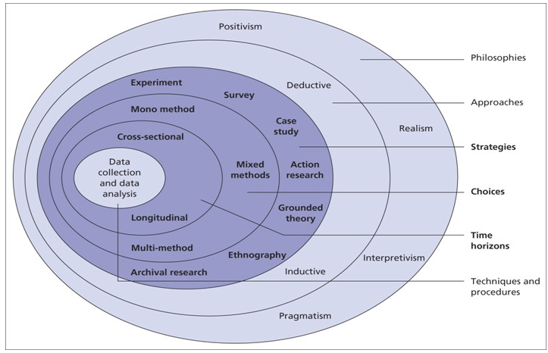
Figure 2- Sanders Research Onion[15]
The main philosophy to this proposed project is that of a positivist as, for the most part, nearly all forms of data analysed would be as a result of experimentation and configuration of the network. As defined by positivism, the produced data will be independent of the subject under study, in this case a computer network, of which cannot change data of once it’s been gathered and therefore is verifiable should the experiment need to be run again. Positivism focuses on the observable, and the fact that the resulting data of the observation will stay consistent despite observation.[16]
In regard to the approach, there are two possible choices as seen in figure 2; deductive and inductive. Deductive works from general to specifics, from theory > hypothesis > observation > confirmation, and is often referred to as the top-down approach. Inductive on the other hand takes the opposite direction, from specifics observations to general theories as the result and as such is often referred to as the bottom-up approach. The deductive approach would be the better approach for this type of project.

Strategy

The next stage in the Saunders research onion is that of strategy, of which dictates the overall plan of a project, and whilst there are many, this project sees similarities with that of the experimentation and action research strategies but will be following the case study strategy. To expand upon this difference, whilst “both case-study research and action research deal with context-bound knowledge”[17], action research could be said to be the observation of a problem, requiring a new solution, or new approach whereas a case study is more akin to the exploration of a problem, of which once the problem is fully explored, propose a solution. Experimentation on the other hand, whilst a significant part of the project, is none the less a part and not the main focus. As this project aims to develop network security in a small enterprise environment, to do so we need to first understand the problem and how to address it, a case study strategy is large enough in scope and offers enough variations in approach to not hinder the project. In addition, for the most part action research has a soft requirement that is links to the industry, of which this writer does not have, making the choice between the two even easier. Worth noting is that whilst it will be following case study strategy/methodology, as indicated by the working title, the project will be development based.
In regards to the method, the resulting dataset will likely be very different per each experiment run and as such a mixed-method research choice will be required, as whilst a mono-method is maybe possible, it wouldn’t present well and would be more difficult than a mixed-method for no additional benefit. This is due to the fact that there is no standard output across experiments, each one while dealing with numerical results, will have to be interpreted to produce presentable results.
The time horizon determines how the experiment is run over time;
- Cross-sectional- Collection of data at a specific time.
- Longitudinal- Collection of data repeatedly over a period of time.
The realistic choice here is cross-sectional as there is no need for repeating experiments over time, the result would be the same, assuming the conditions are identical. Whilst each experiment would be repeated, this is for the assurance of the resulting data rather than difference over time.

Methodology

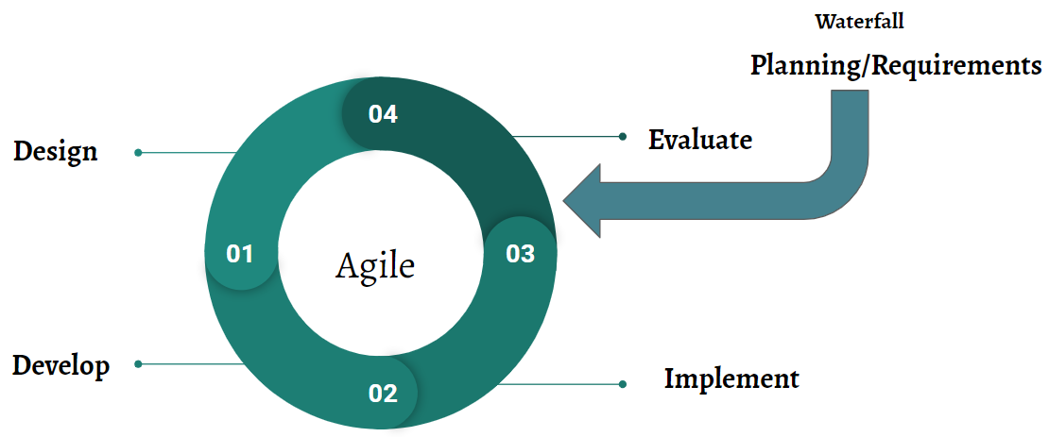
Whilst there are many variations of methodology, the chosen methodology here will be a hybrid of the waterfall method and agile methodologies. This allows for the “sequential dependability on the previous deliverable”, which is characteristic of the waterfall method and the “short iterative cycles”[18] of the agile methodology during the experimentation phase, allowing for the project to adapt to changes in requirements or circumstances depending on the experimentation evaluation. This will be needed due to the experimental nature of a test environment, and a weakness of using the waterfall method alone is that there is too little time to go back to the planning phase should an experiment fail, but rather learning from the failure and stepping back a step and retrying a different implementation is much more suited to the proposed project and its time constraints. A diagram of the hybrid approach can be seen in figure 3, minus the production path, of which there obviously would be in a project.
Figure 3- The Hybrid Development Methodology[19]
In terms of data collection, the final stage of the Saunders Onion, there is no specific type of data collection, as this project will involve primary, secondary and tertiary data at different priority levels at varying level during each stage of the project. Such as mainly secondary and tertiary data in the research in the research stage and primary data during the experimentation phase.

Risks

Whilst this project is development, there are still a number of risks that will be associated with it, especially so as the main topic is security related. They are as follows;
- Poor Time management
- Incompatibility of security implementations
- Damage to equipment due to attacks
- Attacks ‘escaping’ outside the test environment
The risk of poor time management can be effectively mitigated via the use of a Gantt chart to set proper and realistic time constraints for different stages of the project. The risk of this writer conforming to said time constraints is less concrete on the other hand. Whilst on the topic of time management, there is the likelihood of experimentation taking longer than anticipated, even if a realistic amount of time was given. Some attacks, such as password cracking, can take from days to months depending on hardware used, effectiveness of the tool and complexity of the target password. To avoid this, the experiments will have set deadlines independent of the Gantt chart after which the experiment will be labelled inconclusive, or the results at that point will be used for analysis. As you may imagine, neither one of these alternative results would prove entirely beneficial but would still be more so than running out of time, resulting in an incomplete project and as such it is more akin to a compromise rather than a solution.
Secondly, the incompatibility of security implementations; while this is a large enough risk to be listed, it can be quite easily avoided by doing sufficient research beforehand, in the research stage. Whilst it is possible for configuration conflicts to occur during implementation, unless the tool is of critical importance, an alternative can be discovered, or a patch can be implemented to fix the conflict. Luckily due to the likelihood of using open-source tools, it is quite likely that the security implementations can work well together due to community influence.
Due to the presence of security-related attacks in the experimentation stage it is possible for damage to the equipment or data to occur. This is not generally physically, but more likely digitally such as when attacking using ransomware, of which if successful would completely ‘lock down’ the target computer, leaving it unusable. To avoid this occurrence, firstly all data involved in the experiment such as operating systems ,system images and data resulting from experimentation will be regularly backed up to cold storage (disconnected from any computer system) and the cloud to ensure it is secure and redundant. Secondly, and more importantly, the use of dangerous and/or destructive attacks will be avoided as they are high risk- low reward, being that they would produce little in terms of tangible analytical results, especially so for their drawbacks. Another alternative is via the use of virtual machines, so in the scenario that the attack is successful on the targeted virtual machine, nothing of value is lost, and the machine can be restored to an earlier state via the backup system image.
Lastly with any sort of networking attack, there is the possibility of it “escaping” outside of the predetermined area of attack, in this case, the test network. To avoid this possibility, the test network will be either physically disconnected or virtually segmented, as mentioned previously in the documentation. This writer could avoid broadcast attacks to make sure an attack doesn’t escape outside its bounds/ VLAN, on the other hand, if it does, that is a security flaw in of itself, and therefore a broadcast attack, minus the attack payload, can act as an experiment in network isolation as a security implementation.[20], [21]

Limitations

The main limitations of this proposed project can be set into three groups;
- Financial
- Test Environment
- Time
The first and arguably most constricting is that of finances. Whilst it can be said small businesses do not spend enough on IT, it is still significantly more than a student budget, therefore said finances will play a major part in both the hardware and software used in this project. The test network itself will be minimised to only include the needed hardware for security features, as redundancy is not needed on a hardware level for this project. The software used is very unlikely to be that of true enterprise grade, as they often cost from hundreds to thousands and are designed for multiple hundreds of users. Luckily there are many open-source alternatives such as OPNsense, Kali Linux and Parrot OS, all of which include a large variety of tools to both defend and attack computer systems that will be more than adequate for this project.
The test environment in of itself brings with it a number of limitations, mainly the lack of human interaction. Whilst human users will bring a more realistic input into the project, they are too much of a wildcard for this type of project. As the majority of security features can be implemented and tested before being pushed to production environment, the need for human interaction is minimal and as such will be excluded from the project, but not completely ignored as they still play a major part in network security.
Lastly, time is of the essence, with the time frame being set from June to September, as set of the full time students, it does play a major limitation. None the less, this limitation can be mitigated via the same techniques mentioned previously; sticking to the times set out in the Gantt chart in order to effectively use the allotted time and assurance that smaller tasks achieve results in their allotted time.

Data Evaluation

The data generated by this project will be used to evaluate the success in creating a more-secure system for enterprise use, to an extent. Whilst the concept of security is not binary, it can none-the-less be evaluated, in this case multiple different penetration testing software will be used to scan the network for vulnerabilities or take advantage of said vulnerabilities to gain access to the network. Using backups of configurations and system imagining, we can then do the same to the system before being ‘secured’, with minimal configuration and compare the two network set ups. In addition, due to the need for the network to be used by a small enterprise business, the network will also be evaluated on whether or not it accessible to authorised users, as there is no point in securing a system if it is too secure, so much so that it is difficult for authorised users to access their set resources, except in extreme circumstances.
In terms of how the data itself will be evaluated, they will vary greatly depending on the type of attack used, for some it could be a simple positive or negative, whether or not the attacked worked, for some it will be time based. Take for example password cracking, depending on the complexity of the password used, depends on how long it will take to crack. On the other hand attacks such as Virtual Local Area Network hopping, Man in the Middle and Privilege escalation, all of these attacks are binary, either successful or unsuccessful, there is no measurement of how well they did and as such makes them more difficult to compare as a whole. Most likely this will end up as a comparison between a unsecured system and secured system, using the same attacks and then publishing how many of said attacks worked and if possible, to what extent.[22]

Resource Requirements & Planning

As part of this project, of course, equipment of multiple kinds is going to be needed, these can be split into three groups: research, equipment and tools. The specifics are as follows.
- Research
  - Books- For the majority of research in the project, they will be found online and in the university library, of which due to recent events is also online for now.
  - Internet Access- Whilst not technically a resource, accessing the proper webpages, whitepapers and forums will allow for an easier time in implementing security, as well as the actual downloading of any tools/software.
- Equipment
  - PC or Laptop- A device or two will be needed for both the attacking and target device, unless the attack in on network equipment itself or a broadcast-type attack, then only a singular device is need, but due to the multitude of attacks, it would be preferable to have two at minimum, one needing wireless capabilities for wireless-related attacks.
  - Switch- A number of security implementations are done so on a switch, and as such a switch is vital to the project, not only for security implementations but for device-count expansion on the network. A L3 switch would be preferable.
  - Router- As a central part of any network, a router is essential for any sort of network, that being said there are a number of ways to create a network without a dedicated router, such as the aforementioned Layer 3 switch or via a computer running software such as PFsense or OPNsense, both of which are valid options for the test network, due to additional security measures that come with them. The layer 3 switch on the other hand, whilst it does routing, there are certain security measures that cannot be implemented on it, and as such will be avoided, unless it is being used as a switch.
  - Server- Whilst not necessary, a server would be greatly beneficial for the running of the aforementioned OPN/PFsense, as well as a number of other network services, and the speeding up of attacks requiring computational power.
  - Access Point- Due to the very common presence of wireless devices on any network, having a connected access point to secure would be extremely beneficial for the resulting data.
- Tools
  - Penetration Testing Software- These tools are critical to the evaluation section of the project, luckily this writer has both Kali Linux and Parrot OS ISOs available. Any other penetration tools can very likely be found online.
  - Miscellaneous Items- Includes items such as connecting cables, additional wi-fi cards, hard drives to store data backups, anything that while needed, is not a central focus point of the project. Mostly already on hand.
Technically speaking, of the networking equipment such as the switch, realistically a business would want two working in tandem as a redundancy measure but seeing as the test network is being built for the purpose of improving security, seeing as the security implementation is consistent without redundancy measures, a singular switch and router will be sufficient in a test scenario.
Now, the planning of the project using the Gannt chart can be seen in figure 4-7. At this stage in the project planning this Gantt chart is subject to change as the research tasks give a better idea of how long experimentation is going to take per experiment run, this bring why the experimentation section is simply one task, at a later stage in the project this one experiment stage will be broken down into multiple stages, each containing an experiment deadline. As you can see in the Gantt chart, this writer aims to finish the project by early August, giving enough room should something go wrong as well as additional write up of sections of the project not completed during the previous stages and collation and presentation of collected data. Seeing as Microsoft Project was unavailable, alternative measures were used for Gantt chart creation and as such it may look different to ‘normal’ Gantt charts, but it should still suffice.
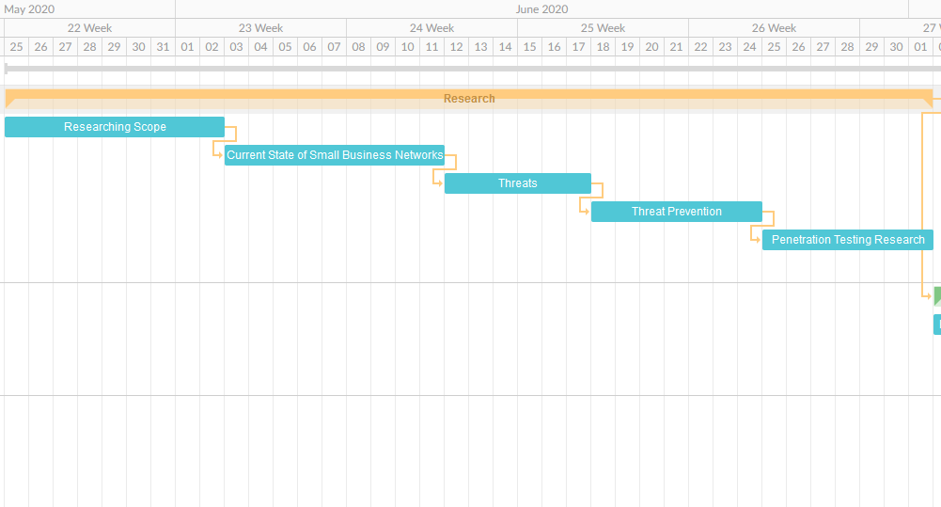
Figure 4- Gantt Chart Part 1
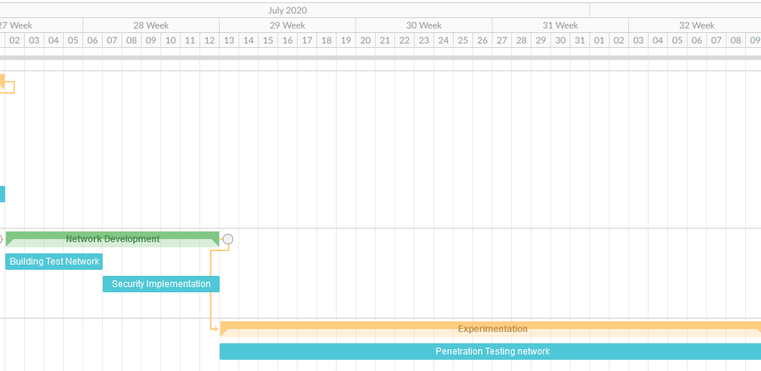
Figure 5- Gantt Chart Part 2
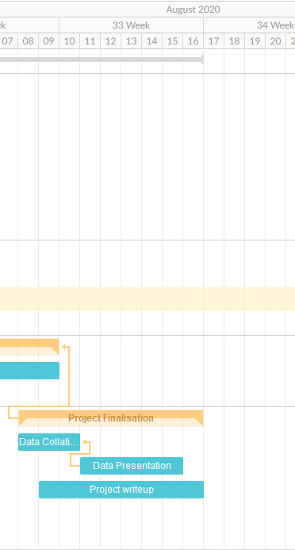
Figure 6- Gantt Chart Part 3
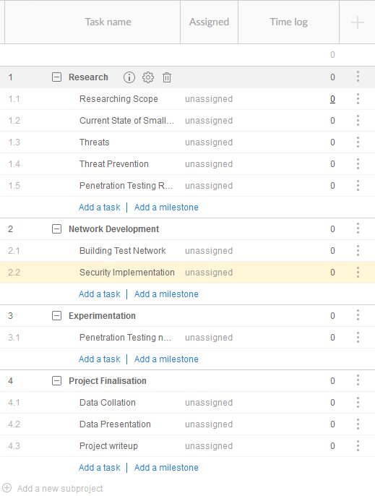
Figure 7- Gantt Chart Table

Bibliography

[1] S. Rebner and Cyleron, “The State Of Cybersecurity Pertaining To Small Business,” Forbes, 2019. [Online]. Available: https://www.forbes.com/sites/theyec/2019/09/18/the-state-of-cybersecurity-pertaining-to-small-business/.
[2] National Cyber Security Centre, “Cyber Security Breaches Survey 2019: Micro/Small Business findings visualisation,” 2019.
[3] D. Mort, “Business Statistics,” UK Stat. A Guid. Bus. users, no. 06152, pp. 93–136, 2019.
[4] “State of SMB Cyber Security Readiness : UK Study Sponsored by Faronics,” no. November, 2012.
[5] “Hiscox Cyber Readiness Report 2019,” Netw. Secur., vol. 2019, no. 5, p. 4, 2019.
[6] R. Klahr, S. Amili, J. N. Shah, M. Button, and V. Wang, “Cyber Security Breaches Survey 2016,” Cyber Secur. Breaches Surv. 2016, no. May, p. 56, 2016.
[7] R. Klahr et al., “Cyber Security Breaches Survey 2017, Micro/Small Business Findings,” no. October 2016, 2017.
[8] HM Government, “2015 Information Security Breaches Report,” p. 49, 2015.
[9] PWC, “Information Security Breaches Survey 2014, Commissioned by the Department for Business Innovation and Skills,” 2014.
[10] Microsoft 365 Team, “What small businesses need to know about cybersecurity,” Microsoft Growth Centre, 2019. [Online]. Available: https://www.microsoft.com/en-us/microsoft-365/growth-center/resources/cybersecurity-small-business.
[11] The Australian Small Business and Family Enterprise Ombudsman, “Cyber Security: The Small Business Best Practice Guide Cyber Security: A Small Business Best Practice Guide,” 2017.
[12] N. C. S. Centre, “The Cyber Security Breaches Survey 2018 - Micro/Small Business Findings,” 2018.
[13] Gallaghar, “SMEs IN AN AGE OF CRISES : The need to bolster resilience to protect the UK ’ s economic heartland.”
[14] BBC News, “Fines up to £17m launched for firms with poor cyber-security - BBC News,” BBC, 2018. [Online]. Available: https://www.bbc.co.uk/news/technology-42861676.
[15] 15writers.com, “Understanding the Research Onion,” 15writers.com. [Online]. Available: https://15writers.com/research-onion/.
[16] M. MacLean, Research methods for business students, 5th ed. 2018.
[17] B. S. Blichfeldt and J. R. Andersen, “Creating a wider audience for action research: Learning from case-study research,” J. Res. Pract., vol. 2, no. 1, p. 6, 2006.
[18] W. Van Casteren, “The Waterfall Model And The Agile Methodologies : A Comparison By Project Characteristics-Short The Waterfall Model and Agile Methodologies,” Acad. Competences Bachelor, no. February, pp. 10–13, 2017.
[19] ProProfs.com and D. Miller, “Hybrid vs Agile Approach: Which is Better for Efficient Project Management,” ProProfs.com. [Online]. Available: https://www.proprofs.com/c/project/hybrid-vs-agile-project-management/.
[20] H. F. Cervone, “Project risk management,” OCLC Syst. Serv. Int. Digit. Libr. Perspect., vol. 22, no. 4, pp. 256–262, Oct. 2006.
[21] U. Anca, B. Cezar, and U. Adrian, “Risk Identification in Project Management,” Int. Conf. Econ. Sci. Bus. Adm., pp. 259–266, 2015.
[22] C. A. Olney and S. Barnes, Collecting and Analyzing Evaluation Data. 2008.

