z
ACDA5011 Control System design
Samuel Page

University of Wales Trinity Saint Davids
Instrumentation and Control

Abstract
In this report, a control system for a CIWS Turret with a given transfer function is modelled in MATLAB/SIMULINK. The PID controller is modelled and tuned, giving the proportional, differential and integral gain along with the filter coefficient for the controller allowing a single block model to be constructed to model the control system. A Nyquist diagram, bode plot and pole-zero plots were created and it became clear that the system was stable and capable of controlling the process within the given specification.

Contents
Abstract 1
1. Introduction 3
1.1. Control Systems 3
1.1.1. What is a Control System? 3
1.1.2. Where are Control Systems Employed? 5
1.1.3. Transfer Function of the angular positioning system of a CIWS Turret 5
2. Simulation Set-up 6
2.1. Diagram of Initial Set-up 6
2.2. Transfer Function Derivation for Combined Controller and Plant 6
2.3. Derivation of Transfer Function with Feedback (Closed-loop transfer Function) 7
2.4. Control System Simulation Set-up 8
3. Results 10
4. Discussion 11
5. Conclusion 12
References 13

Introduction
In this report, the author looks at modelling a control system for the angular positioning system of a CIWS Turret with a given transfer function in MATLAB/SIMULINK. The control system modelled later in this report uses a PID controller and must be able to bring the system under control within 2 seconds of the input signal being changed and must have an overshoot of less than 5%.

Control Systems

What is a Control System?
A control system is a way of maintaining or changing a quantity in a mechanism or piece of equipment in response to an input signal [1]. It is a combination of sub-systems and processes to produce a desirable, controlled output to a process [2]. There are two types of control systems, open-loop, discussed in Section 1.1.1.1., and closed-loop discussed in Section 1.1.1.2.

Open Loop Control Systems
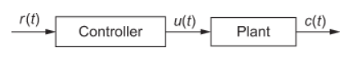
An open loop control system is when the output of a system isn’t monitored. Therefore, no correcting action can be taken so variations to the input signal will produce an unchecked variation in the output signal [3]. This system can’t automatically respond to changes [4]. Manual control systems are classed as open-loop systems and are required to have the input changed by an operator to remove the discrepancy between the input and output signals [4]. This type of control system can only be used when fluctuation around the desired target is unimportant [4]. Should variations around the target be undesirable, then a closed-loop control system should be used. Open-loop control systems can be represented by Figure 1. Open-loop control systems have the advantage of being cheap and easy to implement with relatively good reliability [5].
Figure 1 - Block diagram for an Open-Loop Control system (r(t)=input signal, u(t)=control signal, c(t)=output signal) [4]

Closed Loop Control Systems
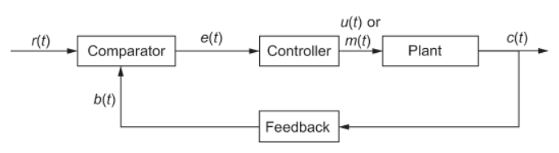
Closed loop control systems are like Open-loop control systems in their operation but consider a feedback signal to compare the output signal to the input signal [6]. It means that closed-loop control systems can respond to changes without the need for operator intervention [4]. In closed-loop control systems, the error signal is subtracted from the input signal creating a negative feedback loop [5]. There are four main types of controllers. These are the Proportional, P, controller, the Proportional-Integral, PI, controller, the Proportional-Differential, PD, controller and the Proportional-Integral-Differential, PID, controller [7]. Closed-loop control systems can be represented by Figure 2.
Figure 2 - Block diagram for a Closed-Loop Control System (r(t)=input signal, e(t)=error signal, u(t)=control signal, b(t)=feedback signal, c(t)=controlled output signal) [4]
The simplest type of controller, however, is referred to as Bang-Bang control [8]. The controller simply switches between two states with no intermediate control [8]. These types of controllers are simple to implement but tend to fluctuate above and below the target, known as hunting [8]. Due to this problem, proportional control was established.
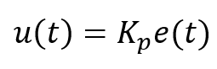
Proportional control is when a controller can vary its output power in relation to the feedback signal [8]. This type of control can be represented by the equation shown in Equation 1 below.
Equation 1 - Mathematical representation of Proportional control (u(t)=output signal, Kp=proportional gain, e(t)=error signal) [7]

Proportional controllers take the error signal and multiply this by a constant gain to determine the output signal. They are heavily reliant on an adequate proportional gain being selected as this will determine the speed the plant being controlled can approach the target value [8]. One problem with the proportional controller is that because it only relies on one parameter, there will always be a steady state error that can’t be removed [7]. A steady state error is when the actual output signal has an offset from the desired output. This can be removed using Integral control.
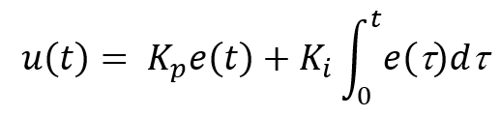
Integral Control considers not only the instantaneous error but also how long the error has existed [8]. This will eradicate the steady state error that has been seen previously [7]. This type of control is commonly used in conjunction with proportional control. These controllers are some of the most common controllers, besides PID controllers discussed later in this report [7]. They can be represented mathematically by equation 2.
Equation 2 - Mathematical Representation of Proportional Integral control (u(t)=output signal, Kp=proportional gain, e(t)=error signal, Ki=integral gain, t=time) [7]

From Equation 2, with time, the integral control element will continue to increase if the error persists, therefore the output signal will increase until the integral element starts to reduce. An error that can still occur though is the overshoot of the target and as controller demand increases, so does the overshoot [7]. A way to reduce this overshoot is to add a Derivative element to the control system.
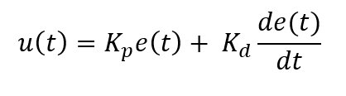
Derivative control doesn’t look at the magnitude of the error, it looks at the rate of change of that signal [8]. If a high rate of change is detected the output signal will work to oppose this [8]. This can be represented mathematically by Equation 3 below.
Equation 3 - Mathematic representation of Proportional Differential control (u(t)=output signal, Kp=proportional gain, e(t)=error signal, Kd=differential gain) [7]
It has been found that should the differential gain be set too high that it can be detrimental to the overall system stability [8].
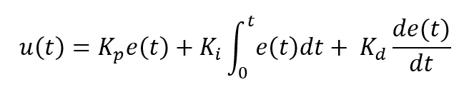
The optimal controller type is the Proportional-Integral-Differential, PID, controller. This is used for the simulations in this report. By combining all these methods, we can eradicate all the undesirable aspects of control systems theoretically. PID control is the most versatile and common control system in use today [9]. All the gain aspects of a PID controller can be tuned to reach a desired output, quickly, avoiding overshoot and without steady state errors [8]. Tuning these systems can prove to be hard and can lead to instability, whilst requiring a complex digital processor making them expensive and less desirable depending on the application [8]. This type of control can be represented by equation 4 below.
Equation 4 - Mathematical representation of PID control (all variables the same as above) [9]

Where are Control Systems Employed?
Control systems are used in everyday life in various forms. Control systems can even include human elements such as humans driving a car. The driver observes the road and takes this feedback information adjusting the speed of the vehicle as necessary [1]. Even on larger ships if the ship is turning too hard one way, the rudder will be actuated to correct the overshoot [6]. Open loop control systems are common in items such as microwaves where there is no monitoring on the item inside, it is just set to run full power for a set time [6]. A good example around the house of an open-loop control system would also be a light switch as it needs to be operated by a human. Closed-loop control systems are also used on modern air conditioning units by using a temperature sensor to monitor the room temperature and use the difference from the set temperature to react to changes in the room [4].

Transfer Function of the angular positioning system of a CIWS Turret
Equation 5 is the Transfer function for the angular positioning system for a CIWS Turret.
$$G\left(s\right)= \frac{1}{3s^{2}+4s+2}$$
Equation 5 - Transfer Function of the angular positioning system of a CIWS Turret [10]

Simulation Set-up

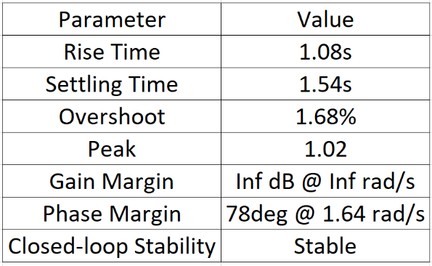

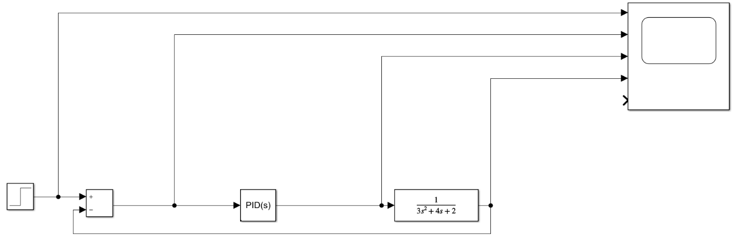
Diagram of Initial Set-up
Table 2 - Characteristics of the tuned PID Controller
Table 1 - Values Used for the PID Controller
Figure 3 - Diagram of the Simulink model of the Closed-loop Control System
This Simulink Model was created to simulate a CIWS Turret Control System that could perform as specified in section 1. Figure 1 shows a step input applied directly to an addition block within Simulink as a comparator. The comparator works out the error signal within the control system using the target, the input signal, and the feedback signal after passing through the controller and the plant. This output signal then passes through the PID Controller with the parameters outlined in Table 1 and is then sent to the plant which will react to this control signal. In the context of a CIWS Turret, this will cause it to move to an azimuthal position and an elevation with 1.54s settling time and an overshoot of 1.68% as specified in Table 2.

Transfer Function Derivation for Combined Controller and Plant
The Forward Transfer Function can be derived by finding the product of Equation 5 and 6. The derivation is below.

$$G\left(s\right)= K_{p}+ K_{i}\frac{1}{s}+ K_{d}\frac{s}{\frac{1}{N}s+1}$$
Equation 6 - Transfer Function for PID Controller (Kp=proportional gain, Ki=Integral gain, Kd=differential gain, N=filter coefficient)
$$\left[K_{p}+K_{i}\frac{1}{s}+ K_{d}\frac{s}{\frac{1}{N}s+1}\right]×\left[\frac{1}{as^{2}+bs+c}\right]$$
$$K_{d}\frac{s}{\frac{1}{N}s+1}= K_{d}\frac{s}{\frac{s}{N}+1}= K_{d}\frac{s}{\frac{s+N}{N}}= K_{d}\frac{SN}{S+N}$$
$$\left[K_{p}+K_{i}\frac{1}{s}+ K_{d}\frac{SN}{S+N}\right]×\left[\frac{1}{as^{2}+bs+c}\right]$$
$$\left[\frac{s\left(s+N\right)K_{p}+\left(s+N\right)K_{i}+s(K_{d}NS)}{s(s+N)}\right]×\left[\frac{1}{as^{2}+bs+c}\right]$$
$$\left[\frac{s^{2}K_{p}+SNK_{p}+SK_{i}+NK_{i}+K_{d}Ns^{2}}{s^{2}+sN}\right]×\left[\frac{1}{as^{2}+bs+c}\right]$$
$$\left[\frac{s^{2}\left(K_{p}+K_{d}N\right)+s(NK_{p}+K_{i})+NK_{i}}{s^{2}+sN}\right]×\left[\frac{1}{as^{2}+bs+c}\right]$$
$$\frac{s^{2}\left(K_{p}+K_{d}N\right)+s(NK_{p}+K_{i})+NK_{i}}{(s^{2}+sN)(as^{2}+bs+c)}$$
$$\left(s^{2}+sN\right)\left(as^{2}+bs+c\right)=as^{4}+bs^{3}+cs^{2}+aNs^{3}+bNs^{2}+cNs=as^{4}+\left(b+aN\right)s^{3}+\left(c+bN\right)s^{2}+cNs$$

$$G=\frac{s^{2}\left(K_{p}+K_{d}N\right)+s(NK_{p}+K_{i})+NK_{i}}{as^{4}+\left(b+aN\right)s^{3}+\left(c+bN\right)s^{2}+cNs}$$
Equation 7 - Forward Transfer Function of the controller and plant

Derivation of Transfer Function with Feedback (Closed-loop transfer Function)
To derive the closed loop transfer function for the system, Equation 7 must be manipulated to fit Equation 8 below which is a mathematical representation of Figure 2.
$$CTF= \frac{Output}{Input}= \frac{G}{1+GH}$$
Equation 8 - Closed Loop Transfer Function general form (G=transfer function of plant, H=feedback factor) [3]

As there are no components in the feedback loop, H, which is the feedback factor, can be thought of as 1.
$$\frac{\left[\frac{s^{2}\left(K_{p}+K_{d}N\right)+s(NK_{p}+K_{i})+NK_{i}}{as^{4}+\left(b+aN\right)s^{3}+\left(c+bN\right)s^{2}+cNs}\right]}{1+\left[\frac{s^{2}\left(K_{p}+K_{d}N\right)+s(NK_{p}+K_{i})+NK_{i}}{as^{4}+\left(b+aN\right)s^{3}+\left(c+bN\right)s^{2}+cNs}\right]×1}$$
Simplify the Denominator
$$1+\left[\frac{s^{2}\left(K_{p}+K_{d}N\right)+s(NK_{p}+K_{i})+NK_{i}}{as^{4}+\left(b+aN\right)s^{3}+\left(c+bN\right)s^{2}+cNs}\right]×1=\frac{s^{2}\left(K_{p}+K_{d}N\right)+s\left(NK_{p}+K_{i}\right)+NK_{i}+as^{4}+\left(b+aN\right)s^{3}+\left(c+bN\right)s^{2}+cNs}{as^{4}+\left(b+aN\right)s^{3}+\left(c+bN\right)s^{2}+cNs}$$
Substitute back into original equation
$$\frac{\left[\frac{s^{2}\left(K_{p}+K_{d}N\right)+s(NK_{p}+K_{i})+NK_{i}}{as^{4}+\left(b+aN\right)s^{3}+\left(c+bN\right)s^{2}+cNs}\right]}{\left[\frac{s^{2}\left(K_{p}+K_{d}N\right)+s\left(NK_{p}+K_{i}\right)+NK_{i}+as^{4}+\left(b+aN\right)s^{3}+\left(c+bN\right)s^{2}+cNs}{as^{4}+\left(b+aN\right)s^{3}+\left(c+bN\right)s^{2}+cNs}\right]}$$
$$\frac{\left[s^{2}\left(K_{p}+K_{d}N\right)+s(NK_{p}+K_{i})+NK_{i}\right]}{\left[s^{2}\left(K_{p}+K_{d}N\right)+s\left(NK_{p}+K_{i}\right)+NK_{i}+as^{4}+\left(b+aN\right)s^{3}+\left(c+bN\right)s^{2}+cNs\right]}$$
$$\frac{\left[s^{2}\left(K_{p}+K_{d}N\right)+s(NK_{p}+K_{i})+NK_{i}\right]}{\left[as^{4}+\left(b+aN\right)s^{3}+\left(c+bN+K_{p}+K_{d}N\right)s^{2}+\left(cNs+NK_{p}+K_{i}\right)+NK_{i}\right]}$$

$$T.F.=\frac{s^{2}\left(K_{p}+K_{d}N\right)+s(NK_{p}+K_{i})+NK_{i}}{as^{4}+\left(b+aN\right)s^{3}+\left(c+bN+K_{p}+K_{d}N\right)s^{2}+\left(cNs+NK_{p}+K_{i}\right)+NK_{i}}$$
Equation 9 - Closed loop transfer function of the controller and the plant

Control System Simulation Set-up
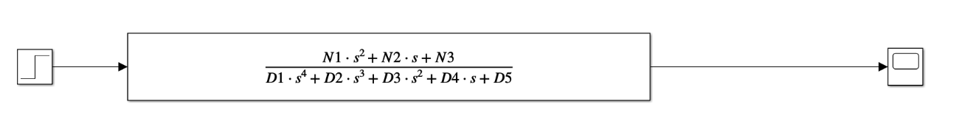
The transfer function in this single block diagram directly relates to Equation 9. The Coefficients seen as N1-3 and D1-5 are determined as above with relevant values from Table 1 substituted appropriately.
Figure 4 - Closed-loop Control System modelled using a single derived Transfer Function

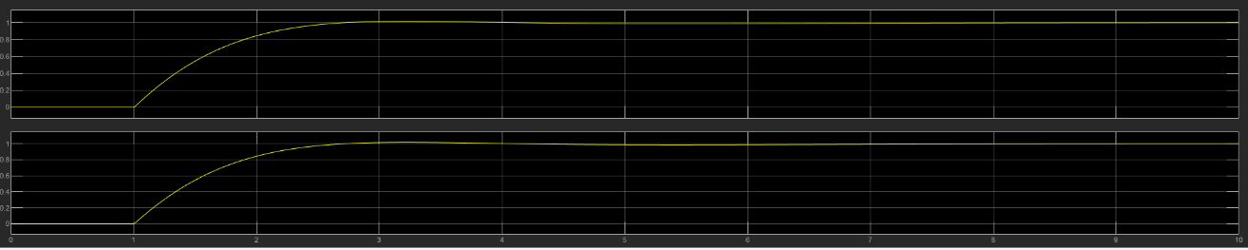
Figure 5 - Output signals from the control system to prove that the Physical (top) and theoretical (bottom) control systems are identical
Figure 5 is a confirmation that the closed loop transfer function used for Figure 4 produces an identical output signal as the model in section 2.1. The transient period is of the same length of time as is the overshoot and decay of any oscillatory behaviour in the steady state.

Results

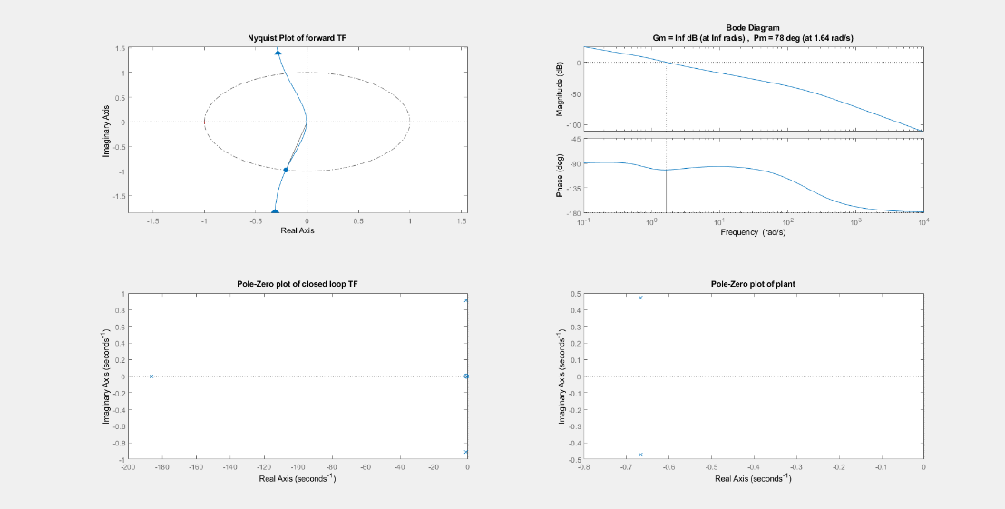
Figure 6 - Nyquist Diagram of Open-loop transfer function (top left), Bode plot (top right), Pole-zero plot of closed loop Transfer Function (bottom left), Pole-Zero plot of plant (bottom right)
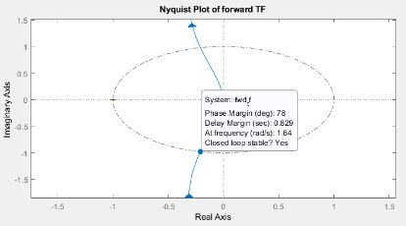
Figure 7 – Nyquist diagram of open-loop transfer function with phase margin marked

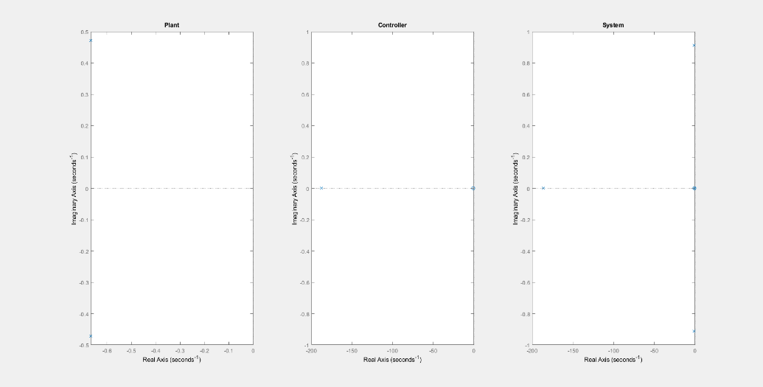
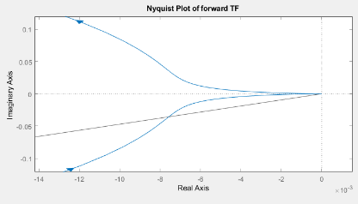
Discussion
Figure 8 - View of the phase crossover frequency point of the open-loop transfer function Nyquist Diagram
Figure 9 – Pole-Zero plots of Plant (left), Controller (middle), System (right)
From the simulations, a Nyquist Diagram, shown in figures 6-8, was plotted along with Pole-Zero Plots for the closed-loop transfer function and the plant in Figure 6 and for the Plant, Controller and the Control System in Figure 9.
A Nyquist diagram is used to predict stability in a system and plots the magnitude and the phase angle of the Forward Transfer function shown in Equation 7 for any frequency [11]. In Figure 7, the open-loop transfer function Nyquist diagram is shown with the phase margin marked. The phase margin is 78 degrees for the control system, telling us that the phase lag of the system can be increased up to 78 degrees without any change in gain and the system will remain stable [3]. The phase margin is determined by the point at which the Nyquist plot crosses the unit circle also shown in Figure 7.
Figure 8 shows the gain crossover frequency of the Nyquist Diagram for the control system. It shows that the phase crossover point occurs at the origin. Therefore, the overall gain of the system at the phase crossover point is 0 so you will never get any output regardless of the input frequency or phase. This shows that the control system will never be de-stabilised. The gain margin is defined as the amount you can increase the loop gain without a phase shift at the phase crossover frequency before the gain becomes unity and destabilises the system [3]. The gain margin of the system will be infinite which can also be seen in the Bode Plots in Figure 6. The Bode Plots are plotted in the Frequency domain, so magnitude and gain must be plotted separately.
Figure 9 shows the Pole-Zero plots of the main components in the control system. From all three of these pole-zero plots, we can see that each stage of the control system is stable as they lie on the negative real side of the plot [12]. The poles indicate when the output of the system tends to infinity so that is where the denominator of the transfer function is equal to zero. It can be seen in Figure 9 that the plant has two poles because the denominator function is a quadratic. This means that there will be an oscillatory component to the output but as it still lies on the negative real side of the plot, it will exponentially decay [12]. As the poles lie close to the line where the real axis equals zero, it will be a slower decay than if they lay further away [12]. This can also be seen in the System Pole-Zero plot which is the combination of both the plant and controller plots.
The controller Pole-Zero plot has one pole far away from the origin that lies on the real axis. This indicates that the controller will have a very fast exponential decay with no oscillatory behaviour. Finally, the system has a zero at the origin. This indicates that at zero frequency, there will be zero gain in the overall system [12].

Conclusion
From the results obtained in this report, a control system capable of controlling the angular positioning system of a CIWS Turret can be created by using a PID controller as was expected. Through creating a Pole-Zero diagram for the complete system and plotting a Nyquist Diagram, after deriving the open-loop transfer function, the author was able to determine that the control system was stable with an infinite gain margin, and a phase margin of 78 degrees. This system was also able to bring the Turret under control within 1.54 seconds with a 1.68% overshoot as was required.
In future works, a comparison of how different controller types can control the CIWS Turret could be studied to determine the easiest and most effective way of controlling this process.

References

[1] | I. J. Nagrath and M. Gopal, Control Systems Engineering Second Edition, New Delhi: Wiley Eastern Limited, 1982.
[2] | N. S. Nise, Control Systems Engineering, Chichester: John Wiley and Sons, 2004.
[3] | N. M. Morris, Control Engineering, Maidenhead: McGraw-Hill Book Company (UK) Limited, 1991.
[4] | S. Salivahana, R. Rengaraj and G. R. Venkatakrishnan, Control Systems Engineering, Chennai: Pearson Eduaction India, 2015.
[5] | W. Bolton, Control Systems, Oxford: Elsevier Ltd, 2002.
[6] | R. Bishop and R. Dorf, Modern Control Systems, EBook, Global Edition, Essex: Pearson Education Limited, 2017.
[7] | L. Wang, PID Control System Design and Automatic Tuning using MATLAB/Simulink, Wiley - IEEE Press, 2020.
[8] | A. Poulton, J. Bromley and S. Lim, T212 Electronic: sensing, logic and actuation, Book 4, Chapters 1-6 Actuation, Milton Keynes: The Open University, 2017.
[9] | P. Antsaklis and Z. Gao, “Control System Design,” in The Electronics Engineers' Handbook, 5th Edition, McGraw-Hill, 2005, pp. 19.1-19.30.
[10] | S. Mosey, Instrumentation and Control ACDA5011 Assignment Brief, Swansea: University of Wales Trinity Saint Davids, 2021.
[11] | K. Dutton, S. Thompson and B. Barraclough, The Art of Control Engineering, Essex: Addison Wesley Longman Limited, 1997.
[12] | Massachusettes Institute of Technology, “Understanding Poles and Zero,” Massachusettes Institute of Technology, Cambridge.

