
Skills for the Workplace
Module Assignment Submission
Student Name: | Lisa Ventrice
Student Number: | 1910781
Module No: | BMSK4003
Module Title: | Digital Skills and Research Methods

Statement of Confirmation of Authenticity
By the act of making this submission, the student declares that this is the work of the student named above. The work has not, in whole or in part, been knowingly presented elsewhere for assessment, or where assessment has been built on a previous assessment, this has been identified. Where materials have been used from other sources it has been properly acknowledged. If this statement is untrue, the student acknowledges that an assessment offence has been committed.
Attention is drawn to the plagiarism and unfair practice policies of both the University and of ILM.
Permission for ILM to use this script
ILM uses learners’ submissions – on an anonymous basis – for assessment standardisation. By submitting, both the centre and the learner agree that ILM may use this script on condition that identifying information is removed. However, if you are unwilling to allow ILM use this script, please refuse by ticking the box: □
Lisa Ventrice bmsk4003

Table of Contents
What has been the impact of 21st Century Technologies on the modern workplace? 3
Part 1 3
An Overview of the 21st Century Workplace 3
An in-depth look at technologies used in own workplace 3
Part 2 4
An exploration of the use of social media in the workplace generally 4
An in-depth look at the use of social media in own workplace 4
The use of social media to enhance networking and career prospects 4
LinkedIn Profile 4
Conclusion 5
References 6
Appendix 1 7
Appendix 2 8

What has been the impact of 21st Century Technologies on the modern workplace?

Part 1
The impact of technology on the modern workplace has helped all business grow with greater productivity. Technology has advanced so quickly, with the click of a button our customers can have their orders processed and sent to us overnight, which means we are able to deliver them to our customers the following day. The technology which we
Lisa Ventrice bmsk4003
have today helps all companies widen the business, by sending videos and emails to potential customers and help themselves expand around the world. With the technology that we have today, most businesses are able to make conference calls with clients and potential new businesses wanting to join the industry by doing it this they are saving time and money, as not much traveling will be involved.

An Overview of the 21st Century Workplace
The 21st technology has had a huge impact for the workplaces of today. Both time and money can be saved, which means a better and safer work environment for people to work around, it is also better for the environment as there is not much paperwork which will save our trees. The technology these days we use every day with the use of mobile phones, sat nav, card machines, to name just a few. These enable us to perform our jobs to a satisfactory standard, there are businesspeople who have to travel all over the world so with the help of technology today there is the use of wi-fi on many forms of transport, which enables us to communicate with the companies we deal with. However, with the technology evolving so quickly, for many people it is difficult for most of the older generation as they did not have the technology as most of us these days. If you were fortunate to have grown up with computers, and the use of technology and social media that we have today you were very privileged to have had the internet and a computer. People of the older generation were not as fortunate, so all company’s need to have in place courses and training available for all their employees, this will result in a happy workplace. For a member of your team not to have the correct training, which all companies should provide, the outcome could be damaging to the business or businesses which in turn can cost them money and time with trying to correct all the mistakes that have been made. So, in turn looking at the over all of the technology and social media that we have in the workplace of today, can be a very positive thing for all businesses to have. For them to up build on and expand their companies, and to be able to promote and advertise themselves worldwide.

Lisa Ventrice bmsk4003

An in-depth look at technologies used in own workplace
The use of technology in my workplace has helped us work more efficiently, with the use of computers we are able to commutate with our branches around the country. We also have the use of handheld scanners with which we are able to do all of our stock checking and allocate all of our stock in the appropriate location in which they have to go in, we also use these scanners when we pick our stock for the customers to make sure it is the correct part and quantity that they are asking for, by using these scanners they can also keep a record of the stock take of what goes out and what comes in.
These scanners are also used to load our vans and they make note of the customers that we have to deliver to, when we have delivered the products it goes back to the data base in our office so they keep a record of it ,this also stops a lot of mistakes from happening ,so it can be corrected immediately. We also have a closed circuit television system (CCTV) which gives us security around our depo, there is also a tracking device put into our scanners, as well as having them in our vehicles which enables our managers to track all employees while they are out on their deliveries, and inform customers if there are any problems which may accrue because of delayed traffic caused through accidents or road works, even closures . We also have cameras fitted in all of our vehicles, which record all of our everyday movements. They are there to record while we are driving in case of reports from the public or accidents. Which then the manager can view straight away by looking at the memory card, which is located in the camera, as soon as we arrive back at the base of work. They just put the memory card into their computers, and by doing this they can view all footage of any incidents that may have accrued whilst we were out doing our deliveries. We also have Bluetooth which connects to our mobile phones, they are provided in all of the radios in all company vehicles, so we can answer phone calls from our employers, family or friends this makes it easier for us to do our jobs as then we don’t have to keep pulling over and stopping to take phone calls. This type of technology is an amazing device for everyone to have in all company vehicles and your own personal vehicles. There are pro’s and con’s with technology in the workplace of today, with the use of Facebook and social media and LinkedIn, that’s naming a few of them.
- The pros; are being able to advertise and promote your business, as well as build a good repour with your customers, and potential new businesses. With the help of this technology and social media of today, it helps all types of companies and businesses to promote themselves and their products. There is a lot of competition out there for the retail business, which enables us to price match with the different companies and businesses that we are up against.
- The cons; on the other hand, the technology and social media that we have can be very damaging to businesses with the likes of competitors and unsatisfied
customers, leaving damaging comments for potential new customers and businesspeople to read. Which can result in businesses losing trade and customers which then result in the businesses or company losing profit, which in these days is not the right place to be in, with so many new competitors out there.

Lisa Ventrice bmsk4003

Part 2

An exploration of the use of social media in the workplace generally
Social media in the workplace is the best way for all our companies to communicate with potential clients and customers by sending emails to each other. Ferraris piston services was founded in 1934 so in those days they didn’t have the use of technology then as we do now, they would have communicated by handwritten letters and photographs. Technology today is important and very useful, as we operate from 20 different regional distribution centres across the united kingdom, we also have over 1000 employees and 400 vehicles to look after and keep on the road, so the social media helps the compony keep everything in order and up to date so that the company can run more efficiently. Since 2016 the company has operated as an independently run and managed business within the Alliance Automotive Group, which is a very large and successful automotive group. Ferraris piston services have a sound financial base, with sales of £170m. Ferraris piston services have been in wholesaling and distribution for over 80years, Ferraris piston services supply to over 8000 delivery points, they have built a very high standard of reputation and service of excellence. Ferraris piston services operate from over 20 regional distribution centres (RDC) across the United Kingdom(uk), in each centre they have over 50,000 different lines of stock. They have a warehouse based in Sheffield, which holds the bulk of stock ready for immediate pick as soon as the orders come in, which then they can load their vans and deliver the goods to the rest of our branches. Our mission is to maintain a very long-term partnership with our suppliers and our customers, So with the technology and the use of social media that we have today, will help our companies and also new company’s which are building themselves forward and to work efficiently, and professionally and to a satisfactory standard. Without this technology, their jobs would take twice as long and a lot more paperwork involved, which means it would cost them more time and money. So, we can safely say, that without the use of technology and the use of social media today there may not be as many happy and satisfied businesses and customers out there.

An in-depth look at the use of social media in own workplace
Social media in the workplace is a good way for the company, to advertise to customers and potential new customers and businesses by advertising on Facebook and advertising on the company vehicles. By doing this they are bringing in new customers and raising profits for the company, which in turn the company will benefit from this, it also allows them to see the different advertisements from other companies which encourages a healthy competition. We can also advertise for upcoming vacancies within the company, for members of staff to better themselves with in the company as well as bringing in new members to join our team. There is also the use of LinkedIn, which is a networking site for professionals, you can advertise jobs for other businesses that you may not know about but use this site to search for new employment. We also have the use of google and google scholar, which are known as search engines. With these, many different companies are able to search different company’s around the world to see what competition is out there, and hopefully they can find valuable information, in which will help their business to grow and keep making profit as well as bringing new customers and employees to also help their businesses grow. Google was founded by Larry page and Sergey Brin, in Menlo park California united states in (1998). Google scholar was founded by Anuray Acharya, while at collage in (2014). Social media can also help a lot of companies and businesses communicate and help with new lines of stock that they may have heard about. Which in return, will bring in new lines of stock and hopefully help all everyone involved make a profit, and by everyone doing this they also save time and money by not having to travel around the country.
The downfalls for having social media in the workplace, is that for any reason whatsoever there may be a disciplinary going to happen to one of your team members, which only managers are supposed to know about not other members of staff. By others finding out that means the email has been sent to the wrong person or persons involved, which in turn can be very damaging to that person’s confidents by everyone then that person’s business.
There are also the good points of having social media in the workplace, for instance, if your boss is going to retire soon and they want to hold a leaving party for him or her they can do so without letting him or her know about it. By passing emails around the company and finding out how many of their work colleges will turn up, and they can do all this in private. Just by sending the information of the upcoming event to the right team members going through the correct emails.

Lisa Ventrice bmsk4003

The use of social media to enhance networking and career prospects
With the use of social media in the workplace it gives employees and employers, the chance to further their career, and to find potential new employees who are looking to better and further their career prospects. Social media is also a way for businesses to advertise and promote their business to many different company’s around the world, which will result in making profit and being able to expand their company’s.
Social media is a networking site, which means that all company’s and different businesses must make sure that their profiles are accurate and up to date. Social media can also be very damaging to companies, if there are some unhappy customers that were not satisfied with service that we have provided, can spread slander about the company’s that they have dealt with. Also, there are new companies that have just started out and trying to build their own business up can try and destroy others with slander, that goes for the businesses that are already up and running they don’t like the challenge’s that new businesses can bring. Social media can also be a bad thing for potentially new employees, as the company can look into their background before they have or even get to go for an interview Below I have attached a graph showing the percentage of companies that use social media to look at applicants before interviewing them. As stated below you can see that 33% of social media is never used in the workplace,16% of companies use social media,23% occasionally and 28% rarely use the social media in their companies. As perversely stated, social media can be very damaging to companies and potential new employees looking to further their career.

There has also been a survey done, by the human resource management in 2011. In this survey they found that 56% of all companies still use social media to find potential new employers. From 2008 this has risen from 34%, which shows that more than 25% of employers have checked their applicants’ profile by using social media, which results in finding out the applicants who are Appling for the job their race, gender and sexual orientation. While there are 33% of companies, say that they never have used social media to check applicants background in that way. This research has been drawn up by Margaret Weigel at the Harvard Kennedy school based on the social media of the workplace. As stated before, with the use of technology and social media that we have today, can be very detrimental to a lot of people and companies and businesses.

LinkedIn Profile
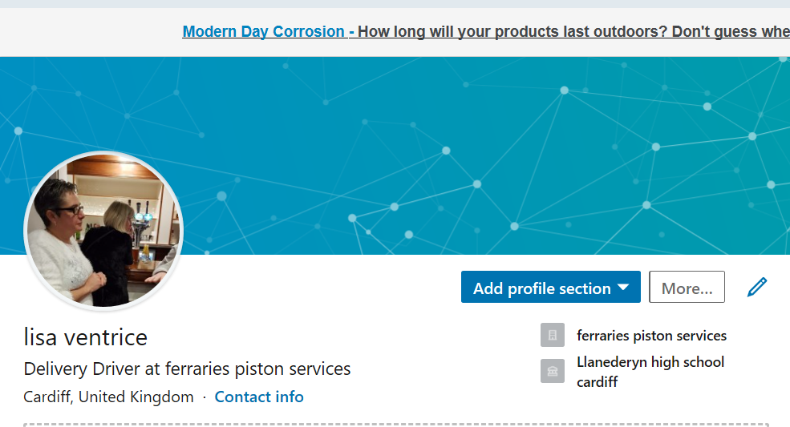
LinkedIn is a professional networking site, for people to try and help themselves further their career, businesses use this site to help promote themselves and attract people who want to further their career. When you set up your account it has to look professional, by uploading your qualifications, education and work experience this will help other businesses find potential employees, you must make sure that your profile is up to date and in order. Around 227 million use this site on a monthly basis’s, there of all ages and genders. This social media site can also put you in contact with people that you have not seen from your school days, it is the same as Facebook but for more professional people. There are always companies out there that are looking for fresh talented people, that have a lot of enthusiasm, skills and the knowledge that companies are looking for, and this will help to further their career.

Lisa Ventrice bmsk4003

Conclusion
Technology and social media have made life of today much easier, which in some ways is better and other ways not so good. As with technology and social media, that we have today, we are able to save copies of invoices and other documents of proof of purchases. Which makes it easier to store in the appropriate files and order of preference to which the employer requires. Even though this has made life easier, just by clicking the right button all files can be put in the right location and order of preference by the manager, by having the technology of today this also means that members of staff that would have done the photocopying, and filing all the paper work in appropriate order and location may have lost their jobs. So, by doing this they save time and money, there are still a few companies out there, which have not caught up with using the technology and social media of today. A lot of the older generation of today, including myself did not have the privilege of growing up and having access to the technology and social media and using the internet which we have today. So, it is very important that companies provide the correct training and information on all the technology systems that they have in the workplace, so as not to lose important documents, like records of receipts for consumables that they have purchased , and records of health and safety as well as documents of employees records. As previously stated, the use of social media, such as Facebook, and other social media sites can be very damaging to potential applicants and businesses, and businesses trying to build up a reputable and reliable company. I have involved the C.R.A.A.P test in my assignment to resource the information and the reliability of the contents. Technology is evolving so quickly, it is part of our everyday life, we use it in work and at home, when at work we use our mobile phones, then when we get home we are on our computers or iPad. While being out on the road we are also able to keep in contact with family and friends, as well as our employers we have Bluetooth in our vehicles, so we can talk while on the move and doing so in a safely way and no time is wasted. Cameras made for all your vehicles is an amazing devise, it stops a lot people trying to claim that another member of the public has caused them to have an accident, which then saves time and money for the police and insurances companies going through the process of trying to find out what actually happened. There is also the use of satnavs in our vehicles, which again will save time so we don’t have to keep stopping and asking the public for directions, it will also let us know if there is any traffic congestion ahead. All the company vehicles are fitted with a tracking system, in case we come across any problems while being out on the road. This lets the company and also the managers of our workplace know our every move, and exactly where we are while out on our deliveries.
Facebook is another form of social media, it is used by over 2 billion people worldwide on a monthly basis, Providing the opportunity to people everywhere in the world of different opportunities that are out there. It can also put us in touch with friends that we have not seen since leaving school, college or university, it lets us know of any upcoming events such as school reunion or any other events going on around the world.
LinkedIn is also another form of social media, it is used in the same way as Facebook but used by more professional members of the public, rather than just advertising things that they have for sale. LinkedIn helps to promote a more professional status, as a lot of companies and all types of businesses, advertise their vacancies for new employees with the right knowledge and skills needed for them to join their company or business. On this site you are also able to catch up with friends, that you have lost contact with after leaving school or even university. As mentioned before, the use of technology and social media can be very rewarding, in helping members of the public find their right career move, and in the right industry of employment that they wish to pursue in their career .On the other hand, with the use of the technology and social media that we have today, it can destroy businesses, companies or even the public, just by clicking on a few buttons or saying the wrong things being said and posted on the social media sites.

Lisa Ventrice bmsk4003

References
WWW.fpsdistribution.com (Ferraris Piston Services)
GOOGLE: Larry Page and Sergey Bin (1988) Ph.D. in Stanford University California.
LinkedIn: Reid Hoffman and team members (2002) Mountain View California.
SOCIAL MEDIA: Andrew Weinrecich (1997).
FACEBOOK: Mark Zuckerberg (2004) at Harvard University.
GOOGLE SCHOLAR: Anuray Achary (2014).

Appendix 1

Appendix 2

