UNDERSTANDING AND ENGAGING IN THE CUSTOMER EXPERIENCE
ORGANISATION’S QUALITY SYSTEMS AND CUSTOMER RELATIONSHIP MANAGEMENT

Table of contents
Introduction 2
Justification of choosing the organization 2
Aim of the report 2
Main discussion 2
A) Background of the organization (Brewdog) 2
B) Key marketing theory of the report 4
C) Critical analysis of the factors that influence the quality systems and controls for customers in times of crisis like COVID-19 of Brewdog 4
Critical understanding of the quality process (relating to customer service) in the workplace 4
Internal and external factors including COVID-19 affect influence in the organisation’s quality systems and controls for customers 5
Critically evaluates the benefits and challenges of developing and maintaining good customer relationships 9
Ways to deal with the new situation and achieve the business objectives by developing and maintaining good customer relationships 11
D) Identify the systems that support Brewdog quality processes 1200 12
Critical understanding of the systems which are effective in meeting customer requirements and maintaining good customer relationships in times of crisis like COVID-19 12
Conclusion 13
Reference list 14
Appendices 17
Appendix 1 17
Appendix 2 18
Appendix 3 19

Introduction
The following report is going to shed light on the quality system as well as in the customer relationship management. For this purpose, Brewdog has been chosen in this paper to discuss the issue. There will be an analysis to assess the factors which influence the organization's ability in order to maximize the customer value in Brewdog.
Despite the huge success model that the company followed to make it to be the biggest brewery company in the UK, Covid 19 pandemic had a huge impact on the business performance of the company. Despite the craft beer boom, the company had experienced a loss of nearly £13m as the bars closed down since the advent of the lockdown situation during the pandemic (Partridge, 2021).

Justification of choosing the organization
The rationale behind selecting the company is that the company has a huge potential to be remaining as the largest brewery firm not only in the UK but also in Scotland and around the globe. As the Covid situation has led most of the organizations in the UK to be shutting down their businesses, most of the companies have been focusing on improving their customer relationship management strategy such that to create a sense of emotional connection with their customers in the process. With the change in the shopping behaviour of the consumers especially during the Covid situation and technological advancement in the country, these companies are not looking for promoting and pitching their products to the consumers but to build a healthy relationship with them. Thus, Brewdog, as a big name in the brewery market, can also revive from the pandemic situation by implementing an effective CRM strategy that could help in connecting with its customers who could become loyal to the brand and will visit its stores once the social distancing rules gets away with.

Aim of the report
The aim of the report is to formulate an effective CRM strategy for Brewdog such that it could be able to build an amicable relationship with its customers to gain their trust and also bring fortune for its business in the future.

Main discussion

A) Background of the organization (Brewdog)
Brewdog is actually a multinational brewery and pub chain organization based in the UK (Brewdog, 2021a). The company has started its business operations in 2007 in the market. The annual production of the goods is around 220,000 hectares. It is noticed that the company is one of the largest independent brewery associations in the country. In 2012, the company became the fastest growing food and drink company in the UK as listed in The Sunday Times Fast Track 100. They mainly deal with different types of ales, lagers, crafted beers and others (Brewdog, 2021a). It is noticed that they have opened 17 new bars with the help of the equity crowdfunding process that has made them one of the strongest aled organizations in the global food and beverage industry (Brewdog, 2021a). BrewDog is a pub chain-based multinational brewery company in the UK founded in 2007. In its 2nd year of establishment, the company became the largest independent brewery in Scotland. In 2012, the company became the fastest growing food and drink company in the UK as listed in The Sunday Times Fast Track 100. In 2015, the company launched the largest scheme in human history that dealt with equity crowdfunding opening 17 new bars and releasing the strongest canned ale in the world (Brewdog, 2021).
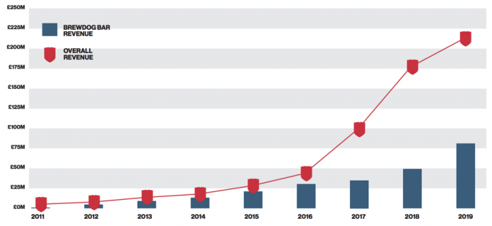
Figure 1: Brewdog revenue growth from 2011 to 2019
(Source: Heyes, 2021)
According to the report of Heyes (2021), it is observed that the company has maintained continuous revenue growth in the market as in 2019, the Brewdog bar revenue was around £75 million. In the same year, the overall revenue of the company reached around £200 million as well (shown in Figure 1). Despite the huge success model that the company followed to make it to be the biggest brewery company in the UK, Covid 19 pandemic had a huge impact on the business performance of the company. The report of Partridge (2021) reveals that the company has lost more than £13 million in the lockdown period due to the Covid-19 situation in the world as they had to close the bars because of the lockdown restrictions.

B) Key marketing theory of the report
The Voice of the Customer (VOC) theory can be referred to as the process for capturing the requirements of the customers. The theory deals in producing a detailed set of the requirements of the customers which are then, organized into a hierarchical structure. It is then, prioritized in relation to the satisfaction and relative importance of current alternatives (MIT, 2021). This theory could be implemented by Bredwdog which could help the company to identify the needs of its consumers at present and thereby formulating an effective CRM strategy for meeting its objectives in the process. Therefore, a range of marketing theory and customer relationship management theory will be used in this report for developing a detailed discussion. The Voice of customer theory is one of the major customer relationship management theories. As mentioned by Tabiaa and Madani (2021) The Voice of the Customer (VOC) theory can be referred to as the process for capturing the requirements of the customers. The theory deals in producing a detailed set of the requirements of the customers which are then, organized into a hierarchical structure. It is then prioritized in relation to the satisfaction and relative importance of current alternatives (MIT, 2021). This theory could be implemented by Brewdog which could help the company to identify the needs of its consumers at present and thereby formulating an effective CRM strategy for meeting its objectives in the process. Apart from this, the social exchange theory of customers is another customer relationship management theory that will be used in this report. As per the view of Cortez and Johnston (2020), social exchange theory refers to the process of exchange that happens between two or more parties and majorly focuses on the behaviour of an individual in response to others. The following theory will be used in this paper in order to analyse the customer experience in the context of Brewdog’s business.

C) Critical analysis of the factors that influence the quality systems and controls for customers in times of crisis like COVID-19 of Brewdog

Critical understanding of the quality process (relating to customer service) in the workplace
According to the view of Kumar and Reinartz (2018), Customer relationship management defines the process of business practices, strategies and tactics that organizations use in order to manage their relationship with the customers. The CRM process is used to connect the customers with the companies and, to improve the profitability of the organizations. From the view of DMA (2021) it is observed that in the Covid-19 situation in the world, it has become a significant issue for most of the business firms in the market to enhance customer engagement in the business and to achieve maximum profitability from this. Along with this, in the post-Covid-19 situation in the world, customers have tended to readdress their own personal values that have brought a change in the customer experience. In the view of Kowalik and Klimecka-Tatar (2018), the quality management process refers to the set of business practices that are used to ensure the deliverable produced in the companies for measuring the actual quality of the deliverables. In this way, the quality management process is used in the management of the customer service to deliver high-quality service to them in the workplace of the organizations.
Brewdog also follows a specific quality management process in order to deliver high-quality products to the customers in the market. According to the report of BrewDog (2021b) the company uses five pillars of quality management to produce the best-crafted beer in the industry. In the first stage, tasting and taster training is conducted by the company by using customized software for measuring the quality of the beers. A world-class quality control lab is used by the company for the quality management process (BrewDog, 2021b). One of the significant quality control processes of the company is to develop quality flavour. Along with this, they maintain a good relationship with the suppliers as well for ensuring the best quality raw materials to manufacture their crafted beer (BrewDog, 2021b).

Internal and external factors including COVID-19 affect influence in the organisation’s quality systems and controls for customers
Internal and external factors of the organizations influence the quality system and the customer service of the organizations. Therefore, in order to analyse the influence of the internal and external factors of the quality system and control of the organization, it is required to discuss the factors first. For this purpose, marketing theories like PESTLE analysis, SWOT framework and others have been used below in detail:
PESTLE analysis
In the view of Christodoulou and Cullinane (2019) PESTLE analysis refers to the process of generating environmental scanning for finding out the external factors that influence the business activities of the companies on the market. The analysis uses six factors majorly for this purpose (Shown in Figure 2).
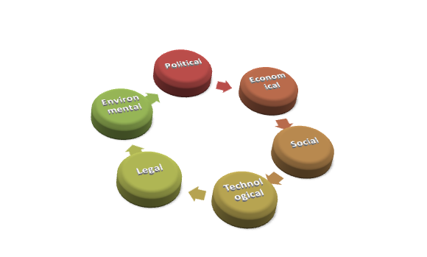
Figure 2: Factors of PESTLE analysis
(Source: Developed by the author)
Below a PESTLE analysis has been performed in order to analyze the external factors and their influence on Brewdog's quality system and control for the customer:
PESTLE factors | External factors
Political factor | It is noticed that due to the Brexit referendum issue, there is a change in the business policies of the UK. That is why it is required to consider these policies by Brewdog to manage the quality service to the customer.
Economical factor | The Covid-19 situation has impacted the GDP of the country massively. From the report of ONS (2021), the GDP has fallen by 2.6% in 2020. It was 8.5% below as well from the previous quarter (Referred to Appendix 1).
Social factor | The report of Statista (2021) reveals that due to the Covid-19 situation, the customer base in different restaurants and bars has declined by 58.55% in 2020. This figure was 6.56% less than the figure of 2019 (Referred to Appendix 2).
Technological factor | The UK has several advances in technology like AI, IoT, Augmented reality, virtual reality and others which can be used by Brewdog effectively to improve the quality service of the organization and to maintain customer relationships.
Legal factor | In the UK, there is a consumer protection act of 1987 that works as a safeguard for the customers from products that do not reach the standard level of quality (Hodges, 2020). Therefore, Brewdog has to follow this legislation for managing good relationships with the customers by providing quality service.
Environmental factor | Currently, the UK is struggling with many environmental issues like air pollution, water pollution, climate change and others that may impact the implementation of the strategies to improve the customer experience of Brewdog.
Table 1: PESTLE analysis
(Source: Developed by the author)
SWOT framework
According to the view of Phadermrod et al. (2019) SWOT framework helps to assess the internal factors of the organizations as well as its impact on the functional activities. There are majorly four elements in SWOT analysis (Shown in Figure 3).
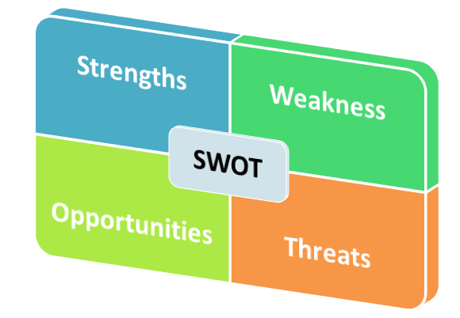
Figure 3: Four elements in the SWOT analysis
(Source: Developed by the author)
Below the SWOT analysis has been performed for Brewdog to assess the internal factors of Brewdog and its influence on the quality systems and controls for customers:
Strengths | Weakness
- Lack of dependency on other organizations as it is an independent company  - An innovative product such as crafted beer  - High brand value and brand reputation in the market  - Using the technological solution for measuring the quality of the products | - Limited customer segment  - Deficiency of clear cut distribution channel  - High competition in the market because of the existence of Sun King Brewing Company, Heineken, Partake Brewing, Reed's and others (Craft, 2021).
Opportunity | Threat
- The lower inflation rate of the UK as in 2020 it was only 0.85% (Statista, 2021b). In 2019, it was also 1.79% (Referred to Appendix 3).  - Internet marketing and sales through the process have increased the opportunity of gaining more customers in the post-Covid-19 situation. | - Increasing competition in the market because of the arrival of many new companies.  - High price increase of the raw materials after the Covid-19 situation in the UK market.
Table 2: SWOT analysis for Brewdog
(Source: Developed by the author)

Critically evaluates the benefits and challenges of developing and maintaining good customer relationships
It is observed that there are benefits as well as challenges in the maintenance of the customer relationship by the companies. Below these are discussed in the context of the Brewdog business in detail:
Benefits of developing and maintaining good customer relationships
The benefits of developing and maintaining good customer relationships by Brewdog are as follows:
High customer satisfaction
Managing the customer relationship is highly effective for Brewdog to satisfy the customers with their products. This is because Brewdog is able to know the customer needs and demands through this that helps them to develop products accordingly. In this context, The Voice of customer theory can be mentioned. From the view of Tabiaa and Madani (2021), The Voice of customer theory has been used to capture the requirements of the customer in the market. In this way, the theory focuses on a specific set of requirements of the customers. Considering the customer requirements is highly effective to satisfy the customers with their purchasing. In this way, managing customer relationships helps to generate customer satisfaction.
Better customer retention
Managing a good relationship with the customer helps in customer satisfaction, which helps in customer retention as well. Fulfilling the customer needs would be effective for Brewdog to gain more new customers among other competitors in the market. In this case, social exchange theory can be mentioned. In the view of Cortez and Johnston (2020) social exchange theory defines that human relationship and social behaviour is based on the exchange process. Therefore, it can be stated that in exchange for managing good relationships with the customer, Brewdog achieves a loyal customer base from them. In this way, it helps to achieve better customer retention by the company.
Better promotion of the products to the customers
A good customer relationship is also effective to protect the customer data in a defined manner. Through the relationship with the customer, Brewdog can use their personal data and utilize it in email marketing, texting and in other areas to promote their products or services. In this way, customer relationships are useful to promote the products to the customers.
Challenges of developing and maintaining good customer relationships
Besides benefits, there are challenges as well in developing and maintaining good customer relationships. They are discussed below in detail:
Personalization of business
In order to develop a good relationship with the customers, companies need to consider the customer's needs, demands and requirements for satisfying them with their products or services. It increases the chance of the personalization of business, therefore, Brewdog may need to compromise in their pricing of the products, packaging, services and others which can be the cause of lower profitability in the market.
Increase of customers’ expectation for discounts and offers
Another major challenge of maintaining good customer relationships is the enhancement of the customer expectation in the discounts and offers of the organization. That is why Brewdog customers may expect more rewards, offers, discounts and others from the company's side which can be the cause of competitive disadvantage in the market.
New customer issue
Along with this, a range of new customer issues arose as well by managing the customer relationship with the existing people. For this purpose, Brewdog can lose their new customers by prioritising the old customers and spending more budget on them. It can be a barrier to the customer growth of the organization in the market.

Ways to deal with the new situation and achieve the business objectives by developing and maintaining good customer relationships
It is a noticeable fact that in the Covid-19 situation in the world, a huge number of business firms have lost their business and competitive advantage in the market and Brewdog is not an exception. However, through the proper business tactics and strategies, it can be possible for Brewdog to deal with the new situation and to achieve business objectives by maintaining a good relationship with the customers in the market. Below, the ways are discussed in detail:
Adopting a multi-channel communication approach
In order to deal with the new situation and to achieve the business objectives, it is needed to adopt a multi-channel communication approach by Brewdog to enhance their relationship with the customers. From the view of Gai et al. (2018), multi-channel communication is a significant communication approach that happens by using multiple channels in business in order to communicate with more customers in business. As the company has to lose a huge number of customers in the Covid-19 situation, therefore a multi-channel communication approach will be highly effective for the company. For this purpose, it is required to use email marketing, enhancing the channels in social media marketing, using web portals, mobile applications and others to manage good relationships with the customers.
Analysing the customer demand in the current situation
According to the view of DMA (2021), the customers' needs and demands have changed massively in the Covid-19 situation in the world as customers have tended to redress their personal values and priorities. That is why it is required to analyse the customer needs and demand in the post-Covid-19 situation by Brewdog for managing the good relationship with the customers. For this purpose, it is required to conduct a market analysis by the company.
Changing in the business plan or model
In the post-Covid-19 of business, the business model of Brewdog should be changed by focusing on maintaining good relationships with the customers. This is because customers of modern days are more focused on the representation of the brand, offers of the organization to their customer, ways to communicate with the customer by the business firms and others (DMA, 2021). That is why, it can be stated that by changing the business model to be more customer-focused, Brewdog could achieve the business objectives significantly.
Appreciating the loyal customers
In order to deal with the new situation, it is also required to appreciate the loyal customer by Brewdog to retain their existing customer base. For this purpose, the company is needed to provide extra discounts and offers to the old customers in order to maintain a good relationship with them. Along with this, providing rewards with the purchasing of Beer to the old customers is also a process of appreciation of their loyalty.
In this way, by using these ways it would be possible for Brewdog to handle the situation of business decline in the Covid-19 situation in the world and to maintain a good relationship with their customer for achieving business objectives.

D) Identify the systems that support Brewdog quality processes 1200
Customer relationship management (CRM): Customer relationship management is one type of technology that helps to manage an organization's relationship and interaction with potential and existing customers. In this crisis period of COVID-19 Brewdog can apply this system to maintain the relationship with their customers and meet their requirements as well. The system helps to contact management, productivity, sales management, and others. The CRM system application in Brewdog will help to find new customers and prospect information that can ensure to build a strong relationship with them and grow the business faster. The customers who regularly purchase beverages including alcoholic and non-alcoholic drinks can be targeted through this system. As this is a COVID-19 crisis going on, hence most of the customers purchase the drinks online. According to a survey it has been found that most purchased products online are alcoholic beverages and that represents 55% revenue of online grocery shops (Statista, 2021). Therefore, it might be one of the effective strategies for Brewdog to attract customers and seek their attention online. CRM system will collect information through customers' websites, email, social media pages, and various other multiple channels where they are active socially.

Figure 4: CRM system
(Source: Pohludka and Stverkova, 2019)
The CRM tool will organize this information to share a complete record of an individual. CRM tools also can connect business applications to develop relationships with customers. This tool helps to engage with the customers by identifying their tastes and preferences as well. As per the view of Pohludka and Stverkova (2019), some of the advantages of a CRM system are; it helps to improve the bottom line of customers, identify and categorize leads, increase referrals from existing customers, offer better customer support, improve product and services. Therefore, this system will be effective for Brewdog to seek awareness through online platforms and make the purchase. In this context, VOC or Voice of process theory can be applied as well to identify the requirements of customers. This theory will help to analyze the perspective of customers in terms of alcoholic and nonalcoholic beverages for Brewdog along with that pricing policy also can be detected through this. Through VOC four types of aspects can be detected which include the needs of customers, hierarchy structure, priorities, and customer perception regarding the product.
As most of the company is facing loss during this COVID-19 pandemic, hence Brewdog needs to make a strategy to enhance all over productivity and on the other hand, a sarong realtor with customers also needs to be maintained. In this context, by application of VOC theory the company can identify the tastes of the customers in terms of beverages, based on that they can be targeted. The pricing factor is crucial in this situation therefore the company needs to maintain the price as low by comparing with other competitors which can help to seek awareness of costumes or significantly. Due to the pandemic the company needs to maintain certain rules and regulations of hygiene and safety as well. These precautionary measures can be highlighted through the CRM system on online platforms. CRM will help to target the customers through social media platforms and collect their basic information which will also help to organize the strategy for Brewdog. Hence, CRM will be an effective system for the organization in this COVID-19 crisis. Quality Management System (QMS)
During the COVID pandemic, customers' behaviours have rapidly changed regarding purchasing. Most of the customers have become health-conscious, and more focused on savings rather than purchasing. In this critical scenario, QMS will help fulfil good customer needs and retain their engagement with the organization.
QMS is a formalized system that is designed for documenting the process, responsibilities, and operational procedures in order to achieve quality policies, and accomplish organizational objectives (Afthanorhan et al. 2019). QMS will be beneficial for Brewdog in coordinating their organizational objectives with their customer’s actual needs and requirements. There is an international standard (ISO 9001:2015) of QMS that specifies the requirements that are to be addressed through this system.
Benefits in QMS
- QMS helps in meeting the customer's specific requirements by segments which will be beneficial for companies in terms of growing sales rates and developing a loyal customer base.
- It also helps in creating customer engagement by inaugurating proper communication channels with them.
There are mainly four types of QMS that are implemented for providing customers with a satisfying experience, such as quality planning, assurance, control, and improvement. Brewdog will get benefits from a QMS as it will allow the company to effectively collect customer feedback to improve the quality of its products. In this context, The Voice of customer theory (VOC) can be applied in order to get an insight into customers' real experience as well as their service expectations from the company.
How QMS can be effective during crisis times like the COVID pandemic: During the hardships of the COVID pandemic, most business organizations have struggled to address customer needs due to fluctuating work practices, and volatile market demands. Brewdog is not exempted from that situation. In critical conditions like the COVID pandemic, QMS can provide customers with quality assurance of the product, and provide them with a high-tech modern experience that can create a consistent safe-purchasing process. As most people have become frustrated, depressed due to constant lock-down conditions, thus "not-so-supportive" customer service can lead to potential loss of customers. QMS can effectively mitigate these issues by properly addressing their requirements. QMS also helps in assessing, monitoring, and reporting on the quality of the product thus providing satisfaction to consumers by fulfilling what they exactly want.
QMS supports caring for the customers by reaching out to them if they are not able to present for purchasing. It includes online supply, maintaining relationships through social media, and sometimes payment relief or even credit support. This helps in creating a positive customer relationship. QMS will help Brewdog in quickly introducing new delivery models that consist of low-touch options to maintain customer safety as well.

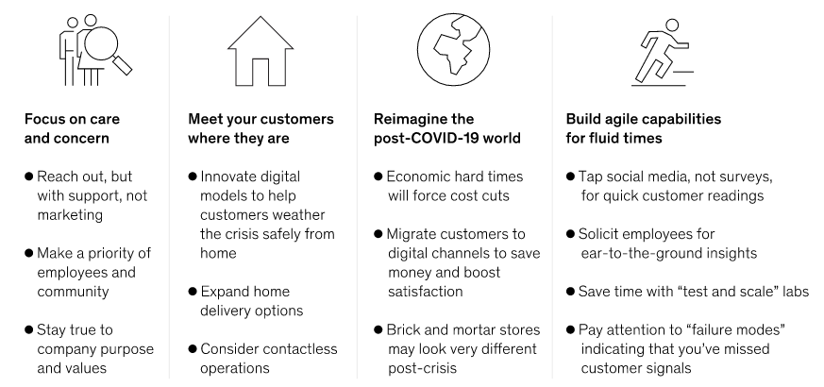
Figure 5: Representing four stages of an effective system that address customer needs during crises like the COVID pandemic
(Source: Mckinsey, 2020)

Conclusion
From the overall discussion, it has been understood that considering the improvement of customer experience has great importance to maintain a good relationship with them. In the post-Covid-19 situation of the business world, the customers' preferences for the past 6s and services has changed massively. It has reflected on the lower profit generation of Brewdog as well. In this case, the internal and external factors of the market have an influence also. The company needs to prioritize the changing needs of the customer's demands in the market besides adopting a multi communication channel approach for developing their relationship with the customer.

Reference list
Afthanorhan, A., Awang, Z., Rashid, N., Foziah, H. and Ghazali, P., 2019. Assessing the effects of service quality on customer satisfaction. Management Science Letters, 9(1), pp.13-24.
Brewdog. 2021a. Our History | Brewdog.[online] Available at: https://www.brewdog.com/uk/community/culture/our-history [Accessed 12 July 2021]
BrewDog. 2021b. FIVE PILLARS OF QUALITY. [online] Available at: <https://www.brewdog.com/blog/five-pillars-of-quality> [Accessed 22 July 2021].
Christodoulou, A. and Cullinane, K., 2019. Identifying the main opportunities and challenges from the implementation of a port energy management system: A SWOT/PESTLE analysis. Sustainability, 11(21), p.6046.
Cortez, R.M. and Johnston, W.J., 2020. The Coronavirus crisis in B2B settings: Crisis uniqueness and managerial implications based on social exchange theory. Industrial Marketing Management, 88, pp.125-135.
Craft. 2021. competitors of brewdog [online] Available at: <https://craft.co/brewdog/competitors#:~:text=BrewDog's%20competitors,Company%2C%20Partake%20Brewing%20and%20Reed's.&text=BrewDog%20is%20a%20craft%20beer,in%20a%20variety%20of%20styles.> [Accessed 21 July 2021].
Dma. 2021. Adapting customer experience in a post-Covid world | DMA. [online] Available at: <https://dma.org.uk/article/adapting-customer-experience-in-a-post-covid-world> [Accessed 29 July 2021].
Gai, K., Qiu, M., Xiong, Z. and Liu, M., 2018. Privacy-preserving multi-channel communication in edge-of-things. Future Generation Computer Systems, 85, pp.190-200.
Heyes, S., 2021. BrewDog Revenue Growth last 10 years - Adventure Bagging. [online] Adventure Bagging. Available at: <https://adventurebagging.co.uk/2015/01/own-shares-brewdog-equity-punk/brewdog-revenue-growth/> [Accessed 22 July 2021].
Hodges, C., 2020. The Consumer Protection Act 1987. In Product Liability: Law and Insurance (pp. 59-86). Informa Law from Routledge.
Kowalik, K. and Klimecka-Tatar, D., 2018. The process approach to service quality management. Production Engineering Archives, 18.
Kumar, V. and Reinartz, W., 2018. Customer relationship management. Springer-Verlag GmbH Germany, part of Springer Nature 2006, 2012, 2018.
Mckinsey, 2020. Adapting customer experience in the time of coronavirus. [online] mckinsey. Available at: <https://www.mckinsey.com/business-functions/marketing-and-sales/our-insights/adapting-customer-experience-in-the-time-of-coronavirus> [Accessed 20 July 2021].
MIT, 2021. The Voice of the Customer theory.[online] Available at: https://www.google.com/url?sa=t&source=web&rct=j&url=https://www.mit.edu/~hauser/Papers/Gaskin_Griffin_Hauser_et_al%2520VOC%2520Encyclopedia%25202011.pdf&ved=2ahUKEwjeybGu9f3xAhWzwjgGHREwD_4QFjABegQIAxAG&usg=AOvVaw1X_T1_qSSp4N2G1Kb4xVhe [Accessed 24 July 2021]
Ons. 2021. Coronavirus and the impact on output in the UK economy - Office for National Statistics. [online] Available at: <https://www.ons.gov.uk/economy/grossdomesticproductgdp/articles/coronavirusandtheimpactonoutputintheukeconomy/november2020> [Accessed 25 July 2021].
Partridge, J., 2021.BrewDog hit by £13m loss as bars close due to Covid despite craft beer boom.[online] Available at: https://www.google.com/amp/s/amp.theguardian.com/business/2021/jul/21/brewdog-hit-by-13m-loss-as-bars-close-despite-craft-beer-boom [Accessed 11 July 2021]
Phadermrod, B., Crowder, R.M. and Wills, G.B., 2019. Importance-performance analysis based SWOT analysis. International Journal of Information Management, 44, pp.194-203.
Pohludka, M. and Stverkova, H., 2019. The best practice of CRM implementation for small-and medium-sized enterprises. Administrative Sciences, 9(1), p.22.
Statista, 2021. UK: Most commonly bought grocery products online 2021 | Statista. [online] Statista. Available at: <https://www.statista.com/statistics/1218481/most-common-online-grocery-categories-uk/> [Accessed 19 July 2021].
Statista. 2021. COVID-19: daily year-on-year global restaurant dining decline 2021 | Statista. [online] Available at: <https://www.statista.com/statistics/1103928/coronavirus-restaurant-visitation-impact/> [Accessed 23 July 2021].
Statista. 2021b. United Kingdom - Inflation rate 2026 | Statista. [online] Available at: <https://www.statista.com/statistics/270384/inflation-rate-in-the-united-kingdom/> [Accessed 24 July 2021].
Tabiaa, M. and Madani, A., 2021. Analyzing the Voice of Customer through online user reviews using LDA: Case of Moroccan mobile banking applications. International Journal, 10(1).

Appendices

Appendix 1
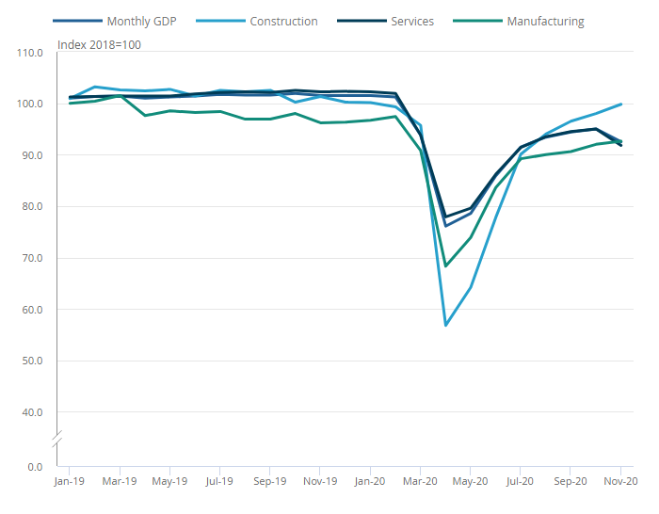
(Source: ONS, 2021)

Appendix 2
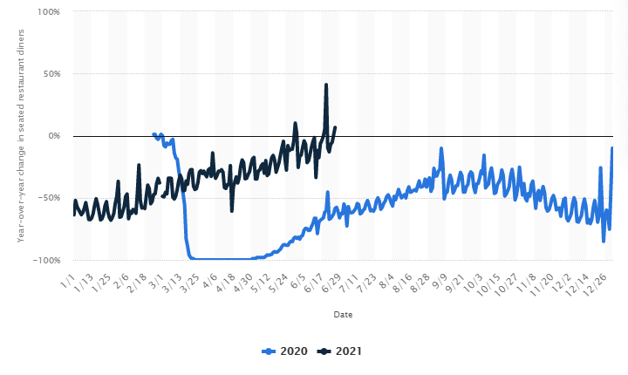
(Source: Statista, 2021a)

Appendix 3
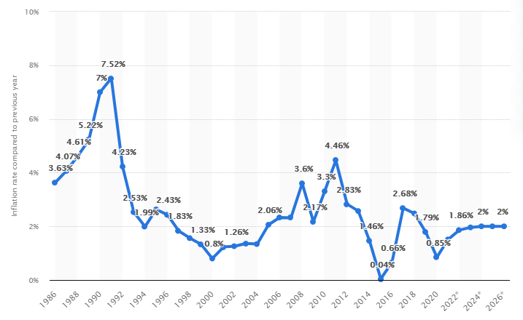
(Source: Statista, 2021b)

