Student Self Evaluation Form
This section repeats in brief the common assessment criteria detailed on previous pages. The extent to which these are demonstrated by you determines your mark. Using these criteria, tick the box that best indicates the level of achievement you feel you have achieved with regard to each of them.
Common Assessment Criteria Applied
Common Assessment Criteria Applied | REFER |  | D | C | B | A
 | OUTRIGHT FAIL | UNSATISFACTORY | SATISFACTORY | GOOD | VERY GOOD | EXCELLENT
1. Subject Knowledge and Understanding (which includes using research-informed literature and knowledge and understanding of the subject)
2. Intellectual Skills (Analysis)
3. Pedagogic and Professional Applications (Practical Application and Deployment)
4. Key Transferable Skills

PLEASE COMMENT ON AREAS IN WHICH YOU FEEL THAT YOU HAVE PERFORMED WELL | PLEASE COMMENT ON AREAS you feel that you need TO DEVELOP
I feel I have tracked the child as best I could within the time given, understood and used the curriculum documents well to judge where the learner currently is in terms of attainment and what her next steps would be. I feel I have used my own teaching philosophy based on research and practice, to suggest next steps. | I don’t feel I have been very critical and found it difficult to combine research, be critical and use the outcome descriptors whilst sticking to the word count.

Title: Supporting pupil progress: a detailed analysis of one child’s holistic development, with justification for the next steps in learning.
Student Number: 1700782
Group: 5
Word Count: 4,949

Introduction
This data analysis was conducted in a large primary school in an area with high unemployment rates and is considered a deprived catchment area. The free school meal percentage is above 50% which is over double the national average.
The child was chosen at random from a Year 2 class list and it was confirmed by the class teacher that the pupil has high attendance levels. The process of data collection was discussed and agreed upon between the researcher, learner and class teacher and upon agreeing that the study was ethical and appropriate, the class teacher signed a letter of approval (See Appendix 1). Furthermore, adhering to ethical recommendations (e.g. BERA, 2011; EWC, 2017; UWTSD, 2017-2020), the purpose of the study was fully explained to the learner in a child friendly manner along with an explanation of her right to withdraw at any time without any adverse consequences. The learner provided accent to participate (See Appendix 2) and continued assent was sought throughout the data collection process.
Data Collection
The report uses learner observations, interviews and work samples to draw conclusions about attainment outcomes and identifies strategies to support the learner progress. Personal details of the child and school will remain anonymous to protect confidentiality. The child will be referred to by a false name, ‘Pearl’, throughout the assignment to protect her true identity but to allow the report to feel personal and have meaning.
The method of data collection was based upon the ‘Mosaic Approach’ proposed by Clark and Moss (2011) and how it was used in the current study is outlined within ‘figure 1’ on the following page. The Mosaic Approach has three stages: firstly, to gather information about children by including them in the process; secondly, to listen to their perspectives of learning and to encourage them to reflect on their experiences to co-construct meaning of what it is like to learn in their environment; and lastly, to decide on continuity and change for the benefit of the learner (Clark et al., 2011). The researchers suggest that it can be done through a multi-method approach that is accessible to young children and not reliant on the written or spoken word but to use pictures, cameras, learning walks, observations and interviews, to form a ‘living picture’ of what their learning environment is like as perceived by themselves (Clark et al., 2011).
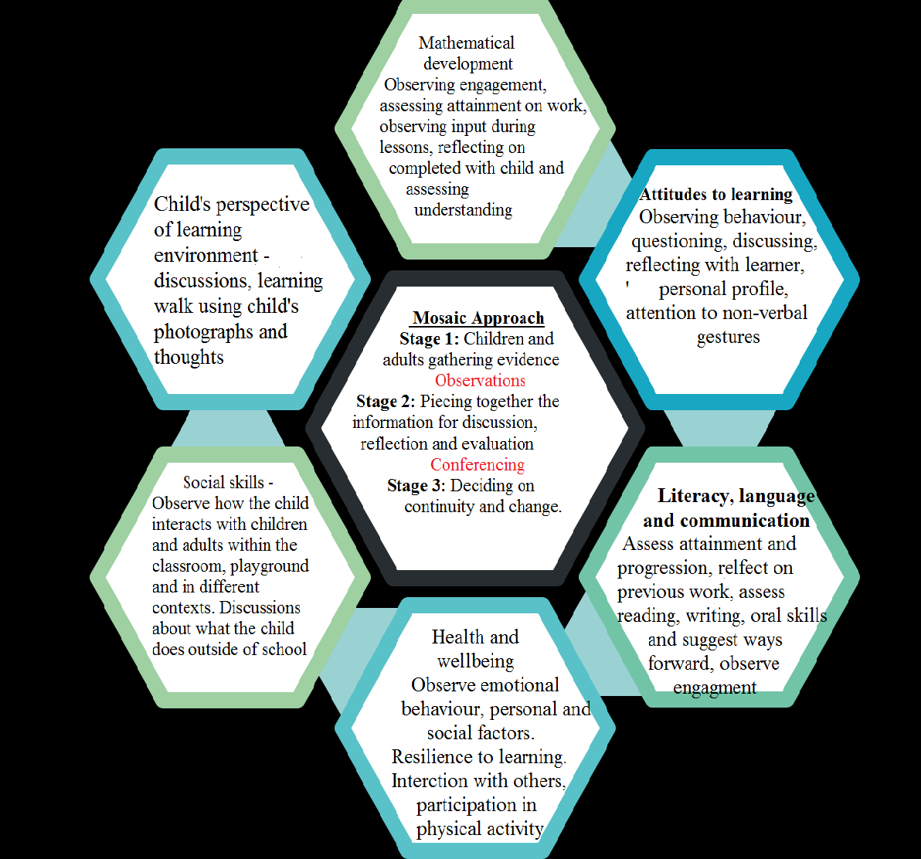
Figure 1 – Data collection plan based upon the Mosaic approach proposed by Clark and Moss (2011)
Clark et al. (2011) propose that listening is an active process that requires interpreting and constructing meaning in a reflective process led by the child to increase the understanding of attitudes and perceptions held by the child. Whilst it could be argued that observer interpretation of behaviours and qualities could lead to biased data, for example Cohen et al. (2007) suggest that intention and motivation cannot be inferred from observation, Clark and Moss argue that interpretation is an essential part of the reflection process. The key difference in this approach is that children are central (i.e. ‘co-constructors’) to the interpretations.
Classroom observations formed a large part of the data collection, strengths of which are that it is first-hand data from naturally occurring events and captures social behaviours among the classroom that may go unnoticed when teaching (Cohen et al., 2007). Furthermore, as the current research used unstructured observations based on opportunity, the likelihood of biased data should be reduced because there was no pre-observation hypothesis to select data for, conclusions were drawn following observations.
Another strength of the observation method is that data should not have been effected by selective memory as they were written up during the observations although potentially, this may have made them more susceptible to the observer effect (Cohen et al., 2007). Similarly, being observed by teachers (i.e. a figure of authority) may have caused the observer effect (Cohen at al., 2007) although this forms part of normal classroom practice and particularly in this case, where the child was a target child of the teacher’s for moderation and so was used to being filmed and observed.
As suggested by Clark et al. (2011) the current researcher did question the child and encourage their interpretations and reflections in part and in doing so, the biases discussed will hopefully have been reduced to a minimal amount. The researcher is aware that the most reliable interviews occur when participants are aware of the purpose and are at ease (Cohen et al., 2007). Therefore, in the current study, always took place informally, within the classroom as part of normal classroom practice and ‘Pearl’ was aware of the purposes. Dudley (2014) also suggested that the outcome of interviews depends on the relationship, communications and understanding between the teacher and learner. A good, trusting rapport with the learner and researcher in comfortable, informal surroundings should secure the validity of data.
Informal discussions can also be useful to clarify perceptions, expand and reflect upon things and clarify ambiguous points as identified by Catane (2000). However, their unstructured nature can also pose a threat to reliability as it generates data that may be difficult to quantify. Furthermore, Csiernik et al. (2017) stress that the researcher must be careful not to ask leading questions and as much as is possible to control, to refrain from giving unconscious signals of approval or disapproval.
The final data collection method was accumulating examples of the learner’s work and using curriculum documents to track their attainment, progress and to suggest next steps. Whilst levelling work is useful for this purpose, it is acknowledged that it is a highly subjective method causing problems even within experienced teachers and school tracking systems due to different perceptions. Coupled with this, my inexperience in assessing using the outcomes, may lead to interpretational errors. Therefore, the class teacher was consulted when making judgements of best fits to describe the current attainment of the learner.
In support of the Mosaic Approach, Walsh et al. (2003) argue that using a range of data collection methods counteracts the weaknesses of one another suggesting using a multi-method approach as used in the current study, provides strong, reliable data.
Analysis of learner
The analysis will be structured based on the ASK model proposed by Nottingham (2013). Therefore, the data will be explored within three broad categories including the attitudes, skills and knowledge of the learner, respectively, to develop a coherent picture of the child’s current achievement and attitude towards their learning. The following section will then discuss how using an integrated development of skills, attitudes and knowledge will support the learner to progress to the next steps.
The child observed was 7 years of age and although born and schooled in Wales, comes from a Chinese family background. She lives in the family home with her mother and younger brother whilst her father works away, returning home occasionally. The child is bilingual, speaking both English and Mandarin and attends Mandarin school on Saturdays which she enjoys and occasionally shares knowledge with her class.
Pearl has a positive attitude towards learning which was evident from one of the earliest conversations. As evidenced by the personal profile completed by Pearl (Appendix 3) she expressed her positive attitude when asked about what she likes about school, responding by saying she likes ‘everything’ and there is ‘nothing’ she does not like about school. The discussion was informal, Pearl was at ease and very sincere. Furthermore, when asked what she was good at, she described herself as being ‘good at everything’. With some discussion and thought, she then responded by saying she is good at ‘meeting people’ and would like to improve at ‘dance’. It took some explaining that it is fine to not be great at everything and as will be discussed throughout the report, some attitudes and attributes described suggest aspects of a fixed-mind-set which will be something to work on.
Nevertheless, Pearl appears a confident individual with a positive attitude towards learning, demonstrating many attributes associated with outstanding learners as described by Nottingham (2013).
Pearl demonstrated curiosity by wanting to know what she had missed when she had been absent due to participation in a reward for full attendance. She was the only child who returned eager to find out what she had missed and sought to ‘catch-up’. Pearl engages with a broad range of tasks and activities as evidenced throughout the learning walk and through various observations and is independent in her choices, sometimes choosing to join in with others and other times following her own choice and has been observed using all the areas of learning.
During discussions, Pearl has implied that she does a lot of learning at home, e.g.
“I have to write every single day when I go home” (See Appendix 4)
This emphasis on the importance of learning knowledge may have been adopted through attitudes valued by the family and would support the cultural learning model developed by Vygotsky (ND, cited in Berk, 2009). This may also be the reason behind Pearl’s choice of free choice activities when given the option, she more often than not chooses construction or role play with peers even though she expressed an enjoyment of colouring within the learning walk, has not been observed doing it (See observations in Appendices 5-7).
Furthermore, she indicated that she would like to get better at dance but does not attend dance classes and as observed, there is little opportunity within school to develop such skills. School and family seem to portray a positive attitude and emphasis towards learning knowledge and skills reflected in the core curriculum areas.
“On Fridays I play …. It’s the only day that I don’t have to do work” (See Appendix 4)
During the learning walk, Pearl took photos of the reading corner and creative area and described them as areas of importance within her learning environment (See Appendix 7). However, upon reflection said:
“I wish we could do more colouring” and “I don’t go in there (book corner) …it’s a little bit boring reading books”.
Upon expansion, suggesting that books of interest and familiar stories would make it more appealing. During this reflection, she also brought me a sounds game from within the corner expressing a preference to playing games involving reading rather than reading books.
Whilst Pearl demonstrates curiosity and persistence which has been documented in a number of observations (See Appendix 8-9), she also appears to not like making mistakes although this is a reflection of many children within the classroom. For example during a reading exercise, Pearl read fluently and independently at a best fit outcome 6, but when she came across any unfamiliar words (which was rarely), she read them quietly and quickly without seeking clarification or support. Again, suggesting attributes of a fixed-mind-set.
In terms of engagement, Pearl shows many aspects of an outcome 6 but has not demonstrated the skill ‘to ask for support’. Having said this, when support has been offered, Pearl listens and engages with the support to learn from her mistakes and persists with challenges. In these situations, her persistence has enabled her to move her learning forward but she has not been seen to seek the support herself. This could be for a number of reasons and would be worth exploring with her to move her learning on and build resilience.
As well as attitudes towards learning, the ASK model stresses the importance of the skills required to learn (Nottingham, 2013) mainly intellectual, social, physical and communication skills. Pearl shows well developed intellectual skills by engaging during whole class and small group discussions and when studying division in mathematics for example, was able to make links with previous learning of multiplication and asked relevant questions to aid her understanding and draw conclusions.
Pearl has well developed social skills as identified by herself in the ‘personal profile’ and within the learning walk, where she identified an enjoyment for social activities.
For example, referring to the role play area:
“I love to cook . . . be the customer . . . with my friends”
and supported by an observation where she chose to join in a social activity with friends over colouring, an activity she enjoys (See observation in Appendix 6). The evidence suggests that a best fit judgement for Personal and Social development, well-being and cultural diversity would be Outcome 6. There is evidence of Pearl showing awareness of the needs of others by adopting behaviour and language and shows respect and plays fairly according to the rules of games (As described in the Foundation Phase Profile Handbook, Welsh Assembly Government (WAG), 2017). Pearl always demonstrates appropriate behaviour for different situations and exercises appropriate self-control. Whilst Pearl responds to others with respect, numerous observations question this. For example, when asked what she thought of a peer’s creation, she simply did not respond (Evidenced in Appendix 5). It could be argued that this shows awareness of the feelings of others if she did not want to hurt their feelings or it could be argued that she is not able to respond sensitively to the emotions and achievements of others. Unfortunately, clarification was not sought on this occasion therefore one is unable to make inferences. It may also link to Literacy, Language and communication (LLC) and be a sign that Pearl is unable to express likes and dislikes with consideration for the feelings of others. This is an area that would require further exploration in order to support the learner develop this skill.
Pearl is able to work individually and as part of team. However, during a paired task whilst Pearl and her partner talked before and throughout their task demonstrating a high level of thought and preparation regarding their answers and presentation, (particularly compared to their peers), which is characteristic of an outcome 6 with regards to collaboration, little things made it evident that Pearl had her own expectations that she wanted followed. Whilst she was not verbally rude, she erased part of her partner’s input because it was not ‘straight’ or in the ‘correct’ position as deemed by Pearl (See Appendix 10). This observation may be a suggestion that other observed activities where Pearl was seen to be ‘on task’ and persevering whilst the rest of the group where disengaged (Appendix 9). Perhaps weaknesses in Pearl’s collaborative skills led to the disengagement and might support earlier judgements that there may be weaknesses in the consideration of others when working to achieve a common goal. These are all inferences and must be taken with caution, further exploration is needed.
The Foundation Phase Framework (FPF) acknowledges the importance of developing sound physical skills to support the development of all other skills (WAG, 2015). With regards to physical skills, Pearl has a mature pencil grip and good control with the ability to draw pictures that are proportionate with an awareness of the position of objects in relation to each other (WAG, 2017). Furthermore, Pearl is able to use her hands with confidence, coordination, control and fluency to manipulate resources for a purpose. For example, this has been seen when dressing ‘Tedi Twt’, personal care and building models using construction. Pearl enjoys creative tasks and throughout curriculum areas has shown the ability to cut out complex pictures and shapes staying on the line most of the time.
Pearl has not been observed during physical education and so it is difficult to evaluate although Pearl moves around the classroom and plays in the yard with control and coordination. Some movement activities within the classroom demonstrate Pearl’s ability to take account for the position and movement of others and she has expressed an enjoyment of learning through movement within a pupil voice exercise.
Overall, within physical development for the strands evidenced, Pearl’s best fit outcome would be 6 although within the ‘improving performance’ strand would be an outcome 5. The reason for this is within a creative activity whilst being able to work safely with peers and explain what they had done, she was unable to give relevant feedback to peers to evaluate the performance of others. In relation to this, she has also been unable to evaluate her own learning, for example during plenaries commenting,
“nothing was challenging” and “I could do it all”
which as previously mentioned, may come back to her mind-set and how she views learning and making mistakes.
Finally, Pearl shows good communication skills with observations suggesting that she is able to ‘talk about an idea and things she has done explaining the processes in detail and uses relevant vocabulary’. An outcome 5 would be a best-fit judgement for communication skills as on a number of occasions she has used resources to help her explain. It is acknowledged that this is a good and developed strategy to use as it shows an awareness of the listeners needs by using resources to help clarify and explain relevant detail, although it indicates that she is not quite an outcome 6 ‘talking extensively and using expressive language to emphasise key points’ (WAG, 2017). This could indicate a language barrier, nevertheless, as mentioned, Pearl is able to use resources to get her point across to the listener and importantly, has found a strategy to do this and is aware of this need.
Pearl communicates clearly, to a wide range of audiences with increasing confidence and fluency. However, she does not consistently differ tone or intonation for different situations. Pearl is always polite and respectful when communicating throughout the school and pays attention to understand the speaker.
In relation to the knowledge aspect of the ASK model, a select few areas of the national FPF will be discussed with reference to the ‘best-fit’ outcome at which Pearl is currently achieving.
Within mathematical development, Pearl has demonstrated understanding with a best-fit of outcome 6, although it must be acknowledged that evidence has only been gathered for some strands of mathematical development due to time constraints and could differ within other aspects. Evidence gathered shows that Pearl is ‘able to count large sets of objects using a range of strategies’ which has been demonstrated through recent multiplication and division work where she is also able ‘to use the 2, 3, 4, 5, and 10 tables to solve multiplication problems’ and is beginning to apply this knowledge to ‘solve division problems within 100’ using concrete resources to support when needed (WAG, 2017).
Demonstrating skills of an outcome 5, Pearl was able to pay for items up to £2 and give change from 20p, using her preferred strategy which was counting backwards from 20. Pearl was observed to be confident and persistent to take on a challenge and try giving change from £1. However, she was unable to think of a more suitable strategy to calculate the change. At this, the teacher encouraged her to use an adding-on strategy and supporting a statement made previously about listening to advice to aid understanding, Pearl persisted with the task and her understanding and confidence grew. When Pearl reflected on this activity afterwards, whilst she was not able to fully articulate how she had completed the activity, she was able to show with accuracy how it would be solved. This suggests that she is beginning to use different strategies and give change from £1 using her knowledge of place value. Later, Pearl evidenced that she as able to order and compare items up to £10 and record money using decimal notation. There is a mixture of skills from different outcomes being displayed, Pearl has achieved outcome 6 whilst there are elements of outcome 5 that need consolidation.
The estimating and checking strand was evidenced through a topic activity where Pearl estimated the height of flowers and checked them to the nearest cm and within mathematics is able to check multiplications using repeated addition and knowledge of inverse operations (evidenced by multiplication pic collage see Appendix 11). These skills demonstrate a best-fit outcome 6.
Pearl also demonstrates many skills from outcome 6 within LLC. For example in the literacy oracy strand, Pearl ‘uses relevant comments and questions to show that she has listened carefully’ and ‘makes connections between information from a speaker and what she already knows’ (WAG, 2017). This is evident from interacting with Pearl and her input during lesson introductions and plenaries. However, within some aspects such as phonological awareness, whilst her ability to use phonological knowledge is reflected in her reading and writing and she can ‘orally blend and segment polysyllabic words’, she is only beginning to recognise rhyme and failed to include it in a poem, whereas she was able to use alliteration and similes.
In addition to this, Pearl showed little creativity when asked to make a simple song/rhyme within mathematics and shows more of an outcome 4 for this skill with evidence of her creating a simple poem based on a familiar model provided by the teacher. This however, could reflect creative skills and the lack of opportunity to develop them rather than LLC skills.
Pearl is able to read and understand a range of materials independently and fluently and identifies the different purposes and features of texts and how they are organised. She ‘skims content and selects text based on the content’. This was evident when she read a non-fiction book, scanned the headings and read sections she was interested in or was familiar with (See Appendix 12). Other reading observations have highlighted that whilst Pearl can identify the uses of punctuation, this is not reflected through change of inflection or pace in her reading.
Within writing, Pearl forms letters correctly, consistently and that are legible. She uses strategies to spell high-frequency poly-syllabic words correctly. Pearl is able to use connectives consistently which was evidenced through discussion writing. She is also able to use ordering words and uses simple grammar accurately. Within punctuation and grammar, a best-fit judgement would be an outcome 5 as use of expressive punctuation is not evident in her writing and other areas are not independently or consistently used in her writing.
Similarly, writing work is characteristic of an outcome 5 within the ‘genre’ strand. Pearl is able to build on a form modelled by an adult to write in a ‘language and structure that is suitable for different audiences’. However, as evidenced by work produced from the ‘three day write’, Pearl demonstrates some outcome 6 skills such as organising writing, re-reading it and improving it for a final draft but again, with support and guidance.
Next steps
Pearl demonstrates some aspects of a fixed-mind-set which would be the first thing to address as it effects learning across the curriculum. Attributes that suggested a fixed-mind-set were not seeking support or identifying mistakes/challenges, and comments such as “I’m good at everything”. Strategies to encourage a growth mind-set would be whole class strategies that promote a reflective and collaborative classroom ethos where children learn it is acceptable, healthy and positive to make mistakes and learn from them (Hattie, 2012). Assessment for learning strategies, across the classroom, building the ability to spot mistakes and suggest improvements, would help develop a growth mind-set although this would take time to build the children’s confidence in sharing their work and to build their reflective skills whereby they refer to the learning objectives and success criteria. Dweck (2006) also stresses the impact of praise used among the classroom which needs to be learned by the staff, to ensure they are referring to the action rather than labelling the child (similar to when addressing behaviour), to help the child recognise the action that enabled them to achieve.
In relation to this, and which may also develop weaknesses identified in Pearl’s collaborative skills, would be to encourage a growth mind-set that encourages the learner to set and work towards their own learning goals rather than comparing to others. This would also be developed from an emphasis on team work skills which could be achieved through activities whereby children need to work together and use each other’s strengths to complete an exercise (for example, outdoor blind-fold activity). This may support Pearl to realise the benefits of team work and collaborative skills.
Whilst Pearl displays positive attitudes towards learning throughout the classroom and school, she seems to be seeking a different, perhaps less formal way of learning. As discussed this may be being reinforced at home due to her cultural background as it is understood that Chinese culture place high emphasis on academic success which often has a negative effect on the well-being of young people (Qinghal et al., 1995; Quach et al., 2015). Whilst Pearl is not demonstrating these effects on her well-being, she has made reference to the amount of work she does at home and chooses less structured activities to ‘play’ within school. To support Pearl, she should be exposed to a range of learning opportunities and curriculum areas. Pearl unfortunately does not have the opportunity to partake in dance sessions because the emphasis appears to be on curricular subjects at home and within school. Therefore, within mathematics we have been learning multiplication through movement and within a pupil voice exercise Pearl expressed her enjoyment for learning through this activity and it supports her identification of areas she would like to develop ‘dance’. Cross-curricular learning and ensuring there is a balance to the areas of learning that are taught, would support Pearl in her enjoyment for learning and allow her to develop a broad range of skills highlighted by the FPF as statutory for our young children. Furthermore, in the long-term, would protect her well-being.
Pearl can read fluently and independently but remarked that the book corner was boring, therefore perhaps she needs more ownership and choice to capture her interest and to extend her skills to read a broader range of reading material. To do this, she could practice library skills and choose her own book. If possible this would be best done through a community library so that she is building knowledge and life-long learning skills (Donaldson, 2015).
In relation to developing the LLC skills mentioned in the previous section, a creative cross-curricular approach would be recommended. For example drama activities could be introduced, building on oracy skills to show an understanding of punctuation through altering intonation and using expression. This would also develop other areas of weaknesses such as creativity, using rhyme, poems and developing genre writing which could be explored following the oracy activities. These activities could incorporate skills from the Digital Competence Framework (DCF; Donaldson, 2015) such as filming and editing the drama which could then be replayed and reflected upon by the children to build those ‘evaluating performance’ skills identified as a gap in Pearl’s learning. Furthermore, it provides rich learning experiences allowing Pearl the opportunity to develop a broad range of skills in a variety of forms, and most importantly capturing curiosity and maintaining her interest in learning.
In opposition to this, where it was noted that Pearl was unable to reflect and identify challenges in her own learning, perhaps the activities were genuinely not challenging enough. It was noted during a topic activity that Pearl could have moved on to measuring metres or even explored the matter to problem solve, but because she was in a particular ‘attainment group’, she was not given the opportunity and the teacher allowed the activity come to a close. To move Pearl’s learning on, she needs to be given the right level of challenge. For example, using tasks that are accessible to all but are open ended. Furthermore, Pearl’s learning would progress from a range of cooperative groups rather than limiting to ability grouping as it may not be having a positive effect on her learning (e.g. Hattie, 2012; Marzano et al., 2001 cited in Nottingham, 2013).
Lastly in relation to Mathematical development, Pearl needs to consolidate her understanding of giving change from £1 and then from £2 to achieve an outcome 6. This could be done using the role-play area within a focused group activity and then within enhanced provision to practise the skill.
The final recommendation would be to reinforce and demonstrate a deeper understanding of mathematical concepts through techniques such as those used in ‘maths mastery’ whereby children complete a sum and argue their decisions stating whether they agree or disagree, using concrete, pictorial, written and mental strategies. This will show a deeper understanding rather than progressive learning which will be able to be applied to different concepts and situations. Particularly for Pearl, explaining her understanding and choice of methods will also develop her LLC oracy skills identified as a weakness by building her language range and skills. The next step for development within mathematics was to apply multiplication knowledge to division and begin to understand remainders which could be developed using the suggested strategy.
Conclusion
This process has developed my understanding of the curriculum outcomes and how to assess where a child is now and to determine what learning opportunities I as a practitioner can prepare, to support them to progress to the next stages of development, across the areas of learning.
Personally, it has been beneficial to track a child who is of a high attainment level as their next steps of development can be less obvious, and regrettably not always met within a classroom. It has been a valuable process highlighting the need for practitioners to ensure they are meeting the needs of all learners using a wide range of strategies across all areas of learning and development. Furthermore, I am more aware of how home life and well-being can be effected, even in less obvious ways, and will endeavour to pay attention to the whole child development throughout my practice to help all children reach their potential and grow to be confident, healthy, life-long learners (Donaldson, 2015).

References
BERA (2011) Ethical guidelines for educational research. London: BERA, Available at: https://www.bera.ac.uk/wp-content/uploads/2014/02/BERA-Ethical-Guidelines-2011.pdf [Accessed: 19th February 2018]
Berk, L. E. (2009) Child Development. (8th ed) Boston: Pearson
Catane, J. (2000) Conducting Research: A Practical Application (Revised ed) Quezon City: JMC Press INC.
Clark, A. and Moss, P. (2011) The Mosaic Approach (2nd ed) London: NCB. [ebook] Available at: https://www-dawsonera-com.ezproxy.uwtsd.ac.uk/readonline/9781907969423 [Accessed: 22nd April 2018]
Cohen, L., Manion, L. and Morrison, K. (2007) Research Methods in Education. (6th ed) London: Routledge.
Csiernik, R. and Birnbaum, R. (2017) Practising Social Work Research. (2nd ed) Toronto: University of Toronto Press. [online] Available at: https://utorontopress.com/us/practising-social-work-research-7 [Accessed: 27th may 2018]
Donaldson, G. (2015) Successful Futures: Independent Review of Curriculum and Assessment Arrangements in Wales. [online] Available at: http://gov.wales/docs/dcells/publications/150225-successful-futures-en.pdf. [Accessed 7th April 2018]
Dudley, P. (2014) Lesson Study: A Handbook. LSUK. Available at: http://lessonstudy.co.uk/wp-content/uploads/2012/03/new-handbook-revisedMay14.pdf [Accessed on 24th March 2018]
Dweck, C. S. (2006) Mindset: The new psychology of success. New York: Random House. [ebook] Available at: http://psycnet.apa.org/record/2006-08575-000 [Accessed: 27th May 2018].
Hattie, J. (2012) Visible Learning for Teachers: Maximizing Impact on Learning. Oxon: Routledge. [ebook] Available at: https://books.google.co.uk/books?hl=en&lr=&id=vSoUT6PXdoIC&oi=fnd&pg=PP1&dq=hattie+2009+visible+learning+for+teachers&ots [Accessed: 26th May 2018]
Nottingham, J. (2013) Encouraging learning: How you can help children learn. Oxon: Routledge.
Qinghal, C. and Lin, J. (1995) Academic pressure and impact on students’ development in China. McGill Journal of Education, 30, 2. [online] Available at: http://mje.mcgill.ca/article/view/8237/6165 [Accessed: 29th May 2018].
Quach, A. S., Epstein, N. B., Riley, P, J., Falconier, M. K., and Fang, X. (2015) Effects of Parental Warmth and Academic Pressure on Anxiety and Depression Symptoms in Chinese Adolescents. Journal of Child and Family Studies, 24, 1, pp 106–116. [online] Available at: https://link.springer.com/article/10.1007/s10826-013-9818-y. [Accessed: 29th May 2018].
UNICEF UK (1990) The United Nations Convention on the Rights of the Child. London: UNICEF. [Online]. Available from: http://www.unicef.org.uk/Documents/Publication-pdfs/UNCRC_PRESS200910web.pdf [Accessed: 15th March 2018].
University of Wales Trinity Saint David (2017-2020) Research Ethics and integrity code of practice. UWTSD, Available at: http://www.uwtsd.ac.uk/media/uwtsd-website/content-assets/documents/research/research-ethics-integrity-code-practice.pdf [Accessed on 19th February 2018]
WAG (2015) Curriculum for Wales: Foundation Phase Framework. Cardiff: Welsh Assembly Government. [online] Available at: https://beta.gov.wales/sites/default/files/publications/2018-02/foundation-phase-framework-revised-2015.pdf [Accessed on: 14th April 2018]
WAG (2017) Foundation Phase Profile Handbook. Cardiff: Welsh Assembly Government [online] Available at: https://gov.wales/docs/dcells/publications/170906-foundation-phase-profile-en.pdf [Accessed on: 14th April 2018]
Walsh, M. and Wigens, L. (2003) Introduction to Research. Cheltenham, Nelson Thornes Ltd. P 104. [ebook] Available at: https://books.google.co.uk/books?hl=en&lr=&id=UhPvq66yVkQC&oi=fnd&pg=PR5&dq=Walsh,+M.+%26+Wigens,+L.+(2003),+Introduction+to+Research&ots [Accessed: 12th May 2018]

Appendix 1
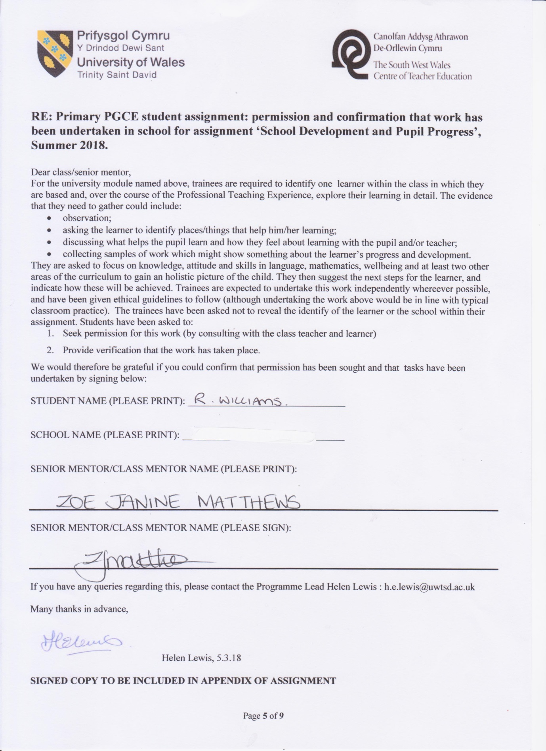

Appendix 2
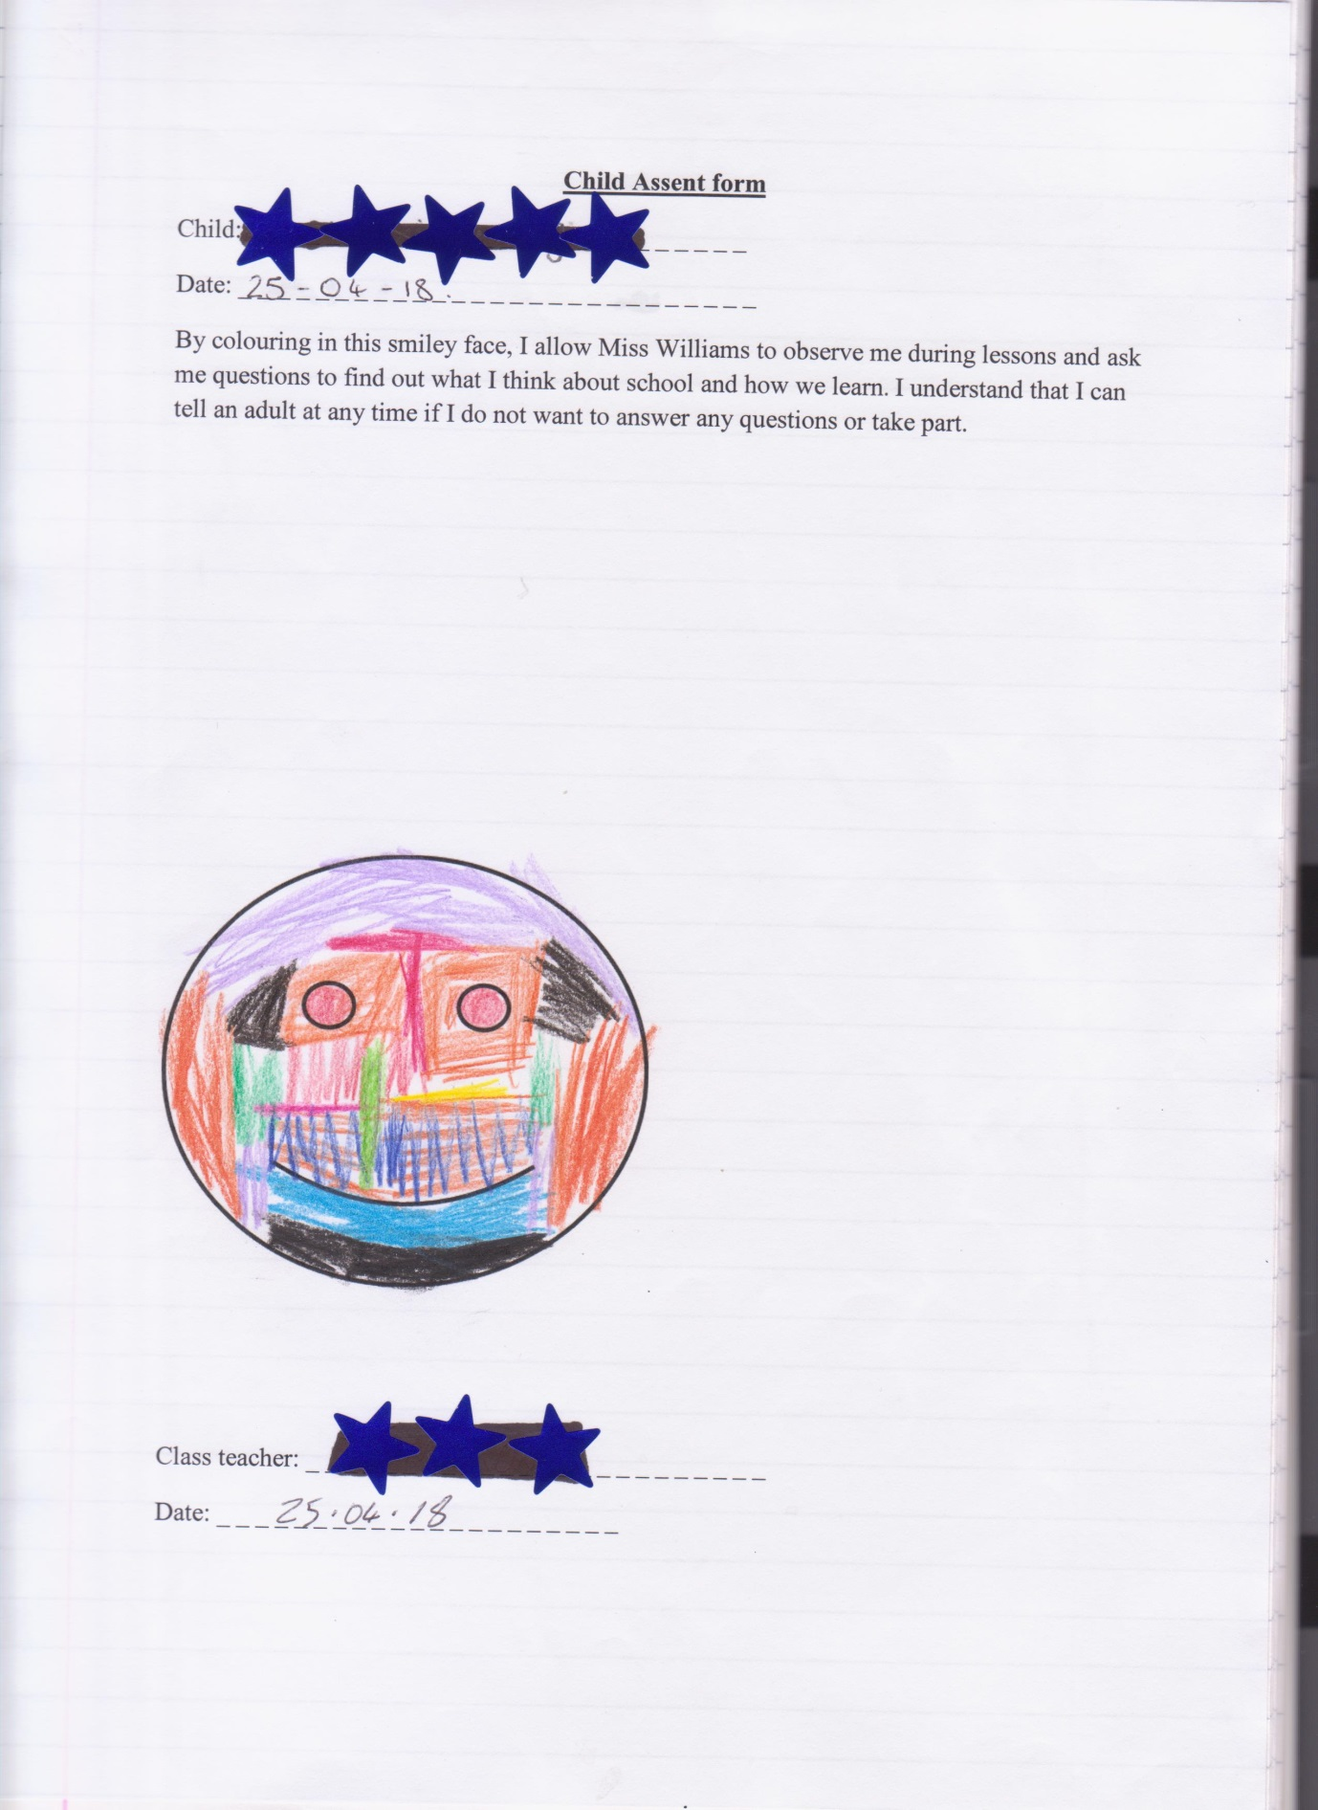

Appendix 3
Personal profile
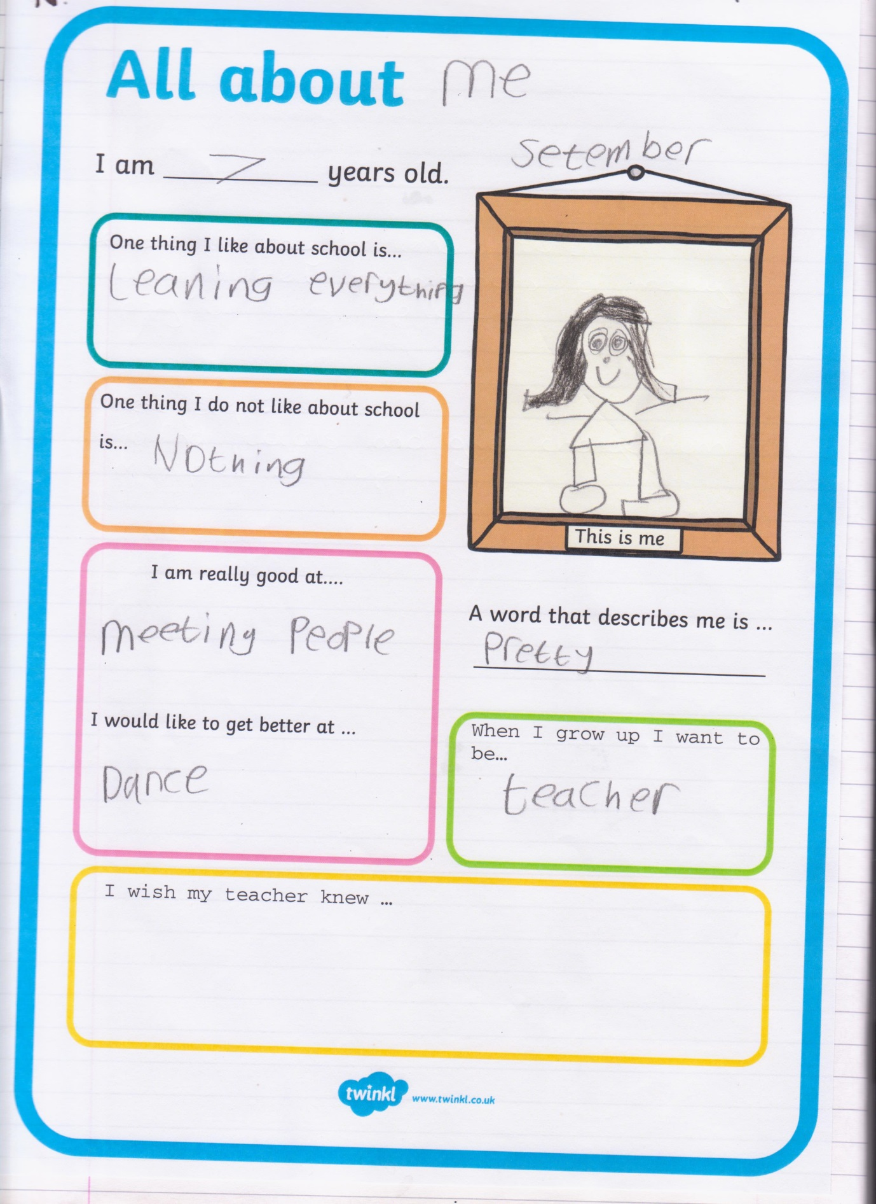

Appendix 4
Reading observations with reference to home life and expectations
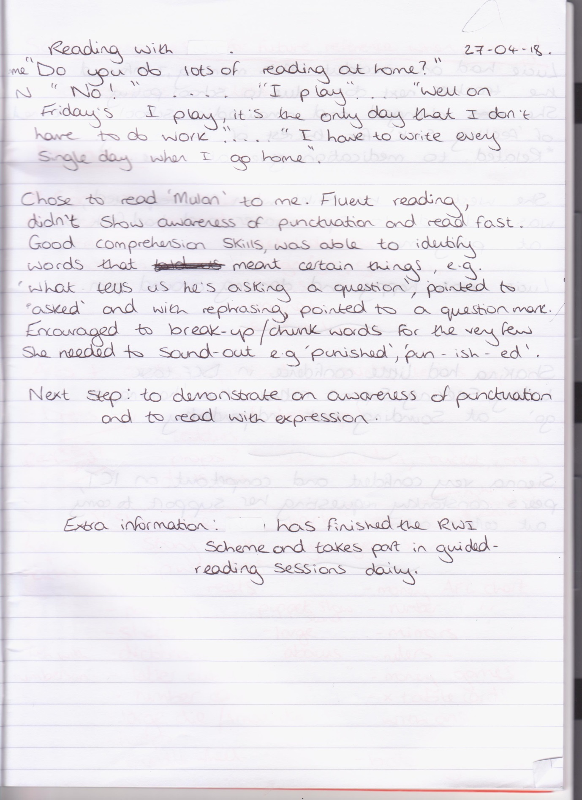

Appendix 5
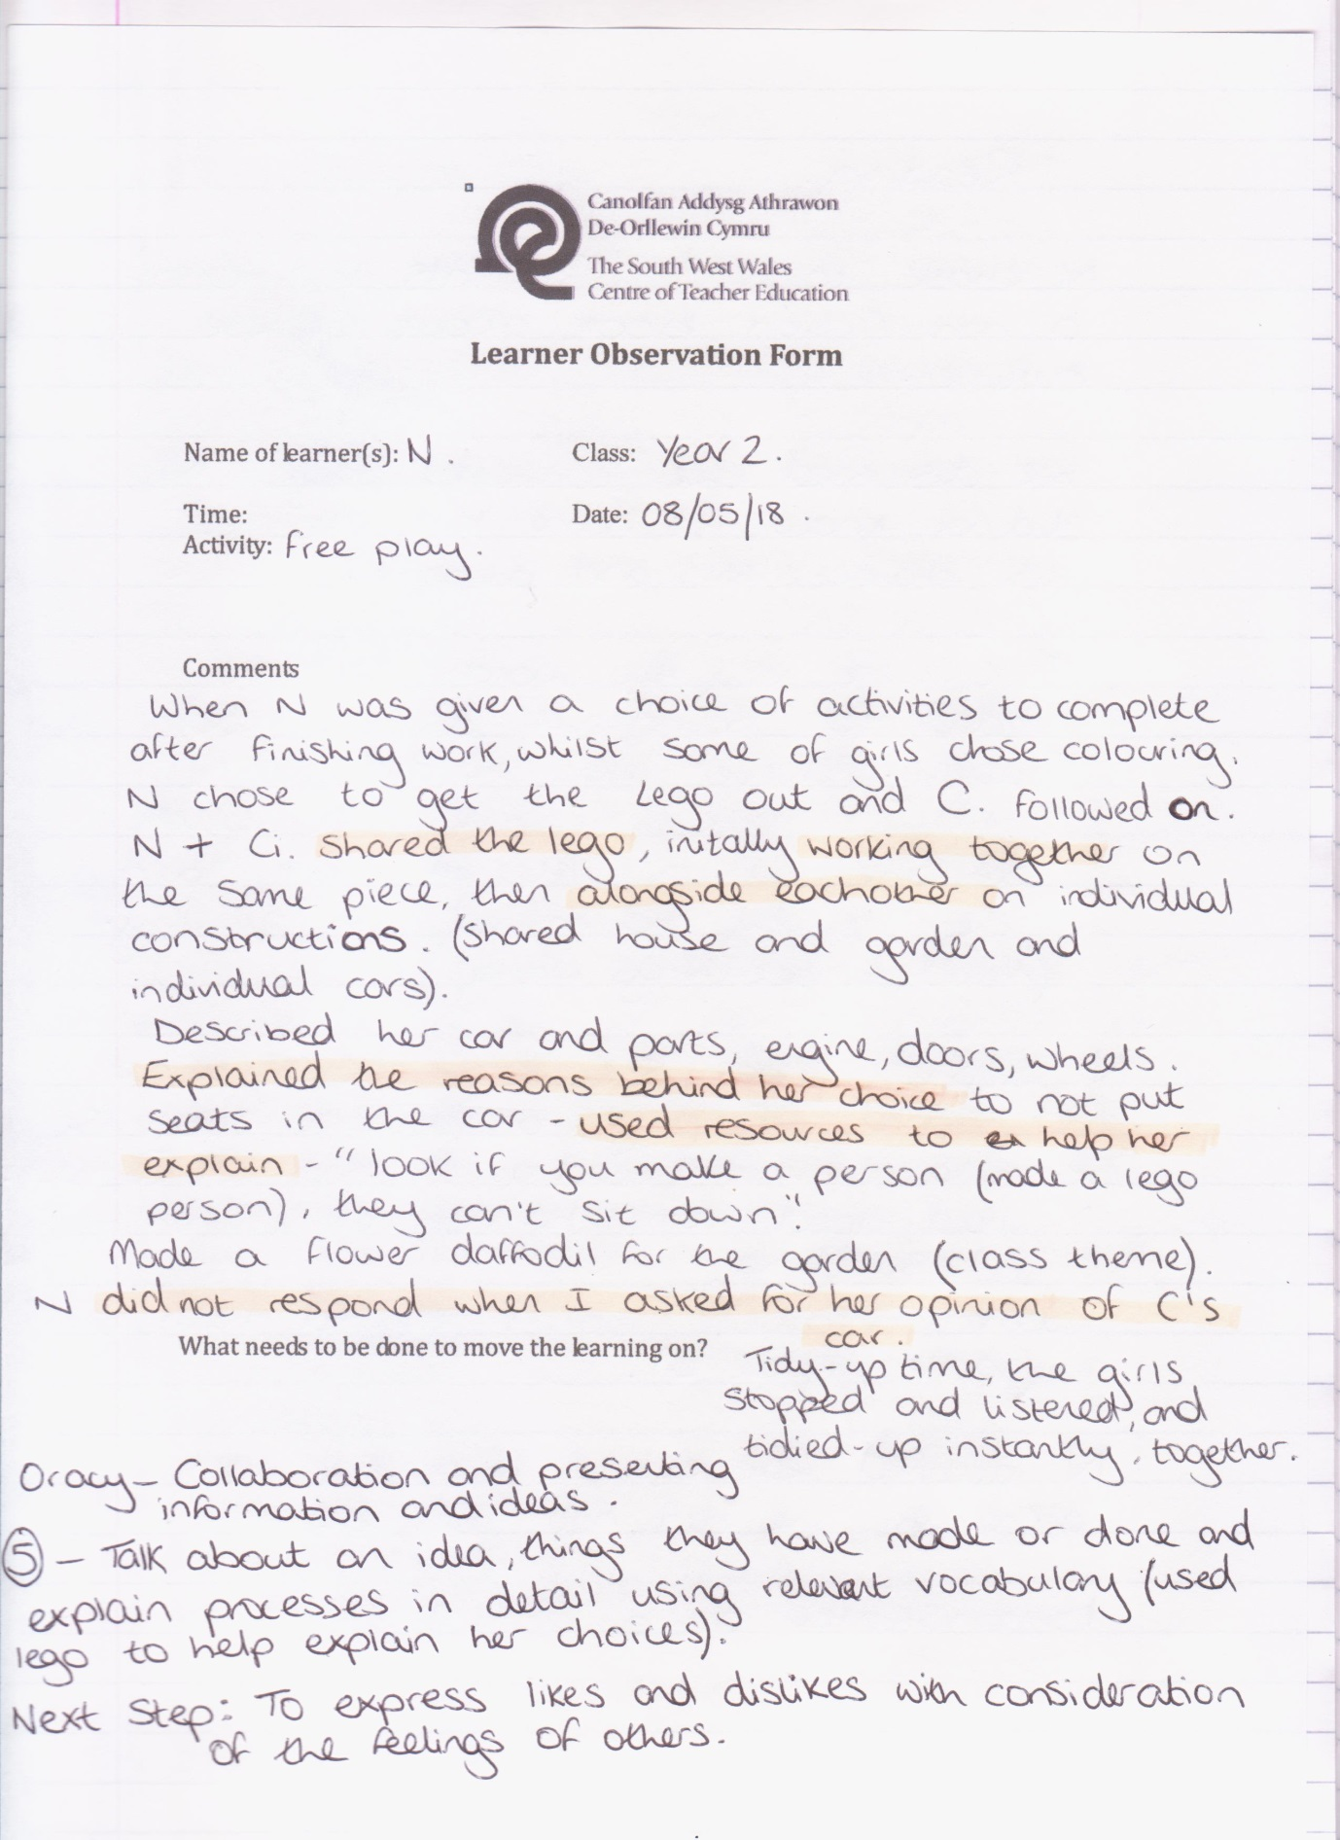

Appendix 6
Free choice observation – chose social activity over colouring
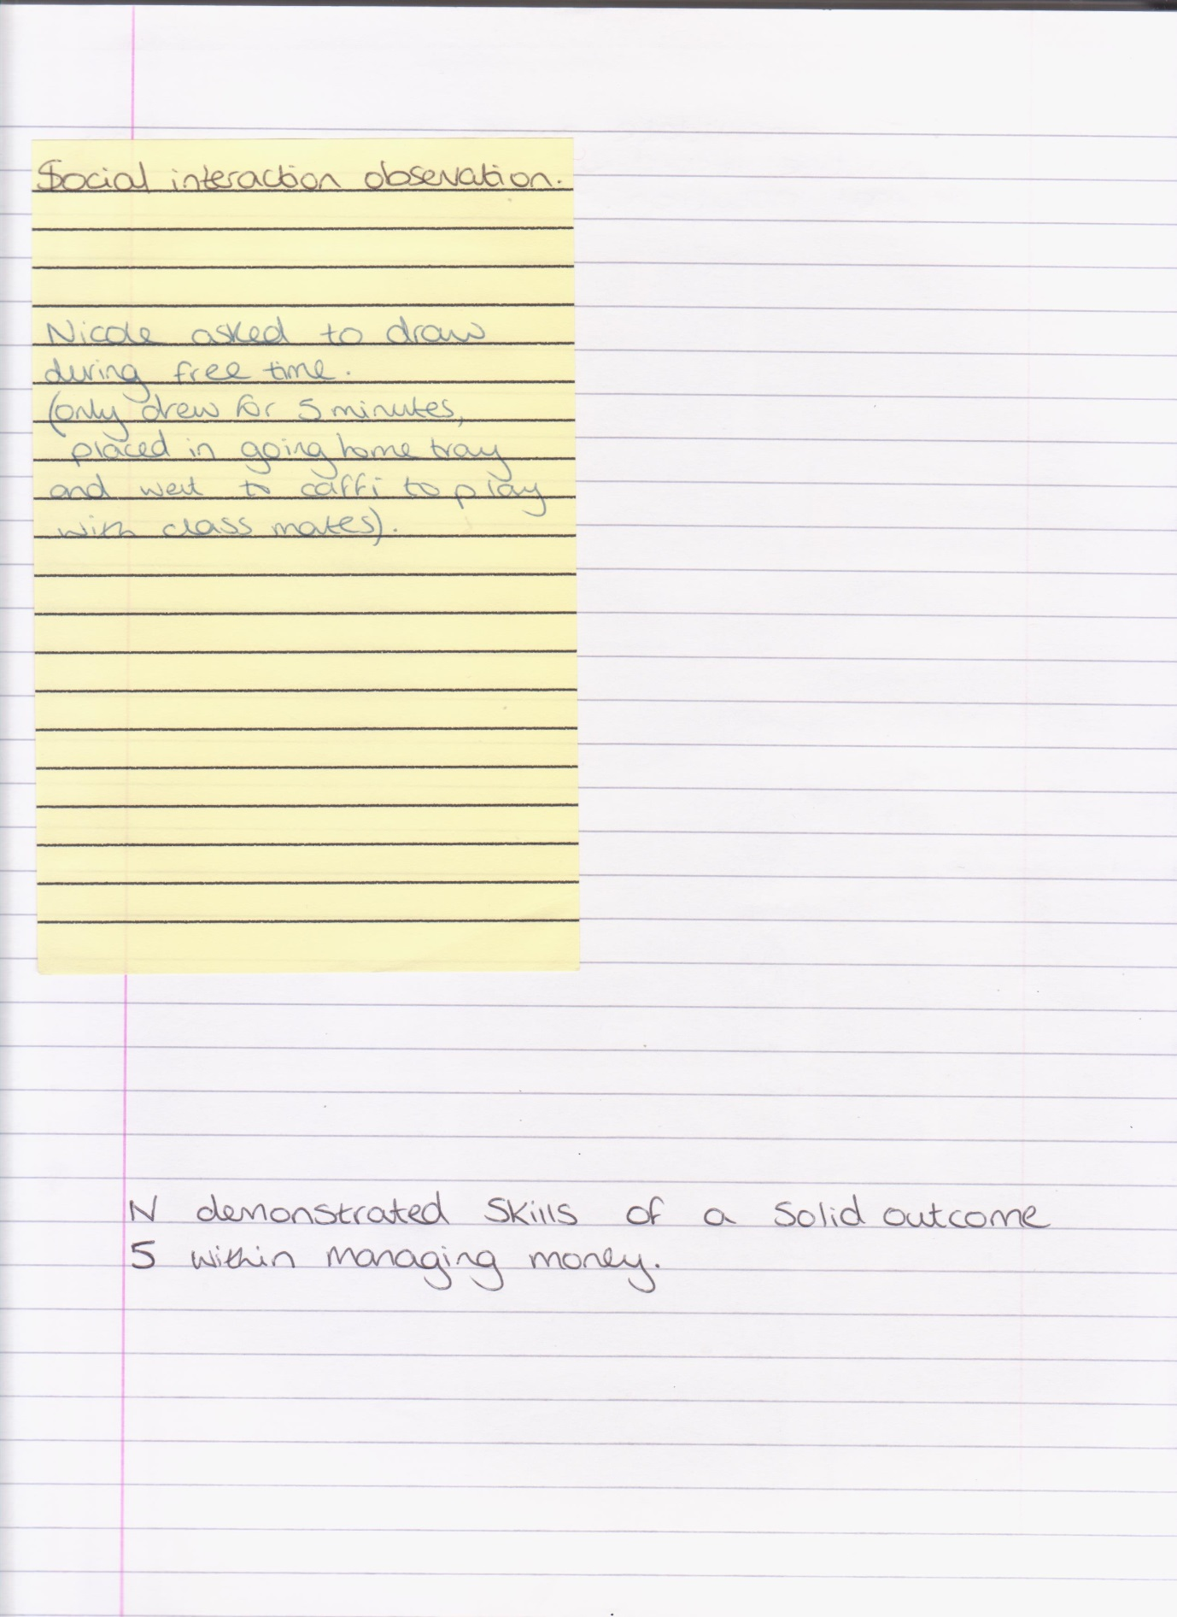
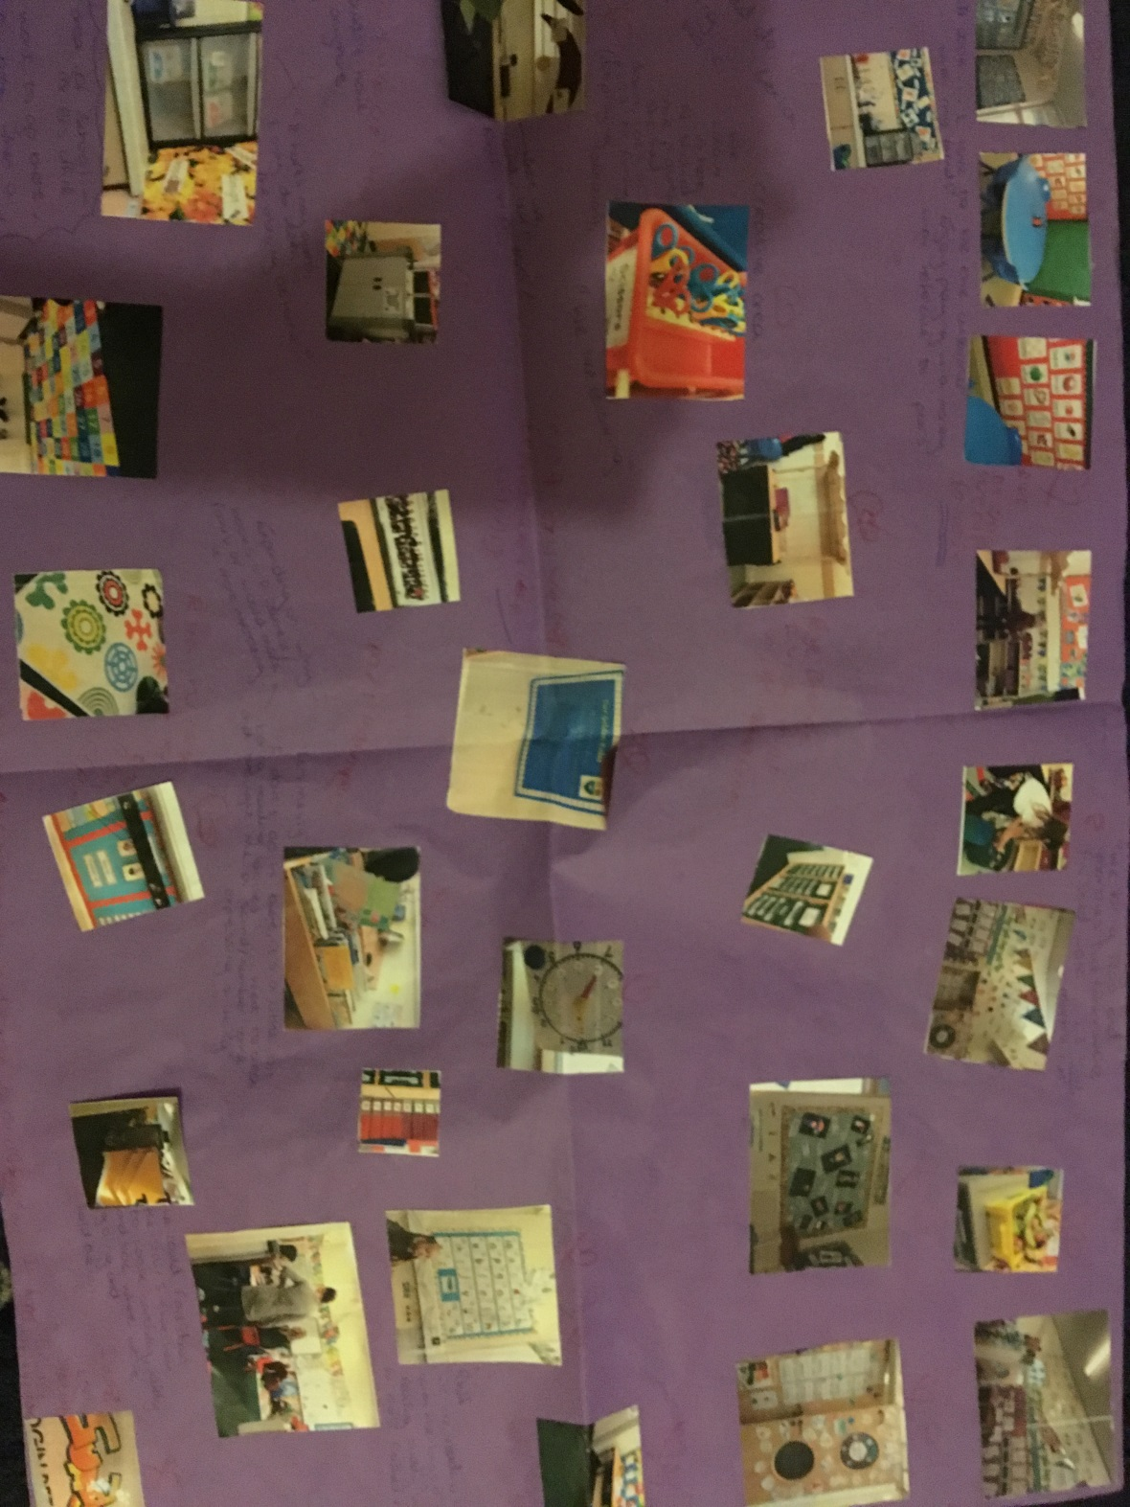
Appendix 7
Learning walk and reflections

Appendix 8
Persisting with a challenge; accepting support to aid understanding
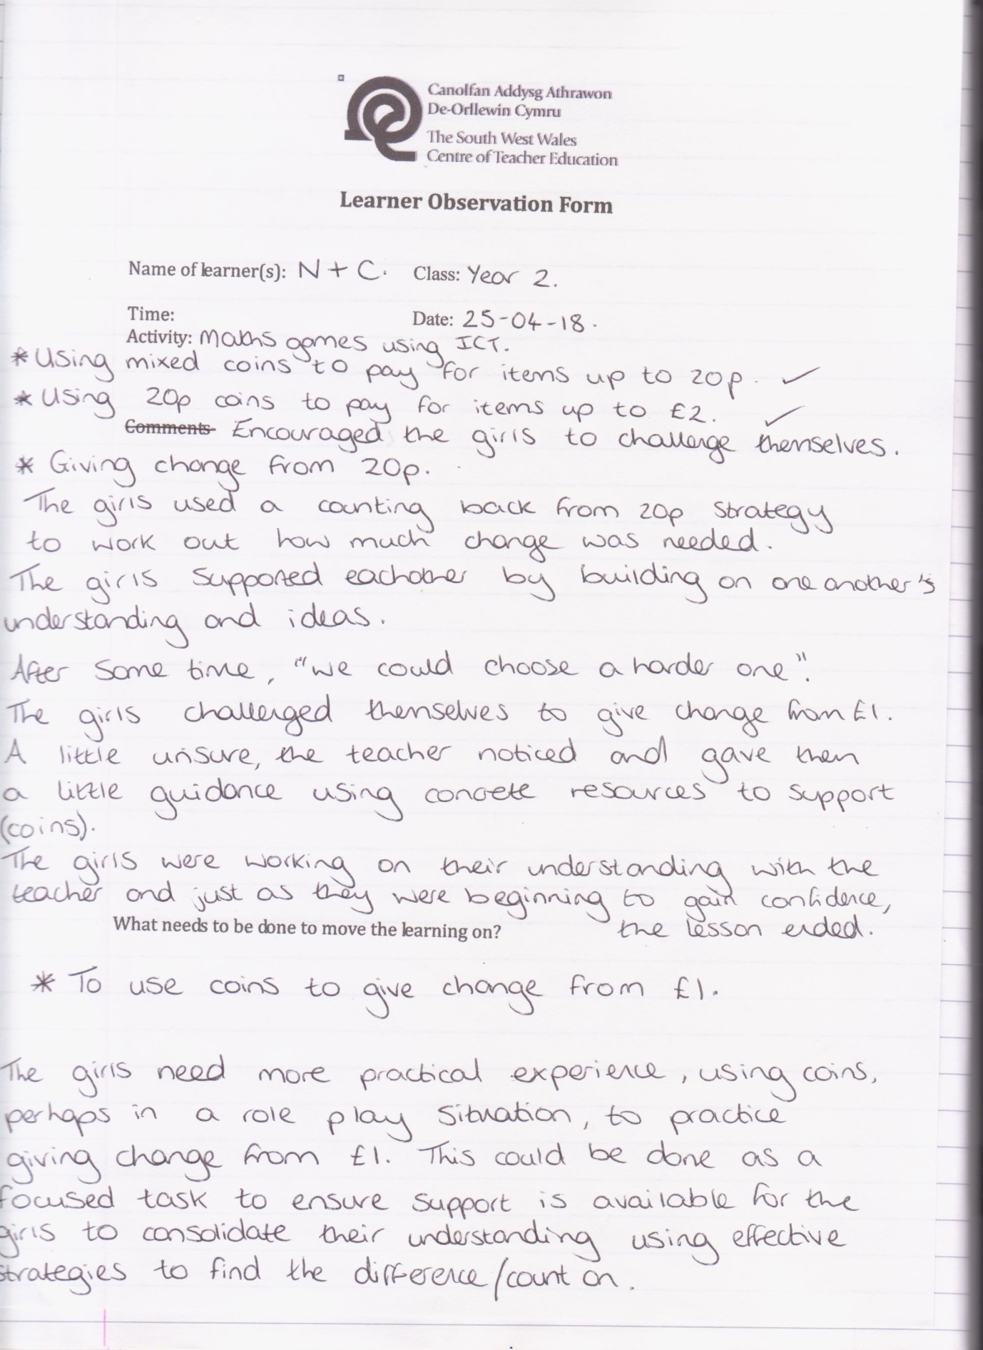

Appendix 9
Persistence and collaborative skills and Mathematical development
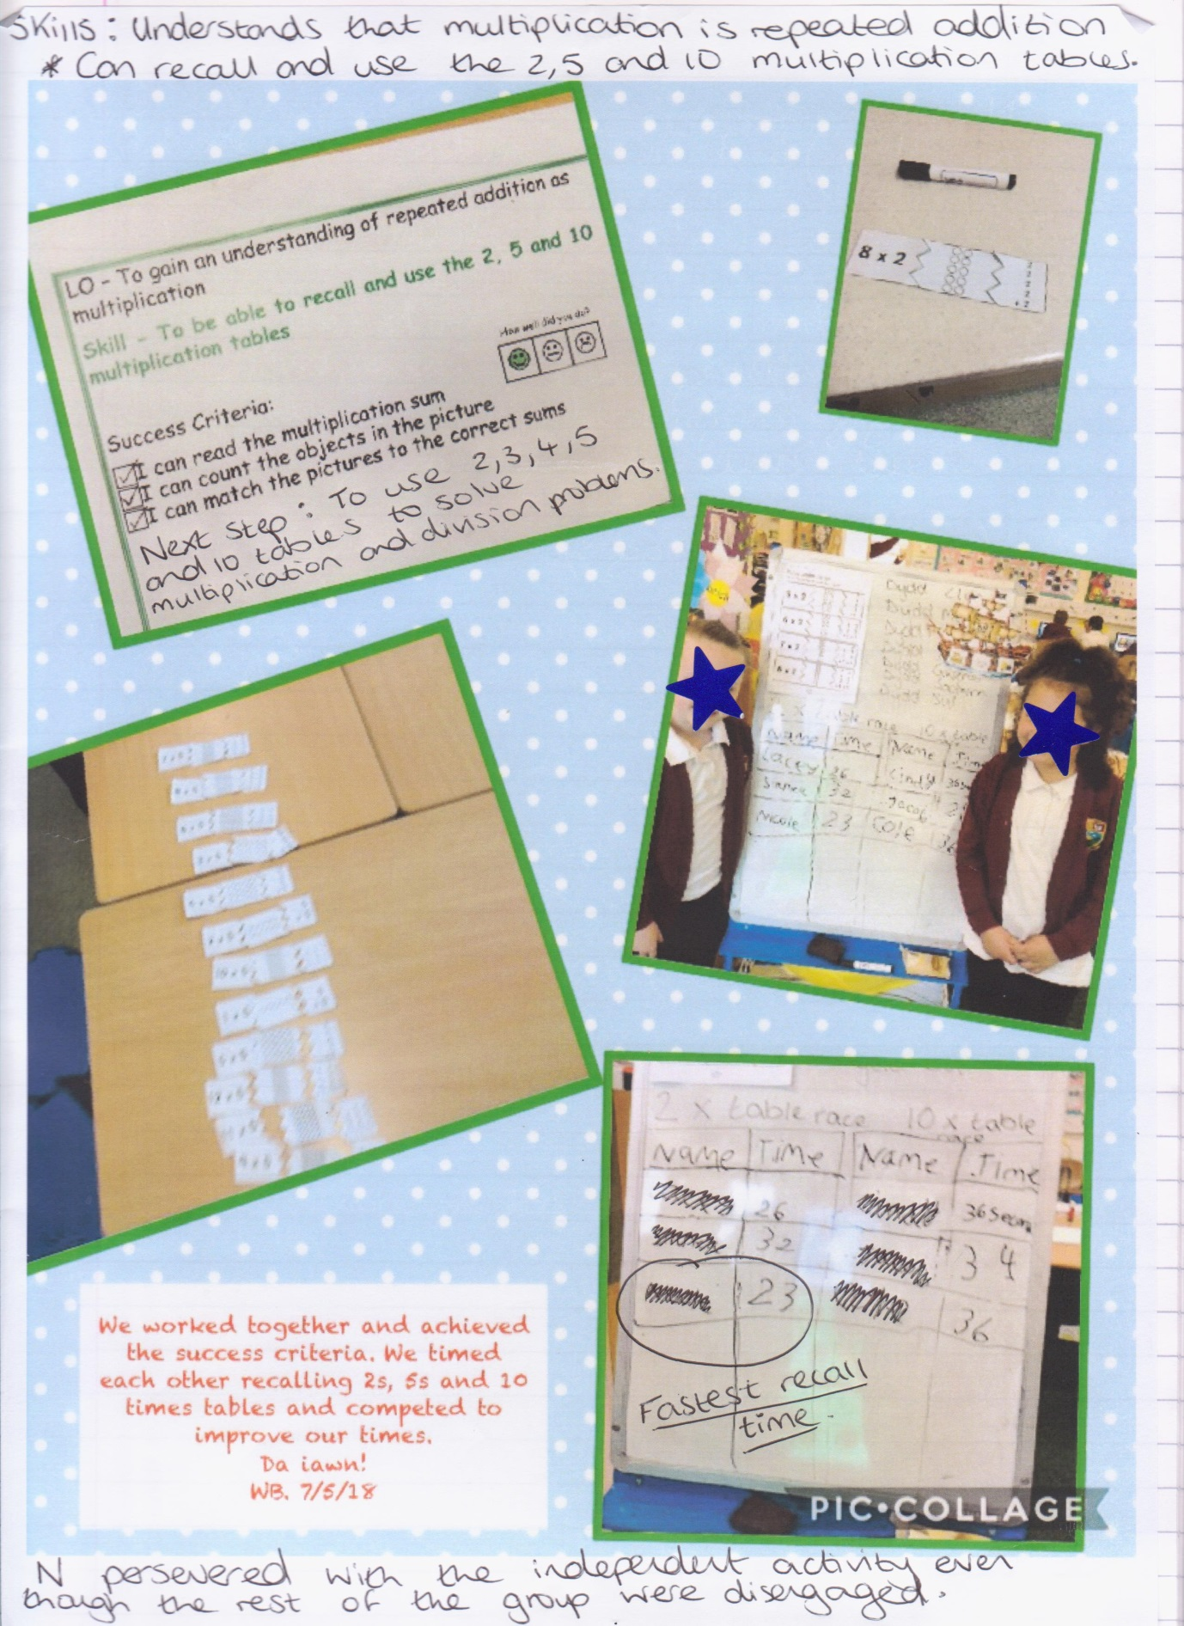

Appendix 10
Strengths and weaknesses in team work/collaboration
ijo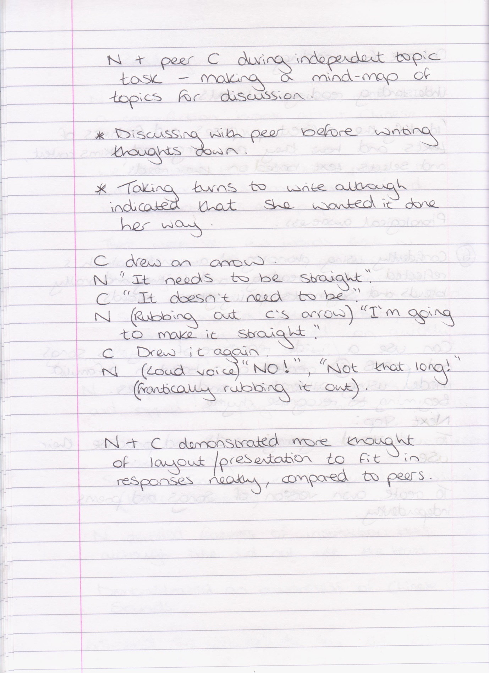

A
Appendix 11
Mathematical development: Multiplication and division
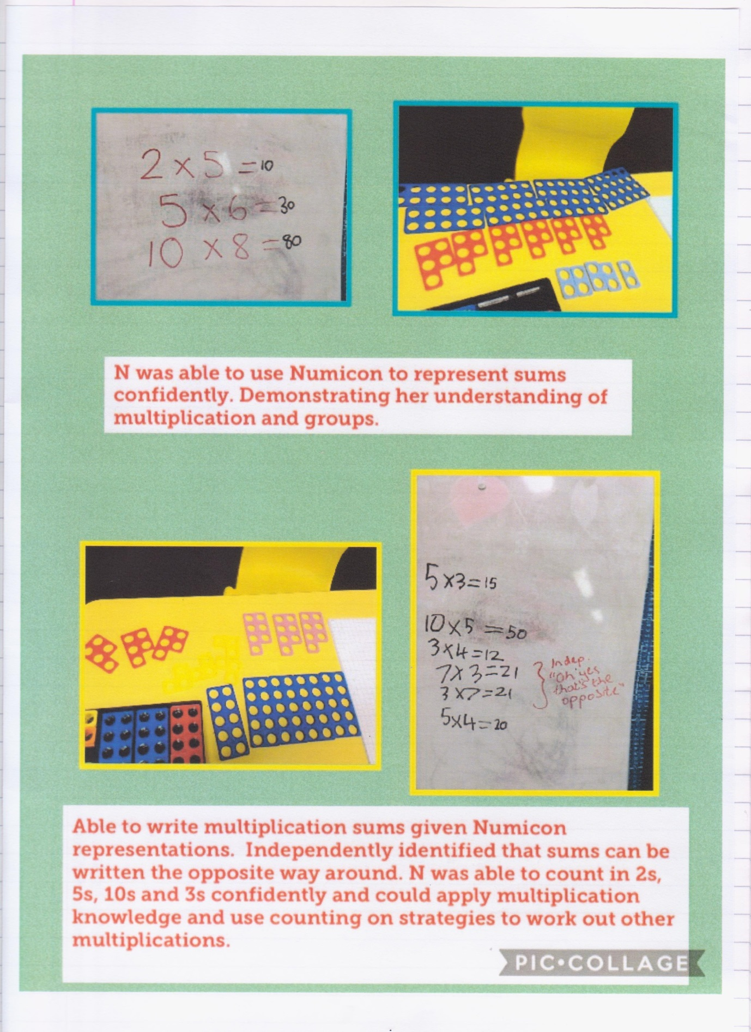
Appendix 12
Reading a range of texts – not seeking support/clarification


