

Module Code and Title: BMSW4010 - Learning in the Digital Era
Assignment Type: Evidence of Learning (E-Portfolio)

Student Name: Md Anamul Haque Chowdhury
Student ID: 2231037
Date of Submission: 09/03/2023

Table of Contents
Introduction 3
Main Findings 4
Task 2 – Academic Writing 5
Task 3 – Critical Analysis 7
Task 4 – Video 8
Conclusion 12
Reference 13

Introduction
The introduction of a report is a critical component of the document which serves as the reader's first impression and should provide an overview of the report's purpose, scope, and objectives. Introduction must set the stage by giving the reader some background on the topic at hand and explaining the research approach taken. Having a report read and understood by the intended audience increases with a well-written beginning (Lee and Baskerville, 2003). For this reason, it is crucial to give great consideration to the beginning in order to guarantee that the significance of the report is conveyed.

Main Findings
The report's primary conclusions are included in the report's main findings section. Content should be organized in a way that makes sense, using relevant headings and subheadings to break down the findings into bite-sized chunks. The findings should be presented in a way that is consistent with the study questions or hypotheses, and should be reported objectively with the use of suitable data and statistics to back up any claims made. Making sure the results are trustworthy, valid, and credible is fundamental (Klenke, 2016). As the study's recommendations and conclusions will be based on the findings presented in the primary findings section, it is essential that these findings be correct and adequately supported.

Task 2 – Academic Writing
Academic writing, also known as scholarly writing, is a more formal style of writing that is typically associated with academic institutions. The hallmarks of this writing style are its clear and short language, its objectivity and analysis, and its reliance on evidence and sources to back up claims and arguments. Academic writing's goal is to relay facts and ideas that are difficult to grasp in a way that is factual, rigorous, and accessible to the reader. Academic writing is a means by which experts in a given topic add to the ongoing discourse in that field (Giltrow et al., 2019).
There are several justifications for the value of academic writing. To begin with, it facilitates the dissemination of academic research to a wider audience, which in turn aids in the expansion of human understanding and the generation of novel concepts. Students can improve their critical thinking, analytical skills, and research methods through academic writing, all of which are crucial to their future success in school and the workforce. Students need to be able to demonstrate their knowledge of a subject and express their thoughts clearly and concisely in written form in order to succeed academically (Cargill and O'Connor, 2013). Academic writing is crucial for evaluative purposes since it allows teachers to gauge students' capacity to apply theoretical understanding to concrete situations.
In addition to the aforementioned pints, academic writing also helps to expand academic networks and sustains the credibility of the peer-review system. Researchers and academics can take part in existing debates and discussions, as well as contribute to the development of their subjects, through the medium of academic writing. Academic writing is the primary mechanism by which scholars communicate with one another, disseminate their results, analyze the work of their peers, and build upon the work of others (Swales and Feak, 2012). Also, the peer-review process, wherein specialists in a certain field examine and assess the quality and validity of research findings, relies heavily on academic writing.
In brief, academic writing is an essential part of the higher education process, with multiple functions including but not limited to information distribution, critical thinking growth, and assessment of students. Writing for academic purposes allows students and researchers to share their research and results with a wider audience, which in turn helps to further the spread of information and sparks creative thinking (Flowerdew and Peacock, 2012). Students' ability to communicate effectively in academic settings is crucial to their future success in both school and the workforce.
Screenshots related to the Turnitin submission of this document is given as followed.
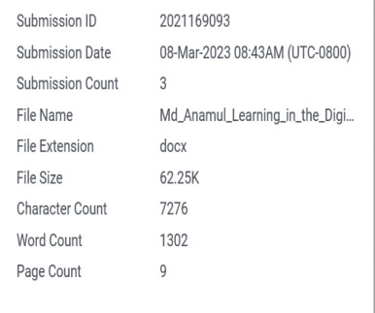
The similarity percentage of merely 5 makes me happy. A Turnitin similarity score of 5% indicates that the majority of the work is original, with only a little portion of the paper matching any available sources. In order to prevent plagiarism, it is crucial to properly attribute all relevant sources. Summarizing, paraphrasing, and quoting are techniques that can be used to increase the similarity score. All sources should be correctly cited using the appropriate referencing style. Although a low similarity score generally indicates that the work is unique, it is nevertheless crucial to uphold academic integrity by avoiding any form of plagiarism.

Task 3 – Critical Analysis
Critical analysis refers looking closely at something to determine its value, flaws, and assumptions. It's a talent that calls for serious consideration of the source material, the author's reasoning, and the larger cultural milieu in which the piece was created. Critical analysis is crucial to academic writing because it encourages authors to grapple with nuanced concepts and generate research that stands the test of scrutiny (Stenberg and Karasti, 2019). This process is not limited to academic writing but can be applied to everyday situations, such as evaluating news articles, advertisements, or political speeches.
The art of critical analysis enhances the quality of work produced by enabling writers to identify and address potential flaws in their arguments or ideas. Through a process of careful examination, writers can identify areas where further evidence or clarification may be needed, and refine their arguments to ensure that they are logically coherent and well-supported. Critical analysis is essential to effective scientific writing because it allows authors to spot any flaws, omissions, or biases in their study and make sure their findings are rock solid ((Kaila and Kaila, 2020). Critical analysis allows writers to produce work that is intellectually sound, well-supported, and of high quality.
Furthermore, critical analysis encourages a culture of intellectual inquiry and discussion, which contributes to the growth of knowledge and the emergence of new ideas. Writers who practise critical reading and analysis are better equipped to disprove commonplace beliefs, cast doubt on long-held notions, and advance novel perspectives on intricate problems. To connect with the work of others in a rigorous and intellectually exciting way, critical analysis is a crucial part of scholarly enquiry (Pomerantz, 2018). It helps in generating new knowledge and leads to the expansion of existing knowledge. Writers can influence the course of future studies and add to ongoing debates in their fields by providing critical analysis.

Task 4 – Video link

https://uowtsd-my.sharepoint.com/:v:/r/personal/2231037_student_uwtsd_ac_uk/Documents/Recording-20230309_194611.webm?csf=1&web=1&e=Y5HX54

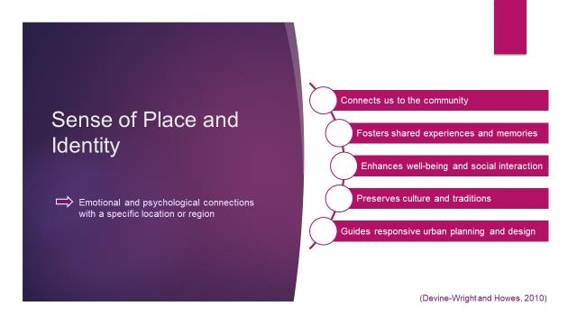
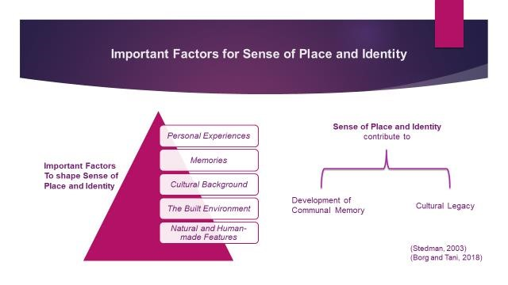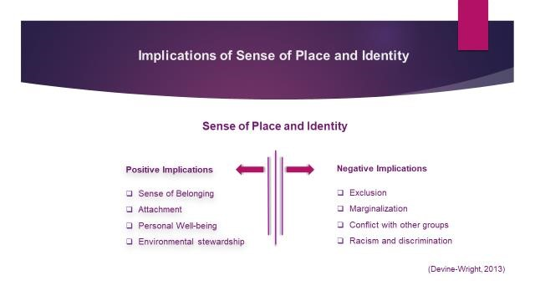
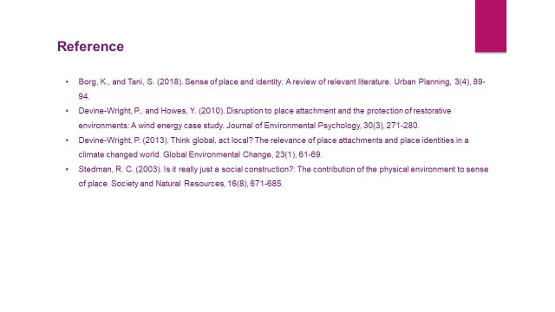

Conclusion
The report's conclusion is crucial since it summarizes the report's main findings and recommendations. The conclusion is the author's last chance to convince the reader of the importance of the work and its potential applicability to future studies. The report's summary should be succinct, logically organized, and relevant to the report's goals (Graham and Lam, 2020). The conclusion of a report needs to do more than just restate the study's main points; it ought to leave the reader feeling satisfied and having grasped the report's central message. The report's conclusion is also grounded in the data and arguments offered throughout it, with nothing new to add (Letchford and Moser, 2021).

Reference
Bhatia, V. K. (2012). Critical reflections on genre analysis. Ibérica, 24, 17-28.
Cargill, M., and O'Connor, P. (2013). Writing scientific research articles: Strategy and steps. John Wiley and Sons.
Flowerdew, J., and Peacock, M. (2012). Research perspectives on English for academic purposes. Cambridge University Press.
Kaila, K., and Kaila, M. (2020). Scientific Writing and Communication: Papers, Proposals, and
Presentations. Oxford University Press.’
Klenke, K. (2016). Qualitative research in the study of leadership. Emerald Group Publishing.
Lee, A. S., and Baskerville, R. L. (2003). Generalizing generalizability in information systems research. Information Systems Research, 14(3), 221-243.
Pomerantz, J. (2018). Critical analysis in academic writing: A pedagogical perspective. Journal of Applied Linguistics and Language Research, 5(2), 74-85.
Stenberg, L., and Karasti, H. (2019). Becoming an academic writer: Reflections on a writing course for PhD students. Studies in Continuing Education, 41(3), 298-314.
Swales, J. M., and Feak, C. B. (2012). Academic writing for graduate students: Essential tasks and skills. University of Michigan Press.
Graham, J., and Lam, C. (2020). The writing process and the writing assignment. In Writing Academic English (pp. 1-21). Routledge.
Letchford, A., and Moser, S. (2021). Writing conclusions. In Writing for Research (pp. 101-109).
Routledge.

