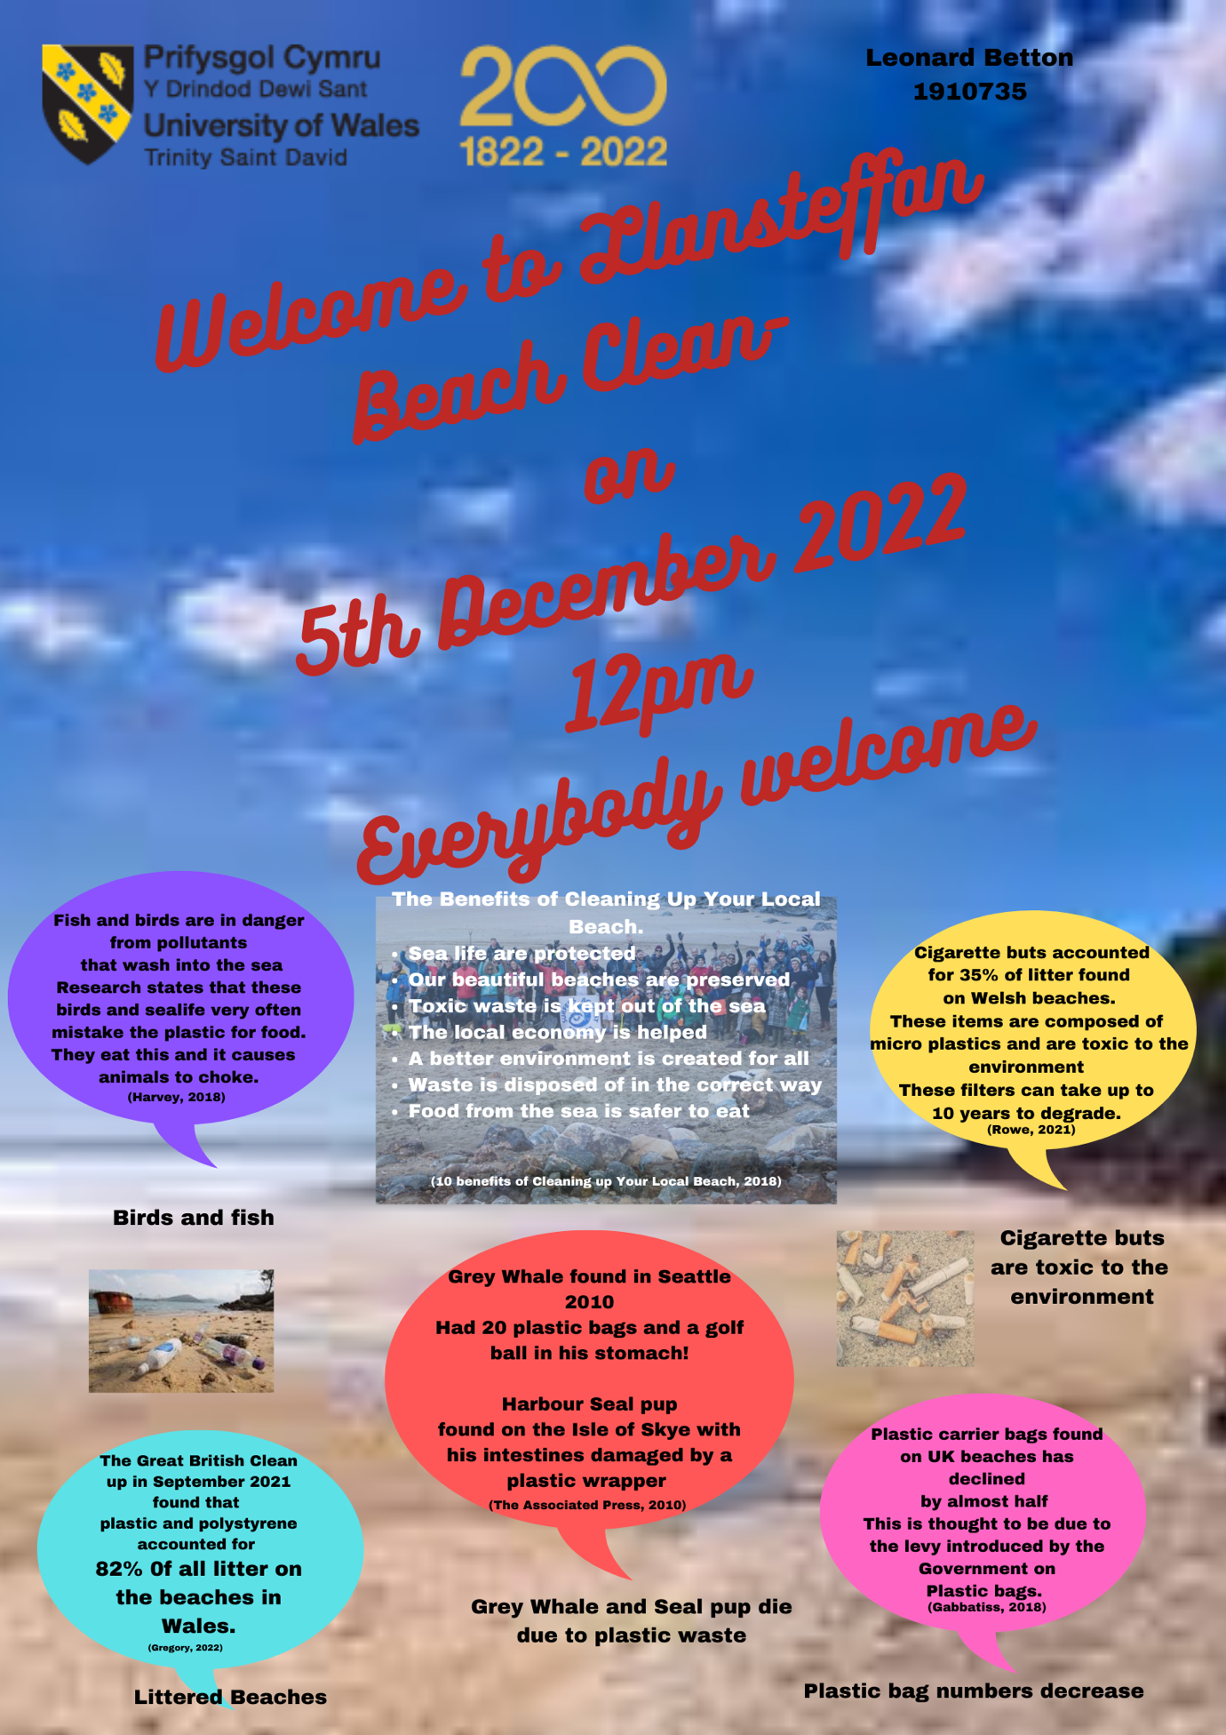

Reference
- Gabbatiss, J. (2018, April 4). Decline in plastic bags on seabed shows tackling waste is working. The Independent. https://www.independent.co.uk/climate-change/news/plastic-bag-uk-seas-seabed-waste-pollution-ocean-reduce-environment-a8288526.html

- Gregory, R. (2022, November 14). Data shows litter on Welsh beaches is not going away. https://www.wales247.co.uk/data-shows-litter-on-welsh-beaches-is-not-going-away

- Harvey, F. (2018, February 14). Fish mistaking plastic debris in ocean for food, study finds. The Guardian; The Guardian. https://www.theguardian.com/environment/2017/aug/16/fish-confusing-plastic-debris-in-ocean-for-food-study-finds

- Plastic Water Bottle Pollution Stock Photos, Pictures & Royalty-Free Images - iStock. (n.d.). Www.istockphoto.com. Retrieved November 19, 2022, from https://www.istockphoto.com/photos/plastic-water-bottle-pollution

- Rowe, K. (2021, November 25). Results of Great British Beach Clean 2021 – More cigarette stubs found on Welsh beaches than ever before. West Wales Chronicle : News for Llanelli, Carmarthenshire, Pembrokeshire, Ceredigion, Swansea and Beyond. https://www.westwaleschronicle.co.uk/blog/2021/11/25/results-of-great-british-beach-clean-2021-more-cigarette-stubs-found-on-welsh-beaches-than-ever-before/

- ‌The Associated Press. (2010, April 20). Garbage found in stomach of dead whale on West Seattle beach. The Seattle Times. https://www.seattletimes.com/seattle-news/garbage-found-in-stomach-of-dead-whale-on-west-seattle-beach/
‌

- ‌10 Benefits Of Cleaning Up Your Local Beach. (2018, September 12). THE ENVIRONMENTOR. https://blog.tentree.com/10-benefits-of-cleaning-up-your-local-beach/
‌
‌

