Strategic Management for SMEs
BMSW6104
Shipa Begum
1715946
Paul Bocij
10/12/2021

Table of Contents
Introduction 3
Uber’s vision/ mission statement 4
Strategic Approach 5
Ubers Current Strategy Analysis 6
Porter's Five Forces Analysis of Competitive Position Birmingham: 7
PESTEL 11
SWOT analysis on Uber 15
Advanced SWOT on Uber 16
Value Chain 19
Stakeholder Analysis 22
Stakeholder Mapping (Uber) 24
Advantages of Stakeholder mapping: 26
Ansoff Matrix 26
Three Possible Strategic Growth 28
SFA Matrix 30
Sustainable Business 31
Recommendations/ Strategy Implementation for Uber Taxi 31
Reaction To Change 32
Conclusion 33
Reference 34

Introduction

The primary objective of this study is to critically appraise the current strategic direction of Uber (Birmingham) a global ride-sharing application that operates in more than 900 metropolitical areas around the world which serves customers with mobility as a service and has transportation systems which has over 9000 drivers in the Birmingham region. Garrett Camp and Travis Kalanick launched Uber in 2009 in the United States (bbc.com,2021). The app allows you to hire a driver from virtually any location at any time using your smartphone. This is where technology detects nearby drivers and offers a variety of options, ranging from the cheapest to the most luxurious methods of travel, all of which are priced and paid for in advance (Uber, 2021). Since then, Uber has disrupted modern transportation and evolved to become the world's most valuable private start-up company.

However, like any other developing or developed company Uber has faced the prospect of financial instability as well as organisational challenges. One of which was when Uber drivers recently went on strike and staged a worldwide demonstration outside the company's headquarters in Birmingham, seeking better working conditions (Rodger, 2021). Uber drivers thought they were barely making minimum wage and claimed they were being treated unfairly and were disregarded because they were classified as self-employed. This resulted in the case going to the Supreme Court of the United Kingdom. Although this has now been resolved it has had a significant impact in terms of reputation, brand loyalty/ customer base and in addition increased employee turnover which has overall affected sales and profitability for Uber.

Uber’s vision/ mission statement

“At Uber, we ignite opportunity by setting the world in motion. We take on big problems to help drivers, riders, delivery partners, and eaters get moving in more than 10,000 cities around the world” (Uber, 2021). We welcome people from all backgrounds who seek the opportunity to help build a future where everyone and everything can move independently. If you have the curiosity, passion, and collaborative spirit, work with us, and let’s move the world forward, together.

Uber’s mission/vision statement is quiet clear, as it summarises the company’s purpose as well as the direction and goals it is pursuing. Uber, for example is a multinational company and well recognised compared to some of its competitors, and what sets them apart is that they don’t just provide taxi services; they also provide food delivery through Uber Eats, they provide freight transportation, couriers, and bicycle sharing systems, and their employees come from a diverse background from all over the world. Their mission statement defines what they want to accomplish and how they plan to do so. Although they have resolved the issues that they had with employees regarding salary the objective is to maintain customer and employee loyalty and increase brand recognition through employee engagement.

In order to understand the current business direction, the report will include various industry analysis highlighting the organization's major strengths and weaknesses, this will aid in maintaining competitive advantage and emphasize on areas that are inhibiting the business from operating efficiently. Porter’s theory of competitive advantage including his Five Forces and Value chain concepts will be discussed to demonstrate approaches that can be used to achieve or maintain competitive advantage. Next, PESTLE research will be conducted to look into Uber's current and future effects. For example, looking for opportunities or problems that might exist in the environment or a problem that may arise later in the future.

Before new strategies are developed, A stakeholder analysis on Uber will be presented as it’s a key element of strategy formation. This will examine stakeholders in terms of power and influence, in addition it’ll guide Uber on how to communicate and deal with stakeholders at different levels of authority using a power and interest grid. Finally, solutions will be given to assist in sustaining competitive advantage through cost leadership, the development of a better workplace culture through employee engagement, resulting in reduced absenteeism, higher productivity, and profitability for the organisation.

Strategic Approach

Lynch (2018), strategic management is the process of creating goals that determines an organization’s long-term performance. Businesses must constantly analyse aspects that affect internal strategies due to the dynamic business environment. The process includes external and internal scanning, strategy design, strategy implementation, and evaluation, control. Strategic management is critical in any business because it provides direction to the organisation and its people. Effective strategic management continuously plans, monitors and test’s an organization’s actions, resulting in increased operational efficiency, market share, and profitability (Chaffe, 1985).

Figure 1: 5 Steps of Strategic Management Process

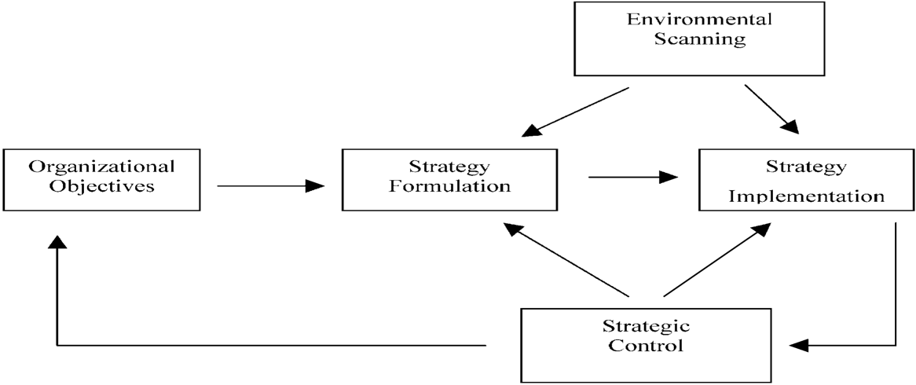

Figure 1: (Adapted from Hofer, (1984).

Ubers Current Strategy Analysis

In order to establish the strategy formulation process and attain the company’s strategic goal, Uber must analyse both internal and external environments it operates in to enhance decision making-and uncover elements that influence the organisation (Ojo, 2017). Uber's current strategy will be defined using the steps of the strategic management process, Porter's Five Forces will be utilised to assess how the company compares itself to its competitors in its sector. The data can be used to determine both the company's competitive advantage and its limitations.

Porter's Five Forces Analysis of Competitive Position Birmingham:

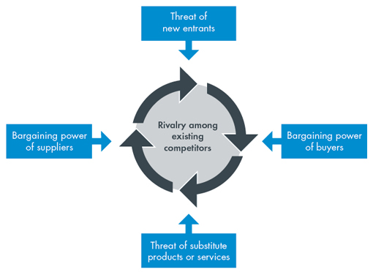

Figure 2: Source: Porter, (1980).

Force | Risk L/M/H | Impact | Mitigation

Threat of new entrants  Ola/ Bolt/24/7 | M | L | - Offer competitive prices for rides  - Offer a variety of services to retain customer loyalty  - Spend money on marketing to build strong identification
Substitute products  Ola, Bolt, 24/7 | M | M | - Being unbeatable on price  - To make sure customers wants and needs are provided  - Becoming the go to taxi company/ offer electric cars
Industry Rivalry  Ola, Bolt, 24/7 | H | H | - Offer better prices with additional offers  - Add incentives and rewards to become more competitive  - Market research to understand demand within the industry
Power of suppliers  Drivers | M | L | - Build a close relationship with drivers so you both benefit  - Use different suppliers for different locations
Power of customers  Customers not wanting to ride with Uber | H | M | - Actively listen and deal with issues rather than leaving it  - Marketing efforts to build brand loyalty  - Differentiate to attract more customer base

Porter’s Five Forces indicates the threat of new entrants is medium for Uber, as It Is nearly impossible to build an app and expand it up to the level that Uber has. Uber already offers a great value proposition and employs a large number of drivers throughout Birmingham. Uber is a well-known corporation, and anyone trying to enter a market as large as Uber’s will have to invest billions of dollars and face a big challenge. To maintain a sustainable competitive advantage Uber should continue with regular offers, to attract customers so that their rivals are unable to match this offer (Scheepers and Bogie, 2020).

Although substitute products are medium, they can have a significant influence on Uber because Ola and Bolt are also car-sharing apps. These firms may attract some users by offering better prices/products, better experience. Therefore, Uber must match customer needs and demands to avoid disruption and use a cost leadership strategy and a differentiation strategy to ensure customers don’t switch to substitute services. In order to do that Uber may wish to invest in technologies such as self-driving cars and innovative products and services to gain a competitive advantage and become the go-to taxi firm in the market.

At present rivalry amongst competitors is high because there are so many other riding apps, such as Ola and Bolt,24/7 so there is a lot of competition among rivals. Uber's market share has already been damaged by these companies. Furthermore, they participate in price wars, resulting in Uber lowering its costs even further to retain customers. Drivers also utilise a variety of apps, the majority of which compete with Uber. Barney & Hesterly, (2008) suggests a company has a competitive advantage over its rivals when it is able to generate more economic value than its competitors by developing strategies to formulate brand image to gain customer and employee loyalty. Uber’s prices are slightly higher than its competitors so it doesn’t fully benefit from cost leadership however this can be resolved if certain strategies are implemented which we’ll discuss further in the report.

Bargaining power of suppliers (drivers) is medium as Uber has reduced idling periods, which encourages drivers to stay with the company rather than leaving it totally as they utilise alternative apps. Anyone with the necessary qualifications can apply for the position and begin working straight away. However, since being classified as employees rather than self-employed, drivers bargaining strength has increased. Drivers will have a considerable impact on decision-making, which could lead to a higher share of revenue, affecting Uber’s profitability.

Because Ubers consumers have access to other transportation applications and alternative methods of travel, their bargaining power of customers is high. These alternatives have the potential to reduce Uber's market share, particularly because Uber's customers are aware of similar apps and services. However, with lower prices, shorter wait times, and lower transaction costs, the firm offers a stronger value proposition since it also has additional services such as Uber Eats that gives the company competitive advantage.

Key Findings:

Although this type of analysis is useful for determining the level of competition and gaining insights into how a company can maintain a competitive advantage, critics of porter (Aktouf, 2005) argues that the model mainly focuses on the reality of large companies that control the industry, and that the model may need adjusting when it comes to analysing competitive behaviour in small business’s because competitive behaviour in smaller business’s differ from large organisations in terms of management, financial structure, and sensitivity to external changes.

According to Porter's study, Uber can grow and sell more by investing in new innovation and discovering new ways to overcome hurdles in order to achieve a competitive advantage. Due to the high level of competition in the Birmingham region, Uber, for example, must develop a cost leadership and also a differentiation strategy to maintain a competitive edge. It also needs to embrace employee engagement across the organisation so that employees feel valued and don’t end up leaving due to the lack motivation. It is not always possible to gather complete information around one method due to the nature of the business environment so businesses need to monitor the environment more regularly and utilize different tools and strategies to identify new and emerging opportunities or threats.

PESTEL

The study will analyse external factors that are impacting Uber, as well as factors that can enhance a competitive edge. Pestel will highlight the strategic consequences of these components to demonstrate how changes in the external environment can affect the business and likewise. Some of these factors can guide Uber and its professionals and senior managers in strategic decision-making. A PESTEL model has been demonstrated below to understand the external environment of Uber Taxi.

Political:

• COVID-19
• Political regulations of drivers as contractors

Minimum wage laws and vacation time have been the subject of political debate. Uber was taken to the Supreme Court, which ruled that Uber drivers should be regarded as employees, with minimum wage, vacation time.

Covid-19 has had a big impact on the business, with fewer employees working during the day and night, and many working from home. Some individuals stayed at home permanently and only went out if they needed to. The demand for taxi rides fell to an all-time low as a result of this.

Economical:

• Career opportunities
• Quicker pick-ups and schedule
• Fuel price

With fuel price arising the economic climate can have an impact on the business, when fuel price goes up it means fares go up. However, in saying that with COVID-19 and people out of a job people are out of pocket and will look for cheaper options or not use the service at all as it all comes down to affordability and who’s competitive out there.

People are examining whether this type of economy creates new employment options or eliminates current ones, or whether it creates new chances with lesser compensation.
The sharing economy is the industry in which Uber operates means Uber hires drivers to react to consumers and drive them to a location that is generally considered to be less expensive and easier to arrange.

Social:

• Change in work-pattern
• Change in preference
• Surge pricing in times of crisis
• Pandemic

Finding and keeping workers, as well as keeping them motivated to drive during unsociable working hours, is a challenge in the industry because drivers are not always prepared to work during those hours because they are concerned about troublesome clients they may encounter.

When there is a high demand for a taxi service, the price rises however, this might have a detrimental effect by prioritising business over people which can result in losing customer loyalty.

Technological:

• Increasing internet penetration
• Self-driving cars in the near future
• Building customer relationship through social media

The app is critical to Uber's operation without it, the company would be unable to operate. Because it is vital for drivers to execute their jobs, the corporation must ensure that everything is working properly. As a result, a strong internet connection and current technologies are required.

Environmental:

• Congestion
• Pandemic

Many people feel that Uber has increased traffic congestion, fuel use, and pollution. Instead of taking public transportation, people prefer to use Uber. This causes environmental and climate pollution this can impact brand name and customer base if nothing is put in place to reduce or help the environment.

Legal:

• Minimum wage increase
• Lawsuits tarnishing brand

Key Findings:

Uber is required to follow laws requiring them to pay drivers the national minimum wage and to adhere to labour and employee safety regulations. This can be beneficial or detrimental to Uber, as it may limit the amount of profit the firm makes, however it allows the company to hire more drivers resulting in greater productivity, profit for the organization.

With PESTEL Uber can thoroughly examine changes and develop a plan in the right way to see the broader picture, to minimise any/all profit increase or damage. It can assist in preparing for potential challenges such as price wars; Uber can adjust and offer extra options in order to remain competitive and avoid losing customers and market share. Without a PESTEL analysis the business could be hit by what appears to be an unpredicted threat. Businesses that adapt to change are more successful and profitable than those that do not effectively identify and respond to risks, resulting in closing down.

SWOT analysis on Uber

Uber needs to figure out where it stands in respect to its competitors in order to perform its business activities more effectively and efficiently. Uber’s strengths and weaknesses are explained using a SWOT analysis. Its goal is to look into the opportunities as well as the risks that the company should be aware of. Uber will get a competitive advantage in terms of performance as a result of this. There are many factors in a SWOT, however only the most crucial aspects have been highlighted below.

Strengths

• Financially stable

• Uber is a global organisation and is a well-recognised brand, provides high standard of service

• System is convenient for drivers they can work flexible hours, can reject unwanted clients

• Uber has a dual rating system which increases trust and safety

Threats

• Drivers not happy with low profit- margin. This can lead to employee turnover

• Increased competition may result in losing drivers and customers

• Self-driving car can eliminate the need of Uber and its drivers

• Ubers court case can damage brand name and loyalty resulting in drivers leaving or new applicants not joining.
Opportunities

• Electric car can be introduced to reduce cost and increase drivers profit margin

• Increase the number of drivers as this will reduce wait times for customers and increase productivity and brand loyalty

• Uber can expand and merge to other countries where taxi service is not available or demand is high i.e.: middle east where taxis are expensive and inconvenient
Weakness

• Ideas can be imitated which can then lead to loss of client’s and profitability

• Relationship between drivers and Uber is questionable and lacks loyalty and connection

• Cost operating for drivers are high, which means drivers are not earning enough which can result to employee turnover

• Not competitive enough on pricing

Advanced SWOT on Uber

STRENGTH | IMPORTANCE (1-5) | RATING (1-3) | SCORE
Financially Stable | 3 | 3 | 6
Well -recognised brand and provides high service standards | 3 | 3 | 6
System is convenient for drivers as they can work flexible hours, have the option to reject unwanted clients | 5 | 2 | 10
Dual rating system increases trust and safety | 5 | 3 | 15

WEAKNESS | IMPORTANCE (1-5) | RATING (1-3) | SCORE
Ideas can be imitated, which can lead to loss of clients and profitability | 5 | 1 | 5
Relationship between drivers and Uber is questionable and lacks loyalty and connection | 5 | 1 | 5
Cost operating for drivers is high, which means they are not earning enough | 5 | 1 | 5

OPPORTUNITIES | IMPORTANCE (1-5) | RATING (1-3) | SCORE
Electric cars can be introduced to reduce cost and increase profit margin for drivers | 4 | 3 | 12
Increase the number of drivers as this will reduce wait times, increase productivity and brand loyalty | 5 | 3 | 15
Expand and merge with other companies and then to countries where taxi services are efficient or not efficient | 5 | 3 | 15

THREAT | IMPORTANCE (1-5) | RATING (1-3) | SCORE
Drivers not happy with low profit margin. This can lead to increased employee turnover | 5 | 3 | 15
Increased competition may result in losing customers/drivers | 5 | 2 | 10
Self- driving cars can eliminate the need of Uber | 3 | 2 | 6
Ubers court case can damage brand loyalty, Uber could end up losing customers and drivers | 5 | 3 | 15

Key Findings: The comprehensive SWOT analysis had revealed vital success aspects as well as business weaknesses. By boosting employee engagement and building employee relationships across the organisation, Uber can offset weaknesses such as disorientated employee relationships. Additionally, threats that have been identified and can be mitigated by looking to increase profit margins for employees. They can also build on their brand name so that employees and clients feel valued, which will attract new customers, new applicants, and build loyalty among existing employees at Uber.

Value Chain

Porter's Value Chain Analysis is another framework that might provide a new perspective on a company's strategy. The framework allows businesses to examine where opportunities for improvement lie. This prompts you to consider how each step adds or subtracts value from the final product or service based on this overview (Hutaibat, 2011).

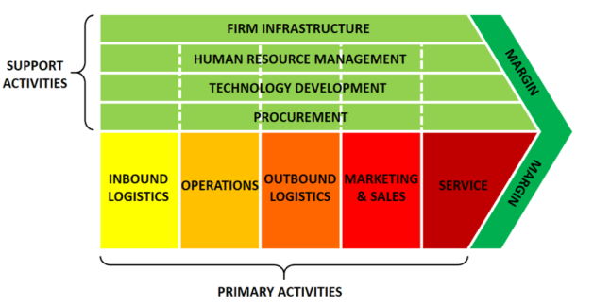
Figure 3: Source: Ruan, (2020).

Primary Activities

Inbound and outbound Logistics:

Despite the fact that Uber is a transportation company, they do not keep or store vehicles in a warehouse. Uber is an internet-based business, they use technology to enhance users to conduct transactions from anywhere via their app.

Operations:
Uber is reliant on mobile applications and technological upkeep as it’s a primary source of revenue. Uber's app may be improved by upgrading to faster and more reliable technology, which will allow them to detect drivers faster via GPRS, resulting in increased productivity and profitability.

Marketing and Sales: Uber promotes itself using social media channels, events, sponsorships, and print adverts. This can be enhanced by using a variety of payment methods to boost sales.

Service: Uber strives to deliver the best possible service to its passengers, and they encourage them to rate drivers so that the organization can manage feedback efficiently. Employee engagement, on the other hand, can be adopted within the organisation to make drivers feel more motivated and valued.

Secondary Activities

Infrastructure: Uber has a hierarchical structure that adds value, yet power is concentrated at the corporate level. Despite having a great organisational culture, Uber's employees are disengaged and unmotivated. With a more diversified structure, the organisation can benefit from higher work satisfaction, increased productivity, and more drivers, all of which lead to increased profitability (Scheepers and Bogie,2020).

Human Resource Management: Uber employs roughly 9000 drivers in the Birmingham area, and because they are categorised as employees, they have an HRM system in place. Although this can add value, Uber still needs to implement employee reward programmes and provide stronger incentives for individuals who go above and beyond.

Technology development: Uber has always focused on bringing new technological improvements to the market faster than its competitors in order to dominate the market; however, Uber can improve technology such as audio reminders for wearing your seatbelt as a safety precaution or how many stops are left before your destination.

Key Finding:

It can be argued that Uber have taken full advantage of the resources available to gain leverage and sustainable competitive advantage over their rivals. However, the analysis of the value chain and Porters suggests that opportunities are available to enhance the business operations such as enhancing employee engagement to make employees feel valued and motivated, this will further increase productivity, advanced technology can be imbedded for quicker GPRS so that customers wait times are reduced.

Stakeholder Analysis

Freeman, (2008) Stakeholders are individuals and groups with a legitimate stake in the organisation, these stakeholders might be internal or external, and based on their position and interest in the firm, they have the ability to influence the organization ’s decision-making process. This is the reason why businesses perform a stakeholder analysis as it helps them prioritise each stakeholder according to their level of power and influence.

Investors
Riders
Competitors

Employees
Drivers
Uber’s Stakeholders

Others
Government/Regulators

Figure 4: Stakeholder of Uber Taxi

Stakeholder Mapping (Uber)

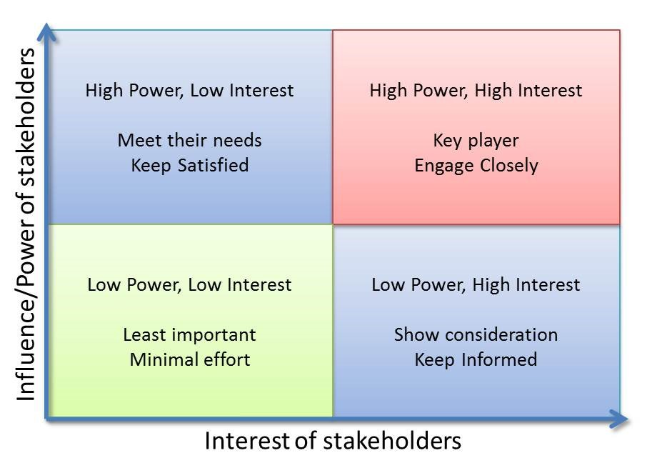
Figure 5: Mendelows Matrix
Source: (Schmidt et al., 2017)

Stakeholder mapping is the process of identifying and categorizing key stakeholders involved in achieving objectives of an organization. Mapping aids in the evaluation of your stakeholder relationships, allowing you to structure communication techniques and engagement activities based on where someone falls on your stakeholder map. Uber's stakeholders have been effectively mapped using Mendelow's Matrix. The amount of influence someone has inside an organisation is determined by the position they occupy. Drivers, for example, will have more power and interest than the general public, who will have less power and interest.

Low
High
• Investors  High Power, Low Interest  Meet their needs  Keep Satisfied | • Government/ Regulators  • Drivers  High Power, High Interest  Key Player  Engage Closely
• Others  Low Power, Low Interest  Least Important  Minimal effort | • Competitors  • Riders  Low Power, High Interest  • Employees  Show consideration  Keep Informed
Power
Low
Interest

High

Advantages of Stakeholder mapping:

1) A better understanding of roles
2) Increased participation
3) Determine who your stakeholders are
4) Creates a communication strategy for stakeholders
5) Allows you to prioritize stakeholders
6) Lowers risk

Ansoff Matrix

H. Igor Ansoff created the Ansoff Matrix, which was first published in Harvard Business Review in 1957 with the title Strategies for Diversification. It has provided corporate leaders with a quick and easy way to consider challenges of growth (Yin, 2016). The Ansoff Matrix outlines four growth strategies for organisations. It also aids in the analysis of the risks that are linked to one another; the threat grows as you progress into a new quadrant.

Whether it’s developing a product or expanding new markets, every organisation faces difficult decisions when selecting how to grow. It’s difficult for a firm to know which option is best. There are numerous options available The Ansoff matrix, on the other hand, facilitates you to think about potential risks of each option when it comes to decision-making, to devise the most suitable plan based on the situation.

The Ansoff Matrix can help UBER assess the risks associated with each quadrant and design a contingency plan to address the ones that are most likely to affect Uber. This will result in Uber making better decisions, and implementing effective strategic marketing decisions.

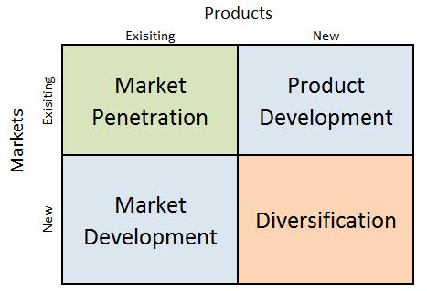
Ansoff matrix (Ansoff, 1957).

- Market Penetration- sell existing products to existing customers, Uber is engaging in this area via various sales and promotion apps. I.e.: Users can get a free ride by inviting friends and getting them to use the app.
- Product development -Developing new product to sell to existing market, Uber have consistently developed, with new services such and Uber Eats, Uber VIP such services increase the operating profit in the existing market.
- Market development- Finding new market for existing products, Uber can merge with other operations and cites in the world, Uber is already making use of this quadrant in the way they operate, however with technological development and acquisition the organisation is able to take into consideration important aspects of different cultures when expanding.
- Diversification- developing new products to sell to new market, Uber started off as a ride hailing app however they have entered other segments such as Uber Eats.

Key Findings

According to the Ansoff report, Uber is operating in its current market and has used a variety of strategies to cater to different market segments. However, Uber should adopt a product development strategy and market development strategy and offer novel products, such as increasing the concentrations of electric cars to reduce pollution, enhance sustainability and increase revenue for Uber drivers as it’ll be more cost-effective. Additionally expand its business venture and merge with other companies to increase revenue, recognition in the industry. This will target an established market for a new and upgraded car model, this will be the most effective approach to expand the company.

Three Possible Strategic Growth

Following an examination of Uber Taxi's internal and external environments, certain strategic development paths have been identified for the company. Three effective strategies for Uber are discussed below:

Strategic Option One: Diversification

As per the analysis, it has been identified that Uber Taxi utilizes market penetration, market development and product development strategies; however, in order to expand further Uber must incorporate a diversification strategy. During the pandemic, more buyers switched to ordering groceries online, resulting in a rapid increase in grocery delivery in 2020. Experts anticipate the transition will be permanent because on-line purchasing was already popular before the outbreak (Margulis and Goulding, 2017). As a result, Uber should have a grocery delivery app as they can attract more customers easily because Uber already have a large user base, and other services that the market is already aware of. Customers can be notified when grocery delivery is available in their city through the app. Expanding into grocery can help diversify the business even more by increasing profitability, providing drivers more opportunities, making it a more attractive platform overall.

Strategic Option Two: Merger and Acquisition

Uber can utilize merger and acquisition as a strategy. Uber needs no introduction as a corporation and a service provider. It has become popular with on-demand cab service, and it is gradually expanding to provide a variety of other services in the same way. By merging with other competitors both sides will benefit from an increase income, market share, and most importantly, it will foster an open culture towards welcoming international companies, which they can later try to expand into where profit margin and revenue is high (Smith, 2016). The merger will be nothing less than a union that has successfully carved a market for itself based on certain criteria, and they will able to exchange ideas and culture. It will also pave the way for future collaboration between companies that have previously been hesitant to so due to culture differences. Overall, it will improve connectivity and customers can expect more existing innovations.

Strategic Option Three: Operation System

Uber is well-known for the app it created, which detects nearby drivers and provides a number of transportation options. Uber is completely reliant on its drivers to fulfil client demands. Because Uber does not have a contract with its employees, the company's profitability may be affected if Uber drivers opt to take on other occupations with other competitors (Eisenbrey and Mishel, 2016). As a result, Uber's business model should be modified so that the company can purchase its own vehicles and launch its own transportation system in various markets. The introduction of Uber taxi transportation via its own vehicles would attract more customers because the company has already established a strong brand image and loyalty. This would also increase Uber's productivity because they'll have drivers working consistently, therefore the company's profitability would increase.

SFA Matrix

When several recommendations are available, the firm can utilise the SFA matrix established by Johnson et al., (2017) to limit down their options based on the strategic choice’s acceptability, feasibility, and sustainability.

Matrix | Strategic Options
Matrix | Option One | Option Two | Option Three
Sustainability | 5 | 7 | 8
Feasibility | 8 | 8 | 6
Acceptability | 6 | 8 | 8
Total Score | 19 | 23 | 22

Sustainable Business

Sustainability refers to doing business without negatively impacting the environment, community, society as a whole. A long-term sustainability strategy is required while every single activity drives a business in the correct direction, greater goals should be set in order to have a longer-term influence (Kuhlman and Farrington, 2010). A business is affected by its environment and also affects the environment therefore the strategy proposed to Uber is long-term since it recognises both the global and local sustainability challenges that affect the company. It considers the initiatives that Uber can do right now against those that will take longer to implement. It also visualises the company's goals and vision, as well as a timeframe that will be conveyed to all parties engaged in achieving the overall goal.

Recommendations/ Strategy Implementation for Uber Taxi

Despite the analysis revealing a number of areas where the organization needs to improve on and where its succeeding they can’t’ develop numerous methods at the same time as this would be unproductive. Based on the SFA matrix's score, strategic option two, a merger and acquisition plan, appears to be the most effective approach for Uber to implement. As a result, this part of the study will provide a full analysis for implementing the proposed strategy.

Identification of Needs: Firstly, Uber will identify the needs of the organisation. The management of the company will do a general assessment to understand whether option two will be beneficial and profitable. Based on the outcome and capital Uber taxi can select the best option for expanding the business.

Identification of Companies: Uber will need to identify the companies for merger and acquisition as there may be several organisations to choose from in the market. Some of these companies can be acquired by Uber Taxi as it will help Uber to expand its operations. For example, the acquisition of a transportation sector can help Uber taxi to introduce their vehicles in their country/city.

Build Relationship: Uber can have a sense of loyalty and establish a relationship once they've decided which organisation, they want to do business with. Companies can't operate well in the long run if they don't build relationships, trust, and ownership. Furthermore, by sharing the same resources and aims, they can successfully influence business processes.

Control and Monitor: Uber must keep track of progress in order to maintain productivity and success. This can be done by regulating and monitoring Uber taxis. Uber can track and monitor progress using a variety of tools. To measure critical targets, tools like Key Performance Indicator, SMART tools can be applied, which helps the team focus on what's important. A strategic KPI, or SMART framework can be used to track Uber's goals as it sets out clear attainable goals which are specific, Measurable, Attainable, Relevant, Time-bound all in which can assist Uber see how the company is performing at any particular time.

Reaction To Change

Change can elicit feelings such as anxiety, disappointment, conflicts, and failure to embrace. People may take out their frustration on one another as a result of this. However, if the strategy is well articulated, with rules and an appropriate structure in place, this can be avoided. Everyone is affected by change, nonetheless change is a necessary component of company success, and easier transitions can be achieved by effective organisational change management.

Reaction By Competitors

Uber can achieve first-mover position in the business by pursuing a merger and acquisition strategy. Uber's competitors, on the other hand, may soon imitate this strategy for their own businesses. Competitors that try to copy this model for themselves could damage their business if they can't keep up with Uber because they have a loyal customer base, enough capital, and resources to become market leader, and invest in resources and technology to get there, unlike their competitors.

Conclusion

To summarise, the methods and principles listed above are all ways and guidelines that Uber, or any other organisation, can employ. It defines success and identifies the tasks Uber should prioritise in order to achieve its goals. Internal and external environmental scanning, PESTEL, Porter's analysis, SWOT, Value chain, Stakeholder mapping, and SAF matrix were all utilised to get a complete picture of the current and future environment in order to achieve a competitive edge. Furthermore, all of the methodologies used provide some insight into how Uber might become a market leader by focusing on key strengths and minimising shortcomings. The recommended strategies will enable Uber to plan for the future, help it stand out from competitors, As a result, Uber will have a competitive edge and will have a better chance of becoming the market leader.

Reference

Akan, Allen, Helms and Spralls. (2006) ‘Critical tactics for implementing Porter’s generic strategies’, Journal of Business strategy, Vol.27 No.1, pp.43-53
Aktouf, O. (2005) ‘The false expectations of Michael porter’s strategic management framework’, 6(11), 75-94, HEC Montreal.
Barney, J. (1991) Firmresourcesandsustainedcompetitiveadvantage.Journal of Management, 17(1), 99-120. Retrieved from https://business.illinois.edu/josephm/BA545_Fall%202011/S10/Barney%20%281 991%29.pdf [Accessed 12 November 2021].

Chaffee, E. E. (1985) Three Models of Strategy. ‘The Academy of Management review’, [Online] 10 (1), 89–98.

Fosher, H. (2018) ‘Understanding the Marketing and Management of trails using PESTEL Analysis’. (Doctoral dissertation, University of New Hampshire).

Freeman, R.E. et al. (2008) Managing for stakeholders. Yale University Press.

Hofer, C.W. and Pitts, R. (1984) Strategic management: A casebook in policy and planning. West Group.

Hutaibat, K.A. (2011) Value chain for strategic management accounting in higher education. ‘International Journal of Business and Management’, 6(11), p.206.
Johnson, G., Whittington, R., Scholes, K., Angwin, D. and Regner, P. (2017). Exploring strategy: text and cases. 11th ed. Harlow, England: Pearson.
Kuhlman, and Farrington, J. (2010) ‘What is sustainability’. Sustainability, 2(11), pp.3436-3448.

Lynch, R. (2018) Strategic Management, Pearson Education, Limited, Harlow, United Kingdom. Available from: ProQuest Ebook Central. [18 October 2021].

McGaughey, E. (2019) Uber, the Taylor Review, Mutuality and the Duty Not to Misrepresent Employment Status. ‘Industrial law journal’. [Online] 48 (2), 180–198.
Mendelow, A.L. (1983) ‘Setting corporate goals and measuring organizational effectiveness—A practical approach’. Long Range Planning, 16(1), pp.70-76.
Mintzberg, H. (1990) The design school: Reconsidering the basic premises of strategic management. ‘Strategic management journal’, [Online] 11 (3), 171–195.
Rodger, J. (2021) This is exactly when Uber strike in Birmingham will start and end. [online] BirminghamLive. Available at: <https://www.birminghammail.co.uk/news/midlands-news/exactly-uber-strike-birmingham-start-15255172> [Accessed 12 November 2021].

Ruan, S. (2020) Research on Strategic Cost Management of Enterprises Based on Porter’s Value Chain Model. ‘In Journal of Physics: Conference Series’ (Vol. 1533, No. 2, p. 022056). IOP Publishing.

Scheepers, and Bogie, J. (2020) Uber Sub-Saharan Africa: ‘contextual leadership for sustainable business model innovation during COVID-19’. Emerald Emerging Markets Case Studies, 10(3), pp.1-18.

Smith, J. (2016) ‘The Uber Taxi-all economy of the future’. The Independent Review, 20(3), pp.383-390.

Uber (2021) About us Uber. [online] Available at: <https://www.uber.com/gb/en/about/> [Accessed: 1 November 2021].

Yin, N. (2016) ‘Application of AHP-Ansoff matrix analysis in business diversification’: The case of Evergrande Group. In MATEC Web of Conferences (Vol. 44, p. 01006). EDP Sciences.

