3/24/2025
University of Wales Trinity Saint David
London campus
Module Name: Learning In the Digital Era
Module Code: ACCA 4025

Student Name: Rike Raranti Siska
Student ID:2531290
Group: 1

Lecturer’s Name: Koushik Modak

Learning in the Digital Era

Assignment1

E-Portfolio Link: https://25312907.wixsite.com/r1k3s15k4
Table of Contents
Learning in the Digital Era 0
Assignment1 0
Introduction 2
Main Body 2
Task 1: Essential Academic and Employment Skills for the Future Career Path 2
Task 1 (a): Report on Essential Academic and Employment Skills 2
Task 1 (b): Evaluation of Task 1 (a) based on Similarity report 4
Task 2: Collaborative Mind Map and Individual Poster 4
Mind Map (Collaborative) 4
Poster (Individual) 4
Task 3: Virtual Collaboration and RefWorks 4
Report on Virtual Collaboration 4
Step-by-step process of using RefWorks with visuals 4
Task 4: E-Portfolio Creation and Evaluation 4
Task 4 (a): E-Portfolio Creation 4
Task 4 (b): Illustrative Review of E-Portfolio tool Selection 4
Conclusion 4
References 4
Task 1 References: 4
Task 3 References: 5

Introduction
Studying computing has been a vital part of my academic journey, helping me develop both technical and problem-solving skills. I have also used digital tools and software, such as Microsoft Office, and collaborative technologies to complete projects and deepen my understanding of computing concepts. These experiences have enhanced my logical thinking, creativity, and ability to work independently and as part of a team. As I continue learning, I am becoming more confident in applying computing skills to solve real-world problems. This journey demonstrates my interest in technologies essential to today’s digital world and prepares me for future academic and career opportunities in it.

Main Body

Task 1 (a): Report on Essential Academic and Employment Skills

In the era of digitalisation and automation, the continued adoption of more technical and sophisticated jobs is likely to continue. This raises the question of how graduates and employees can ensure they will have jobs in the future. Therefore, employability, soft, and 21st-century skills are needed to identify where human skills will remain important. This is the reason for developing and introducing an employability skills module in higher education. Based on the literature, recommendations are made for higher education institutions, tutors, students and employees [1].

Personal and employability development is a systematic approach to enhancing personal, academic, and career-related skills that boost employability. Commonly utilised in higher education, it connects self-awareness with practical strategies for lifelong learning and professional development [2].

According to the Department of Education, the focus will be on skills and competencies as qualifications that can bridge the gap between education and employment, acting as a practical support system for individuals and employers. Certification of technical and non-technical skills facilitates job search activities and opportunities for skills enhancement. Higher education, skills, and work-based learning are the only areas emphasising education and the workplace. Articles with strong implications for practice and policy development include work-integrated learning, cooperative education, graduate employability, work competencies, academic standards, and the workforce. development [3].

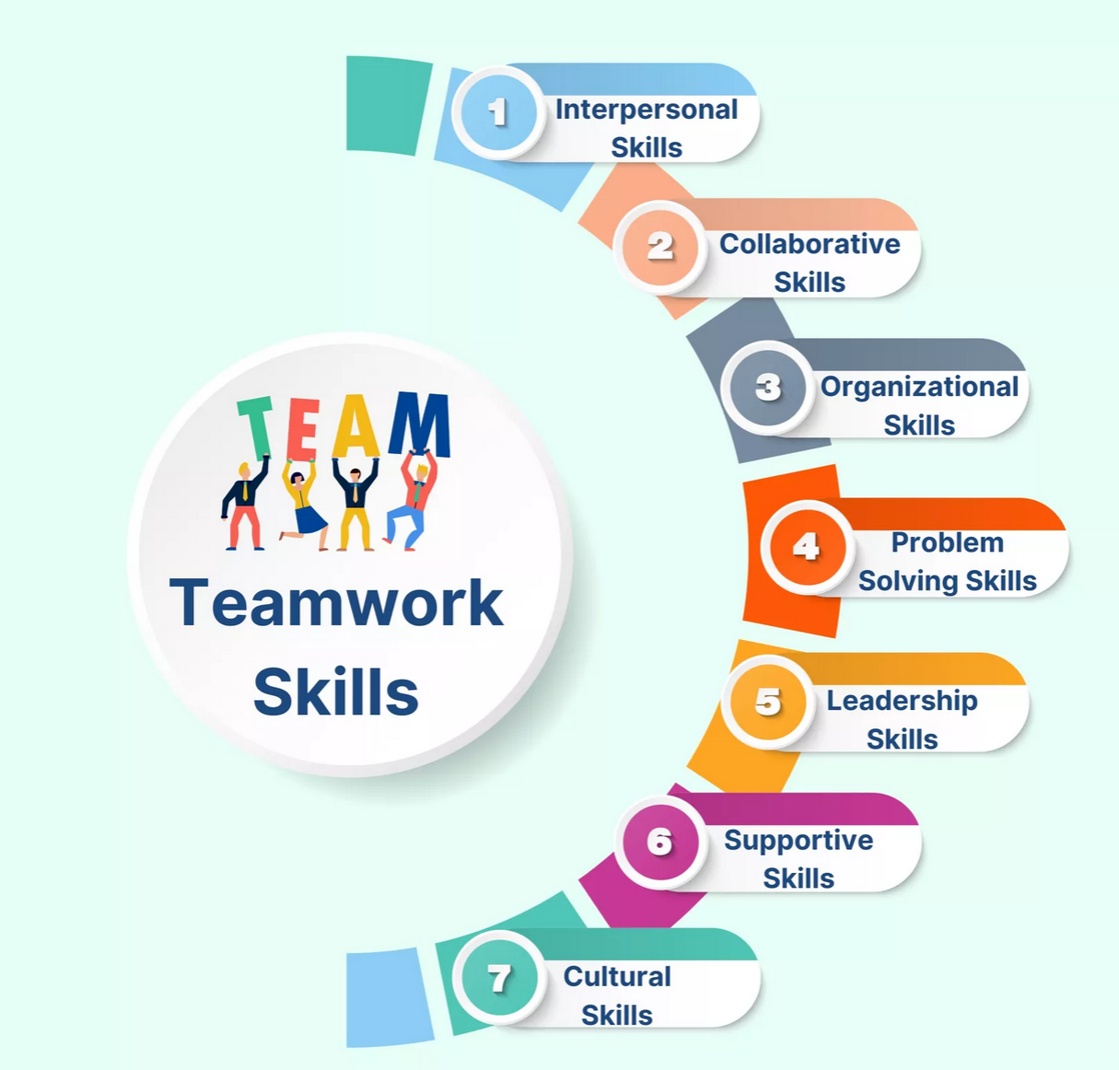
Figure 1: Teamworking skills [4]
Essential academic and employability skills encompass the knowledge, abilities, and personal attributes that individuals require to succeed in both education and the workplace. Academic skills can be developed through formal education, as well as critical thinking, research, writing, and numeracy. These skills enable students to analyse information, solve problems, and communicate ideas effectively. It is also important to develop employability skills, or soft skills, such as communication, teamwork, time management, adaptability, and emotional intelligence. Individuals must be able to respond to challenges, work effectively with others, and operate in a dynamic work environment. The ability to use modern tools and adapt to new technologies is crucial for long-term success [5].
Job-specific training is crucial for those lacking job skills, as employers need dependable, responsible workers with technical, problem-solving, and social skills. Although the academic level required for some entry-level roles may be minimal, a foundation of academic skills remains vital for job performance, and ideally, individuals should be capable of learning and building a positive career and future prospects [6].
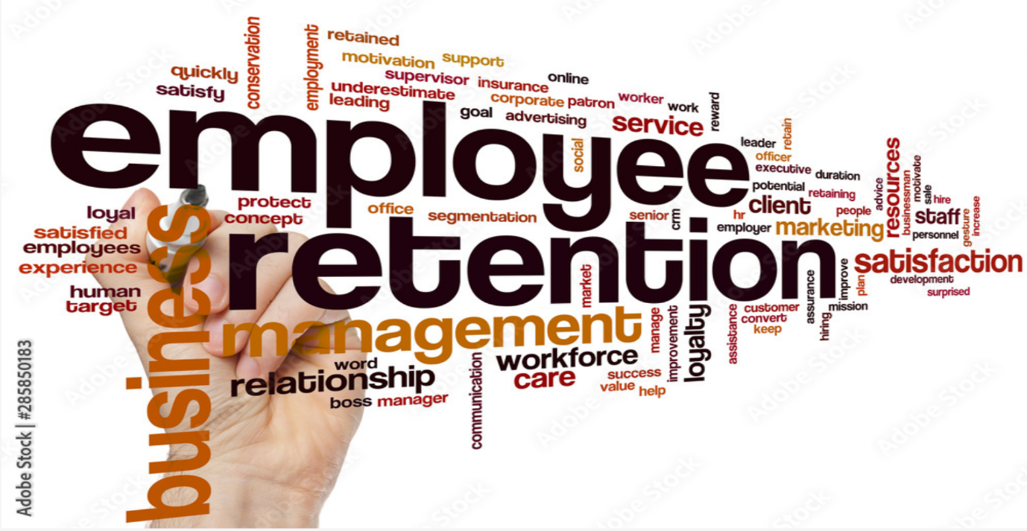
Figure 2: Employment skills [7].

Task 1 (b): Evaluation of Task 1 (a) based on the Similarity report
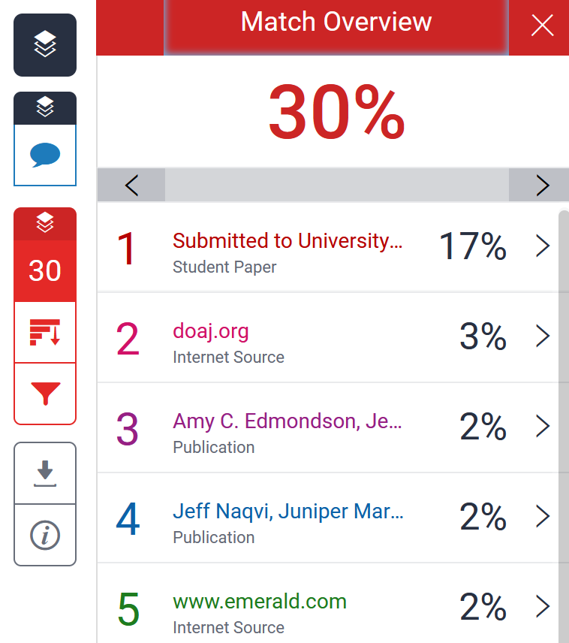
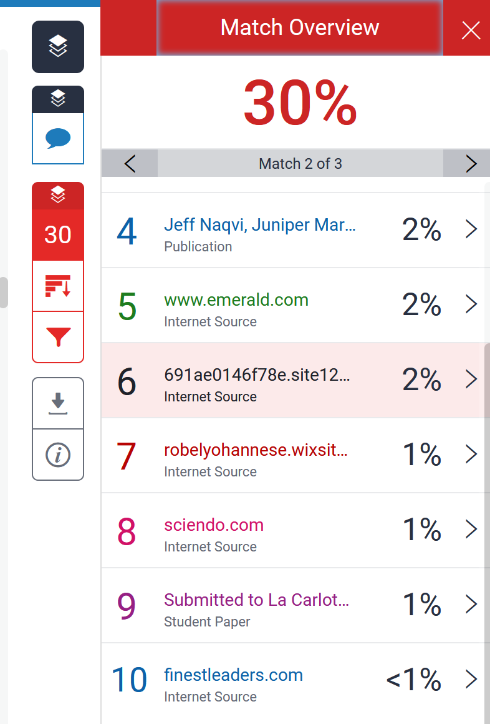
I received a similarity score of 30% on my assignment. Upon reviewing the report, I found that a significant portion of this percentage appears to come from the template provided, which alone accounts for approximately 30%. Additionally, around 2% similarity is attributed to the references included in the assignment. Before completing this work, I conducted thorough research by consulting academic sources, including books and reports on essential academic and employment skills accessed through Google Scholar. Based on my review, I believe the content of my assignment is original and appropriately referenced. I would appreciate it if this could be taken into consideration when evaluating the similarity score.
I gave the similarity report a score of 70 because I searched across multiple sources, including Google Scholar, websites, articles, and online books. My similarity report helped me reflect on my essential academic and employment skills. It highlighted the importance of originality, proper referencing, and critical thinking in academic work. I have learned to paraphrase effectively and avoid unintentional plagiarism by understanding sources rather than copying them. These skills are equally valuable in employment, where integrity, communication, and attention to detail are essential. Improving my writing and research abilities will support both my academic success and future career. Overall, this experience has increased my awareness of ethical practices and strengthened my confidence in producing independent and professional work.

Task 2: Collaborative Mind Map and Individual Poster

Mind Map (Collaborative)
Mind Map Link: https://mm.tt/map/3952545948?t=7zqVEXa2N9

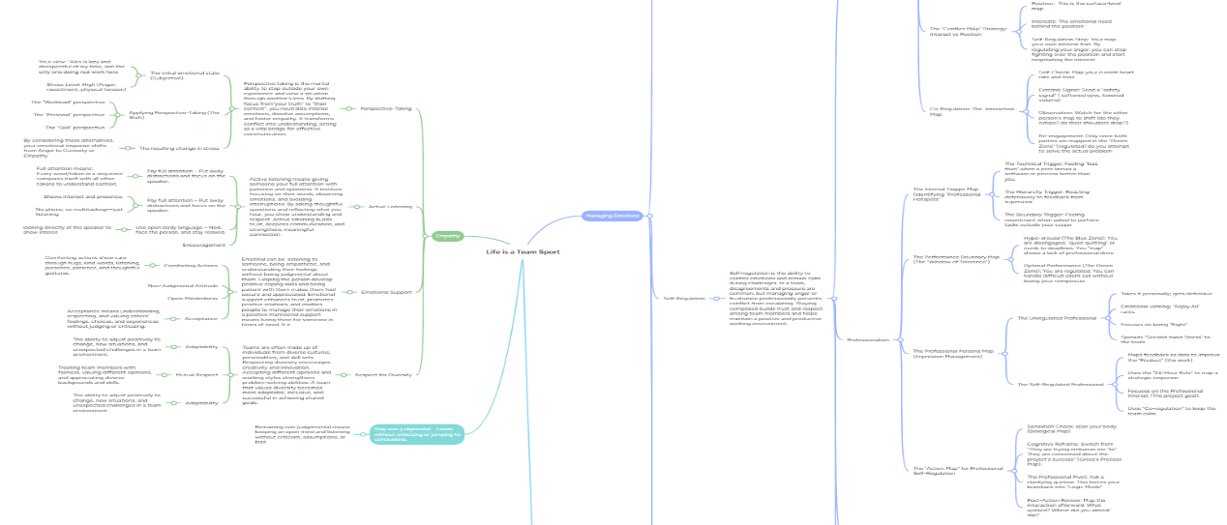

Poster (Individual)
https://www.canva.com/design/DAHD53iMb4g/H3cXQpD3g3ijf4ljL2KSxw/edit?utm_content=DAHD53iMb4g&utm_campaign=designshare&utm_medium=link2&utm_source=sharebutton

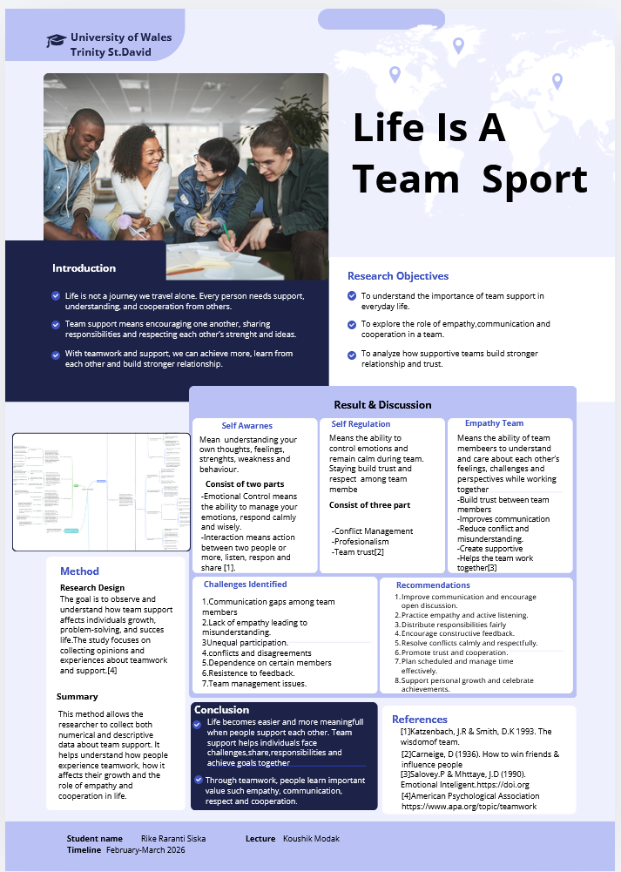

Managing emotions is how we do self-awareness, meaning understanding our own thoughts, feelings, strengths, weaknesses, and behaviour and self-regulation, which means our ability to control emotions and remain calm, build up trust and respect among each other.
Empathy means our ability to understand and care about each other's feelings, challenging and perspective while working together. Need to build trust, improve communication, reduce conflict and misunderstanding and create supportive.

Task 3: Virtual Collaboration and RefWorks

Unit 3 Topic: 2 (Riding the Storm)
In today's digital age, Riding the Storm is a team navigating a difficult, conflict-ridden phase of work. The way to avoid these difficulties is to motivate the team productively. This idea relates to the Tuckman group stage [1].
In today's education world, it is very common for organisations to enlist all team members participating in activities, with diverse representation, to assist with decision-making and ongoing maintenance tasks. A group meets to share something and to allow for specific tasks related to decision-making or implementing new efforts. Everyone brings a variety of skills and experiences to the team, which can enhance or hinder team development. Barriers can arise in these personal interactions, preventing the group from operating efficiently and effectively [2].
The experts have long been interested in how groups develop and change over time. They often explore how individuals come together, build relationships, and, growing research indicates, reach a consensus on the complex, multifaceted nature of team development. and effectiveness. Some teams move forward and then back again because not all teams spend the same amount of time at each stage, and some do not reach full maturity. Many teams experience mid-point corrections, and these experiences can be examined without conflicting with other models of team development [3].
Team performance suffers when leaders focus on the wrong things in designing or supporting teams. Given the specific condition that foster team effectiveness and the right timing for building them, teams that rely on them can perform exceptionally well. Therefore, the primary task of team leaders is to get the team on the right track and then make small adjustments along the way to help team members succeed, rather than constantly managing team behaviour directly [4].
No plan can survive a clash with reality; in running an organisation or participating in a committed relationship, that is where you will find yourself continually thwarted in your best efforts to achieve the team's goals [5].
As leaders striving to make organisations more effective in the face of intense environmental pressures, we are sometimes amazed by how individuals and groups within organisations continue to behave in ways that are clearly ineffective, often threatening the organisation's very survival. When trying to resolve matters involving other groups, we often find that they are not communicating with each other and that the level of conflict between groups within the organisation and in society is often very high [6].

Step-by-step guide to using RefWorks with visuals
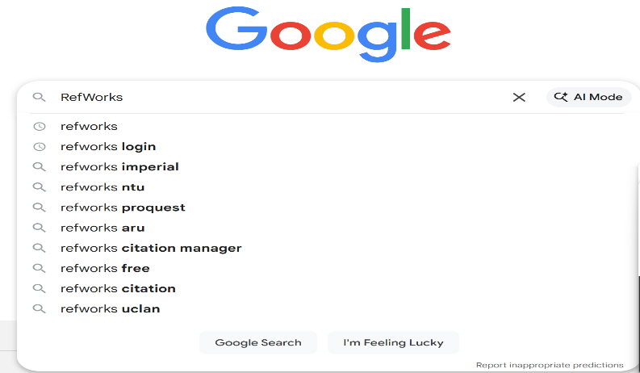
Figure 1. Open Google and type RefWorks

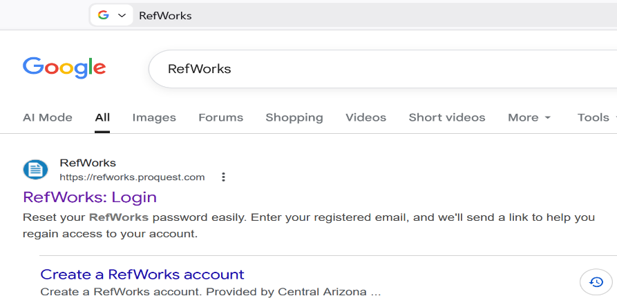
Figure 2. Then choose to create a RefWorks account

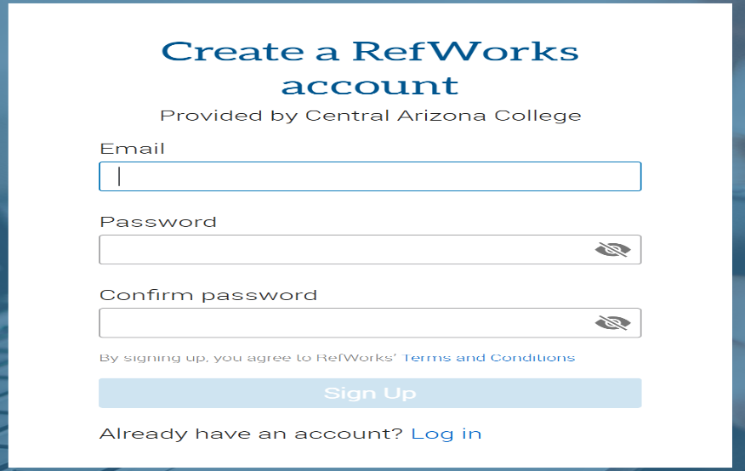
Figure 3. Fill the form with email details and password, and confirm password
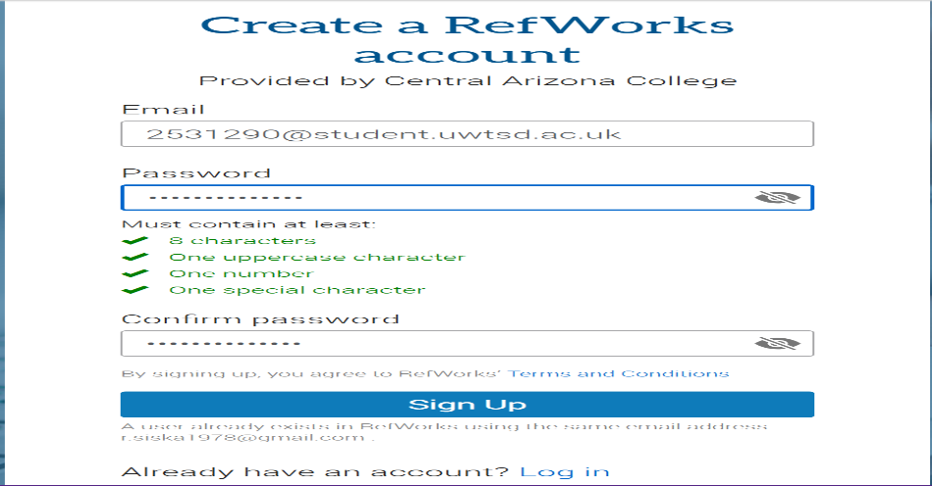
Figure 4. After completely filling out the form with email and password, click " Sign up”

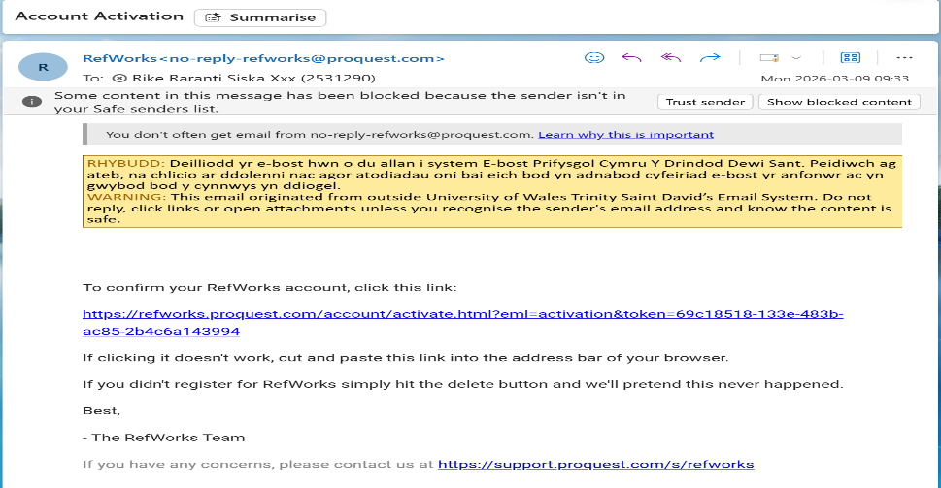
Figure 5. It will direct you to email and click the link to confirm your RefWorks account

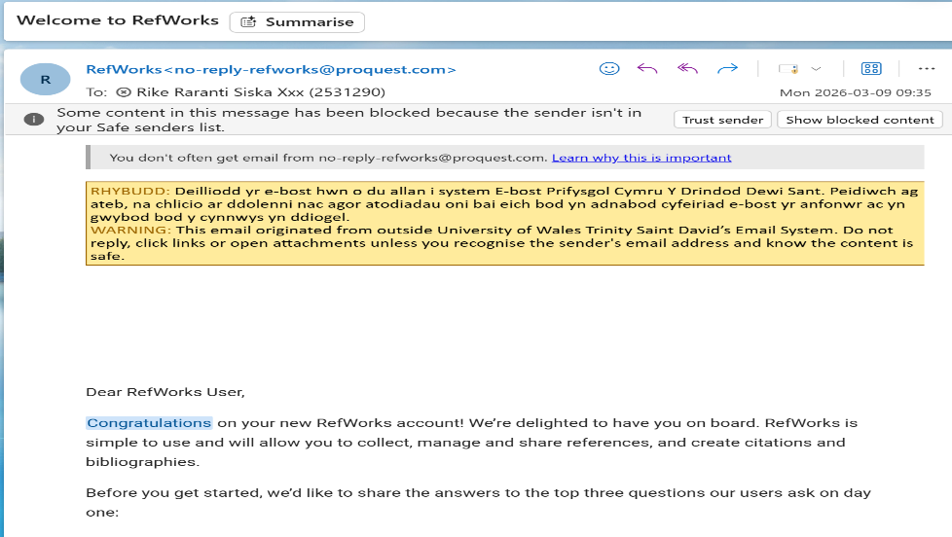
Figure 6. After clicking the link to confirm, you will get another email if RefWorks is ready to use
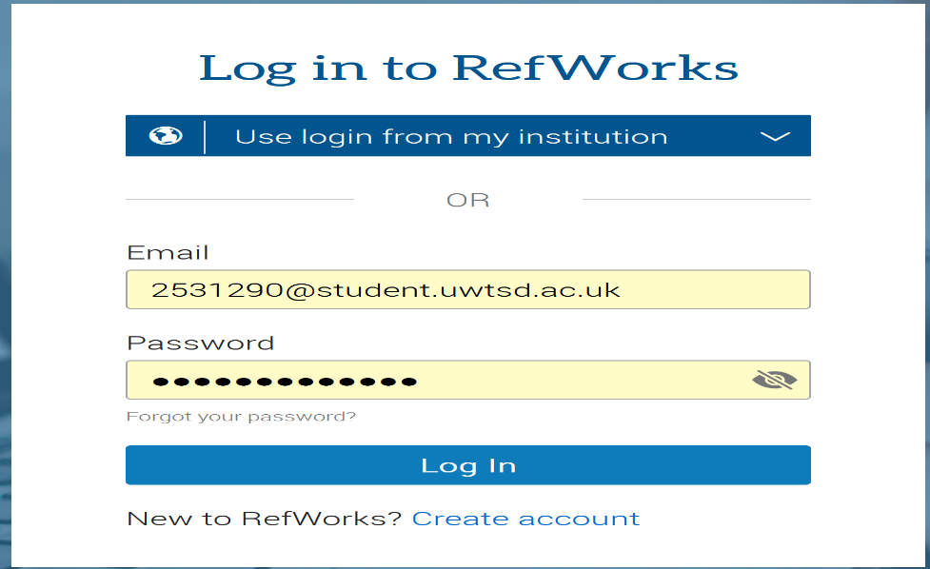
Figure 7. Now log in to your RefWorks account with the email and password that you registered

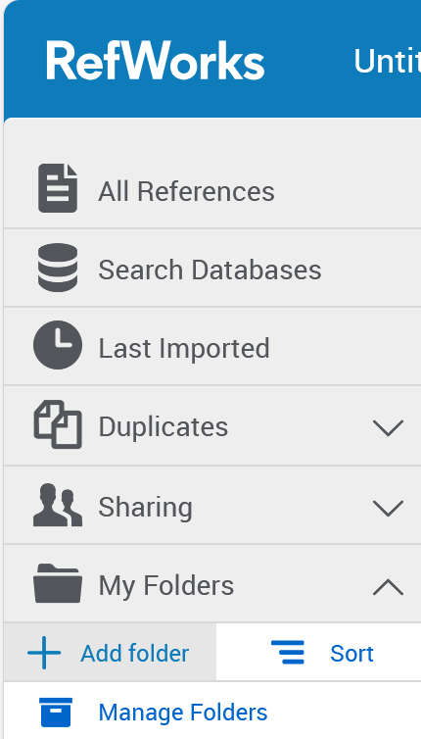
Figure 8. On the left side, click +Add folder to create a new folder

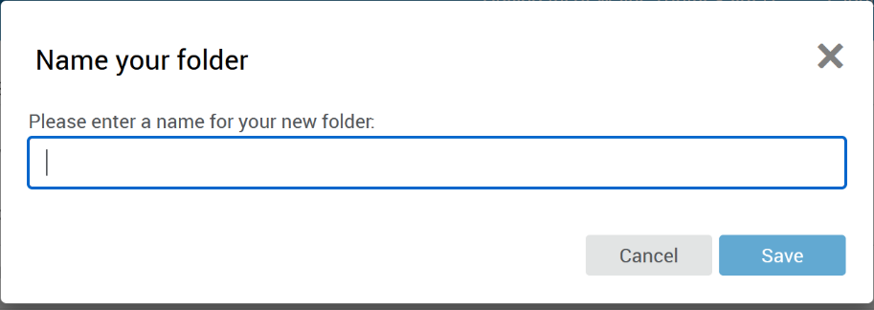
Figure 9. After clicking + Add, there is a blank column
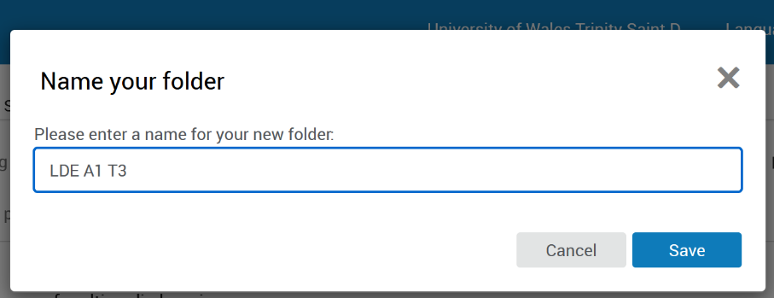
Figure 10 Fill the blank column with a name

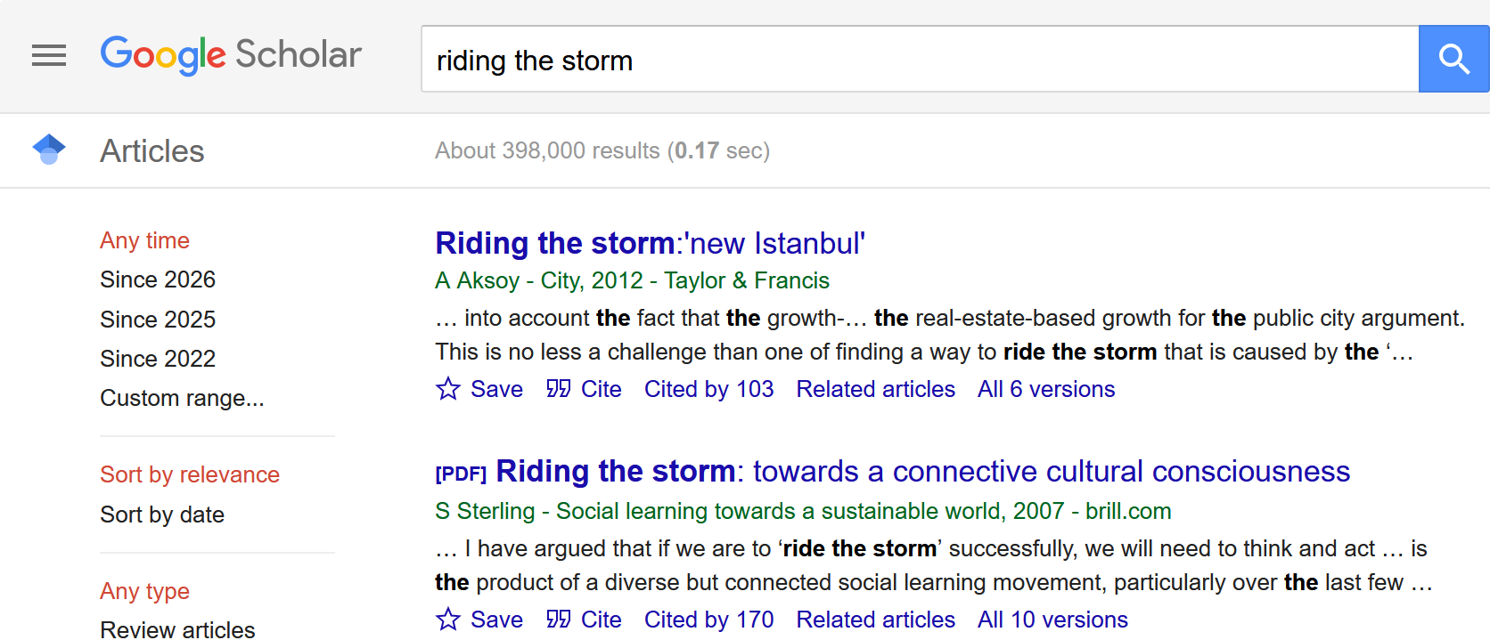
Figure 11. Open Google Scholar and type the topic you are looking for

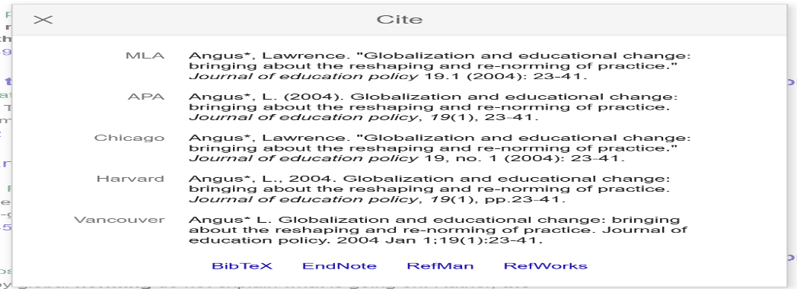
Figure 12. After finding the topic, click cite and choose RefWorks
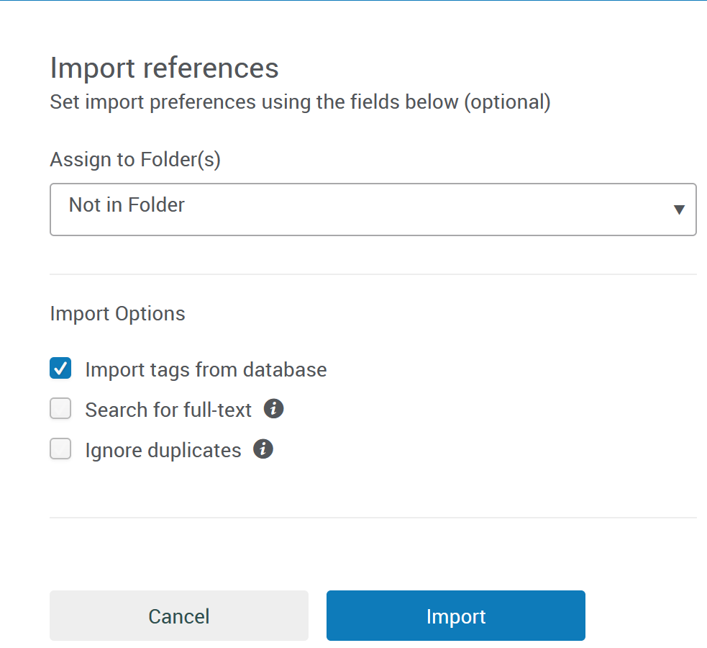
Figure 13. After clicking RefWorks, it will directly connect to RefWorks, and there is an option for a folder

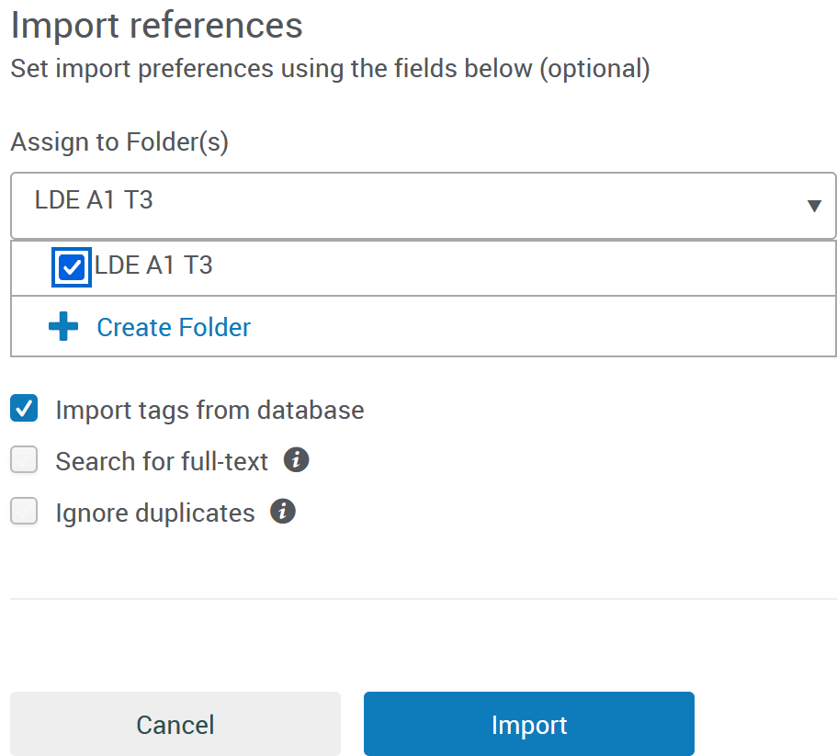
Figure 14. Then choose the option folder that was created already, then click “import

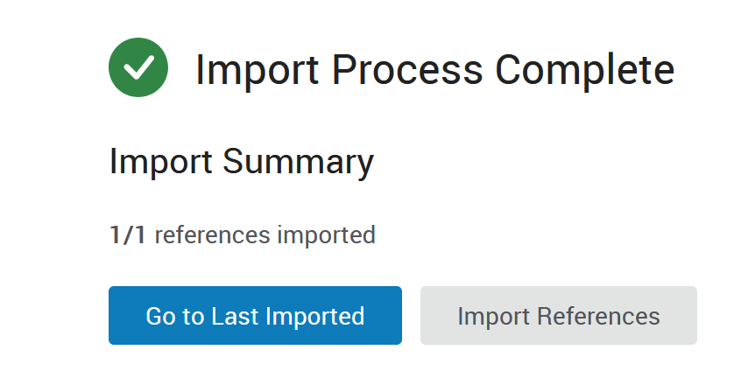
Figure 15. Imported is completed
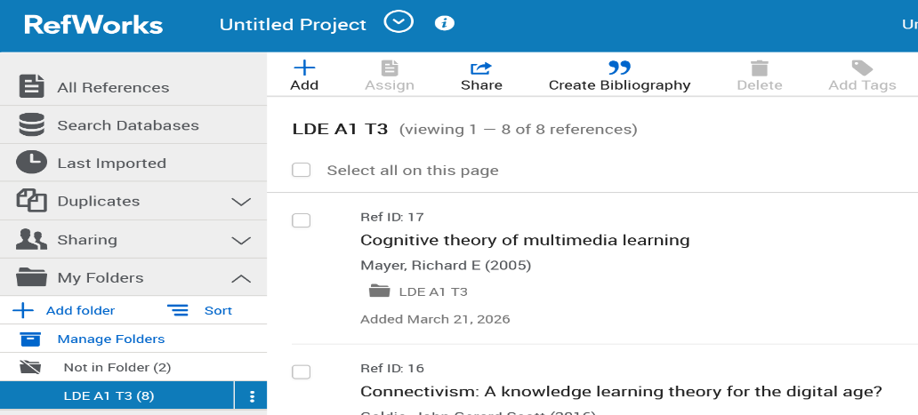

Figure 16. Click Add folder and choose the folder with the name LDE A1 T3 to check that it was imported from Google completely

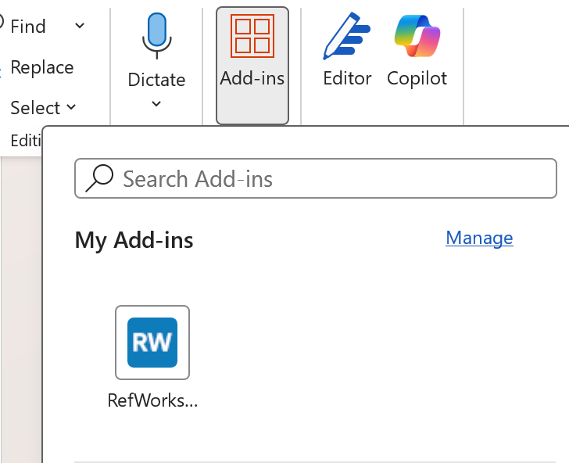
Figure 17. Now open Microsoft Word, on the ribbon, choose Add-ins, and you will see RefWorks, then click

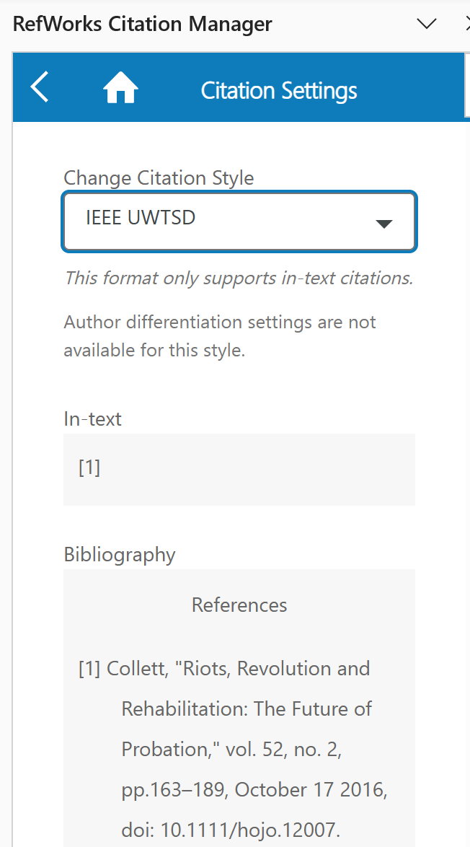
Figure 18. Make sure the citation style is in the format IEEE

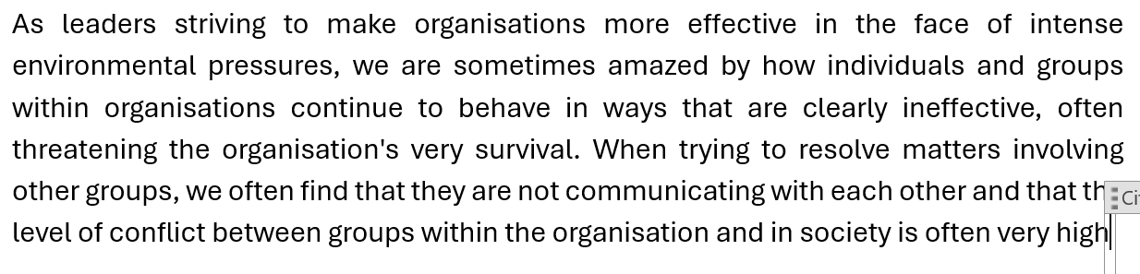
Figure 19. Put the cursor at the end to put the citation

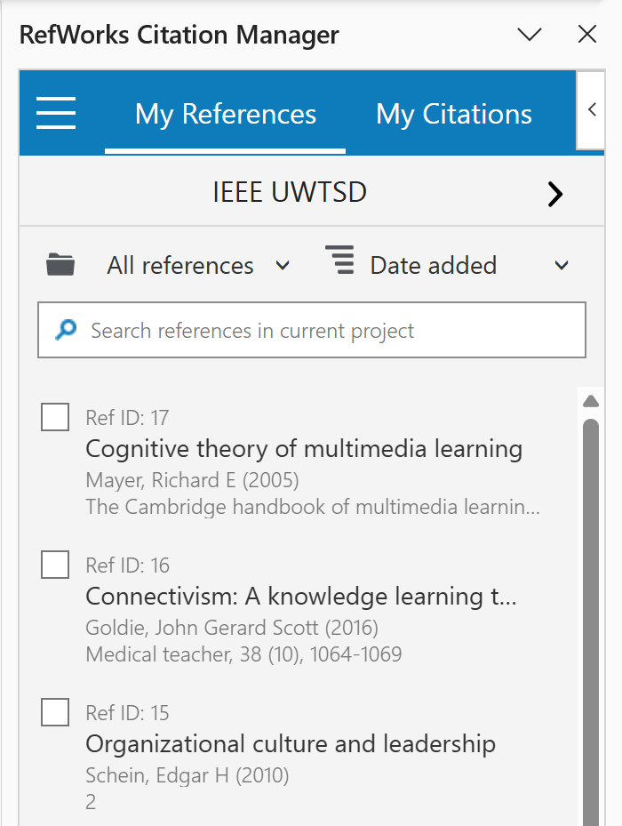
Figure 20. Then choose 1 of the references

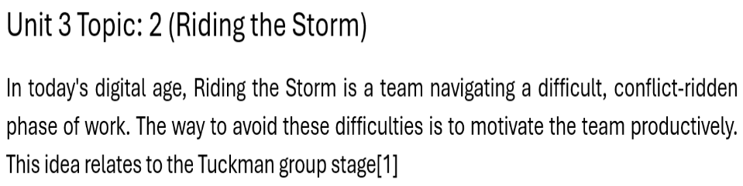
Figure 21 Now a reference is added at the end of the paragraph

Task 4b: E-Portfolio Creation Images

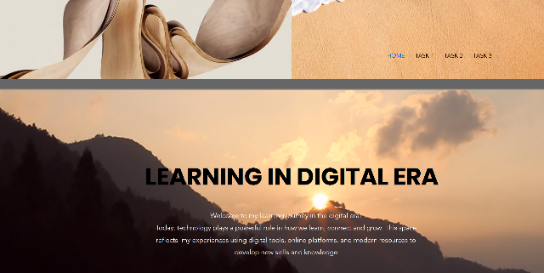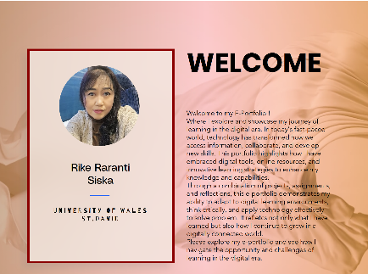
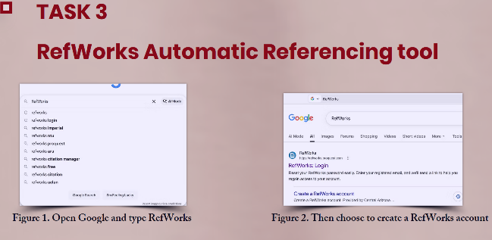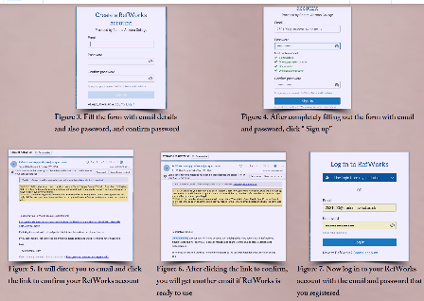
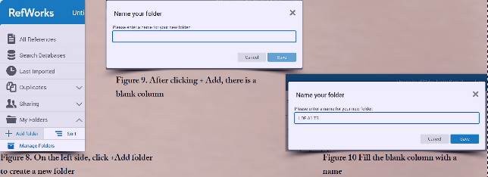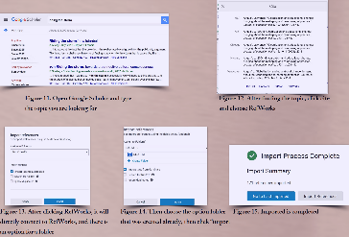
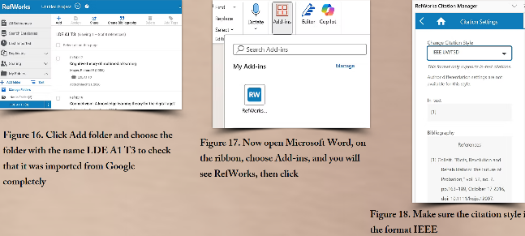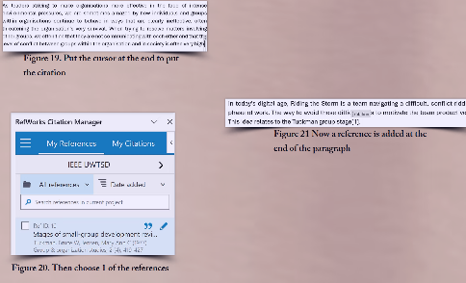

Task 4b: Review Illustration
I chose to use Wix to create my portfolio because it offered an easy and flexible way to design a professional-looking website without needing coding skills. Wix provides a user-friendly drag-and-drop interface that makes the whole process much more accessible [7].
Another reason I selected Wix is that it offers a variety of templates. These templates gave me a strong starting point and helped me visualise how I wanted my portfolio to look. I was able to customise layouts, colours, and fonts to match my personal style, which made the result feel unique and reflective of my identity. Wix also includes built-in features such as image galleries, contact forms, and mobile optimisation, which are essential for a portfolio website. This meant I didn’t have to rely on multiple external tools, saving time and effort [8].
Overall, Wix allowed me to create a clean, functional, and visually appealing portfolio efficiently, making it a practical choice for my needs.

Conclusion
Learning in the digital age has evolved with the integration of advanced technology, such as the internet and mobile devices, into educational practice. These innovations have transformed traditional learning environments into more flexible, accessible, and personalised systems. Digital platforms allow for access to vast amounts of information anytime, anywhere. In addition, the use of interactive multimedia tools, adaptive learning systems, and data analysis enables personalised learning experiences tailored to individuals' needs and performance levels.
Learning in the digital age not only shapes how individuals acquire knowledge but also emphasises collaboration and shared responsibility. In many ways, life can be understood as a team sport, where success depends on communication, cooperation, and collective problem-solving. Digital learning environments reflect this reality by encouraging collaboration through online discussions, group projects, and global connectivity. Therefore, combining technological advances with teamwork skills prepares individuals to thrive in both academic and real-world settings.

Task 1 References:

[1]] | Z. Soproni, “Employability Skills – Rethink Your Learning,” License Creative Commons Attribution, 03 November 2023. [Online]. Available: http://real.mtak.hu/id/eprint/178608. [Accessed 03 November 2023].
[2] | S. Cottrell, “Skills for Success: Personal Development and Employability,” in Study Skills, Bloomsbury, UK, Red Globe Press / Macmillan International Higher Education, 4th edition (2021), p. 432.
[3] | J. Naqvi, “Higher Education, Skills, and Word-based Learning,” About Higher Education, Skills and Work-based Learning, vol. 16, no. 1, p. 1, 10 February 2025.
[4] | “https://chatgpt.com/c/69be3bc1-caa0-8332-94ed-67a695a8552e,” [Online].
[5] | Cottrell, “Essential Academic and Employment Skills for Future Career Path,” Bloomsbury Academic, London, 2021.
[6] | D. J. P. Robinson, “The Workplace,” What Are Employability Skills?, vol. 1, no. 3, p. 3, 15 September 2000.
[7] | “https://stock.adobe.com/uk/search?k=employability&search_page=2&asset_id=285850183,” [Online].

Task 3 References:
[1] R. E. Mayer, "Cognitive theory of multimedia learning," vol. 41, no. 1, pp.31–48, 2005,
[2] J. G. S. Goldie, "Connectivism: A knowledge learning theory for the digital age?" Med.Teach. vol. 38, no. 10, pp.1064–1069, 2016,
[3] E. H. Schein, Organisational culture and leadership, John Wiley & Sons, 2010.
[4] F. Conversations, "Achieving Success at Work & in Life, One Conversation at a Time," 2003,
[5] J. R. Hackman, Leading teams: Setting the stage for great performances, Harvard Business Press, 2002.
[6] A. C. Edmondson and J. Harvey, "Cross-boundary teaming for innovation: Integrating research on teams and knowledge in organizations," vol. 28, no. 4, pp.347–360, 2018, doi: 10.1016/j.hrmr.2017.03.002. Available at: https://www.sciencedirect.com/science/article/pii/S1053482217300219.
[7] J. L. Hamlin, Team effectiveness: A validation study of Lencioni's five functions of a team, University of La Verne, 2008.

