DS 1 Template
- Name: Marcin Zuchlinski
- Student number: 2613725
- Assignment: DS1 – My Digital Life

Screenshot/Photo 1
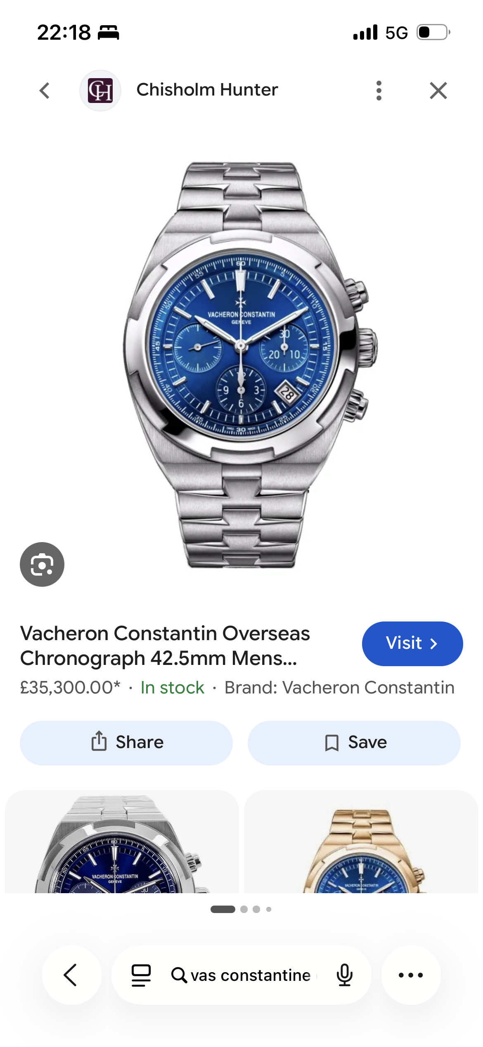
This is me looking at a Vacheron Constantin watch on the Chisholm Hunter website. I was just checking the price and what it looked like.
Screenshot/Photo 2
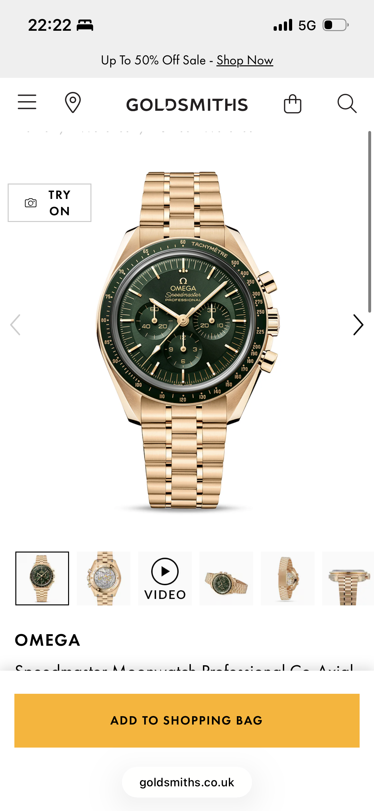
Here I’m on the Goldsmiths website looking at an Omega Speedmaster. I was comparing a few different gold ones.
Screenshot/Photo 3
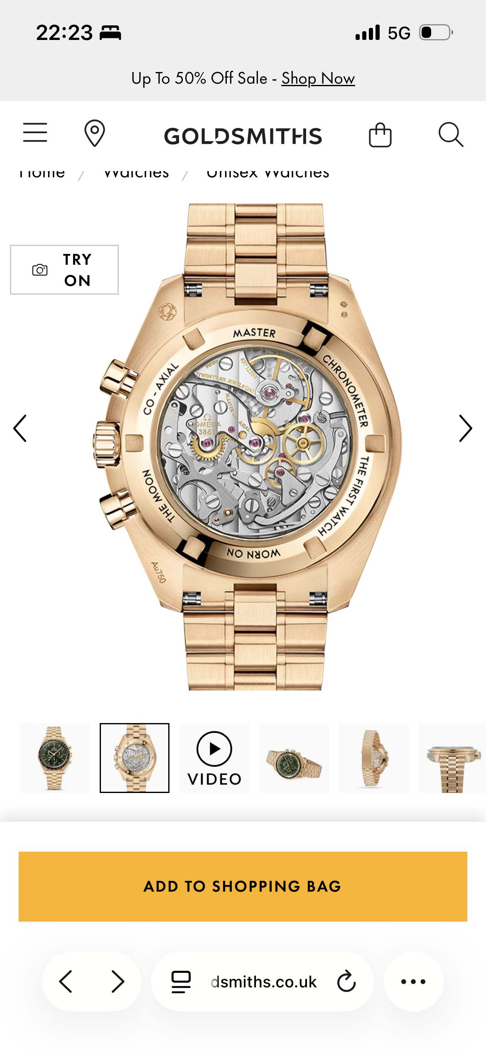
This is the back of the Omega watch showing the movement inside. I just wanted to see what it looked like properly.
Screenshot/Photo 4
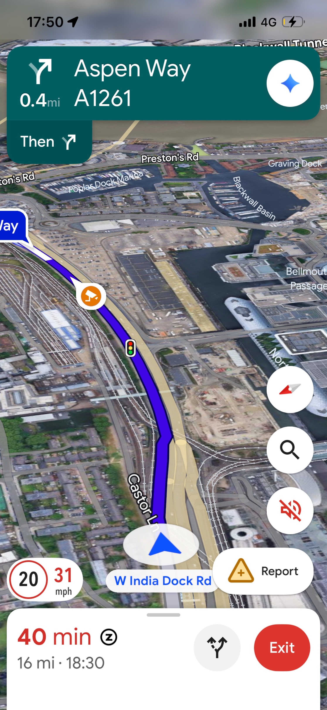
This is Google Maps while I was driving near Aspen Way. I use it a lot for directions when I’m out.
Screenshot/Photo 5
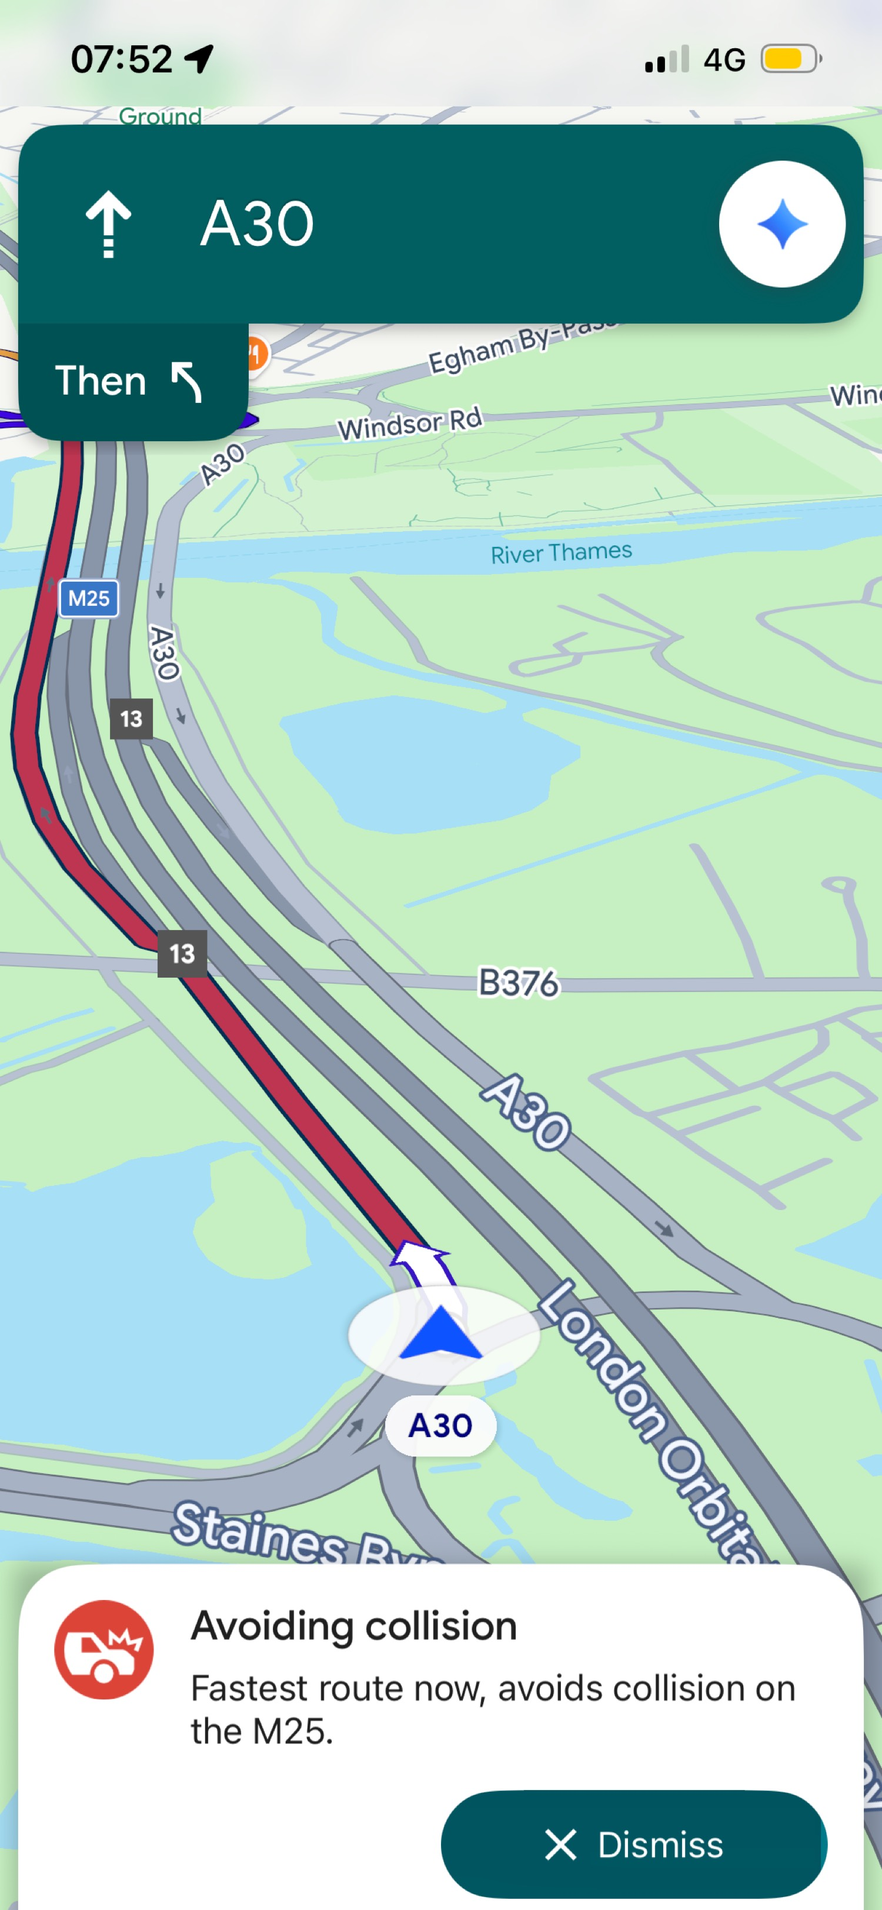
Another maps screenshot from when I was on the A30. It was warning me about a crash on the M25 and giving me a different route.

My Short Reflection
I use digital tools to look up things online and to get directions when I’m driving.
I feel confident when I can check prices and photos of products on my phone.
I often use these tools: Google Maps, shopping websites and my phone browser.
I sometimes feel a bit nervous about buying expensive things online.
I want to improve how careful I am when I’m using websites and apps.
Digital skills are important for me because I do most things on my phone now.
I hope this module will help me get better at using digital tools properly.

