

LOCATION: Swansea | LLEOLIAD: abertawe
LEVEL 4 | LEFEL 4
EXAMINATION PERIOD | CYFNOD ARHOLIADAU
may 2020 | mai 2020

MODULE CODE: M4X00386
ENGINEERING SCIENCE 2
MODEL ANSWERS
TIME: 2 HOURS
answer all questions

Equipment or materials required – Calculator, Thermodynamics Tables

FORMULAE BOOKLET FOR ELECTRICAL ENGINEERING

$$Q=CV$$ | $$Q=It$$ | $$V=IR$$ | $$V=V_{0}e^{-\frac{t}{RC}}$$ | $$I=I_{0}e^{-\frac{t}{RC}}$$
$$Q=Q_{0}e^{-\frac{t}{RC}}$$ | $$P=IV$$ | $$P=I^{2}R$$ | $$P=\frac{V^{2}}{R}$$ | $$E=\frac{1}{2}CV^{2}$$
$$E=\frac{1}{2}QV$$ | $$ρ=\frac{RA}{l}$$ | $$R_{T}=R_{1}+R_{2}+R_{3}$$ | $$\frac{1}{R_{T}}=\frac{1}{R_{1}}+\frac{1}{R_{2}}+\frac{1}{R_{3}}$$ | $$V=ε-Ir$$
$$V_{rms}=\frac{V_{0}}{\sqrt{2}}$$ | $$I_{rms}=\frac{I_{0}}{\sqrt{2}}$$ | $$V_{rms}=I_{rms}R$$

FORMULAE BOOKLET FOR THERMODYNAMICS

- BASIC CONCEPT:
The change in the energy content of a body or any other system is equal to the difference between the energy input and the energy output, and the energy balance is expressed as:
$$∆E=E_{in}-E_{out}$$

E₂ – E₁

WORK:
Work done by the system is considered: POSITIVE
Work done on the system is considered: NEGATIVE

HEAT:
Heat transfer into the system is considered: POSITIVE.
Heat transfer out of the system is considered: NEGATIVE.

- CLOSED SYSTEMS:
Non-flow energy equation:
$$∆U=Q-W$$

- ENTHALPY:
$H=U+P.V$ (J)

Where:
- U = internal energy
- P = pressure
- V = volume

- FLOW WORK:
The flow work, or flow energy, or again displacement energy:

$$W_{flow}=P×V$$

- OPEN SYSTEMS / Steady-flow systems
- Mass Balance:
$$\sum_{in}{\dot{m}=}\sum_{out}{\dot{m} (kg/s)}$$

- Energy Balance:

$$\dot{Q}-\dot{W}=\sum_{out}{\dot{m}.\left(h+\frac{1}{2}.c^{2}+g.z\right)}-\sum_{in}{\dot{m}.\left(h+\frac{1}{2}.c^{2}+g.z\right)}$$
- CONTINITY OF MASS FLOW:
$$\dot{m}=mass flow in {kg}/{s A=cross sectional area in m^{2}}$$
$$v=specific volume in {m^{3}}/{kg} c=velocity in m/s$$
Consider the volume of substance passing the section per second = $\dot{V}$ in m³/s
$\dot{V}=\dot{m}.v also \dot{V}=A.c$ (Continuity equation)
Therefore:
$$\dot{m}.v=A.c$$
From which
$$\dot{m}=\frac{A.c}{v}$$

- OPEN SYSTEMS / Unsteady-flow systems
- Mass Balance:
$$m_{i}-m_{e}=m_{2}-m_{1}$$

Where:
- i = inlet, and e = exit.
- 1 = initial state, and 2 = final state of the control volume.
- Often one or more terms in this equation are zero.
- Energy Balance: (when kinetic and potential energy changes associated with the control volume and fluid streams are negligible)

$$Q-W=\sum_{out}{mh-\sum_{in}{mh+}}\left(m_{2}u_{2}-m_{1}u_{1}\right)$$

- IDEAL GAS:
We defined an ideal gas as a gas whose temperature, pressure, and specific volume are related by:

$$P.v=R.T$$

where:
- R is the gas constant (kJ/kg.K) or (kPa.m³/kg.K)
- P the absolute pressure (kPa)
- T the absolute temperature (K)
- v is the specific volume (m³/kg)
The change in internal energy or enthalpy for an ideal gas during a process from state 1 to state 2 are defined as:
$$u_{2}-u_{1}=c_{v}\left(T_{2}-T_{1}\right) ({kJ}/{kg})$$
$$h_{2}-h_{1}=c_{p}\left(T_{2}-T_{1}\right) ({kJ}/{kg})$$
where:
- c_{v} is the specific heat at constant volume
- c_{p} is the specific heat at constant pressure

Reminder:
$$°C=K-273 K=°C+273$$
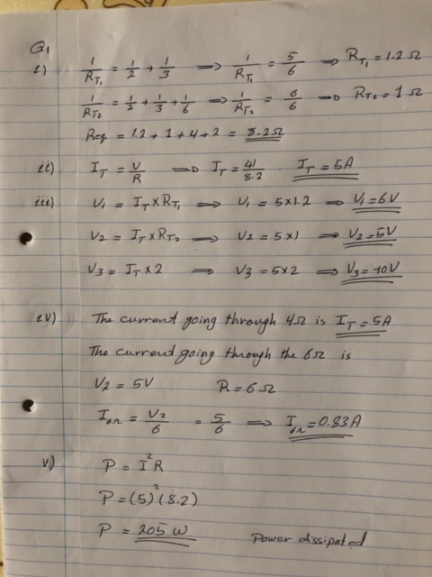
QUESTION ONE (20 marks)
ELECTRICAL ENGINEERING

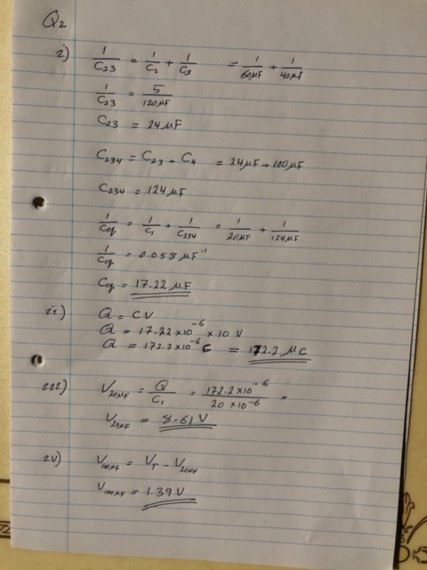
QUESTION TWO (10 marks)

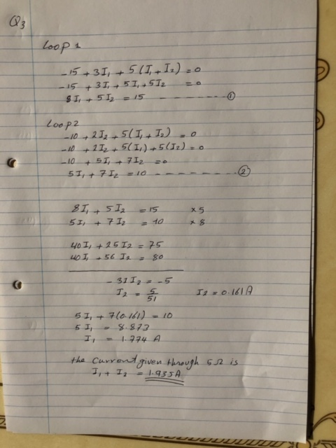
QUESTION THREE(a) (10 marks)

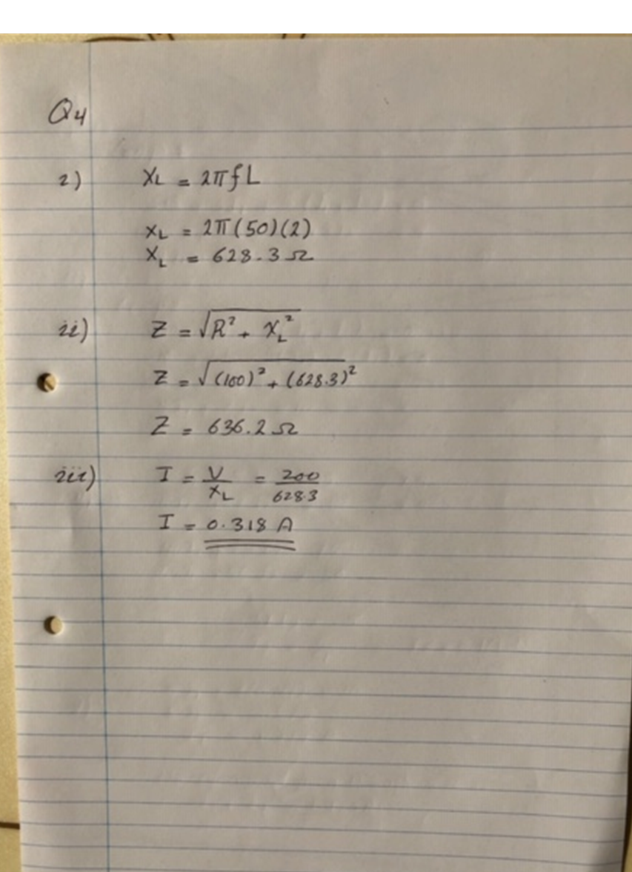
QUESTION THREE(b) (10 marks)

THERMODYNAMICS

- QUESTION FOUR / Closed System (16 marks)

A well-insulated rigid tank contains 5 kg of a saturated liquid-vapour mixture of water as shown in Figure 1. The initial mixture has a quality of 0.35721 and a pressure of 100 kPa. An electric heater placed in in the tank is turned on, until the entire liquid is vaporised (that is, until the quality reaches 1). During the duration of the process, the electric heater resistor is connected to a 110 Volts source, and a current of 8 A flows through the resistor.
- Knowing that the volume remains constant, determine the final pressure. [8]
- Determine the length of time in hour the heater must be kept on.

H₂O
Volume = constant

W_{e}

Figure 1: Well-insulated rigid tank.

Assumptions:
- Kinetic and potential energy changes are negligible.
- The electrical work can be determined from: $W_{e}=V.I.∆t$ where V and I are the voltage and current respectively and $∆t$ the time duration.
- The properties of the fluid can be found in Table A-5.
- In a saturated liquid-vapour mixture, the mass fraction of vapour is called the quality and is expressed as:
$$x=\frac{m_{vapour}}{m_{total}}$$
Quality may have values between 0 (saturated liquid) and 1 (saturated vapour). It has no meaning in the compressed liquid or superheated vapour regions. In the saturated mixture region, the average value of any intensive property y is determined from:
$$y=y_{f}+x.y_{fg}$$
where f stands for saturated liquid, g for saturated vapour and y stands for v, u or h.
- For specific volume, $v_{fg}=v_{g}-v_{f}$

Solution:

- Using Table A-5 at the initial state,
$$\left.\begin{matrix}P_{1}=100 kPa \\ x_{1}=0.35721\end{matrix}\right\}∴ \begin{matrix}u_{f}=417.4{kJ}/{kg} \\ u_{fg}=2088.2 {kJ}/{kg} \\ v_{f}=0.001043 {m^{3}}/{kg} \\ v_{g}=1.6941 {m^{3}}/{kg}\end{matrix}$$

Hence,
$$u_{1}=u_{f}+x.u_{fg}=417.4+0.357×2088.2=1163.3259 {kJ}/{kg}$$

$$v_{1}=v_{f}+x.\left(v_{g}-v_{f}\right)=0.001043+0.35721×\left(1.6941-0.001043\right)$$

$$∴ v_{1}=0.60582 {m^{3}}/{kg}$$
[6 marks]

Using Table A-5 at the final state,
$$\left.\begin{matrix}v_{2}=v_{1}=0.60582 \\ x_{2}=1∴sat. vap.\end{matrix}\right\}∴ \begin{matrix}P_{2}=300 kPa\end{matrix}$$

[2 marks]

- Using Table A-5 at the final state,
$$\left.\begin{matrix}v_{2}=v_{1}=0.60582 \\ x_{2}=1∴sat. vap.\end{matrix}\right\}∴ \begin{matrix}u_{2}=2543.2 {kJ}/{kg}\end{matrix}$$
[2 marks]

According to non-flow energy equation,

$$∆U=Q-W$$

$$∴ m\left(u_{2}-u_{1}\right)=-W_{e} as Q=0 and W=W_{e}$$

Where the electrical work is,
$$W_{e}=V.I.∆t=-110×8×∆t=-880.∆t Joules$$

Therefore,
$$m\left(u_{2}-u_{1}\right)=-W_{e}$$

$$∴ 5\left(2543.2×{10}^{3}-1163.33×{10}^{3}\right)=-\left(-880.∆t\right)$$

$$∴ ∆t=\frac{5\left(2543.2×{10}^{3}-1163.33×{10}^{3}\right)}{880}=7840.17 s$$

$$∴ ∆t=130.67 min$$

$$∴ ∆t=2.18 hr$$
[6 marks]

- QUESTION FIVE / Opens System, Steady-Flow Process (16 marks)

A compressor requires a power input of 4 kW to compress air at 120 kPa and 20°C to 100 kPa and 300°C as shown in Figure 2. The compressor is not well insulated and it is estimated that the equivalent of 10% of the power input is lost to the surroundings in the form of heat. Calculate,
- The mass flow rate of air in kg/s,
- The volumetric flow rate of air in litre/s at both the inlet and outlet.

$$P_{2}=1000 kPa$$
$$T_{2}=300°C$$

$$\dot{Q}=10\% of {\dot{W}}_{in}$$

Compressor

$${\dot{W}}_{in}=4 kW$$

$$P_{1}=120 kPa$$
$$T_{1}=20°C$$

Figure 2: Compressor.

Assumptions:
- The compressor operates under steady-flow conditions.
- Kinetic and potential energy are negligible.
- Air is considered as an ideal gas.
- Air properties can be found in Table A-2.

Solution:
- Mass Balance,
$${\dot{m}}_{1}={\dot{m}}_{2}=\dot{m}$$
[2 marks]
Energy Balance,
$$\dot{Q}-\dot{W}={\dot{m}}_{2}h_{2}-{\dot{m}}_{1}h_{1}$$

$$∴ \dot{Q}-\dot{W}=\dot{m}\left(h_{2}-h_{1}\right)$$

$$∴ -0.1{\dot{W}}_{in}-\left(-{\dot{W}}_{in}\right)=\dot{m}\left(h_{2}-h_{1}\right)$$

$$∴ 0.9{\dot{W}}_{in}=\dot{m}\left(h_{2}-h_{1}\right)$$

$$∴ \dot{m}=\frac{0.9{\dot{W}}_{in}}{h_{2}-h_{1}}$$
[4 marks]

For an ideal gas, and using Table A-2

$$h_{2}-h_{1}=c_{p}\left(T_{2}-T_{2}\right)$$

$$∴ h_{2}-h_{1}=1.005×\left(300-20\right)=281.4 kJ/kg$$
[2 marks]
Therefore,
$$\dot{m}=\frac{0.9×4}{281.4}=0.0128 kg/s$$
[2 marks]

- According to ideal gas equation,

$$Pv=RT ∴ v=\frac{RT}{P}$$
Therefore,

$$v_{1}=\frac{RT_{1}}{P_{1}}=\frac{0.287×\left(20+273\right)}{120}=0.7008 {m^{3}}/{kg}$$
[1 mark]
$$v_{2}=\frac{RT_{2}}{P_{2}}=\frac{0.287×\left(300+273\right)}{1000}=0.1645 {m^{3}}/{kg}$$
[1 mark]
Thus,
$${\dot{V}}_{1}=\dot{m}v_{1}=0.0128×0.7008=8.965×{10}^{-3} {m^{3}}/s=8.965 l/s$$
[2 marks]
$${\dot{V}}_{2}=\dot{m}v_{2}=0.0128×01645=2.104×{10}^{-3} {m^{3}}/s=2.104 l/s$$
[2 marks]
- QUESTION SIX / Open System, Unsteady-Flow Process (18 marks)

A vertical piston-cylinder device initially contains 0.8 m³ of refrigerant R-134a at 1.2 MPa and 120°C. A linear spring at this point applies full force to the piston as shown in Figure 3. A valve connected to the cylinder is now opened, and refrigerant is allowed to escape. The spring unwinds as the piston moves down, and the pressure, volume and temperature drop to 600 kPa, 0.5 m³ and 90°C at the end of the process. The piston-cylinder is not well insulated and heat is exchanged with the surroundings. Knowing that the enthalpy of exiting fluid is assumed to be the average of initial and final enthalpies of the refrigerant in the cylinder, and noting that for a linear spring, the boundary work can be determined from,
$$W_{b}=\frac{P_{1}+P_{2}}{2}\left(V_{1}-V_{2}\right)$$
Calculate,
- The mass of refrigerant that has escaped the cylinder during the process. [8]
- The amount of heat transfer exchange between the piston-cylinder and the surroundings during the process. [10]
OUTLET
$$h_{e}=\frac{h_{1}+h_{2}}{2}$$

R-134a
Final state
V₂ = 0.5 m³
P₂ = 600 kPa
T₂ = 90°C
Initial state
V₁ = 0.8 m³
P₁ = 1.2 MPa
T₁ = 120°C

$$Q=?$$

Figure 3: Vertical piston-cylinder.

Assumptions:
- This is an unsteady-flow process.
- Kinetic and potential energy changes are negligible.
- At both the initial and final states, the refrigerant R-134a is in a superheated state.
- The properties of refrigerant R-134a can be found in Table A-13.

Solution:
- According to Table A-13,

$$\left.\begin{matrix}P_{1}=1.2 MPa \\ T_{1}=120℃\end{matrix}\right\}∴ \begin{matrix}v_{1}=0.024228 {m^{3}}/{kg}\end{matrix}$$

And as V₁ = 0.8 m³, and V = m.v, therefore,

$$m_{1}=\frac{V_{1}}{v_{1}}=\frac{0.8}{0.024228}=33.02 kg$$
And,
$$\left.\begin{matrix}P_{2}=0.6 MPa \\ T_{2}=90℃\end{matrix}\right\}∴ \begin{matrix}v_{2}=0.046318 {m^{3}}/{kg}\end{matrix}$$
[2 marks]
And as V₂ = 0.5 m³,

$$m_{2}=\frac{V_{2}}{v_{2}}=\frac{0.5}{0.046318}=10.79 kg$$
[2 marks]
Mass Balance,
$$-{\dot{m}}_{e}={\dot{m}}_{2}-{\dot{m}}_{1}$$

$$∴ {\dot{m}}_{e}={\dot{m}}_{1}-{\dot{m}}_{2}$$

$$∴ {\dot{m}}_{e}=33.02-10.79=22.22 kg$$

[4 marks]
- Energy Balance,
$$Q-W=m_{e}h_{e}+m_{2}u_{2}-m_{1}u_{1}$$

$$∴ Q=m_{e}h_{e}+m_{2}u_{2}-m_{1}u_{1}+W$$

$$∴ Q=m_{e}h_{e}+m_{2}u_{2}-m_{1}u_{1}-W_{b} as W=W_{b}<0 (work done on the system)$$

$$∴ Q=m_{e}\frac{h_{1}+h_{2}}{2}+m_{2}u_{2}-m_{1}u_{1}-\frac{P_{1}+P_{2}}{2}\left(V_{1}-V_{2}\right)$$
[4 marks]
According to Table A-13,

$$\left.\begin{matrix}P_{1}=1.2 MPa \\ T_{1}=120℃\end{matrix}\right\}∴ \begin{matrix}u_{1}=325.03 {kJ}/{kg} \\ \begin{matrix}h_{1}=354.11 {kJ}/{kg}\end{matrix}\end{matrix}$$

$$\left.\begin{matrix}P_{2}=0.6 MPa \\ T_{2}=90℃\end{matrix}\right\}∴ \begin{matrix}u_{2}=301.67 {kJ}/{kg} \\ h_{2}=329.46 {kJ}/{kg}\end{matrix}$$
[4 marks]
Therefore,
$$Q=22.22×\frac{354.11+329.46}{2}+10.79×301.67-33.02×325.03-\frac{1200+600}{2}\left(0.8-0.5\right)$$

$$Q=22.22×341.785+10.79×301.67-33.02×325.03-270$$

$$∴ Q=-149.79 kJ$$
[2 marks]

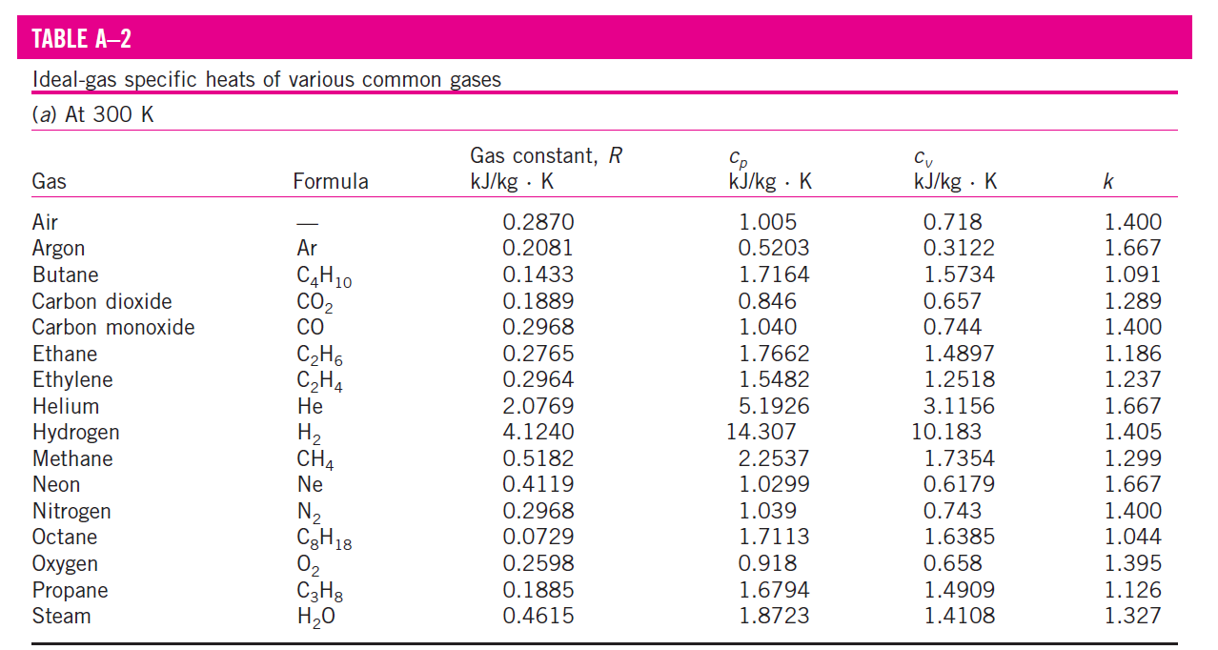

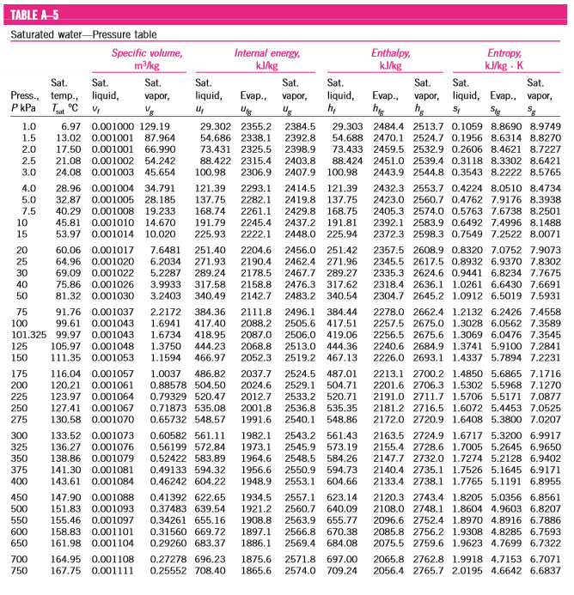
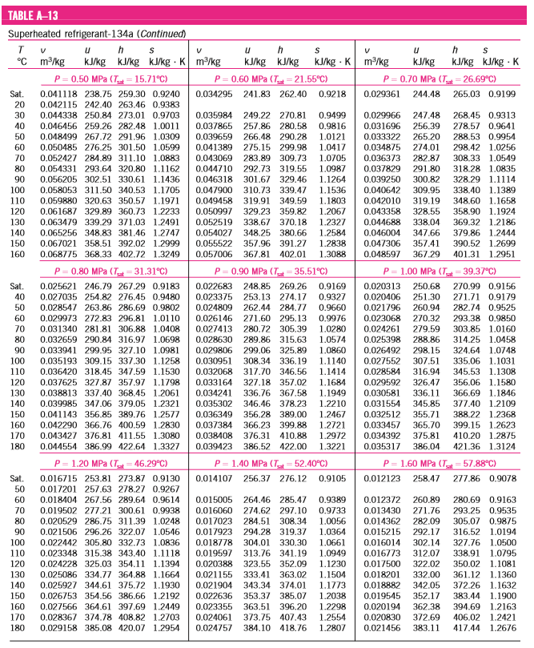

Diwedd/End

