



Module:
Quantitative Research Methods (SBPD7010)

Lecturer: Dr Andrew Chan

Component 2: Reflection

by

Student Name: Chan Pui Luen, Paul
Student Number: 1715381

19 April 2019

Table of Contents Page
Introduction ………………………………………………………………... 4
Literature Review ………………………………………………………………... 4
Conceptualisation ………………………………………………………………... 4
Hypotheses Development ………………………………………………………… 5
Research Methodology ………………………………………………………… 5
Scale Development ………………………………………………………………… 6
The Data Collection and The Data Analysis ………………………………………… 6
Limitation and Conclusions …………………………………………………………… 6
References ………………………………………………………………………… 7
Appendix ………………………………………………………………………… 8

Introduction
The purpose of Component 2 assignment is the reflection of the quantitative research methods to develop a survey instrument and research strategy to test hypothesis to recognize the direct relationship between the employee job satisfaction and the employee’s job performance in banking industry in Hong Kong project report for the University of Wales Trinity Saint David DBA Quantitative Research Methods module (SBPD7010). This reflection includes engagement with literature skills, knowledge and understanding skills, cognitive and intellectual skills, practical application skills and transferable skills for life & professional practice.

Literature Review
The research study is included a critical literature review and bibliography of key research on the topic of “the employee job satisfaction and employee’s job performance” and mainly focus on the banking industry over the last ten years. The literature shows the relationship between employee job satisfaction and employee’s job performance that the job satisfaction factors have a positive impact on employee’s job performance as well as organisation’s performance. (Alnasrallah, 2016; Bernanthos, 2018; Dartey-Baah, 2010; Springer, 2011)
This study is also applied the classical management theories on Elton May of Hawthorne Effect, Abraham Maslow of Maslow’s Hierarchy of Needs and Frederick Herzberg of Two-factor Theory of Motivation because those theories can motivate their staff to achieve the organisation goals effectively and the hygiene factors are important factors for the staff job satisfaction and staff retention (Maslow, 1943; Herzberg, Mausner & Snyderman, 1959). Despite of technology will change, knowledge will change, employee behaviour will change. The classical management theories are still applied to 21st century organisations running situation and working environment.

Conceptualisation
The writer has found there have the literatures are cover the topic of relationship between job satisfaction and job performance, however, there have no related topic related the banking industry in Hong Kong in last ten years. The writer uses his currently working company for this quantitative research study. His working company is one of the Hong Kong local renowned banks (‘the Bank’) established in 1947 and it is a listed company in Hong Kong.
This research study introduced the Framework of Job Satisfaction Factors and Employee’s job Performance (Figure 1) from the literature review. The framework based on the employee’s job performance impact by the job satisfaction factors including Salary & Incentives, Staff Benefit, Training & Development, Social Support, Leadership Influence, Communications and Empowerment for the organisation.

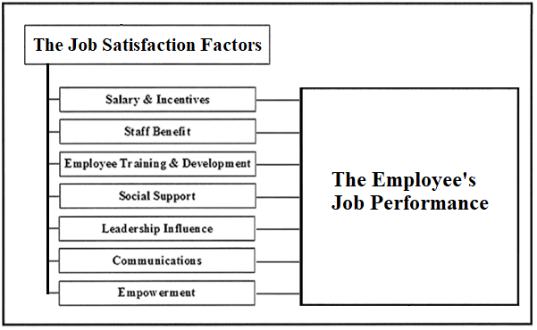
Figure 1. The Framework of Employee Job Satisfaction and Employee’s Job Performance

Hypotheses Development
The hypotheses development of this research study defines the correlational relationship of the employee job satisfaction and the employee’s job performance. There were addressed the research questions and their null and alternative hypotheses as below:
Questions 1. The relationship between the employee job satisfaction are impact the employee’s job performance in banking.
Ho: There is no relationship employee job satisfaction and employee’s job performance in banking.
Ha: There is a positive relationship between employee job satisfaction and employee’s job performance in banking.
Questions 2. The relationship of the employee’s job performance by the influence on each job satisfaction factor in banking.
Ho: There is no relationship of employee’s job performance by the influence on each job satisfaction factor of the employee job satisfaction in banking.
Ha: There is a positive relationship of employee’s job performance by the influence on each job satisfaction factor of the employee job satisfaction in banking.

Research Methodology
This quantitative research study has conducted the correlational research. The correlation method is appropriate when the study is trying to determine more than one dependent variable using to predict one independent variable. Therefore, this method can use in this study to establish the variable of the job satisfaction factors could predict the employee’s job performance.

Scale Development
This research study based on the questions of job satisfaction instrument (Spector, 1994) to develop a new job satisfaction instrument. This instrument scale is comprised of 21 questions are based on seven job satisfaction factors (Appendix). All responses were made using 6-point Likert-type scale, from 1 is Very strongly disagree to 6 is Very strongly agree.

The Data Collection and the Data Analysis
The writer has learned the quantitative research tool to apply the knowledge, tools and techniques for this research study. This research study is related to the pilot test and the sample size. This was a convenience sample of 20 Bank employees to complete the questionnaires.
After the content of job satisfaction survey fixed, the survey transformed to the Google forms to invite the Bank employee to complete the questionnaire through internet. The successful rate was high, and the data can transfer to excel easily.
The research data applied by SPSS to calculate for the descriptive statistic, the inferential statistic and the correlation quantitative research analysis.
After the job satisfaction scale

Limitation and Conclusions
The limitation of this research study is related to the pilot test and the sample size. This was a convenience sample of 20 Bank employees to complete the questionnaires. For the future research study, the questionnaire could be test with more employees within the Bank and/or other banks’ employees in Hong Kong. Although the study has covered almost all bank characteristics. It has 50% of male and 50% of female and the age range is from 24 to 56 years old. There have 50% of employees are holding degree or above. The job level of 50% employees are Officer or Senior Officer or below and 50% of employees are Assistant Manager or above. For the future research study, in the area of the employees work in different function departments in the bank (frontline staff and back-office staff), the organisation’s strategy should direct impact on the employee’s performance. The frontline staff and back-office staff could consider adding in demographic information to test correlation to the employee’s job performance.
In the future, the refining of the Part A of the demographic information and Part B of Job Satisfaction scale in the questionnaire that the Job Satisfaction Survey becomes a reliable and practical tool for employee job satisfaction impacting on the employee’s job performance.

The regression test

References
Alnasrallah, Y. 2016, “Employee Motivation and Performance”, International Journal of Scientific & Engineering Research, 7(1).

Bernanthos, B. 2018, “Employees’ Performance in Islamic Banking”, European Research Studies, vol. 21, no. 1, pp. 1-42.

Dartey-Baah, K. 2010, “Job Satisfaction and Motivation: Understanding its impact on employee commitment and organizational performance”, Academic Leadership (15337812), 8, 4, Education Source, EBSCOhost, viewed 15 July 2018.

Herzberg, F., Mausner, B., & Snyderman, B.B. 1959, “The Motivation to Work’, John Wiley & Sons. Inc., New York, 195.

Maslow, A H. 1943, “A theory of human motivation”, Psychological review, 50(4), pp. 370.

Springer, G J. 2011, “A Study of Job Motivation, Satisfaction, and Performance among Bank Employees”, Journal Of Global Business Issues, 5,1, pp. 29-42, Business Source Complete, EBSCOhost, viewed 15 July 2018.

Appendix



