A critical reflection on use of foundation skills of counselling.
In this essay I will be reflecting on my use of foundation skills in my counselling practice. I will be looking back on recorded footage of myself taking on the role of a counsellor, using the skills that I have learned throughout the course. I will also be linking up certain points of the footage with theory in respect of counselling practice too.

I would like to start this analysis from the beginning with talking about the importance of contracting and how I showed this in my session. In alignment with the BACP ethical framework 2018, it is crucial the “the client has the right to know what the conditions of counselling are” (BACP 2018) before continuing any practice. Contracting is so important in transparency between the client and the therapist in what is to be expected, and especially with the legally binding information that is passed between both parties.

Contracting is made easier with a simple model to follow which will look like the following example of how I went through the stages:

Introduction:
Right from the very beginning of my session, I started with introducing myself in a calm and friendly manor, followed on by explaining to the client that I would be leading the session at that time.

Time:
After introducing myself, I make it clear about how much time there will be for the session. It is important for the client to have a realistic expectation of how much can be used in the session for how they would like to use it.

Confidentiality:
Following on from discussing the dime management, it needed to be noted that there was somebody else in the room observing the session whilst also being recorded. This for some may feel intimidating due to confidentiality reasons. This is also another very important factor to include in contracting. In my session I explain to the client that the observer and camera are there their confidentiality will be upheld and any footage will be secured in a research lab. Although confidentiality must be obtained, it’s crucial that safeguarding is kept in mind and for the client to be aware of any necessary obligations from myself as a therapist should anything arose, that may be of concern. In alignment with the ethical framework of the BACP 2018 there will be considerations made if there is thought to be any harm to the client or anyone else, or if any compliance with the law may need to be made when overriding a client’s confidentiality. It is the right of the client to have this in mind when they are about to disclose any information. Although there may be considerations for breaching confidentiality in these circumstances, shortly after explaining this to the client, I advised them that I would make sure that they are aware of any issues I feel may need to be passed on before doing so. It’s crucial that the client doesn’t feel afraid or anxious about the security of that confidence being broken without being aware of it. With this being said, it’s important to develop, maintain and protect the client’s trust. With the honesty of contracting, this builds a strong foundation for that bond to be made.

Covid-19
With latest restrictions of covid having been relaxed, it is very important to have the client’s comfort in mind as to whether they feel comfortable with such a relaxed environment concerning the virus. Just after talking briefly about confidentiality, I felt it was the time to bring up how the client felt about the use of any restrictions should they wanted myself to wear a mask or perform social distancing. In my own refection to this, I would have done this just after introducing myself, or even before, as by that point they may have already felt uncomfortable with the situation with feeling they couldn’t raise the issue. In asking the client hoe they felt about it, they already have some level of confidence in the session being directed and managed according to their needs or references.

Safeguarding in the session:
Although safeguarding comes under confidentiality, it is also important to maintain safeguarding during a session for the client themselves. The client should have an opportunity to feel like they are able to stop any conversations should they start to feel uncomfortable or triggered in any way. The session is essentially led by the client as much as the therapist. This reminds me of a short sentence used to describe Egan’s three stage model “the helper uses these tools to follow the clients process and not to lead it” (Midwinter and Dickson, 2015, p.16)

Session begins:
After concluding my introduction at around 2minutes in, I ask the client whether they are happy and ready to continue onto the session, allowing them the space for any questions or uncertainty that they wish to discuss before disclosing any information to me.

As the session begins the client seems to already know what they would like to talk about, at this point I am sat in a fairly relaxed position and maintaining active listening whilst making slight gestures to show that I am following the conversation. This is allowing a person-centred approach, a theory in which Carl Rogers played a huge part in originating and developing over many years (Midwinter and Dickson, 2015, p.13). As the client begins to delve into what was on their mind, they suddenly rewound the topic of conversation to a different period of time. Almost as if they wanted to re iterate the roots of where the future issue may have come from. At this point (3minutes 12seconds) I have noticed that I changed my posture. Although this may not be very noticeable, but watching myself over I have realised at this point I sat from a fairly relaxed seated position into more of a formal position with a slight lean towards the client. This would stem from a counselling theory based on Gerard Egan’s SOLER model. A model in which was originated in 1975, in the book ‘Skilled Helper’. (Learning Outcome, n.d.) This model is a reminder of the importance of our body language as well as oral. It looks like this:
S – To sit squarely
O – To keep an open posture
L – To lean toward the other
E – To keep eye contact
R – To uphold respect toward another
As I watch the footage, I notice that I am keeping in touch with this model as I am keeping in touch with what the client is saying. I am actively listening, meaning I am present in the room with no other distractions from the current conversation.

We get into the session and at about five minutes in, the client ends her sentence, I then paraphrase what the client has just said, followed by a question. I asked the client “How does that make you feel when you say that out loud”. I asked this because the client seemed quite hesitant in some of their words and one of them was guilt. I felt that this may have helped the client look into their feelings more in what they were saying and they had already discussed that the period of time during the first lockdown that they started to find things difficult when it came to schooling their children. With working and being new to home schooling, I felt that it was a good opportunity for them to look into how they felt a little more.

Answering the question, I had asked the client, it allowed the them to discover a little more within themself. The client actually had a very good sense of self reflection. They said that they knew they were a good parent, but essentially felt guilt for prioritising work over their children. It was good to get this information because I then had an understanding that the client understood that these actions didn’t debilitate them of their parental status, and may come to the conclusion within themselves that working is just as an important factor in means of providing.

Following on from further discussion, the client had described their life at the time, all the things they had to do on their own as a single parent. Things like the shopping, maintaining a job, shopping, schooling and it all seemed to be a lot for one person to do. This led me to in a simple phrase, repeat what the client had said and asked them “When you talk about all the different things you had to do it sounds quite overwhelming, all for one person” and then left that as an opening for the client to realise just how much pressure they may have been under at the time. At this point I am noticing within myself a lot of empathy in the way that I asked this question, as I have put myself in their shoes and described the situation myself as an overwhelming experience.

Empathy is one of three og Carl Rogers three key words that are crucial to be present in the ‘helper’ relationship. (Midwinter and Dickson, 2015, p.13). Empathy is being able to see and feel from another perspective and to relate to another’s feelings; putting yourself in another person’s shoes. (Adaption from Rogers 1980).

At eight minutes and fourteen seconds into the session, the client comes to a conclusion within themselves, “Maybe it’s anger at myself”. Almost asked as a rhetorical question. At this point, noticed myself smile a little. Not because I was especially happy, but in a sense quite proud that the client is finding answers within themselves just through talking in such an environment that allows that discovery.

“Individuals have within themselves vast resources for self-understanding and for altering their self concepts, basic attitudes and self directed behaviour; these resources can be tapped id a definable climate of facilitative psychological attitudes can be provided” (Rogers 1980:115)

The statement above written by Rogers couldn’t be more clear at this point in the session. You can see the client becoming more aware of their own thoughts and this is why you can see a sense of relief or pride in my facial expression towards the client.

It is shortly after this moment that I raise a question in a way that I also provide an alternate perspective. This strategy can also be seen to be used in Egan’s three stage model image is attached below of this process:
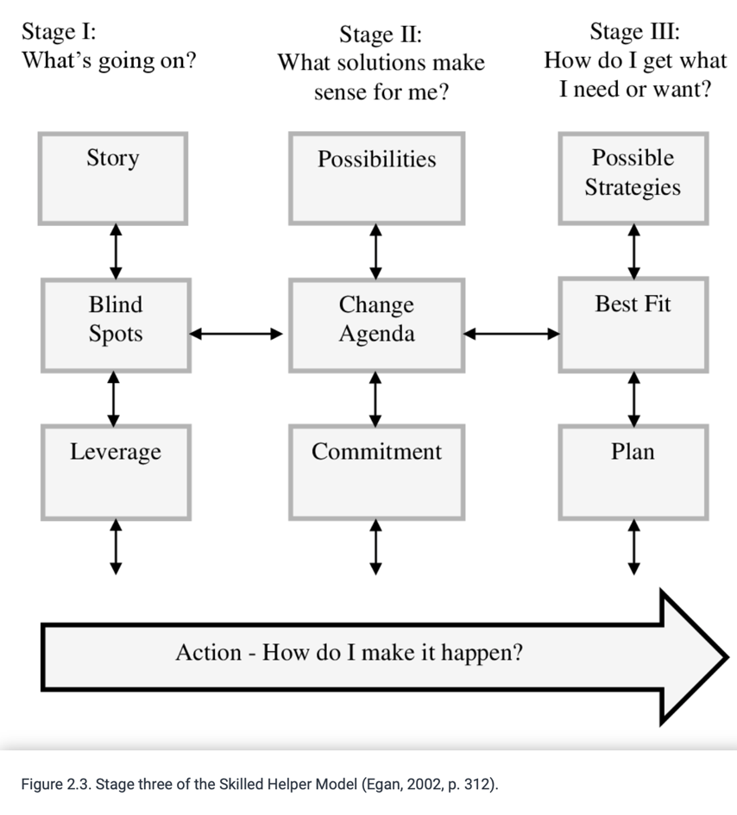

Stage 1B shows the blind spot stage. One in which a therapist may see something that the client may have missed. At eight minutes and twenty-five seconds into the recording, I said “looking at maybe a different perspective, because you say you regret it, all you can do is look back and reflect, where would you have been if you hadn’t have worked as hard as you did for your children”. I feel that this allows space for more of a positive outlook on the client’s decisions. This demonstrated an understanding of how this model could work by providing the client with a different perspective that would then possibly give them the leverage to explore other possible avenues to focus on.

At around ten minutes and fifty seconds into the session, I had previously allowed space for the client to talk without interruption and allowed the space for the client to speak freely and at a point where she came to an end with what they were saying I asked “Do you think that the rolling ‘R’s’ are a constant reminder?” Looking back at this, I wish I hadn’t asked that question as I don’t think this really would have helped the process of what my client was going through, as the client shortly after answered that her child is still using them. Of course, if the client’s child still uses this specific accent, it’s an ongoing issue that the client is facing. Although, hind sight I wouldn’t have asked this, it didn’t disrupt the session in any way. Shortly after the client responding, they had started to laugh at a third-party conversation they had with somebody else and I laughed with her. This was a natural reaction showing congruency in the session.

Congruency is one of Rogers Key words needed to be present in a session. It is the ability to be open and genuine. To have this natural ability to be able to stay present in a conversation and be able to react along with the client, gives the session a more natural feel and tone. Helping both therapist and client to ease into a mutual respected relationship. If I were to stay so serious, it wouldn’t match the flow of conversation that the client was having and thus possibly making them feel uncomfortable about their actions or feelings.
Following on from what the client had said, mentioning the words anger towards the fact that their daughter had picked up this accent due to the client being so busy with work I had said the following:

“From what you’ve said so far it sounds like that you’re essentially blaming yourself for your daughter picking up an accent that hasn’t come from yourself, but you can’t possibly be there of every min of every day and although at that time you say you were working so much and your daughter was on YouTube as much as she was, I don’t think there would be anything to stop an accent being picked up if you understand? Even if you spent more time with her.”

This is another example of congruency and empathy; however, I wish I had worded this in a more question style. I can’t possibly make that judgment that there couldn’t have been another way out of that accent being picked up. Based upon the bond that I had built with this client over the weeks, I do not believe that it would have been taken in a negative way as my intentions were to reassure the client and to question whether guilt was needed. At this point, I ask myself if I had just taken the roll of a ‘fixer’ rather than a therapist whom is there to actively listen and ask certain questions when needed. This potentially could have taken away from the client’s personal reflective process. Shortly having said this, the client then started to describe her values and then said she shouldn’t feel guilty because of the priority’s she has are relevant and understood within herself that without the work, she wouldn’t have the money to then look after her children. This brings me a point that I don’t regret what I had said, but in future to be more mindful not to lead the session or path of conversation so much.

Following on from the clients’ responses throughout the session so far, at seventeen minutes and thirty-seven seconds, I then begin to relay the session back to the client to bring them back into their current feelings of today. This included paraphrasing for mutual agreement of what had been said in the session to then pointing out that we were now out of lockdown and asked how the client currently felt about everything that had been discussed. This allows the client to be brought back into the room and upon the reflections made, assess the difference in how they may feel compared to the more stressful times that were earlier discussed.

It is after this question was raised that we see a more positive mind frame from the client in how they reflect and talk about how they had coped during the lockdown. The client had listed their priority’s and had already made changes in their life to correct what they felt may have gone wrong. This included the reduction of hours at work, and a change of job. At twenty minutes and thirty seconds the client said the following:

“I should, I am actually, I know I feel guilty when people comment on her accent, but the overarching feeling I have is actually under the circumstances, I’m doing alright”

This did put a smile on my face because throughout the session the client had experienced a lot of personal growth in being able to have the space needed to explore their feelings in more detail. Along with some questions from myself to essentially help them along with the process and essentially look into things that they may now have noticed or focussed on prior to the session.

This then becomes the beginning of the end of the session where I begin to draw up a close by summarising the session, keeping that mutual understanding of what had happened. This included more paraphrasing and at twenty-one minutes and forty-nine seconds, I had described the clients’ facial expressions when they talk about their children as being happy and I pointed out that I had felt the pride of being a parent to me outweighed that feeling of guilt, with the client agreeing.

Drawing us to a close it was the fear of being judged that possibly made the client feel guilty for this accent developing and within herself she realised that maybe she shouldn’t care so much about what people think because they had realised that they brought their children up on their own.

I wanted to end the session on a positive note by noting my personal opinion, in this case I felt that it was relevant as the client had already made the personal growth to realise that they are not a bad parent and that they are doing all they can for their children’s welfare. I pointed out her fear of judgment and explained from my opinion “you’ve done an absolutely amazing job with your children” following on from all the positive points the client themselves had pointed out. Continuing with pointing out that the client wouldn’t be the only person to feel guilt as a parent along the way, to ensure a level of inclusion within society. I feel it’s important that people should be helped to not feel alone in these situations.

The session was ended with myself asking the client to think about what they may want to talk about in the next session. Goal setting is also in the three stage skills model. Helping the client set goals is a way of helping them become more self sufficient with a proposed change or agenda in their actions or feelings toward the issue they are facing.

Overall, I am happy with the session and feel that I have included the foundation skills needed in counselling. Although there are areas to improve on, the recorded session has definitely helped with my own reflection process in how I would possibly handle things in a certain manner. I feel I have remained congruent, empathetic and made sure the use of unconditional positive regard was shown along with the ethical frameworks of the BACP throughout this session.

Bibliography
Carver, C. (2015). Basic Counseling Techniques Training: The Differential Effects of Two Models on Skill Development and Fully Functioning. undefined. [online] Available at: https://www.semanticscholar.org/paper/Basic-Counseling-Techniques-Training%3A-The-Effects-Carver/7310acce366e28a4d996bc7a8c2f29df354ba0ca/figure/2 [Accessed 25 Apr. 2022].

Learning Outcome. (n.d.). [online] Available at: https://www.stockton.ac.uk/media/3545/the-soler-model-script.pdf.
‌

Making the contract within the counselling professions. (n.d.). [online] Available at: https://www.bacp.co.uk/media/9547/bacp-making-the-contract-caq-gpia039-sep20.pdf.

Midwinter, R. and Dickson, J. (2015). Embedding counselling and communication skills : a relational skills model. London: Routledge, pp.13–16.
‌

‌

