Programme: | BSc Health and Social Care
Module: | Changemakers: Creativity and Value Creation
Module code: | BMHP5014 | Contribution to Overall Module Assessment (%): | 50%
Name | Mevish Noor | Student ID | 2407526
Assignment Title: | Component 2: Written Assignment (Report) | Word count (or equivalent): | 2,000 words (+/- 10%)
Submission deadline: | Thursday 2nd April 2026  14:00 (2PM) - (Week 12) | Return date of provisional marks & written feedback: | 30th April 2026

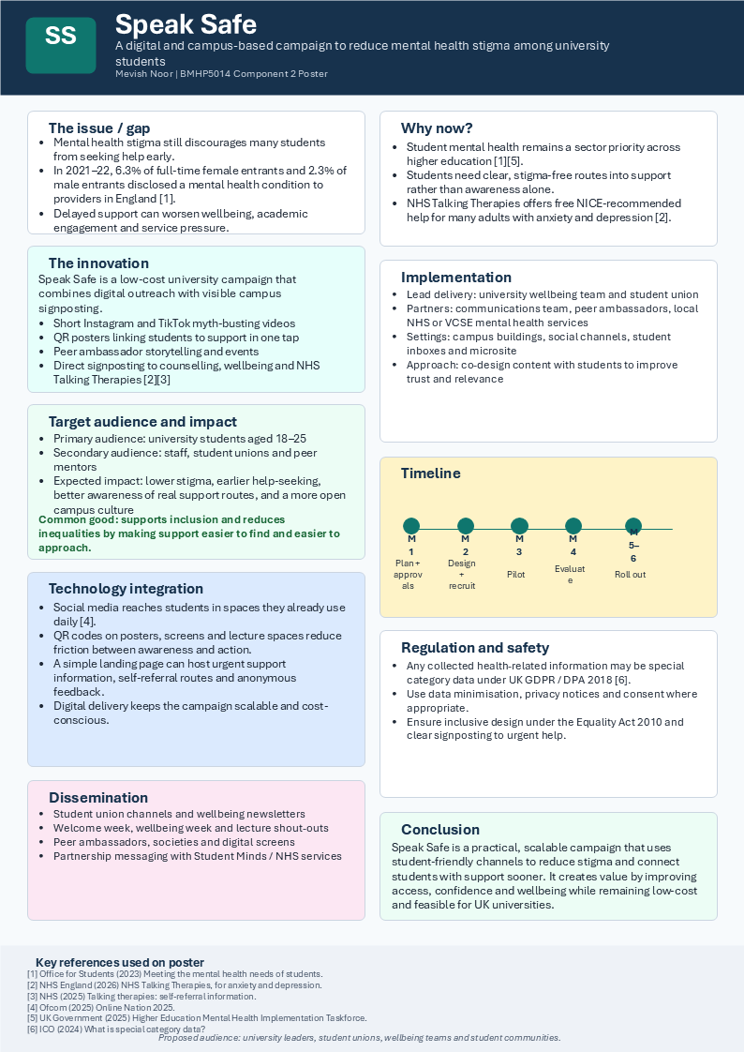
Written Pitch – Speak Safe
I am proposing a university-based mental health campaign called Speak Safe, designed to reduce mental health stigma among students and encourage earlier access to support. My campaign responds to a clear and current problem in UK higher education: many students experience poor mental health, but stigma still prevents them from seeking help early. Thet Office for Students has identified student mental health as an important issue affecting outcomes and wellbeing, and its data shows a continuing rise in the proportion of students disclosing mental health conditions to providers in England (Office for Students, 2023).
The main problem I want to address is not simply mental ill health itself, but the culture of silence around it. Students often experience anxiety, low mood, stress, loneliness, and pressure linked to academic demands, finances, and personal circumstances. However, many delay support because they are afraid of being judged, labelled, or misunderstood. This delay can worsen wellbeing, reduce academic engagement, and place more pressure on university support systems. I believe this is a serious health and social care issue because it affects access, equality, prevention, and early intervention (Rüsch, Angermeyer and Corrigan, 2005; Clement et al., 2015).
My innovation is a low-cost, digitally led, campus-based awareness and signposting campaign. Speak Safe combines short-form social media content, QR-code posters, peer ambassador involvement, and direct links to trusted services. The aim is to make mental health support feel visible, normal, and easy to access. Rather than asking students to search for help during a crisis, my campaign brings support routes directly into the spaces they already use every day, both online and on campus (Care Quality Commission, 2021).
The core features of Speak Safe are simple but practical. First, the campaign would use Instagram and TikTok to share short videos, myth-busting posts, student-led stories, and positive messages about help-seeking. This matters because students are already active on digital platforms, so communication needs to meet them where they are rather than relying only on leaflets or formal emails (Ofcom, 2025). Second, the campaign would use QR-code posters in lecture buildings, libraries, accommodation sites, toilets, and student union spaces. By scanning a code, students could immediately access gcounselling information, university wellbeing contacts, NHS support, and urgent help advice. Third, the campaign would involve peer ambassadors, because students may respond more positively to messages that feel relatable and authentic rather than institutional. Together, these elements make the campaign more accessible, visible, and engaging (Care Quality Commission, 2021).
My campaign also creates value because it is built around early help-seeking. NHS Talking Therapies services in England provide free, NICE-recommended support for anxiety and depression, and many people can self-refer rather than waiting for a GP appointment (NHS England, 2026; NHS, 2025). Speak Safe would signpost students to appropriate support sooner, which could reduce the chance of their problems worsening before intervention. This adds value not only for students, but also for universities and health services, because early support is more practical and sustainable than responding only when students reach crisis point (Care Quality Commission, 2021).
In terms of implementation, I would propose that Speak Safe is led by the university wellbeing team, working in partnership with the student union, the communications team, and selected peer ambassadors. External partnership with NHS or voluntary sector organisations, such as local talking therapies providers or student mental health charities, would strengthen credibility and ensure the campaign signposts correctly. The first stage would be planning and co-design. This would involve gathering student feedback, identifying the clearest support routes, agreeing campaign messages, and developing a visual identity. The second stage would be design and recruitment, including creating posters, making social media content, and training student ambassadors. The third stage would be a pilot, perhaps in one faculty or one campus site, to test engagement. The fourth stage would be evaluation, where reach, scans, clickds, and student feedback are reviewed. The final stage would be a wider rollout across the university (Care Quality Commission, 2021).
This approach is realistic because it does not depend on expensive new clinical infrastructure. It uses existing university systems and trusted public services. It also reflects creativity and value creation, which are central to this module, because it applies a practical and enterprising idea to a real-world health and social care challenge. Instead of inventing a complex or unrealistic product, I am proposing a campaign that is scalable, affordable, and based on actual behaviour: students already use social media, already move through campus spaces, and already need better support pathways (Office for Students, 2023; Ofcom, 2025).
However, I also recognise that there are barriers. One barrier is that some students may ignore posters or view the campaign as generic university messaging. To address this, I would use co-designed content and student voices to improve authenticity. Another barrier is privacy. If the campaign collects any health-related or feedback data, that may involve special category data under UK GDPR, which means extra protection is required. The ICO states that health data is special category data, and organisations must identify a lawful basis and a separate condition for processing it under the UK GDPR and the Data Protection Act 2018 (Information Commissioner’s Office, 2024a; Information Commissioner’s Office, 2024b). For this reason, Speask Safe should minimise data collection, use clear privacy notices, and avoid collecting unnecessary personal information. A further barrier is inclusion. The campaign must be accessible and non-discriminatory, which is important under the Equality Act 2010, which protects people from discrimination in wider society (UK Government, 2015). This means using inclusive language, accessible design, and multiple ways of reaching students, not only digital channels.
The broader social value of Speak Safe is that it supports the common good. It is not only about individual students feeling better; it is about building a more open, compassionate, and informed university culture. If students feel safer discussing mental health and more confident about seeking help, universities can become healthier communities overall. That contribuutes to inclusion, reduces inequalities in access to support, and encourages earlier intervention instead of silence and deterioration (Care Quality Commission, 2021; Clement et al., 2015).
For these reasons, I believe Speak Safe is a relevant and timely innovation. It is practical, evidence-informed, low-cost, and aligned with current health and education priorities (Office for Students, 2023; Care Quality Commission, 2021). I am asking stakeholders to support the development and pilot of this campaign within a university setting. With modest resources, strong partnerships, and thoughtful implementation, Speak Safe could make mental health support easier to find, easier to trust, and easier to approach.

References
Care Quality Commission (2021) Enabling innovation and adoption in health and social care: Developing a shared view. Available at: https://www.cqc.org.uk/publications/themed-work/enabling-innovation-adoption-health-social-care-developing-shared-view
Information Commissioner’s Office (2024) Special category data. Available at: https://ico.org.uk/for-organisations/uk-gdpr-guidance-and-resources/lawful-basis/a-guide-to-lawful-basis/special-category-data/
Information Commissioner’s Office (2024) What are the rules on special category data? Available at: https://ico.org.uk/for-organisations/uk-gdpr-guidance-and-resources/lawful-basis/special-category-data/what-are-the-rules-on-special-category-data/
NHS England (2026) NHS Talking Therapies, for anxiety and depression. Available at: https://www.england.nhs.uk/mental-health/adults/nhs-talking-therapies/
NHS (2025) Find NHS talking therapies for anxiety and depression. Available at: https://www.nhs.uk/nhs-services/mental-health-services/find-nhs-talking-therapies-for-anxiety-and-depression/
Rüsch, N., Angermeyer, M.C. and Corrigan, P.W. (2005) ‘Mental illness stigma: Concepts, consequences, and initiatives to reduce stigma’, European Psychiatry, 20(8), pp. 529–539.
Office for Students (2023) Meeting the mental health needs of students. Available at: https://www.officeforstudents.org.uk/publications/meeting-the-mental-health-needs-of-students/
Ofcom (2025) Online Nation 2025. Available at: https://www.ofcom.org.uk/siteassets/resources/documents/research-and-data/online-research/online-nation/2025/online-nations-report-2025.pdf?v=409837
UK Government (2015) Equality Act 2010: guidance. Available at: https://www.gov.uk/guidance/equality-act-2010-guidance
Clement, S., Schauman, O., Graham, T., Maggioni, F., Evans-Lacko, S., Bezborodovs, N., Morgan, C., Rüsch, N., Brown, J.S.L. and Thornicroft, G. (2015) ‘What is the impact of mental health-related stigma on help-seeking? A systematic review of quantitative and qualitative studies’, Psychological Medicine, 45(1), pp. 11–27.

