

Student name: Tasha Young
Student ID:2316864

Module name: Empowering the Older Person.
Module code: BMHP6027
Lecturer’s name: Laila Surani

Empowering Older Adults in Health and Social Care.  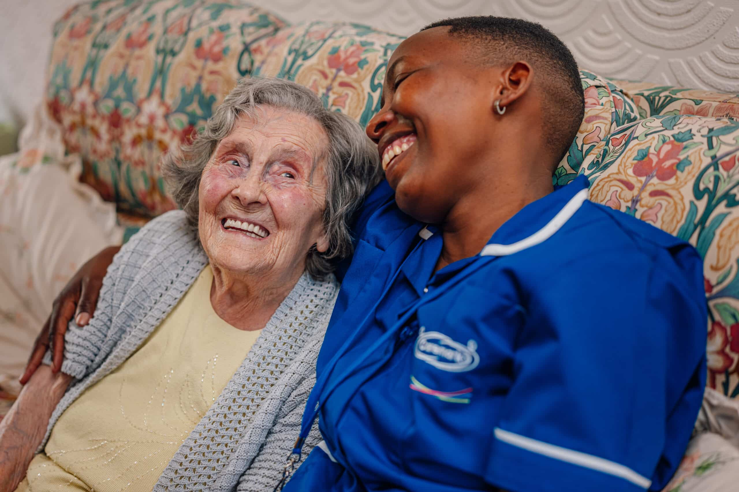 |  | Effective Approaches to Supporting Older Adults.  • Evidence shows that reablement and intermediate care services help older adults regain independence after illness or hospital admission (Social Care Institute for Excellence, 2020).  • These approaches focus on:  - rebuilding daily living skills  - improving confidence  - reducing long-term care and dependence.  • Community-based support and integrated services can improve coordination between the NHS, local authorities and voluntary organisations (NHS England, 2024).  • Theories supporting active ageing include:  - Activity Theory – continued participation in activities improves wellbeing (Havighurst, 1961).  - Continuity Theory – maintaining familiar routines supports stability in later life (Atchley, 1989).  • Person-centred care encourages older adults to maintain control over their daily lives and care decisions. |  | 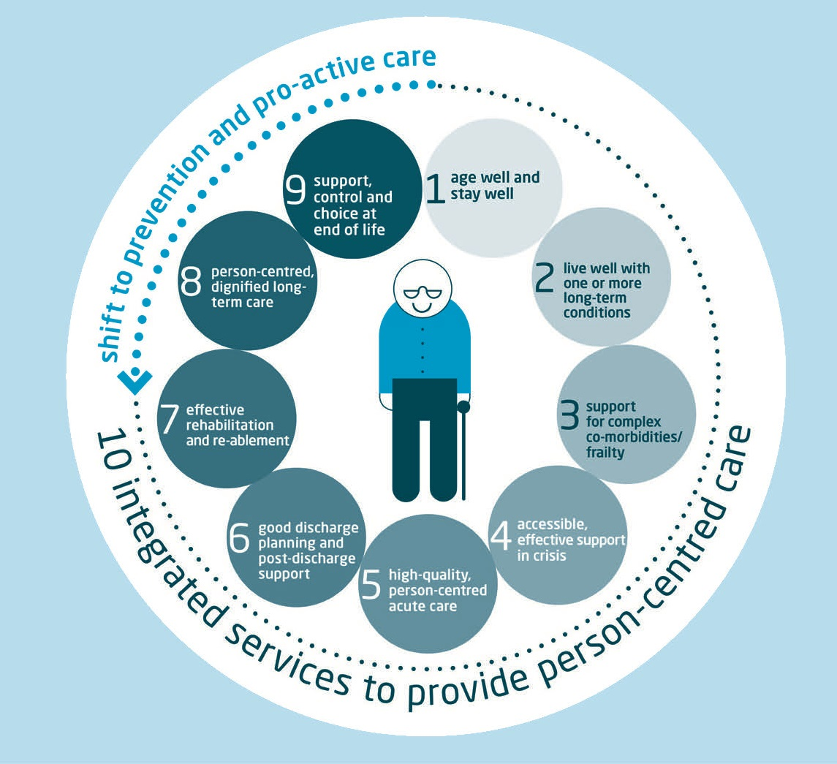  (Endocrinology.2015)
(Bentley, 2024)
Introduction  - The UK population is ageing, with increasing demand for health and social care services.  - Around 12.5 million people in the UK are aged 65 and over, representing about 18% of the population (MHA, 2023).  - Longer life expectancy and lower birth rates mean the number of older adults continues to grow (Centre for Ageing Better, 2024).  - Older adults often experience multiple health conditions, frailty, and social challenges, which require coordinated and person-centred support.  - Empowerment in care focuses on maintaining independence, choice, and wellbeing in later life.  Care, Empowerment and support needs of older people.  • Older adults need support that promotes functional ability, independence and autonomy not just physical care (National Institute for Health and Care Excellence, 2015).  • Maintaining daily living skills is vital for wellbeing and quality of life in later life.  • UK policy, through the Care Act 2014, emphasises empowerment via wellbeing, choice and control, and personalised care.  • Older adults should be actively involved in care planning, decision‑making and goal setting to maintain independence (Bowers et al., 2019).  • Support must also address emotional wellbeing, social participation, identity and meaningful activity.  • Strong social connection is linked to better health outcomes and reduced decline in older adults (Age UK, 2023). |  |  |  | Recommendations to Improve Services for Older People.  • Expand preventative services such as fall‐prevention programs, home adaptations and community placement (Social Care Institute for Excellence, 2020).  • Strengthen integration between health and social care to improve coordination (NHS England, 2024).  • Increase investment in the health and social care workforce, with a focus on training and retention (British Geriatrics Society, 2024).  • Improve digital inclusion so older adults can access online services and health information (Age UK, 2024).  • Continue implementing Care Act 2014 principles to support choice, independence and empowerment.  Conclusion.  - Older adults in the UK face health, social and structural challenges that can affect independence and wellbeing.  - However, policies and evidence-based approaches already exist to support healthy ageing.  - Services such as reablement, community care and personalised support can help older adults maintain functional ability and independence (Social Care Institute for Excellence, 2020).  - Strengthening service integration, workforce capacity and digital inclusion will further improve care outcomes.  - Promoting autonomy and person-centred care ensures that older adults remain active participants in decisions about their health and social care.
Challenges Faced by Older Adults in the UK Care System.
• Many older adults experience frailty, multimorbidity and long‑term conditions, increasing care needs (Care Quality Commission, 2025).
• Delays in accessing rehabilitation, assessments and home‑based care can lead to avoidable loss of independence (Age UK, 2024).
• Health inequalities in deprived areas contribute to poorer outcomes and shorter healthy life expectancy (Iacobacci, 2020).
• Additional barriers to healthy ageing include digital exclusion, social isolation and limited access to physical activity (Office for Health Improvement and Disparities, 2022).
• Fragmented health and social care services reduce continuity of care and support (Care Quality Commission, 2025).
References
Age UK (2023) Later life in the United Kingdom 2023. London: Age UK. Available at: https://www.ageuk.org.uk (Accessed: 24 February 2026).
Age UK (2024) Digital inclusion and older people. London: Age UK. Available at: https://www.ageuk.org.uk (Accessed: 13 March 2025).
Atchley, R.C. (1989) ‘A continuity theory of normal aging’, The Gerontologist, 29(2), pp. 183–190.
Bentley, A. (2024) The UK’s aging population and its growing demand for home care. Available at: https://www.caremark.co.uk/franchise-opportunities/news/why-the-home-care-industry-is-a-smart-investment-in-2025-and-beyond-2/ (Accessed: 10 March 2025).
Bowers, H., Clark, A. and Crosby, G. (2019) ‘Supporting choice and control for older people in home care’, Health and Social Care in the Community, 27(3), pp. 749–758 (Accessed: 13 March 2025).
British Geriatrics Society (2024) Joining the dots: A blueprint for preventing and managing frailty in older people. London: British Geriatrics Society.
Care Quality Commission (2025) The state of health care and adult social care in England 2024/25: Health and care for frail and older people. London: Care Quality Commission. Available at: https://www.cqc.org.uk (Accessed: 10 March 2025).
Centre for Ageing Better (2024) Our ageing population: The state of ageing 2023–24. Available at: https://ageing-better.org.uk/our-ageing-population-state-ageing-2023-4 (Accessed: 24 February 2026).
Department of Health and Social Care (2025) Care and support statutory guidance: Issued under the Care Act 2014. London: DHSC.
Glasby, J. (2022) Understanding health and social care. 4th edn. Bristol: Policy Press (Accessed: 13 March 2025).
Havighurst, R.J. (1961) ‘Successful aging’, The Gerontologist, 1(1), pp. 8–13 (Accessed: 16 March 2025).
Iacobacci, G. (2020) ‘Health inequalities and older people’, British Journal of Community Nursing. (Accessed: 16 March 2025).

MHA (2023) Facts and statistics about older people in the UK. Available at: https://www.mha.org.uk/care-support/later-life-hub/facts-stats-about-older-people (Accessed: 24 February 2026).
National Institute for Health and Care Excellence (2015) Older people: Independence and mental wellbeing (NG32). London: NICE.
NHS England (2024) Intermediate care framework: Improving community-based support for older adults. London: NHS England.
Office for Health Improvement and Disparities (2022) Healthy ageing: Applying All Our Health. London: OHID. Available at: https://www.gov.uk (Accessed: 10 March 2025).
Parliamentary Office of Science and Technology (2024) Healthy ageing and care for older populations. London: UK Parliament.
Social Care Institute for Excellence (2020) Reablement: Key principles and practice. London: SCIE.
Society for Endocrinology (2015) An ageing population: The nature of healthcare and our need to adapt. Available at: https://www.endocrinology.org (Accessed: 10 March 2025).

