

Master of Business Administration
Module Name: International Marketing Principles and Practices
Module Code: LCMB7026
Assessment 1: Individual report
Lecturer Name: Dr Muhammad Tariq
Student Name: Tanya Singh
Student ID: 2433120
Word count: 5475
Submission date: 19th December 2025

Table of Contents
1. Introduction 5
1.1 Purpose of the Report 5
1.2 Rationale for Country Selection 5
1.3 Theoretical Framework 5
1.4 Structure Overview 6
2. Starbucks Brand Overview 7
2.1 Global Brand Identity 7
2.2 Internationalisation Strategy 7
2.3 Presence in the USA and China 8
2.4 Brand Values and Unique Selling Proposition 8
3. Socio-Cultural Comparison Using Hofstede 10
3.1 Hofstede Scores for the USA and China 10
3.2 Critical Interpretation of Cultural Differences 11
3.3 Cultural Implications for Starbucks’ Marketing Strategy 11
4. PESTLE Analysis: USA vs China 12
4.1 Political Environment 13
4.2 Economic Factors 13
4.3 Social Trends 14
4.4 Technological Environment 14
4.5 Legal Considerations 14
4.6 Environmental Factors 15
4.7 Critical Comparative Evaluation 15
5. STP Strategy Comparison 16
5.1 Segmentation 16
5.2 Targeting 16
5.3 Positioning 17
5.4 Strategic Comparison 17
6. Marketing Mix (7Ps) Comparison 18
6.1 Product 18
6.2 Price 19
6.3 Place 19
6.4 Promotion 20
6.5 People 20
6.6 Process 21
6.7 Physical Evidence 21
6.8 Critical Comparative Evaluation of the Marketing Mix 22
7. Performance Evaluation 23
7.1 Financial Performance and Store Footprint 23
7.2 Revenue Profile and Growth Dynamics 23
7.3 Loyalty, Digital Penetration and Customer Metrics 24
7.4 Competitive Dynamics in China 24
7.5 Critical Performance Judgement 25
8. Ethical Considerations 25
8.1 Supply Chain and Sustainability 26
8.2 Labour and Employee Rights 26
8.3 Environmental stewardship and packaging 26
8.4 Cultural Sensitivity 26
8.5 Critical judgement & managerial implications 26
9. Recommendations & Conclusion 28
9.1 Recommendations 28
9.2 Conclusion 29
References 30
Appendices 36

Table of Figures
Figure 1: Starbucks “Third Place” concept 7
Figure 2: Number of Starbucks stores worldwide from 2018 to 2025, by region 8
Figure 3: Hofstede Scores for the USA and China 10
Figure 4: PESTLE Analysis 12
Figure 5: STP Strategy 16
Figure 6: Marketing Mix (7Ps) 18
Figure 7: Starbucks Retail Store 21
Figure 8: Starbucks Revenue Trend and Year-on-Year Growth (2020–2025) 23
Figure 9: Number of Starbucks and Luckin Coffee stores in some of China 24

1. Introduction

1.1 Purpose of the Report
This report is a critical analysis of the international marketing strategy of Starbucks by comparing its operations in the United States and China. The rationale is to test how cultural, macro-environmental, strategic, ethical and performance-related factors influence the marketing choices of Starbucks, and to determine the efficacy of the choices made in the attainment of long-lasting competitive edge in two essentially different markets. The report will be theoretically informed and practically relevant to the insight on international marketing adaptation through the integration of the academic theory with the market evidence.

1.2 Rationale for Country Selection
United States and China are chosen due to the fact that they are the most strategically important markets of Starbucks, but differ greatly in terms of cultural values, regulation frameworks, digital environment, consumer behavior and the level of economic development. As the domestic market of Starbucks, the USA provides a green, saturated environment where brand image and business patterns are well-established. China, on the other hand, is a high-growth but culturally diverse market in which Starbucks will need to localise violently to negotiate a collectivist society, changing middle-class ideals and high domestic competition.

1.3 Theoretical Framework
The report uses various analytical lenses to make it deep and coherent:
- Hofstede Cultural Dimensions to be used to explain cross-cultural behaviour and its marketing implications.
- PESTLE to put opportunities and constraints of the macro-environment into perspective.
- STP (Segmentation, Targeting, Positioning) in order to analyse strategic market selection.
- 7Ps Marketing Mix in order to assess tactical differences in both markets.
- Ethical standards to evaluate the problems of labour, sustainability and cultural sensitivity.

1.4 Structure Overview
The report is structured to proceed through a brand overview, socio-cultural analysis, PESTLE comparison, STP and 7ps evaluation, performance assessment and ethical appraisal and finally giving strategic recommendations and a conclusion. The sections are set to portray high-end critical thinking, theoretical integration and evidence-based judgement needed to achieve grade high.

2. Starbucks Brand Overview

2.1 Global Brand Identity
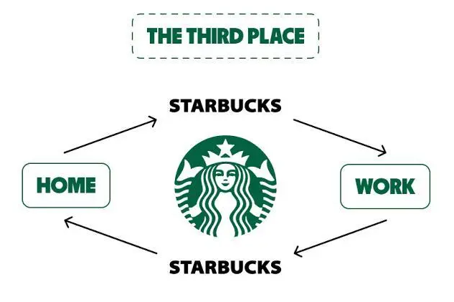
Figure 1: Starbucks “Third Place” concept
Source: (Anand, 2025)
Starbucks is globally located as a high-end specialty coffee chain that is established on the concept of Third Place, providing social spaces in between home and work. The company was started in Seattle, USA in 1971 as a result of the American specialty coffee movement but it expanded later to other parts of the world. Starbucks, which has more than 38,000 stores all over the globe, is reputed to produce ethically-procured Arabica, handmade beverages, and quality cafe surroundings (About Starbucks, 2024). Its product lines are espresso based drinks, cold brews, teas, bakery, and seasonal innovations. Starbucks competes with Dunkin, Costa Coffee, and McCafé brands in terms of internationalisation.

2.2 Internationalisation Strategy
Starbucks uses the hybrid internationalisation strategy that combines its own stores with franchisee collaboration, which enables it to maintain the high quality of control over the global brand and be responsive to the local market. This methodology favours the adjustment to different cultural, economic and regulatory environments. The glocalisation strategy helps it maintain uniform international standards and adapt products, store design and digital capabilities to the local market (Kaur, 2023). The pattern of expansion by Starbucks fits the Uppsala Model well, which involves entry into the market by gradual commitment, up to the point of full involvement and acquiring host-market experience.

2.3 Presence in the USA and China
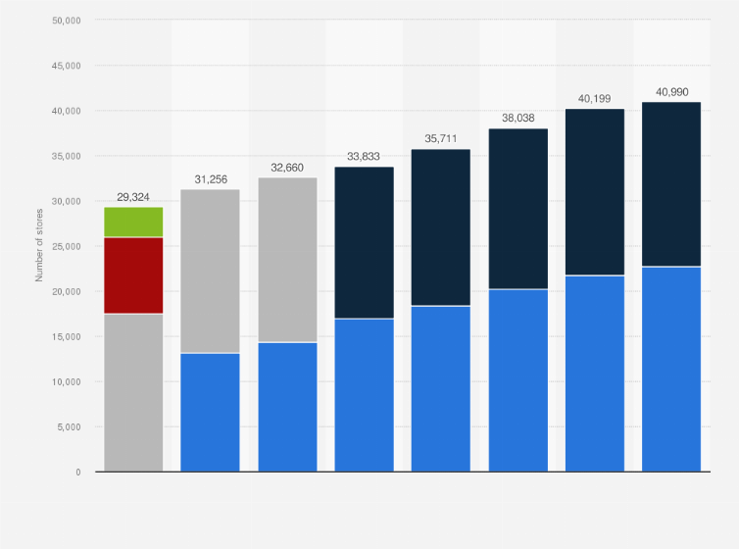
Figure 2: Number of Starbucks stores worldwide from 2018 to 2025, by region
Source: (Statista 2025)
Starbucks is a US-based company, and the USA is its mother country, and has more than 16,000 stores and active involvement based on its Rewards programme (Deep Research Global, 2025). Conversely, the most strategically important host market is China where the company has approximately 7,800 stores in 250+ cities (Starbucks China, 2025). Starbucks first ventured into China in the year 1999 through wholly owned stores, before launching through joint ventures and this has allowed it to have a strategic control as it takes advantage of the local expertise. The sophisticated digital ecosystem adopted in China, which is enhanced by its collaboration with Alibaba and WeChat, supports heavily intertwined mobile ordering, delivery and loyalty interaction (Yu and Goh, 2020).

2.4 Brand Values and Unique Selling Proposition
The USP of Starbucks includes both global and local market differentiation through an international brand. Its values, such as ethical sourcing, sustainability, connexion with the community and personalisation, lead to differentiation. In the USA this facilitates convenience led consumption and routine based consumption, however in China it facilitates aspirational lifestyle positioning and cultural resonance (About Starbucks, 2025).

3. Socio-Cultural Comparison Using Hofstede

3.1 Hofstede Scores for the USA and China
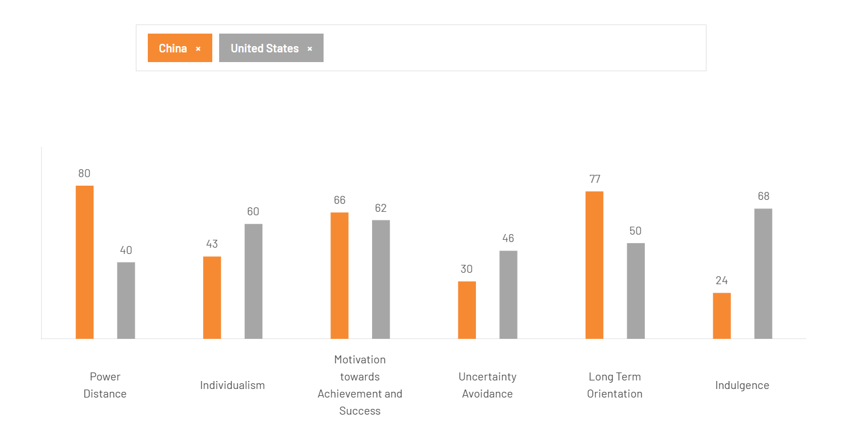
Figure 3: Hofstede Scores for the USA and China
Source: (Theculturefactor, 2020)
Cultural dimensions presented by Hofstede exhibit high differences between the USA and China, which provide a good understanding of Starbucks adaptation to the markets. The USA is ranked as a highly individualistic country (60), with Indulgence (68) and Low Power Distance (40), which means that the culture of this country does not regard authority and respect as important elements of social interactions. However, China exhibits High Power Distance (80), Low Individualism (43), High Long-Term Orientation (77) and Low Indulgence (24), which means that it is a collectivist, hierarchical, and future-oriented society with restraint and group harmony driving the behaviour.
Such differences are reinforced through the macroeconomic indicators. In 2024, the USA boasted of a GDP of USD 27.97 trillion, and GDP per capita was over USD 83,060 showing that it is a high-income, fully developed economy (US FINTECH, 2024). China produced USD 18.3 trillion of GDP, and the GDP per capita was approximately USD 13,000 which is a characteristic of upper-middle-income (IMF, 2023). The levels of urbanisation (USA 83%, China 64. 6) indicate the rapidly growing urban consumer market in China. Both nations are members of the WTO, but China is also a member of RCEP, providing it with a greater range of trade in the region. The USA is a free-market capitalist economy and China is a socialist market economy which also influences consumer behaviour, regulation and strategies used by Starbucks to enter the market (World Population Review, 2025).

3.2 Critical Interpretation of Cultural Differences
Individualism and decadence of the USA promote consumerism based on a personal desire, convenience, and immediacy. This is in line with the Starbucks focus on customisation of beverages, quick service in-store and mobile orders. Low power distance also facilitates the non-formal customer-barista relationships and the consumption of the cafes on high-frequency as a part of everyday life (Felice et al., 2025).
Conversely, the collectivist culture of China views coffee consumption as a symbolic and socially focused one. Demand in high power distance and low indulgence impetus drives demand of high end, aesthetically styled outlets, culturally instilled seasonal items and high usage of mobile payment systems like WeChat and Alibaba (Technavio, 2025; Toplin, 2017).

3.3 Cultural Implications for Starbucks’ Marketing Strategy
Product Strategy:Starbucks focuses on customisation, large quantities and convenience in the USA, which fits into the individualistic and indulgent consumer behaviour and high per-capita consumption of coffee. In China, the products have cultural connotations such as matcha, red bean and lunar products, which represent collectivist tastes and the aspirational lifestyle position of coffee (‌Doshi, 2021).
Service and Experience Design: American stores are more efficient and less social, whereas the Chinese stores focus on atmosphere, high-end design and communal seating, which helps young professionals display their social identities(‌Doshi, 2021).
Digital and Loyalty Behaviour:More than 30 per cent of U.S. orders are Mobile Order and Pay, and China is over 80 per cent mobile transactions because of strong WeChat and Alipay integration, and collectivist behaviour is also strengthened by digital gifting (Soper, 2024;Elad, 2025).
Brand Messaging: U.S. messaging is about individual freedom and living in accordance with the lifestyle; Chinese messaging is about community, harmony of cultures and modernity(Xu and Duan, 2023).
Similarities and Differences
Similarities:
- Both markets have a high level of integration of digital payment and loyalty.
- Starbucks ethical sourcing and sustainability messages work in both settings.
- Both markets have urban consumers who attach importance to high-end experiences, but due to different reasons(Mari, 2024).
Differences:
- USA is an individual, habitual and convenience oriented consumption, China is a social, symbolic and aspirational consumption.
- USA prefers informal service, whereas China prefers structured, premium, and status-based interaction.
- USA is focused on speed and efficiency; China focused on ambience and culture telling (Mari, 2024).
- USA marketing emphasises on the self-expression of an individual; China emphasises on the community, the cultural meaning and status.

4. PESTLE Analysis: USA vs China
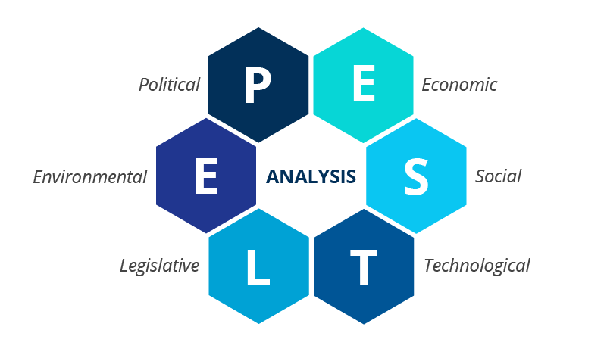
Figure 4: PESTLE Analysis
Source: (Ormston, 2025)

4.1 Political Environment
The USA is a politically stable market-oriented environment, in which the corporate governance and franchise operations are relatively transparent. Regulatory control is predictable that allows Starbucks to scale based on the standardised operations. Nevertheless, rising political rhetoric on the issue of labour, and the minimum wage regulation creates operational difficulties (Lin, 2024).
The political system of China is completely the opposite- state-centred, interventionist and closely controlled. Foreign companies work in a highly restrictive market-entry regulation, data regulation acts and varying geopolitical instability. The use of joint ventures (since changed into wholly-owned enterprises) is indicative of Starbucks having to deal with institutional structures that are relationship-based (guanxi) and preference based on states(‌Cai, 2025).
Critical implication:The approaches of Starbucks in China should be politically adaptive and sensitive and the USA operations have to be more based on regulatory adherence and labour negotiation.

4.2 Economic Factors
The USA is a seasoned and competitive coffee market whose demand is stable and has limited capacity to grow at a high rate. Purchasing power of consumers is strong, but inflationary pressures and increases in labour costs put the price elasticity into test. Starbucks has no option but to keep innovating so that it does not stagnate (Ciardulli, 2021).
China on the other hand has a fast growth in disposable income, booming middle-class consumption and a high aspirational desire towards western lifestyle brands. Even with the economic uncertainties and income inequality across the region, demand in high quality cafe experience is strong (Gerth, 2025).
Critical implication: Starbucks uses premiumisation in China to gain a higher per-store profitability, as in the USA it has to fight in a saturated and cost-conscious market.

4.3 Social Trends
Coffee drinking in the USA is a personalised and convenient habit. Growing health awareness is a force that drives product modification whereas the socio-demographic diversity encourages inclusive marketing (Patrick, 2025).
The Chinese social environment is changing culturally: coffee is ceasing to be a niche emblem of modernity, but becoming a normal social practise. Cafes are also used as study space, group level and display of status. The younger generation of consumers (Gen Z and millennials) segments have resulted in the demand of aesthetic, experiential and shareable products (Charles, 2025).
Critical implication: The brand becomes a cultural mediator between the Chinese and the USA- selling symbolic value as well as beverages and in the USA as an everyday life utility.

4.4 Technological Environment
The USA is a technological country, though the adoption of digital is not centralised amongst the platforms. Starbucks mobile application and loyalty system are broad but gainful operation is dependent on incremental innovation (Cennamo, 2021).
The digital ecosystem of China is unmatched. The mobile payments pass the 80 percent mark; mobile systems, including WeChat and Alipay, establish frictionless, socially embedded consumption experiences. Co-operation with Alibaba has revolutionised the process of ordering and delivery logistics at Starbucks and its data-driven personalisation (Elad, 2025).
Critical implication: China enables Starbucks to work at the edge of digital retail innovation as compared to the USA, which has a more incremental innovation curve which is constrained by platform fragmentation.

4.5 Legal Considerations
The USA has strict employment and food safety legislation and consumer protection. Starbucks is under intense criticism on unionisation, wage and discrimination cases. Such law pressures have been becoming more determinative of operational strategy and brand reputation.
The Chinese legal system is murky and fast changing. The laws on cyber-security, data localisation and intellectual property protections frequently applied with inconsistency require foreign companies to adhere to them. The labour law enforcement is regional (Zahn, 2023).
Critical implication: The legal risk in China is structural and political in USA it is adversarial and law-suing.

4.6 Environmental Factors
The USA demonstrates an increased consumer and regulatory pressure on the sustainability, waste minimization and ethical sourcing. The promises of reusable cups and carbon reduction of Starbucks are highly criticised (Jain, 2023).
The environmental laws in China have been enhanced especially when it comes to plastic waste regulation, as well as maintaining carbon neutrality. Consumers in urban areas are becoming more sustainable by linking the credibility of their brands with premium products (Sun et al., 2022).
Critical implication: In the USA, environmental initiatives are important as compliance costs whereas in China, they act as differentiation costs.

4.7 Critical Comparative Evaluation
The PESTEL analysis shows that Starbucks is functioning in two institutional logics that are deeply different. The USA needs to be resilient in its operations, negotiate labour, and defend its market; China needs to atone its culture, do regulatory diplomacy, and integrate its digital ecosystem. The fact that Starbucks has been able to adapt its strategies to such contexts is what has enabled it to remain competitive in a global market.

5. STP Strategy Comparison
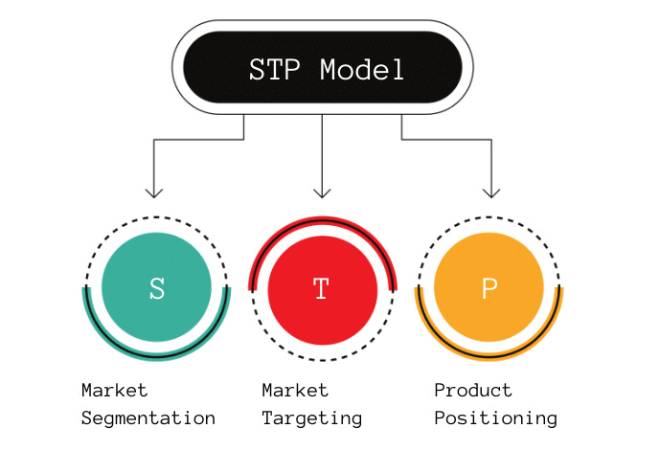
Figure 5: STP Strategy
Source: (Product Mindset, 2022)

5.1 Segmentation
In both markets, Starbucks uses the multi-dimensional segmentation but sets it differently based on the opposite socio-cultural and economic environment. The behavioural and psychographic segmentation is the most common in the USA, as American culture is individualistic and mature about coffee. The main subsets are convenience-induced commuters, millennials who are seeking lifestyle and remote workers in pursuit of the Third Place environments and healthier consumers(Anand, 2025).
China has more socio-economic, aspirational and experiential segmentation. The core segments are urban young professionals, university students who want to find modern social places and young middle-income consumers who want to identify with Starbucks and its cosmopolitan identity and status. The consumption of coffee is more symbolic rather than habitual (Luo et al., 2020).
Critical implication: The U.S. segmentation is based on behavioural diversity; the Chinese is based on cultural meaning and identity.

5.2 Targeting
Starbucks uses a mass-affluent targeting strategy in the USA, which is appealing to a broad audience based on the convenience, personalisation and consistency (Gao et al., 2021). In China, targeting is exclusive and high-end and is aimed at the urban elite, young professional consumers and culturally cosmopolitan consumers that perceive Starbucks as the modern lifestyle symbol (Wang, 2023).
Critical implication: U.S. targeting is ubiquitous and China prestigious.

5.3 Positioning
Starbucks manages to position itself as a functional value, speed and personalisation in the USA as an everyday high-end coffeehouse (Gao et al., 2021). Starbucks in China uses the positioning of aspirational lifestyle by positioning cafes as spaces that are designed as a social environment that signifies high class and being modern (Wang, 2023).
Critical implication: U.S. positioning revolves around utility; China revolves around symbolism and cultural capital.

5.4 Strategic Comparison
In both markets, Starbucks shows a strategic equilibrium between international consistency and national adaptation.
- Segmentation: USA focuses on behavioural heterogeneity, China on social-cultural identity.
- Targeting: USA uses mass targeting; China uses aspirational cohorts of consumers.
- Positioning USA foregrounds functionality; China foregrounds prestige and experience.
The capacity to reset the symbolic and functional context of what Starbucks sells allows it to be relevant in the over-saturated American market and desirable in the rapidly changing consumerism of China.

6. Marketing Mix (7Ps) Comparison
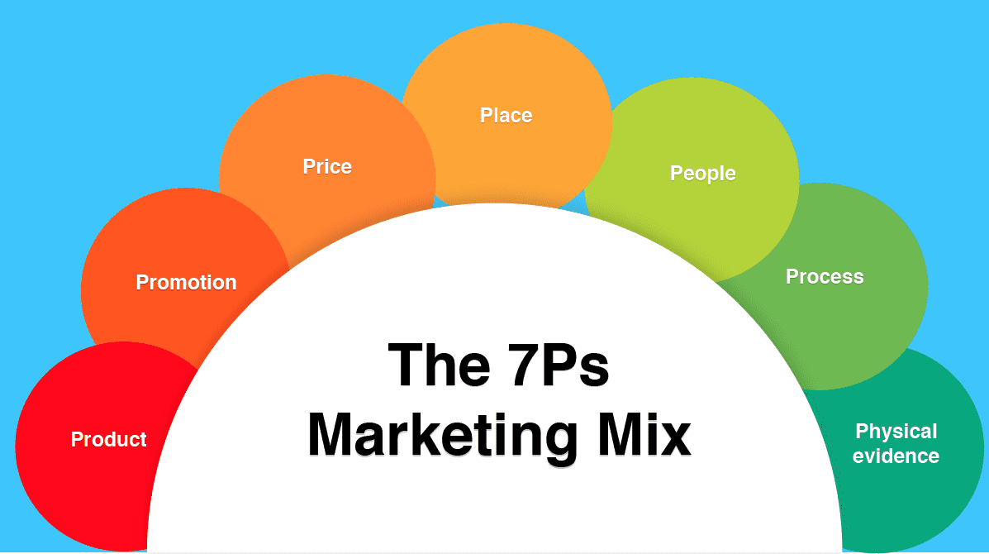
Figure 6: Marketing Mix (7Ps)
Source: (Hanlon, 2023)

6.1 Product
Starbucks is adopting a hybrid product strategy neither over-global standardised nor localised to ensure it is adopted by the market. The basic elements of quality of coffee standards, espresso base, brand image, and the idea of the Third Place are standardised worldwide, which ensures not only profitability and economies of scale in the USA but also in China. It is particularly thriving in the USA with its coffee drinking culture and customers being very sensitive to predictability and functionality (‌Doshi, 2021).
However, Starbucks is the one that believes in high product adaptation in China in order to incorporate cultural beliefs. Local flavours (e.g. matcha, red bean, tea-based drinks) and the products that were committed to a specific festival (e.g. Lunar New Year, Mid-Autumn Festival) were signs of collectivism and symbolic consumption. With these kinds of adaptations, the culture becomes legitimately cultural and aspirational and without diluting the worldwide brand (Starbucks China, 2025b).
Critical Implication:Standardisation of products ensures international brand equity and selective adaptation allows local adoption especially in culturally distant market markets such as China.

6.2 Price
Pricing policies demonstrate the domestic market maturity, competitive forces and cultural consumption practises.
Starbucks employs a competitive premium pricing in the USA. The prices are compared to the large competitors like Dunkin and independent cafes. Since there are escalating labour and input costs, the periodic price rise is needed but the consumers take it personally in the price-sensitive yet over-saturated market (Lau, 2025).
Starbucks uses prestige pricing in China, which makes it a luxurious Western brand. Higher prices are perceived by consumers, particularly the urban professionals, as quality, status and modernity. Although this is subject to greater competition due to a threat of lower-cost Chinese chains (e.g., Luckin Coffee) to replace Starbucks, the premium tier is maintained by the experiential differentiation. Recent storeys indicate that Starbucks has been modifying its prices in 2024-25 to remain competitive (Zhang, 2025).
Critical implication: Price in the USA is limited by competition pressure, and in China it is used as a strategic expression of exclusivity and cultural capital.

6.3 Place
The physical presence in the USA puts an emphasis on ubiquity and convenience. The brand is largely dependent on drive-thru, network of stores in the suburbs and stores with high volume of metropolitan stores. The point of targeting is accessibility and speed, which is in line with a habitual and individualised coffee drink. Mobile ordering helps to promote speedy turnover, which further makes throughput efficiency (Doshi, 2021).
Place strategy in China anticipates high-impact experiential places in the high-end shopping areas, business centres and lifestyle centres. The Shanghai Reserve Roastery is one of the flagship formats that were designed in an architectural style to appeal to tourism and enhance the brand prestige and entrench the brand into the urban cultural life. Cooperation with Alibaba-driven networks on delivery increases the penetration with digitally native buyers (Doshi, 2021).
Critical implication: USA stores are oriented to be operationally efficient, China stores are oriented to experience and cultural positioning.

6.4 Promotion
The values of sustainability, connection with the community, and positioning lifestyle is the standardised global promotion values adopted by Starbucks in every market. This provides brand equality and helps in the quality global image of Starbucks. Promotional implementation in the USA is utilitarian and person-centred and relies on Starbucks app, the application of personal rewards and seasonal campaigns highlighting convenience and frequent usage (Zhang, 2025).
The culture of the promotional strategies in China is focused on the collectivist culture and social-commerce ecosystems. Starbucks incorporates WeChat and Weibo to social gift, and share stories about festivals and share online experiences together. The personalized promotional messages encourage social approval and cultural appropriation and maintains the worldwide brand message (Starbucks China, 2025).
Critical implication:Uniformity of promotions is a continuum of world identity and accommodation of communication channels and cultural representation are constructive towards consumer adoption in China.

6.5 People
The USA has low power distance and relaxed rules of communication which promote personalised communication on a first-name basis. Baristas are friendly service interfaces that support the sense of familiarity and informality that characterises the American service culture (Third Place) (Anand, 2025).
In China, the level of power distance is higher and the service expectations are also different and more formalised, demanding more respectful and aesthetically oriented interactions. The consumers demand a friendly, smooth service that is in line with premium brand positioning. Starbucks educates employees in cultural communication, which focuses on ceremony aspects of drink production and delivery (Starbucks China, 2025).
Critical implication: The people strategy in the USA is concerned with friendliness and efficiency; the people strategy in China is concerned with professionalism, refinement and status reinforcement.

6.6 Process
The processes of service delivery shows the way Starbucks aligns the global form of operations with local behavioural standards.
Process design in USA focuses on speed, optimisation of workflow and convenience. The use of Mobile Order & Pay is a popular initiative because it allows a customer to avoid waiting in line with other people and reduces the need to engage with people in the store. This is in line with the American desire to have independence and little resistance. A mobile channel is used to make more than 30 percent of orders in the U.S. (Soper, 2024).
In China the procedure is digitally intensive and socially construed. Integration in the Alibaba ecosystems allows pre-ordering, cashless, custom recommendations, and fast ordering with the Ele.me delivery service, so the smart stores of Starbucks can be used to personalise experiences and optimise operations through data analytics (Elad, 2025).
Critical implication: Process execution is optimised in USA on functional value; in China it is optimised on experiential, social and digital value.

6.7 Physical Evidence
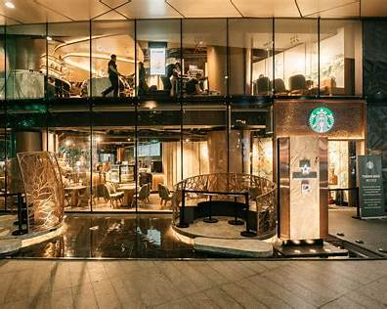
Figure 7: Starbucks Retail Store
Source: (Starbucks Stories Asia, 2025)
Physical evidence in USA has a focus on familiarity, consistency and functionality. The layouts of the stores give importance to rapid movement, comfortable seating to work remotely, and a relaxed appearance. The decor is consistent with the global identity of the brand and is not too stylised; it is also important to the user to see such consistency across the stores (Doshi, 2021).
Physical evidence is very edited and figurative in China. The stores have high quality of materials, design details inspired by the culture and ornate visual displays. Reserve shops emphasise the art of brewing and visual appeal. The physical environment provides prestige and sensitivity of cultures, which supports aspirational positioning of Starbucks (Starbucks China, 2025).
Critical implication: Physical evidence in the USA sustains habitual everyday use whereas in China, it creates cultural and social meaning about the brand.

6.8 Critical Comparative Evaluation of the Marketing Mix
The comparative analysis indicates the strategic ambidexterity of Starbucks, i.e. balancing between global brand coherence and strong local responsiveness.
- Products are customised in the USA and culturally sensuous in China.
- Pricing is competitive viability in the USA but an indicator of exclusivity in China.
- Place is more convenient than prestigious.
- Promotion is an appeal to personal self-expression as compared to the collective identity.
- People behaviours turn out to be nonchalant to refined professionalism.
- Processes maximise operational efficiency in comparison to social-digital immersion.
- Physical evidence indicates the normal lifestyle consumption as opposed to aspirational lifestyle experiences.

7. Performance Evaluation

7.1 Financial Performance and Store Footprint
The financial and operating profile of Starbucks highlights the differentiated functions of the firm in the USA and China. Consolidated net revenues of about 37.2billion of Starbucks were reported in FY 2025 with North America still being the largest revenue contributor even as the International segment has been increasing at a higher rate per year. By the end of Q4 FY2025 Starbucks had approximately 16,864 stores in the U.S. and 8,011 stores in China, which combined make up approximately 61% of the global estate of the enterprise - a number that stabilises cash flows (U.S.) and enables growth potential (China)(Starbucks, 2025).

7.2 Revenue Profile and Growth Dynamics
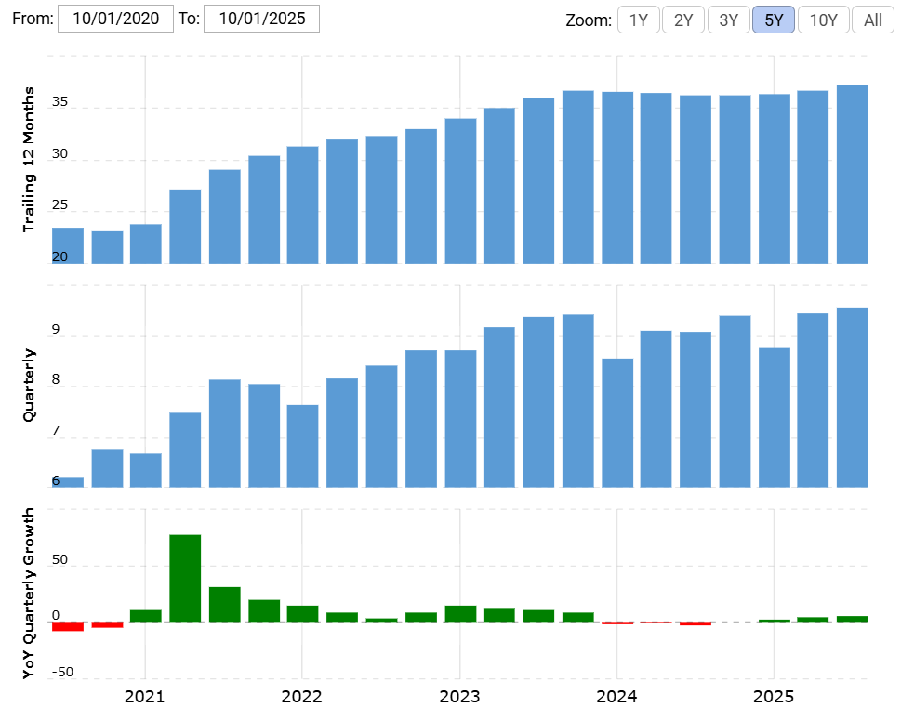
Figure 8: Starbucks Revenue Trend and Year-on-Year Growth (2020–2025)
Source: (Macrotrends, 2025)
Figure 8 indicates the instability and disproportionate rise in the revenues of Starbucks during the last years, which indicates the post-pandemic revival and competitive forces.
The bulk of Starbucks revenues is still generated in the U.S. market, market saturation and pressure on costs limits growth; North America comp growth has been fairly flat and margin compression has been experienced due to restructuring and increases in labour costs. In comparison, China is where the company will grow its strategic growth base: although the near-term fluctuations are high, International (and China, in particular) has shown higher similar-store sales growth within the recent quarters, and can consistently be used as the source of incremental revenues as Starbucks moves towards premiumisation and geographic expansion into low-tier cities. The FY2025 reporting of Starbucks indicates that International net revenues are increasing at a higher percentage rate than North America, which is a dynamic(Starbucks, 2025).

7.3 Loyalty, Digital Penetration and Customer Metrics
Performance differentials are materialised by loyalty and online channels. Starbucks has an under 34.6 million active 90-day Starbucks Rewards members in the U.S. as early FY2025, which is a key foundation driving a major portion of U.S. transactions and enabling personalised promotions. In the meantime, mobile ordering contributed approximately 30%+ of transactions at United States company operated stores (an all time high), which has enhanced convenience but introduced operational burden in certain formats. These online indicators show that the U.S. business is well monetised by using repeat, apps-based customers; the task is to reclaim more growth out of an already mature base(Starbucks, 2025).

7.4 Competitive Dynamics in China
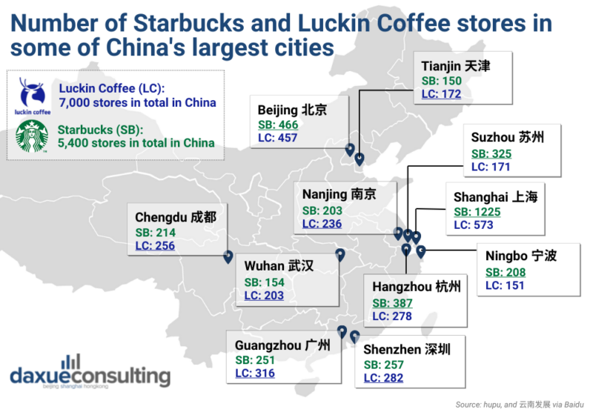
Figure 9: Number of Starbucks and Luckin Coffee stores in some of China
Source: (daxueconsulting, 2022)
The local competition and price sensitivity are intensifying and make the performance of China complicated. Domestic competitors have also grown rapidly in the number of stores and have strong digital-first discounting, with Luckin doing more business in China than Starbucks in China over the last few years, and the market-share estimates indicate that Starbucks has dropped significantly below its high in its share in China. This competitive force justifies the strategic initiatives of Starbucks (price manipulation, product localisation, and partnership/joint-venture strategies) and the reason why the company recently opted to go further with local partnerships and quicken the growth and operational aptitude(Jie, 2024).

7.5 Critical Performance Judgement
U.S. business is empirically attractive, with good cash flows and a high number of digital customers who are loyal but with very little upside without structural alteration (store portfolio optimisation, labour strategy, product reinvention). China has better marginal returns per new store and abundant digital experimentation (super-app integrations, scale of delivery) but is a fought battlefield where scale, localisation and price strategy dictate long-term share. To maintain a high-quality global performance, Starbucks needs to (a) protect U.S. margins with efficiency and innovation, and (b) rejuvenate momentum in China with culturally sensitive high-quality experiences and rapid competitive reactions a dual set of imperatives that can be traced to the FY2025 commentary on the company of Starbucks on Back to Starbucks and strategic restructuring(Starbucks, 2025).

8. Ethical Considerations
Supply-chain governance, labour relations, environmental stewardship and cultural sensitivity constitute the ethical profile of Starbucks. Although the brand shares solid ethical commitments both in USA and China, there are multiple gaps in the statements of ambitions and on-field performance, posing reputational and operational threats.

8.1 Supply Chain and Sustainability
The C.A.F.E. Practises programme is an established economic, social and environmental sourcing programme at Starbucks. Despite its widespread implementation and validation on thousands of farms, independent audits still find non-conformities and inadequate remediation results(About Starbucks, 2024b).

8.2 Labour and Employee Rights
Starbucks is also experiencing an increasing ethical pressure in the USA because of unionisation, pay and time-related issues. Strikes and court battles are indicators of structural imbalance between the expectation of the employees and the policies of the corporate labour, and their long-term brand equity may be affected. The labour issues in China are less obvious but uneven application of labour and excessive workloads can open compliance gaps, which are aggravated by the spread of social-media. In both settings, it is evident that labour ethics are not only regulatory requirements but strategic preconditions of organisational legitimacy(Mistry, 2025).

8.3 Environmental stewardship and packaging
The 2030 objectives of Starbucks such as carbon, water and waste reduction are ambitious but operationalisation is irregular. Reusable cup projects and pilot sustainability programmes are having mixed outcomes, in particular, because delivery channels and digital channels are making more and more use of single-use packaging. Gradual systemic adoption will allow the allegation of greenwashing in the green markets (Pyzyk, 2024).

8.4 Cultural Sensitivity
Cultural awareness is critical in China and Starbucks has localised well in most cases. Nonetheless, any misjudgment during the design of products, pricing or online data utilisation may lead to a quick backlash. The consumer-welfare issue in digital ecosystems is aggravated by the local brands competition like Luckin(Forbes, 2024).

8.5 Critical judgement & managerial implications
Starbucks ought to alleviate the ethical risk by: (1) enhance third-party cheques and remedies in C.A.F.E. sourcing; (2) embrace principled and negotiation-based labour relations in the USA; (3) scale systemic packaging solutions that can fit delivery expansion; (4) implement strict cultural-risk-reviewing of marketing and online alliance in China. In both markets, the ethical implementation is the sole way of maintaining a premium brand equity, rather than aspirational claims.

9. Recommendations & Conclusion

9.1 Recommendations
1. Strengthen Cultural Localisation in China
According to the socio-cultural analysis presented in Section 3, Starbucks needs to become even more local through introducing more culturally significant flavours (e.g., regional teas, beverages exclusive to specific events) and greater cooperation with local artists and designers. This is in direct relation to the collectivist orientation and high Long-Term Orientation in China, where the cultural authenticity and symbolism affect consumption behaviour(‌Doshi, 2021).
2. Enhance Personalisation and Convenience in the USA
Results of Section 6 indicate that U.S. people emphasise on individual choice and practical convenience. Starbucks ought to add digital ordering, customisation, and time-saving formats (drive-through optimisation, pick-up zones) to the value propositions that resonate with individualistic and convenience-driven behaviour(Doshi,2021).
3. Rebalance Pricing Strategies Across Markets
Section 7 indicated that China had a higher level of rivalry and price pressure, especially the low-cost competitors such as Luckin Coffee. Starbucks needs to keep its premium status but use the value-based pricing (e.g., weekday discount, entry-level coffee) in a selective way (to keep aspirational customers without weakening brand equity). The price resistance in the USA is inflation-related, which implies the growth of loyalty-based discounts and personalised price incentives(Jie, 2024).
4. Differentiate Store Formats Based on Cultural Expectations
In line with the cultural comparison in Section 3, Starbucks needs to lay emphasis on huge, experience, high-design shops in China which aid group interaction and social signalling. The USA is to invest in multifunctional stores where remote workers can work, mobile customers and fast turnover preferences are welcome(‌Doshi, 2021).
5. Deepen Digital Ecosystem Integration in China, Enhance Ethical Data Practices in the USA
The current levels of the mobile-payment adoption (more than 80) and social commerce behaviours in China need further investment in integrated applications like WeChat gifting, digital communities, and personalised application journeys. Starbucks should focus on privacy awareness in the USA because its customers are more concerned about it, and it should be ethically acceptable to meet the demands of autonomy and control(Soper, 2024;Elad, 2025).
6. Innovate Health-Oriented and Lifestyle-Relevant Products
Section 6 shows divergent consumption motives. Starbucks ought to launch more low-sugar and more plant-based and functional beverages in the USA, as a response to the consumer trends of wellness. The aesthetic display, symbolic seasonal and high-quality craftsmanship have to remain a key focus of innovation in China, which can be aligned with aspirational preferences in the lifestyle (Doshi,2021).

9.2 Conclusion
The present report shows that the performance of the Starbucks in the USA and China is conditioned by significant socio-cultural, economic and competitive disparities. As the analysis of the sections 2, 3, 6 and 7 demonstrates, Starbucks is performing well because of its ability to strike a compromise between the uniformity of its global brands and the cultural adaptability. USA is a very individualistic, convenience oriented market where, personalisation, speed and routine consumption are the basis of success. China, in its turn, is a collectivist, prestige-based and fast-growing market in which Starbucks operates as a cultural and social icon and not a simple drink seller.
These findings are the foundations of the recommendations provided, and the recommendations provide strategic avenues that Starbucks can use to perfect its localisation strategies, pricing frameworks, digital ecosystems, store format and product innovation in both markets. Through increasing the cultural congruence, improving the value propositions, and addressing the changing consumer expectation ethically, Starbucks will be able to maintain long-term competitive advantage in two of the most strategically important markets.

References
‌‌About Starbucks. (2024a). Starbucks announces new global leadership structure to accelerate company reinvention and elevate the brand. [online] Available at: https://about.starbucks.com/press/2024/starbucks-announces-new-global-leadership-structure-to-accelerate-company-reinvention-and-elevate-the-brand/ [Accessed 12 Dec. 2025].
‌About Starbucks. (2024b). C.A.F.E. Practices: Starbucks Approach to Ethically Sourcing Coffee. [online] Available at: https://about.starbucks.com/press/2024/cafe-practices-starbucks-approach-to-ethically-sourcing-coffee/ [Accessed 12 Dec. 2025].
‌About Starbucks. (2025). About Starbucks. [online] Available at: https://about.starbucks.com/ [Accessed 12 Dec. 2025].
Anand, V. (2025). Starbucks’ Revival: Why Experience, Not Just Coffee, Is Its New Growth Engine. [online] Point of View. Available at: https://onlykutts.com/index.php/2025/08/17/starbucks-revival-why-experience-not-just-coffee-is-its-new-growth-engine/ [Accessed 12 Dec. 2025].
‌Cai, C. (2025). Cyber Governance in China: Balancing State Centrism and Collaborative Dynamics. Taylor & Francis.
Cennamo, C. (2021). Competing in Digital Markets: A Platform-Based Perspective. Academy of Management Perspectives, [online] 35(2), pp.265–291. doi: https://doi.org/10.5465/amp.2016.0048.
‌Charles, S. (2025) 'How China's coffee culture is responding to trade tensions - Coffee Intelligence,' Coffee Intelligence, 6 May. https://intelligence.coffee/2025/05/chinas-coffee-culture-trade-tensions/.
Ciardulli, M. (2021). The coffee market: competitive strategies and firm performances in a saturated market - Webthesis. Polito.it. [online] doi: https://webthesis.biblio.polito.it/secure/21387/1/tesi.pdf.
daxueconsulting.com (2022). Number of Starbucks and Luckin Coffee stores in some of China. [online] Daxue Consulting - Market Research and Consulting China. Available at: https://daxueconsulting.com/infographics/starbucks-luckin-coffee-number-of-stores-in-china/[Accessed 18 Dec. 2025].
‌Deep Research Global (2025). Starbucks - SWOT Analysis Report (2026). [online] Deep Research Global. Available at: https://www.deepresearchglobal.com/p/starbucks-swot-analysis-report [Accessed 12 Dec. 2025].
‌Doshi, R. (2021). The long game: China's grand strategy to displace American order. Oxford University Press.
‌Elad, B. (2025). Alipay vs. WeChat Pay Statistics 2025: Market Share, Innovation & Digital Yuan Impact. [online] CoinLaw. Available at: https://coinlaw.io/alipay-vs-wechat-pay-statistics/ [Accessed 12 Dec. 2025].
‌Felice, F.D., Rehman, M., Petrillo, A. and Baffo, I. (2025). Decoding the coffee supply chain: A systematic review of stakeholders, sustainability opportunities, and challenges. Sustainable Futures, [online] 10, pp.101105–101105. doi: https://doi.org/10.1016/j.sftr.2025.101105.
Forbes (2024). Luckin Coffee’s Resurgence Challenges Starbucks’ Dominance In China. [online] Forbes. Available at: https://www.forbes.com/sites/greatspeculations/2024/11/19/luckin-coffees-resurgence-challenges-starbucks-dominance-in-china/ [Accessed 12 Dec. 2025].
Gao, J. et al. (2021) 'Starbucks’Customer Brand Strategy,' Advances in Economics, Business and Management Research/Advances in Economics, Business and Management Research, 178. https://doi.org/10.2991/aebmr.k.210601.040.
Gerth, K. (2025). As China goes, so goes the world: How Chinese consumers are transforming everything. Macmillan+ ORM.
‌Hanlon, A. (2023). How to use the 7Ps Marketing Mix strategy model? [online] Smart Insights. Available at: https://www.smartinsights.com/marketing-planning/marketing-models/how-to-use-the-7ps-marketing-mix/ [Accessed 12 Dec. 2025].
‌IMF. (2023). China Stumbles but Is Unlikely to Fall. [online] Available at: https://www.imf.org/en/publications/fandd/issues/2023/12/china-bumpy-path-eswar-prasad [Accessed 12 Dec. 2025].
‌Jain, S. (2023). Are businesses responding to the ever-growing sustainable demands of US consumers? [online] Simon-kucher.com. Available at: https://www.simon-kucher.com/en/insights/are-businesses-responding-ever-growing-sustainable-demands-us-consumers [Accessed 12 Dec. 2025].
Jie, Z. (2024). Luckin surpasses Starbucks in China in annual sales. [online] Chinadaily.com.cn. Available at: https://www.chinadaily.com.cn/a/202402/26/WS65dc4065a31082fc043b91e3.html [Accessed 12 Dec. 2025].
‌Kaur, M.M. (2023) How Starbucks Conquered the World Through Expansion, Localization, & Brand Building Success? - Accredian Blog. https://blog.accredian.com/how-starbucks-conquered-the-world-through-expansion-localization-and-brand-building-success/.
‌Lau, S. (2025). Starbucks Pricing Strategy Explained: Balancing Premium Quality with Affordability - NewswireJet. [online] NewswireJet. Available at: https://newswirejet.com/starbucks-pricing-strategy/ [Accessed 12 Dec. 2025].
Lin, T. C. (2024). The New Corporate Political Governance. BCL Rev., 65, 833. Doi: https://bclawreview.bc.edu/articles/3124/files/6602bebc74e68.pdf
Luo, J., Dey, B.L., Cagri Yalkin, Uthayasankar Sivarajah, Khanyapuss Punjaisri, Huang, Y. and Yen, D.A. (2020). Millennial Chinese consumers’ perceived destination brand value. Journal of Business Research, [online] 116, pp.655–665. doi: https://doi.org/10.1016/j.jbusres.2018.06.015.
‌Macrotrends.net. (2025). Starbucks Revenue 2011-2025 | SBUX. [online] Available at: https://www.macrotrends.net/stocks/charts/SBUX/starbucks/revenue[Accessed 18 Dec. 2025].
Mari, M. (2024). Consumerism with Chinese Characteristics: SSRN Electronic Journal. [online] doi: https://doi.org/10.2139/ssrn.4873944.
‌Mistry, A. (2025). Starbucks workers’ union takes month-long strike to more cities. [online] Reuters. Available at: https://www.reuters.com/business/world-at-work/starbucks-workers-union-expand-month-long-strike-more-cities-2025-12-11 [Accessed 12 Dec. 2025].
Ormston, A. (2025) PESTLE Analysis: A guide to understanding market Influences. https://www.b2binternational.com/2025/04/03/pestle-analysis/.
Patrick (2025). Blog Bean Verified. [online] Bean Verified Blog. Available at: https://blogs.beanverified.coffee/daily-coffee-consumption-hits-a-20-year/ [Accessed 12 Dec. 2025].
Product Mindset (2022). STP Model: Segmentation, Targeting & Positioning. [online] Substack.com. Available at: https://productmindset.substack.com/p/stp-model-segmentation-targeting [Accessed 12 Dec. 2025].
‌Pyzyk, K. (2024). Starbucks adds 3 new 2030 sustainability goals for packaging. [online] Packaging Dive. Available at: https://www.packagingdive.com/news/starbucks-esg-report-sustainability-targets-waste-emissions/708403/ [Accessed 12 Dec. 2025].
Soper, T. (2024). Starbucks mobile orders surpass 30% of total transactions at U.S. stores. [online] GeekWire. Available at: https://www.geekwire.com/2024/starbucks-mobile-orders-surpass-30-of-total-transactions-at-u-s-stores-for-the-first-time/ [Accessed 12 Dec. 2025].
‌Starbucks China. (2025a). Starbucks in China - Starbucks China. [online] Available at: https://www.starbucks.com.cn/en/about/ [Accessed 12 Dec. 2025].
Starbucks China. (2025b). Starbucks Mooncake. [online] Available at: https://www.starbucks.com.cn/en/menu/food/mooncake-mobile/ [Accessed 12 Dec. 2025].
‌Starbucks Stories Asia. (2025). Store Design Archives : Starbucks Stories Asia. [online] Available at: https://stories.starbucks.com/asia/stories/tag/store-design/[Accessed 18 Dec. 2025].
Starbucks.com. (2025). Starbucks Reports Q4 and Full Fiscal Year 2025 Results. [online] Available at: https://investor.starbucks.com/news/financial-releases/news-details/2025/Starbucks-Reports-Q4-and-Full-Fiscal-Year-2025-Results/default.aspx
Statista. (2025). Starbucks: store count worldwide by region 2025| Statista. [online] Available at: https://www.statista.com/statistics/218366/number-of-international-and-us-starbucks-stores/ [Accessed 12 Dec. 2025].
‌Sun, Y., Liu, S., Wang, P., Jian, X., Liao, X. and Chen, W.-Q. (2022). China’s roadmap to plastic waste management and associated economic costs. Journal of Environmental Management, [online] 309, pp.114686–114686. doi: https://doi.org/10.1016/j.jenvman.2022.114686.
Technavio (2025). Coffee Market Analysis, Size, and Forecast 2025-2029: North America (US and Canada), Europe (France, Germany, Italy, and UK), Middle East and Africa (Egypt, KSA, Oman, and UAE), APAC (China, India, and Japan), South America (Argentina and Brazil), and Rest of World (ROW). [online] Technavio.com. Available at: https://www.technavio.com/report/coffee-market-industry-analysis [Accessed 12 Dec. 2025].
Theculturefactor.com. (2020). Country comparison tool. [online] Available at: https://www.theculturefactor.com/country-comparison-tool?countries=china%2Cunited+states[Accessed 12 Dec. 2025].
‌Toplin, J. (2017). Starbucks adds Alipay in China. [online] Business Insider. Available at: https://www.businessinsider.com/starbucks-adds-alipay-in-china-2017-9 [Accessed 12 Dec. 2025].
‌US FINTECH. (2024). US RETAINS POSITION OF WORLD’S LARGEST ECONOMY (2024). [online] Available at: https://us-fintech.com/news--insights/us-retains-position-of-worlds-largest-economy-2024 [Accessed 12 Dec. 2025].
Wang, Z. (2023). Analysis of Starbucks in China. [online] ResearchGate. Available at: https://www.researchgate.net/publication/369431952_Analysis_of_Starbucks_in_China.
World Population Review (2025). Most Urbanized Countries. [online] World Population Review. Available at: https://worldpopulationreview.com/country-rankings/most-urbanized-countries [Accessed 12 Dec. 2025].
‌Xu, J. and Duan, R. (2023) 'How do US corporations communicate interculturally with their Chinese stakeholders: Analysis of GM Company’s social media posts from the cultural value perspective,' PLoS ONE, 18(10), p. e0292552. https://doi.org/10.1371/journal.pone.0292552.
‌Yu, S. and Goh, B. (2020). Starbucks expands Chinese order services to multiple Alibaba apps. [online] Reuters. Available at: https://www.reuters.com/article/business/starbucks-expands-chinese-order-services-to-multiple-alibaba-apps-idUSKCN24L1GI/ [Accessed 12 Dec. 2025].
Zahn, M. (2023). Starbucks discrimination lawsuit awarded white employee $25 million: Legal experts weigh in. [online] ABC News. Available at: https://abcnews.go.com/Business/starbucks-discrimination-lawsuit-awarded-white-employee-25-million/story?id=100104620 [Accessed 12 Dec. 2025].
‌Zhang, J. (2025). Analysis of Starbucks’ Differentiated Marketing Strategy. Advances in Economics, Management and Political Sciences, 218(1), pp.222–226. doi: https://doi.org/10.54254/2754-1169/2025.cau27575.
‌

Appendices
Appendix 1: Hofstede Cultural Dimensions – USA vs China
Dimension | USA Score | China Score | Interpretation
Power Distance (PDI) | 40 | 80 | China accepts higher hierarchy; USA prefers equality and low formal authority.
Individualism (IDV) | 60 | 43 | USA highly individualistic; China strongly collectivist.
Masculinity (MAS) | 62 | 66 | Both societies competitive, though China slightly more so.
Uncertainty Avoidance (UAI) | 46 | 30 | USA moderately tolerant of ambiguity; China is highly pragmatic and adaptable.
Long-Term Orientation (LTO) | 50 | 77 | China is future-oriented; USA focuses on short-term outcomes.
Indulgence (IVR) | 68 | 24 | USA highly indulgent; China values restraint and controlled behaviour.
Appendix 2: PESTLE Summary Table – USA vs China
Factor | USA Summary | China Summary
Political | Stable, transparent regulatory environment; rising labour policy debates; unionisation pressures. | Strong state intervention; complex regulations; digital data governance; geopolitical sensitivity.
Economic | Mature, saturated market; rising costs; stable demand. | High growth; rising middle class; regional economic disparities; aspirational spending.
Social | Convenience-driven, individualistic consumption; health trends increasing. | Coffee as a social status symbol; group-oriented consumption; strong youth influence.
Technological | High digital usage; fragmented platforms; mobile ordering ~30%. | Advanced super-app ecosystems; WeChat/Alibaba integration; high delivery penetration.
Legal | Strong labour laws, litigation risk, compliance obligations. | Rapidly changing regulatory environment; data localisation; variable enforcement.
Environmental | Strong scrutiny on sustainability; packaging reduction pressure. | National climate goals; growing consumer sustainability awareness.
Appendix 3: 7Ps Marketing Mix Comparison Table
7Ps Element | USA | China
Product | Large sizes, functional, indulgent, customisation-heavy | Localised flavours, aesthetic seasonal drinks, premium Reserve formats
Price | Competitive premium pricing | Prestige pricing; justified through experience and symbolism
Place | Drive-thrus, high-density stores, mobile pickup | Premium lifestyle locations, experiential flagship stores, strong delivery ecosystem
Promotion | Personalisation, seasonal pushes (e.g., PSL), Instagram, Rewards app | WeChat/Weibo campaigns, social gifting, cultural festival promotions
People | Informal, friendly, first-name service | Polished, premium, high-service expectations
Process | Speed, efficiency, mobile order optimisation | Immersive digital integration, longer dwell times
Physical Evidence | Familiar, functional, workspace-oriented stores | High-design, culturally inspired ambience; luxurious retail environments

Appendix 4: Performance Evidence Table (USA vs China)
Metric | USA | China | Source
Store Count (FY2025) | ~16,864 stores | ~8,011 stores | Starbucks FY2025 Reporting
Active Loyalty Members | 34.6 million (90-day active) | High adoption via WeChat (exact figure not disclosed, but rapid YOY growth) | Starbucks FY2025 & digital reports
Mobile Ordering Penetration | 30%+ of U.S. transactions | Significantly higher (due to super-app ecosystem) | Industry digital data
Competitive Landscape | Fragmented but stable; Dunkin’ major competitor | Intense competition from Luckin Coffee | Market news analysis
Revenue Trend | Slower growth due to saturation | International revenue growing faster YOY | Starbucks FY2025 Results

Appendix 5: Store layout
USA
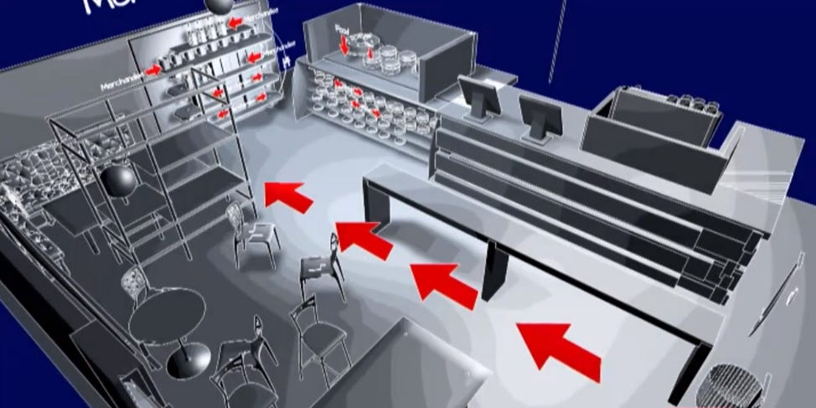
China


