

Developing and Managing Workplace Achievement.

Student Name: Susan Okwera
Student Number: 1806775
Module Title: Developing and Managing Workplace Achievement
Module Code: BMSK5102
Module Lecturer: Ze Zook

Table of Content

Introduction 3
Organisation Background 3
Appropriate Knowledge of Recruitment and Selection 4
Appropriate Skills and Behavior 4-5
Personal Skills Audit 5
Sustainability of the organisation 5-6
Google and HR Policies 6
Pay and Compensation 7
Training and Development 8
Maslow’s Hierarchy of Needs 8-9
Importance of Career Development 9-11
Conclusion 11
References 12
Appendix B 13-14

Trainee Human Resources (HR) Officer

Introduction

This report will aim to analyse what are the requirements of a Human Resources Officer and how relationships are developed through achievement in the workplace, relating to a chosen organisation to determine the appropriate knowledge, skills and behaviors of a Human Resources professional. This report will also identify training and development needs of a Human Resources Officer as well as the potential advantages to the organisation for developing a Human Resources Officer through effective training and development.
Google LLC is a multinational technology company. Established in 1998 by Larry Page and Sergey Brin. Since Google’s establishment, the organisation has continued to evolve. Google particularise in internet connected services and products, which comprises of technology, online advertising, search engine, software and hardware and cloud storage.
The organizational structure that Google LLC uses is a team based or cross functional structure. This type of structure is more geared towards ideas and intelligence. Which best suits the needs of Google and their employees. This type of structure allows working together as a team from all levels and different backgrounds and expertise to achieve a common goal. Google’s management team approach gives encouragement for employees to participate in decision making.
Governments make policies to suit current events, for example; the wearing of masks in the workplace due to Covid 19. Organizations have to adapted and implemented these changes due to the law. However, Human resources recognizes changes and expands on the policies to create job satisfaction to this ever competitive market.
As an (HR) Human resources officer, the human resources officer will be part of a large team at google responsible for planning and development looking to recruit talent and working under the human resources manager.

1.1 Determining the appropriate knowledge, skills, and behaviors required by HR Professional.
According to (Kourtesopoulou and Kiremadis 2008) training and development is a learning process that is available to newcomers and old employees by acquiring appropriate knowledge, skills and expand on attitudes of behavior to further advance and be valuable in their tasks. In addition, (Kourtesopoulou and Kiremadis 2008) states that a company that seeks constant improvement and growth, training and development will be center.
Appropriate knowledge of Recruitment and selection
working for a large organisation like Google LLC, is unlike any other organisation, according to (Pratap 2017) Google’s working practices and culture are different as Google focuses on employees and happiness of their employees centering on employee empowerment, favoring ability over experience, recruiting talented individuals. As a human resources officer at Google you will be expected to work as part of a team in the Human Resources department. However, the knowledge that will be required and is appropriate to the department is knowledge of the law, for instance employment law.
Knowing and understanding employment laws or HRM knowledge is important to the organisation to implement policies and procedure of the organization therefore by the understanding policies what and how the law works found in the employee hand book. The Knowledge of Employment Rights Act 1996, Mental Health Act 1983, Equality Act 2010, as well as recruitment policies, health and safety policies, anti-discrimination and harassment policies to name a few.
In addition, the example of #METOO movement brought in a whole load of changes in organisations and policies were changed in order to suit the events of the cause of sexual harassment at work. As a Human resources officer the skills needed to deal with misconducts of such confidentially, Empathy, Listening and decision making because how you handle such sensitive matters can impact the organisation or the individual towards this allegation and it depends on how it is handled and in most cases it is the boss that has been accused and reported to the Human resources department. Brands like Nike and Adidas, Google have now supported the black lives matter therefore, they are expanding, improving and increasing their customer base. HR officer should also maintain the ethics and standards of the CIPD
Communication skills: dealing with complaints and resolving disputes, writing reports, producing materials in support, delivering training sessions, taking disciplinary notes, drafting employment contracts and conducting interviews.
Information Technology: knowing how to use; Microsoft office word, excel spreadsheet, specialist HR software, the internet, emailing and PowerPoint.
Problem Solving Skills: exploring more options to solving a problem, making good use of verbal reasoning, ability to handle complex data, select useful information, consideration of others and their ideas to assist in solving problems.
Management of People skills: Ensuring positive working environment, planning and vision setting, driving team and individual performances

2.1 Identifying the personal skills which is also another vital function to the organization, according to the personal Skills Audit Appendix B, the skills that are appropriate to the role of a Human Resources officer are Communication skills, Information technology, problem solving skills and managing people skills.
According to the criteria to Appendix B, there are some skills that I need to sharpen or improve on that will enable me to be more effective in the positon of HR officer. Therefore, training and development would be ideal for me in order to achieve my goals at work.
All organizations need to be sustainable but why?
The organizations being able to function eco building is sustainable CSR corporate social responsibility. Organizations used to be seen different from society but are now very much in the society. Where does green marking or business fit in from the 90s to the 2000s.
Flexible working is sustainable and working life balance in recruitment
Sustainability is a long term development to the human society.
The main responsibility or function for a business was to make profit but now it ties in with sustainability. It was perceived to be separate. Not just shareholders but for the wilder community socially. Unlike amazon who are only focused on profits this has seen a wider responsibly of companies like Google, Coca Cola, Sainsbury’s all responsible for the environment and planet. But also needs to make profits in order to stay in business. Amazon bought whole foods which is a contradiction to their concept of profit.
The main business function is what it produces or how it operates.
All reports will be different dependent on the country of origin. To the outside the company presents themselves. As the Volkswagen golf company that fixed its suitability report on emissions and Nissan with the escape of the company director. Private and transparency issues.
Google is a business with sustainability, with all three elements. the plan is to have all the information in a sustainable manner.
Google and HR policies
Equal opportunities are policy that is vital in today’s organisations like Google, as the western world is facing challenges to foster and make changes in this area. There are movements that have changed society as a whole from the #METOO where sexual harassment is no longer tolerated, pushing the agenda at the forefront of organisations and recognizing that women and men who have been abused by their bosses in the past which has been a big problem to deal with, making it easy to report such cases to HR , also the Black Lives Matter movement where race has been used as a goal post for most of the organisations, companies are waking up to the realization of having to hire other ethnic minority groups to bridge the gap on race and gender.
(Google 2020) Quoted “At Google, we don’t just accept difference - we celebrate it, we support it, and we thrive on it for the benefit of our employees, our products and our community. Google is an equal opportunity employer. Employment at Google is based solely on a person's merit and qualifications directly related to professional competence. Google does not discriminate against any employee or applicant because of race, creed, colour, religion, gender, sexual orientation, gender identity/expression, national origin, disability, age, genetic information, veteran status, marital status, pregnancy or related condition (including breastfeeding), or any other basis protected by law. It is Google's policy to comply with all applicable national, state and local laws pertaining to non-discrimination and equal opportunity. The Company's EEO policy, as well as its affirmative action obligations, includes the full & complete support of the Company, including its Chief Executive Officer. Because it's just the right thing to do”
Pay and Compensation
As Goggle LLC is a global organisation that operates in all seven continents, which makes the pay and compensation a challenge for Human resources, this would mean that all employees should be paid accordingly as this factor contribute to the improvement of performance and major consideration should be taken into account, for instance foreign currency, when an individual works in Africa would not be the same pay scheme as the individual working in England and doing the same job.
Good health, training positive work environment, safety at work, less stress or stress free and wellbeing is needed to ensure work ability wellbeing promoted throughout working life if all are not met it would contribute to a working life that is not conducive to the wellbeing of an individual. Some organizations offer gyms and therapy as a way to reduce stress at work and promote a healthy life style. Competitive advantage and problem solve. Offering flexible working life balance. This falls in line with the working life balance in the Google company as they offer a relaxed working environment which their employees wear what they want, play games and relax during the day at work and career progression. Google employees train and do exams all the time and other sectors in the health, doctors, nurses, care workers train all the time due to changes in rules and regulations. And organizations are also trying to reduce risk of job hazards, from the sitting position to lifting
Organizations have included Disability accessibility for example banks have lowered their ATMs for those that need to use their machines that are impaired.
Companies like google the culture to manage their employees is through their end results and not micro managing this depends on the individual’s culture of who is managing treating employees like adults seems to work well. Google also recruits talent through a pool of candidates and selections of interviews
Employee retention at google is great and seems to work well as employees tend not to leave the organization as they have job satisfaction, google create a good work environment as well as pay at the high end because they have high skilled work force and skilled work force
Monitoring employees has become a thing of the past for some organizations, as the current situation has forced organization to now run their businesses at home. This is a transition period that both the companies and employees are going through.

3.1. According to Cambridge dictionary, the word development is defined as “the process in which someone or something grows or changes and becomes more advanced”, (Growth).
(Maund 2018) suggest that the development of employees mainly deals with training employees for future tasks and not in their position they are in currently. Further, (Maund 2018) states that modern 21st century companies should be able to provide workers with career plans and counseling that is fair and realistic in order for the employees to achieve goals that are personal throughout their career.
(Beausaert, 2011) states that, all employees that work within an organization, do annually go through a cycle of assessments. Formally, the cycle of assessment consists of an interview for development and performance, as well as an interview for appraisal with the manager and in the process of assessment, the manager and the employee are able to develop a Personal Development Plan (PDP), and looking ahead, the personal development plan will line up the employees’ competencies that needs developing and accessing between their strengths and weaknesses.
the following questions are asked from the personal development form: ‘’, ‘What are my strengths?’, What are my weaknesses?’, ‘What do I want to achieve?’, ‘Which competencies do I still need development?’ and ‘How do I want to develop those competences?’ and this also would have given an insight to whether the employee looking for promotion or staying in the same position.
Career development theories like, Maslow’s hierarchy of needs, provides a different perspective to how developmental needs, career counseling and organizational fit of the individual are viewed. Over time theories are developing focusing more on suiting basic aptitudes and interests with the requirements of the position, and emphasizing more on the value of satisfaction. (Love your career 2020).
(Maund, 2018) states that both the employee and employer have the responsibility for development and career planning. However, if care is not taken and the planning is not achieved successfully, there will be consequences significant enough to affect both the employee and the employer.

Maslow’s Hierarchy of Needs

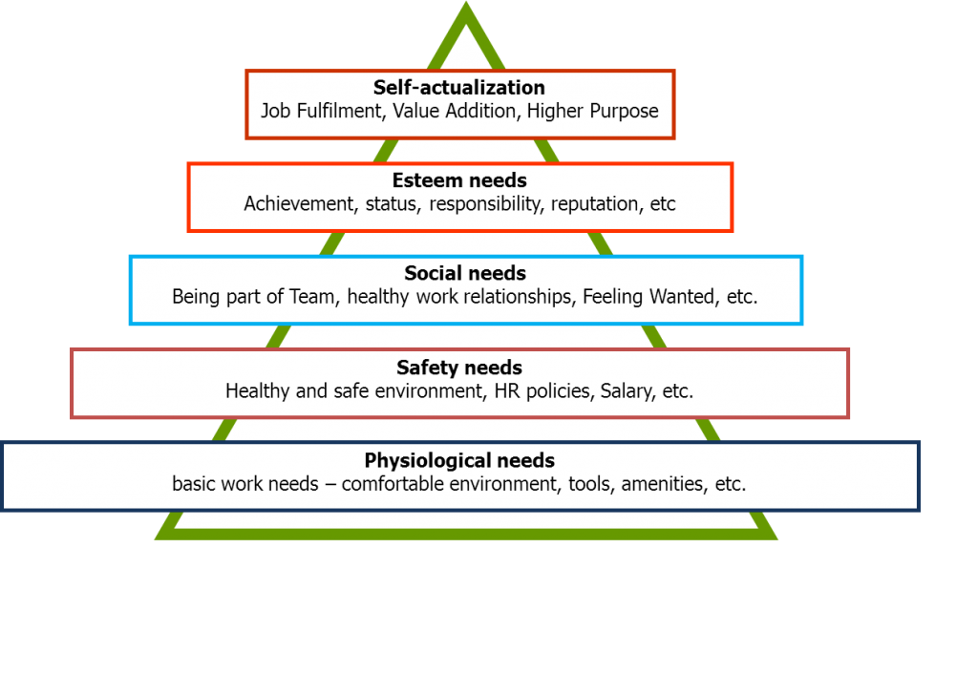
Source: Bing.com
Maslow’s Hierarchy of Needs theory was developed by Abraham Maslow in the 1940s, Maslow’s theory consists of five tires in a pyramid style stating out that there are five motivational needs individuals should satisfy in order to survive emotional and mentally. When the needs are met by dealing with the lowest first and in turn move up the pyramid from physiological, safety, social, Esteem, and self-actualization needs. In the work place these needs should be met and dealt with in order to have job satisfaction and development.
Physiological needs: would are salary, having a good salary to live on and be able to provide food, shelter fuel, water, which are the basic requirements to be able to be safe and survive, being paid enough is an advantage and not questioning whether is your salary is able to sustain you. Employees at Google are very well paid as this is one of the benefits of working for Google.
Security needs are: job security, pension plan and health care plan in the work place, in comparison Google and John Lewis empowers employees, although John Lewis has gone a step further providing and securing their employees by making them shareholders in the company.
Belonging needs are positive work environment and being part of a team with a working friendship.
Self-esteem needs is, having the respect in the workplace and having a job title and respected. Discovering a career that is right for you can lead to life span of satisfaction, however, not discovering a career that is right can also lead to poor self-esteem, or lowered self-efficacy, a lack of life satisfaction, and even depression (Csikszentmihalyi & Le Fevre, 1989; Haworth & Hill, 1992; Wang, Lesage, Schmitz, & Drapeau, 2008; Warr, 2007) cited in (Kosine and Lewis (2008).
Self-actualization needs: management, promotion and performance. Studies have suggested that individuals who discover satisfaction in their occupations demonstrate higher degree of competence productivity and commitment and reporting levels of high life adjustment (Auty, Goodman, & Foss, 1987; Henderson, 2000; Mueller, 2003; Stott, 1970) cited in (Kosine and Lewis (2008).
Although (Maund 2018) discusses the theories as career stages of one’s working life that would concern one or would need development and this would be because of age consideration. human beings tend to have emotions to the stage and age into their career.
Exploration: meeting personal needs, identifying interests, evaluating skills, and tentative working choices.
Importance of Career’s Development
(Kosine and Lewis (2008) discusses Super’s theory of career development and states that the life stages of growth and exploration are essential to the process of obtaining knowledge of how one’s abilities and interests range within the specifications of professions. In addition, (Kosine and Lewis, 2008) states that from the beginning Philosophers and scholars have identified the importance of a human being’s work because in many ways work presents who we are—defining our personality, our habits, and our lifestyle.

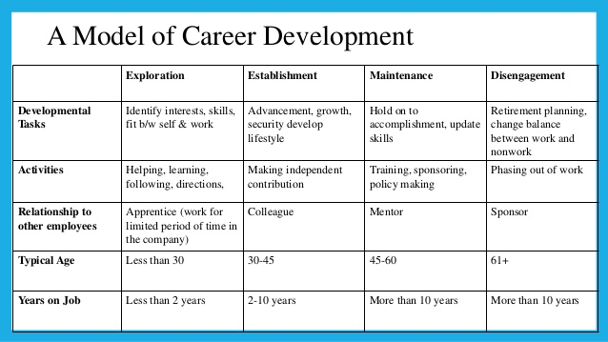
Source: Bing.com

The importance of the organisation to my development because it would:
- Improve my effectiveness in the organisation
- Build employee and client confidence
- Clarity to personal vision
- Give a chance for my talent to shine
- Reduce employee turnover
- Improves unity
- Sharpens current skills
The potential benefits for Google to develop me as a Human resources officer through their effective training and development, as stated from the report that Google is a great employer to work for therefore,
- Be loyal to Google and becoming one of their asset managing my knowledge would be an advantage to Google, that I would be able to pass on my knowledge to those that have been recruited and need guidance in the organisation.
- Training and development would also improve my performance at work and be able to accomplish tasks to my full potential as this can also boost my career at Google. According to (Pratap, 2017), Google uses a 360-degree feedback which is reviewed for performance on each employee and is part of the Google Payment action plan as google rewards those and whose performance is good with generous salary, this is because individuals should perform at their very best.

- Reduce my chances of looking for another job in another organisation, therefore reducing their employee turnover,
(Pratap, 2017), individuals that work at Google LLC organisation, are lucky to have a tall list of benefits and perks that encourages, motivates, stimulates and inspire innovation as this is a HR strategy of motivation and dedication. The package offers;
Health insurance, applicable after joining the team Flexible working, Stock plans, Free meals, snacks and drinks, Onsite medical care, Financial management with an expert, Savings plans for retirement, Bountiful parental leave, promoting keeping fit and healthy onsite gym and Pets are allowed.
HR in Google are professionals with their strategy of knowing what will attract individuals that the perks above would motivate anyone to accomplish goals.

Conclusion

To conclude, overall it has been identified that training and developing employees is of the benefit to the organisation as well as motivating the individual and empowering them to have a vision for themselves and the organisation as they will be more committed and engaged in the tasks. However, there are challenges in being an HR officer, understanding and applying of policies and procedures across a global organisation like Google can be complex and is vital to manage pay and compensation adaptation whilst maintaining the values and culture of Google.

References

Beausaert. S (2011) The use of Personal Development Plans in the Workplace, Effects, Purposes and Supporting Conditions. Available at: file:///C:/Users/Susan%202020/AppData/Local/Packages/Microsoft.MicrosoftEdge_8wekyb3d8bbwe/TempState/Downloads/Thesis_Beausaert_v4_NEW%20(1).pdf (Accessed: 29th August 2020).

Cambridge dictionary.

https://dictionary.cambridge.org/dictionary/english/development

Google Career Equal Opportunity. Available at: https://careers.google.com/eeo/ (Accessed: 30th August 2020).
Kosine. N and Lewis. M (2008) Growth and Exploration: Career Development Theory and Programs of Study Available at: https://scholar.lib.vt.edu/ejournals/CTER/v33n3/pdf/kosine.pdf Accessed: 01st September 2020).

Kourtesopoulou. A and Krikemadis. T (2008) Human resource training and development. The outdoor management method January 2008 CHOREGIA 4(1) DOI: 10.4127/ch.2008.4.1.32-44 university of Peloponnese
https://www.researchgate.net/publication/26543990_Human_resource_training_and_development_The_outdoor_management_method (Accessed: 29th August 2020).
Love your career (2020) Career Development Theories. Available at: http://www.loveyourcareer.org/understand-yourself/32-career-counseling-tools/career-development-theories/26-career-development-theories (Accessed: 29th August 2020).
Maund. A (2018) BA in Leadership and Management: Skills for the Workplace Student Yearbook, 1st Year. London. Sage
Pratap. A (2017). Google’s Human Resources Management Strategy: Google’s HRM: A Look at the Tech Giant’s Strategy, Policies, and Practices. Available at:
https://notesmatic.com/2017/03/googles-human-resource-management-strategy/ (Accessed: 31st August 2020).

Appendix B

Personal Skills Audit

Name Susan Okwera
Job role: Human Resource Officer

Please tick as appropriate to indicate how you would rate your skills in relation to the following work / functional areas.
 | Very good | Good | Adequate | Little or no
Information Technology |  |  |  | experience
Use Microsoft Office Word
Use Excel spreadsheet
Use a Database
Use specialist HR software
Use the internet
Use e-mail
Use PowerPoint

 | Very good | Good | Adequate | Little or no
Communication Skills |  |  |  | experience
Drafting contracts of employment
Taking notes of disciplinary
hearingsWrite reports
Produce material to support
pDreeseliventatioring a ns
training session
Resolving disputes/complaint
sInter viewing
Advising on HR issues

 | Very good | Good | Adequate | Little or no
Problem solving skills |  |  |  | experience
Make good use of verbal reasoning skills, able to handle complex data and make selective use of information
Explore more than one solution in order to solve a problem
Consider the ideas of others to help solve problems

Supervisory Management
How much experience have you had in your role? |  |  | - < 1 month | 1-3 months | > 3 months
How many people have you managed at any one time? | - None |  |  | 1-5 | Above 5

 | I declare that the information given in this form is true
Signed | Susan Okwera
Date | 24th August 2020

