
Applied Leadership and Management in the Workplace
Module Assignment Submission
Student Name: | Jonathon Forshaw
Student Number: | 2238303
Module No: | BMSK5012
Module Title: | Understanding & Engaging in the Customer Experience

Statement of Confirmation of Authenticity
By the act of making this submission, the student declares that this is the work of the student named above. The work has not, in whole or in part, been knowingly presented elsewhere for assessment, or where assessment has been built on a previous assessment, this has been identified. Where materials have been used from other sources it has been properly acknowledged. If this statement is untrue, the student acknowledges that an assessment offence has been committed.
Attention is drawn to the plagiarism and unfair practice policies of both the University and of ILM.

Table of Contents
Introduction 4
Customer Value 5
Quality Frameworks 7
CRM, Value & Purpose 9
Conclusion 11
Quality Frameworks 11
Customer Centrality 12
Continuous Improvement and Its Role in CX 13
Building a Customer-Centric Culture 13
Long-Term Benefits of Quality Management 13
Conclusion 14
References 14
Appendices 16

Introduction

In the contemporary, highly competitive market environment, delivering an outstanding customer experience (CX) has become an essential determinant of a business success. The ability to meet and exceed client expectations is not only a driver of customer satisfaction but also a pivotal factor in fostering customer loyalty and advocacy. These elements, in turn, significantly contribute to the long-term prosperity and sustainability of a company (Lemon & Verhoef, 2016; Homburg, Jozić, & Kuehnl, 2017). Achieving such a high level of customer satisfaction necessitates a profound understanding of consumer needs and a relentless commitment to quality across all touchpoints.
This paper will explore how established quality management frameworks—such as Six Sigma, Total Quality Management (TQM), and Deming's principles—can substantially enhance the customer experience. Through an in-depth analysis of these models, looking at how they can be leveraged to optimize various aspects of customer interactions, thereby improving satisfaction and loyalty (Evans & Lindsay, 2014; Harry & Schroeder, 2000; Deming, 1986). Furthermore, examine critical topics such as the customer lifecycle, customer value, and the significance of expectation management in the context of CX. This analysis is intended to provide actionable insights and recommendations for organizations seeking to utilize quality management as a strategic tool to enhance their customer experience and secure a competitive advantage in a Search Engine Optimisation business.

Customer Value
Customer Centrality
The establishment of solid relationships with one's clientele is absolutely necessary in order to achieve success in the highly competitive industry that exists today. A full awareness of the customer lifecycle, the supply of extraordinary value, the managing of expectations, the cultivation of loyalty, and the prioritisation of customer centrality are all vital components of effective client connection management. According to Kotler and Keller (2016), companies that place a priority on these aspects have the potential to boost customer satisfaction and foster long-term loyalty from their audience. The purpose of this section is to analyse each of these components and provide insights into how they work together to create an excellent customer experience (CX) and overall business performance (Gronroos, 1990).
Customer Lifecycle
For the purpose of assuring continuous engagement and value delivery, it is essential to comprehend and effectively manage the client lifecycle, which begins with the initial contact and continues through post-purchase engagements. Our search engine optimisation (SEO) company makes use of a variety of tactics in order to efficiently recruit, manage, and keep customers.
- Attracting Clients:
In order to communicate with prospective customers, we employ targeted marketing campaigns that make use of both organic search tactics and paid advertising respectively. Additionally, according to Kotler and Keller (2016), superior value propositions, such as customised SEO audits and performance guarantees, are helpful in attracting prospective customers.
We publish high-quality articles, case studies, and white papers that highlight our expertise and success stories in order to attract the attention of prospective customers (Lemon & Verhoef, 2016). Content marketing plays a crucial role in this endeavour.
- Managing Clients:
Continuous relationships are maintained at the engagement and retention stage by providing customers with individualised experiences and maintaining a high level of quality control. We ensure that each client receives individualised attention and constant communication by assigning dedicated account managers to each individual client.
Maintaining openness and trust with our customers is made easier by conducting performance reviews on a regular basis and providing detailed reports. According to Lemon and Verhoef (2016), we take advantage of these opportunities to collect feedback and carry out any necessary revisions to our initiatives.
- Retaining Clients:
Converting happy consumers into champions for the brand is a primary goal of the company. We implement loyalty programmes that provide clients with practical benefits, such as discounts on extra services or exclusive access to new features, in order to encourage them to continue working with us and to refer others (Reichheld, 2003).
Customer Value
For the purpose of preserving a competitive advantage, it is vital to guarantee great value. Specifically, this entails effectively communicating to customers the advantages and distinguishing characteristics of our search engine optimisation services (Porter, 1985). Regular client surveys are used to collect feedback on a frequent basis, and we make adjustments to our services in order to satisfy the ever-changing demands of our customers.
- Customer Knowledge Value (CKV):
By analysing client feedback and performance data, we gain new insights that help refine our service offerings. This knowledge allows us to stay ahead of market trends and continuously improve our strategies to better serve our clients (Parasuraman, Zeithaml, & Berry, 1988).
Managing Customer Expectations
To effectively manage the expectations of our customers, we must communicate clearly about our capabilities and limitations, fulfil our commitments on a consistent basis, and engage with our customers in a proactive manner. We make certain that expectations are established in a manner that is reasonable during the initial consultation and that they are continually met during the delivery of our services.
- Active Engagement
Our account managers make it a habit to reach out to customers on a frequent basis in order to anticipate their requirements and handle any concerns that may arise before they become more serious, so strengthening the connection and fostering trust (Gustafsson, Johnson, & Roos, 2005).
Customer Loyalty
Increasing customer loyalty can be accomplished by a mix of implementing reward programmes, providing personalised interactions, and making ongoing improvements. In our search engine optimisation (SEO) company, we:
- In order to encourage repeat business and long-term commitment, it is recommended to implement loyalty programmes that provide perks such as free consultations or discounted rates on future projects (Sharp & Sharp, 1997).
- In order to improve the connection between the customer and our brand, it is important to personalise interactions in order to adapt to the specific tastes and requirements of each individual customer (Peppers & Rogers, 1993).
Customer Centricity
Coordination across many departments and the development of a culture that places the customer at the forefront of its priorities are both required in order to successfully incorporate the consumer into business objectives. Working together across functional lines makes it easier to integrate all of the departments in order to provide the best possible experience for the consumer (Day, 1994).
Building a Customer-Centric Culture:
- In our SEO company, we ensure that teams such as content production, technical SEO, and client management work together seamlessly to provide cohesive services. This collaboration ensures that every client interaction is optimized for a positive experience (Shah, Rust, Parasuraman, Staelin, & Day, 2006).

Quality Frameworks
Quality Frameworks are crucial for ensuring the consistent delivery of high-quality services by our SEO (Search Engine Optimisation) business to our clients. We improve operational efficiency, service delivery, and customer satisfaction by implementing established quality management frameworks. This section examines prominent quality management models and theories, including Six Sigma, Total Quality Management (TQM), and Deming's concepts, and their potential application in our SEO business, to enhance service quality and enhance the entire client experience.
Models and Theories Related to Quality in SEO

Six Sigma
Analogy: Implementation of a New SEO Strategy Targeting Specific Demographics
Six Sigma is a methodology that relies on data analysis to enhance the quality of a process by finding and eliminating flaws and minimizing variability (Pande, Neuman, & Cavanagh, 2000). Implementing Six Sigma in our SEO company involves several steps that can be compared to launching a new SEO strategy aimed at specific demographics.
- Definition: This stage involves setting clear project objectives and client expectations. For instance, if we are implementing a new SEO strategy to target a specific demographic, we need to define our goals, such as increasing organic traffic from this group by 20% within six months.
- Measure: We gather data on current performance metrics, such as keyword rankings, website traffic, and conversion rates from the targeted demographic. This provides a baseline against which we can measure progress.
- Analyse: We identify the root causes of performance issues. For example, we might analyse why our current content is not resonating with the target demographic and pinpoint areas for improvement, such as keyword optimization or content relevance.
- Enhance: Based on our analysis, we develop and implement solutions. This could involve creating new content tailored to the interests of the demographic, optimizing existing content, or improving the technical aspects of our website to enhance user experience.
- Control: We continuously monitor the implemented changes to ensure consistent performance. Regular reviews of key metrics such as click-through rates (CTR), bounce rates, and conversion rates help us maintain and improve our strategy over time (Harry & Schroeder, 2000).

Total Quality Management (TQM)
Analogy: Continuous Improvement and Customer Value Creation in SEO
Total Quality Management (TQM) is a comprehensive strategy aimed at achieving long-term success by prioritizing customer happiness. The concept highlights the importance of ongoing enhancement, active participation of employees, and a culture cantered around satisfying customer needs (Evans & Lindsay, 2014).
- Customer Focus: Understanding and fulfilling customer requirements and anticipations are crucial. For our SEO company, this means listening to client feedback and continuously adapting our strategies to meet their evolving needs. By doing so, we ensure that our services remain relevant and valuable, thereby enhancing customer satisfaction and loyalty.
- Continuous Improvement: Consistently evaluating and enhancing SEO strategies and techniques ensures that we stay ahead of industry trends and maintain high service quality. For example, regularly updating our SEO tactics based on the latest algorithm changes and industry best practices helps us deliver superior results for our clients.
- Employee Involvement: Encouraging active participation from all team members in quality improvement projects fosters a culture of continuous enhancement. In our company, this might involve regular training sessions and workshops where team members can share insights and learn about new SEO techniques and tools.
- Process Approach: Optimizing SEO procedures to improve efficiency and effectiveness is essential. By streamlining our processes, we can deliver results more quickly and with higher accuracy, which directly impacts customer experience (Oakland, 2014). For instance, using automated tools for keyword analysis can save time and reduce errors, leading to more efficient campaign management.

Deming's Principles
Analogy: Building a Robust SEO Culture Focused on Quality
W. Edwards Deming's ideas promote a methodical approach to enhancing quality and highlight the significance of management in cultivating a quality-oriented culture (Deming, 1986). Key factors that are pertinent to our SEO company encompass:
- Consistency of Purpose: Sustaining a continuous commitment to enhancing quality over the long term involves setting long-term goals for our SEO initiatives. For instance, we might aim to become the leading SEO provider in a specific niche market by consistently delivering high-quality services that meet or exceed client expectations.
- Adopting a New Philosophy: Embracing a proactive approach to ensuring quality and continuous improvement means constantly seeking ways to improve our services. This could involve staying up-to-date with the latest SEO trends and technologies, and being willing to adapt our strategies as needed.
- Process Enhancement: Consistently assessing and refining SEO methods to minimize fluctuations and enhance results is critical. For example, regularly auditing our SEO processes and making necessary adjustments helps ensure that we are always delivering optimal results for our clients.
- Training and Education: Investing in staff development through training and education is essential for enhancing their skills and knowledge. In our company, this might involve providing ongoing training opportunities for team members to learn about the latest SEO techniques and tools, thereby improving their ability to deliver high-quality services to our clients (Deming, 1986).

Overlapping Theories and Practices
Deming’s Principles, TQM, and Six Sigma are interconnected and complementary in guiding quality management within our SEO company:
- Six Sigma as the Quality Project Management Process: Six Sigma provides a structured, data-driven framework for identifying and eliminating defects and optimizing processes. This is particularly useful for specific projects, such as implementing a new SEO strategy or improving existing campaigns (Harry & Schroeder, 2000).
- TQM as the Strategic Management of Quality: TQM provides a broader strategic approach to managing quality across the entire organization. It emphasizes continuous improvement, customer focus, and employee involvement, creating a culture that supports ongoing enhancement of all processes and services (Evans & Lindsay, 2014).
- Deming’s Principles as the Philosophical Foundation: Deming’s principles offer the philosophical foundation for both TQM and Six Sigma. They emphasize the importance of management's role in fostering a culture of quality, the need for continuous improvement, and the focus on meeting customer needs and expectations (Deming, 1986).
By integrating these frameworks, our SEO company can ensure that quality management is deeply embedded in our operations, driving excellence in customer experience. This holistic approach not only maximizes customer value but also fosters long-term client loyalty and advocacy.

CRM, Value & Purpose
The way in which customers perceive and engage with our organisation is highly influenced by quality management systems, which have a substantial impact on customer experience (CX). Through the establishment of stringent quality standards and the ongoing pursuit of improvement, we are able to increase the quality of the customer experience in a variety of different areas. The execution of this strategy results in improved levels of satisfaction, loyalty, and advocacy. There are a number of different ways in which the quality of our services has a significant impact on the overall experience that our customers have.
Reliability and conformity to standards
The delivery of outstanding services is guaranteed to be consistent and reliable when robust processes are in place. In the context of our search engine optimization (SEO) company, this implies continuously attaining the intended results, which may include improved search rankings, greater website traffic, and enhanced conversion efficiency. These consistent results are born from our quality processes, such as those outlined in Six Sigma, TQM, and Deming's principles. According to Parasuraman, Zeithaml, and Berry (1988), maintaining consistency in service delivery helps to foster client trust by ensuring that we consistently meet the expectations of our customers. When it comes to providing a great experience for customers, trust is an essential component since it guarantees that their requirements will be addressed in a dependable manner.

Customer wants/needs
Streamlined quality management systems are essential to meeting customer wants and needs promptly. By rapidly responding to customer requests, providing timely updates, and promptly executing SEO changes based on data analysis and customer input, we align our processes and product design directly with customer demands. According to Berry, Parasuraman, and Zeithaml (1988), efficient procedures reduce waiting times, ensuring fast service, which enhances overall customer satisfaction. Our ability to swiftly adapt to changes in search engine algorithms or client requirements allows us to deliver exceptional customer experiences, directly linking customer needs with our quality-driven processes and product improvements.

Processes/product design
Robust quality management practices play a crucial role in addressing and minimizing errors that impact customer satisfaction. Customers need accurate keyword targeting, functional hyperlinks, and optimized content. By focusing on these quality aspects, we design our processes and products to meet these needs effectively. Mitigating faults like broken links and inaccurate keywords enhances our SEO efforts, reducing customer complaints and dissatisfaction. Prioritizing error reduction through continuous improvement and rigorous quality checks (Crosby, 1979) ensures our processes are consistently aligned with customer needs, creating a smoother and more positive customer experience.

Quality
Quality management systems enable the customization of solutions to meet specific customer requirements. Understanding customer goals, industry specifics, and target audiences informs our SEO tactics, ensuring they are tailored to each client's needs. This direct alignment of customer wants with our product design increases the relevance and effectiveness of our SEO activities. According to Peppers and Rogers (1993), personalization enhances customer satisfaction by making them feel valued and understood. Implementing effective quality management allows us to continuously collect and analyse client data, improving our ability to offer precisely tailored services that adapt to evolving customer needs.

Process/Product design/improvement
Continuous improvement is vital for maintaining high-quality standards that meet customer expectations. By routinely analysing and adjusting our processes, strategies, and services, we ensure our offerings align with customer needs. Evans and Lindsay (2014) emphasize that continuous improvement leads to better performance and higher customer satisfaction. In our SEO company, staying updated on SEO trends, refining keyword strategies, and continuously enhancing client websites are critical. This ongoing cycle of process and product improvement ensures we consistently meet customer needs, delivering exceptional service that drives customer satisfaction.

Customer-Focused Satisfaction
A culture focused on customer satisfaction is integral to successful quality management. This involves placing the customer at the centre of strategic decisions and encouraging collaboration across departments to enhance the overall customer experience. Shah, Rust, Parasuraman, Staelin, and Day (2006) describe a customer-centric culture as one that prioritizes customer satisfaction and encourages employees to focus on exceptional service. Cross-functional collaboration ensures that our services are seamlessly integrated, directly linking customer needs with our internal processes and product design. By fostering such a culture, we ensure every customer interaction is optimized, creating a positive experience and continuous alignment with customer wants.

Ongoing cycle of continuous improvement to enhance CX
In the long term, integrating quality management with customer interaction strategies yields significant benefits. Continuously delivering high-quality products and services enhances our reputation and brand image, directly reflecting our commitment to meeting customer needs. Satisfied customers become advocates, promoting our company through word-of-mouth marketing, which is essential for organic growth and sustainability (Oakland, 2014). Maintaining a competitive edge requires a strong focus on quality control, enabling us to meet the ever-evolving expectations of our customers. Evans and Lindsay (2014) argue that businesses emphasizing quality and continuous improvement are better positioned to differentiate themselves in the market. This continuous improvement cycle ensures our processes and products consistently align with customer needs, driving long-term success and customer satisfaction.

Conclusion
Quality Management and Customer Experience
Quality management frameworks, such as Six Sigma, Total Quality Management (TQM), and Deming's concepts, offer a systematic method for achieving ongoing improvement and ensuring customer satisfaction. These frameworks ensure that consumer desires and requirements are in harmony with our processes and product design, resulting in a continual cycle of enhancement.
Six Sigma, known for its meticulous and data-oriented approach to minimising variation and eradicating flaws, aids in optimising our procedures and attaining superior quality results. The DMAIC methodology, which stands for defining, measuring, analysing, improving, and controlling processes, allows us to constantly fulfil consumer expectations for our products and services (Pande, Neuman, & Cavanagh, 2000). The direct correlation between client requirements and the enhancement of quality leads to an overall increase in the customer experience (CX).
Total Quality Management (TQM) prioritises a holistic strategy towards quality, including all staff members in ongoing enhancement initiatives and centering on achieving long-term success by ensuring customer satisfaction. The principles of Total Quality Management (TQM) promote a customer-centric approach, involving all employees in quality initiatives, and utilising a process-oriented approach to effectively manage and enhance operations (Evans & Lindsay, 2014). By cultivating a culture that prioritises quality and ongoing enhancement, we improve our capacity to provide outstanding client experiences. This is achieved by directly aligning customer desires with our quality-focused procedures and advancements.
Deming's principles promote a methodical approach to enhancing quality, highlighting the significance of management's involvement in cultivating a quality-oriented culture. Deming's emphasis on the constancy of purpose, embracing a new philosophy, and ongoing improvement of procedures is especially pertinent for boosting customer experience (Deming, 1986). By embracing these concepts, we establish a more uniform, dependable, and customer-centric operation, guaranteeing that our procedures and product designs are consistently in sync with customer requirements.
Impact on Customer Relationships
Consistency and reliability are essential for establishing customer trust and satisfaction. A strong quality management system ensures that these qualities are consistently maintained. By constantly providing products and services of superior quality, we can instil confidence in our brand among customers, which in turn fosters long-term loyalty and advocacy (Parasuraman, Zeithaml, & Berry, 1988). Establishing trust is crucial for cultivating robust customer connections and promoting consumer loyalty.
Efficiency and responsiveness are improved by using streamlined quality management processes, resulting in an enhanced customer experience. In our SEO company, streamlined procedures result in prompt responses to client inquiries, timely reports on campaign progress, and swift execution of plan modifications based on data analysis and client feedback. These elements enhance the overall client experience by making clients feel appreciated and adequately assisted (Berry, Parasuraman, & Zeithaml, 1988).
Error reduction involves implementing rigorous quality checks and continuously improving processes to minimise faults and errors. This guarantees that customers obtain products and services that not only meet but also surpass their expectations. Within the SEO field, the act of minimising mistakes such as inaccurate keyword selection or subpar content optimisation has a direct impact on the success of marketing campaigns and the level of pleasure experienced by clients (Crosby, 1979). Emphasising error reduction improves the efficiency of SEO endeavours and reduces client grievances, resulting in a more seamless and favourable encounter.
Customisation and personalisation are essential for providing bespoke solutions that fit individual client requirements. These capabilities are made possible via the implementation of quality management methods. Within our SEO enterprise, this entails tailoring SEO tactics to correspond with the distinct objectives, sector, and intended recipients of each individual client. Customisation improves the pertinence and efficiency of search engine optimisation (SEO) endeavours, creating a sense of comprehension and appreciation among clients (Peppers & Rogers, 1993). Through the utilisation of quality management frameworks, we are able to efficiently collect and evaluate client data, enabling us to tailor our services with accuracy and significant impact.

Continuous Improvement and Its Role in CX
Continuous improvement, a fundamental aspect of quality management, has a substantial influence on customer experience (CX) by consistently ensuring that our products and services are in line with the needs of our customers.
It is essential to regularly assess and improve processes, strategies, and services in order to enhance performance and ensure client happiness. To ensure the success of our SEO firm, it is essential to keep abreast of the most recent SEO trends, enhance keyword tactics, and consistently improve client websites (Evans & Lindsay, 2014). By committing to continuous improvements, we showcase our commitment to maintaining high standards and our proactive attitude towards adjusting to changes and new difficulties for our clients. By taking a proactive approach, we are able to establish long-term trust and loyalty with our clients. They appreciate our commitment to staying ahead of the industry and consistently delivering outstanding outcomes.
Building a Customer-Centric Culture
Incorporating quality management techniques into our business operations entails cultivating a culture that prioritises the needs and satisfaction of our customers. This entails prioritising the client as the central focus of all strategic choices and fostering collaboration across all departments in the organisation to improve the customer experience. A customer-centric culture places customer pleasure as the top priority and motivates employees at every level to concentrate on providing outstanding service (Shah, Rust, Parasuraman, Staelin, & Day, 2006).
Within our SEO enterprise, cultivating a customer-centric culture necessitates the integration of many departments, including content production, technical SEO, and client management, to provide unified and flawless services. By cultivating such a culture, we guarantee that every interaction with the client is optimised to create a great experience, consistently aligning our procedures and product designs with the requirements of our customers.
Long-Term Benefits of Quality Management
The substantial advantages of combining quality management methods with customer interaction tactics over a prolonged period are noteworthy.
Ensuring a consistent delivery of superior products and services strengthens our reputation and brand image. Contented clients are more inclined to transform into steadfast champions, endorsing our firm to others and contributing to word-of-mouth marketing. The process of natural growth is extremely valuable for achieving long-term success and maintaining sustainability.
Our strong emphasis on quality management enables us to maintain competitiveness in a constantly changing industry. Companies that prioritise quality and continual development are better prepared to satisfy rising customer expectations and stand out from competition.
Conclusion
Integrating quality management processes into our business operations is crucial for providing an outstanding client experience. Our SEO company ensures consistency, dependability, efficiency, error reduction, customisation, and continual improvement by implementing frameworks such as Six Sigma, Total Quality Management (TQM), and Deming's concepts. By prioritising quality, we establish trust, improve satisfaction, and cultivate lasting loyalty among our clients, ultimately gaining a durable edge over our competitors.
Integrating quality management with customer relationship strategies results in a customer-centric approach that aligns all aspects of the business to provide exceptional value to customers. The comprehensive emphasis on excellence and client contentment not only propels business prosperity but also enhances a favourable and unforgettable customer encounter. By placing quality as our top priority, we attain long-term success, cultivate loyalty, and uphold a robust name in the market.

References

Berry, L. L., Parasuraman, A., & Zeithaml, V. A. (1988). The Service-Quality Puzzle. Business Horizons, 31(5), 35-43.
Berry, L. L., Parasuraman, A., & Zeithaml, V. A. (1988). The Service-Quality Puzzle. Business Horizons, 31(5), 35-43.
Crosby, P. B. (1979). Quality is Free: The Art of Making Quality Certain. McGraw-Hill.
Day, G. S. (1994). The Capabilities of Market-Driven Organizations. Journal of Marketing, 58(4), 37-52.
Day, G. S. (1994). The Capabilities of Market-Driven Organizations. Journal of Marketing, 58(4), 37-52.
Deming, W. E. (1986). Out of the Crisis. MIT Press.
Evans, J. R., & Lindsay, W. M. (2014). Managing for Quality and Performance Excellence (9th ed.). Cengage Learning.
Evans, J. R., & Lindsay, W. M. (2014). Managing for Quality and Performance Excellence.
Grönroos, C. (1990). Service Management and Marketing: Managing the Moments of Truth in Service Competition. Lexington Books.
Grönroos, C. (1990). Service Management and Marketing: Managing the Moments of Truth in Service Competition. Lexington Books.
Gustafsson, A., Johnson, M. D., & Roos, I. (2005). The Effects of Customer Satisfaction, Relationship Commitment Dimensions, and Triggers on Customer Retention. Journal of Marketing, 69(4), 210-218.
Harry, M., & Schroeder, R. (2000). Six Sigma: The Breakthrough Management Strategy Revolutionizing the World's Top Corporations. Currency.
Harry, M., & Schroeder, R. (2000). Six Sigma: The Breakthrough Management Strategy Revolutionizing the World's Top Corporations. New York: Currency.
Kotler, P., & Keller, K. L. (2016). Marketing Management (15th ed.). Pearson.
Lemon, K. N., & Verhoef, P. C. (2016). Understanding Customer Experience Throughout the Customer Journey. Journal of Marketing, 80(6), 69-96.
Oakland, J. S. (2014). Total Quality Management and Operational Excellence: Text with Cases. Routledge.
Oliver, R. L. (1999). Whence Consumer Loyalty? Journal of Marketing, 63, 33-44.
Pande, P. S., Neuman, R. P., & Cavanagh, R. R. (2000). The Six Sigma Way: How GE, Motorola, and Other Top Companies are Honing Their Performance. McGraw-Hill.
Parasuraman, A., Zeithaml, V. A., & Berry, L. L. (1988). SERVQUAL: A Multiple-Item Scale for Measuring Consumer Perceptions of Service Quality. Journal of Retailing, 64(1), 12-40.
Peppers, D., & Rogers, M. (1993). The One to One Future: Building Relationships One Customer at a Time. Currency Doubleday.
Porter, M. E. (1985). Competitive Advantage: Creating and Sustaining Superior Performance. Free Press.
Reichheld, F. F. (2003). The One Number You Need to Grow. Harvard Business Review, 81(12), 46-54.
Shah, D., Rust, R. T., Parasuraman, A., Staelin, R., & Day, G. S. (2006). The Path to Customer Centricity. Journal of Service Research, 9(2), 113-124.
Sharp, B., & Sharp, A. (1997). Loyalty Programs and Their Impact on Repeat-Purchase Loyalty Patterns. International Journal of Research in Marketing, 14(5), 473-486

Appendices
Customer Value
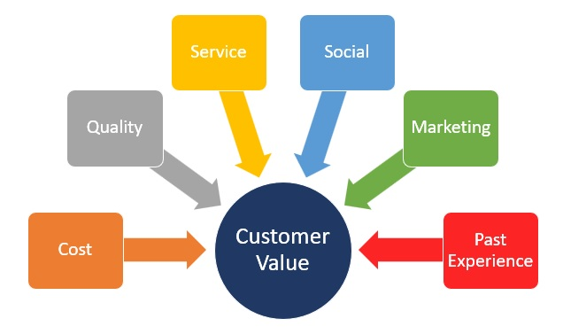
Customer Lifecycle 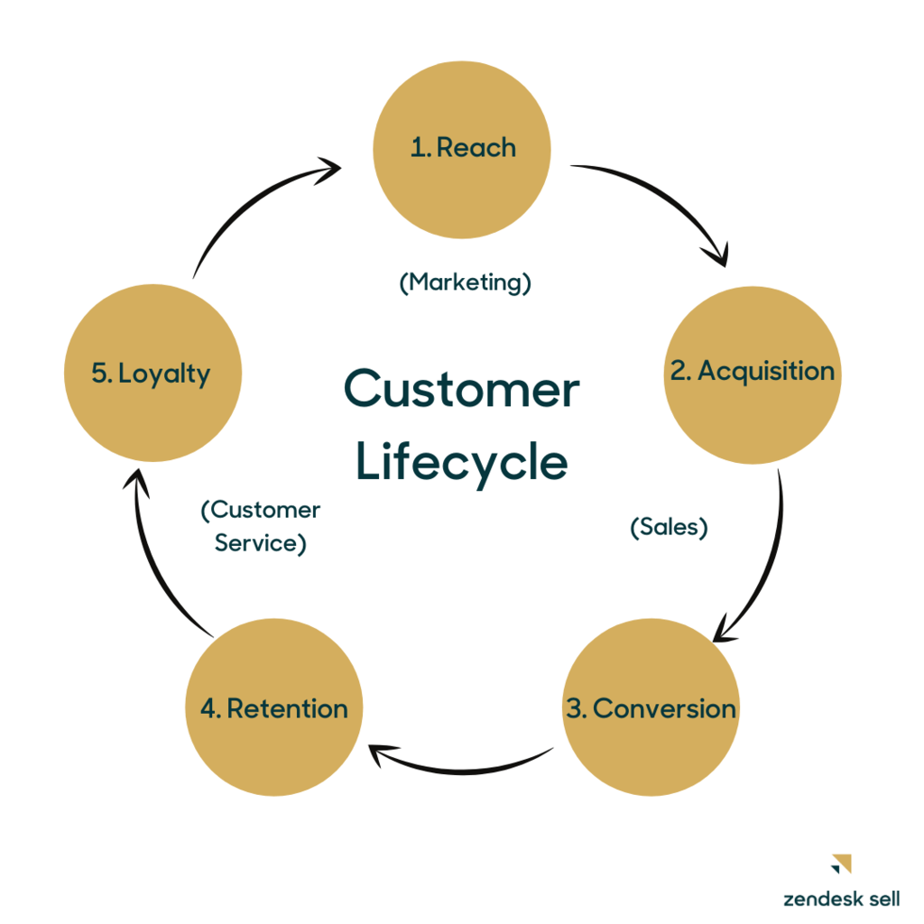
Customer Lifecycle within a CRM Process 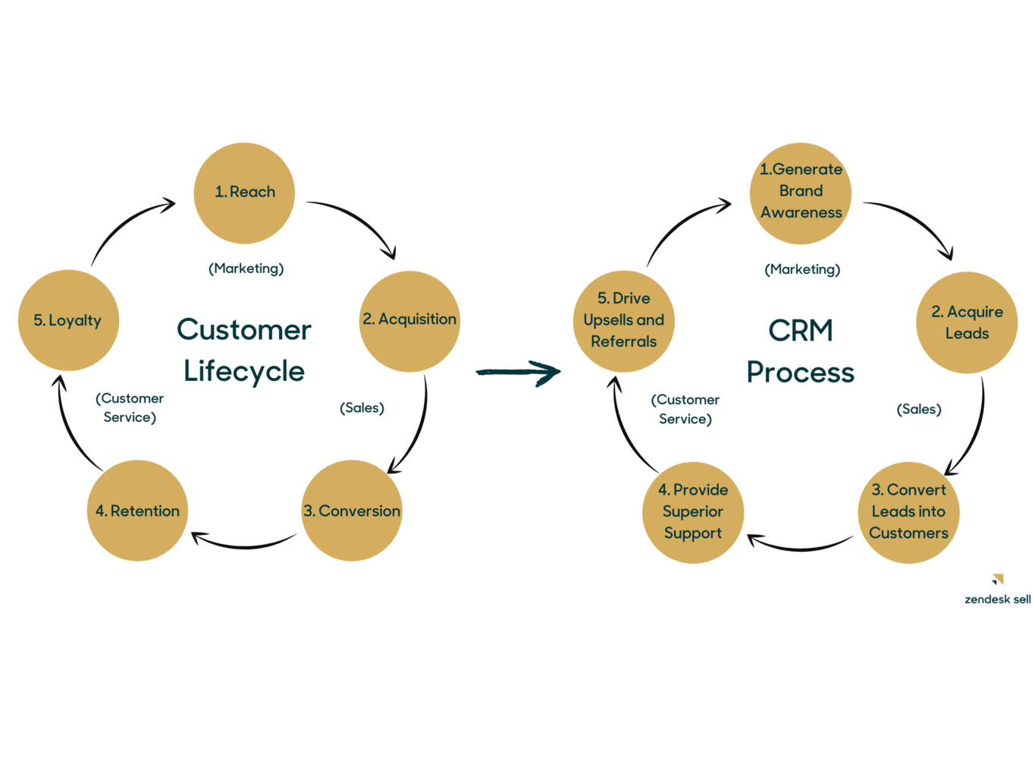
Customer Loyalty

