Title page

Name: Sidrah Javed

ID Number: 2238819

Programme: BSc (Hons) Health and social care

Module: Psychological Classifications and provisions

Module Code: BMHP6029

Lecturer: Neil

Assignment Title: Component 1: Individual presentation (Academic Poster)

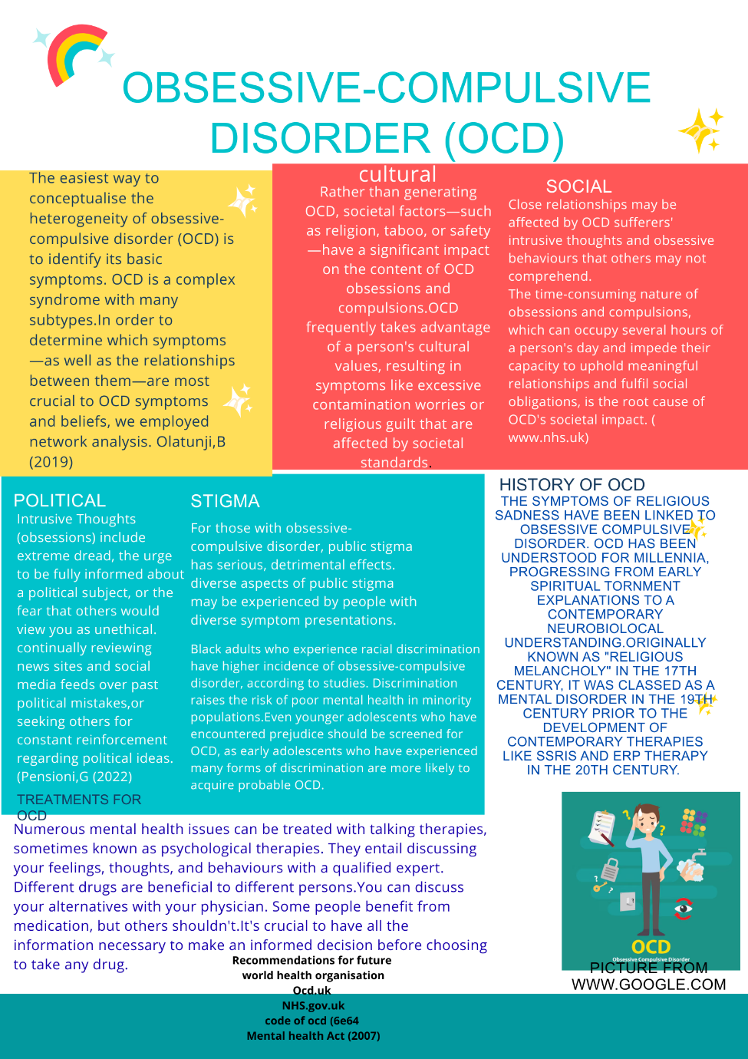
Reference list……………………………..

Train,J.,(2024) Obsessive compulsive symptoms.
Pensioni,G.,(2022) A systematic review of public stigma attributes and obsessive-comulsive disorder symptom subtypes.
Nagata,J.,(2025) Multiple forms of discrimination and obsessive-compulsive disorder.
Mind.org.uk(2025) Medication for OCD Available at https://www.mind.org.uk/information-support/types-of-mental-health-problems/obsessive-disorder/treatment-for-ocd/#MedicationforOCD.
www.nhs.uk (2023) Obsessive compulsive disorder (OCD)Available at https://www.NHS.uk/mental/conditions/obsessive-compulsive-disorder-ocd/overview.
Olatunji,B.,(2019) A network analysis of selected obsessive-compulsive symptoms and beliefs.
Stein,D., (2019) Obsessive-compulsive disorder.
Mental health act (2007) Available at https://www.legislation.gov.uk/ukpga/2007/12/contents.
Davis(2019) History of Obsessive compulsive disorder
Hassan,W,(2024) Variations in obsessive compulsive disorder symptomatology across cultural dimensions.

