Case Study to compare Steel and Concrete Framed Buildings

Created for:
Alan Nantel

Created by:
Tomos Williams

Contents
1.0 Introduction 3
Fig 1.1 www.indiamart.com Fig 1.2 www.udclnigeria.com 3
Fig 1.3 www.indiamart.com Fig 1.4 www.designbuildings.com 3
2.0 University of Newcastle Student Accommodation 4
Fig 2.1 4
Fig 2.2 4
Fig 2.3 4
Fig 2.4 4
3.0 Newton Gems Condominium 5
Fig 3.1 5
Fig 3.2 5
Fig 3.3 5
4.0 Framing Material Comparisons 6
4.1 Likely Durability and Climactic Resistance 6
Fig 4.1.1 Fig 4.1.2 6
Fig 4.1.3 Fig 4.1.4 6
Fig 4.1.5 Fig 4.1.6 7
4.2 Impact on the Environment from Manufacture of Framing Material’s 8
4.2.1 Steel Production 8
4.2.2 Concrete Construction 8
4.3 Frames ease of Assembly and Potential Adaption through their Life Cycle 9
4.3.1 Steel Frames 9
4.3.2 Concrete Frames 9
5.0 Conclusion 10
References 10

Introduction

The purpose of this case study is firstly to report on the details of the design planning, construction method and potential impact on the sites of the two buildings with consideration to social and environmental sustainability. Secondly to analyse the framing material of the two buildings chosen by comparing and contrasting the frames likely durability and climactic resistance given the environmental conditions of the site. Thirdly the likely impact that the framing material had on the environment in the production process, with reference to the biproducts that would have been produced in manufacture. Finally the ease of assembly of the chosen frames and the potential ease of its adaption to different building shape and use, within the life cycle of the buildings.

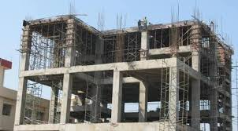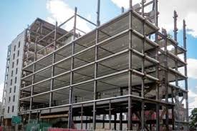

Fig 1.1 www.indiamart.com Fig 1.2 www.udclnigeria.com
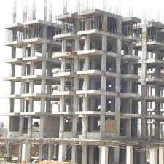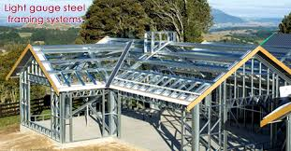

Fig 1.3 www.indiamart.com Fig 1.4 www.designbuildings.com

University of Newcastle Student Accommodation
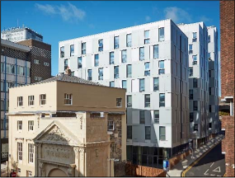
The building is located in the heart of Newcastle’s busy city centre and consists of 3 separate tiered blocks all linked together. Initially the accommodation was to be constructed with an in situ concrete podium level and a precast concrete panel wall and floor system to form the blocks above. It was clear to the main contractor that it was impossible to meet the proposed 20-month deadline by constructing the project this way. It would have been made less likely by the city centre locality of the site, as the size of cranes needed to lift the 10–15-ton panels would not have been practical. However the design was changed after the main contractor put forward a Kingspan designed light steel frame solution with composite floors to sit on top of the podium as an alternative.
The taller blocks had concrete cores to certain floors to help with lateral stability and the light steel frame solution saved 40% of loading to the foundations in some areas. Due to the locality of the site there were issues for onsite storage, laydown areas and deliveries were only possible from one area of the site. Through careful planning of pedestrian segregation and traffic management, the safe unloading and lifting operations were carried out. The deliveries were scheduled to specific time slots, with all team members coordinating to minimise disruption to surrounding activities and maximise crane availability. The weekly schedule consisted of three deliveries of wall panels, one of steel decking and once weekly a 300m2 floor area was concreted. Deliveries of bathroom pods and sealed plasterboard packs were placed into every room to minimise future disruption as each floor was completed.
Information and images taken from (Kingspan, 2017)

Fig 2.1
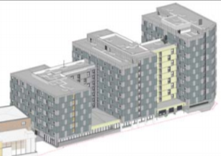

Fig 2.2
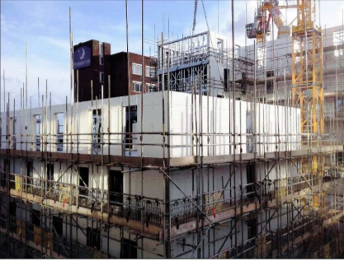

Fig 2.3
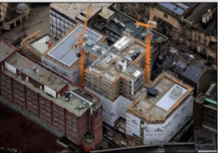

Fig 2.4

Newton Gems Condominium
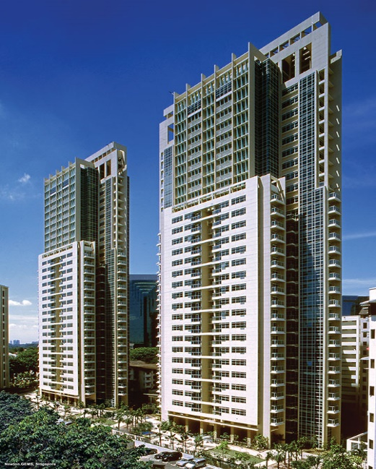
This development comprises of 2 identical 30 storey towers and is located in close proximity to residential buildings and a hotel. Due to the locality of the site the access was very limited, there were strips of 6 – 8 meters wide on both sides for panel deliveries and concrete lorries this was often limited to one side at a time due to ongoing basement works.
Environmental considerations for noise and dust levels had to be considered as the site is squeezed between nearby residential units which could affect working hours. To overcome the limitations of the site constraints and complexity of design cast in situ elements and precast components were used. Through maximisation of prefabrication off site and appropriate joint detail, the precast panels were able to be fitted from inside the building, eliminating the need for external scaffolding. Therefore less debris and wet trades on site due to the nature of prefabrication thus giving more clear space providing critical access.
Vertical cast in situ components including shear walls and columns were placed inside the building and designed for structural stability, the stability was further improved by shear walls with coupling beams to transfer shear. There were load bearing precast columns, shear walls, bay windows and staircase cores used to create the building envelope supporting structural elements.
Almost all horizontal elements were precast. Horizontal floor loads were transferred using floor beams, the beams were used to stiffen the horizontal plate to improve lateral resistance of the building.
Information and Images taken from bsh_ch6.pdf (bca.gov.sg) study 3.

Fig 3.1
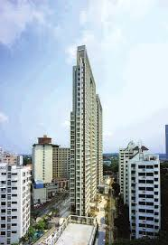

Fig 3.2
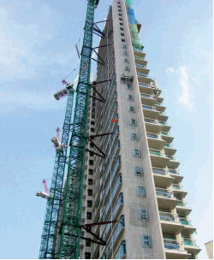

Fig 3.3

Framing Material Comparisons

4.1 Likely Durability and Climactic Resistance

Due to the locations of the buildings there are many differences in environmental conditions between the two locations which affect the choice of framing material and their likely durability (anon, 2021).
Newcastle Singapore
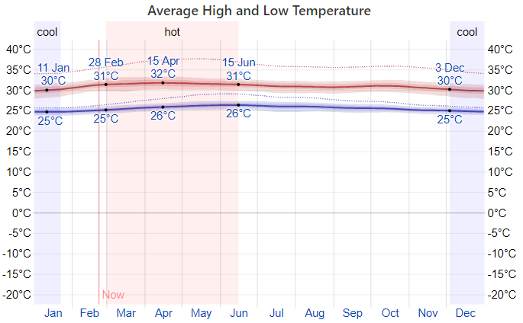

Fig 4.1.1 Fig 4.1.2
Newcastle generally has lower average temperatures throughout the year with lows of 2°c and highs of 19°c on average.

Singapore tends to be warmer all year round with lows of 25°c and highs of 32°c on average.

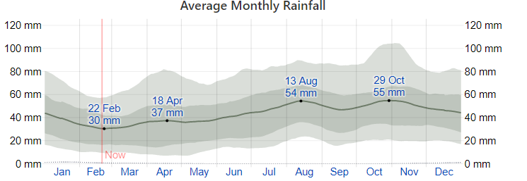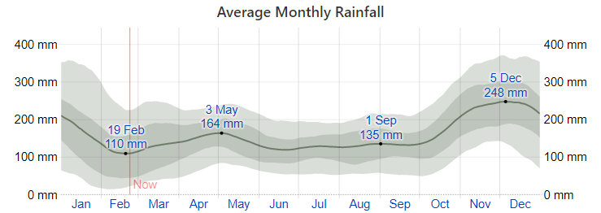

Fig 4.1.3 Fig 4.1.4
Newcastle has some variation in rainfall throughout the year with monthly averages ranging from 55mm being highest and 30mm being lowest.

Singapore experiences extreme variations in rainfall throughout the year with averages from 248mm being highest and 110mm being lowest.

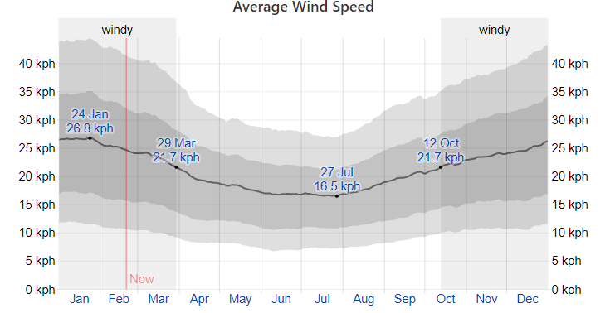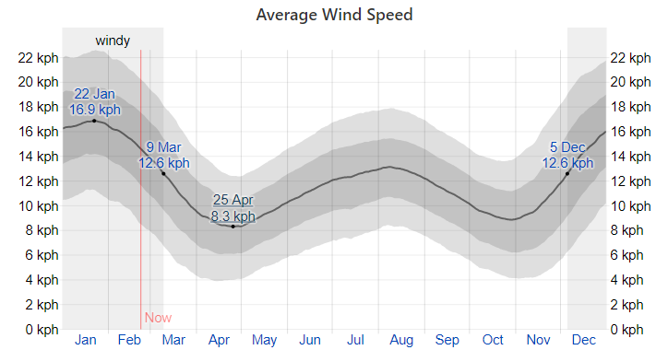

Fig 4.1.5 Fig 4.1.6
Newcastle has an hourly average wind speed of 21.7 kph at its highest and 16.5 kph at its lowest.

Singapore has an hourly average wind speed of 12.6 kph at its highest and 8.9 kph at its lowest.

Steel framed buildings are an increasingly popular construction method due to its modern aesthetic qualities and environmental advantages. More of the benefits of steel that make it a popular choice in larger buildings include:
- The efficiency in speed and engineering through the rise of 3D modelling technology guarantees steel frames will be built precisely, which reduces the risk of error in construction and completion to specification.
- The nature of off-site steel construction reduces the need for on-site labour as compared to cast in situ concrete, means Lowered labour on-site risk and noise disruption to the surrounding community.
- The sustainability of steel frames comes in the form of reduced excess waste removal and the majority of structural steel can be recycled and reused.
Steelmakers point to off-site construction and sustainability as key features of steel over standard concrete. However, the reductions in waste associated with precast concrete over in-situ concrete can match steel’s eco-friendliness. Precast concrete provides the same efficiency and reduced labour costs as steel and offers other added benefits, which give it an advantage over steel framing.
Some of these include:
- Concrete has excellent strength and durability which is ideal for large structures, also when properly maintained concrete buildings can last up to 100 years or more.
- Concrete is versatile and other materials can be added into concrete for extra strength, insulation, and aesthetic purposes.
- Concrete has good thermal properties and reduced temperature changes in buildings, which can reduce energy costs which adds to substantially.
Overall, precast can increase efficiency and reduce labour costs nearly comparable to steel, the possibility of adding to concrete’s strength plus its durability and energy efficiency make it an ideal choice for most large buildings. Also concrete provides distinct cost advantages over steel frames, and precast concrete especially aids in lowered construction and operation costs of larger buildings (anon, 2021).

4.2 Impact on the Environment from Manufacture of Framing Material’s

4.2.1 Steel Production

Over 2,000 million tons of iron ore is mined a year, roughly 95% of which is used by the steel industry. Iron ore is by volume the world’s third most produced commodity after crude oil and coal, it is also the second most traded commodity. Iron ore mining is highly energy intensive causing air pollution from nitrous oxide, carbon dioxide, carbon monoxide, and sulphur dioxide. Some of this comes from diesel generators, lorries and other equipment. Iron ore mining also causes water pollution from heavy metals and acid that drains out of the mines. Acid drainage can continue for thousands of years after the mining activities have stopped.
1.83 tons of CO2 is emitted for every ton of steel produced on average this makes steel production a major contributor to global warming, adding more than 3,3 million tons of CO2 to global emissions yearly. The process of making steel from the iron ore is highly energy demanding and steel production is the most energy consuming, CO2 emitting industrial activity in the world. Burning large amounts of coke/coal provides three quarters of the energy required for steel production, which is extremely damaging to the environment. From the burning of coke/coal in the ovens air pollution such as naphthalene that is highly toxic is emitted and can cause cancer. From the coking process wastewater is also produced and is highly toxic containing a number of carcinogenic compounds along with cyanide, sulphides, ammonium and ammonia (anon, 2020).

4.2.2 Concrete Construction

The main problem with concrete is the fact that it is a major emitter of CO2. Every ton of manufactured cement equates to almost a ton of CO2 being emitted. Roughly 0.5 tons of this comes from the decomposition of the limestone and the other 0.95 tons is generated by the supplying of electricity from the power plant to turn the kiln and ball mills which grind the cement alongside the fuel burned to fire the kiln. Other generators of CO2 such as ready mix lorries add a minor amount to the overall CO2 emissions. For conventional concrete mixtures not using fly ash, slag or silica fume roughly 20 kg of CO2 of CO2 is emitted per 100 kg of concrete produced. This equates to about 7% of the total CO₂ produced worldwide. Through burning gasoline, coal or other fossil fuels Nitrous oxide, carbon dioxide and methane emissions are produced.
Averagely, every ready mix lorries return roughly half a cubic metre of cement per day. After discharge of the remaining concrete there is still around 300 kg of solids (cement, sand and stone) that gets cleaned out with roughly 1000 litres of water. Commonly the returned concrete and the solids were tipped out on the site where possible. It is now considered too valuable to waste and can be recycled or reclaimed as sand and gravel considering that this represents 2 to 4% of the total concrete produced.
The technology to make cement and concrete is in many ways similar to the technology used by the mining industry, therefor advances in this industry have been adopted by the cement and concrete industry. Cement kilns are very energy efficient and mainly spent in making the cement. Therefore in energy cost over the past three decades, concrete finds itself in an excellent position on a first cost basis (Anon, 2020).

4.3 Frames ease of Assembly and Potential Adaption through their Life Cycle

4.3.1 Steel Frames

Steel frames are fairly easy to assemble due to the fact that they are premanufactured off site to specific measurements with tight tolerances and are lighter than concrete. They are also adaptable through their life cycle as it is possible to extend and modify the frame quite easily by connecting new steels to existing ones. Steel is 100% recyclable witch also adds to the adaption as if a building is to be demolished then all of the steel can be re used for other purposes such as building structures, cars, washing machines etc.

4.3.2 Concrete Frames

Concrete frames can be fairly easy to assemble depending on the way they are constructed. If they are poured in situ then it is generally a slower, more time consuming and labour intensive process. If precast panels and beams are used then the speed of construction is comparable to steel and is also manufactured to specific measurements with tight tolerances, though they are heavier than steel. It is not as easy to adapt concrete frames due to the way it is constructed but it is possible. Unlike steel, concrete is not as recyclable with roughly 60% of the crushed product being used as base material for roads and fill (Souza, 2020).

Conclusion

In conclusion to the case study, steel and concrete are similar in the environmental impact they both have in general and have different qualities which can make them better suited to some project than others. The fact that steel is 100% recyclable is a major factor when it comes to sustainability and life cycle impact on the environment, though steel is more expensive than concrete it has other benefits such as possibility for wider spans and its excellent tensile strength. Concrete is less recyclable than steel is cheaper to produce and benefits from excellent compressive strength with the need for steel reinforcement to improve the tensile strength, it can also be made less permeable to improve the water tightness.

References
Anon, 2020. Meka Global. [Online]
Available at: https://www.mekaglobal.com/
anon, 2020. The World Counts. [Online]
Available at: https://www.theworldcounts.com/
anon, 2021. nitterhouseconcrete. [Online]
Available at: https://nitterhouseconcrete.com/
anon, 2021. weatherspark. [Online]
Available at: www,weatherspark.com
anon, 2021. www.cement.org. [Online]
Available at: https://www.cement.org/learn/concrete-technology/durability
Kingspan, 2017. Light steel forum. [Online]
Available at: http://www.lightsteelforum.co.uk
Souza, E., 2020. Arch Daily. [Online]
Available at: www.archdaily.com
Available at: bsh_ch6.pdf (bca.gov.sg)
Kingspan Newcastle Case Study 2017

