University of Wales Trinity Saint David
School of Engineering

Drill Press Main Sliding Unit
Engineering Design
ACMA4008

Kian Evans
1801660
27/04/2021

Contents Page

1. Title Page

2. Contents Page

3. Introduction
3.1 Upright drill press
3.2 Radial drill
3.3 Gang drill
3.4 Anticipated Customer Needs
3.5 Functional Requirements
3.6 Aesthetic Considerations
3.7 Serviceability Requirements
3.8 Any Relevant Ethical Considerations
3.9 Any Relevant Codes of Practice

4. Existing concept design

5. Design Specification

6. Manufacturing method and Material

7. Design

8. Final Design

9. References

Introduction
This report will cover the critical appraisal of the existing ‘concept’ design of the DPMSU, as well as also looking to develop a new design covering a design specification, a suitable material and manufacturing method for a DPMSU in a production run of 1000 units per week. The final design will be created in a technical drawing, identifying any design features incorporated.

A drill press is one of the most commonly used mechanical machines in the construction industry. This specific design was originally used for cutting holes in specimens. It also has other functions such as, reaming and countersinking. There are three main designs of a drill press:

3.1 Upright drill press

The most common drill press is the Upright drill press. It includes the following components:

Base: This is the part that is in contact with the ground that needs to be heavy for sturdiness.

Column: This is the backbone to the drill press as it provides support.

Work Bench: This part holds the workpiece in place.

Drill Head

3.2 Radial drill
The radial drill press has a greater area of cutting holes therefore is used for larger parts. This drill press also includes the components of a base, column, workbench and a drill head. This does not include a radial arm.

3.3 Gang drill

The last type of drill press is the gang drill. The gang drill is commonly used for cutting holes in a sequence on the same piece.

3.4 Anticipated Customer Needs

Anticipating customer needs helps businesses understand what new products to create and how to market them in stores. It is very important to identify a target audience for the product and understand what they want. By meeting the requirements of a customer's needs, means a new product can succeed in the stores. Making sales is significantly easier when having a good idea of its customers requirements and what they want. This allows for the manufacturers to create a product or service that directly meets customers’ requirements. Product life span is one of the main aims of a new product and aims to be around 12 months of operation for the buyers. By generating sales via the understanding of requirements for potential customers, the product has a much greater chance of marketing and sales.

3.5 Functional Requirements
The main requirement is that it should have enough durability to hold many forces that will act on it during operation. The operation cost of the product that includes the maintenance cost should be low. Regarding the safety of the user, sliding motion of the drill sliding unit on the column must be smooth with low amounts of friction present. Due to this product being used in many environments, itv will go through high working temperatures meaning the melting temperature of this part should be able to sustain in the heat. Including the maintenance of the mechanical properties.
3.6 Aesthetic Considerations
When considering the aesthetics in the design., each component will have a definite purpose. It must perform specific functions to the satisfaction of the buyer. The contact between the product and the buyers arises as the main necessity of this functional requirement. When there are a number of similar products in the market that have the same qualities of efficiency, durability and cost, the customer is automatically going to be pushed towards the most aesthetically appealing product. Therefore this product has to be pleasing to the eye in order to tan out against the other products. The external appearance is a key feature in marketing. The external appearance of the product is a cumulative effect of a number of factors such as durability, function, surface finish, materials and noise.
3.7 Serviceability Requirements
The main components of the drill press’ sliding units that are used to hold the drill bit could require serviceability as the temperature of the assembly may rise. Unexpected stresses on the component surface may occur, resulting in a yield of a polymeric component with optimized thermal conditions to avoid any catastrophic failure later on. In terms of serviceability, say the speed of the machine is at a higher rate speed but with less solidification time, this could possibly lead to the start of breakdown of the materials over time. In order to stop this happening, speed of injection molding and time for solidification must be completely optimized during the batch production. To avoid certain variations in the polymeric components, synthetic hardening resins could be used to enhance the hardness of the surface.
3.8 Any Relevant Ethical Considerations
The importance of product design ethics should not be ignored when creating a product as every product that is designed and manufactured is sold globally. If ethical concerns were to arise then the impact of this would be very large. It is very important when considering certain materials to use for the product. It must be considered what materials are being used and whether they are environmentally friendly and sustainable.
3.9 Any Relevant Codes of Practice
Regarding codes of practice, when creating a machine it is crucial that it comes with a manual that communicates details to the user including the safety hazards and instructions of use. These manuals must also contain procedures to be followed when the machine is in use and the precautions to be considered when using this product. The reading of these important documents is highly recommended before the usage of the machine. For example, the user must use a shar bit for the product so it runs true and there is no vibration. This is because if it is a vibrating bit then it will cause damage to the drill press and could cause injury to the user.

Design Specification

Aesthetics | The arm lever follows a streamlined shape made of high speed steel (carbon steel) for durability including rubber handle with grip for ergonomic and safety reasons.
Target audience | This product was aimed for those in the construction or engineering industries. Companies such as AXMINSTER would be able to store this in their stores.
Function | The function of this lever is to support the process with a more sturdy and ergonomic handle to use the drill press.
Materials | High carbon steel has very high strength, extreme hardness and resistance to wear. As it is resistant to wear this means it wouldn't require regular maintenance checks.
Size | The grip rubber handle is 100mm by 18mm which is a great size for the average adult hand to hold with comfort. The length of the steel end is 268mm.
Product life span | The materials chosen for this were chosen based on the fact they are durable. The average lifespan of this is dependent on how it is being maintained but usually lasts a good amount of time.
Standard specs | The standard of this is often the American National Standard in National Coarse or National Fine. NC has fewer threads per inch than NF. NC is most common while NF is favored in precision assemblies.
Ergonomics | The ergonomics of this particular design included the use of a soft but sturdy rubber for a handle that benefits safety and comfort.
Testing | A testing sparkle would have been made before producing 1000 units per week to ensure this handle meets style specifications and is functional for selling.
Safety | The lever was made to ensure it is safe for use and had no ragged edges in the steel that could cause cuts on the user. The rubber is non slip due to the grip to make sure the hand won't slip when in use.1
Cost | The device should cost under £700

Manufacturing method and Material
In correspondence to my decision of material, Carbon Steel and smelting is the material and method I have decided to use. Carbon Steel is a component made from iron, including the involvement of sulfur, phosphorus, manganese and carbon. This variation of a steel element is commonly used globally for machined parts and non-critical components in tool and die sets. High Carbon Steel is also identified as “carbon tool steel” .
This material has a carbon content that ranges between 0.61% and 1.50%. High carbon steel is highly difficult to cut and weld. Once the Carbon Steel is heat treated it becomes very hard and brittle. Smelting is a form of extractive metallurgy that is used to produce a metal from its ore. The procedure of Smelting uses heat and a chemical reducing agent to decompose the ore, driving off other elements as gas elements. The reducing agent is commonly a source of carbon such as coke and coal. The labor cost of this material is reduced via a process that leads the material to be very economical. During the injection process of this material. Wastage can come from it but the leftover steel can be reheated and re used.

Design (Arm Lever)
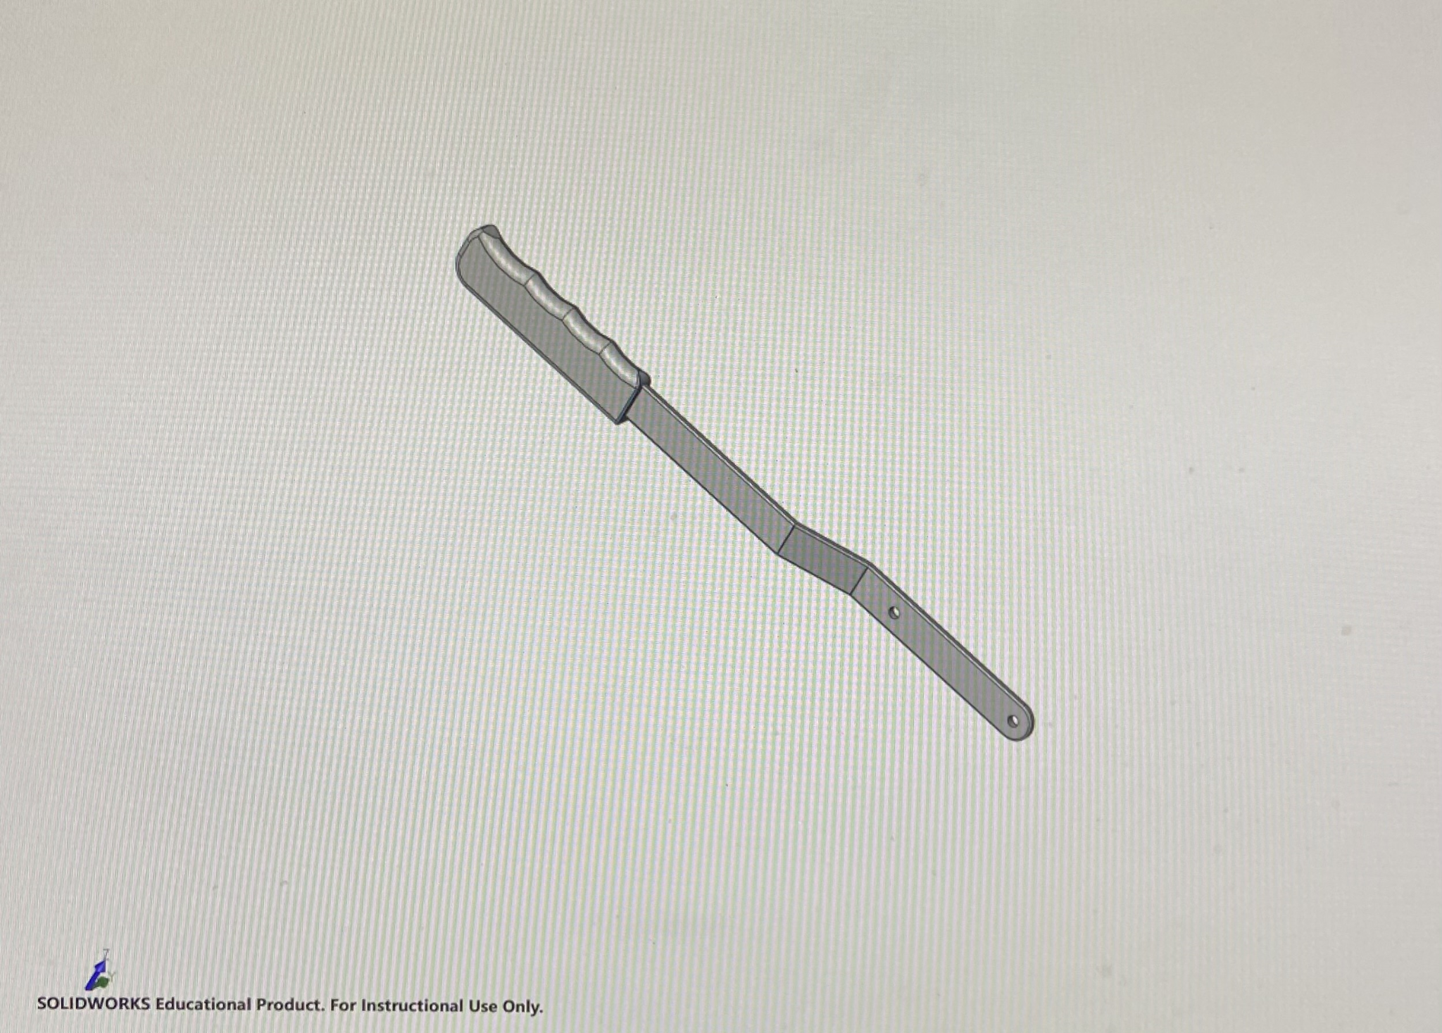
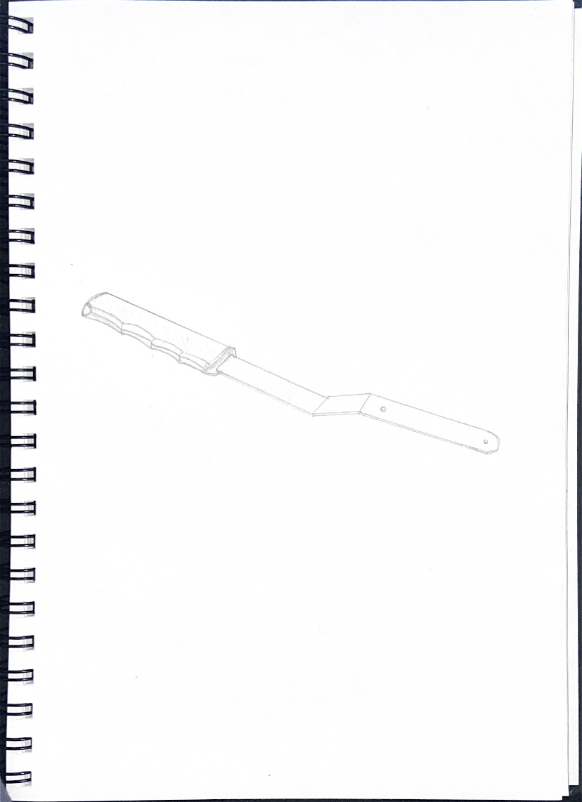

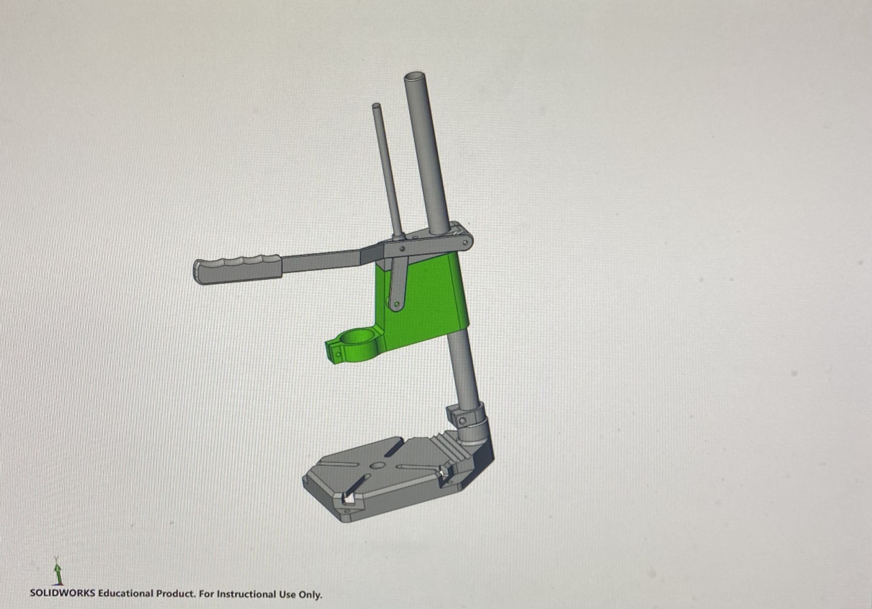
Final Design

References

Sciencedirect.com. 2021. Smelting - an overview | ScienceDirect Topics. [online] Available at: <https://www.sciencedirect.com/topics/engineering/smelting#:~:text=Smelting%20is%20a%20form%20of,coke%2C%20charcoal%2C%20and%20coal.> [Accessed 18 May 2021].

UKEssays.com. 2021. Drill Press Redesign Project - Design for Manufacture. [online] Available at: <https://www.ukessays.com/essays/engineering/drill-press-redesign-project-design-4899.php> [Accessed 18 May 2021].

Openscholarship.wustl.edu. 2021. [online] Available at: <https://openscholarship.wustl.edu/cgi/viewcontent.cgi?article=1022&context=jme410> [Accessed 18 May 2021].

Web.mit.edu. 2021. Drill Press. [online] Available at: <https://web.mit.edu/2.670/www/Tutorials/Machining/drill/Description.html> [Accessed 18 May 2021].

