S-DC
Run the following commands and verify the outputs:
- IPCONFIG /ALL: Confirm the IP address matches the topology provided.
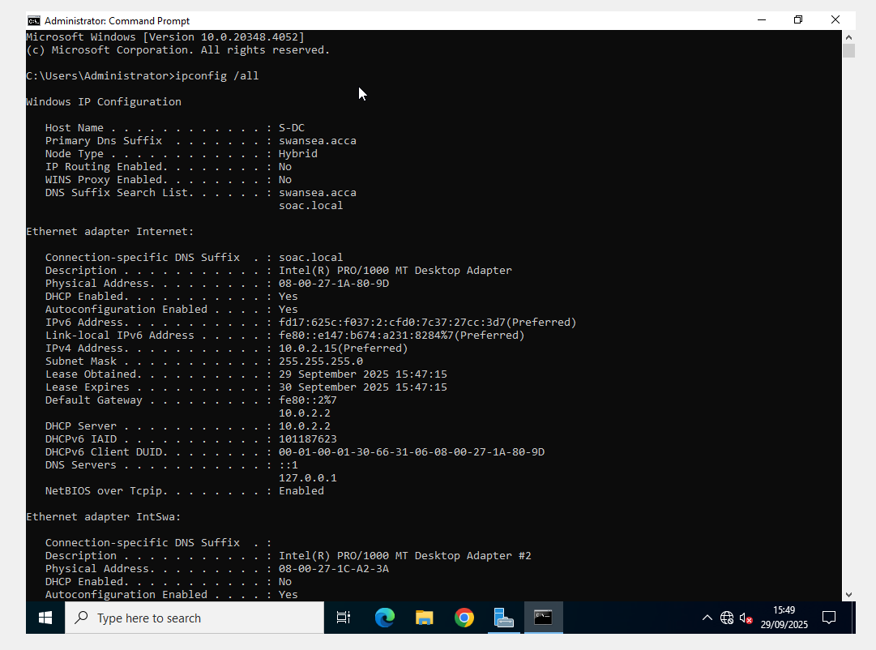
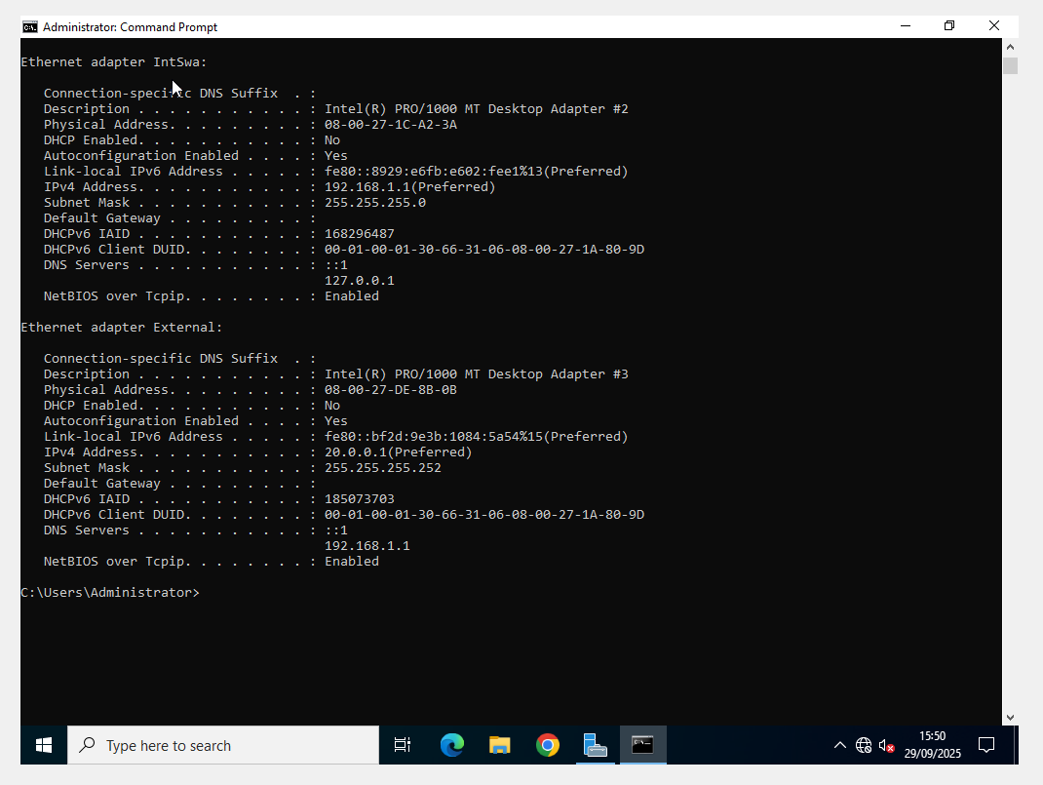
- ping 192.168.1.10: Must be successful.
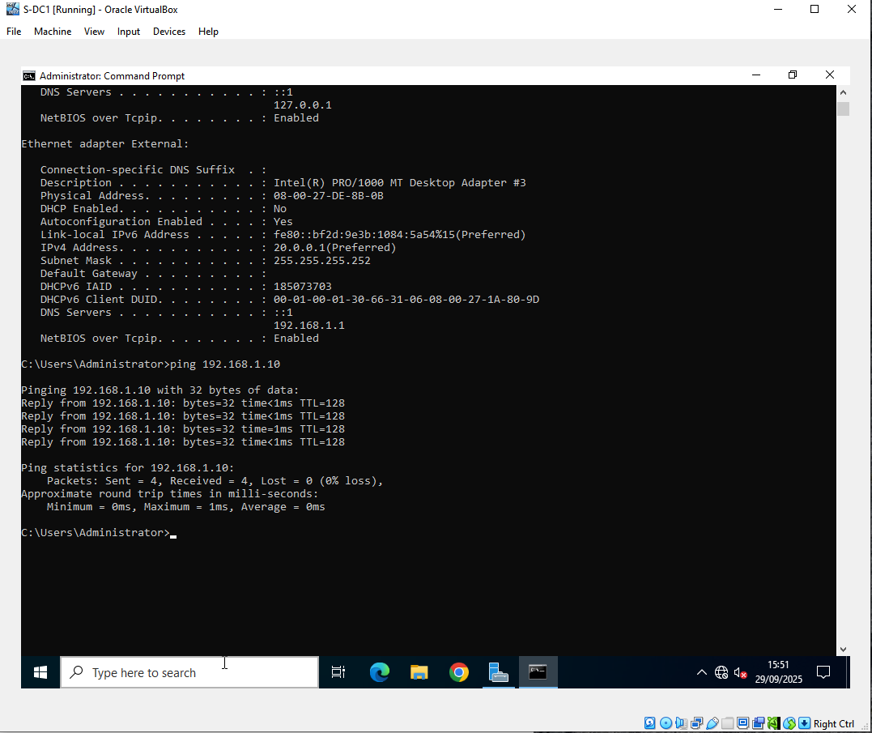
- ping 192.168.2.1: Must be successful. Ping
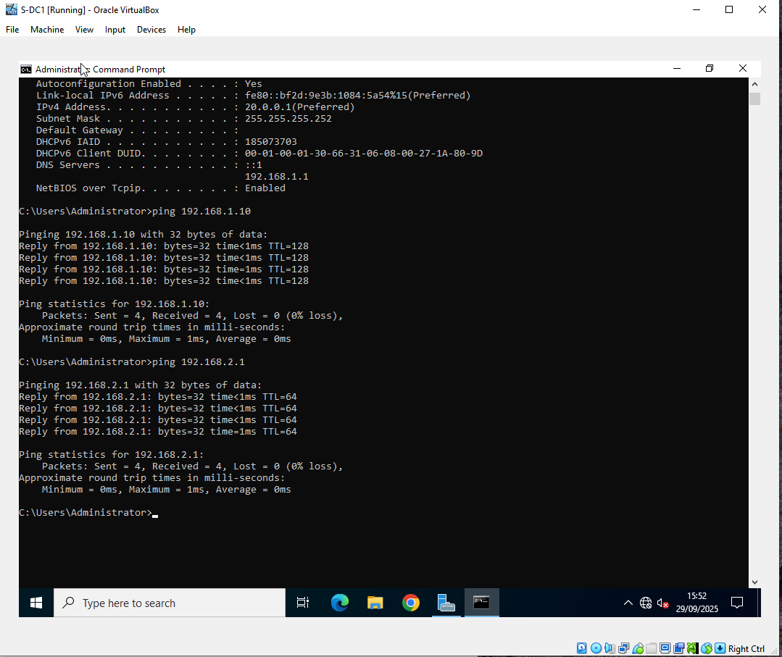
L-CD
Run the following commands and verify the outputs:
- ip address: Confirm the IP address matches the topology provided.
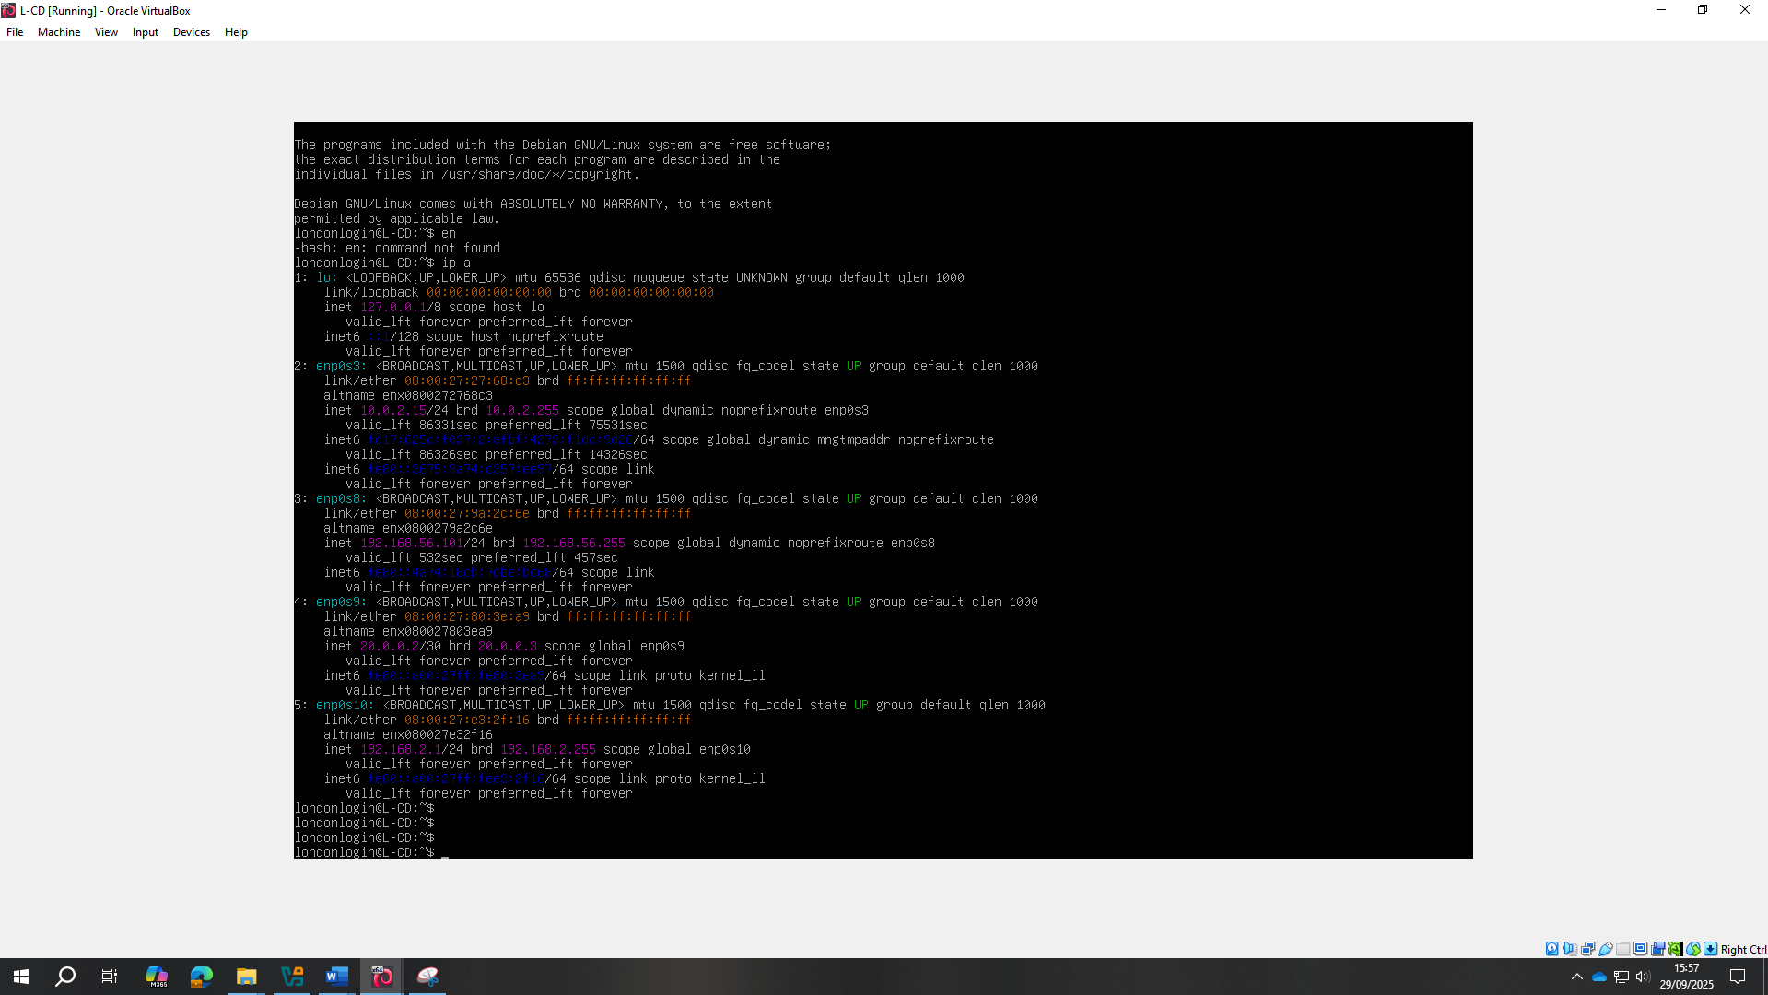
- ping 192.168.1.10: Must be successful.
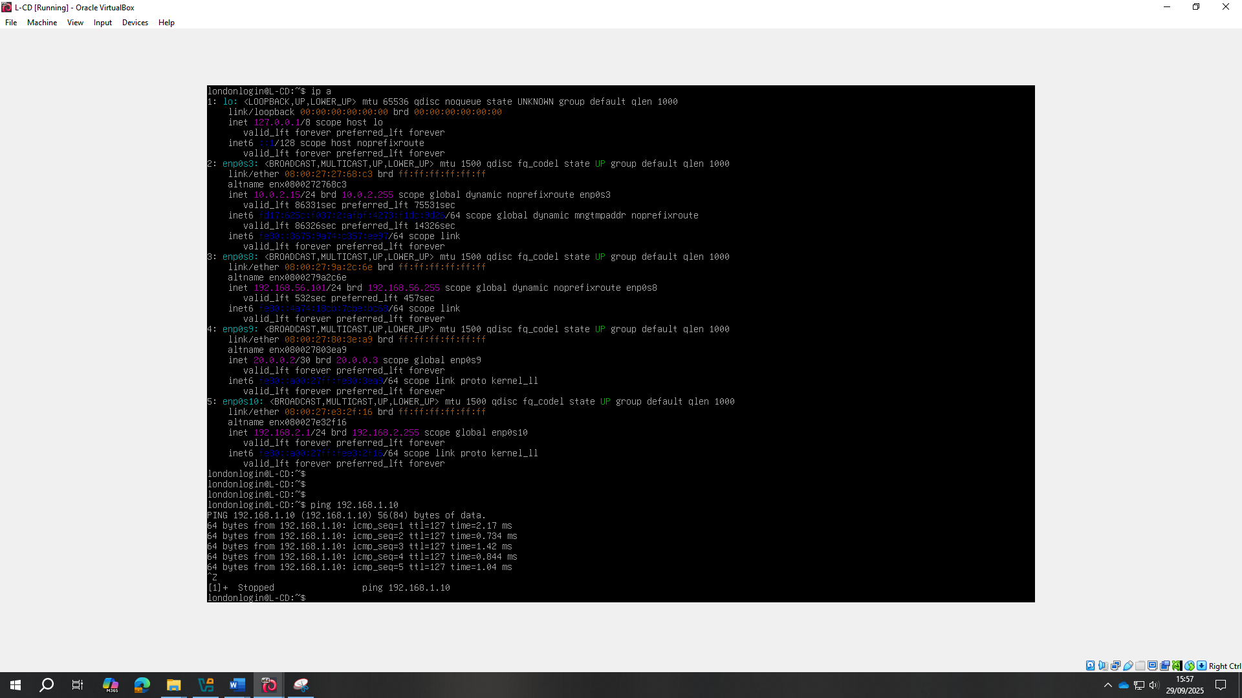

- ping 192.168.1.1: Must be successful.


