Introduction
The following essay will introduce the reader to two iconic buildings situated in the borough of Epsom & Ewell, Surrey. The two buildings standalone to have both architectural and historical significance, of which I shall attempt to establish a brief account, focusing particularly on Context/Historical Background, Plan & Section, Lighting & Materials and Use/Function. The structures in question are known as Odeon Cinema (1937) and Spring House Ewell (1720), which already presents a two-century construction difference, as such, I intend to comparatively analyse both buildings in the pre-mentioned area.

Context & Historical Background
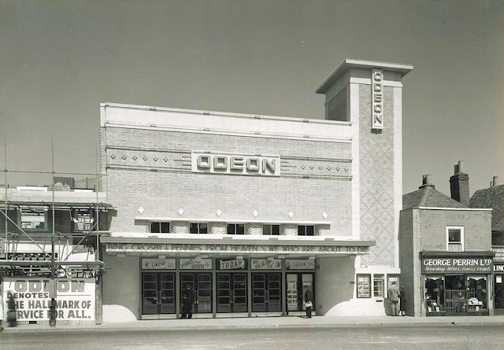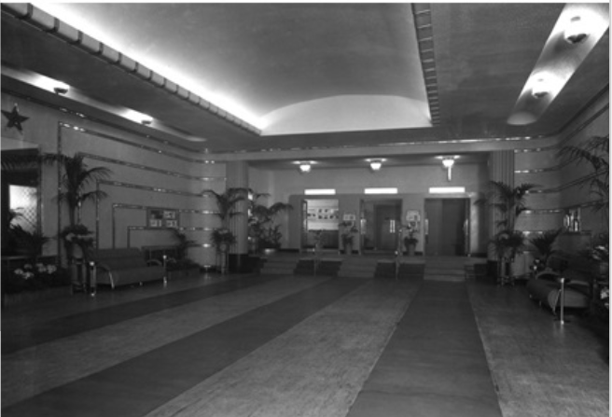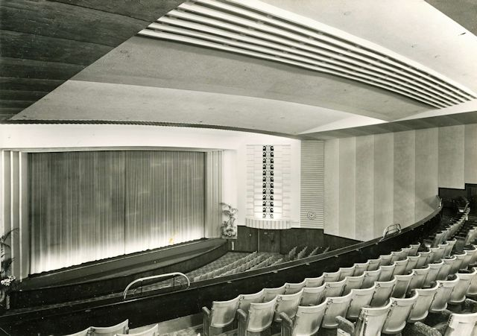
Images taken at opening of Finished Odeon Cinema Building, Epsom (Maltby, 1937) ^{[1]}
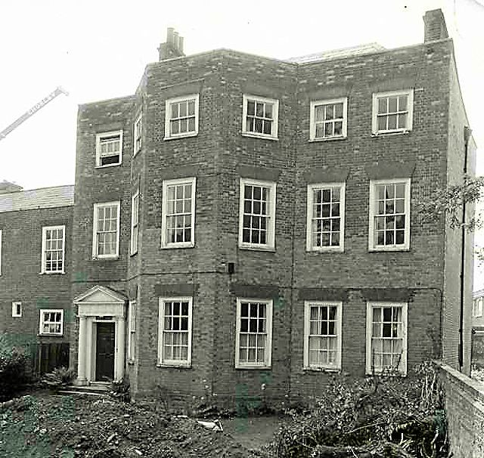
Image showing Spring House, Ewell (Photographer Unknown, Date Unknown)^{[2]}
The Odeon cinema, currently located in the Upper High street of Epsom (1999), was initially located on 114-116 High street, in 1937. Commissioned by Oscar Deutsch and designed by Whinney Son & Austen Hall the building was style in an Art Deco form. It was considered to be optimum siting for it’s requirement, with Epsom high street being an attraction for leisurely activities and shopping, even millennia’s prior when the structures as they are now did not exist, yet seemed the perfect place to spend downtimes and have a relaxed experience, during the Roman era who saw fit to utilize the benefits of nearby rivers and streams to water horses. Centuries after this, the area seemed to hold quite a connection with Anglo-Saxons and later the formed Monarchy, seeing the possibilities with Epsom due to certain aspects such as vast greenery for crops, streams for mills and magnesium sulphate rich waters labelled Epsom salts, eventually leading to Epsom being recognized as a spa town. Whilst the Cinema building had originally been situated in the town centre, Spring House was placed in the adjoining village of Ewell where It has seemingly remained since 1408 however under a different name and form, for which, records are not extensive until later reputed as Spring House. The building, built by John Parker, lives within proximity of Bourne Hall with its inarguable beauty, a number of residences are also close-by. With the abundance of space, due to the openness of the area, it can be easily be understood that the design and construction was non-restrictive as you would’ve otherwise had at the city centre, this allowed free-reign with design style and construction. with an asymmetrical front it resembles styles from the 17-18th century with a relatively neoclassical element, further proven with geometric forms including Doric Columns and the triglyph frieze & pediment of the entrance along with the octagonally shaped rooms, accentuated by the canted front bay Throughout its lifetime, Spring House has served several uses and people, be it the number of businesses that have operated here or just as a large residence, even a base for political figures, a property chosen most likely for the vast area it offers to accommodate a number of requirements. It may have also been chosen for the calmness in the surrounding area, with its many natural features.
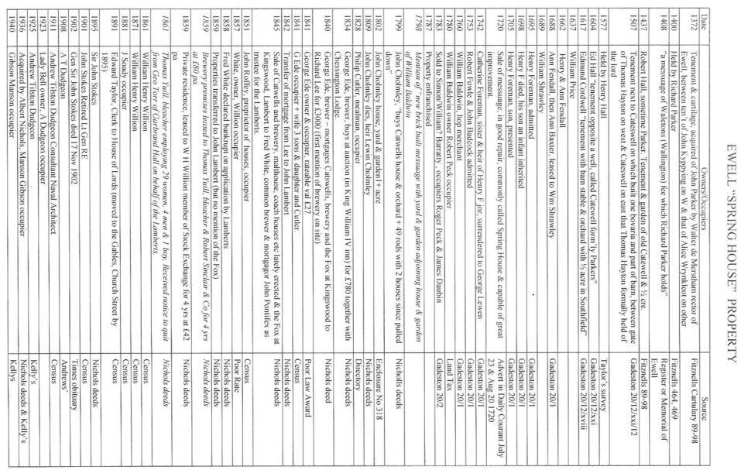
Image showing timeline of ownership for Spring House, Ewell (EEHAS, Date Unknown)^{[3]}
Plan & Section
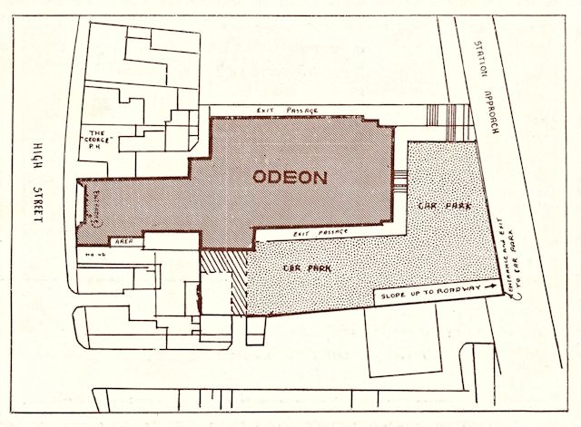
Image showing plan of Odeon Cinema, Epsom (Son & Hall, 1937)^{[4]}
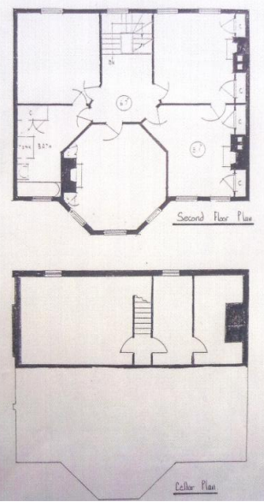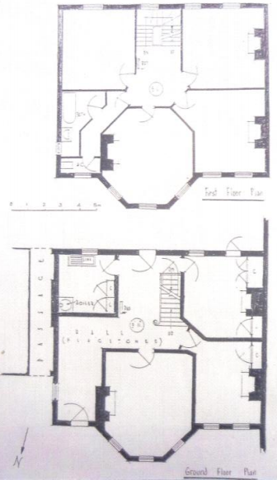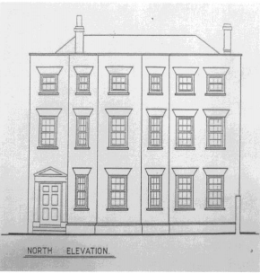Images showing Plan drawings of Spring House, Ewell (EEHAS, Date Unknown) ^{[5]}
The Odeon Cinema being in a more urbanized area, the constrictions and form make sense. As can be expected with a more urbanized area one of the primary concerns is to utilize as much space as possible and with previously constructed buildings surrounding the area, relatively compacted, the Odeon site plan has expanded to fill any possible room, whilst still considering human ergonomics to allow comfort and ease of access to, from and around the building. We can also observe how the entrance extends to stretch out from the main area of the building i.e. The heart of the building, it almost provides large statement pathway so as to say, ‘you’re on your way to discover something wonderful’. You then see the chimney resembling component on the right side of the building which towers above the adjoining buildings, somewhat like the guard tower that stood above all in early English castles, this element asks the visitor of a leisurely town to be noticed drawing their attention in even more. With the main theatre area, the stage and projection screen remain the ‘star of the attraction’ with all seating and pathways revolving round that point, a curved plan focused in on that large screen many have come for. Similarly, the same need to be recognized must be assumed with the unconventional plans of the Spring house, in no way similar to the surrounding structures serving relatively parallel functions, with aspects such as geometrically-sound Octagonal rooms which must tell the observer that this is a featured room, something to be known and acknowledged, possibly used as an event/function room. Yet, from the centre of the house the plan presents quite a few access points to adjoining areas encouraging flow and movement around the house to the numerous rooms nearby including two entrances to the garden behind, quite clearly assuring the visitor that they are free to stray into the natural, open grounds. From the only plans, I could uncover, it seems that both buildings are suited and even go above and beyond the location they’re situated in.

Materials & Light
Materials found with the Cinema include a mix of Red/Suffolk bricks, Concrete blocks and Ceramics externally, along with marble, textiles and various metals internally. The brick and blocks can be expected for use with a construction during this era as they were used in most buildings from the time, considered for their relative inexpensiveness and durability, however the use of ceramics was lesser known but for the growth of the entertainment industry with cinemas, it was not unheard of. The use of reflective brass and marble internally, had added to the appeal of the building, it seemed to present a higher-class experience with its arrangement through the building especially throughout the entrance and foyer. Once again, this was almost synonymous with the spring house without the use of the theatre’s internal elements, which seems appropriate as this only had the requirement to be more residential. The brick industry was thriving during the current iteration of the spring house, explaining the use of the bricks for the shell of the building. Synonymous with this period, the building is timber-framed, inexpensive, admired for the impressive performance that the material could provide and quite easy for transport. In essence, wood was use for most of the internal environment of the building however various types of wood are unknown. Salt-glazed stoneware and Stone appear throughout and around the house, confirming its connection with 18th century construction some of this can be seen from the columns and pediment at the entrance.

Conclusion
Both buildings have been observed intensely and studied for many decades, adored for the unique construction ideologies and the rich histories they provide. I’ve discovered how important it is to witness and document the Architectural preservation of structures throughout their lifetimes, acknowledging that it’s only through the past, mistakes or successes, that we can learn, strive and thrive to making an Iconographic future.

Word Count: 1130 (Excluding Referencing)

Bibliography
Images
^{[1]}Maltby, J. (1937). Finished Cinema Building. [image] Available at: https://www.architecture.com/image-library/RIBApix/gallery-product/poster/odeon-cinema-high-street-epsom-surrey-the-entrance-foyer/posterid/RIBA59589.html?Action=Cookie, http://www.epsomandewellhistoryexplorer.org.uk/Odeon1937.html [Accessed 20 Jan. 2019].
^{[2]}The Epsom and Ewell Local and Family History Centre. (Date Unknown). Spring House. [image] Available at: http://www.epsomandewellhistoryexplorer.org.uk/StokesSirJ.html [Accessed 20 Jan. 2019]
^{[3]}E.E.H.A.S. (Date unknown). Ewell “Spring House” Property. [image] Available at: http://www.epsomewellhistory.org.uk/ [Accessed 20 Jan. 2019]
^{[4]}Son, W., Hall, A. (1937). Site Plan. [image] Available at: http://www.epsomandewellhistoryexplorer.org.uk/Odeon1937.html [Accessed 20 Jan. 2019]
^{[5]}E.E.H.A.S. (Date Unknown). Spring House Plan and Elevation. [image] Available at: http://www.epsomewellhistory.org.uk/ [Accessed 20 Jan. 2019]

Online Literary Materials
E.E.H.A.S. (Date Unknown). Spring House. [online] Available at: http://www.epsomewellhistory.org.uk/download/i/mark_dl/u/4008405184/4583911914/Spring+House.pdf [Accessed 20 Jan. 2019]
Epsom and Ewell History Explorer (Date Unknown). The 1937 Odeon Cinema. [online] Available at: http://www.epsomandewellhistoryexplorer.org.uk/Odeon1937.html [Accessed 20 Jan. 2019]
RIBA. (Date Unknown). Odeon cinema, High Street, Epsom, Surrey. [online] Available at: https://www.architecture.com/image-library/RIBApix/gallery-product/poster/odeon-cinema-high-street-epsom-surrey-the-entrance-foyer/posterid/RIBA59589.html?Action=Cookie [Accessed 20 Jan. 2019]
Jackson. L (2014). Sir John Stokes. [online] Available at: http://www.epsomandewellhistoryexplorer.org.uk/StokesSirJ.html [Accessed 20 Jan. 2019]

