By Lynzi-Kim Reed
UWTSD – BMPF7018: Managing Work-based Projects.

Assignment Component 2

Discuss how you would plan and design a Project Management process for the workplace.





Contents
Introduction 2
The Local Authority’s current Project Management Methodology and Approach 3
Monitoring and Control 6
Additional Key info to the Plan and Design of a Project Management Process 6
Project Governance 9
How can this be improved when planning and designing a project management process? 10
In Conclusion 12
Bibliography 13

Introduction
In this assignment, I will discuss the current Local Authority Project Management approaches, plan, and design a Project Management practice.
Designing an effective project management process within a local authority setting is crucial to successful project management and delivery.
Firstly, I will discuss the key steps involved:
Resource Allocation:
- Mobilize the necessary staff and resources required to build project deliverables.
- Ensure that the right team members required are chosen with the relevant skills required.
- Allocate resources effectively, to support any project activities.
Planning and Control
- Plan the work and resources needed to achieve the desired project objectives and outcomes.
- Effectively manage risks and issues as they arise during the project process.
Stakeholder Communication
- Agree and maintain an effective communication with the stakeholders who are impacted by the project.
- Regularly update stakeholders on any progress, challenges, and changes as they happen.
- Report the project status to the Project Board, Project Sponsor and Senior Responsible Officer as well as any other relevant stakeholders.
Project Initiation
- Develop a Project Initiation Document that outlines the project objectives, scope, and approach. (Also known as an Engagement Document which is currently used within the workplace of this employee)
- When required to do so, create a Business Case to justify the project’s value and benefits to the organisation / department involved.
- Conduct a stakeholder analysis to identify key stakeholders and manage their expectations.
Project Organization Designing
- Ensure roles and responsibilities are defined within the project team.
- Establish the reporting lines and any decision-making processes.
- Ensure that the project organisation is aligned with the local authority’s structure and strategies.
Viability and Benefits of Project Realisation
- Ensure that the project deliverable is fit for purpose and will enable the desired outcomes and benefits of the project.

The Local Authority’s current Project Management Methodology and Approach
The Local Authority has developed a corporate approach to managing projects that are based on sector best practice. A toolkit is available and intended to be used in the knowledge that there is no ‘one size’ fits all approach, but that a core set of principles will always apply.
Projects will be required to:
- Be linked to a corporate programme and / or the corporate Pillars.
- Have a valid Business Case
- Have clearly defined roles and responsibilities within the context of the project.
- Clearly define a shared understanding of what the project is setting out to achieve, by when and with those resources.
- Make efficient and effective use of the resources and funding.
- Adhere to regular monitoring and control mechanisms.
The toolkit was developed and designed to provide guidance to everyone that is involved in a project, this ensures that roles and responsibilities are clarified and provides structure for the planning and delivery, and closure of the projects.
The toolkit was developed and designed to be scalable.
When the toolkit is not applied, there is an increased risk that the project will not be thoroughly planned, monitored, and controlled, therefore the project will have a higher risk of not filling the objectives.
Project Matrix Stages of The Toolkit
Stage 1: Developing your idea:
The aim of the 1st stage is to develop the project idea without committing major resources and expenditures. To ensure that it is viable, aligned with the corporate objectives and is worthwhile.
Key Goals - End of Stage 1
- Documented and received approval of the Project Proposal Form or Business Case that shows the project to be viable and doable, and outlines the benefits, costs, risks and resource implications of the project.
- Identified a Project Board (where appropriate) a Senior Responsible Officer and Project Manager
- Identified external funding opportunities and commenced any funding applications.
- Contacted the Procurement Unit to begin discussing requirements.
Stage 2: Developing the Project:
The aim of this stage is to document the common understanding of the reason for the project itself and the detail of what will be delivered by the project, by whom, how, when and at what cost.
It is the preparation for the delivery stage.
As this stage is warranted by the scale, complexity and risk involved this should be undertaken thoroughly.
It is communicated that best practice shows that it is important to prepare thoroughly, but that this must be balanced with the need to deliver the project in a timely manner and controlled way.
It is noted that change is an inevitable part of the project development and delivery and should be recognised as a factor within the planning stages so that any unexpected changes can be efficiently and effectively managed, and any new opportunities are embraced.
By the end of this stage, an approved Project Business plan containing the detail of the project; what success will look like, how the project will be managed, resourced, delivered, communicated, and measured will be produced.
This will help to ensure progression to start the next stage of the project (Delivering the Project)
Stage 3: Delivering the Project:
The delivery of the project to achieve the objectives, outputs and benefits is the priority of this
stage. These are the three key areas of activity during this stage that support effective delivery and can be summarised under the following activities:
- Planning – confirming what needs to be achieved, by when and by whom responsible, and updating the project plan to reflect any changes.
- Delivering – ensuring that the work packages and their outputs are completed to the required cost, time, and quality.
- Managing – managing the project plan, reviewing overall progress, taking management decisions, monitoring, and managing any risks and issues, controlling and approving any changes where necessary to keep the project and team on track in order to achieve its agreed objectives.
It is noted that by the end of this stage, the project should have been effectively managed and delivered, or stopped if it became necessary to do so.
Stage 4: Reviewing and closing the project:
One of the main features of a project is that it is finite: the project has an end date. If a project loses this, it becomes operational or business as usual activity.
As part of this stage, it is crucial that at the end of the project any procedural lose ends need to be tied up, experiences should be reviewed, and any accomplishments and lessons learnt should be captured appropriately.
However, this does no need to be a time-consuming stage but is still important.
Following the completion of the project at the end of this stage, it should then be handed over for an operational phase (if appropriate). The Project Board will then confirm that the project has come to an end and the project will have been reviewed to capture the benefits, lessons learnt and other relevant experiences.
Example of the Toolkit Model
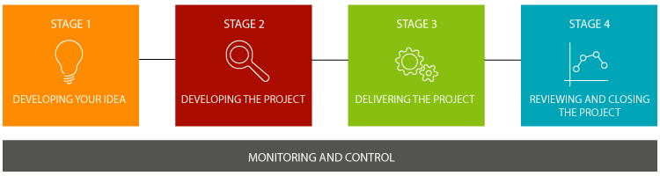
(Council, 2023)

Monitoring and Control

As part of the Local Authority’s Project Management and Process, a Monitoring and Control Matrix has been developed to provide a guide to the minimum level of seniority required to make decisions at the Control Points in different types of the project.
Here are the Control Point/ Key Decisions Stages of the matrix:
- Control Point Stage 1: Approval of the Project Proposal Form / Business Case – The forms will need to be approved by the Head of Service & SASG to secure capital budget for the project. Additional approvals are required for IT projects and this requiring External Funding
- Control Point End of Stage 2: Approval of the Business Plan, approval to continue – The Business Plan must be approved by at least the Senior Manager.
- Control Point Stage 3: End of each Delivery Stage and/or Key Milestone – Monitoring of progress and approval to continue to the next stage of delivery or project close. Sign off Project Deliverables/ Outputs/ Benefits. Approval to continue.

It is to be noted that the project progress monitoring, sign off project deliverables and approval to continue will be required from the Project Board involved, if one is in place, or the Senior Manager where no Project Board has been appointed in that case.

- Control Point End of Stage 4 – Confirmation of project closure and handover - The project closure will be undertaken by the Project Manager; confirmation of the closure will be required from the Senior Manager.

Additional Key info to the Plan and Design of a Project Management Process

Defining Project Benefits
At the start of the project planning process, it is important to understand and define the benefits of the project. Benefits are measurable improvements which are delivered through a project or programme which need to be seen by the stakeholder as both positive and worthwhile.
Project Benefits should always be aligned to the objectives of the project and organisational priorities. It is important to define, realise and measure the benefits as well as the dis-benefits so that we can understand and measure the impact of the project of the Stakeholders and end users.
However, measuring benefits is not always straight forward, so when they are defined in the Local Authority’s Toolkit under Stage 2 (Developing a Project) the definitions need to align with SMART, for example, specific, measurable, achievable, relevant and time bound.
In some case, project benefits are not always realised until after the project has been delivered and closed. Within the Local Authority Project Management Process, it is important that before the project closes, an appropriate individual is nominated to be responsible for realising and measuring the benefits of the project beyond the project closure.
Communication Plan:
At the basis of the communication plan within the project will be the Stakeholder Analysis that has been undertaken and carried out as part of the Project Business Planning Process.
- Stakeholder Analysis: Identify common messages that need to be communicated out and create lists of who those messages need to be delivered to.
- Method of Communication: Always consider the best method of communication to use throughout the process. It is important to remember that communication is a two way process and there maybe a need to plan for formal consultations in order to facilitate open channels of communication to gain feedback from stakeholders.
- Assigning Responsibilities: Nominate and agree for an individual who will take responsibility for each communication.
- Planning for Timing of Communication: From the list collated, it is essential to plan the timing of communications, as it may not be always possible to be accurate with dates it could be useful to plan the timing according to Key Milestones or achievements in the project.
- Formal Reporting Process: A formal reporting process should also be included within the communication plan with what information needs to be presented to the Project Board / Members/ External Funders and or anyone who is required to be reported to the of the progress and identify when the information will be required by.
(Council, 2023)

Within the Local Authority, a Communication Plan template has been designed and is available for the Project Team to use as a guideline during this process. The template has been made available for staff to use and is found on the Intranet pages.

Below is an example of the communication plan currently used within the Local Authority.
Appendix 1 – Communication Plan Template
Key Message or Formal Report | Who needs to Know? | What is the best way to let them know?  E.g. Press release, marketing campaign, formal meeting, formal reports, email, letter… | When do they need to know?  This may be a date or a particular point in the project | Is this a two way communication?  How will the communication be facilitated  (E.g. Open meeting, helpline/ email) | Is there anything particular that needs to be considered?  For example a history of interaction that may influence the outcome of the communication, level of influence of the stakeholder group? | Who is the nominated individual responsible for making this communication happen?

(Council, 2023)

Project Governance

Project governance is a crucial system that is put into place to ensure leadership, decision making, and accountability is effective across all stages of the delivery of a project. A Governance system includes:
- Project Structures
- Processes (including reporting and risk management) and roles.
Effective governance is important as it will help to ensure that decisions are properly informed and that they are made when required and the outcome is communicated appropriately: Projects depend upon the timely consideration and resolution of issues by people with both the knowledge and authority to make and implement decisions. Failure to achieve this will invariably result in delays, inappropriate decisions, and project failure.
It is always important that there is an overall point of accountability (usually in the case of the Senior Responsible Owner) where the responsibility lies for realising the business case. This role should be backed up by a team of supporting individuals who have clear roles and responsibilities assigned to which they and others understand. Failure to define accountability can result in a culture where poor performance carries no consequences.
An example of Four Key Principles of Good Project Governance:
These Four Key Principles of good governance are applicable to any project:
- Clear objectives
- Delegated authority and clear roles
- Reporting – sound information to govern by
- Independent assurance and clear decision gates
(Council, 2023)

How can this be improved when planning and designing a project management process?

- Start with a Project Design phase, after developing the idea. This will allow creativity and enable a more tailored project management process to each project
- The Project Design Phase will help to define the overall project methodology that will be used for this project
- Estimate and communicate what resources will be needed for the project
- Structure the Project Strategy – resources, budget
- Use analysis of similar projects to review what lessons were learnt and can be applied to the project (ie. SharePoint lists)
- Contingency planning
- Use tools available such as real time dashboards which can help keep track of costs, timescales and progress (ProjectManager is great example of this with beneficial features)

Examples of Tools That Can Be Used Within the Project Management Process:
Project Manager Dashboard:
By taking an online data visualization approach to handling your company’s strategic activities, big or small, you will make your business more cohesive, collaborative, intelligent, and profitable – and project management dashboards will help you do just that. With the help of modern solutions, you can monitor, optimize, and enhance your projects' performance while increasing the productivity of the whole team, saving countless working hours, and, ultimately, costs.
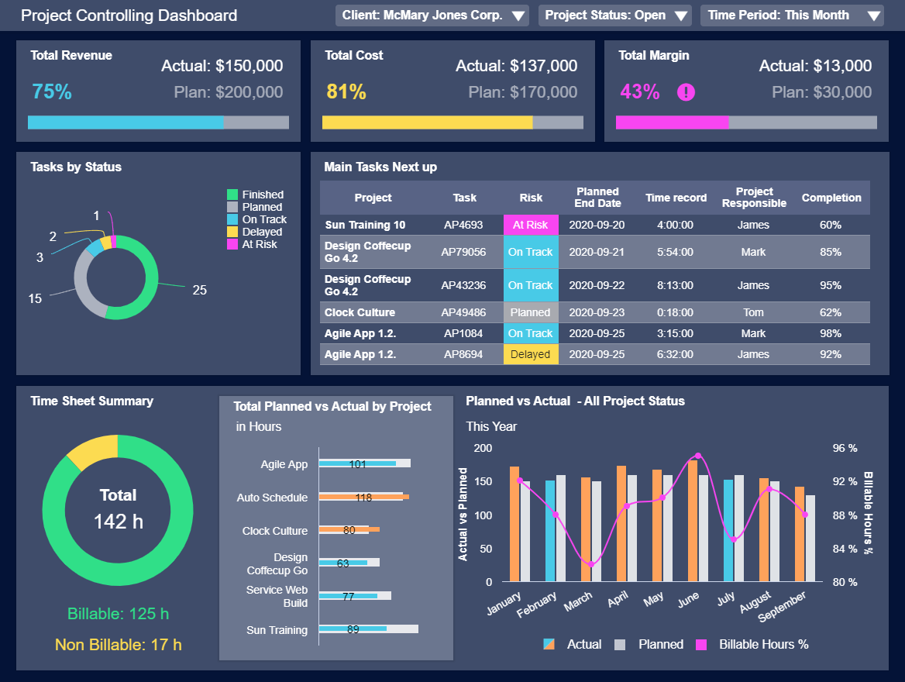
(Calzon, 2021)
Share Point Lists:
There are free SharePoint Project management templates available that can help manage and re-plan projects using SharePoint On-premises. Templates come with lists, web parts and reports which can assist to streamline the project management and efforts.
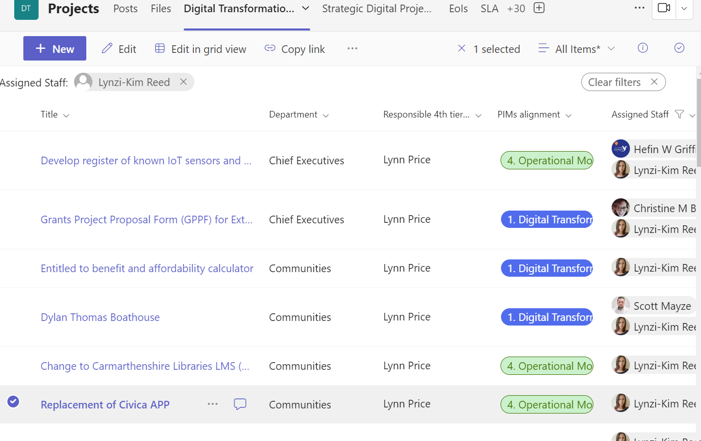

As a Project Manager, I have leveraged SharePoint lists extensively within our local authority for effective project management. These lists serve as a crucial tool for tracking progress, facilitating collaboration among fellow Project Managers, ensuring seamless communication, providing valuable insights through retrospective analysis of completed projects.
Through harnessing the power of SharePoint lists, we can enhance our ability to inform future projects and optimize decision-making.

In Conclusion
As a Project Manager operating in a dynamic environment within the local authority, I firmly believe that there is no need to re-invent the wheel when it comes to planning and designing project management processes.
Various methodologies exist to cater to different project types, sizes, and complexities. By meticulously assessing each individual project, considering its unique needs and goals, we can determine the most suitable methodology and apply an appropriate approach that yields optimal results.
For instance, by adopting an agile approach to a particular project that allows for flexibility, which enables us to make necessary improvements and adjustments as the project unfolds.
It is worth also noting that during the “Design Phase” of a project, thorough analysis and brainstorming can play a pivotal role in shaping the project’s requirements. This process allows us to identify the most fitting methodology and leverage the appropriate tools available.
I believe that by taking a more tailored approach to project management it becomes essential for several reasons:
- Diverse Project Types: As projects can vary significantly in scope, complexity and objectives, using a rigid one-size-fits-all methodology may not address the unique needs of each project.
- Stakeholder Expectations: Different stakeholders (clients, team members and executives) all have varying expectations so by customizing project management practices, this allows us to align with these expectations.
- Team Dynamics: As all teams within the local authority setting have distinct dynamics, skills and preferences, adopting a flexible approach allows us to adapt to teams strengths and weaknesses.
- Risk Management: Risks can differ across projects. By applying a tailored approach, this enables us to address any specific risks more effectively.
- Project Size: Small projects tend to need more streamlined process while larger and more complex projects tend to demand a more robust methodology.
I firmly believe from experience that project management success lies in recognizing the uniqueness of each project and adapting our practices accordingly.

Bibliography
Calzon, B. (Ed.). (2021, September 21). https://www.datapine.com/blog/project-management-dashboards-examples-and-templates/. Retrieved February 11, 2024, from https://www.datapine.com: https://www.datapine.com
Council, C. C. (2023, May 11). http://intranet/our-people/project-management/. Retrieved February 11, 2024, from http://intranet/our-people/: http://intranet/our-people/

