Introduction to International Innovation

Assessment B

International Operation

Bernadette Lessimore – Student ID 1908595

Word Count -3560

Summary
You work as part of a consultancy firm who is assisting Griffiths & Hughes to expand their business, you must produce a report that includes the following:
1. Select the three locations that would appear to be Suitable for the company’s needs, one from each of the identified global regions. Your consideration may include, but not limited to the following factors:
- Manufacturing & Production | - Logistics & Transportation
- Marketing | - Political aspects
- Skills & capabilities of the local workforce | - Cultural & Social implications

2. Report on how innovation management standards such as the ISO56000 series may be of benefit to the organisation as it grows to a sustainable and prosperous future

Note: Using the following locations

South America | Asia | Africa
Porto Alegre (Brazil) | Lahore (Pakistan) | Lagos (Nigeria)
Montevideo (Uruguay) | Mumbai (India) | Bulawayo (Zimbabwe)
Buenos Aires (Argentina) | Dubai (UAE) | Tunis (Tunisia)

General Overview & Contents
Following the companies instruction I have actively researched the 9 global regions that were shortlisted following the intitial review.
Unfortunately, due to the guidance given in terms of the length of this report I have included a list of contents below that is reflective in all three sections and whilst the report is extremely brief in certain areas, I would hope that the overall details and summary of my findings will aid with the considerations put forward.
You will find details below to include:
- A brief on each region / country
- A data matrix to compare important information about each region/ country
- GDP Per Capita - This metric is used to determine a country economic output per person. This information is a good representation of the country’s standard of living.
- Sales and Forecasts of security products
- Politics
- Logistics and Warehousing – Note: I have looked at warehousing initially on a fullfilment system whilst the business is establishing itself. But this can be reviewed if this scenario is not favoured by the company.
- Final Summary
To Note : I have established the English Language is recognised in all 9 regions (Britannica, 2023)
ASIA
Lahore – Pakistan
- Pakistan is the 2nd largest economy in South Asia
- There are good opportunities to increase UK exports
- Lahore was part of the 1947 partition that saw British India split into 2 new states that became India and Pakistan
(Newsround, 2022) (Bank, 2023)

Mumbai - India
- India and the UK are commited to a partnership that delivers to both countries
- A roadmap by 2030 is in place to develop the likes of trade , defence and security
(Gov.Uk, 2023)

Dubai- UAE
- The UAE is the largest export market in the Middle East
- Dubai is strategically located and is known as the regional hub for commercial capital for the Middle East
- Dubai is also known for being a rich culture with a fast growing economy.
(Britannica, 2023) (Gov.Uk, 2023)

1st | 2nd | 3rd
DATA MATRIX
 | LAHORE | MUMBAI | DUBAI | References
Total Trade in goods and services with the UK in 2022 | Pakistan  4. 4 Billion | India  35.9 Billion | UAE  21.6 Billion | (Trade, 2023)
Population | 14,000,000 | 21,000,000 | 3,000,000 | (Review, 2023)
Expected Growth by 2035 | 19,000,000 - 28% | 27,000,000 -35% | 3,500,000- 16% | (Review, 2023)
How many days to start a company up | 16.5 Days | 17.5 Days | 3.8 Days | (Statista, 2023)
Global Business City Index  Based on 4 areas. Economy and Operational /Environment/ Society /Charisma - Out of 200 Companies | 198th | 119th | 83rd | (Statista, 2023)
Corporation Taxes | 29% | 40% | 9%  From June 2023 | (PWC, 2023)  (Kumar, 2021)
Average Salaries  Example – Business Development Manager | 3,399,065 PKR  = £9,566 GBP | 2,651,134 INR  = £25,709 | 431,200 ED  = £93,000 | (Convertor, 2023)  (Salaries, 2023)
Number of Universities ranked in the Top World Universities | 3 | 2 | 3 | (QS, 2021)
Of which are producing the most Employable Graduates | 3 | 2 | 1 | (QS, 2021)

GDP Per Capita

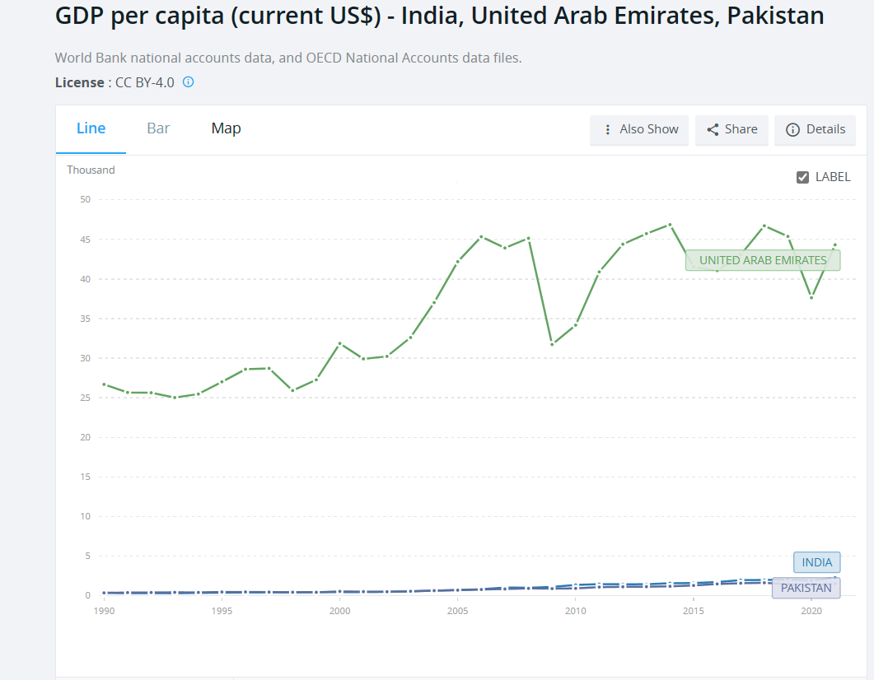
GDP per capita is the sum of gross value added by all resident producers in the economy plus any product taxes (less subsidies) not included in the valuation of output, divided by mid-year population. (Bank, 2023)

sales and forecasts for security products (USD) (Statista, 2023)

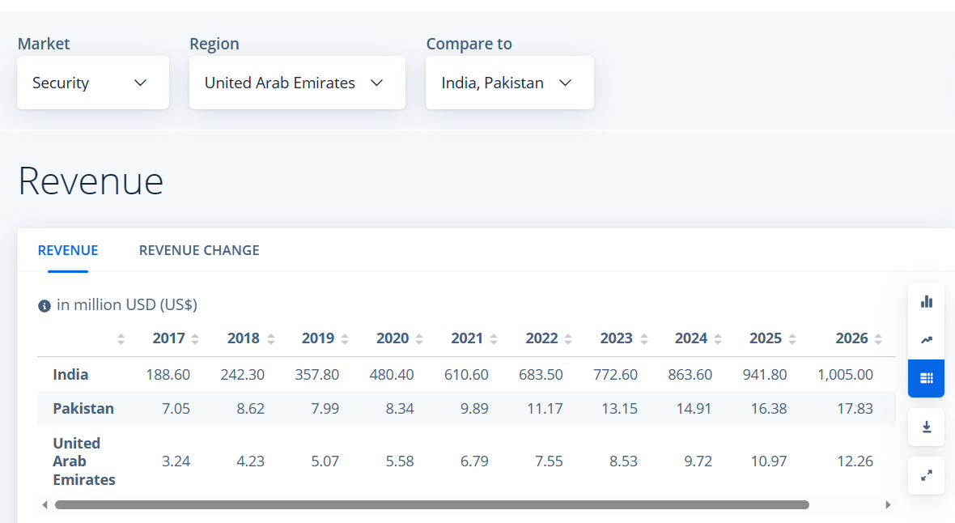

Politics
The UAE is Pakistan’s largest trading partner in the Middle East and a major source of investments. Pakistan opened a Business Council in Dubai in 2004 and since has played a pivotal role in bringing the business communities together. (Today, 2021)

DUBAI - UAE INDIA PAKISTAN

India and UAE have shared trade links for Centuries. Both countries are striving to strengthen their ties for mutual benefits. (Chadha, 2022). In 2022 they signed a bilateral free trade deal, with plans to boost trade by $100 billion within the next five years. (Parkin, 2022)
To date India and Pakistan have fought 4 wars,1947-1948, 1965, 1971. (Bibliograhpies, 2016). It’s been recently reported that India desires normal neighbourly relations with Pakistan to create an environment that is free of terror and hostility. (Express, 2023)

Logisitics and Warehousing:
- Dubai has one of the world’s largest man-made ports to one of the world’s busiest international airports.

- It’s part of the Worlds Logistic Passport and part of the Dubai Silk Road Initiative it encourages trade through the Emirate in return for enhanced custom clearances, cost and time savings to increase the ease of moving goods between Latin America, Africa and Asia. (Dubai, 2023)

- Mumbai is connected by a network of roads to the rest of India.

- Trains from the city carry goods to all parts of the country.

- Air traffic is handled by Chhatrapati Shivaji International Airport in the northern part of the city.
(Britannica, 2023)

- Lahore has a main airport with a cargo terminal, Allama Iqbal Terminal.

- Lahore also has a dry port. A dry port is an inland terminal which connects road or rail but can limit cargo movements.

Dubai Warehousing:
- Home (aramex.com)
- Logistics | Warehousing | Freight Forwarding - NAQEL Express
Mumbai Warehousing:
- Best eCommerce Fulfilment Services India | WareIQ
- E-Commerce Fulfilment Solution for Large Companies - DHL Supply Chain

Lahore
- Best eCommerce Distributor in Pakistan | eCommerce Solution | Rholab Distribution

Summary
In light of the information provided above I would suggest further research is carried out in Dubai. The matrix used has suggested this region has far more advantages than the other two regions. There are also comments made in the politics section that are highly relevant to companys decision. Even with the stats being lower on the security sales in UAE, all considerations should be taken into account before a final decision is made.

To aid with your research I have listed some useful links for you to review:
- Dubai announces $8.7 trillion economic plan to boost trade, investment (cnbc.com)
- Full foreign ownership of commercial companies - The Official Portal of the UAE Government
- British Embassy Dubai - GOV.UK (www.gov.uk)

- Set up your Business in Dubai | Invest in Dubai (visitdubai.com)

- How UAE life will change in 2023 as new laws come into force (thenationalnews.com)

SOUTH AMERICA
Porto Alegre -Brazil
- The city has many business and financial institutions and is also an education centre.
- The UK has a strategic partnership with Brazil and has done since 1825
- The UK has singled out Brazil to work with within the framework of it’s ‘Global Britain’ foreign policy, with importance of trade and investment
(Britannica, 2023) (Gov.Br, 2023)
Montevideo – Uruguay
- The port handles the majority of Uruguays Trade and is also the hub for international transport
- A milestone meeting took place in October 2022 between the UK and Uruguay to renew and strengthen economic relationships and the aim is to promote trade and investment
(Britannica, 2023) (Gov.Uk, 2023)

BUENOS AIRES – Argentina
- Buenos Aires port is one of Latin America’s most important ports
- The city is a national centre of commerce for policies, culture and technology
- Unlike much of the rest of the country, the city has a varied economy, which helps to maintain a degree of stability.
(Britannica, 2023)

1st | 2nd | 3rd
DATA MATRIX
 | PORTO ALEGRE | MONTEVIDEO | BUENOS AIRES | References
Total Trade in goods and services with UK for 2022 | Brazil  £7.7 Billon | Uruguay  £466 Million | Argentina  £2 billon | (Trade, 2023)
Population | 4,211,933 | 1,774,396 | 15,490,415 | (Review, 2023)
Expected Growth by 2035 | 4,538,702 – 7% Inc | 1,842,494 – 3% Inc | 17,127,740 -10% | (Review, 2023)
How many days to start a company up | 30-150 days | 45 days | 11.5 days | (Guide, 2023)  (Guruguay, 2023)  (Argentina, 2021)
Global Business City Index  Based on 4 areas. Economy and Operational /Environment/ Society /Charisma - Out of 200 Companies | Not Listed | 114th | 95th | (Statista, 2023)
Corporation Taxes | 34% | 25% | 25% | (Profit, 2023)  (Economics, 2023)  (PWC, 2023)
Average Salaries  Example – Business Development Manager | 273,951 Brazilian Real  = £43,782 | 4,432,204 Uruguayan Pesos  =£49,578 | 10,308,559 Argentine Peso  =£35,473 | (Salary.com, 2023)  (Convertor, 2023)
Number of Universities ranked in the Top World Universities | 2 | 4 | 11 | (QS, 2021)
Of which are producing the most Employable Graduates | 0 | 2 | 5 | (QS, 2021)

GDP PER CAPITA (Bank, 2023)

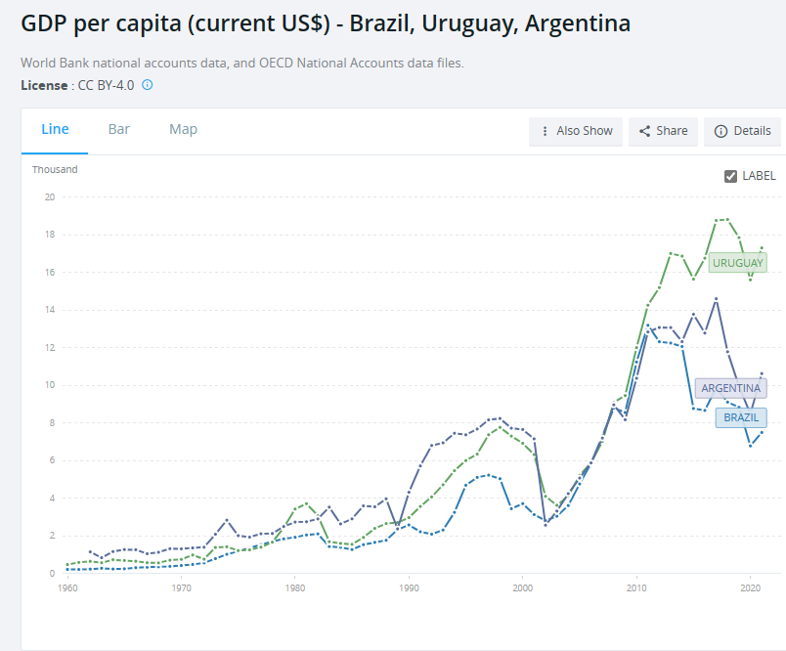

Security Sales and forecasts ahead

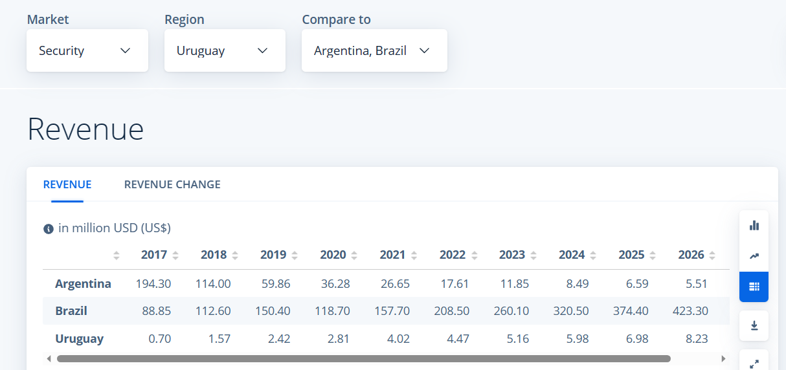

Politics
BRAZIL
Brazil faces several political and economic challenges. The country is currently tackling corruption.
British Government reports that Brazil is among the world’s leasing investment destinations. However, corruption and bribery are still serious obstacles in doing business in Brazil.
Brazil was a country of recession for 3 years but is slowly heading towards a recovery. (Gov.Uk, 2023)

URUGUAY
Uruguay’s political party is one of the most institutionalised in the world. It has a favourable environment for investment and good economic performance according to the British Government. Uruguay has over 30 trade investments in place.
Uruguay has clear business rules, macroeconomic stability, financial and trade openness, and attractive investment incentives. (Gov.Uk, 2023)

ARGENTINA
Human rights problems in Argentina include police abuse, poor prison conditions, and endemic violence against women. A longstanding economic crisis has particularly impacted people living in poverty.
A political crisis fuelled by economic problems and polarization has created a challenging environment for human rights progress. (HRW.Org, 2023)

Logistics and Warehousing
- Porto Alegre houses both a main port and airport

- Montevideo has a high level of infrastructure, including shipping ports and a modern, well-maintained airport providing a great deal of access.

- Buenos Aires has an airport that is located 22 kilometres away, however it does service the main port in Argentina and handles around 11.7m tons of cargo every year.

Fulfilment Warehousing
Porto Alegre
No options available currently

Montevideo
Services — Lobraus
Formisur S.A.

Buenos Aires
E-commerce Shipping - Crane Worldwide Logistics (craneww.com)
Mecalux | www.mecalux.com.pa

Summary
Although the data matrix presents Buenos Aires as more favourable, I would be more inclined to advise you to carry out more research in Montevideo based on the other information that has been provided.
The UK Government has marked Uruguay as a favourable environment for investment. The GDP per capita is strong against the other regions. And Uruguay government seems to have a clear direction for foreign trade.

To aid with your research I have listed some useful links for you to review:
- Department for Business and Trade Uruguay - GOV.UK (www.gov.uk)

- Trade and Investment Factsheet (publishing.service.gov.uk)

- Starting a business in Uruguay - Guru'Guay (guruguay.com)

AFRICA
LAGOS (Nigeria)
- Lagos is the centre of commerce for finance, administration and education.
- It was originally governed as a British Crown Colony but was amalgamated under Southern Nigeria in 1906
- Lagos city is the chief port for Lagos State.
(Britannica, 2023)

BULAWAYO (Zimbabwe)

- Bulawayo is the 2nd Largest City in Zimbabwe
- It’s the principal Industrial Centre
- It’s the headquarters for Zimbabwe’s railway with main transhipments to and from South Africa
(Britannica, 2023)

TUNIS (Tunisia)

- Tunis is the capital and largest city of Tunisa
- The government is working to increase foreign trade and lower unemployment rates
- Budget deficits still remain high and external debt has climbed
(Britannica, 2023) (Guide, 2023)

1st | 2nd | 3rd
DATA MATRIX
 | LAGOS | BULAWAYO | TUNIS | REFERENCE
Population | 15,945,912 | 649,509 | 2,475,446 | (Review, 2023)
Expected Growth by 2035 | 24,418,768 – 53% INC | 874,479 – 34% INC | 2,842,948 - 14% | (Review, 2023)
How many days to start a company up | 7.2 Days | 5-7 Days | 10-20 Days | (Kreston.com, 2023)  (Formations, 2023)  (Economics, 2023)
Corporation Taxes | 30% | 24% | 15% | (PWC, 2023)
Number of Universities ranked in the Top World Universities | 0 | 0 | 9 | (QS, 2021)
Of which are producing the most Employable  Graduates | 0 | 0 | 5 | (QS, 2021)
Average Salaries  Example – Business Development Manager (P.A) | 6,580,000 NGN  =£11,472 | 3,920,000 ZWD  =£8,702 | 77,900 TND  =£20,353 | (Salary.com, 2023)

GDP PER CAPITA (Bank, 2023)

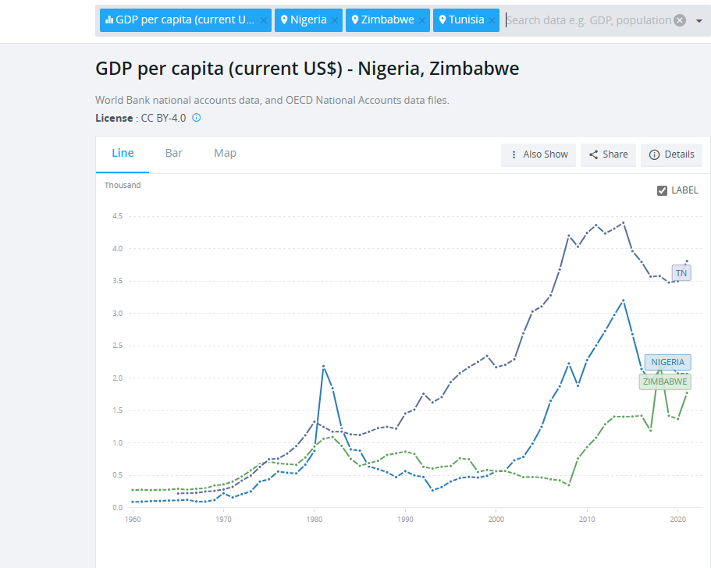

Security Sales and Forecasts
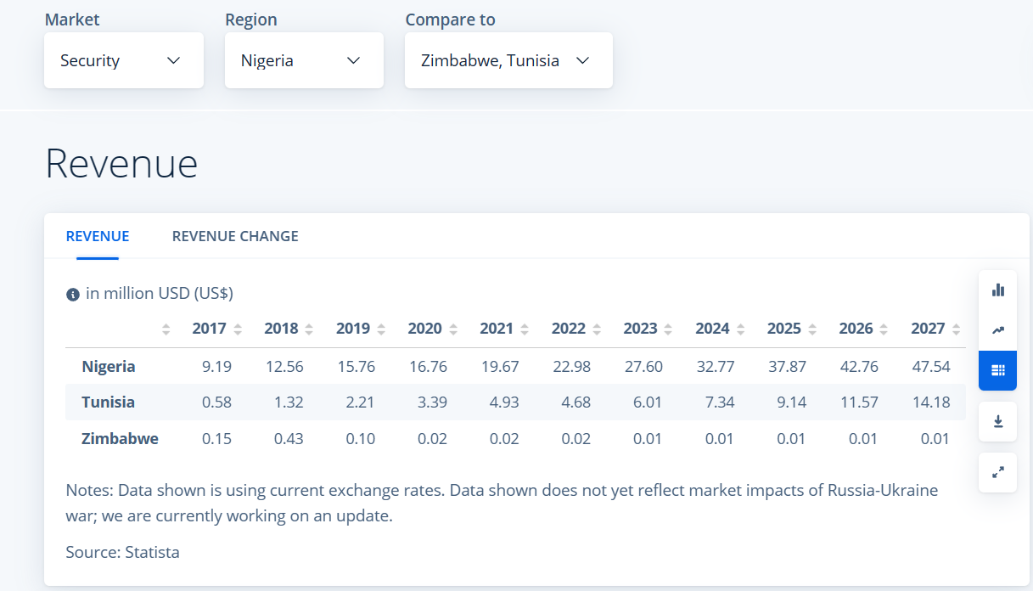

POLITICS
Nigeria
Its reported that 4 in 10 Nigerians live below the poverty line. Its further reported that jobs do not translate Nigerians hard work into an exit from poverty & just 17% of Nigerian workers hold a job able to lift them out of poverty. (Bank, 2023)
However, Lagos itself is on track to become the economic powerhouse for Nigeria and West Africa. But, it’s reported that governing lagos is not for the fainthearted. (Conversation, 2022)

Zimbabwe
The human rights climate in Zimbabwe deteriorated in 2022 without the government taking any meaningful steps to uphold rights and ensure justice for serious past abuses primarily committed by state security forces. There has been little progress on investigations into abductions, torture, arbitrary arrests, and other abuses against opposition politicians and activists. (HRW.Org, 2023)
Tunisa
Tunsia’s transistion to democracy remains incomplete and under stress. Since the presidential measures to suspend the parliament, dismiss the government and draft a new constitution were enacted in 2021 conditions have continued to deteriorate. (USIP.Org, 2022)
Its reported that in 2022 human right violations continue, including the restrictions on free speech, violence against women and arbitrary restrictions under the country’s state of emergency. (HRW.Org, 2023)
Protests and associated classes are still being carried out due to high unemployment, rising inflation and amid opposition parties continued calls for demonstrations against the government. Thousands of protestors have periodically taken to the streets in Tunis and other major cities in response to the deterioriating social economic conditions. (24, 2023)

Logistics & Warehousing
Lagos port is also known as Premiere Port as it’s the largest port in Nigeria. It is well equipped and modern for handling cargo. It connects very well with road connections. (Authority, 2023) . Lagos also has cargo terminals at Murtala Muhammed Airport.
Bulawayo comprises of five modes of transport, road, rail, aviation, inland water and pipeline transport. Unfortunately it does not operate from a main port. (Logistics, 2023)
Tunis operates many freight carriers from its main airport and also from the port. The port is the main port in Tunisa, called La Goulette.

Fullfillment Warehousing
Lagos
Services – Sednawanger
ShipIt | E-COMMERCE FULFILMENT

Bulawayo
None Listed

Tunis
None Listed

Summary
I’m finding it hard to make any natural suggestions from these 3 regions given the politics behind each of them. But if further investigations were to be carried out I would suggest looking further afield into Lagos. Given its reported to become the economic powerhouse for Nigeria and the substanial port it has for logistics.

To aid with your research I have listed some useful links for you to review:

- Starting a business in Lagos: What you need to know (startupguide.com)

- (54) Why Lagos Is A Good Market For The Short-let Business | LinkedIn

ISO 56000 - Review of Innovation Management Standard

Whilst the company is looking to pursue a global expansion its important to remain focused on a companies ability to innovate is a recognised key factor for sustained & economic growth, viability, increased well being and the development of society.
To aid with this transistion this standard provides a structured approach which can lead to better decision-making and more efficient use of resources and improve the overall companies results. It can ensure there is a consistency between all areas of the business, whether that be in the UK or internationally, giving clear direction to all employees, especially senior managers and leaders in that if they show respect to the elements of the standard others will follow.
With the knowledge that the company has already established an innovation vision, this should now be followed up by an innovation policy that will provide a framework of the strategy and objectives that have been set out.
The company should also document the management system and have a control in place to monitor any updates. By providing these guidelines, all employees can follow one process and in turn hopefully reduce the time and costs associated with this expansion and future innovations as they will all be following one system.
Its important to note that one of the greatest assets of a company is communcation and this is included in this series and its vitally important this is managed well, allowing internal and external communications to take place. Especially with the given guidance of on what should be communicated/ when to communicate / with whom to communicate and how to communiate.
The standard also touches on external issues and given the scope of this project is to globally expand it will be key for the company to identify the priority elements of this reference, such as scanning and analysing economic, market, social, cultural, legal, political and environmental aspects during the whole process and beyond. That said its also vitally important to remain focused on internal issues and not to take the eye off the main business structure.
Although I have only touched on a few aspects of the standard and there are many other guidelines such as Time, Finance, Knowledge,Planning etc the overall focus and its exsistence is purely one to help and aid the business with an understanding of innovation and to create a consistent way through its journey so no matter who is working on what there is only one direction to be followed by all.
The standard is broken down into many sections and I would suggest this is throughly reviewed against the current business success and how to build on this.

Bibliography
24, C., 2023. Crisis 24. [Online]
Available at: https://crisis24.garda.com/alerts/2023/03/tunisia-protests-and-clashes-likely-to-continue-nationwide-through-at-least-late-april-update-18
[Accessed 18th May 2023].
Argentina, B. i., 2021. TMF Group. [Online]
Available at: https://www.tmf-group.com/en/news-insights/articles/2018/october/top-10-challenges-of-doing-business-in-argentina/#:~:text=The%20World%20Bank%20Doing%20Business,taking%2011.5%20days%20on%20average.
[Accessed 17th May 2023].
Atlas, W., 2023. World Atlas. [Online]
Available at: https://www.worldatlas.com/articles/languages-of-uruguay.html
[Accessed 6th May 2023].
Authority, N. P., 2023. Nigerian Port Authority. [Online]
Available at: https://nigerianports.gov.ng/lagos-port/
[Accessed 20th May 2023].
Bank, T. W., 2023. The World Bank. [Online]
Available at: https://www.worldbank.org/en/news/press-release/2022/03/21/afw-deep-structural-reforms-guided-by-evidence-are-urgently-needed-to-lift-millions-of-nigerians-out-of-poverty
[Accessed 10th May 2023].
Bank, W., 2023. World Bank. [Online]
Available at: https://data.worldbank.org/indicator/NY.GDP.PCAP.CD?end=2021&locations=IN-AE-PK&start=1990
[Accessed 15th May 2023].
Britannica, 2023. Britannica. [Online]
Available at: https://www.britannica.com/place/Porto-Alegre
[Accessed 5th May 2023].
Chadha, S., 2022. India Times. [Online]
Available at: https://timesofindia.indiatimes.com/business/india-business/trade-benefits-explained-all-you-need-to-know-about-the-india-uae-trade-deal/articleshow/89658408.cms
[Accessed 6th May 2023].
Conversation, T., 2022. The Conversation. [Online]
Available at: https://theconversation.com/the-challenges-of-governing-lagos-the-city-that-keeps-growing-175753
[Accessed 11th May 2023].
Convertor, X. C., 2023. XE Currency Convertor. [Online]
Available at: https://www.xe.com/currencyconverter/convert/?Amount=726618&From=INR&To=GBP
[Accessed 9th May 2023].
Dubai, U. o., 2023. University of Dubai. [Online]
Available at: https://ud.ac.ae/academics/college-of-engineering-it/
[Accessed 30th April 2023].
Dubai, V., 2023. Visit Dubai. [Online]
Available at: https://www.visitdubai.com/en/invest-in-dubai/newsroom/news-insights/trade-logistics-guide
[Accessed 30th April 2023].
Economics, T., 2023. Trading Economics. [Online]
Available at: https://tradingeconomics.com/uruguay/corporate-tax-rate
[Accessed 6th May 2023].
Economy, T. G., 2022. The Global Economy. [Online]
Available at: https://www.theglobaleconomy.com/rankings/security_threats_index/Asia/
[Accessed 14th May 2023].
Express, I., 2023. Indian Express. [Online]
Available at: https://indianexpress.com/article/india/india-pakistan-trade-relations-better-ties-diplomat-8504851/
[Accessed 6th May 2023].
Formations, C., 2023. Company Formations. [Online]
Available at: https://companyformations.co.zw/#:~:text=How%20long%20does%20it%20take,available%20within%2024%20working%20hours.
[Accessed 17th May 2023].
Google, 2023. Google. [Online]
Available at: https://www.google.co.uk/search?q=how+to+calculate+land+area+in+marla&source=hp&ei=fj1OZOyxC9CcgQacxo7QDQ&iflsig=AOEireoAAAAAZE5LjiFEuZK8-ACU8h0DNpeRaeUsR2VV&oq=unit+area+in+marla&gs_lcp=Cgdnd3Mtd2l6EAEYAjIGCAAQFhAeMggIABCKBRCGAzIICAAQigUQhgMyCAgAEIoFEIYD
[Accessed 30th April 2023].
Gov.Br, 2023. Brazil Government. [Online]
Available at: https://www.gov.br/mre/en/subjects/bilateral-relations/all-countries/the-united-kingdom-of-great-britain-and-northern-ireland
[Accessed 18th May 2023].
Gov.UK, 2021. British Embassy. [Online]
Available at: https://www.gov.uk/world/organisations/british-embassy-dubai
[Accessed 12th May 2023].
Gov.Uk, 2023. Gov.UK. [Online]
Available at: https://www.gov.uk/government/publications/exporting-to-pakistan/doing-business-in-pakistan-pakistan-trade-and-export-guide
[Accessed 18th May 2023].
Government, U., 2023. UAE Government. [Online]
Available at: https://u.ae/en/information-and-services/business/full-foreign-ownership-of-commercial-companies
[Accessed 12th May 2023].
Guide, S. U., 2023. Rio Grande De Sul. [Online]
Available at: https://startupguide.com/rio-grande-do-sul-ecosystem
[Accessed May 17th 2023].
Guide, W. T., 2023. World Travel Guide. [Online]
Available at: https://www.worldtravelguide.net/guides/africa/tunisia/business-communications/
[Accessed 19th May 2023].
Guruguay, 2023. Guruguay. [Online]
Available at: https://www.guruguay.com/starting-a-business-in-uruguay
[Accessed 17th May 2023].
Guru, U., 2023. University Guru. [Online]
Available at: https://www.universityguru.com/universities
[Accessed 6th May 2023].
HRW.Org, 2023. HWR.Orj World Report. [Online]
Available at: https://www.hrw.org/world-report/2023/country-chapters/tunisia
[Accessed 18th May 2023].
Kreston.com, 2023. Kreston. [Online]
Available at: https://www.kreston.com/doing-business-in/tunisia/#:~:text=I%20should%20know%3F-,How%20quickly%20can%20I%20set%20up%20a%20business%3F,for%2010%20to%2020%20days.
[Accessed 17th May 2023].
Kumar, S., 2021. CBNC News. [Online]
Available at: https://www.cnbc.com/2022/01/31/the-uae-introduces-its-first-ever-corporate-taxes-set-to-start-in-2023-.html
[Accessed 30th April 2023].
Logistics, Z., 2023. Zimbabwe Logistics. [Online]
Available at: https://dlca.logcluster.org/2-zimbabwe-logistics-infrastructure#:~:text=The%20transport%20sector%20in%20Zimbabwe,12.1%25%20are%20bitumen%20surfaced).
[Accessed 20th May 2023].
Map, G., 2023. Google Maps. [Online]
Available at: https://www.google.co.uk/maps/search/lahore,+mumbai,+dubai/@27.1601819,52.5376566,4.25z
[Accessed 30th April 2023].
Monitor, A., 2023. AL Monitor. [Online]
Available at: https://www.al-monitor.com/originals/2023/01/dubai-unveils-8-trillion-economic-plan
[Accessed 30th April 2023].
Newsround, B., 2022. BBC. [Online]
Available at: https://www.bbc.co.uk/newsround/46428985
[Accessed 2023 April 2023].
Parkin, S. K. &. B., 2022. Financial Times. [Online]
Available at: https://www.ft.com/content/0cc60d7d-8461-4584-b497-508ea3ac8dd0
[Accessed 6th May 2023].
Profit, T., 2023. Take Profit. [Online]
Available at: https://take-profit.org/en/statistics/corporate-tax-rate/brazil/
[Accessed 6th May 2023].
PTI, 2023. Ecomonic Times - India Times. [Online]
Available at: https://economictimes.indiatimes.com/news/india/india-never-halted-trade-relations-with-pakistan-indian-diplomat/articleshow/98749224.cms?from=mdr
[Accessed 30th April 2023].
PWC, 2023. PWC Worldwide Taxes. [Online]
Available at: https://taxsummaries.pwc.com/pakistan/corporate/taxes-on-corporate-income
[Accessed 2nd May 2023].
QS, 2021. Top Universities.com. [Online]
Available at: https://www.topuniversities.com/university-rankings-articles/qs-best-student-cities/lahore#:~:text=Study%20in%20Lahore,-By%20Chloe%20Lane&text=There%20are%20three%20universities%20currently,Lahore%20University%20of%20the%20Punjab.
[Accessed 30th April 2023].
Review, W. P., 2023. World Population Review. [Online]
Available at: https://worldpopulationreview.com/
[Accessed 2023 April 2023].
Salaries, W., 2023. World Salaries. [Online]
Available at: https://worldsalaries.com/average-business-development-manager-salary-in-mumbai/india/
[Accessed 9th May 2023].
Salary.com, 2023. Salary.com. [Online]
Available at: https://www.salary.com/research/br-salary/benchmark/business-development-manager-salary/br/porto-alegre
[Accessed 10th May 2023].
Salary, A., 2023. Average salary. [Online]
Available at: https://www.averagesalarysurvey.com/business-development-manager/montevideo-uruguay
[Accessed 10th May 2023].
Statista, 2023. Statista. [Online]
Available at: https://www-statista-com.ezproxy.cardiffmet.ac.uk/outlook/dmo/smart-home/security/custom?currency=USD&locale=en&token=PgtGYzeMjBKlfODPfjPc_D9rM9DRFR42Vk1ZYo8JHVVBr76eHusUtfhnM2nIeWVLCL-ahY8R3sZfe5myf8tvd222CNDh7VB2698nEUXk7zYQShCQtRVeOhD5LA%3D%3D
[Accessed 10th May 2023].
Today, G., 2021. Gulf Today. [Online]
Available at: https://www.gulftoday.ae/business/2021/05/06/uae-and-pakistan-to-bolster--trade-investment-relations
[Accessed 6th May 2023].
Trade, D. f. B. &., 2023. Department for Business & Trade. [Online]
Available at: https://assets.publishing.service.gov.uk/government/uploads/system/uploads/attachment_data/file/1156547/united-arab-emirates-trade-and-investment-factsheet-2023-05-18.pdf
[Accessed 18th May 2023].
USIP.Org, 2022. USIP.Org. [Online]
Available at: https://www.usip.org/publications/2022/12/current-situation-tunisia
[Accessed 18th May 2023].

