Module Title :Management & Organisational Behaviour
Module Code :BMIH5004

Student Name: Alina Grigore
Student ID: 2127560
Lecture Name: Charlotte Joyner

Table of Contents
Introduction 1
Company Overview 2
Organisation structure 2
Organisational Culture 3
Organisational Goals 4
Recent Change Initiatives and Their Impact 4
Current Business Performance 7
Future Strategic Direction 8
Conclusion 10
References 11

Introduction
IHG, known as InterContinental Hotel Group, the leading hotel group worldwide has a strong customer base throughout the world who are familiar with and get served through their varied range of companies that are unique from one another. They have the ideal hotel business to serve the tourists and business proprietors, regardless of the requirements that they may have. Moreover, the company is implementing crucial plans to ensure that its management system, depending on the culture, can gradually grow its strategic performance day by day. This report will briefly discuss the company’s organisational structure, culture and goals. Then it will look into the recent change initiatives that it has taken and how it has impacted gradual growth. Lastly, it will explore the future strategic direction and its current business performance.

Company Overview
The British global hospitality firm IHG has its headquarters in Denham, which is in Buckinghamshire country, England. IHG Hotels & Resorts is a prominent hotel company with approximately 345,000 employees operating in over 100 nations, dedicated to providing True Hospitality for Good (Maalouf, 2023). It has over 6,261 hotels worldwide consisting of 929,987 rooms altogether. The company runs hotels through franchising, management, and ownership.

Organisation structure
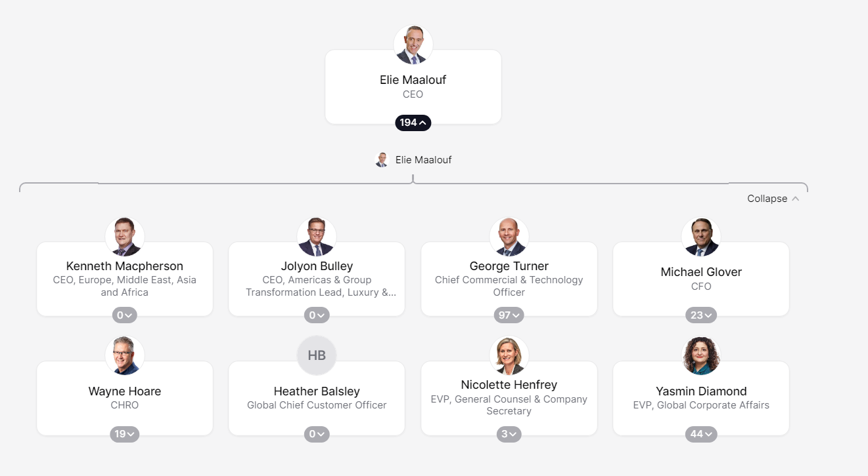
Figure 1: Organisational Structure of IHG (IHG ORG, 2024)
Since it is an international hotel that operates in a number of nations throughout the world, the Intercontinental Hotel has a complicated organizational structure. The hotel experienced a significant reorganization in several areas, including the Asia Pacific region, between the years 2002 and 2003 (Evans, 2023). In the earlier structure, there were numerous tiers of administration, which resulted in the company incurring a great deal of expense due to the extremely substantial operating expenses. This reorganization was carried out with the intention of lowering the layers of leadership as well as the expenditures associated with activities. IHG is described as having an integrated organizational structure, which combines both operational and area management structures.

Organisational Culture
The well-organized governing council has been instrumental in shaping the social responsibilities of the firm during the course of its existence( Boddy, 2014). The corporate social liability of the firms has been improved throughout the past decade as a result of the measures that have been proposed by the regulatory body. These regulations include safeguarding the environment, healthcare assurance, and a few other ecological obligations (Mullins, 2020). Intercontinental Hotels Group is a huge corporation that has a significant number of workers; the firm views its people as a strength by treating them as such. The IHG's organizational culture has the goal of fostering a constructive work environment, and in order to accomplish this objective, the firm is continuously working to enhance its operational procedures. Communicating, being fair, working together as a cohesive unit, consuming risks, and being creative are all encouraged by the firm. IHG has a culture that encourages suggestions from all of its workers and maintains a policy of transparency as part of its corporate culture (Avelar, 2020). The IHG is currently making preparations to extend its business activities to other nations. In order to do this, they will need to devise approaches that are congruent with the goal of the firm as well as the culture that exists in the nation in which they will be operating.

Organisational Goals
IHG’s objective is to influence the culture, animate businesses, and demonstrate a dedication to positively impacting the visitors, coworkers, directors, and groups, as well as safeguarding the environment. Engaging intentionally in this manner enables the company to seize chances to create beneficial changes, ensuring that True Hospitality for Good is experienced in various forms (Maalouf, 2023). It involves forming relations to unite family and friends, fostering a sense of community for peers as they advance in their jobs at IHG, equipping individuals in numerous groups with the required abilities for professional success through IHG, and aiding hotels in implementing attainable practices to protect their environment.

Recent Change Initiatives and Their Impact
Intercontinental Hotels Group emphasizes highly its leadership. On a daily basis, IHG handles workshops for their staff to comprehend a management structure that is aligned with IHG’s vision to create a positive work culture. This is why IHG has taken certain change initiatives that significantly changed the outlook of this group. Such as,
- The hotel sector on a worldwide scale has been taking action to the shifting public perception towards sustainable getaways by championing a variety of projects and procedures, ranging from trash elimination campaigns to renewable energy technologies. In 2019, IHG made history by becoming the very first hotel operator to make an agreement to substitute bathroom replicas with larger conveniences throughout every brand. In 2021, IHG went even further by making an affiliation removing disposable products and changing to reusable or repurposed substitutes throughout the guest stay by the year 2030 (Maalouf, 2023).
- IHG Hotels & Resorts firmly believes that it has the obligation and the potential to create a constructive influence and contribute to the development of sustainable tourism in the coming years. IHG launched 'Journey to Tomorrow' in 2021 as a result of its pledge to bring about positive improvements (Voegeli, 2021). This initiative is a 10-year endeavour that includes specific promises to promote progress for individuals, groups, and the world. It is connected with their mission of 'True Hospitality for Good' and the United Nations Sustainable Development Goals.
- IHG began providing training on deliberate inclusiveness to general managers and executives in major markets in 2021. Since then, it has expanded the program to include hotel colleagues, and by 2023, over sixteen thousand individuals had successfully attended the training (Roy, 2022).
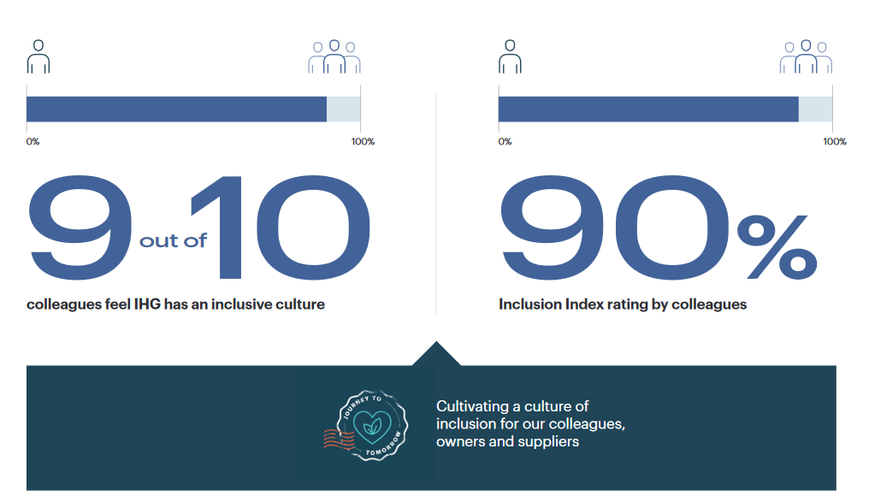
Figure 2: Diversion of Culture and the Inclusive Index (IHG Plc, 2022)
- The Employee Resource Groups (ERGs) that they have, personnel engagement discussions, and the knowledge that they have gained from their Inclusivity Index are some of the various ways that they are monitoring the achievements. In the year 2023, the index revealed that nine out of ten workers said that IHG had a working environment that embraced diversity and inclusion (IHG Plc, 2022).
- Through the implementation of IHG Green Engage, a web-based green management structure, they are able to assist the hotels in accomplishing their sustainability objectives (Roy, 2022). For their real estate located all over the world, this system serves as a worldwide standard that enables them to monitor, summarise, and control their consumption of power and water, as well as their junk management, all while likewise lowering their expenditures on utilities and minimizing their effect on the surroundings. It acknowledges the advancements that its hotels have made across 4 different grades of accreditation, and there are over two hundred Green Solutions offered to assist them in making more environmentally friendly decisions (IHG Plc, 2022). An example of this would be the implementation of mass facilities as a component of the objective to remove disposable plastic goods, the use of technologies based on artificial intelligence to decrease food wastage, and the collaboration with community members to address water conservation challenges in places that are at the highest risk. Furthermore, IHG is continuing the collaboration with the hotels in order to cut the use of carbon in accordance with established climate research. There is a significant emphasis placed on enhancing the energy effectiveness of all of the facilities through the implementation of an Energy Reduction Metric in the year 2022 (Evans, 2023).

Current Business Performance
The accomplishments of recent years demonstrate IHG’s capacity to boost returns and enhance its values, operations, and reputation among important stakeholders (Voegeli, 2021). This approach allows the firm to capitalize on this market need, and the successes of this year demonstrate their capacity to do so.
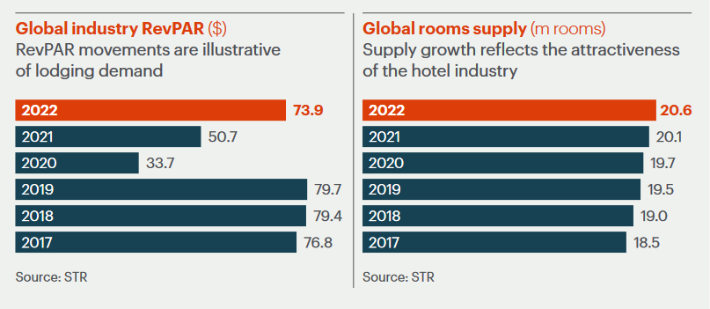
Figure 3: PevPAR index of IHG (IHG Plc, 2023)
Gathering substantial interest for the goods and services, alongside worldwide RevPAR coming near the levels seen in 2019, notably ADR 8% surpassing the competition. The RevPAR is continuously increasing, even if it had a notable fall in 2020-2021 due to COVID-19.
Improving the worldwide procuring solutions, collaborating directly with the IHG Owners Association and the employees to prepare for the demands of owners, and discovering further methods to use centralized buying to offer services that are affordable while also maximizing efficiency. Even the relaunch of the iconic Regent Hotels in Hong Kong and the signing of eight incredible properties for Six Senses Hotels properties & Spas were two of the most significant events for the premium brands (IHG Plc, 2023).
Momentum continues to grow around the larger recent brands as well, with the 6 companies that it has acquired since 2017 (with the exception of Iberostar Beachfront Resorts) currently generating over 10 per cent of its overall backlog. In the Americas, IHG has established the primary Atwell Suites facilities, and in Canada, it launched the debut avid lodges facility (Maalouf, 2023). The voco business that it represents has just reached the significant milestone of 100 hotels that have been built and executed, and the VignetteTM Series is committing to its first 17 hotels before its closure in 2022 (IHG Plc, 2023).
To realise this goal, IHG needs to collaborate with one another and make ecology a top priority in all sectors of the company's activities. It is imperative that governing agencies, hotel owners, providers, and tourists all collaborate in order to establish a tourism environment that is more environmentally conscious and accountable.

Future Strategic Direction
In order to build a hotel industry that is reliable and successful, it is essential to embrace long-term viability which is not only a fad but a required step (Fuchs, 2022). It should imagine a future in which tourists migrate to different nations not just because of the country's diverse cultural diversity, but additionally because of the genuine and mindful ecological activities that the country can provide.
Certain strategic actions it initiates to play in the coming years are,
- Despite the fact that their sector needs to adjust to a macroeconomic climate that is always shifting, the foundations of its continued development have not altered. These fundamentals include the desire of people to travel, the expansion of the population as a whole, and the increasing affluence in emerging economies (Fuchs, 2022). It is anticipated by Oxford Economics that the number of hotel room nights consumed throughout the world will surpass the levels seen in 2019 by the year 2024 and will continue to increase at a compound annual growth rate of +6% from 2022 until 2032 (Rafahat, 2022).
- It is clear that their well-established brands continue to be a tremendous development engine, as evidenced by the fact that the Holiday Inn Brand Family will be responsible for half of all hotel launches in 2022 (Rafahat, 2022). As part of its continuing improvement in adhering to the 2021 excellence assessment, it has introduced affordable create assistance or meals and drinks notions for Holiday Inn, Hotel Indigo, InterContinental Hotels & Resorts, and EVEN Hotels (Voegeli, 2021). Additionally, by the year 2025, IHG will have revised two-thirds of the Americas Holiday Inn property and seventy per cent of the Crowne Plaza Hotels & Resorts estate. Additionally, IHG celebrated the inauguration of Kimpton Hotels & Restaurants' first location in Australia, as well as the opening of 18 new locations for Hotel Indigo, and they were awarded World Travel Awards for Holiday Inn, InterContinental, and Voco Hotels (Fuchs, 2022).

Conclusion
IHG, as the leader in this business, has a responsibility to take action with an unshakable conviction in sustainable development as the number of tourists who place an increased emphasis on sustainable encounters continues to rise. Through the power of working together, it has the ability to create a future in which travel provides a fresh impetus to good influence, passing behind an ethic of sustainability, preserving culture, and communal growth. This report has looked into the company’s structure and diversified culture, mentioning its goals and missions. It has also discussed the recent change initiatives and their impacts. Lastly, it has discussed the company’s strategic direction focusing on its current business performance.

References
Avelar, P.A.S., 2020. Hotel industry growth trends–the case of intercontinental hotels group (Doctoral dissertation).
Boddy, D. (2014) Management: An Introduction (6th Ed), Harlow, Pearson
Evans, N.G., 2023. IHG – competing on the World Stage. Strategic Management for Tourism, Hospitality and Events, pp.681–693.
Fuchs, M., 2022. Crisis communication and corporate social responsibility: a case study on IHG Hotels & Resorts and what organizations can learn from Covid-19 (Doctoral dissertation).
IHG ORG (2024) IHG - org chart, teams, Culture & Jobs, THE ORG Chart, Culture and Structure. Available at: https://theorg.com/org/ihg (Accessed: 22 February 2024).
IHG Plc, 2022. Annual-report-2022.pdf. [online] IHG Plc. Available at: <https://www.ihgplc.com/~/media/Files/I/Ihg-Plc/investors/annual-report/annual-report-2022.pdf> [Accessed 21 Feb. 2024].
IHG Plc, 2023. [online] Responsible business report 2022. Available at: <https://www.ihgplc.com/~/media/Files/I/Ihg-Plc/investors/annual-report/ihg-responsible-business-report-2022.pdf> [Accessed 21 Feb. 2024].
Maalouf, E., 2023. [online] InterContinental Hotels Group plc. Available at: <https://www.ihgplc.com/en> [Accessed 21 Feb. 2024].
Mullins, L. (2020) Organisational Behaviour in the Workplace (12th edition) Harlow: Pearson
Rafahat, M., 2022. Service Strategy of Hotel Holiday Inn (Doctoral dissertation, Sonargaon University (SU)).
Roy, S., 2022. Changes in Hotel Accommodation Trends in the Past Decades. ATITHYA: A Journal of Hospitality, 8(1).
Voegeli, C., 2021. A Case Study of Knowledge Management Practices at the Intercontinental Hotels’ Group. Available at SSRN 3819409.

