Software Development
Florin iotu -2020809
Table of Contents
A1. Control structures 3
A2. Different types of loops in python 5
A3. List 6
References 9

A1. Control structures
The control flow is generally known as a form through which the code gets executed. It mainly states the order at which the code gets executed. In the case of the python programming language, the control flow is basically done with the help of loops, conditions along with the function and function calls. These are the things that are mostly required for any coding language its line of code one after another but in case of python these are the main dependent. There are three type of controls structures are present in the python language such as;
- Sequential
- Selection
- Repetition
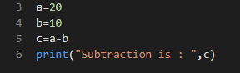
Figure 1: sequential
(Source: Educative.io, 2021)
The sequence control structures or sequential statements are the one which is known as the default mode of the execution process. If the code is to be executed by itself without any guidance then this type of control structures will be used as common unless and until a specific structure is not implemented. As the name suggests this type control structure which allows every line of code to get executed in a sequential order. The sequence or an order at which the code is written or presented in that order the code will get executed one after another. In this type of control structure one problem arises in common that is if any line code or logic contains errors or issues then complete execution will be affected.
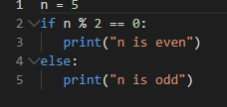
Figure 2: selected
(Source: Educative.io, 2021)
Selection statements are the one which are used in order to control the execution and implementation of the program. This is a special type of control structure that is used in order to tackle multiple options or to use multiple options as per situation or the data coming into it.
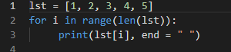
Figure 3: repetition
(Source: Educative.io, 2021)
Another most important and main used in order to lower done or to shorten the code or the line of code in such a place where a single condition or a function is used multiple times (Louati et al. 2019). This is mainly used to repeat a group of code to be used multiple times without implementing similar code in multiple places. This repetition or reusing is generally done with the help of for loop and while loop.
Detail selection control structure
The selection control structure is also stated as the branching and decision control structure. This is a structure where multiple actions are used at once and among all these actions only certain actions work as per the condition and data. This selection structure uses several statements but among those one of the most used statements are the if and elif
If statement
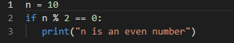
Figure 4: if statement
(Source: Educative.io, 2021)
The if statement is the most common statement where a condition is used in the statement and under the statement some action is placed. If the condition is true, then the below action will run or else it won't execute.
Elif statement
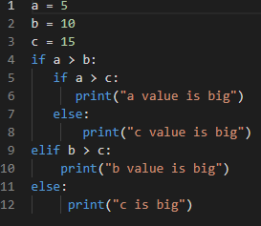
Figure 5: elif
(Source: Educative.io, 2021)
The Elif statement is also known as the nested statement. This is a type of statement which is present in the same line of the if statement and this statement is mainly under another if statement. This statement is used in order to check all parts of the order and to get correct output at once

A2. Different types of loops in python
Loops are one of the most important and most used properties in any kind of coding language. This helps in arrays, calculation, condition implementation and many more as per the requirement of the code. The Main loops that are used in the python languages are:
- For loop
- While loop
- Nested loop
The for loop is the most used and very essential type of loop that is used in programming. This is a type of loop that allows the programmer to implement or to use a similar set of code multiple times and in a proper sequential way. The for loop is also widely used with the if statement in order to continue a circle properly unless and until a proper output has occurred.
Another most used loop type is the while loop; this is one of the initial loop statements which are used in a program. It is a type of loop that allows the programmer to reuse a particular statement or multiple statements in case of true or correct condition. It initiates the loop only after the execution of the condition (Häfner et al. 2018).
Lastly the nested loop, this is a type of loop that is mainly used under another loop. The term nested here states that a loop is inserted into another loop in order to provide multiple conditioned loops. This makes the programmer use multiple types of loops as per the output coming from the previous stage.
Difference between the loops
The for loop is the one in which the loop is implemented as per the range that has been provided in the range part. The loop gets executed up to the range that has been provided. The action that is present under the loop also gets executed up to such range. The while loop is the one that at first implements the condition and then the actions are followed under it. This type of loop is used so that at first the condition is checked then the continuation (Mcgibbon et al. 2021). Another type of loop is the nested loop, this loop that is present under another or with another loop. Loops that are associated with each other contain different actions with some condition as per the condition the loop gets executed.
For loop
This programming language allows the use of the if and else statement perfectly in the case of the loops. In case of this for loop the if else statement plays a huge role. In the for loop the range can be setted up to a certain extent or a specific range can be allocated. Under this loop the if and else conditions are placed so that the conditions can be applied to different types of numbers or values. In this condition the break function is used so that it can allow the loop to divert into the next number or value.

A3. List
A list is a type of place where multiple integers, characters, strings and float type of values are kept in an order. These values can only be called through their order number at which they are inputted or present. The values present in the list are separated through commas and are mainly presented in third brackets. A list variable can be initiated in multiple ways such as:
- Empty list values
- Specific type of values such as integer or string or character or float
- Mixed data type values
- Nested values
The empty type of list is the one which can be initiated if the values are unknown, or the values can be implemented of different types. This initialization helps in creating list types where multiple values can be stored in an order of any type, or the type can also be specific during the initial stage.
Another type is the list containing a single type of data type’s values. In this type only a single type of values is stored in the list variable. Any other type of data type values cannot be stored as during the initial stage the type of variable is initiated.
Figure 6: multiple data type list
(Source: Dataquest.io, 2021)
The mixed type of list is the type of list that contains multiple data type values in it. This type of list can be very beneficial for stored and extracting purposes as it contains multiple types of values such.
Another most important and essential type of list is present. In this list type another list present in a list. This type of list is used in order to get the details of one list or the other as per the requirement. The values present in the list can be extracted through numbers and the list is also to be chosen through the numbers (Kopei, Onysko and Panchuk, 2019).
Difference between list and normal variables
A normal variable contains a single value without any order to anything and the normal variable does not even require an order too. But the list variable contains multiple values in it and can take up to 'n' number of values. In the list the value present or entered is scheduled in a specific order which mainly starts from 0. The first number of values inserted in the list is inserted in the 0th value and followed by 1, 2 and so on. In the normal variable only one type of value can be gathered but, in the list, different values can be fetched as per the requirement. The value is the list can be selected from one end to the other too. The value selection is mainly done through their insertion number (Triantafyllidis and Papageorgiou, 2018).
Accessing element of list
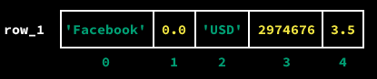
Figure 7: element and its values
(Source: Dataquest.io, 2021)

The elements that are inserted in the list can only be accessed or through their values. As every element whether it is of integer, float or strong are stored in a sequential way by numbering their insertion number. As this insertion number is initiated with the particular element through these values. Through these values the range or a particular element can also get selected by specifying the starting and ending values of the element.

PART B
Exercise 1:
Below given is the script of the finding the total number of the products and total price of the products.
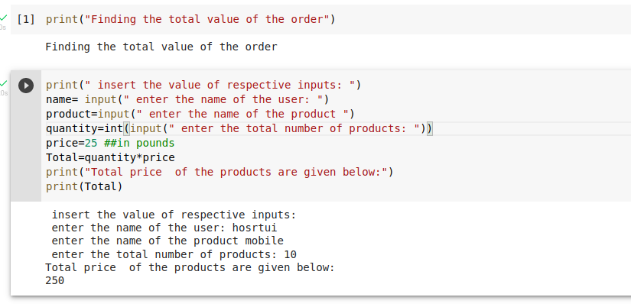
Exercise 2:
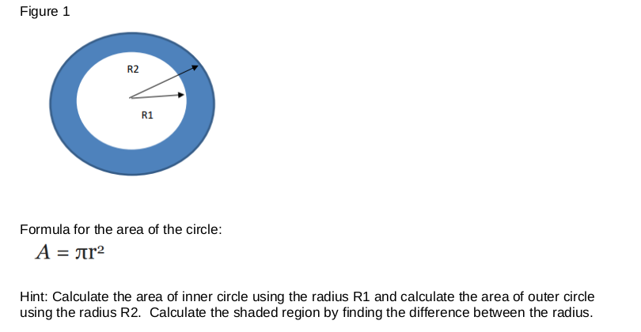

We will be using the python to try to find out the area of the circle and also the difference of the two circles.
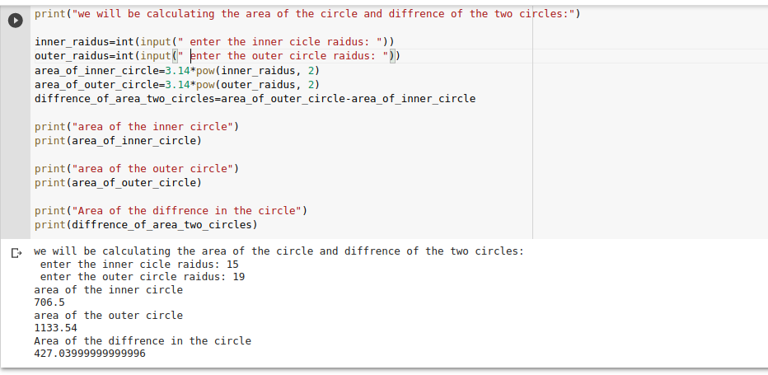

EXCERCIS:3
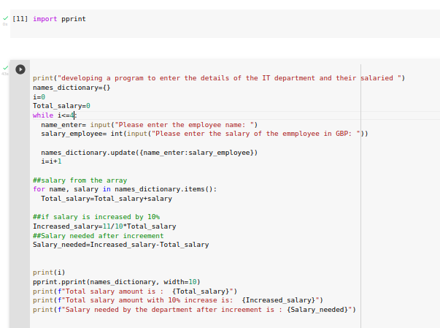

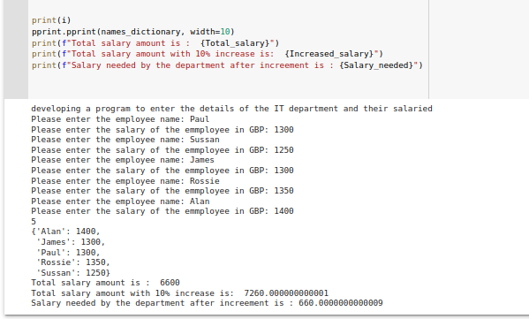

EXCERCISE:5
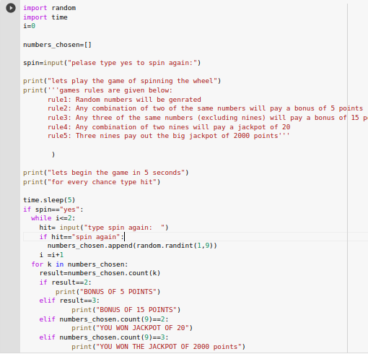

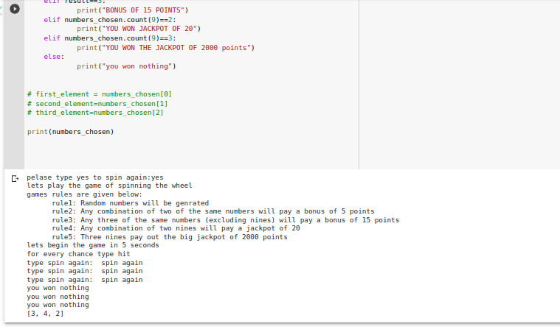

References
Dataquest.io, 2021. Python-list-tutorial, visited on: 29.07 2021 https://www.dataquest.io/blog/python-list-tutorial/
Educative.io, 2021. What-are-control-flow-statements-in-python, visited on: 29.07 2021
Häfner, D., Jacobsen, R.L., Eden, C., Kristensen, M.R.B., Jochum, M., Nuterman, R. and Vinter, B., 2018. Veros v0.1 – a fast and versatile ocean simulator in pure Python. Geoscientific Model Development, 11(8), pp. 3299-3312.
https://www.educative.io/edpresso/what-are-control-flow-statements-in-python
Kopei, V.B., Onysko, O.R. and Panchuk, V.G., 2019. Component-oriented acausal modeling of the dynamical systems in Python language on the example of the model of the sucker rod string. PeerJ Computer Science, .
Louati, A., Elkosantini, S., Darmoul, S. and Lamjed, B.S., 2019. An immune memory inspired case-based reasoning system to control interrupted flow at a signalized intersection. The Artificial Intelligence Review, 52(3), pp. 2099-2129.
Mcgibbon, J., Brenowitz, N.D., Cheeseman, M., Clark, S.K., Dahm, J.P.S., Davis, E.C., Elbert, O.D., George, R.C., Harris, L.M., Henn, B., Kwa, A., Perkins, W.A., Watt-Meyer, O., Wicky, T.F., Bretherton, C.S. and Fuhrer, O., 2021. fv3gfs-wrapper: a Python wrapper of the FV3GFS atmospheric model. Geoscientific Model Development, 14(7), pp. 4401-4409.
Triantafyllidis, C.P. and Papageorgiou, L.G., 2018. An integrated platform for intuitive mathematical programming modeling using LaTeX. PeerJ Computer Science, .

