Emerging IS/IT in Health and Social Care Settings (International Context)
Introduction
To address evolving challenges across health and social care settings, there is an active global demand to implement modern, innovative digital technologies. Two distinct themes contributing to this challenge are an ageing population and chronic disease prevalence, which can affect both workforce capacity and efficiency, and rather than asserting more of the same resource, meaningful digital transformation is needed. (Wolf, 2025)
The rise and exploitation of Artificial Intelligence (AI) within the medical field has been fuelled by the growth of clinical data capture, and breakthroughs in Deep Learning (DL) and Machine Learning (ML), which has seen improvements in accuracy and efficiency when supporting clinical decision making (Meca and Ali, 2024).
Digital health advocates believe Remote Patient Monitoring (RPM) has the potential to transform disease management, health outcomes, and patient care, especially for individuals with multiple chronic conditions who lack convenient access to providers (Bipartisan Policy Centre, 2004). While AI-driven Clinical Decision Support Systems (CDSS) actively incorporating AI models to better analyse clinical data and support more efficient and accurate decision making.
RPM and AI-CDSS have the potential to enhance health outcomes by improving medical diagnosis and data-based treatment decisions as well self-management of care and person-centred care (World Health Organisation, 2021). This essay will explore both technologies and provide insight, analysis and comparison, whilst considering their strength, value and limitation within the global health and social care setting.
Method
To identify and evaluate the appropriate technologies, searches were conducted utilising the UWTSD online resource library, as well as PubMed, BrowZine and Google Scholar.
Exclusive criteria were applied through search filters to restrict results to less than 5 years old, ensuring literature was reflective of emergent technology status. Keywords including ‘international’, ‘global’ and ‘non-UK based’ were also used within searches to remove the appearance of UK-related literature.
Information was gathered from peer-reviewed journals, case studies and vendor documentation, with a total of 27 items of literature evidenced from and referenced.
Review of emerging technology 1 - Remote Patient Monitoring (RPM)
The aim of Remote Patient Monitoring (RPM) or telemonitoring is to remotely capture and share patient health-related data with clinicians via digital transmission. The reported benefits of this include early detection of disease decompensation, earlier intervention opportunity, increased patient education and improvements to the patient–physician relationship (Farias et al., 2020). Whilst there is reported evidence to support benefit realisation, there are contrary findings in which success has been limited. Barriers such as reliable device connectivity and patient resistance to adopt RPM are documented, with correlations identified across age, location and level of income.
The significance of RPM can be traced back to a key milestone event during May 1961, when NASA successfully tracked an astronaut’s biological data via electrocardiogram (EKG) in real time from the ground. Over the following decades, RPM experienced a slow-but-steady growth, but it was the COVID-19 pandemic which propelled this technology to the forefront of medical revolution (Hegde and Eid, 2021).
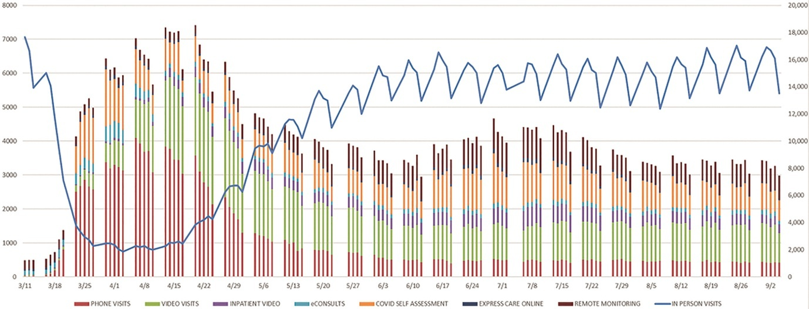
Fig.1 Chart showing the growth of telehealth and virtual care cases during the COVID-19 pandemic (Haddad et al., 2021)
In address to the pandemic the Mayo Clinic Centre for Digital Health, in partnership with a multidisciplinary team of COVID-19 physicians, created a strategy to leverage existing products (including RPM technology) to rapidly support clinical management of patients with Acute COVID-19. The expected goals were a reduction in healthcare resource utilisation, greater fostering of self-management, and reductions in the cost of care (Haddad et al., 2021).
Two Clinical workflows were established to address patients identified as either high-risk or low-risk for contracting severe COVID-19. Dictated by their clinical assessment outcome, patients would receive care-model appropriate home-based RPM devices, including pulse oximeters, thermometers and blood-pressure monitors. Utilising these devices, patients were required to report symptom assessments twice daily. To address the intake of new data, RPM registered nurses were introduced made responsible for responding to the initial clinical assessments, validation of abnormal physiologic data, evaluating concerning symptoms, and providing supportive care recommendations when appropriate. The introduction of a nurse-led care model resulted in only 9-18% of alerts requiring escalation to the small core team of physicians (Haddad et al, 2021). This approach shows the significance of having appropriate resource enabled to realise RPMs value.
Lathauwer et al. (2025) investigated the use of non-invasive RPM intervention on patients diagnosed with Heart Failure (HF), citing causes for increasing numbers of HF cases due to an ageing population, enhanced survival and earlier diagnosis. An objective of the study was to understand whether RPM could reduce HF related hospitalisation, with results being measured using the Odds Ratio (OR) method. Multiple studies across over 16,000 patients were analysed with the types of RPM considered extending beyond the use of at-home devices, with a view to identifying the effectiveness of each. As this paper is focussing on those classified as at-home devices, the discussion will be restricted to these types only. The outcome of data analysed showed that when devices monitoring weight, blood pressure and heart rate were implemented, reductions in instances of hospitalisation could be observed, with OR scores ranging from 0.74 to 0.82. Whilst not considered within this discussion it is worth noting that use of other forms of RPM showed a greater reduction of instances, with Video Calls being the most effective at 0.54.
When considering barriers to success, Thomas et al. (2021) undertook a systematic review of RPM which acknowledged that whilst incorporating technology capable of accurately detecting a decline in health is significant, data and generated alerts must trigger actionable and timely responses by health care workers to realise the benefits RPM can introduce. This proposes that considerations to change the model of care may also required in addition to implementing new technology.
A study examining patient experience with at-home RPM devices also identified numerous barriers to successful adoption, including patient access to a reliable internet connection to transmit data. This contributes to an inconsistency in data reporting and presents clinicians with an incomplete picture of a patient’s condition, which could lead to delays in clinical decision making or misdiagnosis, which in turn, introduces patient safety concerns (Chu et al., 2024). The availability of reliable internet connection could also be correlated to patient age, location and economic factors, requiring additional consideration when assessing the effectiveness of home-based RPM devices.
The findings of Haddad et al., (2021) Thomas et al., (2021) and Chu et al. (2024) suggest that more efficient outcomes and improved workflow is achievable when patients are supported to feel empowered with the use of at-home RPM devices, leading to enhanced self-management. Of equal importance is the need for health care workers to be appropriately trained and given appropriate capacity to react to incoming alerts and data to support better outcomes and inform and improve the future use of efficient RPM use.
Review of emerging technology 2 – AI Driven Clinical Decision Support (CDS) Systems
Once relegated to standalone systems reliant on human-programmed medical knowledge, CDSS were introduced to assist health care workers in decision making, and to increase efficiency and accuracy of diagnoses. They have seen a rapid evolution since their initial use in the 1970s and 1980s, driven by an increasing global integration of rich-data electronic medical records. CDSS now make use of web-applications or direct integration with Electronic Health Records (EHRs) and use advanced AI models and AI subsets ML and DL to leverage large-scale data sets and advanced algorithms (Chen et al., 2023; Ramgopal et al., 2022 and Sutton et al., 2020).
Effective disease diagnosis is still considered to be a global challenge and viewed as an area where AI tools could be effective in supporting health care workers in making better informed decisions. An example of this is an AI-DL model mining and reviewing large sets of data to establish pattern-identification, with evidence supporting that this can be applied to enable predictive and early detection of diseases (Alowais et al., 2023).
Whilst AI within CDSS possesses the capability to support with improved decision-making and diagnostic accuracy, there is a reliance on the completeness of EHRs, developed algorithms, technology and the availability of statistical and analytical data to ensure it can function efficiently. Studies into data imbalance and its impact on AI-DL emphasises the need for language/label consistency within datasets to enable efficient training of algorithms. and reduce the volume of anomaly detection (Mun et al., 2024 and Ouanes and Farhah, 2024).
Alfieri et al. (2021) conducted a study into a DL model's ability to obtain a predictive diagnosis score for Acute Kidney Injury (AKI) across a dataset of 35,573 Intensive Care Unit (ICU) patients. Data extraction focussed on analysing patient levels of urine output and serum creatine across hourly readings. The DL model was trained to identify trend data and predict probabilities of severe AKI development in patients. The results showed that the DL model was able to predict 88% of AKI cases 12 hours before they met the diagnostic criteria. Despite 12% of alerts generated to health care workers being false positives, the overall result supports the use of a DL model to inform early diagnosis of AKI, however it should be considered that the study is a retrospective analysis of patient data and therefore presents a limitation of the findings.
Wang et al. (2025) also acknowledged the benefits of utilising AI to support earlier diagnosis against conditions such as AKI and Chronic Kidney Disease (CKD), but highlighted barriers to effective algorithm training when smaller, more constrained datasets (also known as low-dimensional data) were analysed. Their findings also draw upon the human-element, specifically the need for robust peer-review of ML model output, the purpose of which is to ensure its quality and integrity is appropriate to inform future clinical practice. Unlike traditional clinical research, this demands a layer of comprehensive ML understanding from those involved, to ensure low-quality research does not inform future clinical practice and introduce the potential for patient safety risk. To address this, there is a recommendation to broaden panel review membership to include subject matter experts who can assist in bridging the gap of understanding to maintain high-quality research outputs.
Another AI subset which can be considered within CDSS is Natural Language Processing (NLP). Whilst DL can consider unstructured data in its analysis, the specific objective of NLP is to bridge the gap between clinical human language and computational systems (Chen et al., 2023 and Juhn and Liu, 2020). Estimates from Gartner and the International Data Corporation (IDC) report that unstructured data accounts for almost 80% of healthcare data currently available (Hyland, 2022) and is defined as being “less organised and more subject to irregularities, such as information contained within clinician notes and imaging reports” (Ramgopal et al., 2022).
Cohen et al. (2022) sought to evaluate the performance of NLP in suicide risk prediction. A key focus of their study was to assess the efficiency of NLP at assessment phase, rather than the evaluation of existing records. The model selected was previously trained using 440 patient transcripts, with 70 new patient participants selected and split into one of two groups (Case and Control). Those in the Case group we identified as having presented to an Emergency Department (ED) with suicidal ideation or attempt within the last 30 hours, whilst Control group participants presented to an ED with no history of suicide or mental health related conditions. Both groups were assessed as per the study and modelling content in Fig. 2.
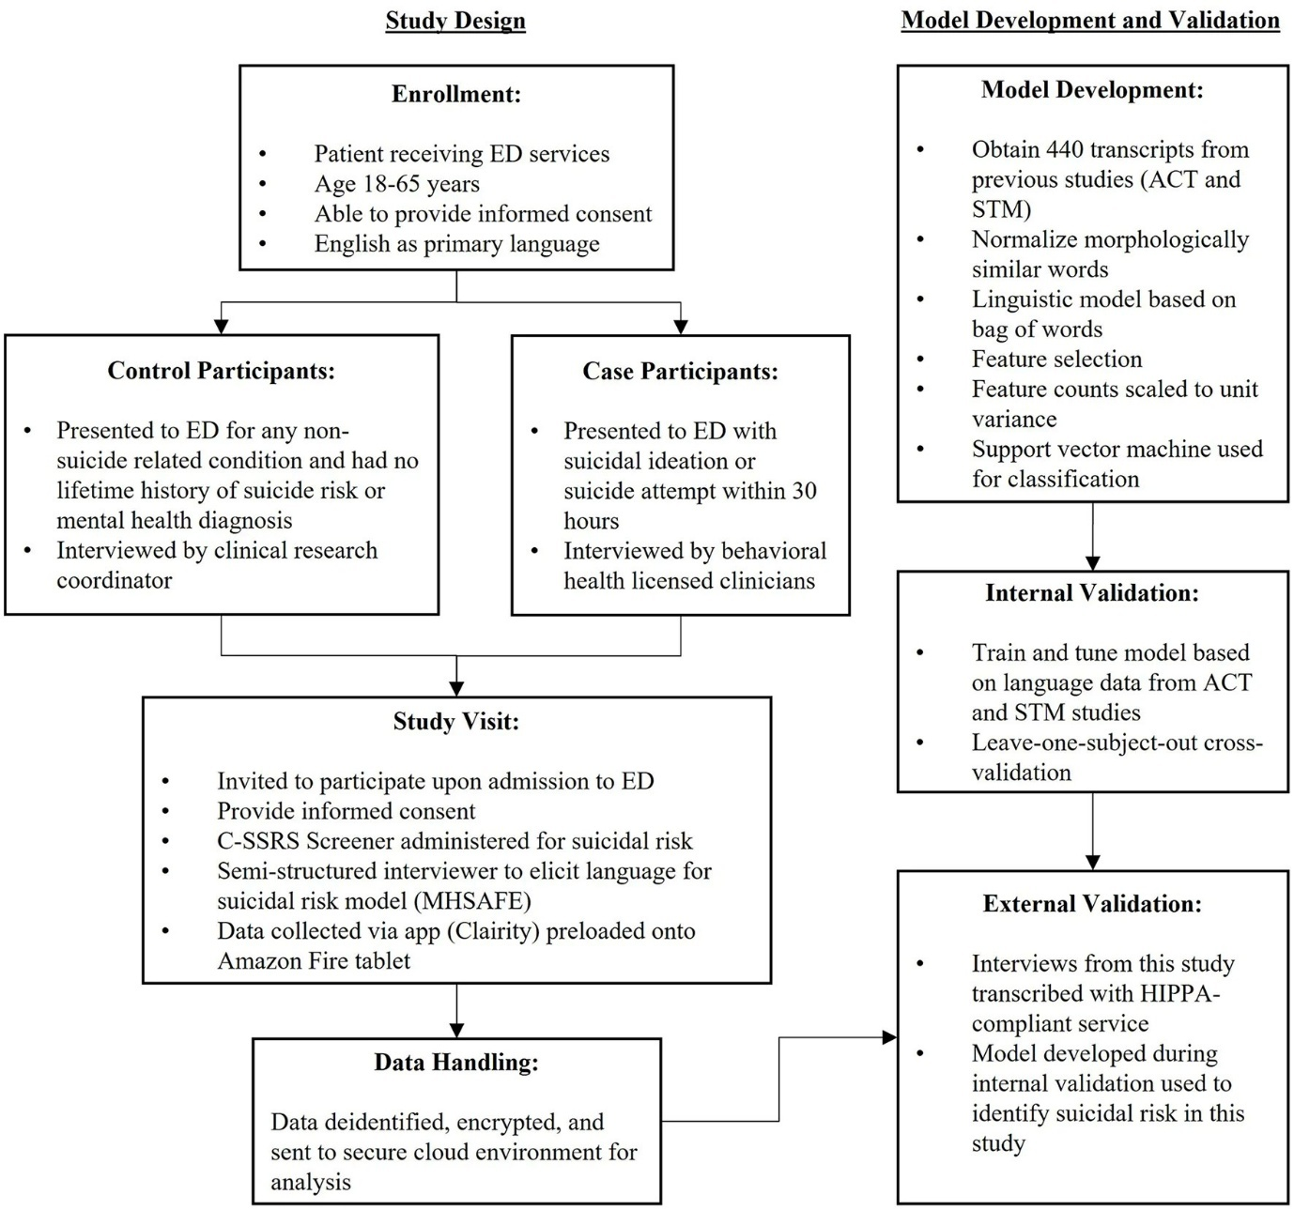
Fig. 2, Schematic of study and modelling procedures (Cohen et al., 2022)
Using patient language from the Case and Control group interviews, the NLP was able to interpret the speech data and achieve an 81% accuracy when identifying a participant deemed as higher-risk of suicide. This evidence shows that NLP can support health care workers to identify potentially high-risk suicide in patients and inform reactive decision making however, as the study was dependant on a previously trained model to drive efficiency and due to the small number of engaged participants, there were limitations relating to age and location.
Another study of NLP-analysed data was undertaken by Hossain et al. (2023), who found a direct correlation between the consistency of user-recorded medical terminology, including the use of varying abbreviations and acronyms, as well as misspelled words, which were shown to impede an NLP’s ability to recognise patterns and interpret data efficiently, affecting the quality output.
Discussion
Both evaluated technologies seek to utilise patient health data to better inform future clinical practice with benefits realisation goals of improved efficiency, patient self-management, decision making support and earlier disease diagnosis. Whilst RPM focusses more on direct patient engagement with device technology, AI in CDSS analyses available data to support its objectives. From this we can link these two technologies, with patient data extracted via RPM being housed in EHRs and datasets potentially used to develop models and algorithms within AI-ML, DL and NLP.
Suitability of both technologies should be considered against their expected output value prior to utilisation. Limitations with AI should be reviewed against the task to be completed, and when reviewing existing studies, factors such the source, scale and type of data being analysed must be considered as these can affect the quality of output results. In addition, RPM requires a patient centred view to maximise efficiency and increase likelihood of consistent data reporting to inform clinical decision making.
Globally, AI is continuing to see rapid growth and improvement however future developments must ensure the human aspect is not excluded. As the evidence reviewed throughout shows, there is an observable correlation between the quality and availability of data being analysed and the quality of the data being output. Review and validation of the output is also necessary to ensure low-quality research is not progressing to inform future clinical practice.
The evidence reviewed shows that as AI-CDSS has a wider area of application, it can be considered to offer greater value across health and social care areas. It’s ability to analyse both structured and unstructured data across low and high dimensional datasets means any area where data is collected is potentially suitable for its consideration. AI is also becoming easier to leverage with the evolution of cloud-computing increasing its access and scalability (Salari, M., 2025).

No generative AI was used to produce content within this document.
References
Alfieri, F., Ancona, A., Tripepi, G., Crosetto, D., Randazzo, V., Paviglianiti, A., Pasero, E., Vecchi, L., Cuada, V. and Fagugli, R. (2021) ‘A deep-learning model to continuously predict severe acute kidney injury based on urine output changes in critically ill patients’, Journal of Nephrology, 34(6), pp. 1875–1886. Available at: https://doi.org/10.1007/s40620-021-01046-6.

Alowais, S., Alghamdi, S., Alsuhebany, N., Alqahtani, T., Alshaya, A., Almohareb, S., Aldairem, A., Alrashad, M., Bin Saleh, K., Badreldin, H., Al Yami, M., Al Harbi, S. and Albekairy, A. (2023) ‘Revolutionizing healthcare: the role of artificial intelligence in clinical practice’, BMC Medical Education, 23(1), p. 689. Available at: https://doi.org/10.1186/s12909-023-04698-z.

Center, B.P. (2024) Executive Summary, The Future of Remote Patient Monitoring. Bipartisan Policy Center. Available at: http://www.jstor.org.uwtsd.idm.oclc.org/stable/resrep56945.3.
Chen, Z., Liang, N., Zhang, H., Li, H., Yang, Y., Zong, X., Chen, Y., Wang, Y. and Shi, N. (2023) ‘Harnessing the power of clinical decision support systems: challenges and opportunities’, Open Heart, 10(2), p. e002432. Available at: https://doi.org/10.1136/openhrt-2023-002432.

Chu, F., Stark, A., Telzak, A. and Rikin, S. (2024) ‘Patient Experience in a Remote Patient Monitoring Program for Hypertension: A Qualitative Study’, American Journal of Hypertension, 37(11), pp. 861–867. Available at: https://doi.org/10.1093/ajh/hpae086.

Coffey, J., Christopherson, L., Glasgow, A., Pearson K., Brown, J., Gathje, S., Sangaralingham, L., Caromna Porquera, E., Virk, A., Orenstein, R., Speicher, L., Bierle, D., Ganesh, R., Cox, D., Blegen, R. And Haddad, T. (2021) ‘Implementation of a multisite, interdisciplinary remote patient monitoring program for ambulatory management of patients with COVID-19’, npj Digital Medicine, 4(1), p. 123. Available at: https://doi.org/10.1038/s41746-021-00490-9.
Cohen, J., Wright-Berryman, J., Rohlfs, L., Trocinski, D., Daniel, L. and Klatt, T. (2022) ‘Integration and Validation of a Natural Language Processing Machine Learning Suicide Risk Prediction Model Based on Open-Ended Interview Language in the Emergency Department’, Frontiers in Digital Health, 4. Available at: https://doi.org/10.3389/fdgth.2022.818705.

De Lathauwer, I., Nieuwenhuys, W., Hafkamp, F., Regis, M., Brouwers, R., Funk, M and Kemps, H. (2025) ‘Remote Patient Monitoring in Heart Failure: A Comprehensive Meta-Analysis of Effective Programme Components for Hospitalization and Mortality Reduction’, European Journal of Heart Failure, 27(9), pp. 1670–1685. Available at: https://doi.org/10.1002/ejhf.3568.

Farias, F., Dagostini, C., Bicca, Y., Falavigna, V. and Falavigna, A. (2020) ‘Remote Patient Monitoring: A Systematic Review’, Telemedicine and e-Health, 26(5), pp. 576–583. Available at: https://doi.org/10.1089/tmj.2019.0066.
Geneva: World Health Organisation (2021) Global strategy on digital health 2020-2025. Available at: http://www.who.int/docs/default-source/documents/gs4dhdaa2a9f352b0445bafbc79ca799dce4d.pdf (Accessed 16th July 2026)
Haddad, T., Blegen R., Prigge, J., Cox, D., Anthony, G., Leak, M., Channer, D., Underwood, P., Williams, R., Hofschulte, R., Christopherson, L., Coffey, J., TerKonda, S., Yiannias, J., Costello, B., Russi, C. and Ommen, S., Demaerschalk, B. (2021) ‘A Scalable Framework for Telehealth: The Mayo Clinic Center for Connected Care Response to the COVID-19 Pandemic’, Telemedicine Reports, 2(1), pp. 78–87. Available at: https://doi.org/10.1089/tmr.2020.0032.
Hailu, R., Sousa, J., Tang, M., Mehrotra, A. and Uscher-Pines, L. (2024) ‘Challenges and Facilitators in Implementing Remote Patient Monitoring Programs in Primary Care’, Journal of General Internal Medicine, 39(13), pp. 2471–2477. Available at: https://doi.org/10.1007/s11606-023-08557-x.
Hegde, S. and Eid, N. (2021) ‘Telehealth and Remote Patient Monitoring After the COVID Pandemic’, Pediatric Allergy, Immunology, and Pulmonology, 34(4), pp. 130–131. Available at: https://doi.org/10.1089/ped.2021.0162.
Hossain, E., Rana, R., Higgins, N., Soar, J., Barua, P., Pisani, A. and Turner, K. (2023) ‘Natural Language Processing in Electronic Health Records in relation to healthcare decision-making: A systematic review’, Computers in Biology and Medicine, 155, p. 106649. Available at: https://doi.org/10.1016/j.compbiomed.2023.106649.

Hyland (2022) Unstructured data in healthcare: The missing link to interoperability. Available at: https://www.hyland.com/en/resources/articles/unstructured-data-in-healthcare-the-missing-link-to-interoperability (Accessed 18 Oct 2026).
Juhn, Y. and Liu, H. (2020) ‘Artificial intelligence approaches using natural language processing to advance EHR-based clinical research’, Journal of Allergy and Clinical Immunology, 145(2), pp. 463–469. Available at: https://doi.org/10.1016/j.jaci.2019.12.897.

Meça, A. and Ali, M. (2024) ‘A Comparative Analysis of Startups Applying AI in Clinical Oncology’, 2024 International Conference on Computing, Networking, Telecommunications &amp; Engineering Sciences Applications (CoNTESA). IEEE, pp. 37–45. Available at: https://doi.org/10.1109/CoNTESA64738.2024.10891291.
Mun, C., Ha, H., Lee, O. and Cheon, M. (2024) ‘Enhancing AI-CDSS with U-AnoGAN: Tackling data imbalance’, Computer Methods and Programs in Biomedicine, 244, p. 107954. Available at: https://doi.org/10.1016/j.cmpb.2023.107954.

Ouanes, K. and Farhah, N. (2024) ‘Effectiveness of Artificial Intelligence (AI) in Clinical Decision Support Systems and Care Delivery’, Journal of Medical Systems, 48(1), p. 74. Available at: https://doi.org/10.1007/s10916-024-02098-4.

Ramgopal, S., Sanchez-Pinto, L., Horvat, C., Carroll, M., Luo, Y. and Florin, T. (2023) ‘Artificial intelligence-based clinical decision support in pediatrics’, Pediatric Research, 93(2), pp. 334–341. Available at: https://doi.org/10.1038/s41390-022-02226-1.

Salari, M.A. (2025) ‘AI Needs Cloud, Cloud Needs AI: How Google Cloud AI is Revolutionizing Healthcare’. Available at: https://doi.org/10.36227/techrxiv.174001015.56858483/v1.

Stevens, J., Ghapanchi, A., Purarjomandlangrudi, A and Bruce, S. (2025) ‘Patient Experiences of Remote Patient Monitoring: Implications for Health Literacy and Therapeutic Relationships’, Technologies, 13(10), p. 464. Available at: https://doi.org/10.3390/technologies13100464.
Sutton, R., Pincock, D., Baumgart, D., Sadowski, D., Fedorak, R. and Kroeker, K. (2020) ‘An overview of clinical decision support systems: benefits, risks, and strategies for success’, npj Digital Medicine, 3(1), p. 17. Available at: https://doi.org/10.1038/s41746-020-0221-y.

Thomas, E., Haydon, H., Mehrorta, A., Caffery, L., Snoswell, C., Banbury, A. and Smith, A. (2022) ‘Building on the momentum: Sustaining telehealth beyond COVID-19’, Journal of Telemedicine and Telecare, 28(4), pp. 301–308. Available at: https://doi.org/10.1177/1357633X20960638.
Thomas, E., Taylor, M., Banbury, A., Snoswell, C., Haydon, H., Gallegos Rejas, V., Smith, A. and Caffery, L. (2021) ‘Factors influencing the effectiveness of remote patient monitoring interventions: a realist review’, BMJ Open, 11(8), p. e051844. Available at: https://doi.org/10.1136/bmjopen-2021-051844.
Wang, Y., Cheungpasitporn, W., Ali, H., Qing, J., Thongprayoon, C., Kaewput, W., Soliman, K., Huang, Z., Yang, M. and Zhang, Z. (2025) ‘A practical guide for nephrologist peer reviewers: evaluating artificial intelligence and machine learning research in nephrology’, Renal Failure, 47(1). Available at: https://doi.org/10.1080/0886022X.2025.2513002.

Wolf, H. (2025) ‘Global Healthcare Enters a Transformative Era of Accelerating Technology’, Frontiers of Health Services Management, 41(4), pp. 34–39. Available at: https://doi.org/10.1097/HAP.0000000000000219.

