Task 1
Academic and employment skills definition
Academic skill is the ability of learning, understand and applying the right knowledge and skill required to help you get the task done, this increases the chances of getting your desired future employment. At the end of your academic year, you would receive and certificate which implies you have the skills and knowledge that your future employment needs so that you meet the requirements which means you are able to do any task without causing problems or issues in the workplace in the field you studied. The higher the education level the higher the chances of you getting your desired employment increases compared to someone who doesn’t have it however this is not guaranteed as a lot move people strive to get the highest level of education this makes the competition of getting the right job harder and require a lot more skills or experience. Employment skills is the ability and skill to maintain and be successful at your job, these skills require you not just to have a good understanding of you work but to also adapt to any situation and being able to have good communication skills and being able to work in a team based environment.​ [1]​

​​References
​​
​[1] | ​Kelvin M Mwita (a) Nivad H Mwilongo (b) *, 2024. [Online]. Available: https://download.ssrn.com/2024/8/20/4931628.pdf?response-content-disposition=inline&X-Amz-Security-Token=IQoJb3JpZ2luX2VjELT%2F%2F%2F%2F%2F%2F%2F%2F%2F%2FwEaCXVzLWVhc3QtMSJHMEUCIQDYX4eUPoKputDhQQW6ymisxKIGTMXe8RcuLXarktONDgIgWf24P3NPhhhZNrmUQurXZL0UFnJv83. [Accessed 19 feburary 2026].
​[2] | ​Tom Burns & Sandra Sinfield , “Essential study skills,” 2022. [Online]. Available: https://d1wqtxts1xzle7.cloudfront.net/85223282/74301_Burns_Essential_Study_Skills-libre.pdf?1651321223=&response-content-disposition=inline%3B+filename%3DEssential_study_skills_the_complete_guid.pdf&Expires=1772112169&Signature=C4x0rZSHCQn3K3eADUfV54W4f9t. [Accessed 26 febuary 2026].
​[3] | ​Nuryake Fajaryati , Budiyono , Muhammad Akhyar and Wiranto, “The Employability Skills Needed To Face the Demands of Work in the Future: Systematic Literature Reviews,” 2 july 2020. [Online]. Available: https://www.degruyterbrill.com/document/doi/10.1515/eng-2020-0072/html. [Accessed 26 feburary 2026].
​​​￼
​​​

Academic Skill required for your studies
There are many academic skill that are essential in being successful in you studies however the main skills that a student should focus on are reading and writing skill, being organised, and taking a short rest. Having good reading and writing skill is important because you would need take notes of the information that you are reading so that you can go over your notes at any time of the day giving you the opportunity to make sense and understand the information so you can make use of it. Being organised is important for a student due to the amount of work you could get it could cause you to be overwhelmed, so it helps you keep track of your work and deadlines so that you are always ahead and are never rushing. Also, the benefits don’t just stop with work but also with your time because you are able to plan your day ahead which makes the chance of you being overwhelmed diminish since you can balance your work and daily life easier. Lastly the main important skill which every student needs is the ability to take a short rest, a lot of students always over work themselves to exhaustion which negatively impacts there work and mind however being able to take a short rest helps improve concentration, memory retention and many more.​ [2]​

Employment skills required for your future career
In this new era student having multiple skill is know long an option but a necessity in increasing the chance of you getting your future career. For example, having this main skill such as technical, communication, problem solving, and learning skill is sort after by many governments and companies due to the advantages you give such as having good communication skills helps you keep everyone updated and informed of any information that is important without wasting time. Problems solving skills is the process of finding a solution without panicking or causing any further issues. Finally, the last skill which will help a lot in increasing your chances of getting a job is learning skill, this helps you always improve and gain new knowledge which you can use. This makes you always evolve and increases your values as a worker because you are always updated with new information which could benefit your employers.​ [3]​

​​References
​​
​[1] | ​Kelvin M Mwita (a) Nivad H Mwilongo (b) *, 2024. [Online]. Available: https://download.ssrn.com/2024/8/20/4931628.pdf?response-content-disposition=inline&X-Amz-Security-Token=IQoJb3JpZ2luX2VjELT%2F%2F%2F%2F%2F%2F%2F%2F%2F%2FwEaCXVzLWVhc3QtMSJHMEUCIQDYX4eUPoKputDhQQW6ymisxKIGTMXe8RcuLXarktONDgIgWf24P3NPhhhZNrmUQurXZL0UFnJv83. [Accessed 19 feburary 2026].
​[2] | ​Tom Burns & Sandra Sinfield , “Essential study skills,” 2022. [Online]. Available: https://d1wqtxts1xzle7.cloudfront.net/85223282/74301_Burns_Essential_Study_Skills-libre.pdf?1651321223=&response-content-disposition=inline%3B+filename%3DEssential_study_skills_the_complete_guid.pdf&Expires=1772112169&Signature=C4x0rZSHCQn3K3eADUfV54W4f9t. [Accessed 26 febuary 2026].
​[3] | ​Nuryake Fajaryati , Budiyono , Muhammad Akhyar and Wiranto, “The Employability Skills Needed To Face the Demands of Work in the Future: Systematic Literature Reviews,” 2 july 2020. [Online]. Available: https://www.degruyterbrill.com/document/doi/10.1515/eng-2020-0072/html. [Accessed 26 feburary 2026].
​​​￼
​​​
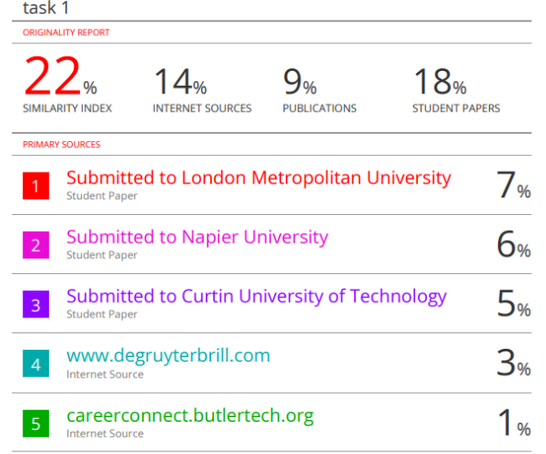
The work I presented was full of information and good references which help explain my point and reasons however my percentage of similarity is over 5% so to improve that I could use my own language more and do better and paraphrasing so that it meets the standard of getting 5%.

Task 2
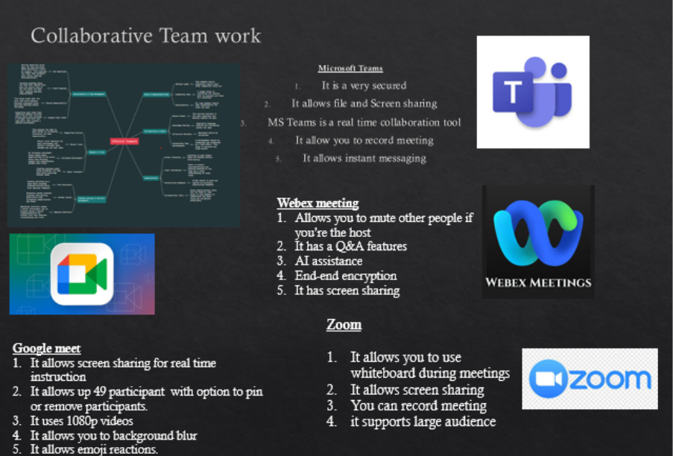
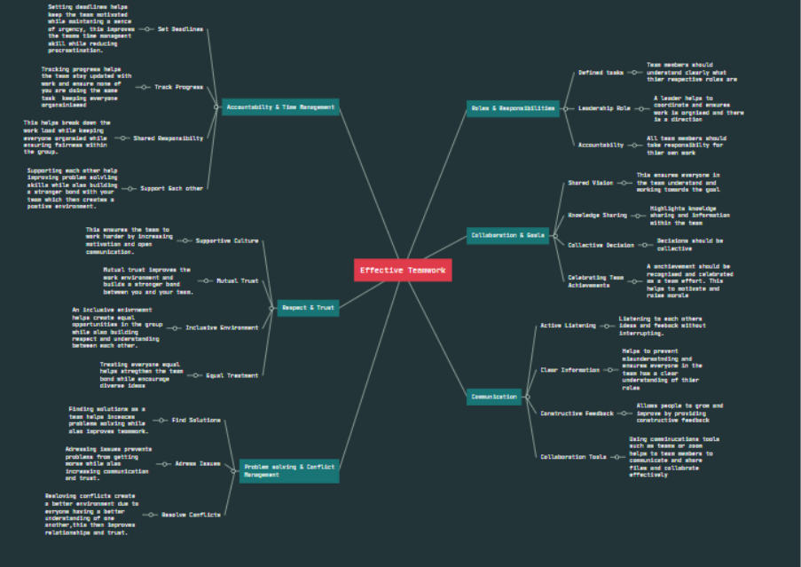

Task 3
Storming
When working in a person- to -person team of new people conflict will naturally occur due to many factors such as someone being competitive with each other, lack of communication, a member trying to dominate and not trying to adapt and work together. These are a clash of different characteristic and is a real challenge for many people because every person has a preferred way of working and thinking however it is more difficult when its virtual teams because the chance of misunderstanding is more likely to happen, people in your group will not be as motivated because they need more direct interaction and instructions and lastly due to that lack of interaction and having not being able to build trust, members of your team have a higher chance of feeling isolated which could negatively impact there mindset. When using Tuckman’s stages of development, its states that this is second stage and is called storming and, in this stage, conflict arise due to the absence of trust, Tuckman’s team development models have 5 stages which go as forming, storming, norming, performing and adjourning. When looking at Lencioni’s five dysfunctions of team table it states that when there is a lack of trust it then lead into conflict avoidance this then negatively affects the teams commitment and decision making because if you are not able to be open and speak your mind it doesn’t allow you to be honest and have constructive debates. The way to resolve any issue in a team is to have good conflict management skill and normally when working in a person-to-person team it is relatively easier to fix compared to a virtual team this is because there is a lack of empathy when you start a conflict online.
Empathy is crucial role in developing successful relationship with your team which also helps you have a better understanding of your teammates while also makes you become a better listener and be supportive which then increases team efficiency, motivation and productivity all at once, this is explained by Alhattab(2020) video with six more helpful ways to resolve virtual conflict within your team.
When in team know matter if its person-to-person or virtual teams it is important that every person within in the group knows their roles and responsibilities because without it the group will become disorganised and doesn’t allow them to stick to their strengths. This could also cause someone in the group to do the same task as another person which will make completing task more tedious and less effective, to help find everyone strengths in the group to help assign roles which helps increase productivity in the group it is a good idea for everyone to do a SWOT analysis to help figure out everyone strength, weakness, opportunities and threats. Once everyone in the tam completes a SWOT analysis it is important to share this information within the team so that they can assign you to a role that minimises your weakness and gain a better understanding of one another.[1]
Task 3b
- 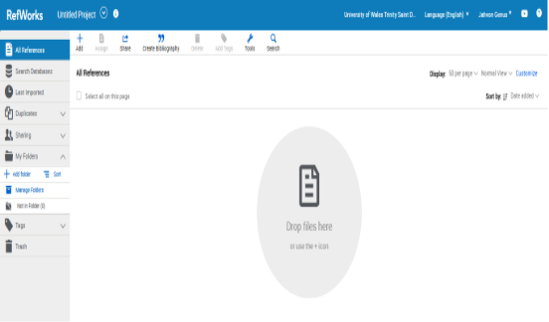 First, we log into RefWorks

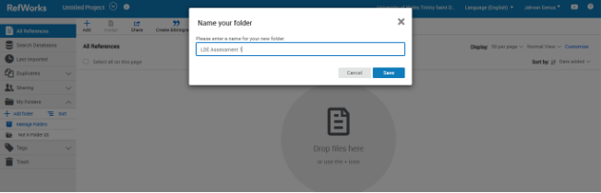 next we create a folder.
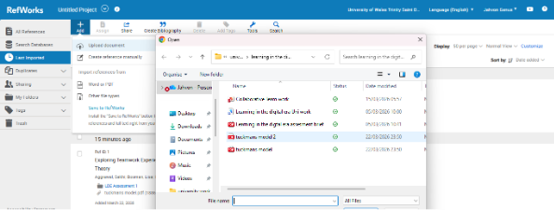then we upload the PDF file onto ref works.
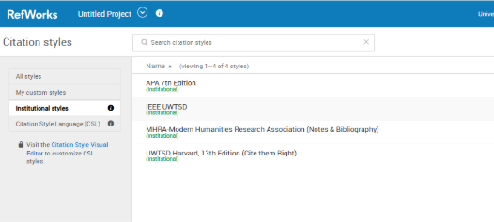 then you change the institutional style to IEEE UWTSD.
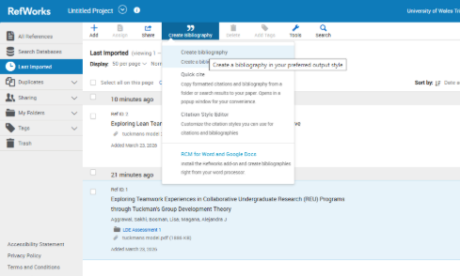 then you click on create bibliography

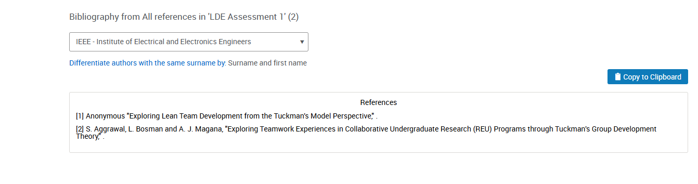then you click IEEE - Institute of Electrical and Electronics Engineers to generate your reference
Task 4
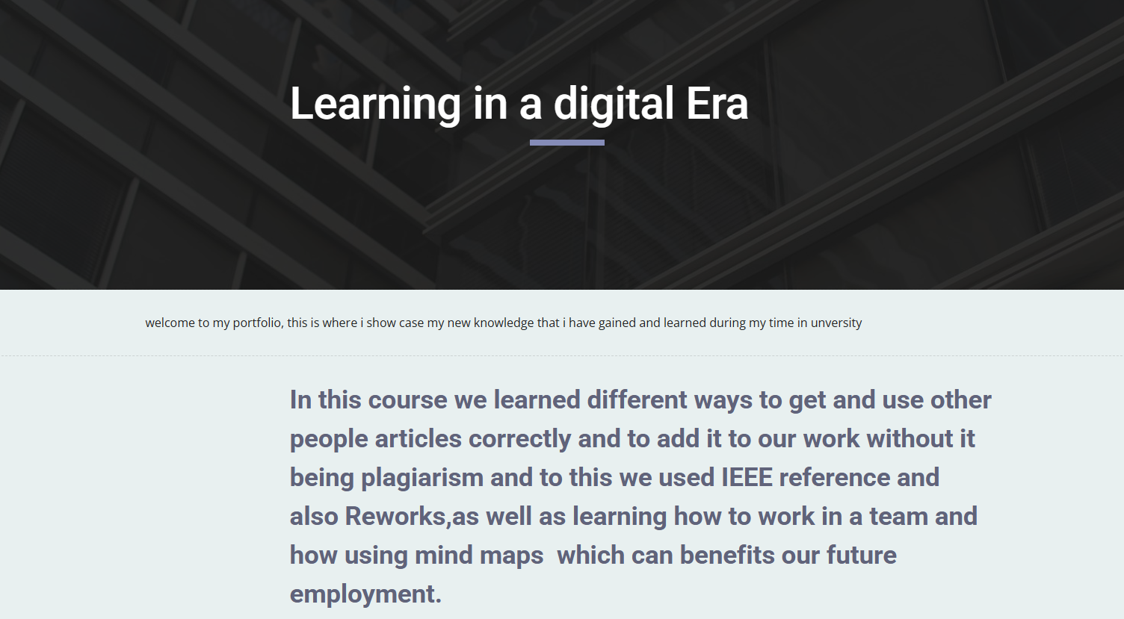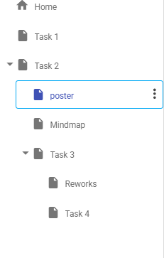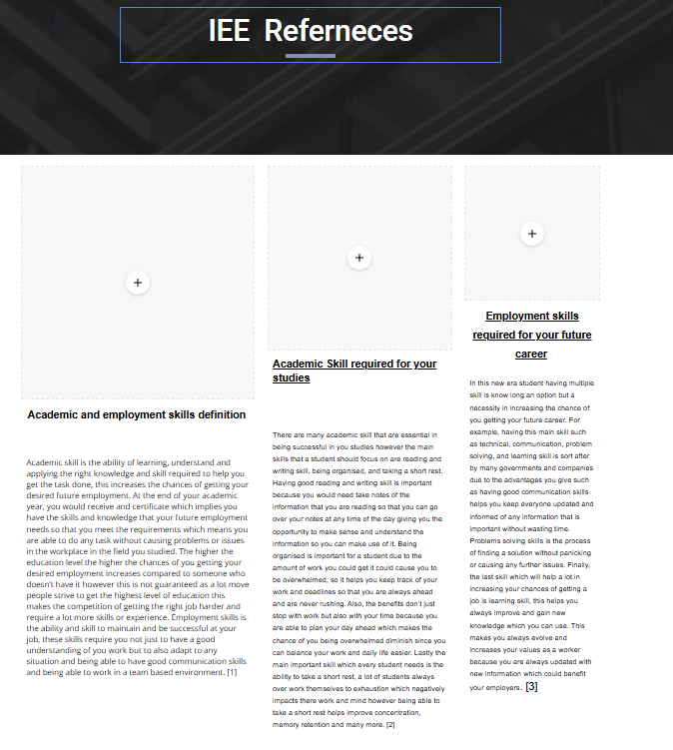

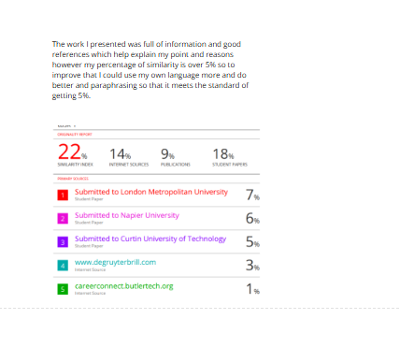
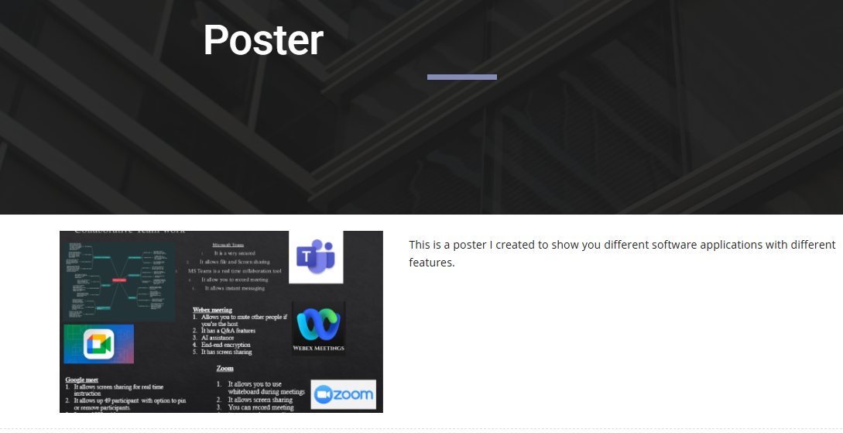
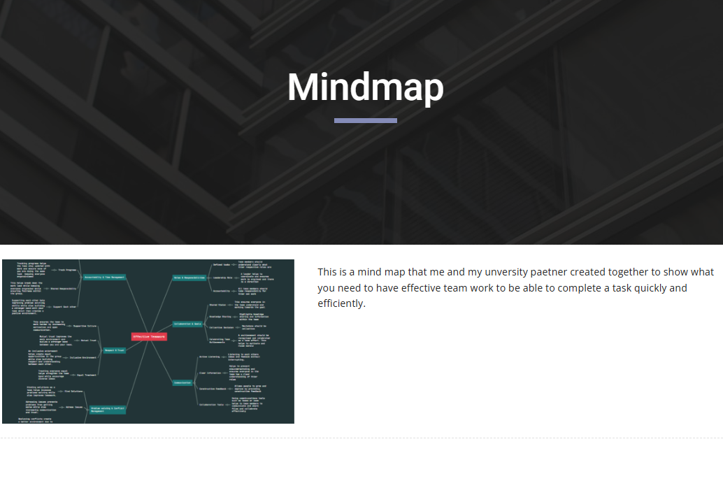
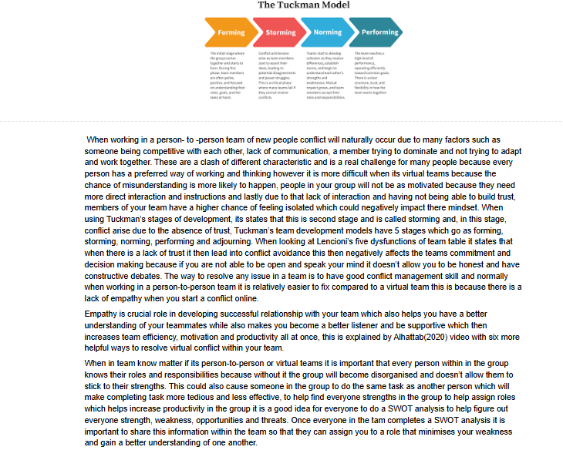
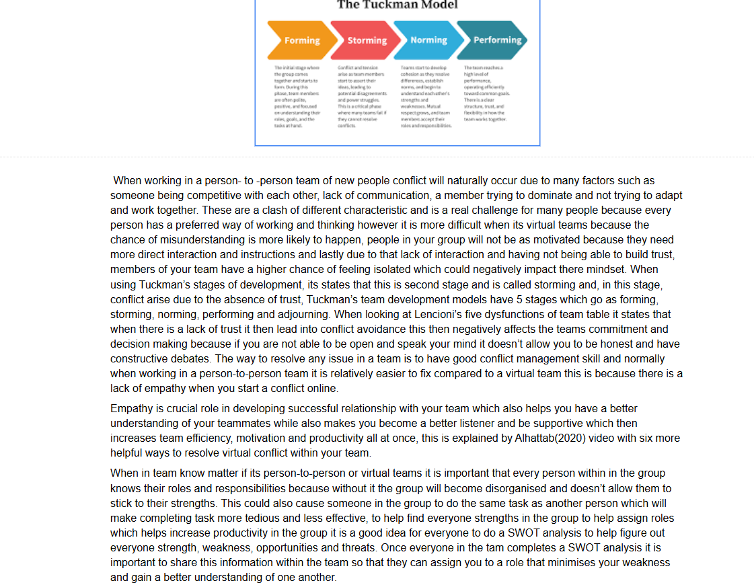
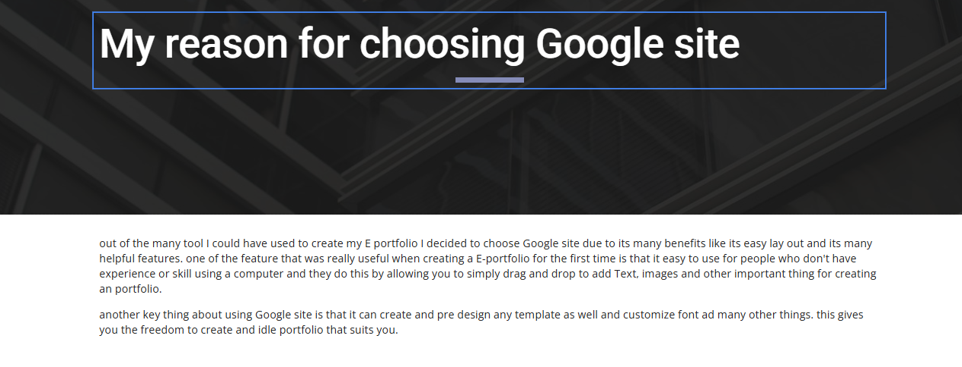
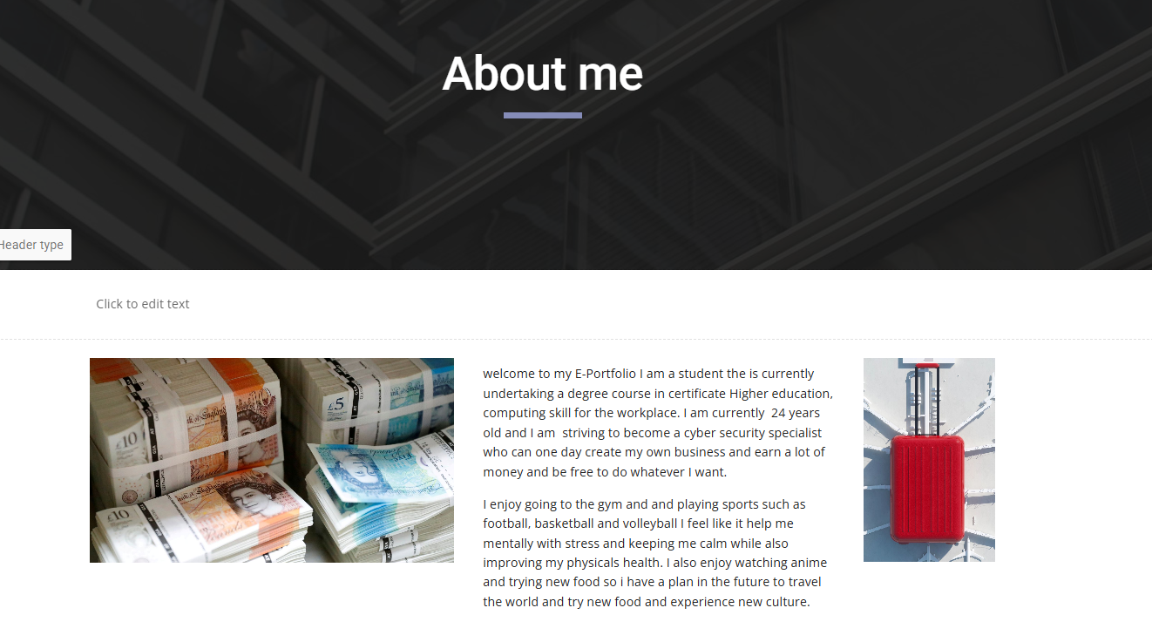

References
[1] Anonymous "Exploring Lean Team Development from the Tuckman's Model Perspective," .
[2] S. Aggrawal, L. Bosman and A. J. Magana, "Exploring Teamwork Experiences in Collaborative Undergraduate Research (REU) Programs through Tuckman's Group Development Theory," .

Website Link
https://sites.google.com/d/1318pOUFvwexZYdWHIkS3zkFJPkFieZZE/p/1c03wyDMO30-VL5y7DnwqL7337qSKM6IZ/edit

