Module: Introduction to Web and Database Concepts.

Module code: ACCA4023.

Assignment title: HTML and CSS Web Development.

Submission date: 15th of January, Tuesday.

Student name: Shaun James Davies.

Student number: 2317135.

Table of Contents
Introduction 3
Requirements 3
Design 4
Implementation 5
Validation 7
Evaluation Research 8
Research 8
Website evaluation 10
Usefulness 10
SEO Techniques within website 11
Accessibility 12
References 13
Appendix 14

Introduction
Brief description: I will design a website called Unearthed Conspiracies. This will be a hub for information based off an interest of mine: conspiracy theories. The website will detail many conspiracies and will be dedicated to exploring, analysing and discussing a wide range of conspiracy theories from around the world.

Requirements
Purpose
Unearthed Conspiracies aims to serve as a hub for people interested in conspiracy theories as a form of satire or interest where they can find information on perspectives of a variety of conspiracy theories. The website is not a news site and does not aim to misinform but to entertain users. The subject matter of my website is conspiracy theories
Target Audience
The website caters to individuals curious about unconventional narratives, sceptics questioning the status quo, and enthusiasts eager to explore alternative viewpoints. Whether you're casually intrigued or deeply immersed in conspiracy theories, Unearthed Conspiracies is an inclusive space welcoming anyone keen on conspiracy theories.
Key Functionalities
- Diverse conspiracy theories.
- Discussion and conversation forums.
- Expert opinions.
- Resources for further reading.
Accessibility and Web Standards
I aim to adhere to Web Content Accessibility Guidelines (WCAG). WCAG have been developed through the W3C process apart of the Web Accessibility Initiative (WAI) which aims to allow for accessibility for all people with inclusivity its main focus. I aim to adhere to the principles set out under WCAG; perceivable, operable, understandable and robust [1]. Listed below are the key areas of each principle.
“
PERCEIVABLE | OPERABLE | UNDERSTANDABLE | ROBUST
Text alternatives | Keyboard accessible | Readable | Compatible
Time-based media | Enough time | Predictable
Adaptable | Seizures and physical reactions | Input assistance
Distinguishable | Navigable

”
[1]
The website will be inclusive and aim to be accessible to those with disabilities so that they can use the digital content effectively. This can be achieved through alt text for images, keyboard navigation, clear headings, colour contrast for readability and ARIA roles which enhance accessibility. This helps users with disabilities and aligns with ethical responsibilities when creating accessible and inclusive websites.

Design
- Home/Landing Page:
  - Header: Contains the site's title and a tagline.
  - Navigation (Nav.): Menu for site navigation, with links to the main sections like "Home" ,"Conspiracies", "Discussion", "Expert Opinion" And "About".
  - Main Content Area:
    - Two images: These will be featured stories with relating important graphics on trending conspiracies.
    - Two text blocks: Provides introductions to the articles featured throughout the website.
  - Footer: Standard website footer which will contain copyright information.

- Conspiracies Page:
  - Header/Nav: Same as the previous page.
  - Main Content Area:
    - Rows of content with a title, image, and accompanying text: Each row to represent a different conspiracy topic, with the title being the name of the conspiracy, the image of a related graphic, and the text of a summary.
  - Footer: As before, for continuity.

- Discussion Page:
  - Header/Nav: Same as the previous page.
  - Main Content Area:
    - Columns of content with titles and text: This layout is a forum or discussion board format, where each column represents a different thread or topic of discussion.
  - Footer: Standardized across the site.

- Expert Opinion Page:
  - Header/Nav: Continues the consistent header/navigation layout.
  - Main Content Area:
    - Rows with a title, image, and text: This section features opinions or analyses from experts on various conspiracy theories. The format is a mix of written content.
  - Footer: The same footer for uniformity across the site.

- About Page:
  - Header/Nav: Consistency across the site, except the home page.
  - Main Content Area:
  - Two text blocks: Detailing the purpose of the site, background information, and any details about the mission of "Unearthed Conspiracies."
  - Footer: Matches the footer on the home page for consistency.
Wireframe design: see appendix.

Implementation
Website
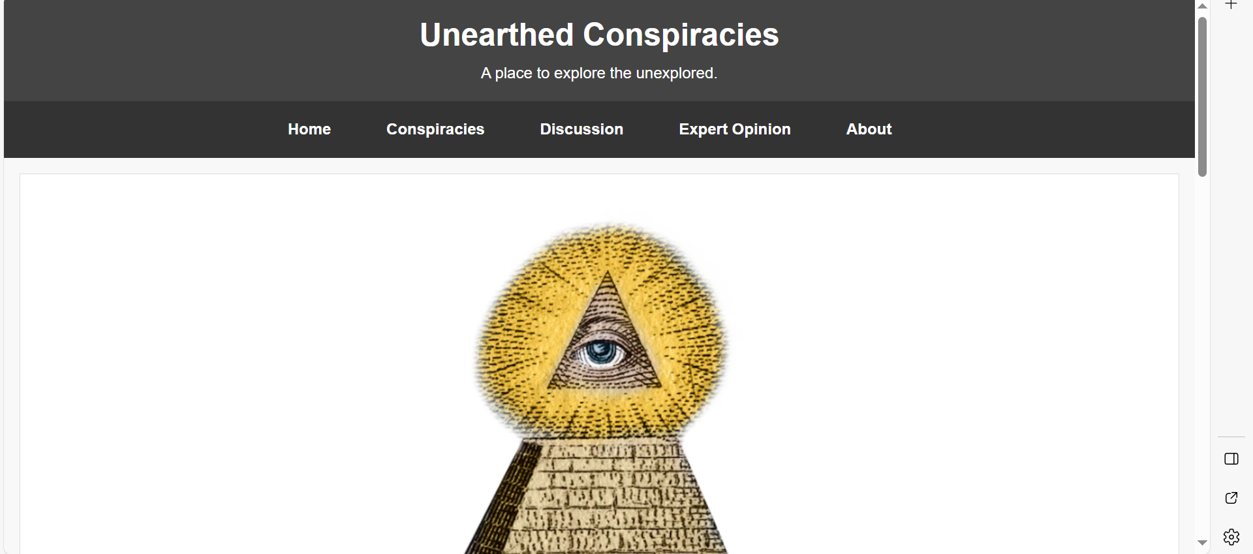
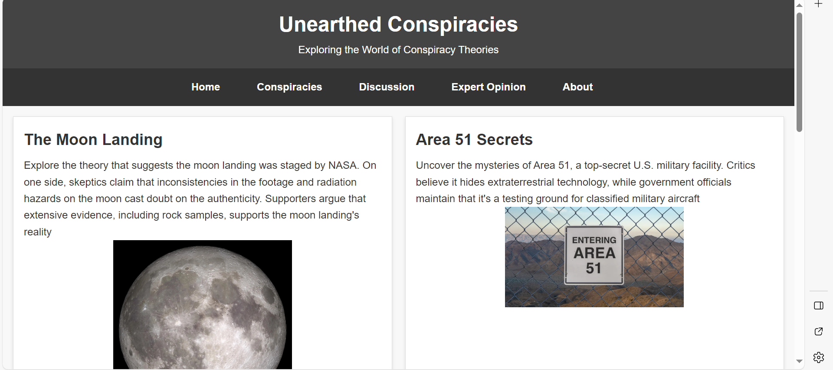
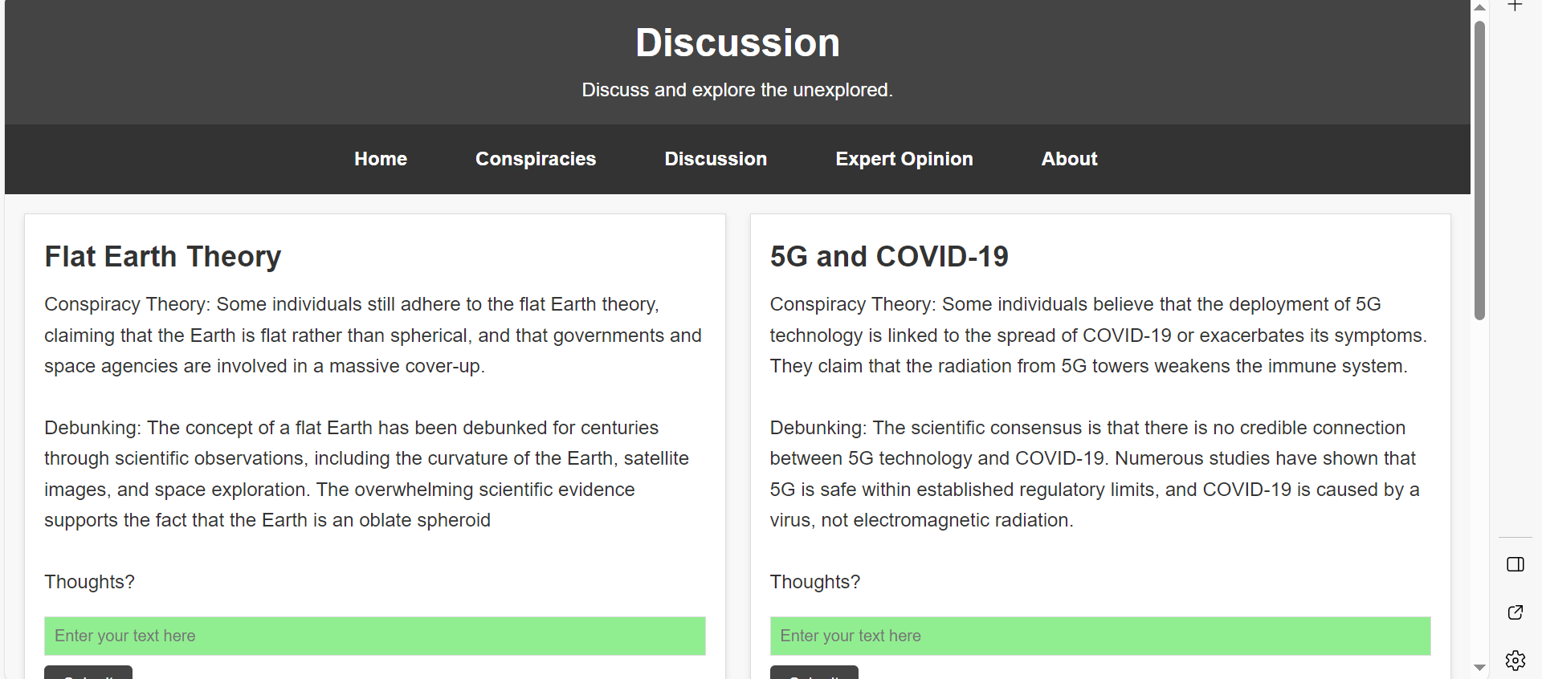
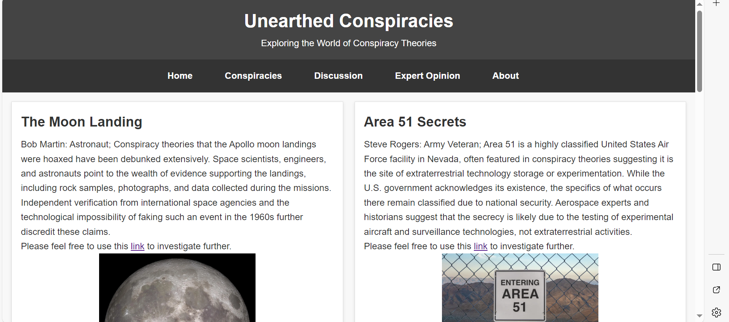
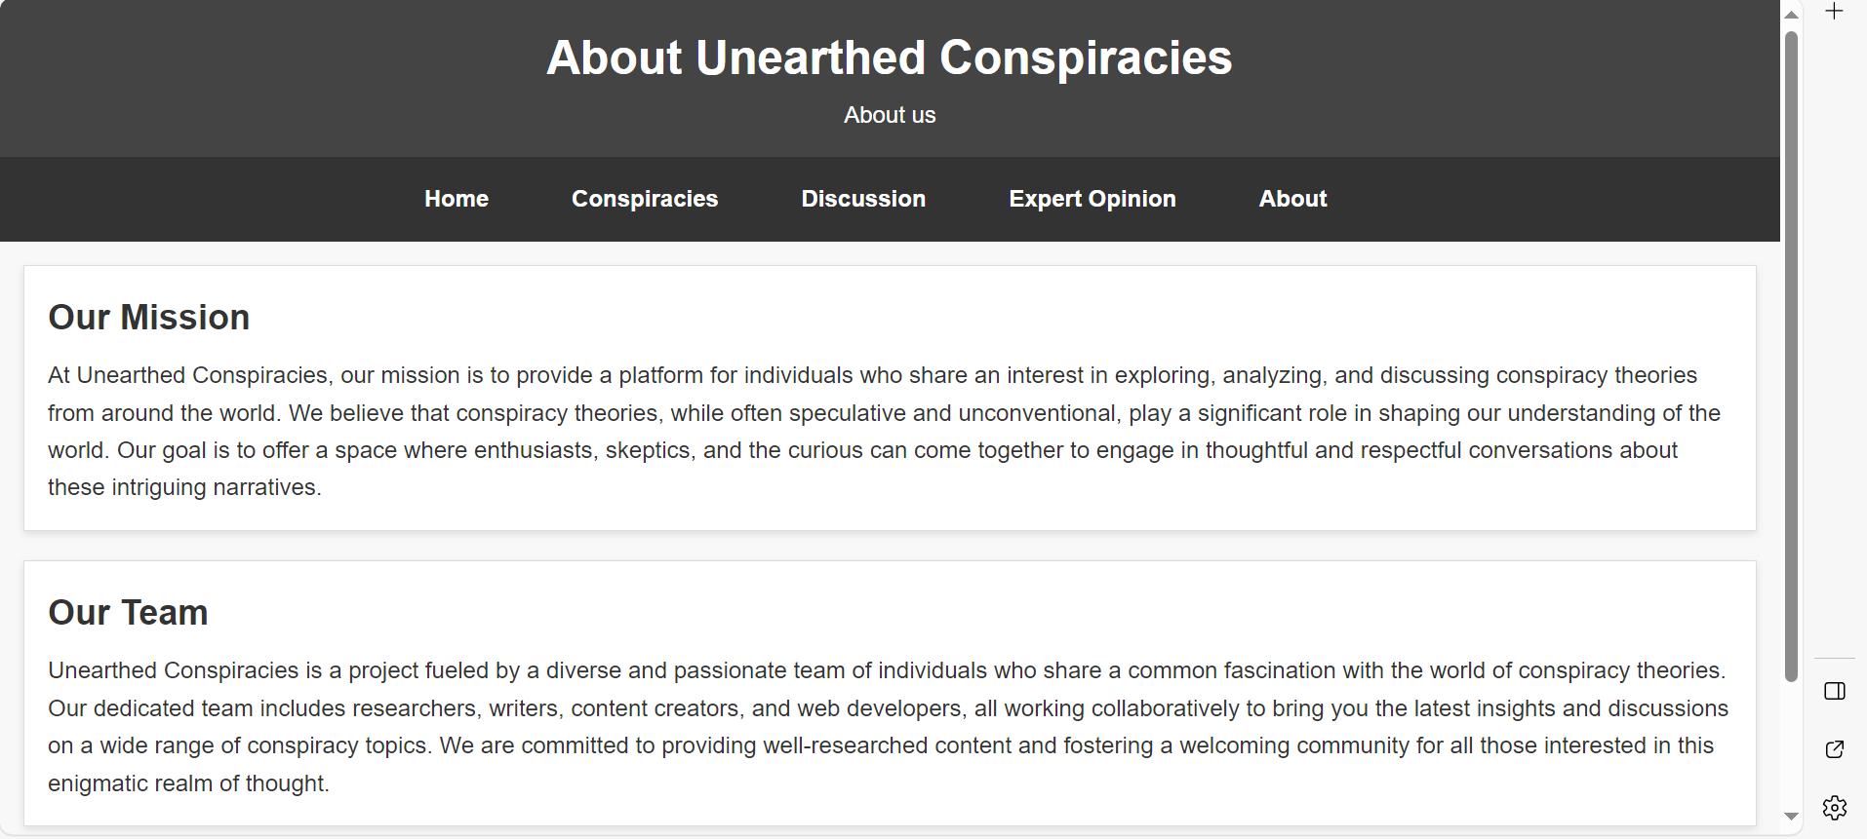

Validation
Home
HTML:
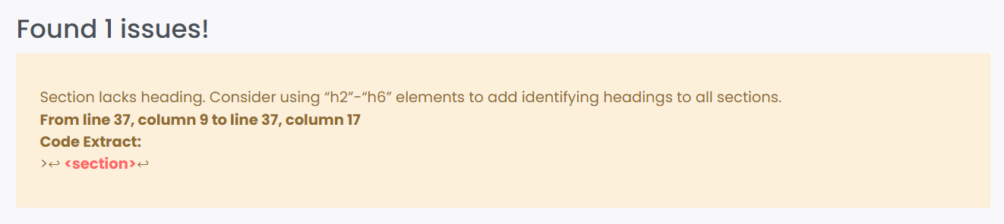
This is the “Our purpose section”. I considered using h2-h6 however this won’t be appropriate for a whole section.
CSS:


Evaluation Research

Research
Usability
The usability of a website is a design approach that focuses on what the user requires. By using user-centric design methods to guarantee that websites are user-friendly and efficient for the individuals utilizing them [2]. Expanding on this, usability refers to the extent to which a website can be used by specified users to achieve specified goals with effectiveness, efficiency, and satisfaction in a specified context of website use. Summarising, usability is about how effectively and efficiently a website is used by its intended audience, with focus on user satisfaction. Usability is key in designing and implementing web development. Younghwa Lee and Kenneth A. Kozar detail a study by Spool et al describing usability factors: “ease of use, readability, content quality, fun, productivity, completeness and relevance” [3] which highlights the aspects of usability. Continuing with the prior journal, it delves deeply into the theoretical aspects and measurement of website usability, it also provides insights that are directly relevant to web development. It details a definition and importance of usability, describes the multifaceted nature of usability, describes metrics and guidelines, objective and subjective measure of usability and demonstrates impact on user behaviour.
Accessibility
The article "Web Accessibility" by Peter Brophy and Jenny Craven provides an extensive analysis of web accessibility, particularly focusing on users with disabilities. It highlights the shift from text-based web interfaces to dynamic multimedia ones, emphasizing the need for universal design in web development to ensure accessibility for all, including visually impaired individuals using assistive technologies. Key issues discussed include the principles of web accessibility, methods of access, and the impact of evolving web technologies. The document also reviews legislation and guidelines like the W3C's WCAG and discusses the role of assistive technologies, the design of accessible web interfaces, and the importance of user-centred design. The challenges of ensuring web usability for people with disabilities, the assessment of web accessibility, and the need for increased awareness and training among web developers are also explored [4]. As stated, by developing web sites with accessibility in focus it allows for all users to participate and use the website.
Search Engine Optimisation (SEO)
Nursel YalçÕna and Utku Köse define SEO throughout their conference paper as the process of enabling a website to appear in the top results of a search engine for specific words. In words of Li, Runtao “Search engine optimization is a way to improve the ranking of websites in relevant search engines by using search rules of search engines” [5]. The text highlights the importance of many optimisation techniques via internal and external routes to achieve better visibility on search engines. The text details the role of SEO in web development and is crucial for web developers to ensure their website appears higher in search engine results. Additionally, an effective, well-structured and visually appealing website is important for web developers introducing companies, services or products [6].
Keyword Research and analysis
As detailed by YalçÕna and Köse, analysing and understanding what relevant keywords relate to a website is key in driving user traffic into the website. Before filling a website with content, a keyword analysis should be carried out which involves finding out the target keywords of top-ranking websites and strategically using the keywords in various elements of the webpage [6].
Content Optimization
Extending from the contributions from YalçÕna and Köse conference paper, SEO emphasizes the optimization of webpage content including title tags and page titles, meta descriptions, header tags and descriptions. The conference paper suggests a keyword content density of 5-8% and using keywords in different styles which catches the attention of search engines; bold, italic, underlined [6].
Technical Optimization
Whilst designing a webpage, technical considerations such a proper web design, the structure of HTML, and the use of appropriate, relevant tags can enhance the visibility of the webpage to search engines; according to YalçÕna and Köse. Avoiding the use of frames will improve SEO as search engines may find it challenging to index and understand the structure of such sites. [6].
Link building
Other websites can influence the use of user and search engine attention on a primary website. Backlinks are when a primary websites’ link has been used on another website (from external and relevant websites). The conference paper, by YalçÕna and Köse, emphasises the significance of backlinks. For example, Google’s search engine considers websites with backlinks a measure of authority, credibility and popularity. Continuing, Google uses tools to measure link popularity, like PageRank, which can increase overall SEO performance [6].
Mobile Optimisation
Allowing for dynamic change to the website depending on the viewport of the user allows for mobile optimisation.

Website evaluation

Usefulness
Utility
Unearthed Conspiracies fulfils it’s purpose as a hub for conspiracy theories whilst including diverse content, discussion forums and expert opinions and resources. The inclusion of meta tags and SEO techniques should help improve the website's visibility for search engines. The input sections and submit buttons on the discussion and conspiracy pages provide interactivity, allowing users to engage and share their thoughts.
Usability
The website’s layout has changed from the design. This was in effort to make the layout easier to navigate across all pages and for users to move around seamlessly. Originally, the landing page had the navigation down the left hand-side of the page. This may confuse users as the other pages have a navigation bar and header above hence the change. I initially wanted to the conspiracies and expert opinion page to have three boxes per row. Upon creating this, the page looked cluttered and messy. To increase readability, I removed one box from each row which focuses the users attention and doesn’t clutter the viewport. CSS Grid has been used to create a visually appealing, responsive and adaptive design. As the screen adjusts to different sizes the webpage adjusts dynamically which will be perfect for mobile users.
By adding hover effects on the navigation, the navigation panel is more clear to users which page they’re selecting. The use of ARIA roles and the ability to access the navigation links via the keyboard (tab) increase the usability of this website and accessibility of users with disabilities.
The design of the website was chosen to suit mature audiences. The contrast between the colours makes it clear and increases readability. The choice of arial font for the body text ensures readability and there’s a clear divide between the paragraph text and the bold headings and subheadings which allows users to be guided to information easier. The header and footer creates a clear separation between content and each box. Each section has a clear title and clear outline which makes the site more visually appealing for users.
Overall, the website is user friendly with intuitive navigation and accessible features. It serves it purpose of providing information and facilitating discussions on and around conspiracy theories.
Content
The website covers a vast amount of theories and adds depth and credibility to the content. As the website comments on many theories, the website is engaging and informative for users.
Further recommendations
To ensure consistency in both layout and accessibility, I recommend maintaining a singular design across all pages in future iterations of the webpage. Enhancing SEO can be achieved by adding more conspiracy theory-related keywords and using vibrant colours for visual appeal. Implementing user names in discussions is essential for a forum page, and consolidating CSS into a central file will reduce redundancy. Finally, utilizing Photoshop for unique visuals can elevate the site's overall aesthetics.

SEO Techniques within website
Meta tags and titles:
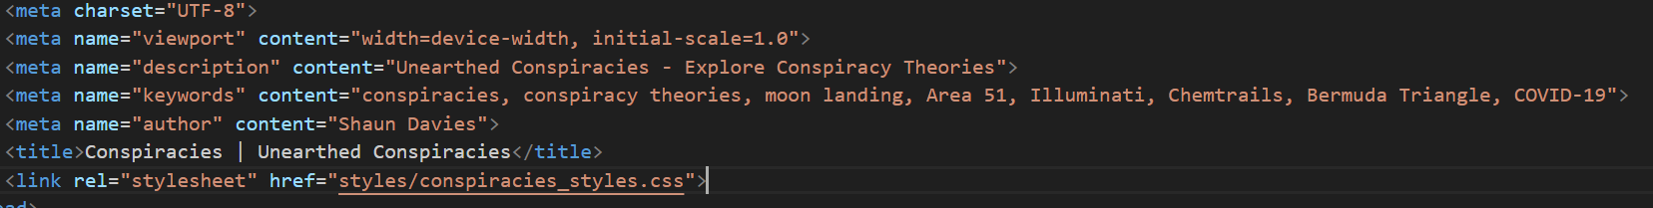
Semantic HTML using headers, footers, nav, main, section and others like this to lead to better understanding for the search engine:
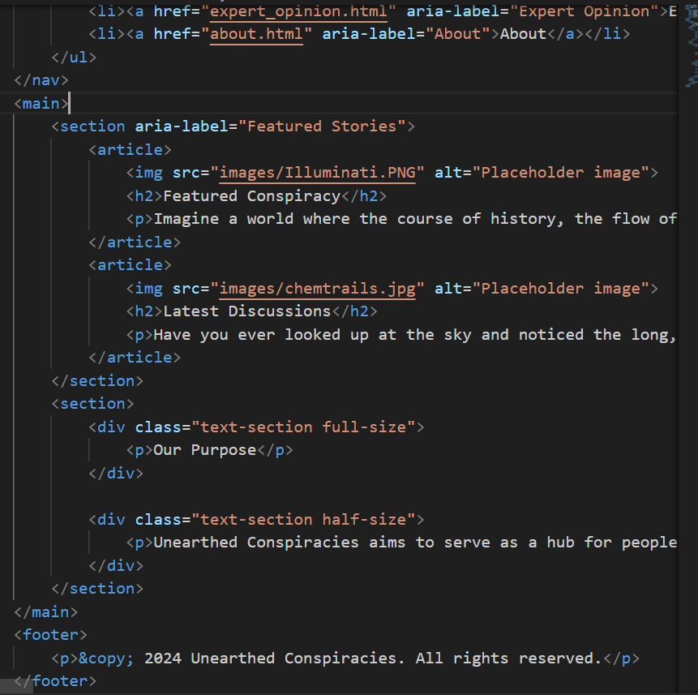
Image Alt text:
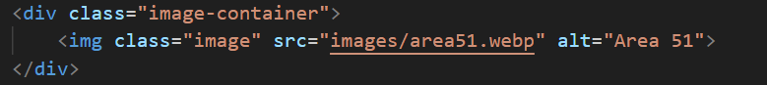
Internal and external links:
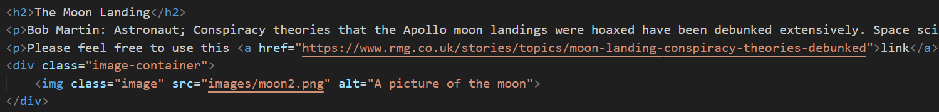
Navigation and the use of ARIA labels for text descriptions which can make it clear to screen readers what each link represents:
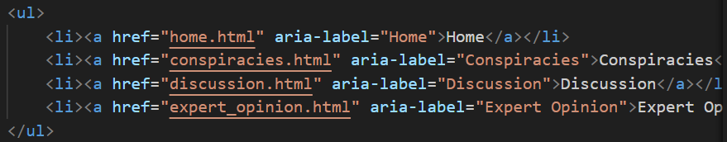

Accessibility
Adhering to the Perceivable principle, the website ensures accessibility for all users, including those with sensory impairments. This is achieved through descriptive alt text for images, text alternatives for non-text content, consistent typography, proper contrast and colour choices, and ensuring critical information is not reliant on multimedia alone. This ensures effective content perception and understanding for users with visual impairments or those who rely on text-based content.
Operability ensures my website's functionality and user-friendliness. This is achieved by ensuring keyboard accessibility, clear navigation labels, consistent layouts, visible focus indicators, and keyboard-friendly interactive elements. These practices enhance usability, ensuring all users can navigate your site easily, regardless of their input method.
The understandable principle highlights the significance of clarity and comprehension. My website accomplishes this through readable content, descriptive labels for inputs and buttons, consistent navigation and a logical layout. This predicts user-friendly interactions and navigation, resulting in an intuitive user experience.
Robustness is crucial for my website's resilience against different technologies and users. Achieving robustness involves maintaining cross-browser compatibility, using valid HTML and CSS, applying responsive design principles, employing semantic markup, and adhering to consistent coding practices. I’ve aimed for all these whilst designing and developing my website. These measures ensure that my site functions reliably across various platforms, devices, and remains compatible with assistive technologies, providing a durable and consistent user experience.

References

[1] | “How to Meet WCAG (Quick Reference),” World Wide Web Consortium, 2023. [Online]. Available: https://www.w3.org/WAI/WCAG22/quickref/?versions=2.1. [Accessed 13 January 2024].
[2] | “99designs.com,” 99designs, 2021. [Online]. Available: https://99designs.com/blog/web-digital/website-usability-principles/#1. [Accessed 13 01 2024].
[3] | Y. Lee, “Understanding of website usability: Specifying and measuring constructs and their relationships,” ScienceDirect, 31 August 2011. [Online]. Available: https://www-sciencedirect-com.ezproxy.uwtsd.ac.uk/science/article/pii/S0167923611001679?via%3Dihub. [Accessed 13 January 2024].
[4] | P. C. J. Broph, “Web Accessibility,” Johns Hopkins University Press. https://muse.jhu.edu/article/216646, vol. 55, no. 4, pp. 950-972, 2007.
[5] | R. Li, “Keywords of Search Engine Optimization based on Corpus,” Journal of Physics: Conference Series, vol. 1881, no. 3, p. 1, 2021.
[6] | U. K. Nursel Yalcin, “Procedia - Social and Behavior Science,” Elsevier, 26 January 2011. [Online]. Available: https://www-sciencedirect-com.ezproxy.uwtsd.ac.uk/science/article/pii/S1877042810022901?via%3Dihub. [Accessed 13 01 2024].
[7] | “The Christian Eye of Providence: Meet the Man Who Started the Illuminati,” [Online]. Available: https://www.nationalgeographic.com/history/history-magazine/article/profile-adam-weishaupt-illuminati-secret-society. [Accessed 12 January 2024].
[8] | R. Lee, “Area 51: What is it and what goes on there?,” 11 April 2011. [Online]. Available: https://www.space.com/area-51-what-is-it. [Accessed 14 January 2024].
[9] | J. Morgan, “Conspiracy Sails: Exploring The Intriguing Bermuda Triangle,” 7 December 2023. [Online]. Available: https://www.bluewateryachting.com/news/conspiracy-sails-exploring-the-intriguing-bermuda-triangle-1808. [Accessed 14 January 2024].
[10] | “Britanica,” 1 December 2023. [Online]. Available: https://www.britannica.com/science/full-Moon-lunar-phase. [Accessed 14 January 2024].
[11] | W. H. Organisation, “Coronavirus disease (COVID-19),” [Online]. Available: https://www.who.int/health-topics/coronavirus#tab=tab_1. [Accessed 14 January 2024].
[12] | Wikipedia, “Chemtrail conspiracy theory,” [Online]. Available: https://en.wikipedia.org/wiki/Chemtrail_conspiracy_theory. [Accessed 14 January 2024].

Appendix
Images
Figure 1: The Christian Eye of Providence
Source: Adapted from [7]


Figure 2: Area 51
Source: Adapted from [8]
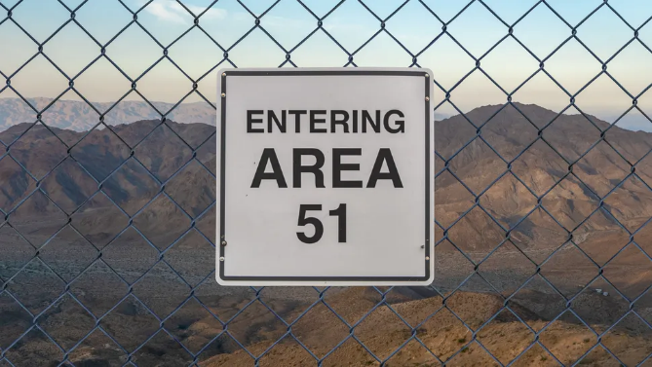

Figure 3: Burmuda Triangle
Source : Adapted from [9]
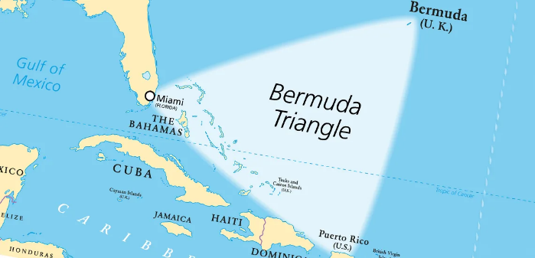

Figure 4: The Moon
Source: Adapted from [10]
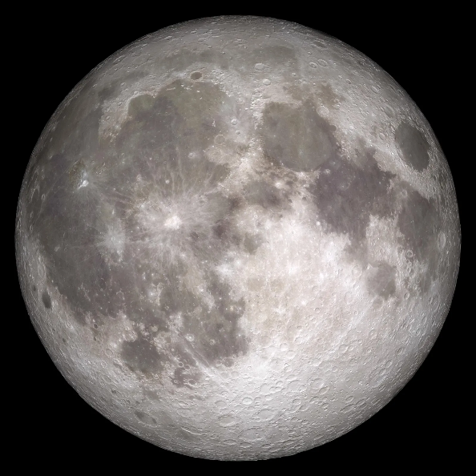

Figure 5: Covid-19
Source: Adapted from [11]


Figure 6: Chemtrails conspiracy theory
Source: Adapted from [12]
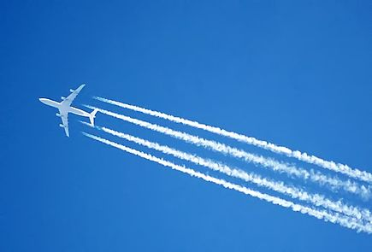
Wireframe Website design
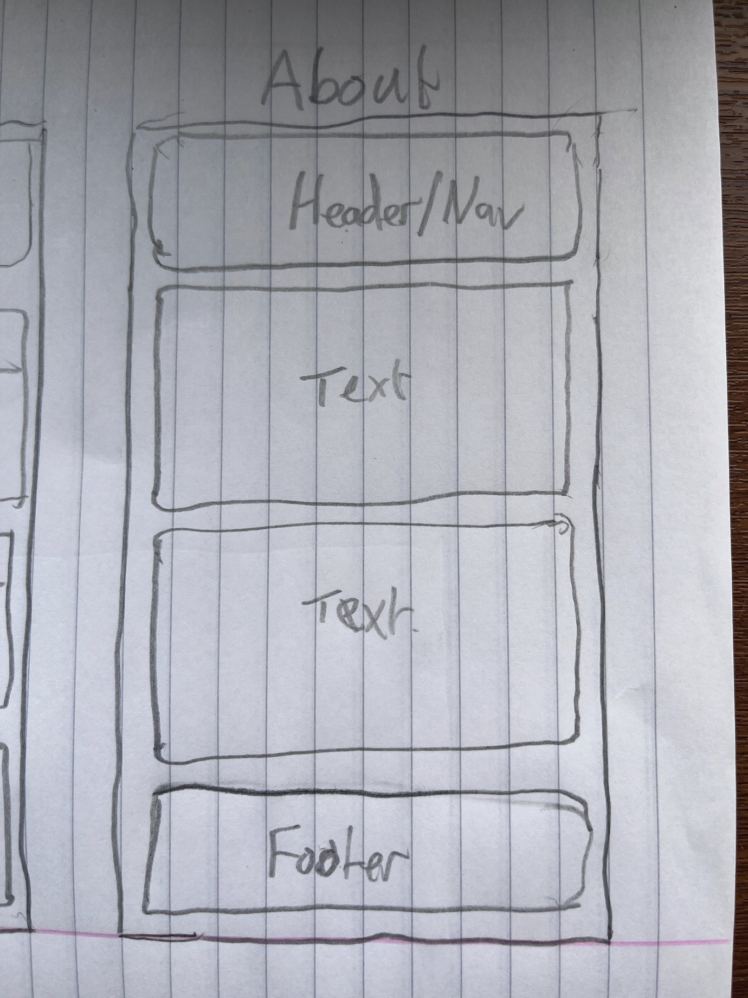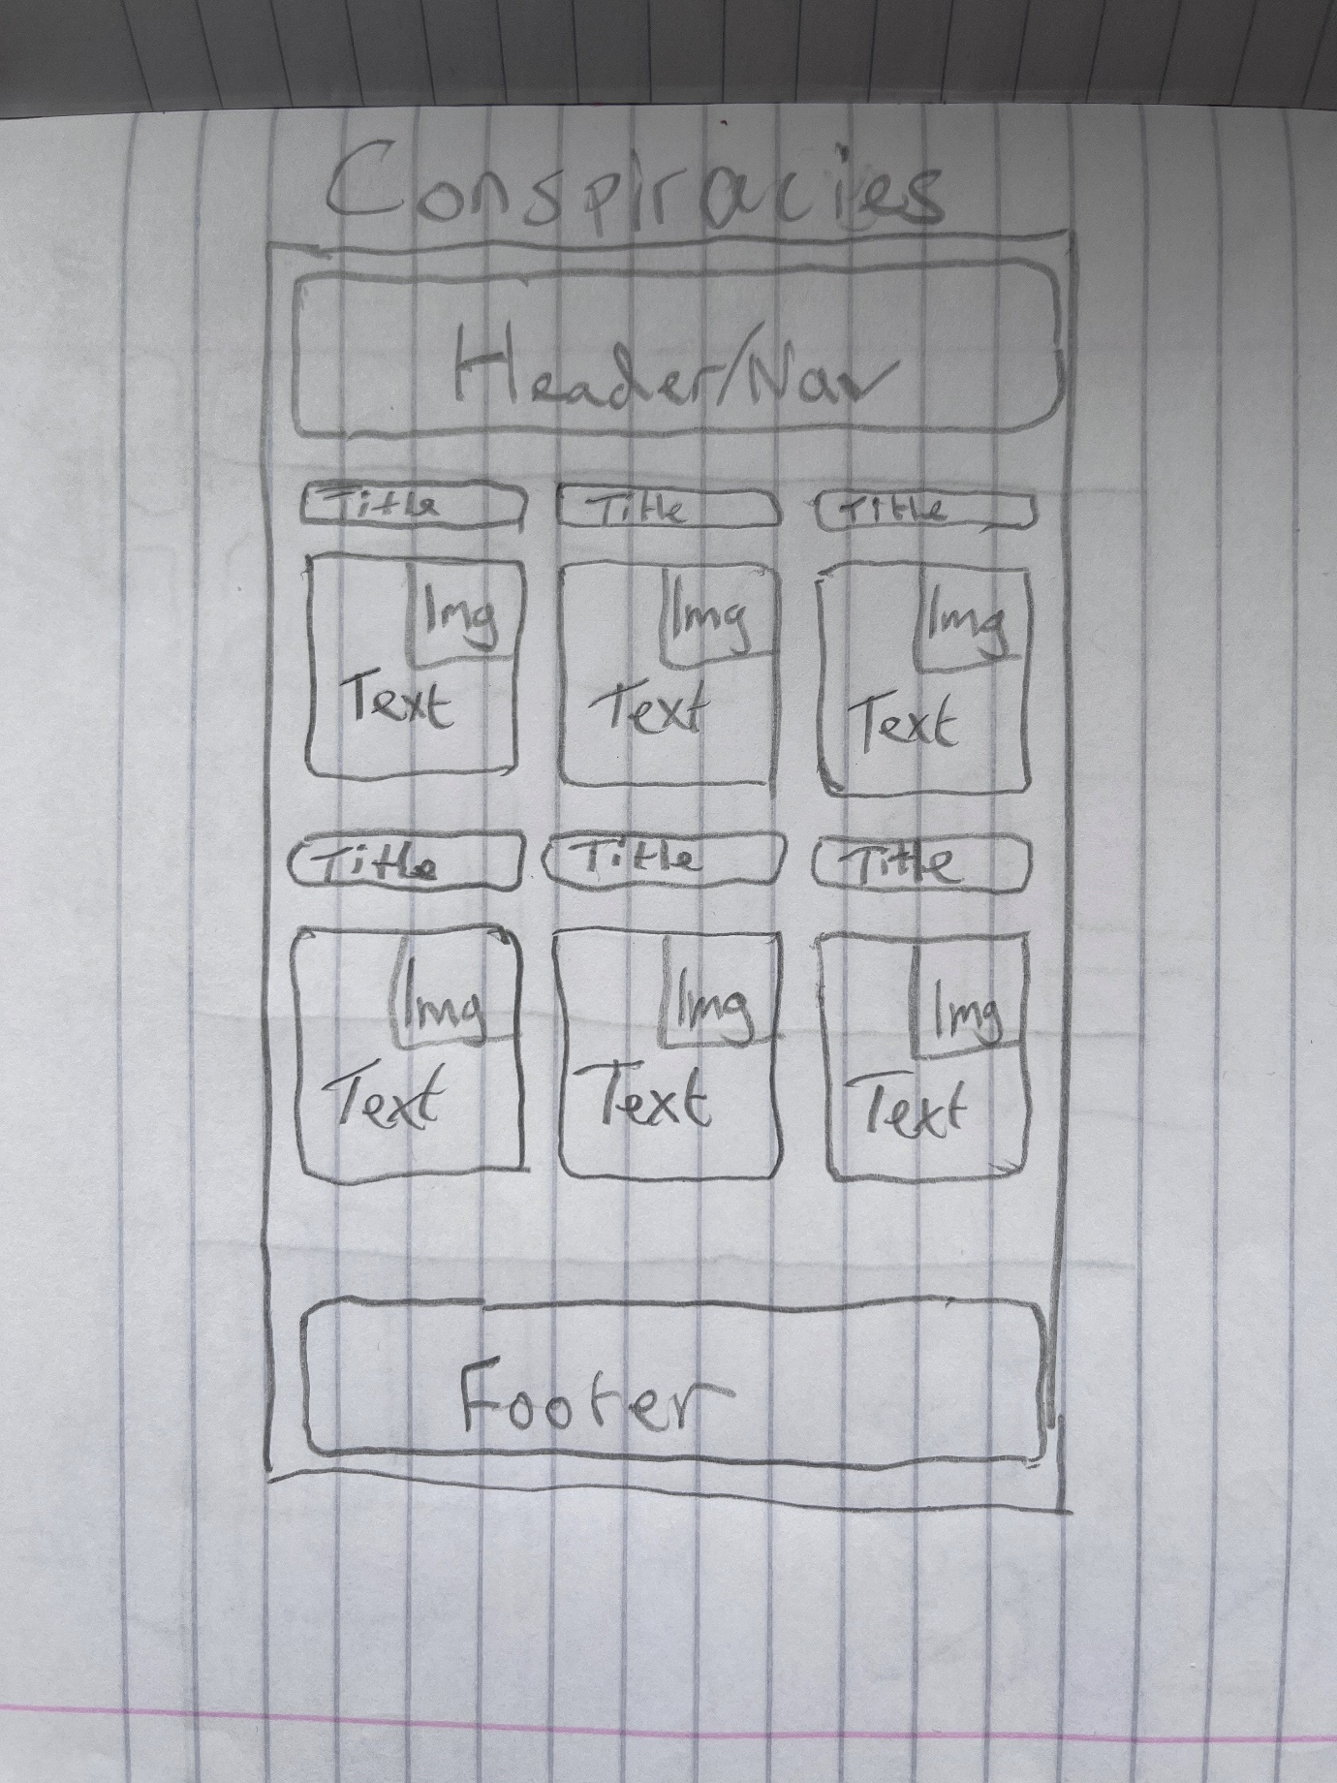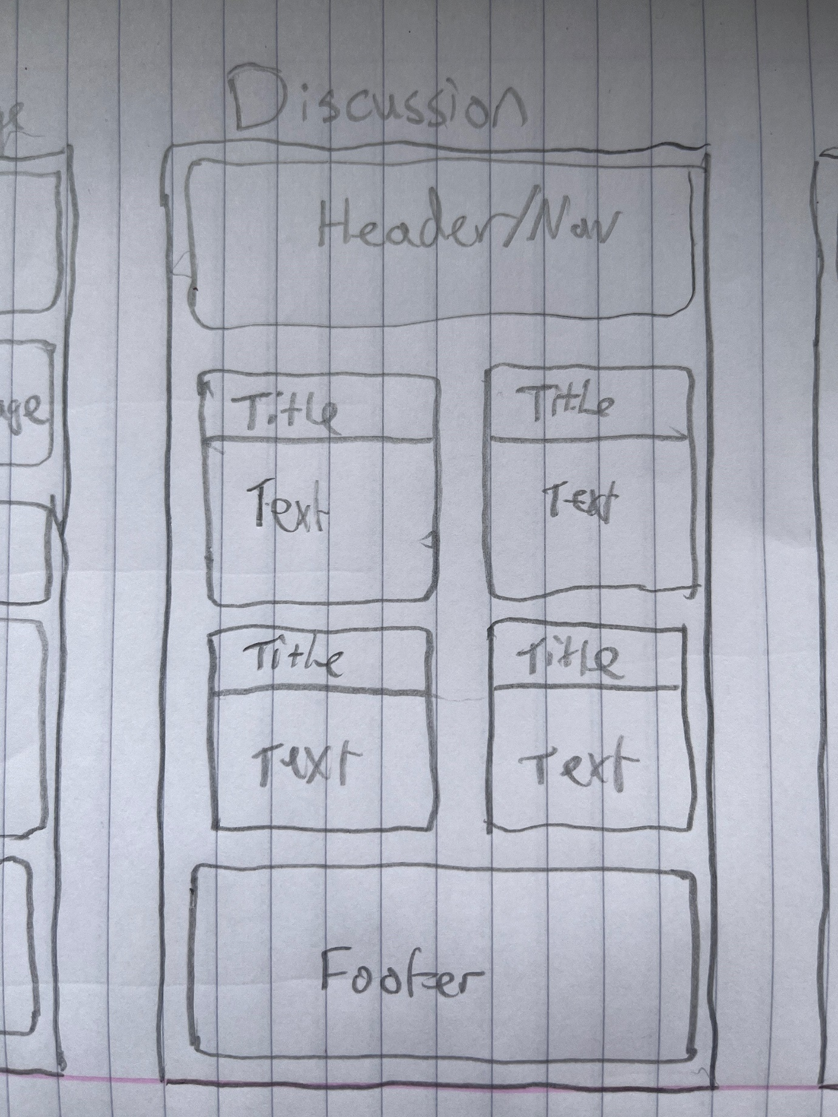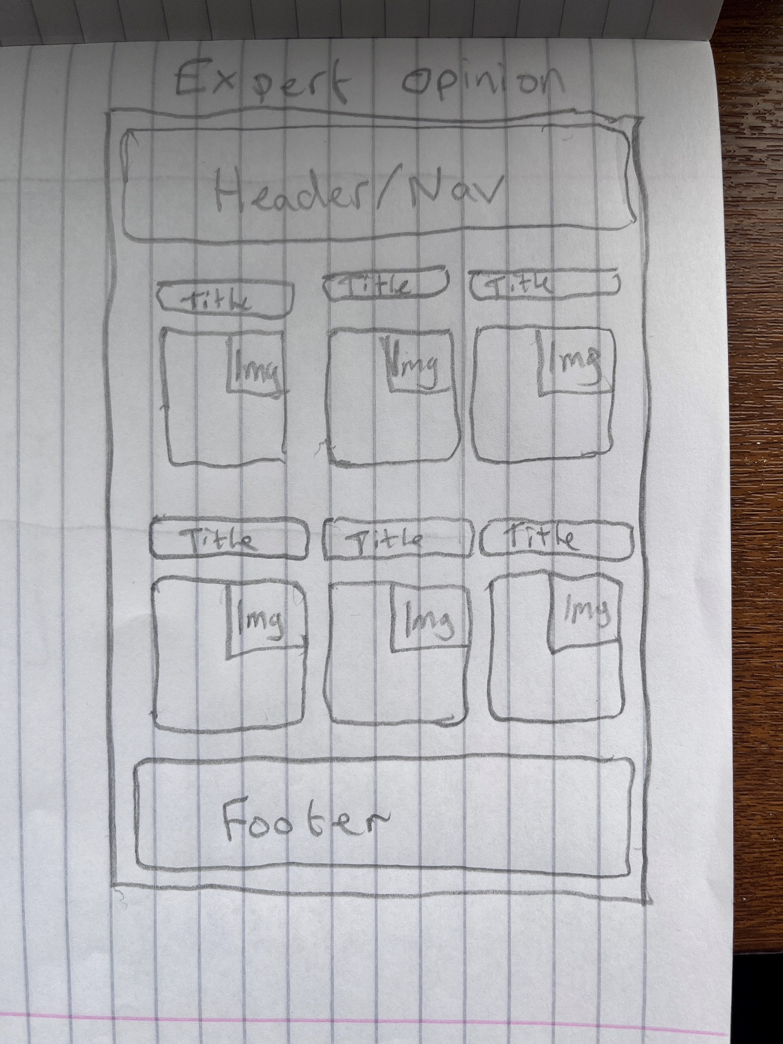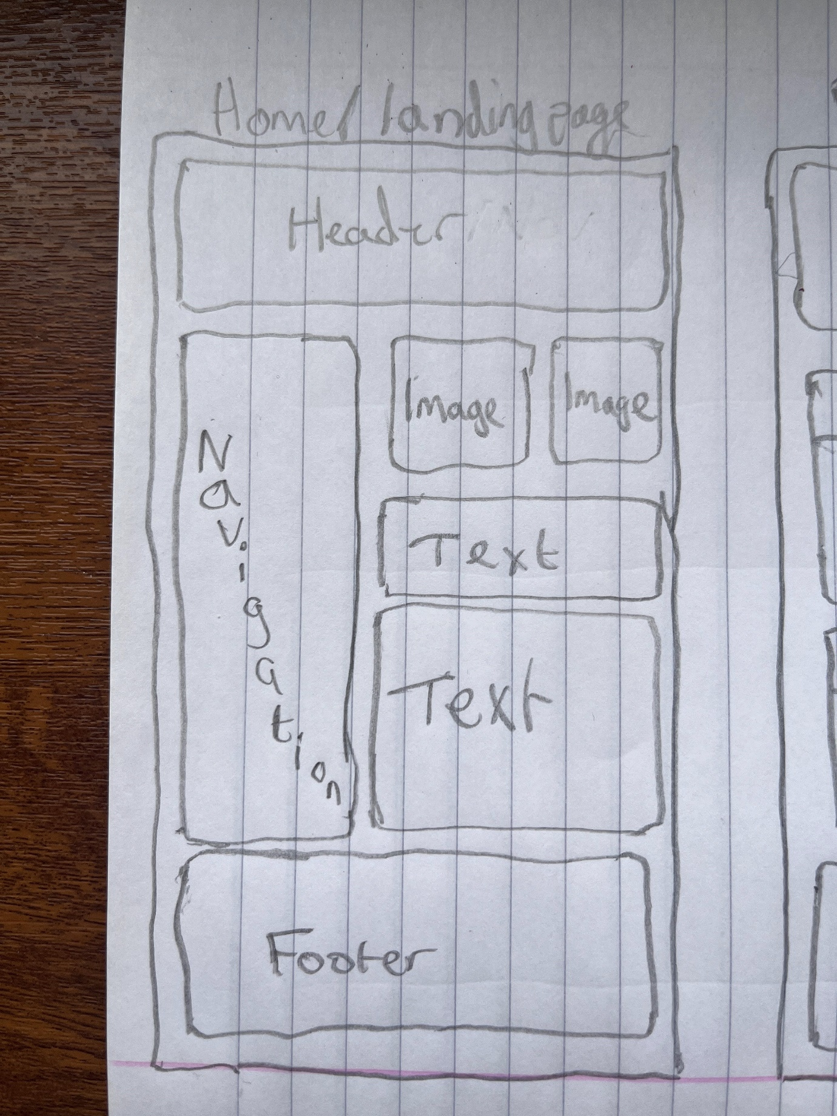

HTML
Home:
<!DOCTYPE html>
<html lang="en">
<head>
<meta charset="UTF-8">
<meta name="viewport" content="width=device-width, initial-scale=1.0">
<meta name="description" content="Unearthed Conspiracies is a hub for exploring and discussing conspiracy theories from around the world.">
<meta name="keywords" content="conspiracies, conspiracy theories, moon landing, Area 51, Illuminati, Chemtrails, Bermuda Triangle, COVID-19">
<meta name="author" content="Shaun Davies">
<title>Unearthed Conspiracies</title>
<link rel="icon" type="favicon" href="images/moon2.png">
<link rel="stylesheet" href="styles/home_styles.css">
</head>
<body>
<header>
<h1>Unearthed Conspiracies</h1>
<p>A place to explore the unexplored.</p>
</header>
<nav>
<ul>
<li><a href="home.html" aria-label="Home">Home</a></li>
<li><a href="conspiracies.html" aria-label="Conspiracies">Conspiracies</a></li>
<li><a href="discussion.html" aria-label="Discussion">Discussion</a></li>
<li><a href="expert_opinion.html" aria-label="Expert Opinion">Expert Opinion</a></li>
<li><a href="about.html" aria-label="About">About</a></li>
</ul>
</nav>
<main>
<section aria-label="Featured Stories">
<article>
<img src="images/Illuminati.PNG" class="imgcenter" alt="Placeholder image">
<h2>Featured Conspiracy</h2>
<p>Imagine a world where the course of history, the flow of information, and even the fate of nations are governed not by democratic processes or random chance, but by a clandestine society of the world's most influential and powerful individuals. The Illuminati, a name that echoes with mystery and elite power, is rumored to be this very group. Dating back to the Enlightenment, this secret society is said to have survived in various forms, weaving its influence through the tapestry of global politics, finance, and media. What if beneath the surface of our everyday reality lies a shadowy dominion where the Illuminati shape the world according to their own agenda? The thought of such a hidden hand guiding global events, while unsettling, is undeniably fascinating, offering an alternative lens through which to view the complexities of world affairs.</p>
</article>
<article>
<img src="images/chemtrails.jpg" class="imgcenter" alt="Placeholder image">
<h2>Latest Discussions</h2>
<p>Have you ever looked up at the sky and noticed the long, white trails that planes leave behind? These are commonly known as contrails, but some believe there's more to them than meets the eye. Enter the realm of 'Chemtrails', a theory shrouded in intrigue and mystery, suggesting that these trails are actually chemical or biological agents secretly sprayed by the government for purposes unknown. Proponents of this theory point to patterns and persistency in the sky as evidence of a larger, more sinister operation at play. Could it be for weather manipulation, population control, or even biological testing? The idea that we might be living under an invisible threat, one that crisscrosses our very skies, is a captivating notion for those who question the narratives fed by mainstream science and seek answers in the unexplained shadows of our world. Continue the discussion on the Discussions page</p>
</article>
</section>
<section>
<div class="text-section full-size">
<p>Our Purpose</p>
</div>

<div class="text-section half-size">
<p>Unearthed Conspiracies aims to serve as a hub for people interested in conspiracy theories as a form of satire or interest where they can find information on perspectives of a variety of conspiracy theories. The website is not a news site and does not aim to misinform but to entertain users. The subject matter of my website is conspiracy theories</p>
</div>
</section>
</main>
<footer>
<p>&copy; 2024 Unearthed Conspiracies. All rights reserved.</p>
</footer>
</body>
</html>

Conspiracies:
<!DOCTYPE html>
<html lang="en">
<head>
<meta charset="UTF-8">
<meta name="viewport" content="width=device-width, initial-scale=1.0">
<meta name="description" content="Unearthed Conspiracies - Explore Conspiracy Theories">
<meta name="keywords" content="conspiracies, conspiracy theories, moon landing, Area 51, Illuminati, Chemtrails, Bermuda Triangle, COVID-19">
<meta name="author" content="Shaun Davies">
<title>Conspiracies | Unearthed Conspiracies</title>
<link rel="icon" type="favicon" href="images/moon2.png">
<link rel="stylesheet" href="styles/conspiracies_styles.css">
</head>
<body>
<header>
<h1>Unearthed Conspiracies</h1>
<p>Exploring the World of Conspiracy Theories</p>
</header>

<nav>
<ul>
<li><a href="home.html" aria-label="Home">Home</a></li>
<li><a href="conspiracies.html" aria-label="Conspiracies">Conspiracies</a></li>
<li><a href="discussion.html" aria-label="Discussion">Discussion</a></li>
<li><a href="expert_opinion.html" aria-label="Expert Opinion">Expert Opinion</a></li>
<li><a href="about.html" aria-label="About">About</a></li>
</ul>
</nav>

<main>
<section class="grid-container">
<!-- Row 1 -->
<div class="box">
<h2>The Moon Landing</h2>
<p>Explore the theory that suggests the moon landing was staged by NASA. On one side, skeptics claim that inconsistencies in the footage and radiation hazards on the moon cast doubt on the authenticity. Supporters argue that extensive evidence, including rock samples, supports the moon landing's reality</p>
<div class="image-container">
<img class="imgcenter" src="images/moon2.png" alt="A picture of the moon">
</div>
</div>
<div class="box">
<h2>Area 51 Secrets</h2>
<p>Uncover the mysteries of Area 51, a top-secret U.S. military facility. Critics believe it hides extraterrestrial technology, while government officials maintain that it's a testing ground for classified military aircraft</p>
<div class="image-container">
<img class="imgcenter" src="images/area51.webp" alt="Area 51">
</div>
</div>
<div class="box">
<h2>The Illuminati</h2>
<p>Learn about the enigmatic Illuminati, a secret society believed to control world events. Critics see it as a baseless conspiracy, while believers argue that its symbols and alleged influence are widespread.</p>
<div class="image-container">
<img class="imgcenter" src="images/Illuminati.PNG" alt="the eye of providence">
</div>
</div>
<div class="box">
<h2>Chemtrails and Geoengineering</h2>
<p>Examine claims about chemtrails—high-flying aircraft leaving chemical trails in the sky. Critics assert that these are ordinary contrails, while proponents allege weather manipulation and harmful effects.</p>
<div class="image-container">
<img class="imgcenter" src="images/chemtrails.jpg" alt="A plane flying with trails of white clouds behind it">
</div>
</div>
<div class="box">
<h2>The Bermuda Triangle</h2>
<p>Explore the mystery of the Bermuda Triangle, an area in the western part of the North Atlantic Ocean where ships and aircraft have allegedly disappeared under unusual circumstances. Some theorists suggest supernatural causes or extraterrestrial involvement, while skeptics argue that many incidents can be attributed to natural phenomena and human error.
</p>
<div class="image-container">
<img class="imgcenter" src="images/bermuda.png" alt="Burmuda_Triangle">
</div>
</div>
<div class="box">
<h2>COVID-19 Conspiracy Theories</h2>
<p>Investigate various COVID-19 conspiracy theories. On one side, skeptics question the virus's origin and vaccine safety. Public health experts argue for the importance of vaccinations and the validity of scientific research</p>
<div class="image-container">
<img class="imgcenter" src="images/covid19.png" alt="covid19">
</div>
</div>
</section>
</main>

<footer>
<p>&copy; 2024 Unearthed Conspiracies. All rights reserved.</p>
</footer>
</body>
</html>

Discussion:
<!DOCTYPE html>
<html lang="en">
<head>
<meta charset="UTF-8">
<meta name="viewport" content="width=device-width, initial-scale=1.0">
<meta name="description" content="Unearthed Conspiracies - Explore Conspiracy Theories">
<meta name="keywords" content="conspiracies, conspiracy theories, moon landing, Area 51, Illuminati, Chemtrails, Bermuda Triangle, COVID-19">
<meta name="author" content="Shaun Davies">
<title>Discussion | Unearthed Conspiracies</title>
<link rel="icon" type="favicon" href="images/moon2.png">
<link rel="stylesheet" href="styles/discussion_styles.css">
</head>
<body>
<header>
<h1>Discussion</h1>
<p>Discuss and explore the unexplored.</p>
</header>

<nav>
<ul>
<li><a href="home.html" aria-label="Home">Home</a></li>
<li><a href="conspiracies.html" aria-label="Conspiracies">Conspiracies</a></li>
<li><a href="discussion.html" aria-label="Discussion">Discussion</a></li>
<li><a href="expert_opinion.html" aria-label="Expert Opinion">Expert Opinion</a></li>
<li><a href="about.html" aria-label="About">About</a></li>
</ul>
</nav>

<main>
<section class="grid-container">
<div class="box" id="box1">
<h2>Flat Earth Theory</h2>
<p>Conspiracy Theory: Some individuals still adhere to the flat Earth theory, claiming that the Earth is flat rather than spherical, and that governments and space agencies are involved in a massive cover-up.</p><br>
<p>Debunking: The concept of a flat Earth has been debunked for centuries through scientific observations, including the curvature of the Earth, satellite images, and space exploration. The overwhelming scientific evidence supports the fact that the Earth is an oblate spheroid</p><br>
<p>Thoughts?</p>
<input type="text" class="input-field" placeholder="Enter your text here">
<button type="submit" class="submit-button">Submit</button>
</div>
<div class="box" id="box2">
<h2>5G and COVID-19</h2>
<p>Conspiracy Theory: Some individuals believe that the deployment of 5G technology is linked to the spread of COVID-19 or exacerbates its symptoms. They claim that the radiation from 5G towers weakens the immune system.</p><br>
<p>Debunking: The scientific consensus is that there is no credible connection between 5G technology and COVID-19. Numerous studies have shown that 5G is safe within established regulatory limits, and COVID-19 is caused by a virus, not electromagnetic radiation.</p><br>
<p>Thoughts?</p>
<input type="text" class="input-field" placeholder="Enter your text here">
<button type="submit" class="submit-button">Submit</button>
</div>
</section>

<section class="grid-container">
<div class="box" id="box3">
<h2>The Great Reset</h2>
<p>Conspiracy Theory: Some conspiracy theories suggest that "The Great Reset" is a secretive plan orchestrated by global elites and organizations to reshape the world's economy and society under a single, centralized authority.</p><br>
<p>Debunking: "The Great Reset" is actually a term used by the World Economic Forum to describe discussions on how to address global challenges like the COVID-19 pandemic, climate change, and economic inequality. It is not a secretive plot but rather a proposal for addressing pressing global issues through collaboration and innovation.</p><br>
<p>Thoughts?</p>
<input type="text" class="input-field" placeholder="Enter your text here">
<button type="submit" class="submit-button">Submit</button>
</div>
<div class="box" id="box4">
<h2>Bill Gates and Vaccine Control</h2>
<p>Conspiracy Theory: There is a conspiracy theory that claims Bill Gates is using his wealth to develop vaccines with tracking devices to control the world's population or for other nefarious purposes.</p><br>
<p>Debunking: There is no credible evidence to support this theory. Bill Gates and the Gates Foundation have been involved in philanthropic efforts to improve global health and access to vaccines, and their work is transparently documented.</p><br>
<p>Thoughts?</p>
<input type="text" class="input-field" placeholder="Enter your text here">
<button type="submit" class="submit-button">Submit</button>
</div>
</section>
</main>

<footer>
<p>&copy; 2024 Unearthed Conspiracies. All rights reserved.</p>
</footer>
<script>
// Get all submit buttons
const submitButtons = document.querySelectorAll('.submit-button');

// Loop through each button and attach a click event listener
submitButtons.forEach((button, index) => {
button.addEventListener('click', () => {
const inputField = document.querySelector(`#box${index + 1} .input-field`);
const inputText = inputField.value;
const newParagraph = document.createElement('p');
newParagraph.textContent = inputText;
newParagraph.classList.add('submitted-text');
const box = document.querySelector(`#box${index + 1}`);
box.insertBefore(newParagraph, inputField);
inputField.value = '';
});
});

</script>
</body>
</html>

Expert Opinion:
<!DOCTYPE html>
<html lang="en">
<head>
<meta charset="UTF-8">
<meta name="viewport" content="width=device-width, initial-scale=1.0">
<meta name="description" content="Unearthed Conspiracies - Explore Conspiracy Theories">
<meta name="keywords" content="conspiracies, conspiracy theories, moon landing, Area 51, Illuminati, Chemtrails, Bermuda Triangle, COVID-19">
<meta name="author" content="Shaun Davies">
<title>Conspiracy Opinions | Unearthed Conspiracies</title>
<link rel="icon" type="favicon" href="images/moon2.png">
<link rel="stylesheet" href="styles/conspiracies_styles.css">
</head>
<body>
<header>
<h1>Unearthed Conspiracies</h1>
<p>Exploring the World of Conspiracy Theories</p>
</header>

<nav>
<ul>
<li><a href="home.html" aria-label="Home">Home</a></li>
<li><a href="conspiracies.html" aria-label="Conspiracies">Conspiracies</a></li>
<li><a href="discussion.html" aria-label="Discussion">Discussion</a></li>
<li><a href="expert_opinion.html" aria-label="Expert Opinion">Expert Opinion</a></li> <li><a href="about.html" aria-label="About">About</a></li>
</ul>

</nav>

<main>
<section class="grid-container">
<div class="box">
<h2>The Moon Landing</h2>
<p>Bob Martin: Astronaut; Conspiracy theories that the Apollo moon landings were hoaxed have been debunked extensively. Space scientists, engineers, and astronauts point to the wealth of evidence supporting the landings, including rock samples, photographs, and data collected during the missions. Independent verification from international space agencies and the technological impossibility of faking such an event in the 1960s further discredit these claims.</p>
<p>Please feel free to use this <a href="https://www.rmg.co.uk/stories/topics/moon-landing-conspiracy-theories-debunked">link</a> to investigate further.</p>
<div class="image-container">
<img class="image" src="images/moon2.png" alt="A picture of the moon">
</div>

</div>
<div class="box">
<h2>Area 51 Secrets</h2>
<p>Steve Rogers: Army Veteran; Area 51 is a highly classified United States Air Force facility in Nevada, often featured in conspiracy theories suggesting it is the site of extraterrestrial technology storage or experimentation. While the U.S. government acknowledges its existence, the specifics of what occurs there remain classified due to national security. Aerospace experts and historians suggest that the secrecy is likely due to the testing of experimental aircraft and surveillance technologies, not extraterrestrial activities.</p>
<p>Please feel free to use this <a href="https://www.nationalgeographic.com/culture/article/area-51-aliens-ufos-real-history">link</a> to investigate further.</p>
<div class="image-container">
<img class="image" src="images/area51.webp" alt="Area 51">
</div>
</div>
<div class="box">
<h2>The Illuminati</h2>
<p>Jeff Bezos; Multi-millionaire and definitely NOT an illuminati member: The Illuminati conspiracy theory involves a supposed secret society seeking world domination. Historically, the Illuminati was a real Enlightenment-era group, but it disbanded in the late 18th century. Contemporary references to the Illuminati are considered fictional by historians and political scientists. There is no credible evidence of such a groups existence or influence in modern times.</p>
<p>Please feel free to use this <a href="https://en.wikipedia.org/wiki/Illuminati">link</a> to investigate further.</p>
<div class="image-container">
<img class="image" src="images/Illuminati.PNG" alt="the eye of providence">
</div>
</div>
<div class="box">
<h2>Chemtrails and Geoengineering</h2>
<p>Gareth Richard: Professor and Lecturer; The chemtrail conspiracy theory posits that the long-lasting condensation trails (contrails) left by high-flying aircraft consist of chemical or biological agents deliberately sprayed for unknown purposes. Scientific consensus rejects this theory. Studies have shown that contrails are simply water vapor condensing into ice crystals under specific atmospheric conditions. Climatologists and atmospheric scientists emphasize that alleged evidence for chemtrails is based on misunderstandings of atmospheric phenomena.</p>
<p>Please feel free to use this <a href="https://www.bbc.com/news/blogs-trending-62240071">link</a> to investigate further.</p>
<div class="image-container">
<img class="image" src="images/chemtrails.jpg" alt="A plane flying with trails of white clouds behind it">
</div>
</div>
<div class="box">
<h2>The Bermuda Triangle</h2>
<p>Peter Square: Square and triangle enthusiast and holder of a PHD in Burmudaology: The Bermuda Triangle, a region in the western part of the North Atlantic Ocean, is known for a number of aircraft and ships supposedly disappearing under mysterious circumstances. Experts, including marine scientists and meteorologists, largely agree that the incidents within the Bermuda Triangle can be attributed to natural environmental factors, navigational errors, and statistical misrepresentation. The region is heavily trafficked, and the reported disappearances are proportionate to the amount of traffic in the area</p>
<p>Please feel free to use this <a href="https://oceanservice.noaa.gov/facts/bermudatri.html">link</a> to investigate further.</p>
<div class="image-container">
<img class="image" src="images/bermuda.png" alt="Burmuda_Triangle">
</div>
</div>
<div class="box">
<h2>COVID-19 Conspiracy Theories</h2>
<p>Rishi Sunak; Prime Minister of the United Kingdom: Various conspiracy theories have emerged around COVID-19, ranging from its origins to the vaccines developed against it. Virologists and public health experts have thoroughly investigated the virus's origins, concluding that it likely has a natural animal origin. The development and testing of vaccines have been transparent and rigorous, with extensive peer-reviewed research backing their safety and efficacy.</p>
<p>Please feel free to use this <a href="https://www.government.nl/topics/coronavirus-covid-19">link</a> to investigate further.</p>
<div class="image-container">
<img class="image" src="images/covid19.png" alt="covid19">
</div>
</div>
</section>
</main>

<footer>
<p>&copy; 2024 Unearthed Conspiracies. All rights reserved.</p>
</footer>
</body>
</html>

About:
<!DOCTYPE html>
<html lang="en">
<head>
<meta charset="UTF-8">
<meta name="viewport" content="width=device-width, initial-scale=1.0">
<meta name="description" content="About Unearthed Conspiracies">
<meta name="description" content="Unearthed Conspiracies - Explore Conspiracy Theories">
<meta name="keywords" content="conspiracies, conspiracy theories, moon landing, Area 51, Illuminati, Chemtrails, Bermuda Triangle, COVID-19">
<meta name="author" content="Shaun Davies">
<title>About | Unearthed Conspiracies</title>
<link rel="icon" type="favicon" href="images/moon2.png">
<link rel="stylesheet" href="styles/about_styles.css">
</head>
<body>
<header>
<h1>About Unearthed Conspiracies</h1>
<p>About us</p>
</header>
<nav>
<ul>
<li><a href="home.html" aria-label="Home">Home</a></li>
<li><a href="conspiracies.html" aria-label="Conspiracies">Conspiracies</a></li>
<li><a href="discussion.html" aria-label="Discussion">Discussion</a></li>
<li><a href="expert_opinion.html" aria-label="Expert Opinion">Expert Opinion</a></li> <li><a href="about.html" aria-label="About">About</a></li>
</ul>
</nav>
<main>
<section class="text-block">
<h2>Our Mission</h2>
<p>At Unearthed Conspiracies, our mission is to provide a platform for individuals who share an interest in exploring, analysing, and discussing conspiracy theories from around the world. We believe that conspiracy theories, while often speculative and unconventional, play a significant role in shaping our understanding of the world. Our goal is to offer a space where enthusiasts, skeptics, and the curious can come together to engage in thoughtful and respectful conversations about these intriguing narratives.</p>
</section>
<section class="text-block">
<h2>Our Team</h2>
<p>Unearthed Conspiracies is a project fueled by a diverse and passionate team of individuals who share a common fascination with the world of conspiracy theories. Our dedicated team includes researchers, writers, content creators, and web developers, all working collaboratively to bring you the latest insights and discussions on a wide range of conspiracy topics. We are committed to providing well-researched content and fostering a welcoming community for all those interested in this enigmatic realm of thought.</p>
</section>
</main>
<footer>
<p>&copy; 2024 Unearthed Conspiracies</p>
</footer>
</body>
</html>

CSS
Home:
* {
margin: 0;
padding: 0;
box-sizing: border-box;
}

body {
font-family: 'Arial', sans-serif;
color: #333;
background: #f8f8f8;
line-height: 1.6;
}

header {
background-color: #444;
color: white;
padding: 1rem;
text-align: center;
}

nav {
background-color: #333;
padding: 0.5rem 0;
}

nav ul {
list-style: none;
text-align: center;
}

nav ul li {
display: inline;
margin-right: 20px;
}

nav a {
color: white;
text-decoration: none;
font-weight: bold;
padding: 0.5rem 1rem;
display: inline-block;
border-radius: 5px;
transition: background-color 0.3s;
}

nav a:hover {
background-color: #555;
}

main {
padding: 1rem;
}

.imgcenter {
display: block;
margin-left: auto;
margin-right: auto;
width: 50%;
}

article {
background-color: #fff;
border: 1px solid #ddd;
padding: 1rem;
margin-bottom: 1rem;

}

article img {
max-width: 100%;
height: auto;
}

.text-section {
margin: 1rem 0;
}

.text-section.half-size {
font-size: 0.75rem;
}

.text-section.full-size {
font-size: 1.5rem;
}

footer {
background-color: #444;
color: white;
text-align: center;
padding: 1rem;
margin-top: 1rem;
}

@media screen and (max-width: 768px) {
nav ul li {
display: block;
margin-bottom: 0.5rem;
}
}

Conspiracies:
* {
margin: 0;
padding: 0;
box-sizing: border-box;
}

.image-container {
position: relative;
width: 100%;
height: 100%;
}

.image {
top: 0;
right: 0;
width: 25%;
}

body {
font-family: 'Arial', sans-serif;
color: #333;
background: #f8f8f8;
line-height: 1.6;
}

header {
background-color: #444;
color: white;
padding: 1rem;
text-align: center;
}

nav {
background-color: #333;
padding: 0.5rem 0;
}

nav ul {
list-style: none;
text-align: center;
}

nav ul li {
display: inline;
margin-right: 20px;
}

nav a {
color: white;
text-decoration: none;
font-weight: bold;
padding: 0.5rem 1rem;
display: inline-block;
border-radius: 5px;
transition: background-color 0.3s;
}

nav a:hover {
background-color: #555;
}

main {
padding: 1rem;
}

.grid-container {
display: grid;
grid-template-columns: 1fr 1fr;
gap: 20px;
margin-bottom: 20px;
}

.box {
background-color: #fff;
border: 1px solid #ddd;
padding: 1rem;
box-shadow: 0 2px 5px rgba(0,0,0,0.1);
}

.box h2 {
font-size: 1.5rem;
margin-bottom: 0.5rem;
color: #333;
}

.imgcenter {
display: block;
margin-left: auto;
margin-right: auto;
width: 50%;
}

footer {
background-color: #444;
color: white;
text-align: center;
padding: 1rem;
margin-top: 1rem;
}

@media screen and (max-width: 768px) {
.grid-container {
grid-template-columns: 1fr;
}

nav ul li {
display: block;
margin-bottom: 0.5rem;
}
}

Discussion:
* {
margin: 0;
padding: 0;
box-sizing: border-box;
}

body {
font-family: 'Arial', sans-serif;
color: #333;
background: #f8f8f8;
line-height: 1.6;
}

header {
background-color: #444;
color: white;
padding: 1rem;
text-align: center;
}

nav {
background-color: #333;
padding: 0.5rem 0;
}

nav ul {
list-style: none;
text-align: center;
}

nav ul li {
display: inline;
margin-right: 20px;
}

nav a {
color: white;
text-decoration: none;
font-weight: bold;
padding: 0.5rem 1rem;
display: inline-block;
border-radius: 5px;
transition: background-color 0.3s;
}

nav a:hover {
background-color: #555;
}

main {
padding: 1rem;
}

.grid-container {
display: grid;
grid-template-columns: 1fr 1fr;
gap: 20px;
margin-bottom: 20px;
}

.box {
background-color: #fff;
border: 1px solid #ddd;
padding: 1rem;
box-shadow: 0 2px 5px rgba(0,0,0,0.1);
}

.box h2 {
font-size: 1.5rem;
margin-bottom: 0.5rem;
color: #333;
}

.input-field {
width: 100%;
padding: 0.5rem;
margin-top: 1rem;
border: 1px solid #ddd;
background-color: #fff;
box-sizing: border-box;
}

.input-field:focus, .input-field:valid {
background-color: lightgreen;
}

.submitted-text {
color: #333;
margin-top: 0.5rem;
}

.submit-button {
background-color: #444;
color: white;
border: none;
padding: 0.5rem 1rem;
margin-top: 0.5rem;
cursor: pointer;
border-radius: 4px;
transition: background-color 0.3s, color 0.3s;
}

.submit-button:hover {
background-color: #333;
}

footer {
background-color: #444;
color: white;
text-align: center;
padding: 1rem;
margin-top: 1rem;
}

@media screen and (max-width: 768px) {
.grid-container {
grid-template-columns: 1fr;
}

nav ul li {
display: block;
margin-bottom: 0.5rem;
}
}

About:
* {
margin: 0;
padding: 0;
box-sizing: border-box;
}

body {
font-family: 'Arial', sans-serif;
color: #333;
background: #f8f8f8;
line-height: 1.6;
}

header {
background-color: #444;
color: white;
padding: 1rem;
text-align: center;
}

nav {
background-color: #333;
padding: 0.5rem 0;
}

nav ul {
list-style: none;
text-align: center;
}

nav ul li {
display: inline;
margin-right: 20px;
}

nav a {
color: white;
text-decoration: none;
font-weight: bold;
padding: 0.5rem 1rem;
display: inline-block;
border-radius: 5px;
transition: background-color 0.3s;
}

nav a:hover {
background-color: #555;
}

main {
padding: 1rem;
}

article {
background-color: #fff;
border: 1px solid #ddd;
padding: 1rem;
box-shadow: 0 2px 5px rgba(0,0,0,0.1);
margin-bottom: 20px;
}

.text-block {
background-color: #fff;
border: 1px solid #ddd;
padding: 1rem;
box-shadow: 0 2px 5px rgba(0,0,0,0.1);
margin-bottom: 20px;
}

.text-block h2 {
font-size: 1.5rem;
margin-bottom: 0.5rem;
color: #333;
}

footer {
background-color: #444;
color: white;
text-align: center;
padding: 1rem;
margin-top: 1rem;
}

@media screen and (max-width: 768px) {
nav ul li {
display: block;
margin-bottom: 0.5rem;
}
}

