
Skills for the Workplace
Module Assignment Submission
Student Name: | Liam Ellis
Student Number: | 1910792
Module No: | BMSK4002
Module Title: | Effective Team Working and Communication  Part 2

Statement of Confirmation of Authenticity
By the act of making this submission, the student declares that this is the work of the student named above. The work has not, in whole or in part, been knowingly presented elsewhere for assessment, or where assessment has been built on a previous assessment, this has been identified. Where materials have been used from other sources it has been properly acknowledged. If this statement is untrue, the student acknowledges that an assessment offence has been committed.
Attention is drawn to the plagiarism and unfair practice policies of both the University and of ILM.

Table of Contents
Part 2 Communication 3
1.0 3
Communication Cycle 3
2.0 5
Assessing Own Communication Skills 5
Gap Analysis 6
PDP 6
References 7
Appendix A 7
Skills You Need Communication Quiz 7
Mind Tools Communication Quiz 9

Introduction

In Part 2 of this assignment will be talking about communication, different forms of communications. Talking about my self-assessment on my own communications skills with my results screen shot in the appendix down below at the bottom, will also be showing/ talking about my GAP analysis and my PDP (Personal Development Plan)

Part 2 Communication
Communication is a big part of everyday life and for business across the board, transferring information from one place, person, or group to another. All communications consist of (at least) one sender, a message and a recipient or recipients. Communications messages can consist of any message being that of verbal-written, verbal-oral-face to face, verbal-oral-distance, formal and informal types of communications.
Here is a few examples down below of different forms of communications like sign language, facial expressions, gestures, Hobo signs and programming languages.
Sign Language.
In the 1500s Benedictine monks were signing to side-step ‘vows of silence’. One such monk went beyond the pale. Pedro Ponce de León is called the father of education for the deaf. He invented the first manual alphabet for fingerspelling. Perhaps the most famous finger speller in history is the Helen Keller. Left blind and deaf after a childhood illness, she wrote and lectured extensively, championed disability rights, worked as an educator and humanitarian, and co-founded the ACLU. She was a hero to countless many and changed how the world saw people unable to see, hear, or speak.
French Sign language took off in the second half of the 1700s and led to the most widely used form of sign language, American Sign Language (ASL). Marlee Matlin famously signed her way to an Academy Award in the movie Children of a Lesser God. Today, an ASL speaker who knows only English and an ASL speaker who knows only Greek can still speak fluently, for example, making foreign travel within deaf circles one of mutual understanding.
Sign language can be written in images that suggest hieroglyphics, and there have been several attempts to codify writing systems. There is even a request in to create an ASL version of Wikipedia in Signwriting.
Still, the fingerspelling aspect of signing is language dependent. Moreover, there are more than 100 variants of sign language used world-wide so not all signing systems are mutually intelligible. But the main drawback remains the silence.

Facial Expressions.
You think you know what angry, sad, and happy look like on someone’s face? Chances are you really do. Human express core emotions on their faces as a primal form of communication. Moreover, these expressions seem to be ancient as they are shared across cultures.
The great naturalist Charles Darwin recognized his. He wrote his third book about this fact. He entitled it The Expression of the Emotions in Man and Animals and suggests that key emotions are even readable on animals. If you’ve watched great apes, you can see they ‘feel’. Research shows that chimps laugh when tickled,
even as babies and can smile. They can also read our facial expressions of pleasure and disgust.
While facial expressions for emotions might be close to universal, they lack nuance. You might signal the world is falling apart and you are about to cry but you probably can’t tell someone how to bake a cake or fix a car. Profound but not practical.

Gestures.
Gestures add to what you can do with facial expressions. Anyone trying to communicate through a soundproof window, for example, might dip into this pool of information-giving instructions. It’s easy enough to point to signal directions and suggest movements (up, down, left, right) or signal a target of interest (point at yourself, point at someone else), but gestures vary widely between cultures.
Just look at the extensive body language gestures of the Japanese: to start with, to be polite, you never point. In Western cultures eye-contact is considered a cornerstone of polite conversation. In Japan, it signals aggression.

Hobo Signs.
Non-verbal signals can also be written down. One set of intriguing symbols created by those travelling the American railroads, often looking for work, are ‘hobo signs’, or hobo code. Used from the 1880s until WWII, and especially widespread during the Depression, hobo signs could appear on any blank, flat location, from walls to fences.
You might leave a slanted T-shape to warn others to ‘get out fast’, a tic-tack-toe symbol to mark the house of a policeman or five circles, to mean ‘good chance to get money here’. More complex shapes meant ‘help here if sick’, ‘judge’ or conveyed other pieces of information useful to transients new to town.
This form of communication evolved in an altruistic fashion – to help those who followed in your tracks. Naturally, the motivation to do so stemmed from hoping someone would give you a heads up before you arrived in the next place.
Symbols have the advantage of being language independent. The disadvantage is that you must see them to use them as communication. A Hobo sign enjoyed the huge advantage of lasting long after the one who ‘uttered it’ left, especially if carved into stone. Then again, a bramble might grow up over it and silence it.
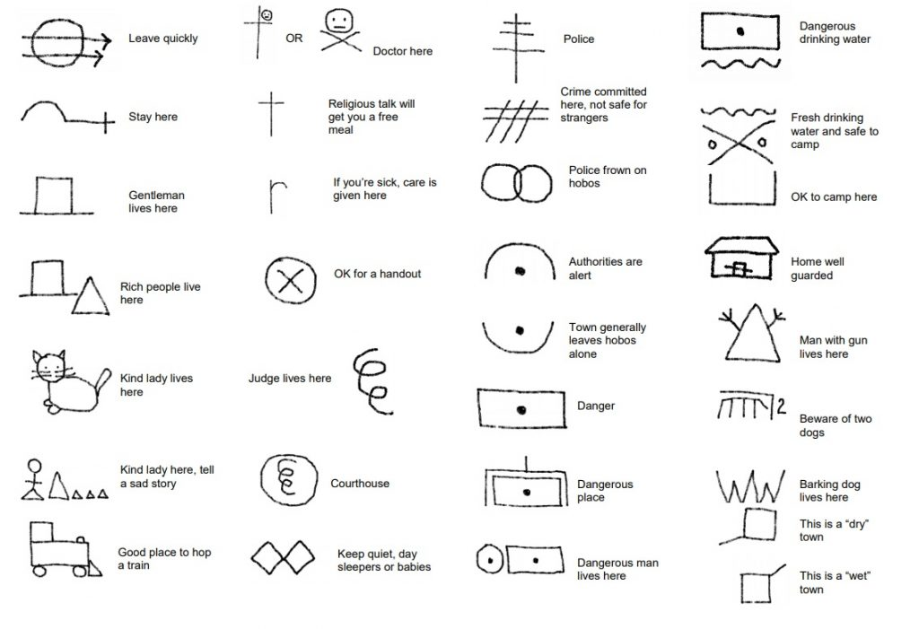
Programming Languages.
What can describe all of math, so much more, and be used to talk to computers to make them do any number of amazing computations? Computers make the world go round, from banking to the internet to looking for intelligent alien life, and it’s all down to human-devised programming language. Actually there are thousands of programming languages, but this is about the general concept: the speed of uptake means they are ‘universal.’ They are written in the language of logic and math using symbols and the majority are take words from English.
Programming languages originated in English-speaking countries or were devised by non-native speakers in English to promote uptake. Programming languages have vocabulary and syntax (word order) just like real languages. Key words (like “print”) define functions to do tasks and symbols (like quotes and parenthesis) help organize logic and actions (add, divide, multiply).
While a Java programmer might speak any native language, she will always type “print” to make the computer to send a message to the screen. This code will be legible to all Java programmers.

Still, there are non-English programming languages and only a fraction of the world can read programming code, much less write it from scratch. And of course, programming code runs chatbots that mimic the human ability to communicate in language, but so far you can’t use ‘code’ to order a coffee.
Maybe someday, a pool of programmers, native in a range of human languages, will write a universal translator software and bring us all together.

1.0

Communication Cycle
There is 8 stages of communication and here are some of those stages are the official message, encoding, transmission through choice channel and medium, decoding and understanding after the transmission, the reception, and the respond and feedback after the reception.

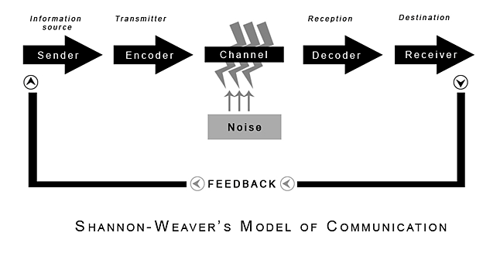
(Shannon and Weaver, 1949)

2.0

Assessing Own Communication Skills

Having done a self-assessment of my own communications skills,
Here is my results from the questionnaire and you will find some screen shots in the appendix A.
My total score was 45% on the answers I have provided my interpersonal skills are below average, I should spend time developing and practising my interpersonal skills, this is likely to lead to better and more successful relationships with other people, at home, socially, and at work or school.
My listening skills are 50% (Average) based on my answers I provided my listening skills are average. I may have picked up bad listening habits or never previously thought about the active processes involved in effective listening. Although my listening skills are OK! I should think about developing them further by consciously practising effective and active listening.
My Emotional Intelligence score was 55% (Average) achieved an average score for the emotional intelligence part of the assessment. Emotional intelligence is a measure of how well I understand and deal with my emotions and the emotions of others. Developing a better awareness of emotions and understanding why I and others behave in certain ways which will enhance my interpersonal skills. It is worth taking some time to understand and improve my emotional intel as it could be the most important aspect of my personal development. Research has shown that people with higher emotional intel enjoy more satisfying and successful careers and relationships.
My Verbal Communication score was 27% (below Average) scored below average on spoken and communication, should think about ways to I can practise and improve my verbal and communication. My verbal communication skills maybe a result of low self-esteem or over-confidence, this is something that you will be able to recognise in myself. Over-confident people may use unfamiliar language or jargon when speaking to others, making them difficult to understand. People with low esteem may not feel able to confidently communicate their ideas and opinions. It is also possible that I have been overly self-critical in my assessment.

My Communicating in groups score was 46% (Average) based on the answers I provided I have average confidence levels when communicating in group situations. I am likely to handle most group situations adequately, although I may well be nervous in some situations. Communicating effectively in groups is an important part of my overall interpersonal skills and is useful in many different areas of life. Next time I am in a group situation watch the other participants to pick up some ideas of what I can do, and what I can avoid doing, to improve your presence in group situations

Gap Analysis

Objective | Current Position | Deficiency | Action
What do I want to do? | What can I already do? | What am I lacking? | How do I fix this?
Presenting to an Audience. | keep practicing talking to people and in a group/audience. | The confidence in doing that. | Keep on practicing.
Build up my confidence in myself without becoming nervous or stuttering | Keep on talking to people/groups giving me that boost/ confidence I need. | Keep self-teaching to help me get that confidence that I need/want. | keep doing what I am doing, engaging with my classmates.
Gain that experience in teaching or giving a lesson/ PowerPoint classes to my fellow students. | Talk more with my class/lecturer take experience into account to help myself. | Lacking the experience in talking to a group of people out. | Take in the previous experience, listen and take notes from other students and my lecturer.

PDP

Objectives | Tasks | Success Criteria | Time Frame | Resources
List your Goals | What do you need to do to achieve these goals? | How will you identify your success? | When do they need to be done by? | Who or what do you need to help you?
Gaining confidence/experience in teaching and giving lessons. | keep on practising giving lesson to my fellow students and groups. | when I feel confident in myself. | N/A. | Help from my lecturer, Fellow students, family and friends.

References

Blenkinsop, P. (2010) The Communication Cycle. [online] Available at: http://manyana-education.blogspot.com/2010/10/communication-cycle.html Accessed: 15.05.19
MindTools (2019) How good are your communication skills? [online] Available at: https://www.mindtools.com/pages/article/newCS_99.htm Accessed: 15.05.19
Shannon, C. and Weaver, W. (1949) The Mathematical Theory of Communication. Urbana: University of Illinois Press.
Skills You Need (2019) Interpersonal Skills Self-Assessment. [online] Available at: https://www.skillsyouneed.com/ls/index.php/343479 Accessed: 15.05.19
https://www.history.com/topics/womens-rights/helen-keller
https://www.history101.com/the-intriguing-history-of-hobo-signs-symbols/

Appendix A

Skills You Need Communication Quiz

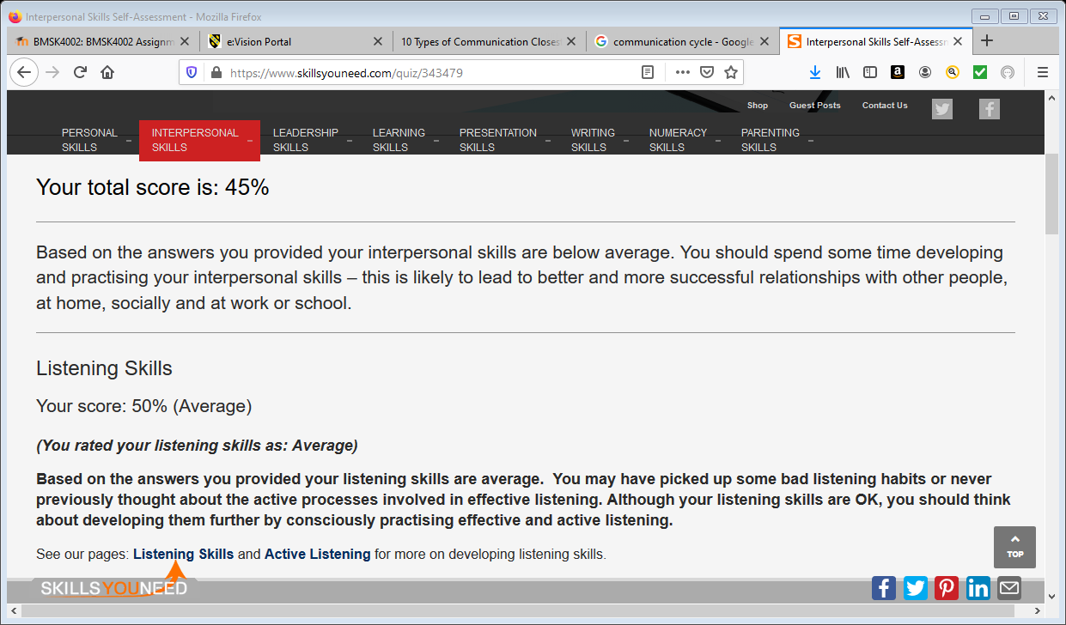

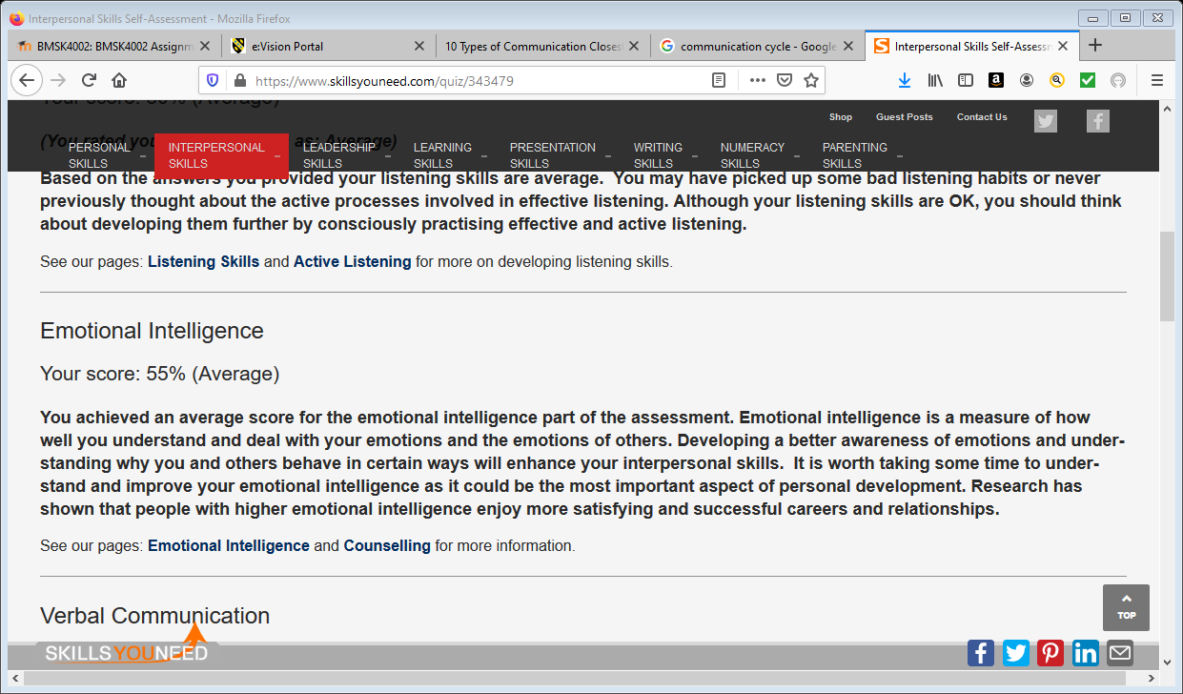

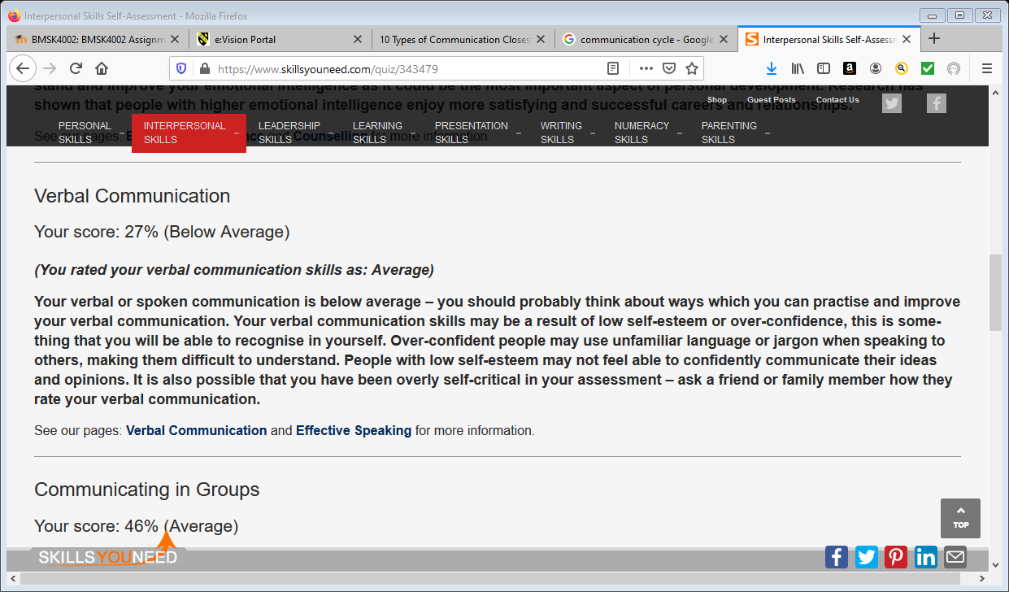

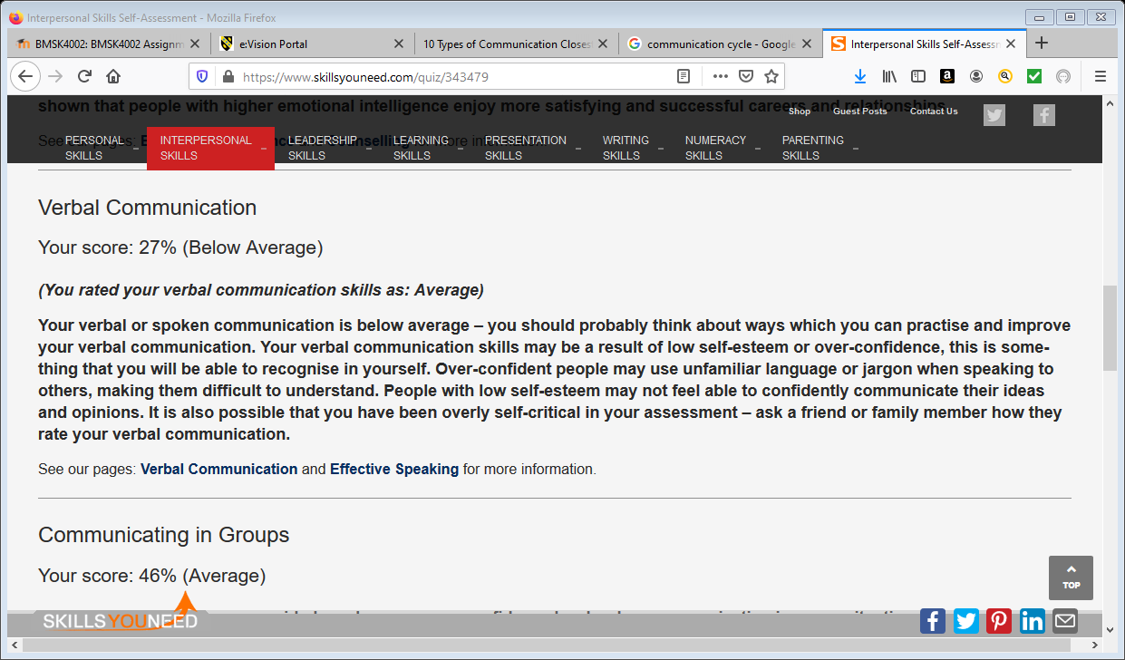
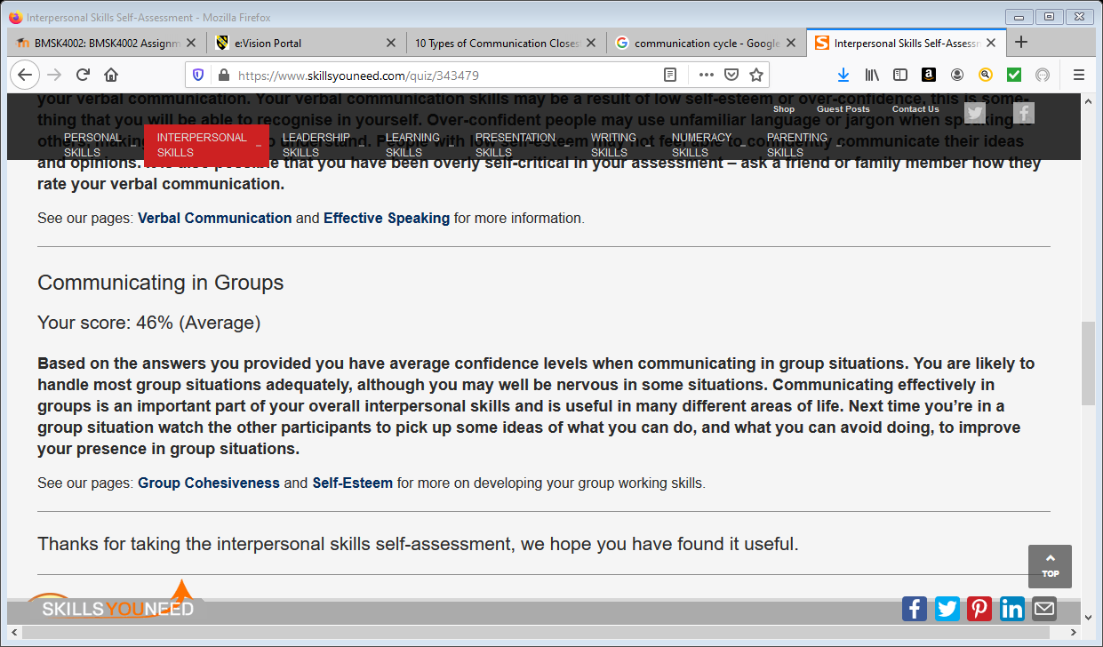

Mind Tools Communication Quiz

