Managing Enterprise in the 21st Century
BMSW 4006

Group : 2

Task 2 : Written Business Plan

Students Name and ID Number :
- Alexandra Felicia Merauta 2121306
- Anamaria Nicolaescu 2120243
- Madalina Zaharia 2123633
- Nicoleta Mocanu 2118432
-Valentin Rizea 2120085

Lecturer Name : Rajesh Kumar

Executive Summary
The study covers the business plan of a beauty salon venture named Simply Devine. The study is divided into multiple sections, to sum up, the business plan thoroughly. The study covers the proper description and specifications of the start-up. Besides, the market audit was also conducted by analysing tools like PESTLE and SWOT. Moreover, the target audience is briefly described here explaining the rationality of segmentation. After that appropriate marketing plans are devised to implement the project. Finally, the management team is defined and the financial plan is justified to allocate resources.

Table of Contents
Executive Summary 1
Product and Business Overview 3
Product and Services 3
Competitor Analysis 4
SWOT Analysis 5
PESTLE Analysis 6
Target Market 7
Marketing and Sales Plan 7
Management Team 8
Reference 9
Financial Plan 11

Product and Business Overview
The company will be established as a player in the beauty service industry and the name will be “Simply Divine”. The core service will be the “Hair to Toe” care where the potential customers will get complete treatment for their skin and get beauty care solutions. The business will focus on three fundamental areas including Beauty, Personally Specialized Service, and Professional Service. The fundamental areas will be integrated as per the company’s mission to offer a broad range of beauty solutions and meet the customer's expectations (Wang, 2022). The vision of Simply Devine states that one hour spent in the salon will make customers feel special. Customers will get the proper me-time forgetting about the stress and relaxing through the proper care of the experts. The location will be the Birmingham City Centre and the legal structure will be formed through a partnership.

Product and Services
Simply Devine will offer an assortment of services that covers the umbrella of the most offered solutions in the beauty care industry. The offerings are categorised into Hair-Cutting, coloring, Styling, Make-up, Facials and Skin care treatments, Eyebrow Styles, Pedicure/Manicures, and Massages. Both men's and women haircuts are offered here. Customers can get diverse coloring like Basic tint, Ombre, and highlight along with styling like “Blow Dry” (Fernandes et al., 2019). Besides, people can get a makeover for a Day or Night or can get a makeover for a Wedding. Besides, signature offerings like gel polish, organic treatment, and facials are offered with the eyebrow styles like tint and Shape. Besides, the beauty care provider will also offer both full body and back massages.

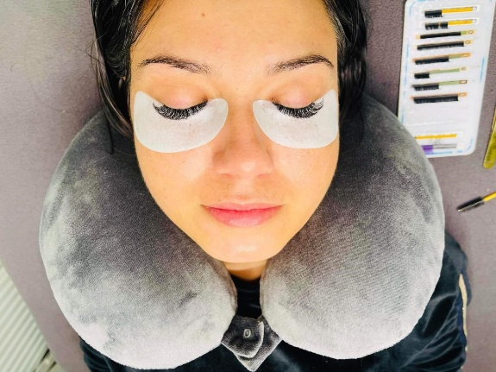

Competitor Analysis
In today's global world, companies are trying hard to differentiate themselves from the mass by focusing on supposedly trivial features. Managers of corporate entities are tasked with, among other things, exploring and identifying consumer preferences in order to design initiatives that will appeal to them (Kuan et al., 2020). There are certain USPs that will distinguish the establishment from the other market players. Firstly, the start-up will focus on providing skincare-friendly and natural solutions. The price structure will also offer market-going prices with promotional discounts. Furthermore, the newest technology in the beauty industry will also create market disruption leading to a seamless customer experience. The core competitors are the other local beauty service providers including Two hairdressers, a nail salon, one barbershop, and a spa. However, there is no all-stop beauty solution provider in the area that integrates all the services. As per the survey conducted by Ourahmoune and Jurdi (2021), consumer demands prompt service and convenience when considering beauty salon. As the establishment plans to become an “all-stop” platform, the start-up is expected to capture one-third of the local market by 2024.

SWOT Analysis
As per Nguyen (2020), when it comes to preparing and overseeing a company's future, a SWOT analysis can come in handy. This tool is useful for developing both organisational and competitive tactics. The SWOT is mainly formulated through internal analysis like Strengths and Weaknesses and external analysis like Opportunities and Threats. Here is the SWOT analysis of Simply Devine which will show the potentiality of the firm’s micro-environment. The SWOT analysis of Simply Devine is given below:
Strength | Weakness
- Competitive cost structure which will create a competitive edge  - Extensive beauty knowledge about the current trends  - Communication skills from professionals offering the finest customer service (Leung et al., 2019).  - A morale boost for personnel | - The location is quite expensive  - The products or solutions offered through automation are quite expensive  - New employer base  - Employee turnover is quite high for new startups  - Electricity bills are quite high
Opportunities | Threats
- Sophisticated target audience  - Fashion shows covering beauty trends  - Increasing Productivity after a New Item's early successes.  - Expanding the use of resources available online | - Economic downturn due to the recession 2023  - Chemical products are getting the upper hand.  - Growing monopolistic tendencies of products within the service sector  - The next decades will provide difficulty for personnel management.

PESTLE Analysis
PESTLE is an abbreviation for the six groups of situational variables that make up the framework consisting of Political, Socio-cultural, Economic, Legal, environmental, and Technological. Initially, the framework helps companies determine which environmental factors (possibilities vs. hazards) they should be evaluated as they advance future growth. As per Kim et al. (2021), to improve projection and decision-making in the present, the framework can then begin to envisage possible alternatives based on these unknowable factors. The PESTLE analysis of the start-up is provided below:
Political: Constitutional change and resilience are political considerations. UK government laws and restrictions can moderately affect company activity. Food and Drug Regulations, and the Customer Packaging and Labeling Act are enacted by the UK authority (Kuan et al., 2020). Protocols for implementing these rules can be costly and time-consuming. There will be no substantial political threat as the government backing is backing up the beauty salon industry through fashion and beauty contests.
Economic: Britain's salon sector expanded rapidly from 2014 to 2020. The luxury services business has prospered from rising spendable income and private consumption over the last six years. The impact on the workforce and growing rate of NINO have increased the per capita disposable income, giving potential customers more freedom to spend (Chin and Yuk, 2020). Besides, the company's sales are estimated to boost by 5.6% each year due to the advantage of Birmingham's vibrant economy and easy access to financial trading volume.
Social: Aesthetics, preferences, inclinations, favorites, and detest are social influences. Usually, salon customers desire the current trends. Perfect hair boosts personality, thus everyone desires it. Salons enable women to communicate with their hairdressers and other clients, unlike religions. Different individuals, ethnicities, faiths, and cultures value different skincare products and haircuts, necessitating the beauty sector. Changing needs have created new beauty care future prospects.
Technological: A beauty salon's innovation is crucial. It influences the corporation greatly as it fluctuates often. New gear and tools are required to keep up with hairstyling trends and patterns to cope with other salons. Grooming employees must be taught about emerging technologies, and with their help, the beautification company can perform great assistance and give consumers the most return for their spending.
Legal: To satisfy commercial and customer hygienic requirements, a grooming salon's products, tools, and appliances must be cleansed and sterilized. Disinfecting sinks, towels, floors, and fingertips are crucial procedure (Lee et al., 2019). Most nations, including the United Kingdom, give beauty salons informative materials on preserving clean and wholesome facilities.
Environmental: Climate, temperature change, and precipitation may affect healthcare companies. Climate disruption knowledge affects how enterprises work and the commodities they give, creating new marketplaces and depleting old ones. Using ecological and natural treatments may help the beauty boutique be more eco-friendly. Organic beauty centers often utilise botanical or henna hair colors.

Target Market
Corporations often end up spending a deal of time and effort speculating about which consumers to direct to specifically. A firm's market strategy, supply chain, and distribution networks are just a few of the multiple business choices that are determined by this one. As per Kaur and Kumar (2020), after performing a thorough market segmentation study, in which variables including scaling factor, number of players, volatility, and viability are taken into account, a relevant target audience is chosen. In this case, two distinct sets of the target group are selected. The first target market includes the existing set of current and shifted clients and the second group is the more detailed segment ranging demographics like 20-50 aged unisex personalities who are either model or VIP. The multiple targeting techniques are used to deliver seamless and novel service to the existing providers and become a stand-out creating disruption.

Marketing and Sales Plan
In case the venture is successful the firm must raise awareness about their firm which will ultimately lead to conversion. So, the start-up will require the Marketing Funnel approach, especially both the ToFU (Top of Funnel) and BoFU (Bottom of the Funnel) to increase client traffic leading to a business boost (Fernandes et al., 2019).
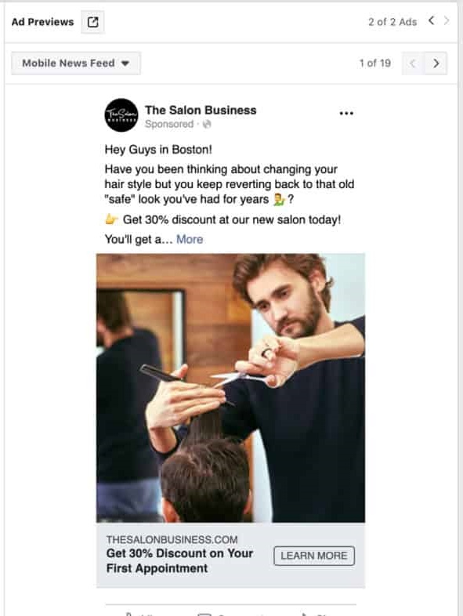
Figure 1 Online Portal of Salon

To increase the awareness of the offering and to retain loyal client’s social media like Facebook, Instagram and Twitter could be great mediums. Besides, the UK local newspaper and magazines along with online blogs and portals can also increase conversions. At some point, the company also needs to measure the local ratio of advertising are increase the frequency based on the rate of impressions. Besides, along with the flyers and reward programs, the brand advocates also increase conversion leading to the predicted boost of the business.

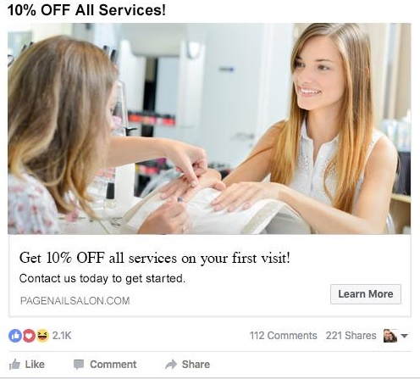

Figure 2 Facebook Marketing of Simply Devine

Figure 2 Facebook Marketing of Simply Devine

Management Team
The Simply Devine venture will include five partners where four of the owners will work as Beauty Artists and the rest will serve as Therapists. Based on the trend curve the business will shift its marketing plan. So, the integrated marketing policy should be included in the company’s corporate structure. Here the responsibility of the executive panel is described thoroughly.
Name | Alexandra M | Madalina Z | Anamaria N | Nicoleta M | Valentin R
Responsibility | Being a Make-up artist, the person will provide a professional makeover. He also monitors the hair-styling section | Expert in the makeover, who will give elegant touchup (Chin and Yuk, 2020). The person will also monitor advertising | Pedicure and Manicure Expert, who also looks over the technical aspects. | Expert in beautification specializing in Eyelashes also manages the advertising activities | Mainly works as a therapist for proper beauty care. Also oversees the massage section. The person is also responsible for the accounts.

Financial Plan
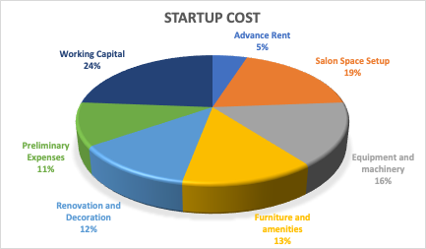
Figure 3 StartUP Cost
The financial plan includes the planning about the use of the fixed capital, working capital, projected revenue streams, costs as well as probable profit or loss in the upcoming periods. Capital investments are made for the fixed assets which will be used for the salons.
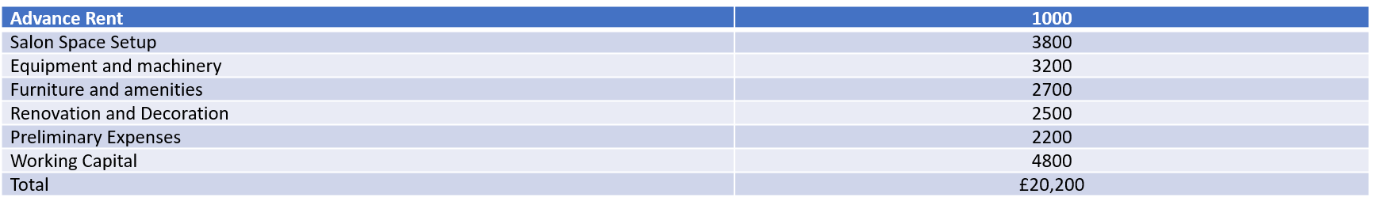Figure 4 Expected Cost
These funds will be collected from loans, bootstrapping, or other sources. 24% of the startup costs will be used for meeting the working capital needs (Kaur and Kumar, 2020). The company will be using £12,200 for salon setups, equipment as well as furniture and renovation. £1,000 has been used for making advance payments of rent which is a part of the working capital. The preliminary costs include research costs, business planning, and so on. It covers 11% of the total costs.

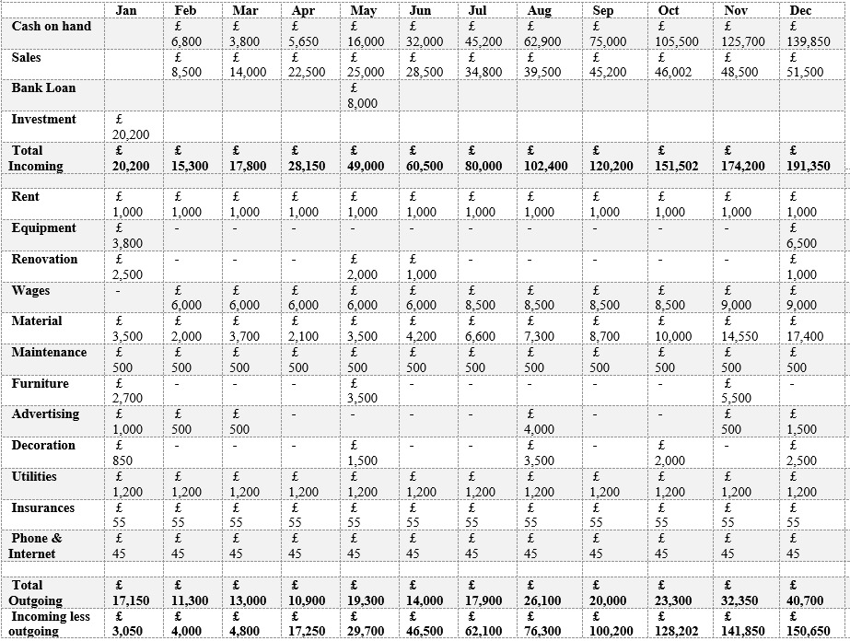
Figure 5 Monthly Cash Flow
According to the projected cash flow, rent, maintenance expenses, utilities, insurance, and phone bills are fixed costs for the salon. The sales will have a steady growth starting from £8,500 in the month of February. With increasing sales, the cost of materials will be increased too. The materials include all the products needed for the salon services (Fernandes et al., 2019). The business will spend £4,000 for advertising with some prior investments to attract clients. The salon will invest in equipment at the beginning and the end of the year. New furniture will be bought in the months of January, May, and November. With the increasing number of sales, the number of clients will increase too. it will have increased the requirement for furniture, decoration, and renovation. Also, the costs of wages will increase with increased sales. The salon will be generating profits from the month of March with sales of £14,000 and total costs of £13,000. By the end of the year, the projected difference between inflows and outflows will be £150,650, which was £3,050 at the beginning of the year.

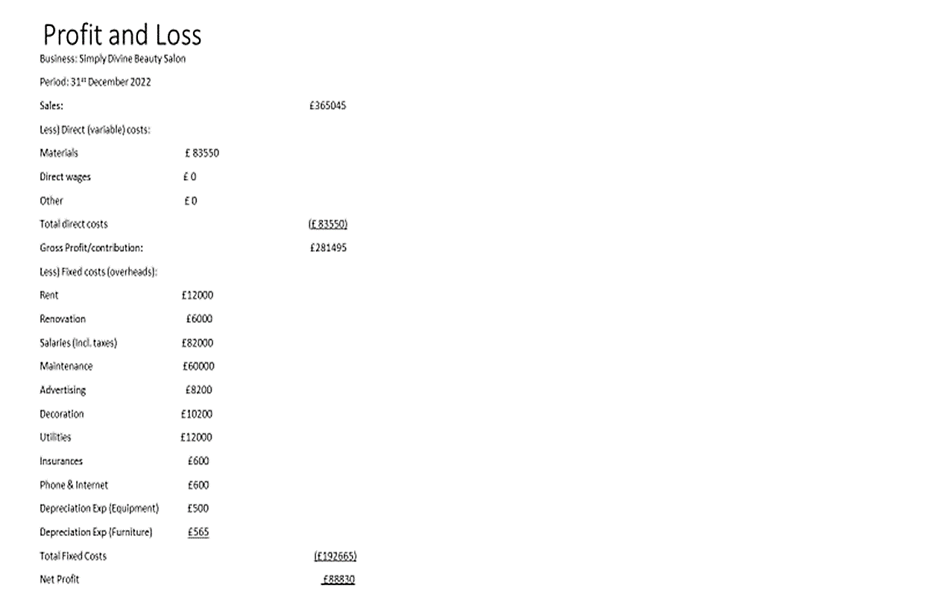
Figure 6 Profit and Loss
The projected profit and loss statement for the period of 2022, the total sales will be £365,045 with direct costs of £83,550. The direct costs will only cover the material costs as it is a salon business. The contribution margin is 77.11% with an amount of £281,495. The total fixed cost for the period is £192,665 including depreciation for the furniture and equipment. So, the net profit of the salon will be £88,830 with a margin of 24.33%.

Reference
- Chin, C.H. and Yuk, H.J., 2020. An analysis on the Factors of the Consumption Expenditure on K-beauty Service Industry. Journal of the Korea Convergence Society, 11(7), pp.351-359.
- Fernandes, E., Semuel, H. and Adiwijaya, M., 2020. The influence of social media advertising on purchase intention through utilitarian and hedonic shopping motivation: A study at beauty care and anti-aging clinic service in Surabaya. Petra International Journal of Business Studies, 3(1), pp.23-36.
- Kaur, K. and Kumar, P., 2020. Social media usage in Indian beauty and wellness industry: a qualitative study. The TQM Journal.
- Kim, Y.J., Lee, J.H., Lee, S.G. and Lee, H.H., 2021. Developing sustainable competitive strategies in the beauty service industry: a SWOT-AHP approach. Sustainability, 13(19), p.10852.
- Kuan, N.Y., Yang, F.C. and Fei, L.K., 2020. An Application of Quantitative Strategic Planning Matrix for Small Business: A Case of a Beauty Salon. Global Business & Management Research, 12(2).
- Lee, C.H., Chen, C.H. and Trappey, A.J., 2019. A structural service innovation approach for designing smart product service systems: Case study of smart beauty service. Advanced Engineering Informatics, 40, pp.154-167.
- Leung, P.P., Wu, C.H., Ip, W.H. and Ho, G.T., 2019. Enhancing online-to-offline specific customer loyalty in beauty industry. Enterprise Information Systems, 13(3), pp.352-375.
- Nguyen, T.T.N., 2020. Developing and validating five-construct model of customer satisfaction in beauty and cosmetic E-commerce. Heliyon, 6(9), p.e04887.
- Ourahmoune, N. and Jurdi, H.E., 2021. Beauty salon-a marketplace icon. Consumption Markets & Culture, 24(6), pp.611-619.
- Wang, G., 2022, March. The Application of 7P Analysis Model in the Market Strategy-Taking the Beauty Industry as an Example. In 2022 7th International Conference on Financial Innovation and Economic Development (ICFIED 2022) (pp. 1620-1624). Atlantis Press.

