Qualification: CIPD Diploma in Applied Human Resources

Module Name: Contributing to Resourcing and Talent Planning in the Organisation

Word Count: LO1 – 1,332
LO2 – 741
LO3 – 1,052

Student Name: Elinor Beynon

Student Number: 2016038

CIPD Membership Number: 57493068

By signing below, I confirm that the work/evidence presented is my own, unaided work. I understand the regulations pertaining to candidate malpractice and the action that may be taken as a result.

Signed: 

Date: 23rd May 2022

Contents
Evidence Matrix 1
LO1 6
LO1 - References 8
LO1 – Evidence 9
LO2 73
LO2 - References 74
LO3 74
LO3 - Evidence 77

Evidence Matrix
Candidate name: Elinor Beynon |  |  |  |  | CIPD Membership/registration No.:  57493068
Qualification title: CIPD Diploma in Applied Human Resources (Level 5) |  |  |  |  | Unique Learner No. (ULN):  2016038
Unit code | Unit title |  | Assessment criteria no. | Evidence description | Evidence reference number |  | Assessor  initials | I/V initials if sampled
5CDPP | Contributing to Resourcing and Talent Planning in the Organisation |  | 1.1 | Screenshot of Workforce Planning page on Staffnet | 1
5CDPP | Contributing to Resourcing and Talent Planning in the Organisation |  | 1.1 | Workforce Planning Service Review template | 2
5CDPP | Contributing to Resourcing and Talent Planning in the Organisation |  | 1.1 | Skills Development and Pathway Framework document | 3
5CDPP | Contributing to Resourcing and Talent Planning in the Organisation |  | 1.1 | Workforce Planning – A Managers Guide (first few pages as document is too long to include) | 4
5CDPP | Contributing to Resourcing and Talent Planning in the Organisation |  | 1.1 | Workforce Planning – Manager's Checklist | 5
5CDPP | Contributing to Resourcing and Talent Planning in the Organisation |  | 1.1, 1.3 | Succession Planning Process document | 6
5CDPP | Contributing to Resourcing and Talent Planning in the Organisation |  | 1.1 | Appraisal Guide Staffnet Screenshot | 7
5CDPP | Contributing to Resourcing and Talent Planning in the Organisation |  | 1.1 | Corporate Plan | 8
5CDPP | Contributing to Resourcing and Talent Planning in the Organisation |  | 1.1 | Exit Interview | 9
5CDPP | Contributing to Resourcing and Talent Planning in the Organisation |  | 1.1 | Secondment Policy | 10
5CDPP | Contributing to Resourcing and Talent Planning in the Organisation |  | 1.1 | Redeployment Policy | 11
5CDPP | Contributing to Resourcing and Talent Planning in the Organisation |  | 1.1, 3.3 | Recruitment and Selection Policy | 12
5CDPP | Contributing to Resourcing and Talent Planning in the Organisation |  | 1.2 | Email asking data team to send verification list | 13
5CDPP | Contributing to Resourcing and Talent Planning in the Organisation |  | 1.2 | Verification List of Workforce Service Centre | 14
5CDPP | Contributing to Resourcing and Talent Planning in the Organisation |  | 1.3, 3.3, 3.4 | Redeployment Portal Screenshot | 15
5CDPP | Contributing to Resourcing and Talent Planning in the Organisation |  | 1.3, 3.3, 3.4 | Current Vacancies on Website Screenshot | 16
5CDPP | Contributing to Resourcing and Talent Planning in the Organisation |  | 1.3, 3.3 | Shortlisting Form | 17
5CDPP | Contributing to Resourcing and Talent Planning in the Organisation |  | 3.1 | Delegated Powers Report | 18
5CDPP | Contributing to Resourcing and Talent Planning in the Organisation |  | 3.2 | Email from Manager asking to advertise | 19
5CDPP | Contributing to Resourcing and Talent Planning in the Organisation |  | 3.2 | Email trail to Manager explaining advert process | 20
5CDPP | Contributing to Resourcing and Talent Planning in the Organisation |  | 3.3 | Advert | 21
5CDPP | Contributing to Resourcing and Talent Planning in the Organisation |  | 3.3 | Job Description | 22
5CDPP | Contributing to Resourcing and Talent Planning in the Organisation |  | 3.3 | Equality Policy Statement | 23
5CDPP | Contributing to Resourcing and Talent Planning in the Organisation |  | 3.3 | Application Form | 24
5CDPP | Contributing to Resourcing and Talent Planning in the Organisation |  | 3.4 | Email asking HR&OD to send job evaluation scores | 25
5CDPP | Contributing to Resourcing and Talent Planning in the Organisation |  | 3.4 | Position from | 26
5CDPP | Contributing to Resourcing and Talent Planning in the Organisation |  | 3.4 | Email to Data team asking to create posts | 27
5CDPP | Contributing to Resourcing and Talent Planning in the Organisation |  | 3.4 | Email from Data team confirming posts have been created | 28
5CDPP | Contributing to Resourcing and Talent Planning in the Organisation |  | 3.4 | Email to external recruiters | 29
5CDPP | Contributing to Resourcing and Talent Planning in the Organisation |  | 3.4 | Email to manager with costings for advertising in journals | 30
5CDPP | Contributing to Resourcing and Talent Planning in the Organisation |  | 3.4 | Email from manager approving costings | 31
5CDPP | Contributing to Resourcing and Talent Planning in the Organisation |  | 3.4 | Email to Welsh translation for advert and job description | 32
5CDPP | Contributing to Resourcing and Talent Planning in the Organisation |  | 3.4 | Appointment Letter | 33
5CDPP | Contributing to Resourcing and Talent Planning in the Organisation |  | 3.4 | Contract | 34
5CDPP | Contributing to Resourcing and Talent Planning in the Organisation |  | 3.4 | Reference Request Letter | 35
5CDPP | Contributing to Resourcing and Talent Planning in the Organisation |  | 3.4 | New Starter Checklist | 36
5CDPP | Contributing to Resourcing and Talent Planning in the Organisation |  | 3.5 | Email confirming adverts on website | 37
5CDPP | Contributing to Resourcing and Talent Planning in the Organisation |  | 3.5 | Email confirming adverts in journals | 38
5CDPP | Contributing to Resourcing and Talent Planning in the Organisation |  | 3.5 | Email chasing reference | 39
5CDPP | Contributing to Resourcing and Talent Planning in the Organisation |  | 3.5 | Email confirming start date to new starter | 40
5CDPP | Contributing to Resourcing and Talent Planning in the Organisation |  | 3.5 | Email SW1 to payroll and pensions | 41
5CDPP | Contributing to Resourcing and Talent Planning in the Organisation |  | 3.6 | Email from manager thanking me for advertising | 42
5CDPP | Contributing to Resourcing and Talent Planning in the Organisation |  | 3.6 | Email from manager thanking me for setting new starter up | 43
Candidate declaration:
- I confirm that the work/evidence presented for assessment is my own unaided work.
- I have read the assessment regulations and understand that if I am found to have ‘copied’ from published work without acknowledgement, or from other candidate’s work, this may be regarded as plagiarism which is an offence against the assessment regulations and leads to failure in the relevant unit and formal disciplinary action.
- I agree to this work being subjected to scrutiny by textual analysis software if required.
- I understand that my work may be used for future academic/quality assurance purposes in accordance with the provisions of the Data Protection Act 1998.
- I understand that the work/evidence submitted for assessment may not be returned to me and that I have retained a copy for my records.
- I understand that until such time as the assessment grade has been ratified through internal and external quality assurance processes it is not final.
Signature: |  |  |  |  |  | Date: | 3rd January 2022

LO1
  - Assess how and to what extent the organisation undertakes workforce and talent planning.

It is important for organisations to know their current talent profile and their current/future requirements in order to have effective and efficient resourcing strategies (CIPD, 2020a). On the Staffnet for Swansea Council there is a page dedicated to Workforce Planning which includes a range of documents to help managers with workforce planning (EV1). The Workforce Planning Service Review template (EV2) is for Heads of Service and Senior Managers to identify the needs of the current and future workforce using current workforce data. This is then used to inform Service Planning and to comply with the Council’s Workforce Planning procedures. The form involves looking at the composition, capacity and capability of the current and future workforce which fits in to Wilkinson’s and Taylor’s (2016) 4 steps of forecasting demand, forecasting supply, identifying gaps and addressing the gaps.

The Skills Development and Pathway Framework document (EV3) shows which qualifications are suitable for each post and is used to ensure that the correct skills are available to ensure effective and efficient service delivery and ensure a sustainable workforce. This is a form of job analysis as it determines what skills and experiences are needed for a role (Wilkinson and Taylor, 2016, p.63). The information from this document is then used by employees and managers to discuss potential training and development either within formal appraisals or in everyday conversations. It can also be used to identify transferable skills so the organisation can make the most of their talent (CIPD, 2021).

Other documents include the Workforce Planning – A Managers Guide (EV4) and Workforce Planning – Manager's Checklist (EV5) which provides information for managers to plan and develop a workforce plan for their area. There is also a document for Succession Planning (EV6) to help managers fill business-critical vacancies by identifying and growing talent (CIPDb).
One way Swansea Council undertakes workforce and talent planning is by conducting annual employee performance management appraisals (EV7). This is a way of forecasting supply by looking at current employee’s skills (Wilkinson and Taylor, 2016, p. 58). The appraisal form assesses employees against the Council’s set of priorities, values and principles described in the Swansea Council corporate plan (EV8). It allows for action plans to be developed between the manager and employee in order to meet a satisfactory standard in the future. Exit Interviews (EV9) are conducted when an employee leaves the Council which provides information on reasons for leaving and allows the employee to provide feedback on what was good and bad working in their role for Swansea Council.

Swansea Council offers secondment opportunities to their current employees to either go to other areas of work in the council or to partner organisations (EV10). Secondments are used for the organisation and staff development. By allowing an employee to experience work in a different area, they are able to bring those skills back to their substantive post which is beneficial for both their career development and the organisation as they can use their new skills and experience in their substantive post (CIPD, 2020b).

Redeployment is possible within Swansea Council and the redeployment procedure takes place when an employee has been informed in writing that their job is at risk because of redundancy, if they are being dismissed due to health capability or disciplinary or if their fixed term contract is coming to an end and they have more than one year of continuous service (EV11).

Redeployment allows for the Council to look at in-house talent which is beneficial because the employees already know the culture of the Council and can have organisation-specific knowledge and experience (CIPD, 2020b).

Swansea Council as a strict recruitment procedure (EV12) which aims to recruit and retain the best employees and to ensure the right people with the right skills in the right place at the right time are employed (Swansea Council, 2022). Focus is given to diversity and the recruitment and selection policy follows The Equality Act 2010.

  - Analyse internal and external information relating to the organisation’s future people and skills needs and the availability of talent.

Swansea Council employs over ten thousand employees which is too much to analyse so I asked the Workforce Data Team (EV13) to run a verification list of the Service Centre which includes almost 100 employees (EV14). A verification list allows an area to see an overview of their current workforce. The majority of the Service Centre Workforce are over the age of 40 with only 4 employees being in their 20s. An IES report found 12% of the total public sector workforce is made up of 18-24 year olds compared to 25-34 year olds making up 20%, 35-44 year olds making up 24% and 45-54 year olds making up 26% (Churchill, 2019). This might mean the public sector is not doing enough to market itself to young people (Churchill, 2019).

The verification list also shows that about a third of staff have been in the same post for 25 years plus and there are currently no vacant posts to be filled. Therefore, there may be no available jobs for external people to go in to. The retention of staff in the Service Centre is high which is beneficial to the Authority in terms of experience and knowledge of how the organisation works but the Council is at a disadvantage where it comes to introducing new ideas and innovation as well as creating a more diverse workforce from external employees (Taylor, 2019, p. 231).

The verification list also shows that 6 employees in the Service Centre are in their 60s which means that the Service Centre might need to plan for filling their posts after retirement. Succession planning could be a good option here (CIPD, 2020b).

  - Assess the extent to which current organisational planning activities are addressing potential needs.

Posts that need to be filled are added to the redeployment portal (EV15) for two weeks before the post is advertised on the Council’s website. The post remains on the redeployment list until the post is filled and priority is given to redeployees. Redeployees work with HR to decide what skills they currently have that will fit into a role on the redeployment portal. They can then apply for the post and are given a four-week trial period if they meet the criteria the manager is looking for. If the redeployment trial is successful the employee will remain in the post but if it is not, the post will be advertised externally (EV16). Redeployment allows for the Council to look at in-house talent which is beneficial because the employees already know the culture of the Council and can have organisation-specific knowledge and experience (CIPD, 2020b).

Another advantage is that it’s cost-effective for the Council as they do not have to spend money on advertising (Taylor, 2019, p.231) and any in-house training given to redeployees in their past post is not wasted (Bright HR, 2022). However, by giving priority to internal staff reduced the amount of ‘new blood’ entering the Council which means they can miss out on new and innovative ideas, having a more diverse workforce and turning down an internal employees can lead to low morale within the Council (Taylor, 2019, p.231).

When managers are shortlisting for a role, they complete a shortlisting document (EV17) to ensure candidates are meeting the required skills and experience for their role. Shortlisting is first done when applications form and received and are done again when interviewing for the post. Having a consistent framework to measure candidates against which has been drawn up specifically for each post is useful as it allows the recruitment process to be fairer (CIPD, 2021).

Succession planning (EV6) is present in Swansea Council, but it follows the traditional top-down succession scheme to identify internal successors. Swansea Council has a strict hierarchy which can be limiting especially in recent times where there are higher speeds of change. A flatter structure might be more beneficial for succession planning as it is open to more diversity (CIPD, 2020b). Since the pandemic, regular one-to-ones are occurring instead of just annual appraisals which are insightful for understanding staff career development plans and for coming up with targets to help them reach their goals (Wilkinson and Taylor, 2016, pp. 59-60).

LO1 - References

Bright HR (2022) Popular recruitment techniques. Available at: https://www.brighthr.com/articles/hiring/recruitment/popular-employee-recruitment-techniques/ (Accessed: 23 April 2022).

Chartered Institute of Personnel and Development (2020a) Resourcing and talent planning survey 2020. Available at: https://www.cipd.co.uk/knowledge/strategy/resourcing/surveys (Accessed: 30 March 2022).

Chartered Institute of Personnel and Development (2020b) Succession planning. Available at: https://www.cipd.co.uk/knowledge/strategy/resourcing/succession-planning-factsheet (Accessed: 22 April 2022).

Chartered Institute of Personnel and Development (2021) Competence and competency frameworks. Available at: Competence & Competency Frameworks | Factsheets | CIPD (Accessed: 23 April 2022).

Churchill, F. (2019) Younger workers underrepresented in public sector, report says. Available at: https://www.peoplemanagement.co.uk/article/1744811/younger-workers-underrepresented-public-sector-report-says#:~:text=The%20report%2C%20published%20by%20the,cent%20were%20aged%2045%2D54. (Accessed: 23 May 2022).

Swansea Council (2022) Recruitment and Selection Policy.

Taylor, S. (2019) Resourcing and Talent Management. 7th edn. London: Kogan Page Limited.
Wilkinson, K. and Taylor, S. (2016) ‘Resourcing and Talent Planning’ in Taylor, S. and Woodhams, C. (ed.) Human Resource Management: People and Organisations. London: Chartered Institute of Personnel and Development.

LO1 – Evidence

EV1
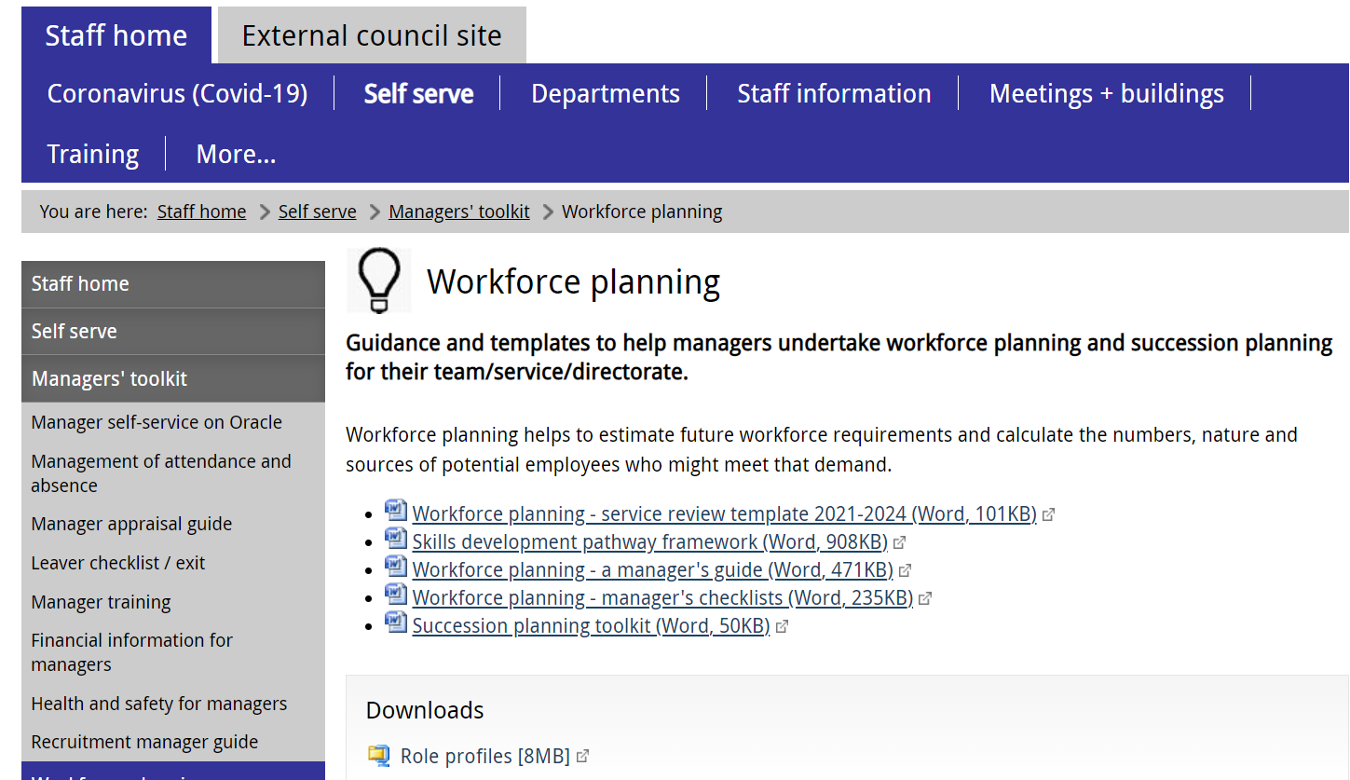
EV2
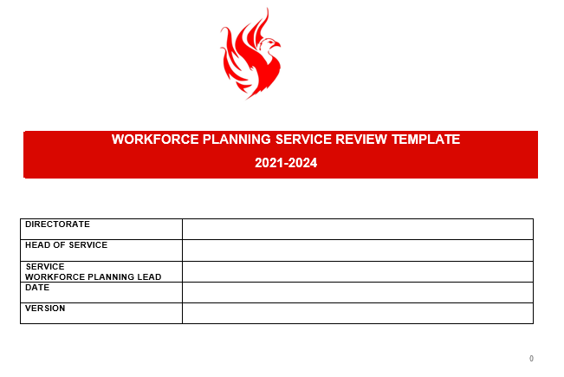
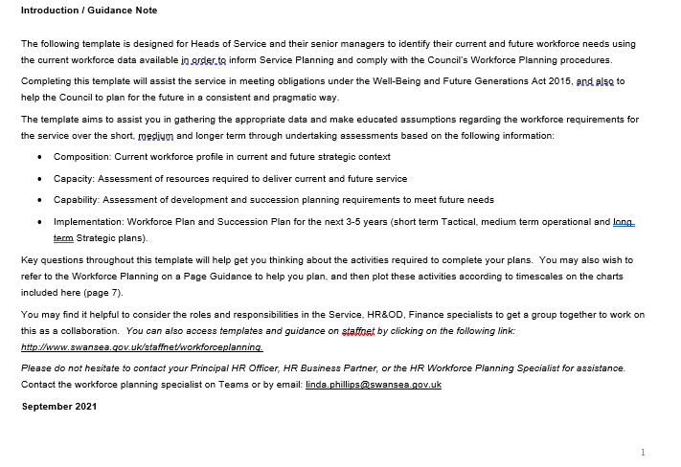
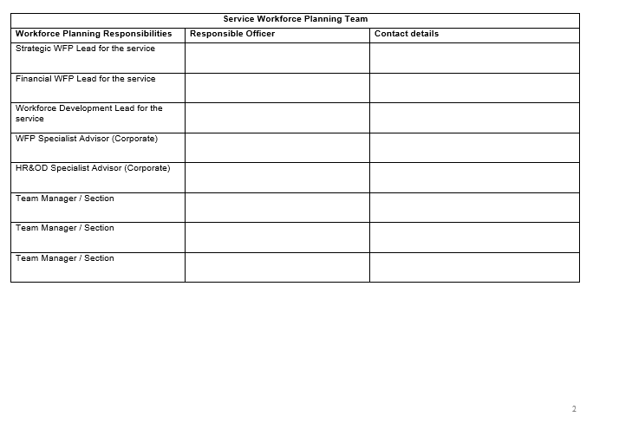
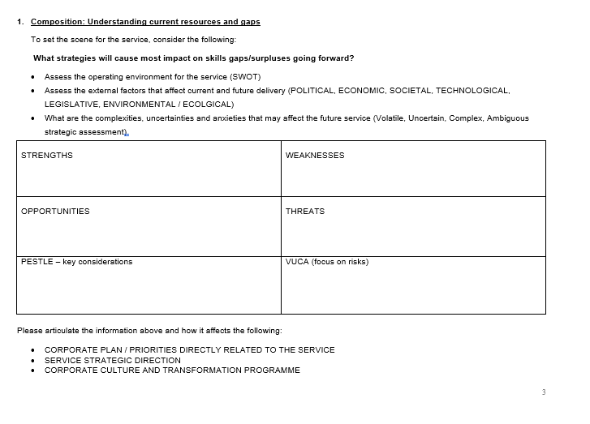
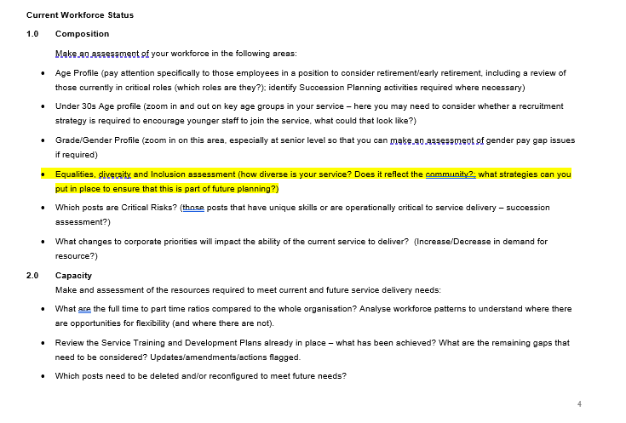
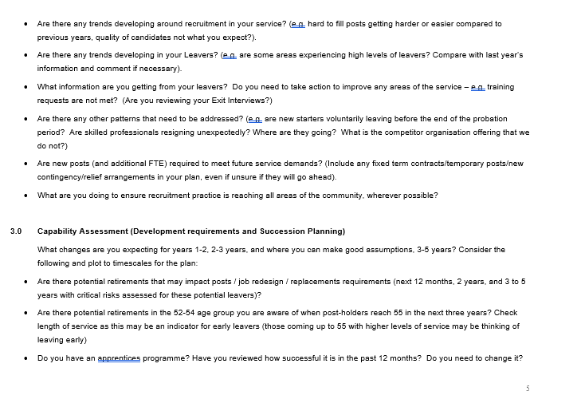
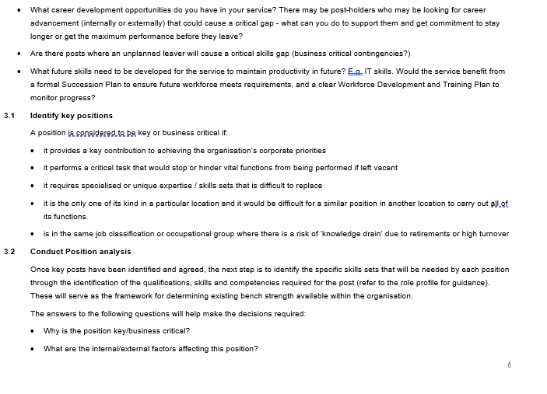
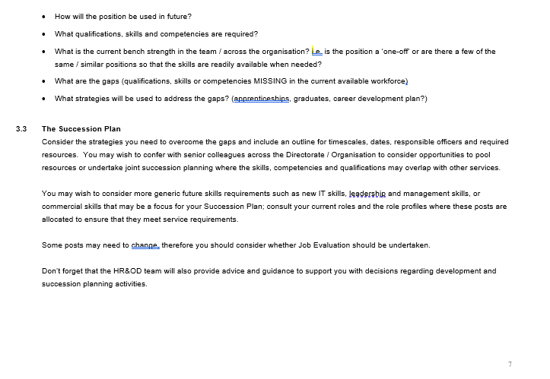
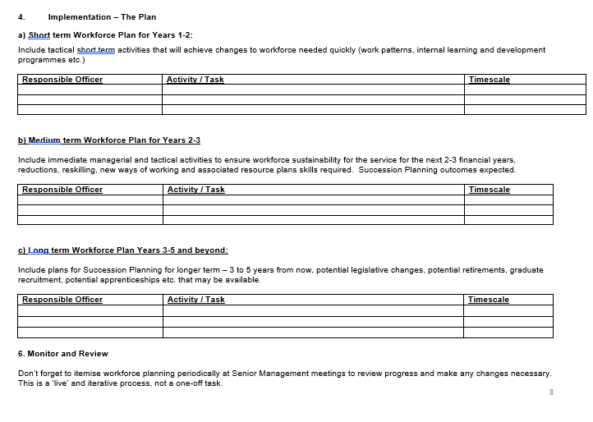
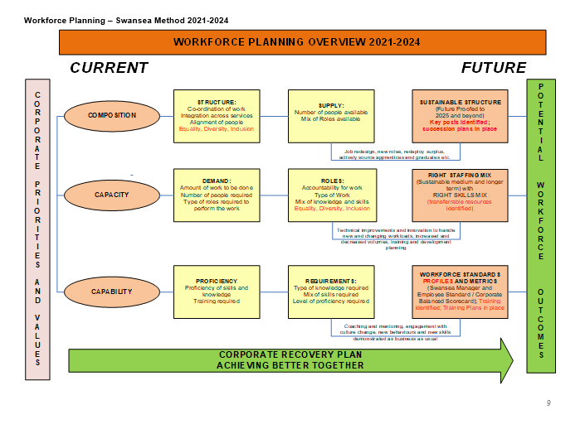
EV3


Swansea Council

SKILLS DEVELOPMENT PATHWAY FRAMEWORK

A Guide to Qualification Routes
for Job Families Role Profiles

Release date:
January 2018 v.1

Contents

Executive Summary 3
Help with understanding new qualifications 3
Job Families and Role Profiles 4
Introduction to the Framework 4
How does the framework work? 4
Note on I.C.T. Qualifications: 5
Undertaking Qualifications 5
Ethical application of the framework 6
Funding and Contact details 6

Executive Summary
The Skills Development Pathway has been designed to provide employees and managers with a reference guide to the level and types of qualifications required by Job Families Role Profiles. This framework has been completely revised and updated to meet current and future needs, and replaces the original issued in 2012.

The Pathway has been updated to reflect the Job Families approach to roles across the Council and reflects current qualifications and role level requirements as a general guide for the role, not the employee undertaking the role, and therefore is not a prescription of qualifications for each profile.

The Pathway provides a generic level of qualification or ‘indicator’ that allows managers and employees the flexibility to decide on the best qualification for the post within the service to ensure the skills are available to support effective and efficient service delivery and ensure a sustainable workforce (Sustainability Principle, The Well-being of Future Generations (Wales) Act 2015.

In the current climate, it is important for managers and employees to be looking at how their skills can be transferred across the service and the organisation as a whole so that we can maximise the skills available and retain our highly skilled and committed staff wherever and whenever possible.

The Pathway is also designed to assist managers with handling discussions with employees who are considering their career aspirations within their current service area and beyond. It is recommended that conversations exploring potential future career paths as undertaken as part of development reviews with managers in order to support workforce and succession planning activities within the context of annual business planning and appraisal processes.

This guide also supports employees and managers in roles that require specific qualifications that are unique to the Council (Education, Social Care, Planning etc.). The Council wishes to maintain the ‘grow our own’ custom and practice to support employees in developing career paths into these areas, where appropriate (e.g. apprentices, interns, and redeployees).

The Social Care and Welfare family is an exception, and therefore more detail is provided in order to ensure employees and managers know the minimum level of qualifications required by the profile.

Help with understanding new qualifications
There may be new qualifications in the framework that are unfamiliar to you, please do not hesitate to contact the Organisational Learning, Training and Development team on 01792 636232 (which incorporates the Social Services Staff Development team) for further advice and information.

Job Families and Role Profiles
Our current role profiles have been mapped to the relevant qualifications that were available at the time they were implemented, and therefore we have provided an up to date equivalent in the attached charts.

Introduction to the Framework
This document is designed to provide a starting point for employees and managers to discuss potential training and development routes as part of everyday development conversations and formal appraisals. Advice and guidance is available from departmental training specialists, or the Organisational Learning, Training and Development team.

In order to assist employees across the organisation in their personal development, the framework has been designed as follows:

Job Family – each job family has been mapped on a single page
Role Profile – each profile is mapped separately according to family
Grade Allocation – each profile is mapped to its relevant grade
Qualification Level – each profile has an ‘indicative’ qualification level, including academic, vocational and Key Skills indicators, as appropriate to the level of tasks and competencies in the role profile.

Some posts may cross over these qualifications so you may wish to seek advice from your line manager on the appropriate route to take within your service. If you are seeking to develop your skills outside your service area, you may wish to seek guidance from the Organisational Learning, Training and Development team.
How does the framework work?
Each Job Family is mapped on a separate page. The qualifications allocated to each grade level are suited to that level and include both vocational and academic routes to provide employees with a choice for their preference in order to develop their skills.

Each Level provides information on a selection of development activities that may be suited to the roles within that role profile. However, any development activity undertaken by employees at the level of qualification identified must be agreed by the line manager as appropriate for the role.

Employees do not need to complete every (or any) qualification listed on the flowcharts, unless there is a specific qualification required because of the role itself.

The different qualifications are listed to provide employees and managers with a choice of routes that can be considered in conjunction with the current role and the individual’s development requirements, at a level that is appropriate to the roles within that role profile and grade.

Note on I.C.T. Qualifications:
Information, Communication and Technology (ICT), while recognised as an important business support function, has generally been excluded from the framework. This is due to the rate of change in this field, and the recognition that employees and managers are best placed to ensure that their skills are up to date and meet operational and individual needs. The first port of call should be our Organisational Learning, Training and Development team as we provide a wide range of software training internally.

Local Colleges and our Adult Learning service provide a good starting point to identify other opportunities in this area – it is recommended that these development requirements are discussed by the employee and line manager in line with the requirements of the role and the future service.

Where appropriate, ECDL is included as a potential qualification that may be required in some role profiles. This is a recognised qualification offered and
Organisational Learning, Training and Development team.

The framework is not designed to be compulsory.

The following charts are a guide to help employees choose the best development pathway that suits their needs and the needs of the service.

All development should be discussed with line managers in order to be assured of their support.

Undertaking Qualifications

This Framework is designed to provide an illustration of the paths that employees can follow in order to gain the qualifications that could aid career progression and ensure the Council maintains the professional and vocational skills required to deliver our services in future.

Employees are not required to undertake any of the development routes outlined in this framework unless they are a requirement for the current role or potential future roles, as directed by the line manager. Undertaking additional qualifications will not affect future salaries unless you are successfully promoted into a more senior grade where the qualification is a requirement of the role.

Managers may wish to assist employees through other development routes, as suited to the individual and the role. Undertaking development does not guarantee promotion, but will assist employees by providing the necessary knowledge and skills to improve performance in current roles and may assist employees who wish to pursue promotion opportunities when they arise.

There may be other qualifications that may be suited to specific roles that are not listed here. It is up to managers and employees to decide on the best route to suit their needs and the needs of the service.
Note:

NVQs and academic qualifications require commitment and investment of resources and time by managers and employees. Employees will be expected to invest their personal time as part of the development process, and managers are expected to recognise this commitment and support it appropriately. This should be considered by the employee and manager prior to undertaking any qualification, and should be discussed and recorded as part of the Employee Performance Management (appraisal review) process.

Ethical application of the framework
Managers may wish to use the framework to assist with development discussions with employees.

The framework should not be used as part of the recruitment and selection process, as this may contravene the Council’s Equal Opportunities Policies.

Managers are not constrained by the qualifications listed in the flowcharts – the framework is not intended to be prescriptive. This framework provides suggested pathways of development.

Managers may continue to support other qualifications that have been identified as essential to a specific function within their section / department to maintain the appropriate skills necessary for effective service delivery.

For further details on the content of qualifications, please contact Organisational Learning, Training and Development on 01792 636232.

Funding and Contact details

Social Services – to discuss funding opportunities for training, please contact the Social Services Staff Development team on 01792 482600.
Health and Safety Training – to discuss training in this area, please contact the team by email at: healthandsafety@swansea.gov.uk

Other Training – if you are looking for information on qualifications not listed on this framework, please contact your staff development officer or Organisational Learning, Training and Development on 01792 636232, or email at: OD.&CorporateTraining@swansea.gov.uk

For assistance with Succession Planning or Employee Performance Management please contact the Organisational Learning, Training and Development team on 01792 636339, or email: OD.&CorporateTraining@swansea.gov.uk

EV4


City and County of Swansea

Workforce Planning

A Manager’s Guide

April 2016
Introduction
There are quite a few guides and frameworks for workforce planning available. While each of these may look a little different the underlying principles are the same. The main aim of this step guide is to set out the elements that should be in any workforce plan in a straight forward framework.
The order of the steps is less important than ensuring that all the elements are considered.

1: Defining the plan
2: Forces for change
4: Assessing Supply
3: Assessing demand
5: Gap analysis - Action planning

6: Implementation and Review

FUNDAMENTALS of WORKFORCE PLANNING
It is important to remember that employees are people and that workforce planning activities need to engage with employees along the way – it is a process that requires involvement and engagement in order to succeed.
The overall aim of workforce planning should be to ensure the future workforce of the organisation has the right skills and capabilities, and is deployed in the right place, at the right time.
The following summarises a 6 steps approach which is based on best practice.

If you require any support on getting started, please contact the Corporate Workforce Planning specialist directly on 01792 636078.

SUMMARY OF THE 6 Steps:
The list below summarises the six steps in the guide. The steps are expanded in later pages.
Step 1: Defining the plan
Step 2: Mapping the forces for change
Step 3: Assessing demand
Step 4: Assessing supply
Step 5: Developing an action plan
Step 6: Implementation and review
It is important to remember that Workforce planning is a CYCLICAL and therefore continuous process that cannot be achieved overnight. It takes time to fully understand the workforce and the process – and both must be achieved within the Business Planning context.

Services should identify key managers and team leaders to take part in the workforce planning element of Business/Service Planning. Line managers are best placed to provide up to date information to support the planning activities required to develop an effective workforce plan to align with the Service Business Plan.

Help with Workforce Planning

Ideally, each Directorate will have a team of officers who will take the lead role in workforce planning activity – this group should include HR colleagues, Business Performance specialists and/or the Corporate Workforce Planning Specialist, as appropriate.

Workforce Planning activities that result in role redesign due to restructuring must be verified by the Pay and Grading Team to ensure compliance with the Job Families Approach role profiles.

There are also a number of checklists available in Appendix 1 to this document to aide these activities.

Project planning
Many organisations use a project planning approach to their workforce planning which includes 'ownership', stage reports, variance reports and so on. By using project management, the organisation is also geared up to the review processes it entails. The Service Workforce Planning Template is available on the intranet, and may be used to assist workforce planning groups to managing the work outputs and activities.

EV5

City and County of Swansea

Workforce Planning

Manager’s Checklists

April 2016
Checklist for Step 1: Defining the Plan

Identify the corporate and service priorities that will drive the Business Plan in the workforce resource context.
This is the critical first step in any planning process. You must be clear why a workforce plan is required and what it will be used for. You must determine the scope of the plan, whether it will cover a single service area, cross service links, external partnership links and, given this, be clear who is responsible for ensuring the plan is delivered and who else will need to be involved in the planning process.

Activity Checklist
Before moving to step 2, it is important to have the following information in place.

Purpose
What is the problem you are trying to solve?
What will a good plan enable you to do?
Who initiated the plan and why?
Who will the plan impact upon?

Scope
What geographical area is covered by the plan?
What services and organisations does it cover?
What types of staff are covered?
What client groups does the plan cover?
Is this a short term or long term problem and solution?

Ownership
Who owns the workforce plan?
Who needs to be influenced if the plan is to be successful?
Do stakeholders understand their part / contribution to the delivery of the plan?
Is everyone involved signed up to achieving the plan?

Checklist for Step 2 : Mapping Service Change
Identify the purpose and shape of any proposed service change that will impact on future workforce requirements.
This is the first of three interrelated steps. You must be very clear about current costs and outcomes and identify the intended benefits from service change. You should identify those forces that support the change or may hamper it. There must be a clear statement about whether the preferred model better delivers the desired benefits or is more likely to be achievable, given anticipated constraints. You may decide that a new service delivery model is not required after full service review. Map any suggestions for improvements to processes or job redesigns as they occur to address in detail in stage 4.

The key elements of this step are:
Goals/benefits of change
What are the objectives and anticipated benefits of the proposed service change?
Current baseline
What are current service costs and current performance measures?
Drivers/constraints
What context must the new service operate within?
What national/regional policy or legislation may influence the change?
What forces will support the change in services and what resistance is expected?
Option appraisal
What different scenarios for service change have been considered/costed?
Working models
What is the preferred model(s) and why?

Step 2 Checklist
Before moving to step 3, it is important to have the following information in place.

Goals and benefits of change
What are the drivers behind the service change?
What are the costs and outcomes under current models?
What are the intended benefits from the service change?
How will the change be effectively monitored?
Drivers / constraints
What are the forces that support the service change?
What are the forces that hamper the change?

Option appraisal
What different scenarios for service change have been considered?

Working models
Does the preferred model deliver the described benefits more effectively than other models?
Or is the model simply more likely to be achievable given the anticipated constraints?
Is there a clear and shared understanding of the future service configuration based on the customer/citizen experience, outcomes and financial realities?

Checklist for Step 3: Defining the Required Workforce

Identify the skills required and the type/number of staff to deliver the new service model (workforce demand)
This step involves mapping the service activities and identifying the skills needed to undertake them and the types and numbers of staff required. This step needs to be completed whether there is a proposed change to service delivery or not.
This involves consideration of which types of staff should best carry out particular activities in order to reduce costs and improve the customer/citizen experience even where this leads to new roles and new ways of working.

The key elements of this stage are:
Activity analysis
What are the key tasks within the service/new service delivery model?
Types/numbers
Can the required numbers of different staff types with the required competences be modelled with existing staff?
Do new posts need to be designed?
Do current posts need to be redesigned?
Productivity - Can new ways of working be considered and can the costs of different blends of skill mix be measured?
Step 3 Checklist
Before moving to step 4, it is important to have the following information in place.
Activity analysis
What are the key tasks within the service/new service delivery model?
Have the activities been broken down into skills, time, individual or team?
Has the standard required been identified including links with other activities?
How are roles constructed including duties and responsibilities?
Have any new roles been identified, or current roles need to be redesigned?

Types / numbers
Have the units through which the service is delivered been identified – Department, Service, Section, team?
Have the workload and skill mix been identified for individual service / sections?
Has an assessment of the size and composition of the team needed to deliver the service been identified?

Productivity and new ways of working
Have productivity implications been considered based on technology, patterns of working, service models and redistribution of tasks?
Have different blends of skill mix been measured?
If new ways of working identified, have the fundamental principles in section 3 been applied?

Checklist for Step 4: Understanding Workforce Availability:
Identify current and future staff availability based on current profile and deployment (workforce supply)
This step involves describing the existing workforce in the areas under consideration, its existing skills and deployment and assessing any problem areas arising from its age profile or turnover. It may be the case that the ready availability of staff with particular skills or, alternatively, the shortage of such staff. This contributes to service redesign and Steps 2 and 3 will need to be revisited.
Consideration should be given to the practicalities and cost of any retraining, redeployment and/or recruitment activities that could increase or change workforce supply.

The key elements of this stage are:
The current workforce - What are the characteristics of the current workforce, wherever it is located?
Workforce forecasting
What turnover, vacancies, recruitment patterns do you anticipate and what might impact on this even without service change e.g. demographic (population) changes, legislation changes, etc.?
Options for changing supply
What initiatives for retention, retraining, recruitment, redeployment etc can realistically be developed?

Step 4 Checklist
Before moving to step 5, it is important to have the following information in place.

Current workforce
What are the characteristics of the current workforce?
Has this been described in terms of numbers of certain types of staff, skills or service unit?

Workforce forecasting
What turnover / attrition is expected and what numbers are in the commissioning pipeline?
What influences on supply are there even with no service change? (e.g. potential retirements?)
What is the local labour market?
What is the anticipated competition for skills?

Options
What models for retention can be developed to increase supply e.g. redeployment, retaining, recruitment?
Have options been analysed and costed to increase workforce availability?
Have the options for working differently been analysed and costed?

Checklist for Step 5: Developing an Action Plan:
Plan to deliver the required workforce (new skills in new locations) and manage the change
This step involves reflecting on the previous three steps and determining the most effective way of ensuring the availability of staff to deliver redesigned services, even if this means some further service redesign. A plan for delivering the right staff, with the right skills in the right place needs to be developed with milestones and timescales. You should also include in your plan an assessment of anticipated problems and how you will build a momentum for change, including clinical engagement.

The key elements of this stage are:
Gap analysis
What key changes are needed to the current workforce?
Priority planning
What are the most significant areas for change?
Action planning
How do other strategies support the main plan?
Managing the change
How do you build options into a plan and how do you build momentum for change?

Step 5 Checklist
Before moving to step 6, it is important to reflect on the previous three steps and determine the most effective way of ensuring the availability of staff to deliver redesigned services, even if this means some further service redesign.
Therefore, the following will need to be in place:

Gap analysis
Have you undertaken a gap analysis of each scenario?
What changes are needed to the current workforce?
Priority planning
What are the key hotspots that need the most significant change?
What cold spots need the least change?
Action planning
What is the plan based on your ‘best’ option?
How do other strategies support the plan?

Managing change
How do you build momentum for change?
How do you sustain the momentum for change?

Checklist for Step 6: Implementation, Monitoring and Refresh:
Implement the plan, measure progress and refresh the plan as required

After the plan is implemented, it will need periodic review and adjustment – these timescales should be identified during Step 1 of this process.
The plan will have been clear about how success will be measured; but unintended consequences of the changes also need to be identified so that corrective action can be taken.

Therefore, the key elements of this stage are:
Implementation
Measuring progress
Revisiting Six Steps

How will you ensure your plan is delivered?
What are the key milestones of your plan?
How are the outcomes and unintended consequences going to be measured?
What is the process for revisiting your plan and refreshing any requirements?
Can your plan be related directly to your Business Planning objectives?

EV6
Succession Planning PROCESS 2017-2020

What is Succession Planning and why should we do it?

Succession Planning is the process of identifying the critical positions within an organisation and then developing an action plan to ensure these positions are filled with appropriate employees who have the required skills to undertake the role efficiently and effectively.

Succession planning is future-focused, and supports the organisation in delivering its Workforce Strategy by assessing, evaluating and developing a pool of potential candidates to fill critical positions when required. It is a process that identifies and captures crucial information on posts that could be adversely affected by retirements, resignations, promotions etc. It is a tool to meet staffing needs appropriately by ensuring that skills and competency requirements are met by ensuring we have them available in the talent pool when we need them.

The process highlights the posts that require succession planning to be considered as business critical according to specific criteria. However, it is inevitable that the skills and abilities that employees bring to the organisation are vital to service delivery; this process is designed to ensure that all employees are considered in the Succession Planning process based on their ability to supply the service with appropriate skills, competencies and qualifications to meet service delivery requirements.

Succession Planning Process

Managing changes within the workforce is as important as managing service delivery, finance or any other key resource, thus, it is essential that managers have a coherent and consistence formal Succession Planning process to follow that outlines the activities that are essential in order to ensure that we have the right people in the right posts at the right time to ensure we can deliver those services effectively.

There are 4 stages to this process, and it is important to remember that identifying critical posts and potential candidates for succession planning should not preclude managers and employees having open discussions about opportunities for career development, and sometimes this may lead to employees seeking opportunities outside the Council. These stages are:

Identify key/ ‘business critical’ positions
Conduct position analysis
Develop succession plan
Monitor, evaluate, revise plan

It is important that managers and employees agree that investment in employee development advances performance of both the individual and the service – keeping up to date with new technology, best practice and new methods of working can only help both parties to deliver the best service we can to our residents.

In order to be successful, succession planning must align with:

Business and service planning strategies – particularly workforce planning
Senior management vision and priorities
Employee, Manager and Leadership development programmes
Employee Performance Management processes

Building a Talent Strategy and Talent Pool

Succession planning in the public sector must take into account our recruitment and redeployment processes. With this in mind, it is important when considering Service / Organisation requirements for succession planning that we ensure the process we implement is fair under employment law.

It is essential that all CCS managers identifying areas that require formal succession planning arrangements consider the POST not the person currently occupying the post. The following guidance enables managers to consider the post requirements objectively, and offers tips on what to do to ensure that the process is conducted fairly and meets the needs of the organisation going forward.

Roles and Responsibilities

Heads of Service are encouraged to include their SMT managers in this process to provide a clear Succession Plan for the Service area and ensure that the approach is generic, future-focused, and highlights posts/role profiles not people. The SMT team will be responsible for engaging with all employees regarding the processes that enable effective succession planning, gathering relevant data, highlighting potential risks and issues, and communicating with teams on the rationale behind the plan.

Overall, the objective is to ensure that the process is transparent, fair and equitable.

Step 1: Identify and categorise key positions / business critical posts

At least one of the following criteria must apply for the position to be considered for formal Succession Planning:

Business Critical (professional/strategic) - the post provides a key contribution to achieving the organisation’s mission / corporate priorities
Business Critical (location) - the position performs a critical task that would stop or hinder vital functions from being performed if left vacant
Specialist - the position requires critical organisational knowledge, specialised or unique expertise / skills sets that are difficult to replace (e.g. local government specific roles)
Single incumbent - the position is the only one of its kind in a particular location and it would be difficult for a similar position in another location to carry out all of its functions. Note: these posts may not be senior level, but provide a key operational function that the service relies upon to deliver services to the community
Attrition risk - positions in the same job classification or occupational group are identified as being at risk of ‘knowledge drain’ due to retirements or unplanned resignations (turnover) and will be hard to find in the external labour market
Retention risk – specialists with skills, knowledge and experience that are in high demand externally (with attractive salaries and compensation packages, e.g. IT) that may be finding it difficult to match their ambitions internally, and therefore may be seeking opportunities elsewhere, which is a risk to the delivery of your Service Plan.

Step 2: Conduct Position analysis

Once step 1 has been established, the next step is to identify the specific skills sets that will be needed by each position through the identification of the qualifications, skills and competencies required for the post. These will serve as the framework for determining existing ‘bench strength’ available within the organisation (this is the resilience within the workforce to fill potential vacancies in critical areas/roles). This can be identified though answering the following questions:

Why is the position key/business critical? (categorise using the above criteria)
What are the internal/external factors affecting this position?
How will the position be used in future?
What qualifications, skills and competencies are required?
What is the current bench strength (in the team / across the organisation)?
What are the gaps (qualifications, skills or competencies MISSING in current available workforce)
What strategies will be used to address the gaps? – where will you source these critical skills in future, and how will you ensure they are available when you need them?

Step 3: Conduct Position risk assessment

This should be based on factors such as the marketable skills required of the post (and if there is a shortage externally), the incumbent’s tenure with the organisation and their potential eligibility for retirement, and the time it would take to transfer skills and knowledge within the internal team or the difficulty in sourcing these skills externally.

Other criteria you may consider includes:

Does the post manage staff?
Does the post have budget responsibility?
Is the post in a complex/sensitive service area?
Does the post directly impact service delivery of corporate priorities?

If you answer yes to three or more of the above, the impact is high, 2 it is medium, 1 it is low.

Position Impact score: High ◻  Medium ◻ Low ◻

Step 4 Conduct an Attrition risk assessment

The Manager must objectively assess the function, responsibility, authority, strategic priorities to replace the current post-holder:

The post requires critical and unique knowledge (e.g. Specialist such as town planner)
The post requires important procedural knowledge/skills (e.g. housing benefits etc)
Does the post require key qualifications and skills that are scarce in the labour market at present (e.g. new technology skills)
Are there other reasons you know of that make the post a potential attrition risk? (this is the only time the post-holder should be considered – i.e. the post-holder is over 55, there is a potential of early retirement in the next 2 years, etc.).

Attrition Risk Score: High ◻ Medium ◻ Low ◻

Step 5. Develop the Service Succession Plan

The succession plan is a culmination of steps 1 to 4.

The benefit of taking a generic approach to skills and competency development is that it will widen the talent pool considerably, enabling more candidates to apply for future vacancies, some may come from other departments, thus ensuring that the process is not favouring some employee groups unfairly.

Reviews of posts and risk assessment work should now be articulated in the context of individual positions and high turnover jobs, the gaps and strategies that are formulated at a service / team level etc.

In this phase the strategies to overcome the gaps are outlined to include target completion dates, responsible parties and required resources. You may wish to confer with senior colleagues across the Directorate / Organisation to consider opportunities to pool resources, or undertake joint succession planning where the skills, competencies and qualifications may overlap.

You may wish to consider more generic future skills requirements such as new IT skills, leadership and management skills, commercial skills that may be a focus for your Succession Plan. If this is the case, you may wish to consult your current roles and the role profiles where these posts are allocated to ensure that the current profiles meet service requirements. Some posts may need to change, therefore you should consider whether Job Evaluation should be undertaken.

Step 4. Undertaking Career development activities:

This step in the succession planning process is focused on helping employees and managers discuss career development within the Council.

Discussion and encouraging career development with employees is an important part of management. In terms of succession planning activities, this becomes a critical task which necessitates prioritising some posts / candidates over others in order to secure service delivery and sustainability.

The annual performance and development review/appraisal process is designed to assist conversations about personal development activities required for each post. However, for the purpose of succession planning, managers need to keep in mind and clarify that career development discussions are separate to the performance review itself.

Performance management is focused on the past year’s performance in the role and the future objectives for the role in the next year. Career development discussions are about the aspirations of the individual and how these may be supported by the Council in order to meet its future skills requirements for the service.

As well as career development opportunities, managers will need to address potential barriers that may occur to hamper the aspirations of the individual. Sometimes feedback on this can be difficult, but managers and employees who focus on actual evidence based discussions that refer to observation and potential will be very productive. Managers and employees need to trust that the process/activity will provide opportunities that are fair and achievable.

Based on these open and fair discussions, managers should refer to internal development offerings in the first instance, utilising corporate training and Employment Training facilities in order to source development programmes and activities. Examples of such opportunities include:

Corporate training and development courses
E-learning offerings
NVQs
On the job training
Voluntary participation in the Innovation Community
Coaching and mentoring opportunities
Shadowing key officers to develop wider knowledge of the organisation
Self study/reading
Professional support websites/articles

Participation in the above development programmes/activities is not a guarantee of promotion or job selection.

Step 4. Monitor, evaluate and revise

Ongoing evaluation and adjustments are vital to effective succession planning. Although the succession plan covers a 3-5 year period, it should be reviewed at least annually.

If an organisation does not review regularly it runs the risk of failing to meet goals or not having the ability to respond to change. Status/Progress updates should be recorded in order to enter comments to reflect any action required of each item, and this should feed into the Workforce Planning cycle.

Note: The attached appendices have been designed to help identify the key business critical posts and develop effective Workforce and Succession plans to ensure future business sustainability.

EV7
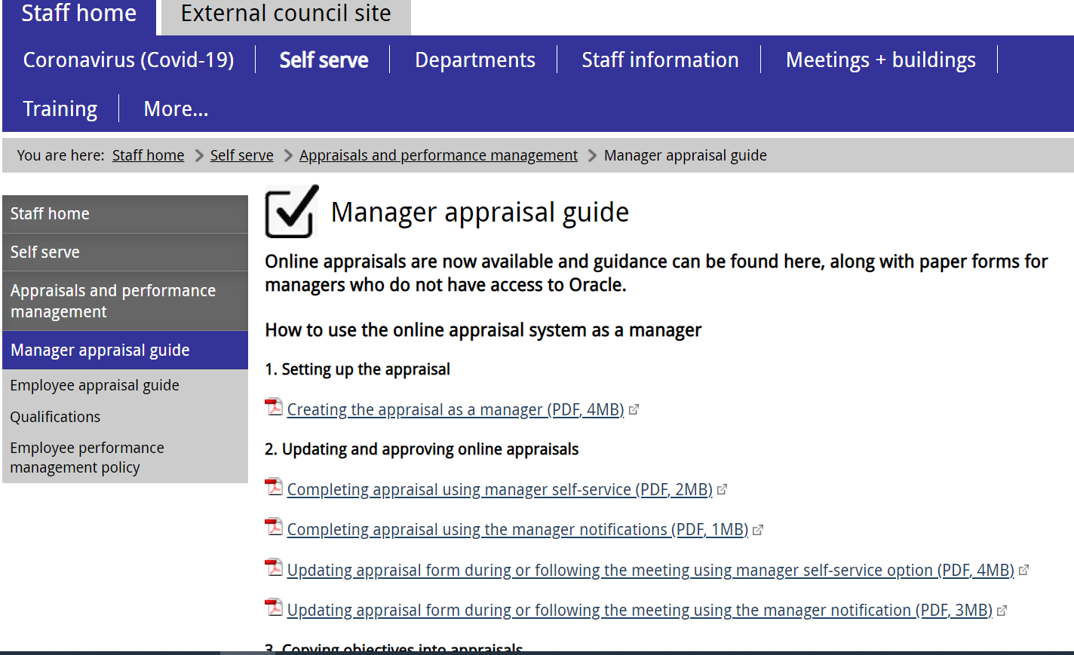
EV8
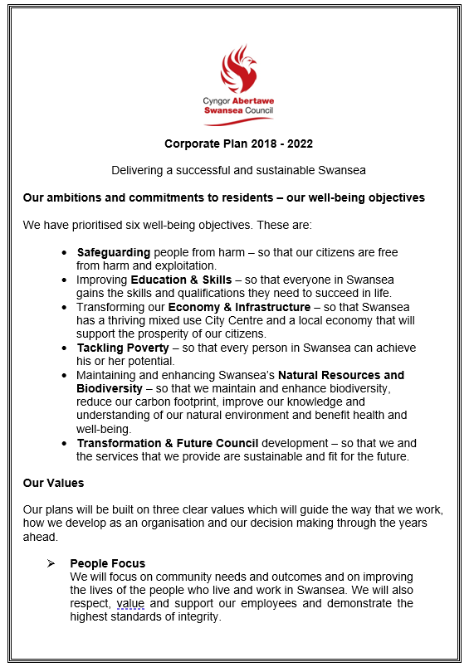
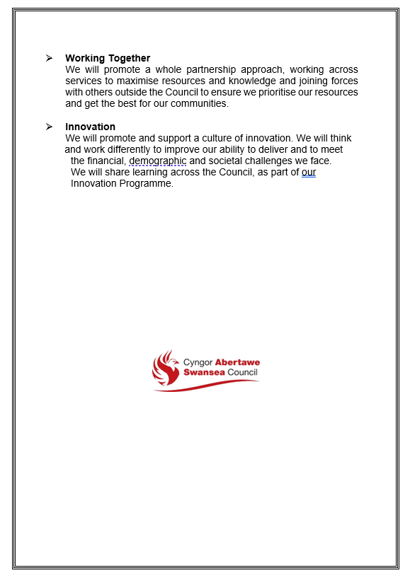
EV9


Exit Interview Questionnaire
Exit Interviews are undertaken with staff who are leaving the Authority in order to better understand why people leave and where necessary, make changes to the Authority in order to improve performance.
Your completed questionnaire will be reviewed by HR and used for information and statistical purposes and will be treated with total confidence.
There could be issues raised in your Exit Interview that the Authority may need to act upon. Such action may include HR raising the issues with line management for further investigation.
This Exit Interview should be conducted by your Line Manager. However, if you do not feel comfortable with your current Line Manager undertaking the Interview, arrangements can be made for a HR Officer to conduct the Interview with you.

Employee Details
Name:
Staff No:
Position:
Service Unit/Section:
Grade:
Date of commencement:
Date of leaving:
Reason for Leaving
Normal Retirement
Early Retirement
Ill Health Retirement
Redundancy
Resignation
If the reason is resignation, please select one or more of the following:
1. | Please provide details:  If applicable, what is the name of your future employer & what role will you be undertaking?
  Higher Pay |  | Career change
  Improved work life balance |  | Better benefits
  Conflict with other employees |  | Job Instability
  Conflict with manager |  | Family/Personal Reasons
  Better Career Opportunity |  | Other
  To work closer to home

2. | If you could change anything about your job, what would you change?
3. | Would you consider returning to work for the Authority?  Yes No
Please rate the following:
The Job Itself |  | Strongly Disagree | Disagree | Agree | Strongly Agree
Job was challenging
Your skills were effectively used
Workload was manageable
Sufficient resources
Your colleagues listened and appreciated your suggestions
You had access to adequate training
Received clear expectations, aims and objectives
Received adequate and regular communication
What do you think could be improved about the job?

Remuneration & Benefits |  | Strongly Disagree | Disagree | Agree | Strongly Agree
The salary was adequate in relation to the responsibilities
Other benefits were good i.e. annual leave, sickness entitlement
Work-life balance was promoted and practiced
What improvement, other benefits could the Authority offer?

The Authority/Department |  | Strongly Disagree | Disagree | Agree | Strongly Agree
When started, did your induction help?
Was a good positive place to work in
Had adequate equipment and facilities to do the work
Communications worked well
There was no discrimination or bullying/harassment
Got on well with other staff within the Department/ Authority

What do you think can be improved about the Department/Authority?

Management |  |  | Strongly Disagree | Disagree | Agree | Strongly Agree
Gave fair and equal treatment
Encouraged feedback and suggestions
Maintained consistent policies and practices
Provided recognition for achievements
Gave opportunities to develop
Provided constructive feedback
Clearly communicated decisions and how they would affect work
Received Appraisal regularly
Received Supervision regularly
What do you think can be improved about the Department/Authority?

Social Services Staff Only
Please tick one of the following boxes:
Have you left for another post in Social Care (Local Authority)
Another post in Social Care (External)
Another post outside of Social Care
Employee’s Comments
This is an opportunity for you to comment on your employment
If you feel you cannot discuss this with your manager, you can complete the Exit Questionnaire which will be returned directly to Human Resources
Signature of employee:
Date:
Manager’s Comments
This is an opportunity to make any further comments.
Signature of Line Manager:
Date:

Thank you for completing this information.
Your responses will be treated with total confidence

Exit Interview Checklist

Item/Issue | Please Tick | Comment
- ID/Security/Flexi Card Returned
- Uniform/PPE returned
- Keys returned
- Annual Leave balance discussed
- Flexi time credit/debit to be balanced
- P-Card returned (notify Oracle Purchasing)
- Mobile Phone returned
- Laptop or other IT related equipment returned
- Home Working equipment (if applicable)
- Parking Permit returned
- Car Loan repayment discussed
- Training Expenses re-payment discussed (if applicable)
- Notification of leaving sent to Employee Services
- Notification sent to IT to close accounts
Please confirm whether any of the following applies to you:
Item/Issue | Please Tick | Comment
- First Aider
- Fire Marshall
- Premises Key Holder
- Health & Safety Representative
- Resilience Co-coordinator
- Rest Centre Manager

EV10
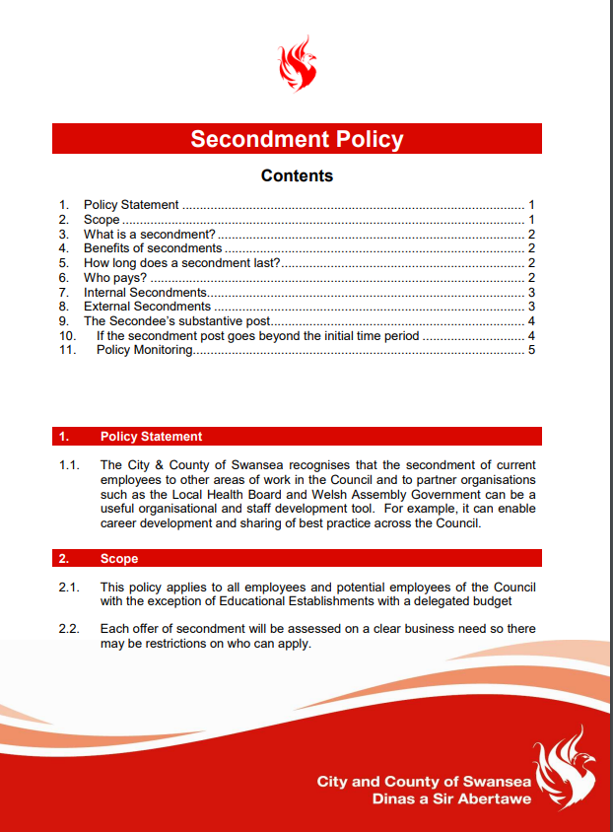
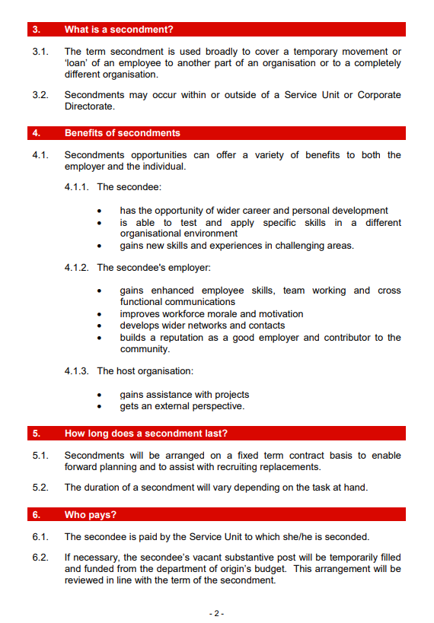
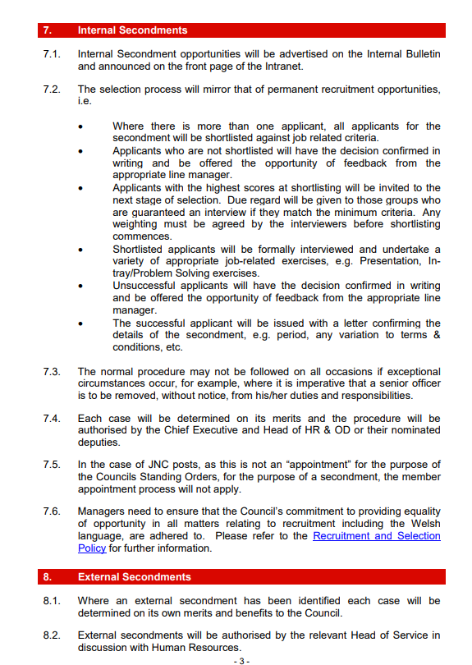
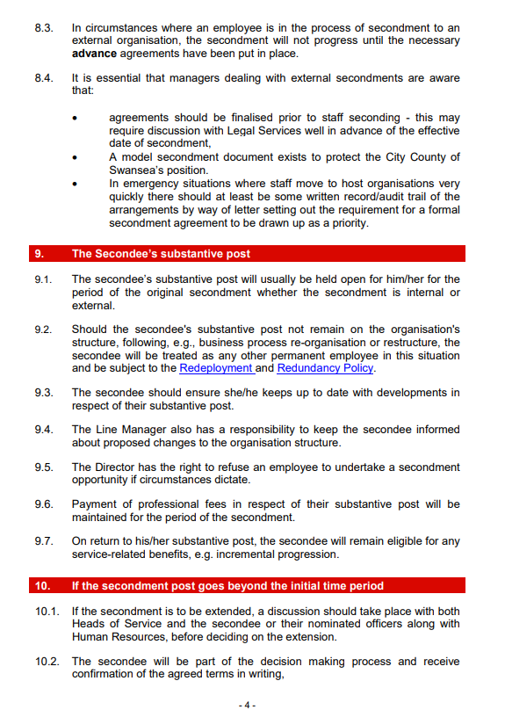
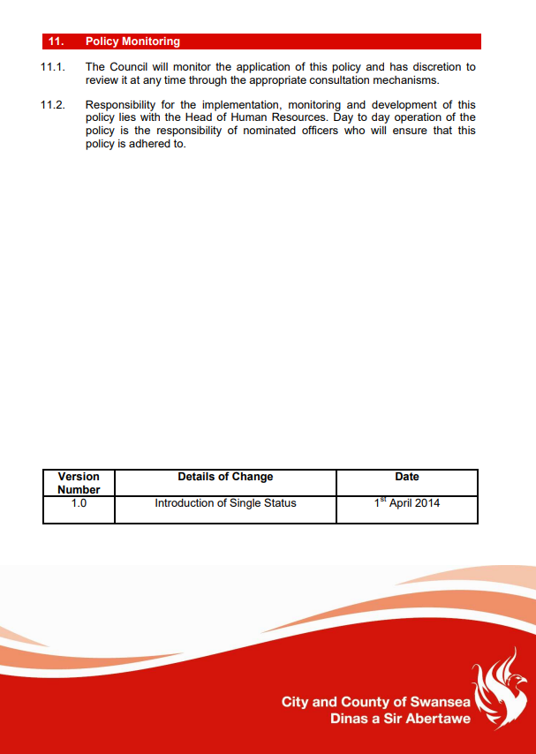
EV11
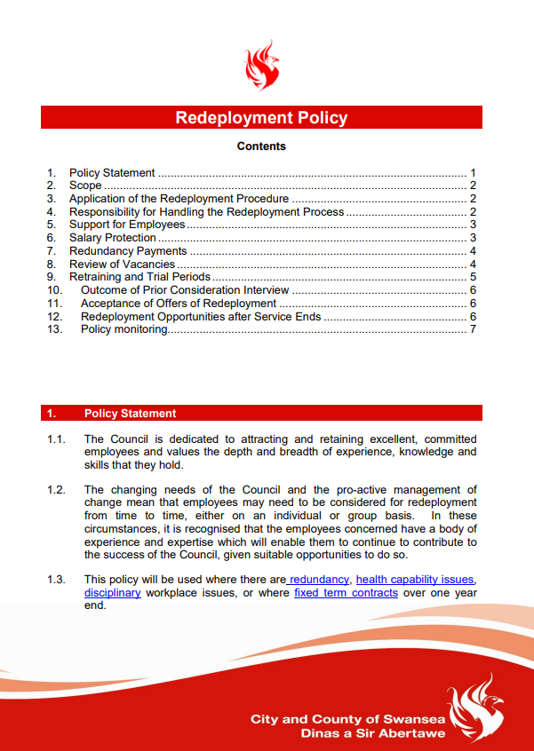
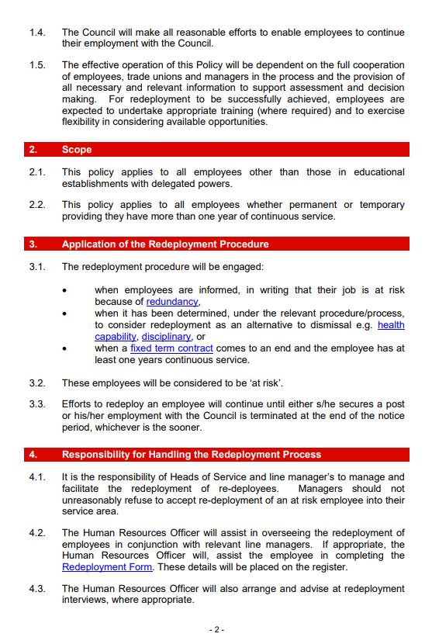

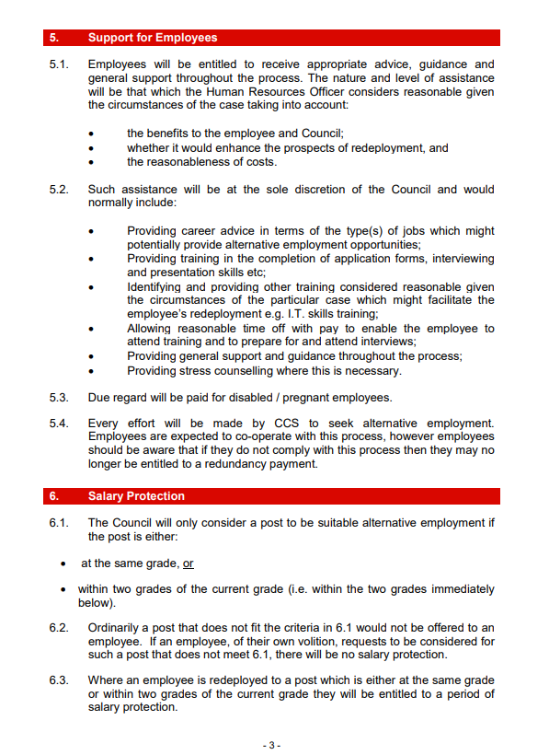
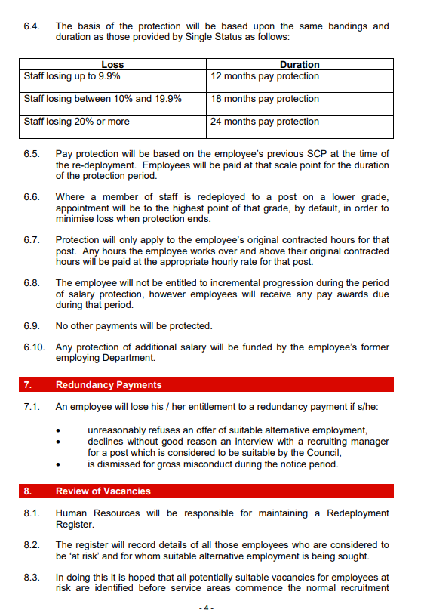
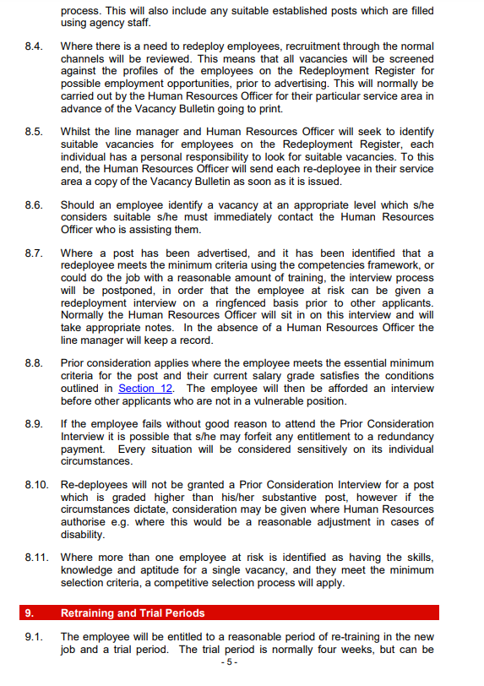
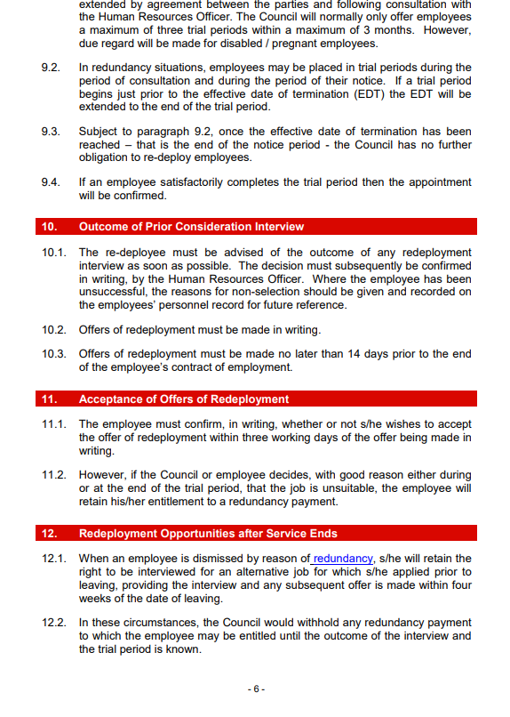
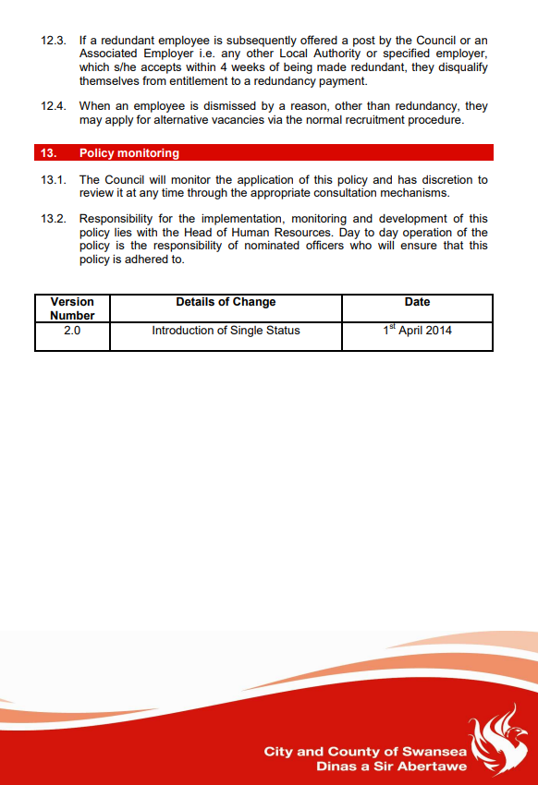

EV12



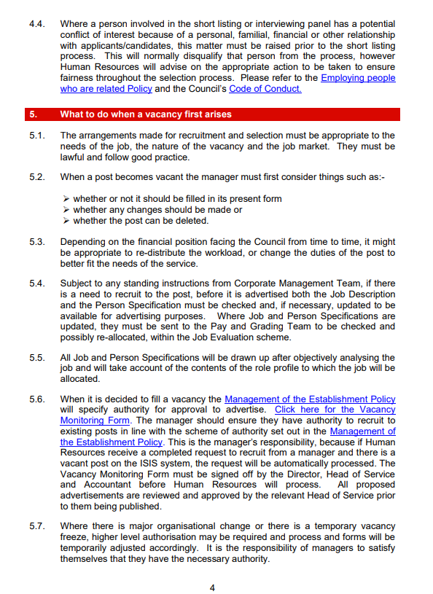
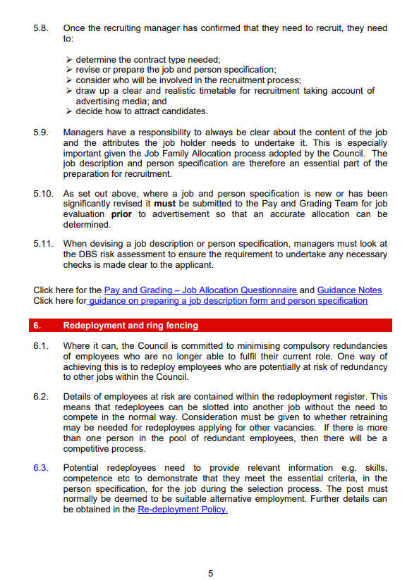
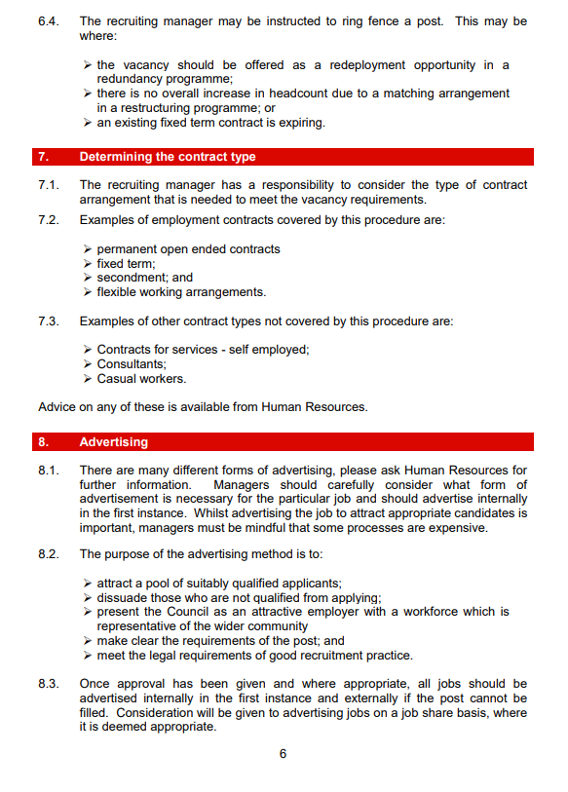
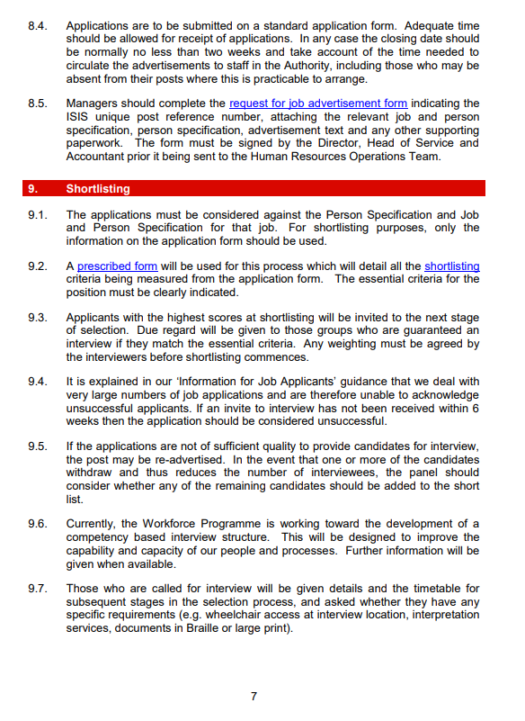
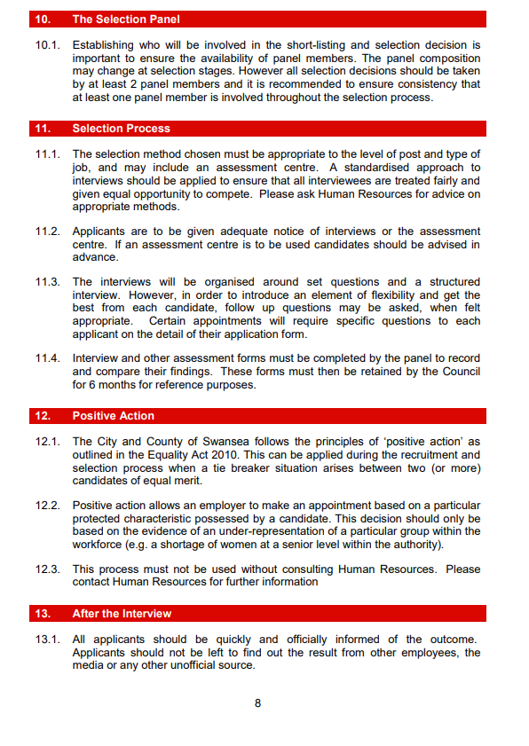

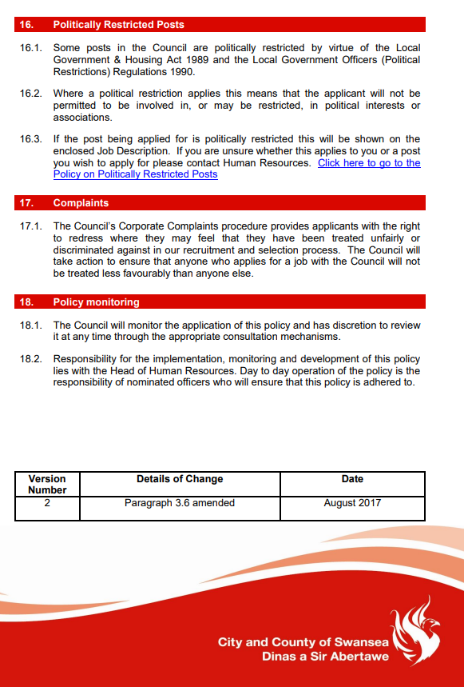
EV13

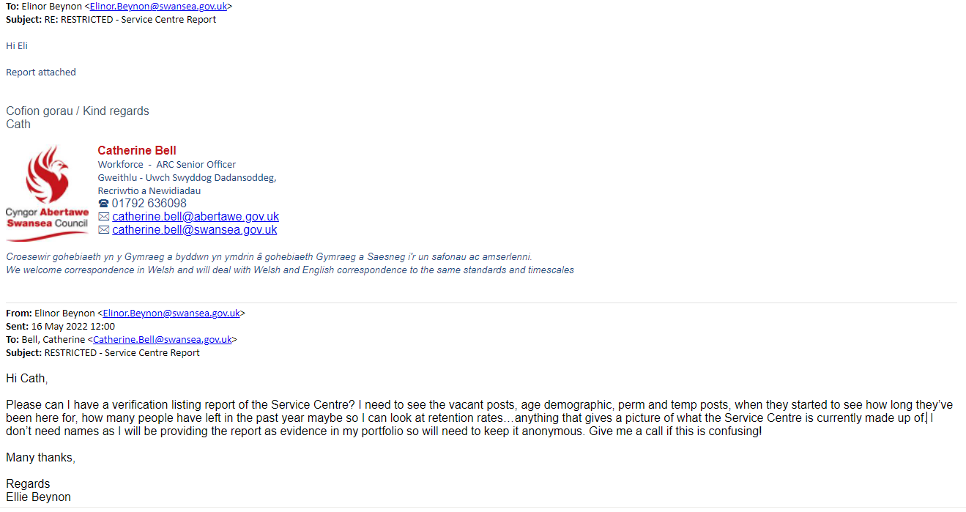
EV14
EV15
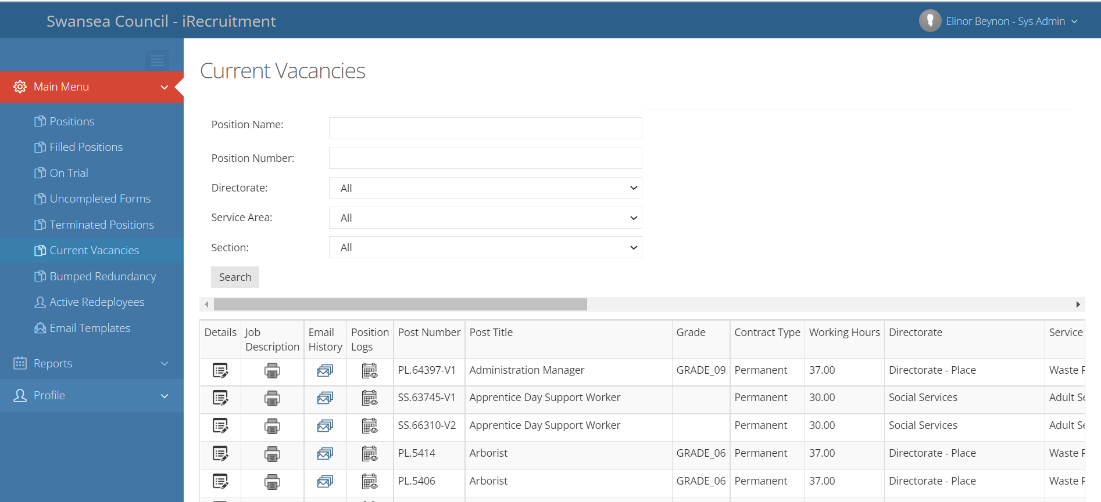
EV16
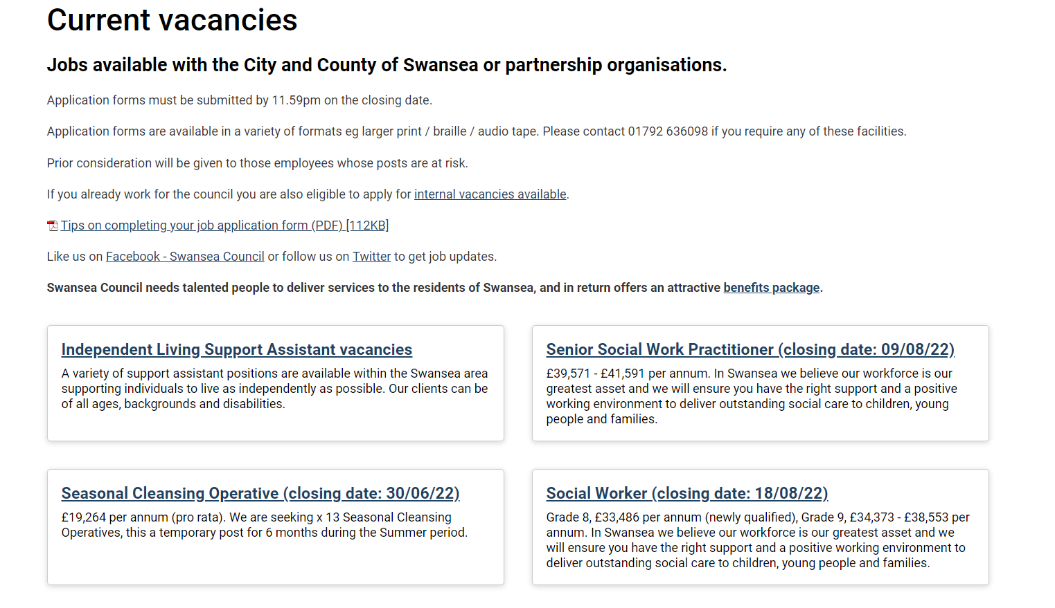
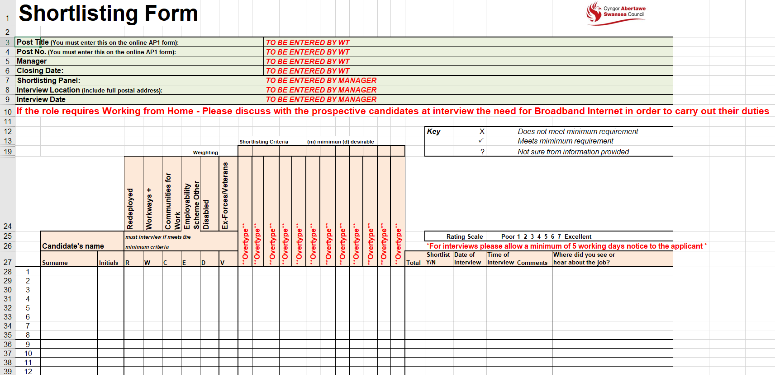
EV17

LO2
2.1 Make reasoned recommendations for how the organisation can maintain an appropriate number of people with the skills required by the organisation.

As Swansea Council is a public organisation, it cannot offer the same financial rewards as competitors in the private sector. Therefore, I would recommend Swansea Council promoting the benefits it can offer as part of its brand to show what attributes and qualities make them different from other organisations (CIPD, 2021). Benefits include flexible working hours, a great pension scheme, possibility to work from home, job security from redeployment, annual leave, discounts etc (Vantage Circle, 2020). By conducting staff attitude surveys (CIPD, 2021) discoveries on what makes Swansea Council positive and unique (Wilkinson and Taylor, 2016, p. 62) can then be communicated to potential future employees. One organisation that has good employer branding is Admiral who focuses on recruiting talent. Their open, inclusive, fun, hardworking and rewarding achievements culture reflects their philosophy ‘people who like what they do, do it better’ (Admiral, 2022). Good employer branding can be advantageous when there are skill shortages and organisations are competing for talent (CIPD, 2021).

As there is a shortage of young people joining the public sector, I would recommend recruitment going out to schools, colleges and universities to promote the benefits of working for Swansea Council and what experiences the Council can offer. This also plays into employer branding by advertising Swansea Council as a whole. An IES report showed that the public sector is not attracting younger employees so it would be beneficial for Swansea Council to address this issue when marketing itself in a competitive labour market (Churchill, 2019). Swansea Council offers apprenticeship programmes which are ideal to advertise in schools for those who do not want to go on for further education as a way to attract young people to the council and as a way of possibly retaining staff.
I would recommend Swansea Council to make more use of social media as a way of recruiting to best people for the job. Sites such as LinkedIn can target the appropriate groups of people and can be used to communicate job opportunities to them. It has also been found younger people use social media more than older people which could benefit the council as young people are lacking in their workforce. Social medial is also a less expensive form of advertising which can save the council money (Taylor, 2019, p. 247).

I would also recommend Swansea Council making the most out of social media for branding. This requires consistency and using the correct methods to engage with the target audience (Sherman, 2019). Past and present employees can leave positive or negative feedback on social media, so it is important for the council to be aware of this (CIPD, 2021).

The pandemic has led to a lot more work for teams in the Council. Working on the recruitment team I have found that many times when a post is advertised, no suitable applicants apply which leads to posts being re-advertised sometimes multiple times. Whilst the Council waits for a suitable applicant to recruit, the current workforce must deal with the increased workload without extra help which can lead to stress and can be a reason for resignations. Low levels of unemployment and external factors such as Brexit have led to a tight labour market making it difficult to find people with suitable skills. One way to retain staff is to offer market supplements. This can be put in place during recruitment difficulties to make competitors in the private sector less attractive as the pay is brought up to market rate. However, this is not a long-term fix and needs to be closely monitored and reviewed regularly (Rickard, 2017).

I would also recommend Swansea Council introducing a flatter structure instead of the current hierarchal structure. A flatter structure can boost innovation and creativity as it allows employees from all levels, areas and roles to interact with each other and share ideas. If training is taking place amongst employees, then it would be advantageous to allow employees to share what they have learnt and to use their skills where they can. Research also suggests that allowing staff to be involved with organisational decisions leads them to feeling more valued which can increase retention rates (Nguyen, 2021).

Netflix is a good example of an organisation which makes the most of its employees knowledge and skills by allowing everyone to take charge of their careers and directing the company by sharing information across the company and not just limiting this to senior managers (Nguyen, 2021).

LO2 - References

Chartered Institute of Personnel and Development (2021) Employer branding. Available at: Employer Branding | Factsheets | CIPD (Accessed: 23 April 2022).

Churchill, F. (2019) Younger workers underrepresented in public sector, report says. Available at: https://www.peoplemanagement.co.uk/article/1744811/younger-workers-underrepresented-public-sector-report-says#:~:text=The%20report%2C%20published%20by%20the,cent%20were%20aged%2045%2D54. (Accessed: 23 May 2022).

Nguyen, T. (2021) Inside Netflix company culture: Amazing and unusual. Available at: https://blog.grovehr.com/netflix-company-culture (Accessed: 23 April 2022).

Rickard, C. (2017) Market pay supplements in the public sector. Available at: https://www.employment-studies.co.uk/news/market-pay-supplements-public-sector (Accessed: 22 May 2022).

Sherman (2019) The Ultimate Guide to Social Media Branding for Small Businesses. Available at: https://www.lyfemarketing.com/blog/social-media-branding/#:~:text=Social%20media%20branding%20is%20about,a%20robust%20network%20of%20fans (Accessed: 23 May 2022).

Vantage Circle (2020) Top 10 Employee Retention Strategies in 2020 - Vantage Circle. Available at: Top 10 Employee Retention Strategies in 2020 - Vantage Circle - YouTube (Accessed: 23 April 2022).
Wilkinson, K. and Taylor, S. (2016) ‘Resourcing and Talent Planning’ in Taylor, S. and Woodhams, C. (ed.) Human Resource Management: People and Organisations. London: Chartered Institute of Personnel and Development.

LO3
3.1 Identify and explain the rationale for a specific resourcing activity within the organisation.

The Planning and City Regeneration Service Unit of Swansea Council, particularly the Nature Environment Section and the Nature Conservation Team, were struggling with limited capacity to undertake their work. Therefore, a delegated powers report (EV18) was written to create a Natural Environment Volunteer Coordinator post and two Community Greenspace Officer posts. All posts are grant funded so there is no cost to the Authority but there is a time limit to fill these posts, so no grant money is wasted as all posts are temporary.

3.2 Agree roles and responsibilities with other contributors to the activity.

I am a Workforce Analytical, Recruitment and Changes Officer within the Service Centre of Swansea Council and I am based on the Recruitment team. Therefore, it is my responsibility to liaise with managers across the Authority to recruit to posts. My role involves helping to create new posts, ensuring all necessary advert paperwork and approvals are received and advertising through the appropriate channels, inviting shortlisted candidates for interviews, dealing with new starters and putting new starters on to our system and informing payroll.

I initially spoke to the manager via a Microsoft Teams call to explain the advert process and what I needed from them to process the advert. Once I received the email with the necessary paperwork and approvals (EV19), I emailed the manager to explain the advert process (EV20).

3.3 Identify organisational procedures and legislative requirements which underpin the activity.

All posts that need to be recruited to need to first be approved by Director, Head of Service, Finance, Chief Finance Officer and HR before they can be filled. When these approvals are received, posts are then added to the redeployment portal where they remain for two weeks (EV15). If no redeployee is interested or suitable, the post can then be advertised internally for two weeks on our website and if no internal staff are interested or suitable the post is then advertised externally for two weeks or for however long the manager wants to the advert to remain on the website (EV16). The post remains on the redeployment portal until the post has been filled and redeployees are given priority.

Before posts can be advertised on Swansea Council’s website, the advert (EV21) and job description (EV22) must be translated into Welsh.

The Recruitment and Selection Policy (EV12) states that Swansea Council aims to recruit and retain the best employees and to ensure the right people with the right skills in the right place at the right time are employed. The successful candidate must get the job on merit, jobs must be designed to take advantage of current employee skills and equality duties must be considered. The quality, experience and career aspirations of current employees must be considered (Swansea Council, 2022).

Recruitment at Swansea Council must follow The Equality Act 2010 (EV23) and effort is made to make up a diverse workforce to reflect Swansea’s diverse population. Recruiters need to be aware of equal opportunities legislation and understand how direct and indirect discrimination can occur in the recruitment process (Swansea Council, 2022).

There is opportunity on Swansea Council’s application form (EV24) to state if the candidate has a disability and if they meet the essential criteria for the job they are guaranteed an interview (Swansea Council, 2022). The shortlisting form (EV17) sent to managers with the application pack makes a note of candidates who have a disability, so the manager is aware to give them an interview if they meet the essential criteria for the post.

3.4 Plan and prepare for agreed role, ensuring the availability of any materials or resources required.

As the posts I need to advertise are new to the Authority, I had to arrange for the posts to be created. I emailed HR&OD to ask for job evaluation scores (EV25) so I could complete the positions forms (EV26) to send to the Data Team to create the posts (EV27). Once the Data Team confirmed the posts had been created (EV28), I could then proceed with advertising on the redeployment portal (EV15).

The manager also requested that I advertise in relevant journals for the posts. I therefore had to contact our external recruiters to ask for the costings to advertise in the requested journals (EV29) and send the costings to the manager for them to approve (EV30). Once approvals were sort (EV31), I could advertise the posts externally on our website (EV16) and in the journals. I also arranged for Welsh translation of the advert and job description (EV32).

When the successful candidates had been agreed I had to prepare their new starter packs before sending them out. This includes an appointment letter (EV33), contract (EV34) and reference requests (EV35). I keep a new starter checklist (EV36) which I update as the necessary paperwork is sent to me throughout the process so I can keep on track.

3.5 Undertake agreed role in a timely and accurate manner, in line with organisational procedures and legislative requirements.

As there was a need to recruit to these grant funded posts as soon as possible in order to make the most of the grant money, it was important for me to ensure the advert process was carried out efficiently and urgently. I emailed the manager once the adverts were live on our website (EV37) and live in the external journals to let them know (EV38). #

If references do not come back in a reasonable time, I will chase these up with the reference contacts (EV39). The successful candidates often have a start date in mind, and we have a payroll deadline to meet so it is important to get the references along with the rest of the new starter paperwork back in time so we can set them up on the system for payroll.

When all new starter paperwork is back, I send the new starter a confirmation of start date letter to confirm their start date (EV40). I also send an SW1 form to Payroll and Pensions (EV41) once I have set them up on the system.

3.6 Reflect on the effectiveness of the resourcing activity in meeting required objectives and report back to stakeholders.

All approvals were given to create and advertise the new posts in the Planning and City Regeneration Service Unit in Swansea Council. Advertising the posts were done in a timely manner (EV42) as well as recruiting the new starters to the posts (EV43). As a result, the team now have more staff to perform the proposed actions raised from the Natural Environment Scrutiny Inquiry which were accepted at Cabinet in June 2019 along with meeting a number of corporate policy commitments. The new starters were set up in time for payroll deadline and were in post at the start for the grant funding.

LO3 - Evidence

EV18

Resources Directorate
Director’s Delegated Powers – Staffing

Decision |  |  |  |  |  |  | Yes | No
1. | Creation of new post(s) |  |  |  |  |  | X
2. | Revision of existing structure |  |  |  |  |  |  | X
3. | Regrading of existing post(s) |  |  |  |  |  |  | X
4. | Restructure (i.e. change to more than 5 posts) |  |  |  |  |  |  | X
5. | Posts been evaluated by Job Evaluation Team |  |  |  |  |  | X
6. | Does this post undertake a business support function?  If yes, then the post will be highlighted and will be considered as part of the Business Support Programme |  |  |  |  |  |  | X
7. | If the post has been highlighted - has the Job Description and Person Specification been assessed against the agreed Business Support Model? |  |  |  |  |  |  | X
8. | If a post is to be advertised, it is to be advertised externally? |  |  |  |  |  | X
9. | If these are additional posts, has Corporate Property Services been consulted to consider any asset implications? |  |  |  |  |  |  | X
10. | Need to go to CMT |  |  |  |  |  | X
11. | Other – please state. |  |  |  |  |  |  | X
Report Title: Appointment of three temporary part-time grant funded posts to the Natural Environment Section
Summary: 100% grant funding has been awarded by Welsh Government to create the following three new posts:
- Natural Environment Volunteer Coordinator Part Time (2.5 days/wk) (Grade 8): to engage with local communities to encourage volunteers and to support them taking action to enhance and maintain their local greenspaces and wildlife sites
- Two Community Greenspace Officers one Full Time, one 4days/wk (Grade 9): to map existing Biodiversity and Green Infrastructure assets and ecosystem service provision on a ward by ward basis working with local communities to identify areas which provide the best opportunities for improvement and to design and implement enhancement schemes
The grant funding for each post would be for a temporary period until 31st June 2023.
The work would meet identified actions to deliver the Corporate Biodiversity Priority, Service Plan targets and Section 6 Plan proposals as well as actions identified in the Local Biodiversity Action Plan.
Undertaking this work was part of the proposed actions arising from the Natural Environment Scrutiny Inquiry which were accepted at Cabinet in June 2019. It will also meet a number of corporate policy commitments including:
- Enhance and sustain our parks and natural habitats
- Development of Green Infrastructure in our estates
- Develop a natural environment that encourages higher levels of physical activity
- Encourage greater use of public access land for informal recreation
- Working with ‘friends of parks ‘ organisations

A Job Evaluation of each post has been undertaken (Appendix 1). Job Descriptions are set out in Appendices 2-3.
There would be no financial implications for the Council. The salaries and on–costs would be fully met by the grant. The figures given in the financial summary below are based on appointment at this point in time. However given the delay in taking the posts through the advertisement and appointment process there will be scope to increase the hours of the part- time posts to 3 and 5 days/week respectively and the posts should be advertised as having the potential for appointment on this basis subject to confirmation that costs would be covered.
There has been limited capacity within the Nature Environment Section and the Nature Conservation Team in particular to undertake this work to date, so the appointments will free up the team to concentrate on other aspects of their work programme which is focused on delivering the Council’s Corporate Biodiversity Priority and Section 6 duties.
Financial Summary
Post Title | Post No. | Weekly Hours | Grade | SCP (mid - grade) | Salary per annum (including 36.5% on costs)
Natural Environment Volunteer Coordinator (2.5 days /week) | TBC | 18.5 | 8 | 29 | £23,078.14
Community Greenspace Officer (FT) | TBC | 37 | 9 | 34 | £53,140
 | TBC | 30.5 | 9 | 34 | 42,613.56
  Community Greenspace Officer (4 days/week) | TBC | 5 | 9 | 32
Total
Total annual salary and on costs |  |  |  |  | £118,831.76

Recommendation[S]:
That appointment to the above temporary posts is agreed and the posts advertised externally should there be no suitable internal candidates following placement on the redeployment vacancy list.
Prepared by: Paul Meller |  |  | Date: 24/9/2021
Details of Consultation Undertaken |  |  |  | Yes | No | Signature | Date
Equality Impact Assessment Screening undertaken and assessed by Access to Services Unit |  |  |  | X |  | R Millar | 7.10.21
For Head of Human Resources |  | Agreement |  | X |  | A Chard | 12.10.21
Job Evaluation Manager [if applicable] |  | Post(s) evaluated? |  | X |  | S Raynor | 24.9.19
Finance |  | Budget Available? |  | X |  | A Dyer | 12.10.21
Head of Service |  | Agreement |  | X |  | P Holmes | 7.10.21
Director |  | Agreement |  | X |  | M Nicholls | 12.10.21
Head of Financial Services & Service Centre |  | Agreement |  | X |  | B Smith | 12.10.21
CMT approval (if applicable) |  | Agreement |  |  | X


EV19
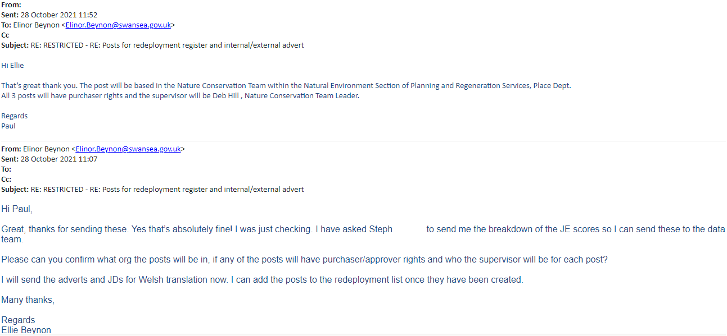
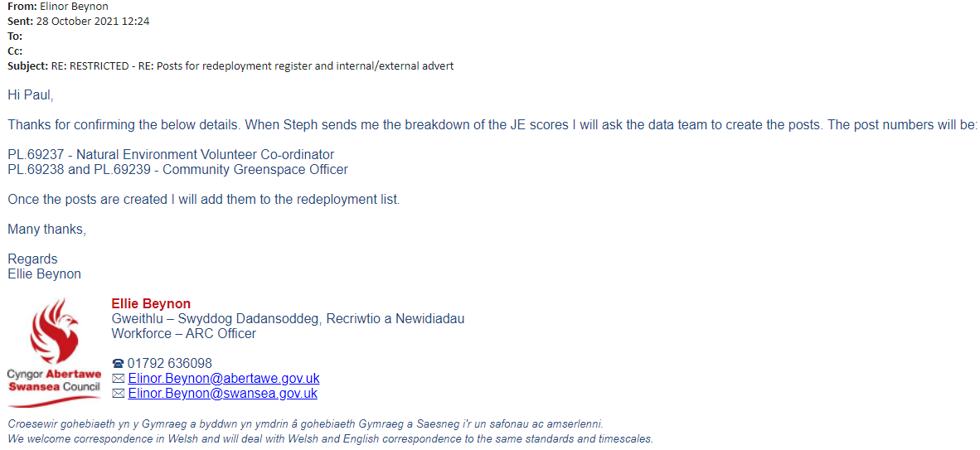
EV20



EV21


Request for Job Advertisement
- All vacancies will be placed on the Redeployment List in the first instance before advertising.
- For all Business Support posts, Managers should access the Business Support Portal
- Director approval will be needed before post is advertised on an external basis – please refer to Vacancy Monitoring or Delegated Powers Form
Directorate: |  | Place | Section: | Natural Environment
Post Number: |  | TBC - Data team to create post on Oracle ??? | Post Titles: | Community Greenspace Officer x 2
Salary Grade: |  | Grade 9 | Salary: | £33,782
Text for Advertisement:
Working within the Council’s Nature Conservation Team you will be responsible for helping to deliver our commitments to the Regional Green Infrastructure Project through engaging communities, businesses, public bodies and others in local biodiversity and green infrastructure management and enhancement activities that can help deliver a long-term, sustainable difference to nature recovery, climate change, ecosystem and community resilience.
A relevant degree, sound ecological knowledge, survey skills and habitat management experience are required, as is a clear understanding of relevant legislation and policies. Excellent communication skills and experience of partnership working are also essential. The successful candidates will be diligent, passionate, professional and enthusiastic.

These are temporary full time posts until at least the end of June 2023.They are funded by the Welsh Government to deliver the South West Wales Green Infrastructure Project through the Enabling Natural Resources and Well-being Grant with part funding from the European Union.
For further details contact
Apply on line at …
Closing Date : tbc

Advertisement Details
Where to be advertised  (please complete either section a or b |  |  | Date of insertion |  | Closing date
A. | Internal Section of the Job Bulletin only |  | Tbc following redeployment register |  | 2 weeks ?
B. | External Section of the Job Bulletin, Intranet, Internet, Job Centre |  | At same time as internal advert |  | 4 weeks tbc
B. | Professional Journal, Press or other Publication |  | At same time as internal advert |  | 4 weeks tbc
NB. | a) Correct Job Description & Person Specification must be attached – see below  b) Details to be submitted to adverts@swansea.gov.uk
Name, Location & Telephone Number of the Manager who should receive the Pack of Application Forms:
Paul, Natural Environment Section Manager, agile working -

EV22

Job Description

Directorate: |  | Place
Service Area & Section: |  | Planning and City Regeneration, Strategic Planning and Natural Environment
Unit Manager: |  | Nature Conservation Team Leader
Post Title: |  | Community Greenspace Officer
Job Family & Role Profile: |  | RT55A
Post No: | PL.69238 | Grade: | 9

Summary of Role
Reporting to: | Nature Conservation Team Leader
Purpose of the Post: | - To fulfill Swansea Council’s commitments to the Regional Green Infrastructure project through engaging communities, businesses, public bodies and others in local biodiversity and green infrastructure management and enhancement activity that can help deliver a long-term, sustainable difference to nature recovery, climate change, ecosystem and community resilience.
The post holder is responsible for the following: | - To work collaboratively with Ward Councillors, community groups ,schools, and others to identify opportunities and locations for maintaining and enhancing biodiversity and Green Infrastructure (GI) and strengthening the resilience of ecosystems within each ward (e.g. through tree planting, habitat management and creation, wildflower planting, improving connectivity, etc).  - To prepare landscape plans/technical designs for biodiversity and GI enhancements in collaboration with key stakeholders.  - To undertake GI mapping, evidencing the need, demand and potential for improvements.  - Prepare individual ‘Wild about Your Ward’ maps and a GI/Biodiversity Action Plan for each selected Ward.  - To assist with the preparation, review and implementation of management plans for Local Nature Reserves and Sites of Importance for Nature Conservation (SINCs).  - To support schools to improve their school grounds and to access and use their local wildlife sites for outdoor learning.  - To contribute towards the delivery of priority actions identified in local plans and policies (such as Area Statements, Green Infrastructure Plans, Pollinator Action Plan and Local Nature Recovery Action Plans (and Well-being Plan, Working with Nature Action Plan).  - To work alongside the Natural Environment Volunteer Co-ordinator, LNP Officer the local community and others to help plan, design , implement and manage practical conservation schemes, including GI enhancements within targeted wards.  - To assist in supporting implementation of the Section 6 – Biodiversity and Resilience of Ecosystems Duty Action Plan at a local community/ward based level.  - To help raise environmental and biodiversity awareness at a ward level through: close working with local partner organisations and communities; and delivery of nature-related activities and events and information.  - Promote and publicise biodiversity projects and good practice within each ward.  - To facilitate learning and sharing of best practice in relation to biodiversity and GI, through collaborative working, training and awareness and demonstration initiatives.  - To work collaboratively with the Local Environment Record Centres and others to increase involvement in the gathering, reporting and use of local biodiversity records at a ward level.  - To be responsible for managing a small budget for landscape materials.  - To provide regular progress reports to the project manager  - Any other duties commensurate with the grading of the post.
Job Working Circumstances  The post holder will be | - Expected to work in a flexible manner across tasks and locations throughout the County.  - Required to ensure that health & safety and equal opportunities requirements are complied with and that required standards of performance and best practice are maintained.  - Expected to undertake other duties that can reasonably be assigned within capability and grade, including working where necessary in other units within the Department and a degree of flexibility may be required in relation to hours of work. Some weekend and evening work will be expected.  - Aware that the post is politically restricted in accordance with the Local Government and Housing Act 1989.

Person Specification

Directorate: |  | Place
Service Area & Section: |  | Planning and City Regeneration, Strategic Planning and Natural Environment
Unit Manager: |  | Nature Conservation Team Leader
Post Title: |  | Community Greenspace Officer
Job Family & Role Profile: |  | RT55A
Post No: | PL.69238 | Grade | 9

Role Criteria No.1 | Education, Qualifications & Training
Essential | Appropriate professional qualification in ecology, landscape design or related subject.
Desirable | Membership of a professional organisation.
Evidence | All certificates to be provided at interview for validation.
Role Criteria No.2 | Skills /Technical / Professional Competence
Essential | Candidates must have a high level of technical competence in the areas specified in the Job Description.
Desirable
Evidence | Valid certification and/or registration/CPD.
Role Criteria No.3 | Experience
Essential | - Experience in planning and designing biodiversity and green infrastructure enhancement schemes e.g. urban tree planting, wildflower planting, SUDs, etc.  - Good ecological knowledge including knowledge of relevant legislation {Nature Recovery Action Plan (Wales); and Environment (Wales) Act 2016}.  - Experience of developing and/or delivering Green Infrastructure (GI) or environmental related practical projects (e.g. biodiversity improvements, green space improvements, planting for air quality, etc.).  - Ability to develop and deliver multi-disciplinary environmental/GI projects.  - Experience of GIS mapping.  - Basic wildlife survey experience/ID skills.  - Proven experience working with multidisciplinary teams, external contractors and other organisations especially within a local government context.  - An understanding of the key pressures on biodiversity including climate change and Invasive Non-Native Species.  - Experience of preparing funding bids and managing budgets.  - Experience of preparing management plans for Local Nature Reserves and community wildlife sites.
- Good knowledge of the project area.
- Experience of community engagement and partnership working, especially in relation to biodiversity/conservation work.
- Experience of the practical implementation of conservation works in urban and rural settings.
- Experience engaging/working with contractors.
Understanding and experience of participatory community engagement approaches.
Evidence | At interview, then in post.
Role Criteria No.4 | Competencies & Abilities
Essential | - Working knowledge of landscape/GI design principles and technical design skills.  - Ability to build relationships and work effectively with a range of organisations.  - Good interpersonal and negotiation skills, with the ability to work with cross-sector partners, other departments and the public in a diplomatic manner.  - Ability to inspire, influence and communicate effectively with a wide range of audiences.  - Able to work on own initiative, with flexibility, and collaboratively as part of a team.  - Understanding of GI; its benefits to individuals, communities and ecosystem resilience e.g. for air quality, flood alleviation, biodiversity, etc.  - Ability to map environmental data onto a GIS format  - Good organisational skills, with the ability to meet deadlines, undertake monitoring, and report on progress for grant and managerial requirements.
Desirable | - Promotion and influencing skills and the ability to build relationships.  - Being innovative and creative and adapting to the changing needs of the project.  - Ability to create and deliver new ideas that further the projects’ aims in engaging people with nature.  - Ability to use social media.  Computer literate with an ability to use the Microsoft Office package and AUTOCAD
Evidence | At interview, then in post
Role Criteria No.5 | Commitment to Equal Opportunities
Essential | Candidates will demonstrate that all activities are undertaken in accordance with the Equalities Act 2010 and Swansea Council’s Equal Opportunities Policy and Procedures.  All employees and managers must be aware of the Equality Act so that it is considered in their work, where relevant, to ensure compliance with legislation.
Desirable
Evidence | At interview, then in post

Role Criteria No.6 | Current Driving Licence
Essential | Ability to attend meetings, events, etc at locations other than the main office.  Should the post holder have a disability and/or be unable to drive, then they may seek alternative means of transport/assistance, which must be an effective and cost effective method of travelling.
Desirable | Use of own car.
Evidence | Evidence the post holder is appropriately insured for business purposes to be provided annually.
Role Criteria No. 7 | Compulsory Requirements for Introducing Change and New Ways of Working
Essential | - Demonstrate commitment to the Council’s new ways of working, providing a positive and supportive environment that initiates and enables innovative and sustainable working practices that deliver high quality services for our citizens.  - Embrace change through actively and flexibly participating in and adapting to new ways of working with our citizens, as agreed through formal consultation with Trades Unions and HR Policies and procedures.
Desirable
Evidence | At interview, then in post.
Role Criteria No. 8 | Other Requirement
Essential | - Standard office equipment.  ICT literate in standard office software and GIS.
Desirable | Standard design packages and AutoCAD.
Evidence | At interview, then in post.

Health Surveillance and Monitoring: | This post will require the post holder to take part in health surveillance and monitoring procedures.

Safeguarding: | The Authority is committed to safeguarding and promoting the welfare of children and young people and expects all staff and volunteers to share this commitment.

Welsh Language
The Authority is committed to delivering an equally high quality service in Welsh and English and will support staff in providing this.
Assessment of Posts
All posts have to be assessed in respect of the Welsh Language requirements. The evidence of which has to be retained and available for (a) audit trail and (b) inclusion in annual report figures.
Requirements for this post
(See attached Welsh Language Skills Assessment)
Understanding | Level: 1 | Speaking | Level: 1
Reading | Level: 1 | Writing | Level: 1
Based on the above, requirement for this post is as follows:
Essential |  | Desirable | x
To be learned |  | Not required

Disclosure and Barring Service (DBS): | This post requires the postholder to have the level of DBS disclosure as indicated below:
Disclosure and Barring Service (DBS): | Standard DBS Disclosure Application | Enhanced DBS Disclosure Application | No DBS Disclosure Application
Disclosure and Barring Service (DBS): | x

Review/  Right to vary: | This Person Specification is as currently applies and will be reviewed regularly according to the Employee Performance Management Review Policy and the Performance Development Review and Appraisal process. The Job and Person Specification may be subject to other Variance within the remit of the Role Profile.
Sign off
Line Manager: |  | Date:
Post Holder: |  | Date:

EV23

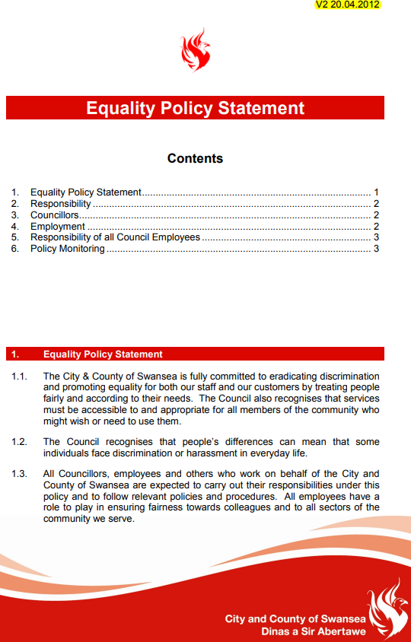



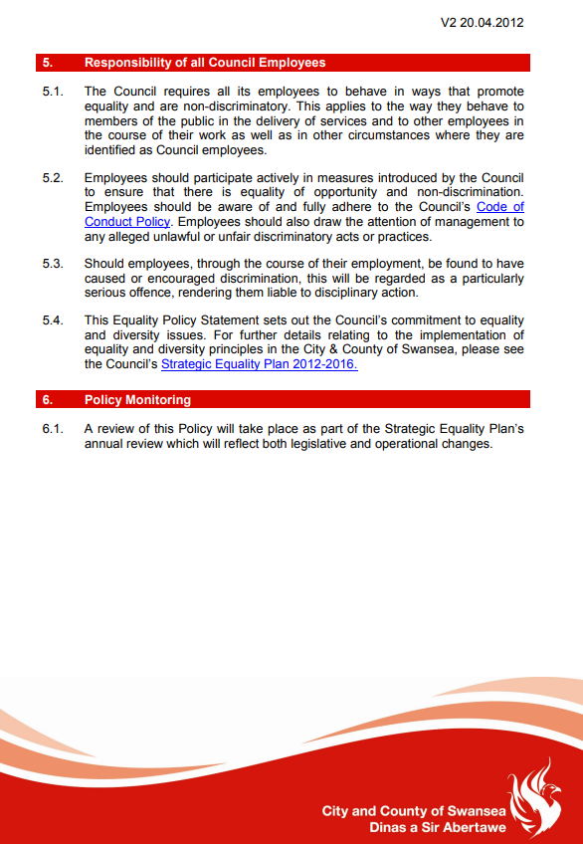

EV24
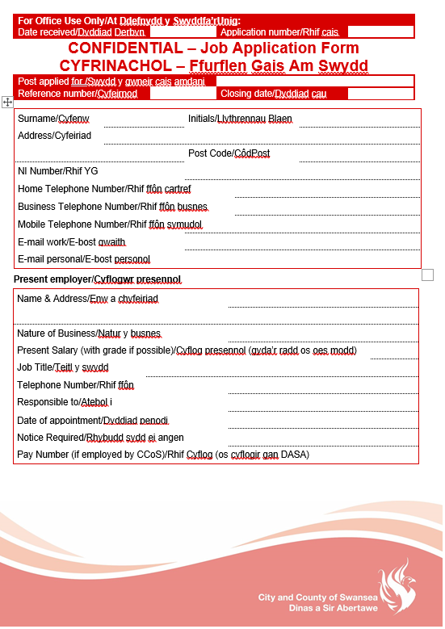
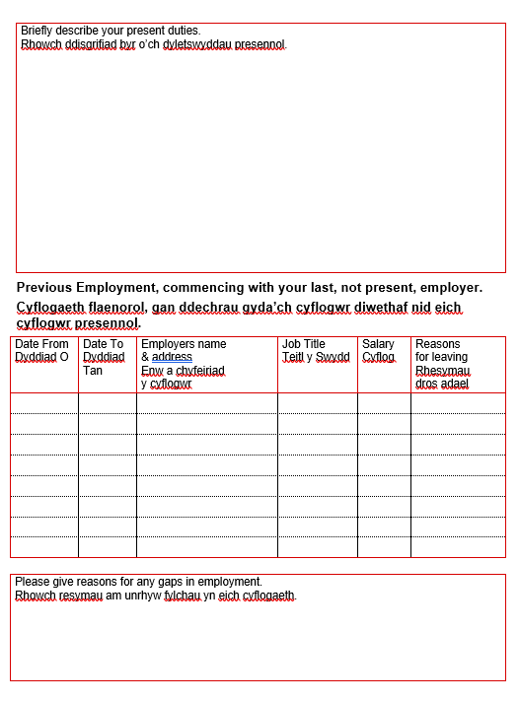
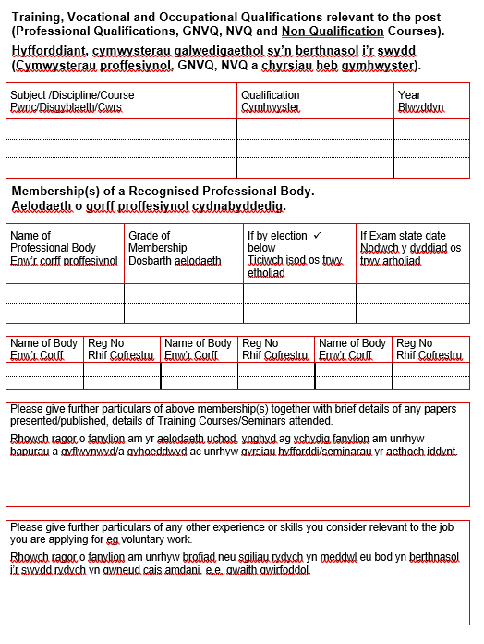
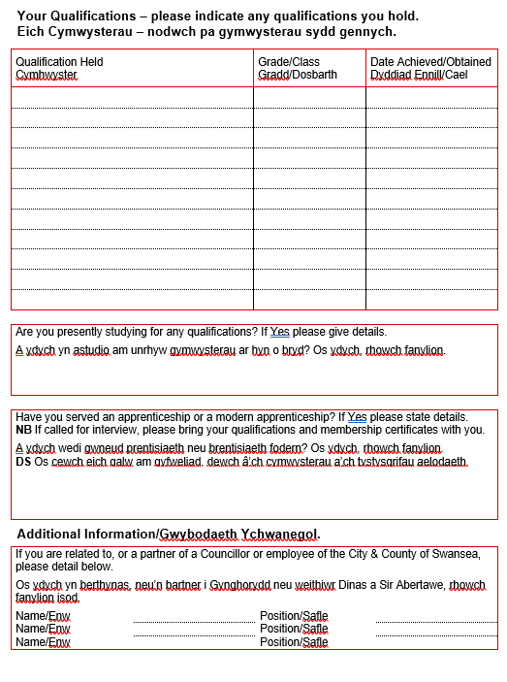
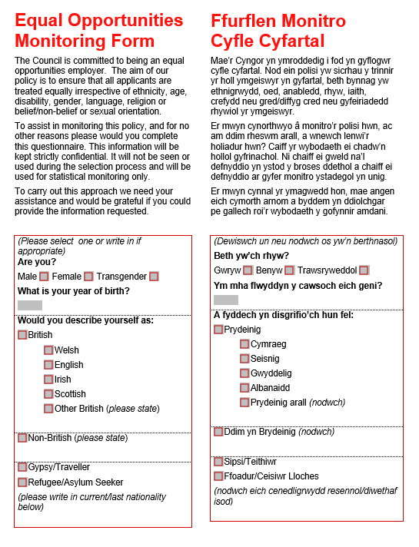
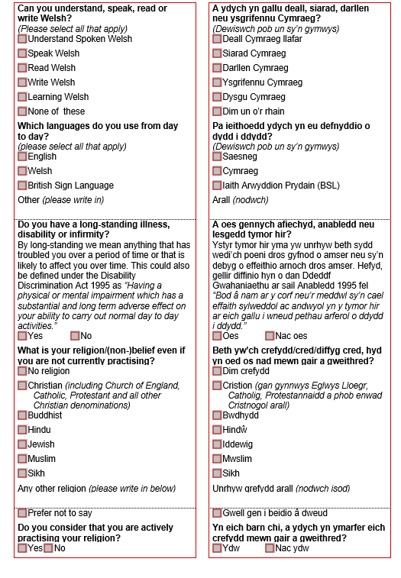
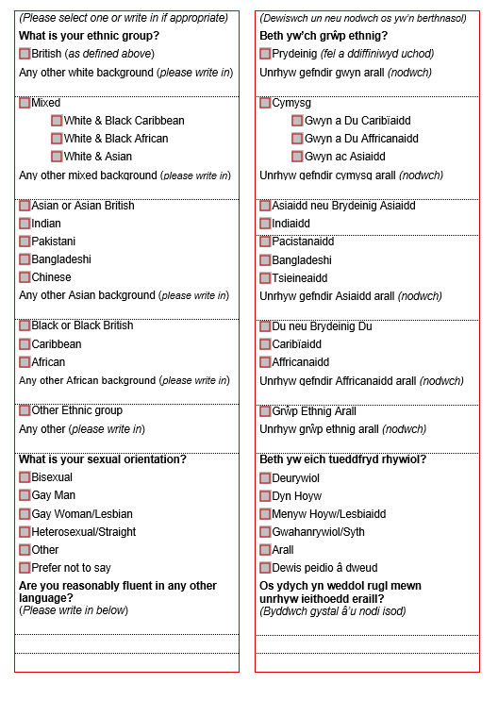

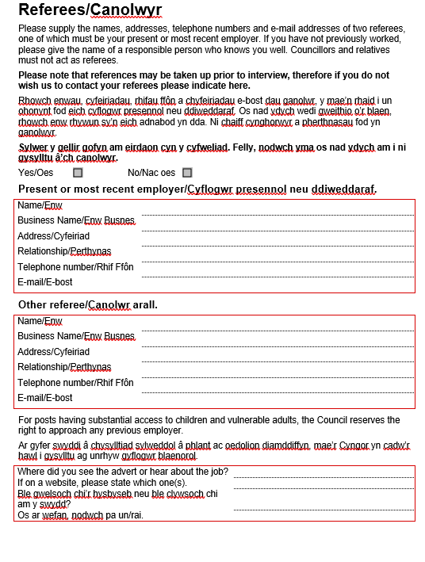

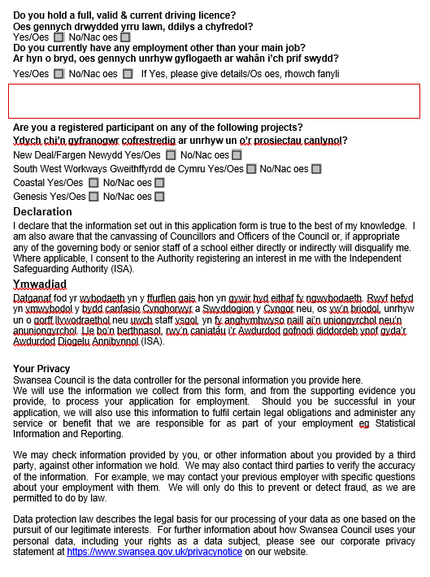
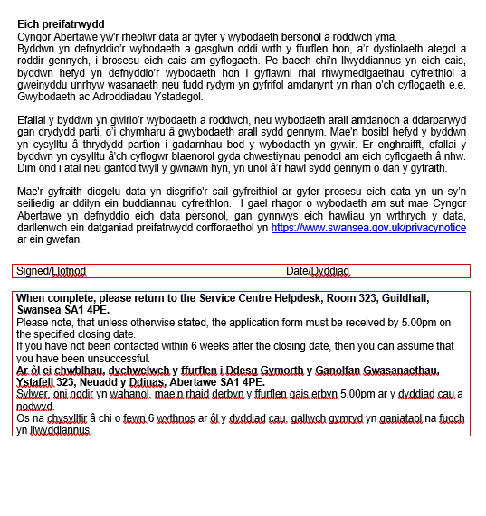
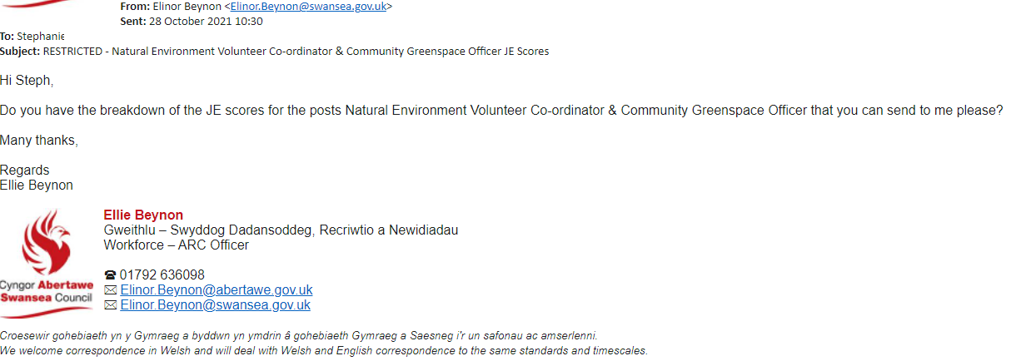
EV25

EV26
 | POSITION INFORMATION
 | To be used for the creation of all new permanent and temporary positions
Start date of position |  |  |  | 28th October 2021 |  |  | Position Number and Title
 |  |  |  |  |  |  | PL.69238 and PL.69239 - Community Greenspace Officer
End date of position (if temporary) |  |  |  | 30th June 2023 |  |  | Grade |  |  |  | 9
Position Status
Please highlight the selection |  |  |  |  |  |  | Supervisor |  |  |  | Y/N
 |  |  |  |  |  |  | Politically Restricted |  |  |  | Y/N
A | B |  |  | C |  |  | Career Grade |  |  |  | Y/N
Permanent | Full-Time |  |  | Centrally Funded (Schools Only)
Temporary | Part Time (please state hours) |  |  | Externally Funded |  |  | Any special requirements relevant to the position e.g. Welsh Speaking, Car Driver, relevant qualifications/training, please specify: Appropriate professional qualification in ecology, landscape design or related subject.
Supply | Job Share
Relief | Seasonal
 |  |  |  |  |  |  | CCS Non School |  |  |  | x
Does this post have Purchaser/Approver rights? |  |  |  |  |  | Y/N | School - Associated
 |  |  |  |  |  |  | Teacher
Directorate | Place
 |  |  |  |  |  |  | Supervisor Name
Service Unit | Planning and City Regeneration
Section | Natural Environment |  |  |  |  |  | Supervisor Pay No |  |  |  | 057141
Org Name | Nature Conservation
 |  |  |  |  |  |  | Supervisor Post No |  |  |  | PL.0475
Location | Civic Centre
Authorised by |  |  |  |  |  | Position | Workforce – ARC Officer
Name | Ellie Beynon |  |  |  |  | Date | 28th October 2021
PLEASE ENSURE PAY AND GRADING AND WELSH LANGUAGE LEVELS ARE COMPLETED BEFORE SUBMITTING FORM
PAY AND GRADING ALLOCATION |  |  |  |  |  | WELSH LANGUAGE LEVELS
Knowledge | 5 |  |  |  |  | Please state levels (1-5)
Impact | 6 |  |  |  |  | Welsh Language Speaking |  |  |  |  | 1
Relationship | 4 |  |  |  |  | Welsh Language Written |  |  |  |  | 1
Advising | 6 |  |  |  |  | Welsh Language Reading |  |  |  |  | 1
Effort | 3 |  |  |  |  | Welsh Language Understanding |  |  |  |  | 1
Dexterity | 1 |  |  |  |  | Criteria (Essential/Desirable/Must be Learnt and N/A |  |  |  |  | Desirable
Conditions | 4
H&S | 3 |  |  |  |  | Agile | YES/NO
Emotions | 1
Job Family | RT
Role Profile | 55
Type | A
Indicator | Y
Family Points | 528
JWC Points | 43
Total Points | 571
JFA Excluded
Analytics Team Only
New Position Created
Entered Hierachy
JE Updated
Welsh Language Updated
Agile Updated
Sign
Date

EV27
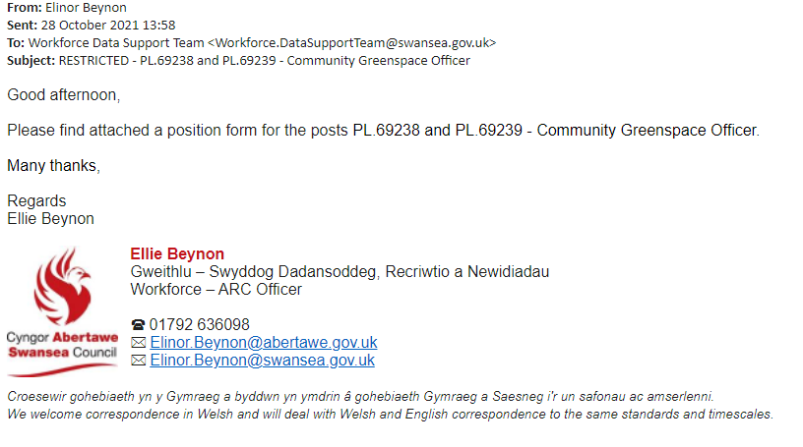

EV28
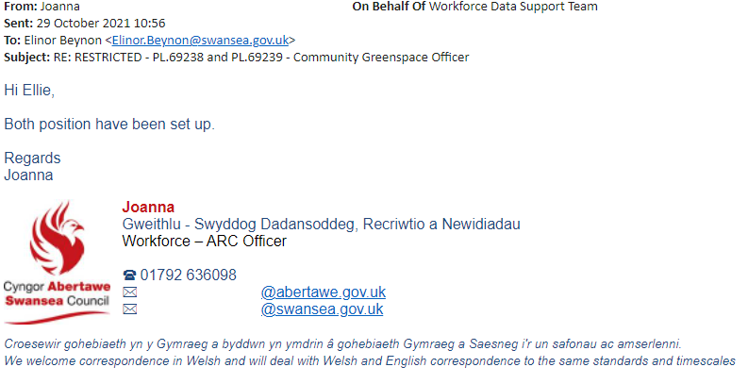
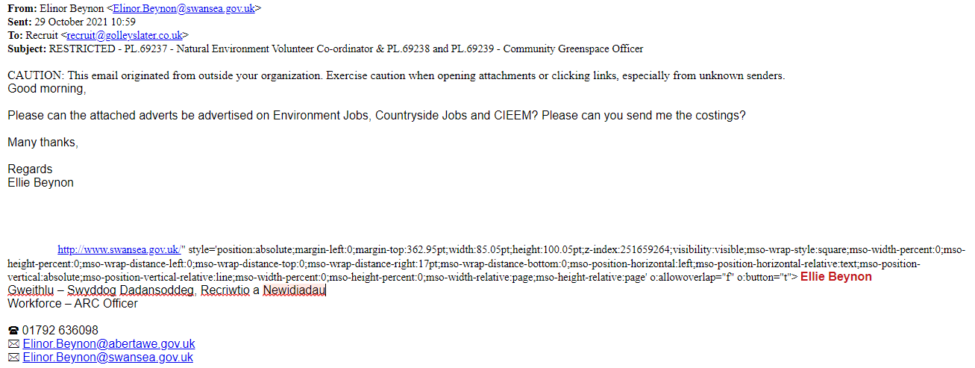
EV29

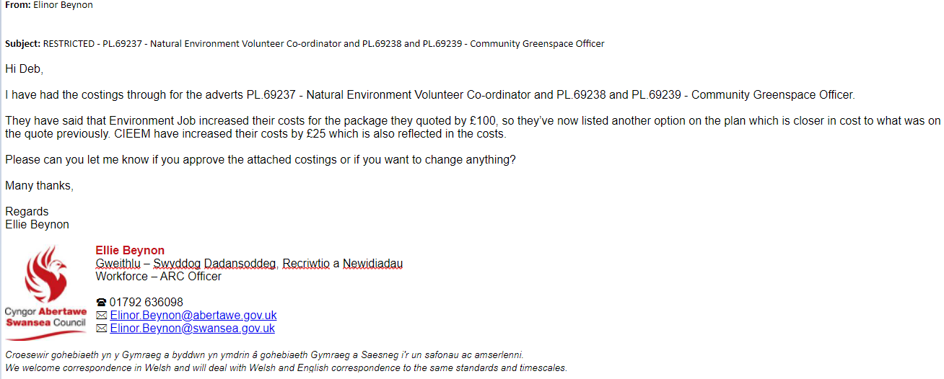
EV30

EV31
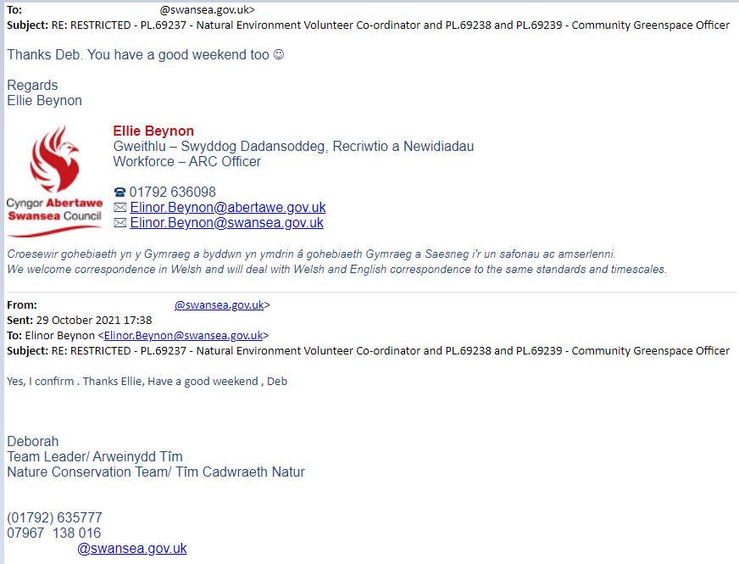

EV32
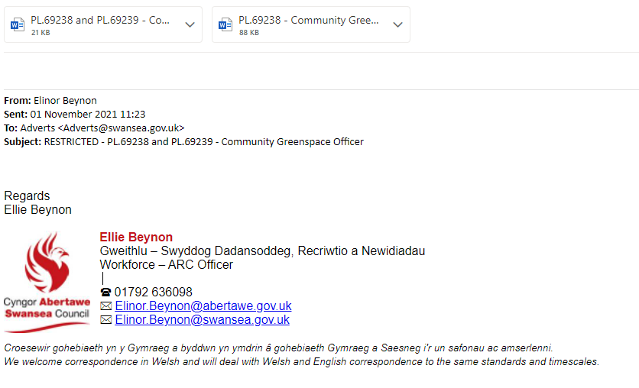
EV33
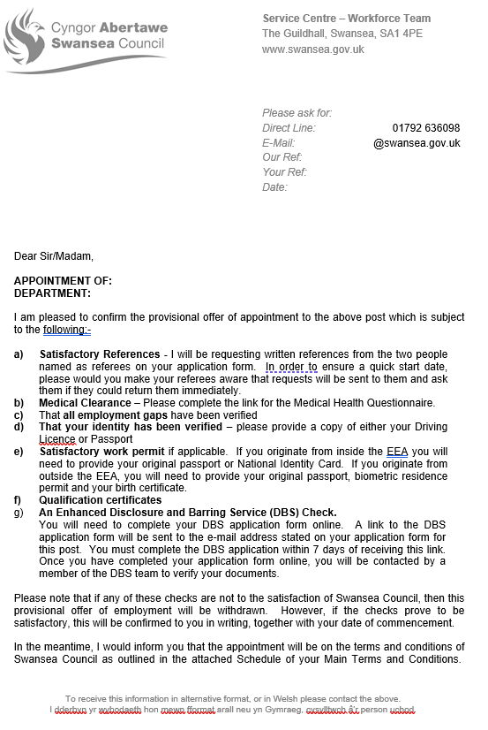



EV34



SCHEDULE OF THE MAIN TERMS AND CONDITIONS WHICH APPLY TO THE POST OF:
POST TITLE _ POST NUMBER
WITH SWANSEA COUNCIL

- This Agreement constitutes a written Contract of Employment for the purposes of the Employment Rights Act, 1996 and, other appropriate employment legislation.

- Your Contract of Employment consists of this statement of written particulars of employment, together with your original appointment documents. The main terms of your Contract are those contained in the National Joint Council for Local Authorities, Local Terms and Conditions and Local Agreements made collectively with the appropriate recognised Trade Union. The Local Terms and Conditions and Local Agreements are documented in the Swansea Council’s Staff Handbook. Any changes to these Local Terms and Conditions and Local Agreements will be notified to you.

- Name of employer: Swansea Council.

- Name of employee:

- Date of commencement of employment with Swansea Council as a within the Directorate of the Authority: 1st January 2022.

- Term of Employment
The term of employment shall commence on the and is permanent/temporary until .

If you require a Work Permit, the Authority will need confirmation from the UK Border Agency that you are able to live and work in the UK. It is your responsibility to ensure that you have a valid Work Permit.

- Continuous Employment
Your period of continuous employment for statutory employment rights began on .

However, if you have previous continuous service with an organisation covered by the Redundancy Payments (Local Government Modification) Orders, (which covers Local Authorities and related bodies or any other organisation from which you have been transferred via TUPE regulations) which is continuous to the employment with Swansea Council, then this will be included in calculating your entitlement to: a redundancy payment, sickness allowance, maternity leave and annual leave entitlement.

- Date on which this statement is given:

- Job Title
You are employed in the post of: based within the Directorate of the Authority.

10. Place of Work
You will normally work at the fixed centre of
The main business address of Swansea Council is Civic Centre, Swansea, SA1 3SN. You may also be required to undertake any agile working arrangements i.e. hot desking etc adopted by the Authority. You may also be asked to work from your home if service needs dictate. Health and Safety Risk Assessments will be carried out as necessary.

11. Hours of Work
Your normal working week comprises of hours, and meal breaks will not be paid. There may be occasions when you will be requested to be flexible and your line manager will ask you to work additional hours or be able to change working patterns / days in line with the needs of the Service, complying with the Working Time Regulations as in accordance with any rotas / working arrangements within your place of work. Full consultation will be undertaken with you and your personal circumstances taken into consideration. Your manager will be reasonable in making such requests and will seek to achieve this by mutual agreement. The Council will seek to achieve a reasonable work life balance wherever possible.

Examples of arrangements you may be asked to work include:

  - Weekends,
  - Unsocial Hours
  - Night Working
  - Shift Working,
  - Bank Holidays
  - Standby arrangements
  - Mornings / Evenings

You may be requested to also work a reasonable amount of overtime on an ad-hoc basis at critical times to ensure that service delivery is maintained and specific project deadlines are achieved. Any overtime will be paid in line with the Overtime Policy or Time off in lieu Policy. In civil emergencies the Council will require you to participate in any role as deemed necessary and appropriate.

- Flexibility of duty
Whilst your post and place of work are as described above, the Council may transfer you to any of its establishments within the geographical boundary of Swansea Council, at any other location or service area, to maximise the efficient and effective delivery of Council services and facilitate the Welsh Government’s objective of greater collaborative working between local authorities and across the public sector.

If the Council needs to transfer you this will be subject to full consultation with you and your personal circumstances being taken fully into consideration, which will include:
- your domestic and family circumstances
- the nature of the work to be undertaken
- your knowledge, skills, experience and qualifications
- the alternative post being graded differently by no more, and no less, than one pay grade (pay protection will apply if the new post is graded lower)
- the distance and travelling time of the move in terms of location
- the hours of work
- the business need for the move
- the duration
- the timescale for the move
- and the selection process if appropriate

Swansea Council shall not be liable to provide you with travelling facilities or reimburse whole or part of any travel expenses which you may incur as a result of the transfer.

- Salary details, method of payment and calculation of hours
Your current salary is £ per annum pro rata on Spinal Column Point within salary grade , SCP - . Your salary will increase within the scale by annual increments, (up to the maximum of the scale), however annual increments may be withheld if an employee is subject to the Council’s Capability Policy. It should be noted that officers with less than 6 months’ service by 1st April shall be granted their first increment 6 months after their appointment, promotion or regrading.

For part time staff, the annual salary is pro rata dependent upon the number of hours worked compared with the annual salary of a full time member of staff.

Your annual salary is paid monthly on the 25th day of each month (or nearest working day before) by BACS system into your bank or building society account. For each calendar month you will receive 1/12th of your annual salary.

Your hourly rate for full time and part time employees is calculated as follows:-

(Annual (salary/365 days) x 7 = hourly rate
37 hours

14. Probation
All new appointments to Swansea Council are subject to a six month period of probation during which there will be regular appraisals. The Council may extend the six month probationary period where appropriate.

Posts in Children’s Establishment and those covered by Warner are subject to a probationary period, which comprise of reports at the following intervals after appointment:

- Three months
- Six months
- Nine months
- Twelve months

All Social Worker Staff must register and maintain their Care Council for Wales Registration.

15. Leave
Every employee is entitled to paid annual leave. The amount of leave entitlement will depend on your length of unbroken service in Local Government. A summary of the annual leave entitlement is given below:-

Continuous Local Government Service of:
Up to 5 years  24 days | Over 5 years  Up to 10 years  29 days | 10 years & Over  33 days

If you are a part time employee, you are entitled to a pro rata entitlement, agreed with your Line Manager.

16. Bank Holidays
In addition to the annual leave set out above you are entitled to eight bank holidays plus one extra statutory day at Christmas. If you are a part time employee, you will have a pro rata entitlement, agreed with your Line Manager.

Certain Services have to be provided on Bank Holidays and if you work in such a service, you will be contractually required to work at these times and will be given a day in lieu and paid the relevant Single Enhanced Rate to compensate you. Other employees may be required to work on a Bank holiday where necessary for the needs of the Service.

17. Maternity Rights
Rights of pregnant women to leave and pay are in accordance with the NJC. Agreement referred to in paragraph 2, and are detailed in the Swansea Council’s Maternity Policy. These rights are dependent on pregnant women complying with criteria and notification requirements. The legislation and employment policies relevant to pregnancy, paternity leave and adoption leave are available in the Staff Handbook.

- Sickness
Swansea Council operates a Management of Absence Policy and Management of Absence Administrative Procedure, which is available in the Staff Handbook or from your Line Manager. Your entitlement to sickness allowance, as per Part 2 of the NJC Green Book is as follows:-

During 1st year of service | 1 month’s full pay and (after completing 4 months’ service) 2 months’ half pay
During 2nd year of service | 2 months’ full pay and 2 months’ half pay
During 3rd year of service | 4 months’ full pay, 4 months’ half pay
During 4th & 5th year of service | 5 months’ full pay, 5 months’ half pay
After 5 years’ of service | 6 months’ full pay, 6 months’ half pay

Absence in respect of industrial disease, accident or assault arising out of or in the course of employment with the Council is entirely separate from absence in respect of normal sickness and shall not be set off against the other for the purpose of calculating entitlements under the scheme. In line with the Management of Absence Policy the payment of occupational sick pay may be suspended in certain circumstances. Please refer to the Management of Absence Policy and Absence Administrative Procedures for more information.

19. Pensions
The pension arrangements for this post are administered by Swansea Council Pension Fund. Employee contribution rates will be tiered, details of which can be found in the Employee Handbook.

All payments which are considered pensionable are taken into account. Regular reassessments and re-bandings will take place to take into account, for example, pay awards, increments and promotions.

The band ranges will be increased each April in line with the Pensions (Increase) Act 1971, which is currently the Consumer Prices Index (CPI). The Regulations set out that the employer will be responsible for assessing each employee and setting their contribution rate.

Employees will be allocated into contribution pay bands and all payments which are considered pensionable will be taken into account.

The Council must enrol employees into the LGPS and you will become a member of the Pension Scheme automatically on appointment, provided you have a contract of at least 3 months and are aged under 75 but have the right to opt out if you so wish. If your contract is for less than 3 months you will not be automatically brought into the Pension Scheme but you may elect to join if you wish.

If you have transferred or have been promoted into this post, your pension arrangements remain unchanged.

- Notice
Either party may terminate this Contract by giving notice in writing to that effect. The minimum periods of notice to which you are entitled from the Council are:

Period of Continuous Employment with the Swansea Council | Minimum Notice Period
Less than 6 months  6 months up to 2 years  2 years or more but less than 12 years  12 years or more continuous employment with the Authority | 1 week  4 weeks  1 week for each completed year of continuous employment with the Authority (with a minimum of 4 weeks notice).  12 weeks
The minimum periods of notice of termination of your employment which you are required to give to the Council are:

Post to the Council | Notice Period
Post in Grades 1 to Grade 8 (Spinal Column Points 1 - 29)  Posts in Grade 9 and above (spinal Column Points 30 and above) | 1 month  2 months

An earlier departure date can be mutually agreed between the employee, line manager and Human Resources & Organisational Development. In certain circumstances the Council may require you to not attend work during your notice period and you will still receive pay during this period. There may also be circumstances where the Council will not require you to work your notice period and instead you will receive pay in lieu of notice.

- Deduction from Salary
Where an overpayment of salary, wages, or any other form of expense is made, the Council will reclaim the overpayment via a deduction from salary. It is the right of the Council to reclaim any overpayment at a reasonable rate.

Where you have exceeded your annual leave entitlement or permitted flexi time allowance, the Council may reclaim this overpayment from you via a deduction from salary.

If you are on the flexi time system and you exceed your agreed number of debit hours Swansea Council may deduct the excess from your salary. Likewise if you are on the flexi time system any hours in debit at the effective date of termination will be deducted from your final salary. This principle will also apply should you have overtaken your annual leave entitlement and wish to leave Swansea Council’s employ, and a deduction equivalent to the excess will be deducted from your final salary. Deductions from salary may take place if you:

- Fail to attend work through an impediment, avoidable or otherwise such as imprisonment or imposition of bail conditions
- Fail to attend an arranged medical appointment with the Occupational Health Advisers
- If you fail to attend a medical appointment, without good reason, a deduction will be taken from your salary. This amount will be reviewed annually
- Any training / course fees paid by the Council for your benefit and fail to complete the course without good reason or leave the Council within two years of completing the training / course.

The above list is not exclusive or exhaustive

Swansea Council also reserves the right to require you to repay to Swansea Council either by deduction from salary or any other method:

- Losses sustained in relation to the property or monies of the Council, client, customer, visitor or other employee of the Council during the course of your employment and which were caused through breach of the Council’s rules or any dishonesty on your part;
- Any amounts of remuneration, expenses or any other payments (statutory, discretionary, etc) which are overpaid to you whether made by mistake in fact or through any misrepresentation or otherwise;
- Any other sums owed to the Council, including, but not limited to, outstanding loans or advances, or relocation expenses.

Any underpayment of salary will be rectified in the next available pay period after the underpayment has been identified.

Any overpayment of salary is recoverable over a reasonable period which will be agreed with the Council and you. As a general rule this would ordinarily be recovered in no less than the period in which the overpayment occurred.

It is your responsibility to check each payslip received and inform Employee Services of any errors suspected.

Knowingly continuing to receive any payments you are not entitled to is a disciplinary offence.

22. General Data Protection Regulation (GDPR)
By signing this contract you are confirming that you have read and understood the Council’s Data Protection Policy, a copy of which is available on our website. You must comply with the terms of this Policy, and the provisions of the General Data Protection Regulation and the Data Protection Act, at all times when handling or processing personal data on the Council’s behalf in the proper performance of your job duties and responsibilities during your employment. This includes personal data relating to any current or former employee, worker, agency worker, apprentice, volunteer, contractor, consultant, client, service user, customer or supplier of the Council, or personal data relating to any other third party.
  - Your Privacy
Swansea Council is the Data Controller for the personal information you will be asked to provide in relation to your appointment to this post. We will use this information to fulfil certain legal obligations and administer any service or benefit that we are responsible for as part of your employment e.g. statistical Information and reporting.

We may check information provided by you, or other information about you provided by a third party, against other information we hold. We may also contact third parties to verify the accuracy of the information. For example, we may contact your previous employer with specific questions about your employment with them. We will only do this to prevent or detect fraud, as we are permitted to do by law.

Data Protection Law describes the legal basis for our processing of your data as one based on the pursuit of our legitimate interests. For further information about how Swansea Council uses your personal data, including your rights as a data subject, please see our corporate privacy statement at https://www.swansea.gov.uk/privacynotice on our website.

You must inform your line manager immediately of any change in the personal information you have provided to us, such as a change of address or your personal circumstances.
22.2 Prevention of Fraud - Data Matching
Personal information you have supplied to the Council as an employee will be retained on both manual and computerised records of the Council, and the Council shall use the same for data matching purposes under the Council’s Anti-Fraud and Corruption Policy & Strategy, in order to detect and take action against fraud, debt, or any other civil or criminal law right

- Trade Union Membership

You are entitled to be a member of a Trade Union of your choice.

This Council, as your employer, supports the principles of collective bargaining and therefore encourages employees to join a Trade Union of their choice. You will be bound by the outcome of collective bargaining whether or not you are a member of a trade union. However, not every Trade Union is recognised for collective bargaining purposes. For practical purposes this is best conducted by representatives of the employer and the employees. The Council is represented on joint national and provincial councils dealing with such matters. It is equally sensible for you to be in membership of a Trade Union representing your group of employees on the appropriate negotiating bodies at national, provincial and local levels.

The Council will, at your written instruction, deduct from your salary the subscription to a trade union recognised by the Council for negotiating purposes.

All collective agreements will be represented in the Staff Handbook which will be immediately updated as soon as possible.

24. Health and Safety
All Swansea Council employees, irrespective of their position or employment status, have a responsibility to comply with the Health and Safety at Work etc. Act 1974. Swansea Council Corporate Health and Safety Policy, its arrangements and all subordinate policies provides a framework to meet our duty of care and obligations under law.

The Policy requires that each employee is responsible for conducting work in a manner which is safe for them, their colleagues and the public who may be affected by what they do or do not do - say or do not say. Every employee is expected to be involved in health and safety every day and will be provided with the opportunity to contribute positively to a safer and healthier workplace.

In particular each employee must cooperate with the Council and will:

- Follow health and safety information, instructions and training on safe systems of control and you must notify your Manager of any shortcomings in their health and safety arrangements.
- Employees should carry out any reasonable management request but not undertake any work which they are not competent, appropriately trained, appropriately equipped or authorised to carry out safely.
- Report all hazards and potential risks to your Manager.
- Attend Health and Safety training courses as required by your Manager and the Swansea Council
- Use any equipment, machinery, safety devices, protective clothing provided to them in accordance with any training and instruction as identified in risk assessments or safe procedures
- Not misuse or interfere with any item, sign, article, piece of equipment, engineered system or facility provided in the interest of Health, Safety and Welfare or Fire Safety
- Participate in pro-active accident/ill health prevention and monitoring measures as required by the Swansea Council and advise their manager or the Occupational Health and Wellbeing Unit of any health matter that may affect their ability to undertake their work duties safely.
- Report all accidents or near misses to your Manager or Supervisor.

The Corporate Health and Safety Policy forms part of this contract of employment and the Policy will be made available to you for further reference and clarity of your obligations under the Policy particularly if you have a management role.

The Swansea Council Disciplinary Policy applies to all employees and covers compliance to health and safety rules and standards which cause or could cause risk to the individual, other employees or the public.

Serious and deliberate violation of Swansea Council’s Health & Safety Policy, health and safety rules and standards may be viewed as gross misconduct under the Disciplinary Policy of the Swansea Council.

25. Car and Subsistence Allowances
If your post requires you to undertake duties away from your fixed centre of work you will be required to be qualified to drive a vehicle and use your own car for business purposes or have the ability to travel within and outside of Swansea Council boundaries in an efficient and most cost effective manner. It will be your responsibility to ensure it is suitably safe for business purposes and that you are appropriately insured for business purposes and hold a valid driving licence. Should you have a disability and be unable to drive, then you may seek alternative means of transport/assistance, which must be an effective and cost effective method of travelling.
If you use your own car for transport, then a single car user rate will be used for all authorised car use. The single rate will be the HMRC rate as set out in the Staff Handbook.

Out of county use will be reimbursed on the basis of fixed rates.

For further information please refer to the Council’s Car, Travel and Subsistence Allowance Policy.

26. Employment outside the United Kingdom
Not applicable.

27. Employees’ General Obligations
Employees of Swansea Council are reminded of the confidentiality of information given to them or acquired by them in the course of their employment. Any breach of confidentiality will lead to disciplinary action under the disciplinary procedure of Swansea Council.

All employees wishing to undertake secondary employment outside or within the Council, or to engage in a private business in any capacity, shall inform their line manager who will escalate the request to their Head of Service in writing giving sufficient details about the proposed job role, the organisation with which this job would be taken, the proposed number of hours to be worked in each week and any other relevant information. Please refer to the Secondary Employment Policy for more information.

Subject to any obligations you may have to make a disclosure in accordance with the Whistle Blowing Policy you shall not, at any time during your employment (except insofar as you are required to do so as part of your duties) or at any time after your employment has terminated, for any reason whatsoever, disclose to any person any information as to the practice business service or affairs of the Council, or its successors in title or the Council’s or it’s successors in title, customers, clients, or service receivers, without the prior written consent of the Council and shall not, for the avoidance of doubt, release any information concerning any part of the authority involved in trading or charging activities.

Subject to the provisions of the Patents Act 1977 and the Registered Designs Act 1949 and the Copyright, Designs and Patents Act 1988, or any modification for the time being in force, if, at any time during your employment with the Council, you alone or in participation with others, either employees, members, clients or partners of the Council, produce, make, discover or manufacture, during the course of your employment or that which might reasonable be expected to result from the carrying out of your duties, produce, make, discover or manufacture any invention, intellectual property goods or thing capable of ownership, you shall pass all information in your possession to the Council upon written request and in any event at the termination for whatever reason of your employment and shall agree by the signing of this agreement that all rights and obligations under this clause shall be the rights and obligations of the Council and you waive your actual and/or moral rights in this respect.

The copyright of any intellectual, training / IT programmes and written material produced by you in the course of your employment shall be vested in the Council.

You are required to notify Human Resources & Organisational Development promptly, of any change of your personal or contact details such as name, address, telephone number, and next of kin, and of any circumstances which might affect the Council’s insurance cover for you. The Council reserves the right to share this information with appropriate officers as necessary.

If you fail to advise Occupational Health of any changes to your health status relating to any issue of potential disability under the provisions of the Equality Act 2010, the Council will not be held liable for a failure to make reasonable adjustments or undertake relevant assessments. Should you fail to disclose information which could adversely affect the health and safety of either yourself or another you may be subject to disciplinary action.

28. Professional Bodies
The Council will pay any fees where registration or membership to a professional body where it is an essential requirement for an employee to carry out their duties.

Where registration or membership to a professional body is not an essential requirement for you to carry out your duties, you should endeavour to belong to a professional body that represents your profession and pay the appropriate fees.

Staff who are required to have registration or professional membership as a condition of their employment and fail to continue with their registration / professional membership will be in breach of contract which could result in the termination of their employment or being placed on leave without pay.

29. Contractual Policies
The following policies have contractual status and any proposed amendment will be consulted upon and notified to you by giving the appropriate notice after collective agreement through the recognised trade unions:

- Management of Absence Policy and Absence Administrative Procedure
- Disciplinary Policy
- Capability Policy
- Grievance Policy
- Harassment and Bullying Policy
- Health and Safety Policies
- Redundancy Policy
- Redeployment Policy

These policies can be found in the Staff Handbook. The Council reserves the right to review, revise, amend or replace the contents of this handbook, and introduce new policies from time to time reflecting the changing needs of the business.

30. Rehabilitation of Offenders Act, 1974
If this post is exempt from the provisions of the Rehabilitation of Offenders Act 1974, it is made to you subject to the following;

That you have made a true disclosure of all criminal cautions, charges, reprimands or warnings. Should you not have a true disclosure of any criminal cautions, charges, reprimands or warnings, then your employment may be terminated immediately.

31. Disclosure of criminal convictions whilst in employment
You are required to disclose details to your manager if you are cautioned, arrested and subsequently charged, cautioned or prosecuted for any offence whilst in employment with City and County of Swansea.

In respect of road traffic offences, you should inform the Council of the offence accordingly if you are required to drive as part of your duties.

32. Service Specific Requirements
As part of your role you will be expected to comply with the following service specific terms and conditions as set out on the sheet entitled ‘Additional Terms and Conditions’:

33. Please note that failure to comply with any provision in this contract will be classed as gross misconduct and may lead to dismissal.
Please confirm that you have read and accepted the terms and conditions laid out in this document by signing below:-

Signature on Behalf of  Swansea Council |  | Signature of Employee
Signed: |  | Signed:
Position : |  | Name:
Date: |  | Date:

NB. Both copies to be signed by both parties; with one copy being retained by the employee and the other returned to the Workforce ARC Team, Service Centre, Room 153, Guildhall, Swansea SA1 4PE.

EV35
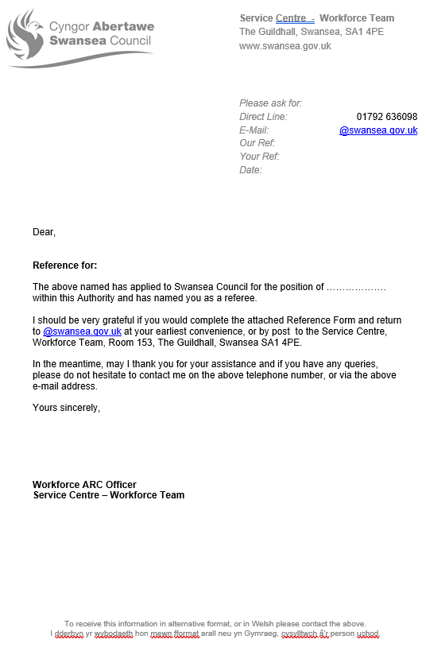

EV36
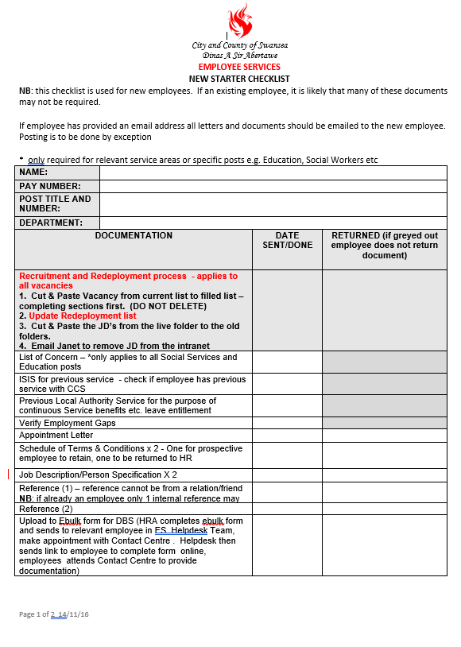
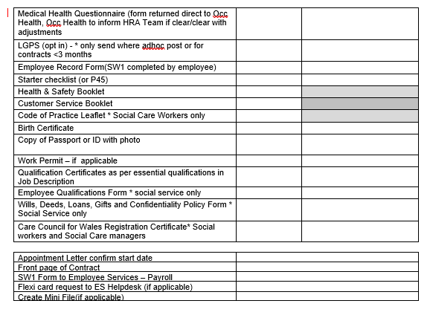
EV37
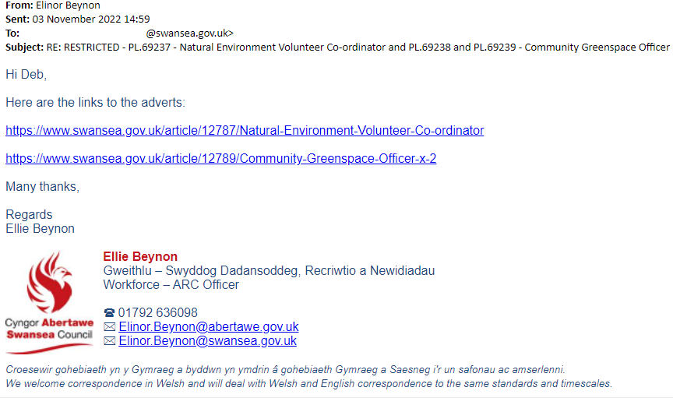
EV38
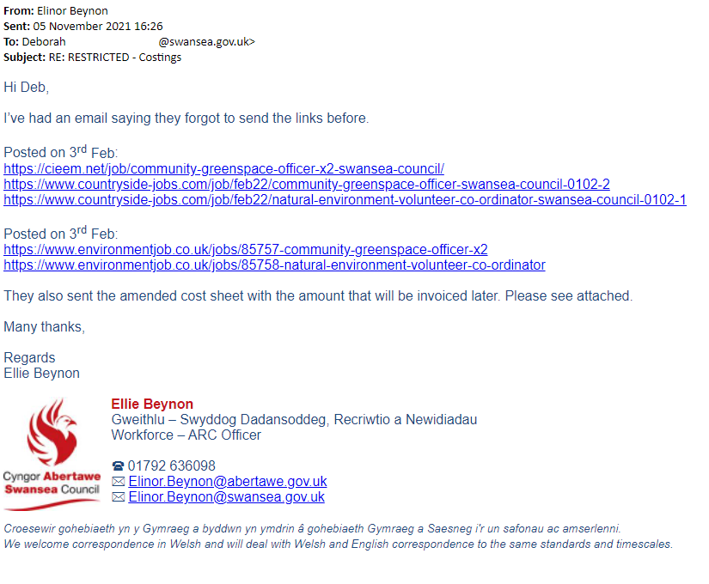
EV39
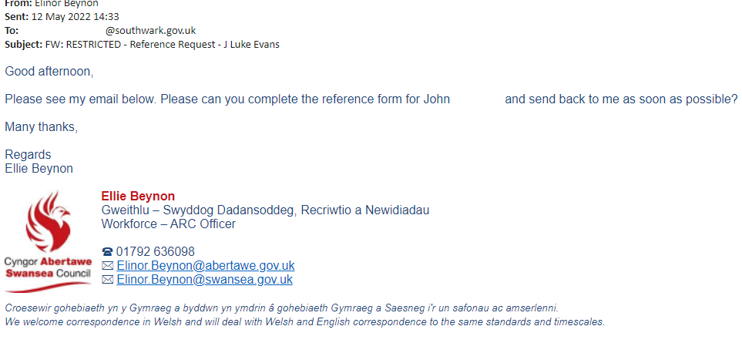
EV40
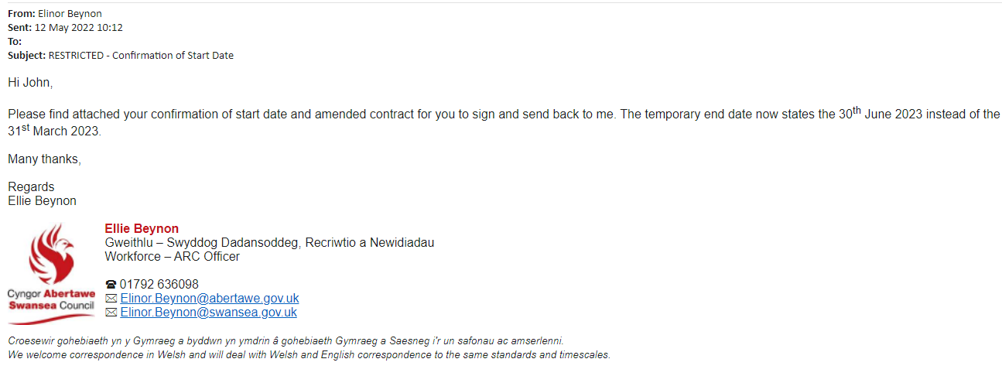
EV41
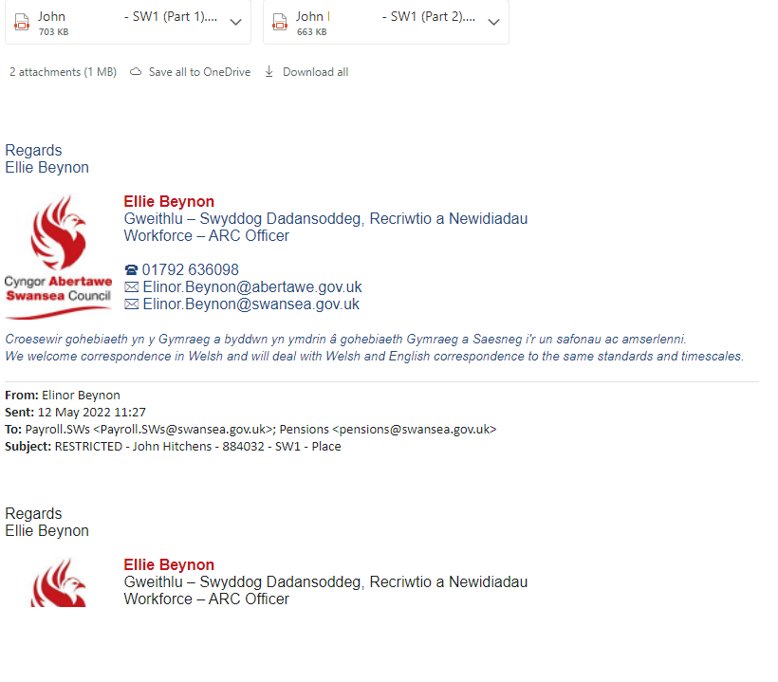
EV42
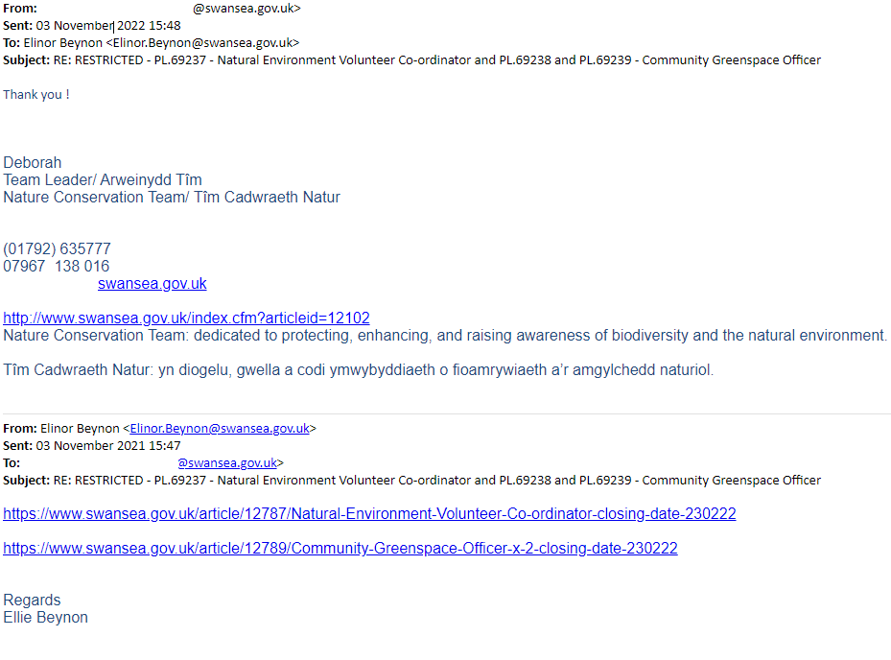
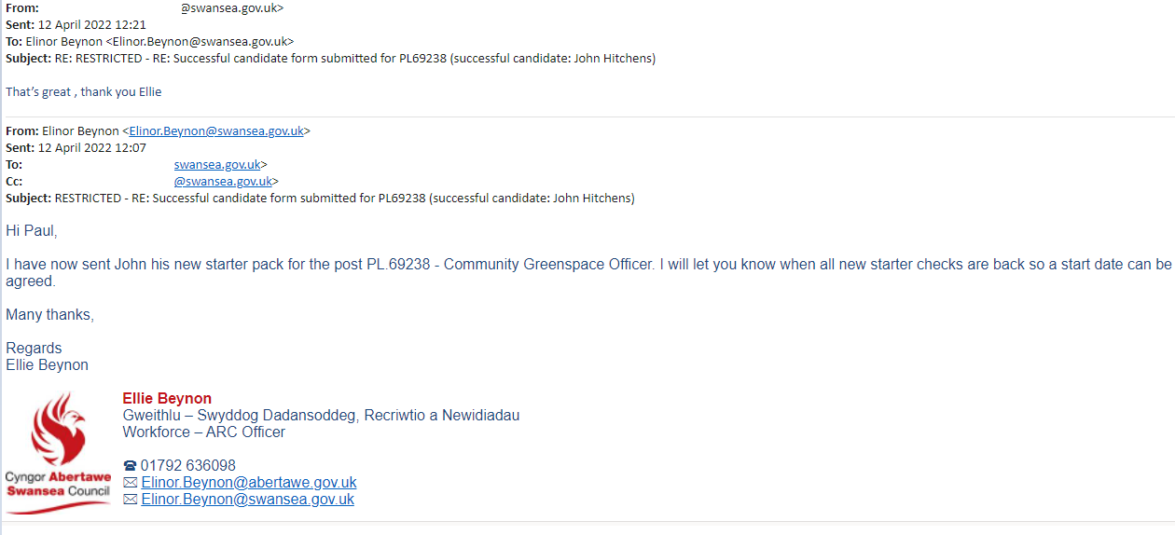
EV43

