Electrical Principles Theory Assignment
GOEE5001
Dafydd Evans

Contents
Task 1 3
A 3
B 3
C 3
D 3
E 3
Task 2 4
Task 3 6
Task 3 – A 6
Task 3 – B 6
Task 3 – C 7
Task 3 – D 9
Task 3 – E + F 10
Task 4 11
Task 4 - A 11
Task 4 – B 12
Task 4 – C + D 13

Task 1

A
Write down an explanation for how one might differentiate simple periodic, complex periodic, impulse and noise waveforms by their shape.
A simple periodic waveform consists of one consistent sized wave, whereas a complex periodic waveform has varied sized waves combined into one. It consists of harmonics, which adjust the shape to incorporate different amplitudes. Impulse and noise waveforms are random in shape. It can vary from your input. They also don’t repeat like simple/complex periodic waves.

B
Define Fourier series and Fourier Transform. Explain the importance of Fourier Transform in the field of engineering.
Fourier series is a tool to represent the sum of multiple sine and cosine waves. It allows us to analyse harmonics and frequencies from a complex signal.
Fourier transform is an extension of the fourier series, you can break down a signal into multiple harmonics. This will then give us the information to filter a signal. It is where you take a signal from the time domain into the frequency domain.
Fourier transform is used in a wide range of products in the field of engineering, such as signal processing, communications, control systems and electromagnetics.

C
Discuss the limitations of using an FFT.
One limitation of using a FFT is limited frequency resolution. When analysing rapidly changing frequencies, the limited frequency resolution can make it challenging to correctly distinguish the components. Another limitation is leakage, this happens when a frequency doesn’t line up perfectly to the FFT bin centres.

D
Write out definitions in your own words of the term’s fundamental frequency, harmonic and spectrum.
Fundamental frequency is the primary frequency component of a simple periodic waveform, it determines a pitch or tone of a sound acting as the base frequency.
A harmonic is an additional frequency component that is present in a waveform. The harmonics determine the overall shape of the waveform.
The spectrum is a representation of a signal in the frequency domain. It provides information on the frequency contents, allowing analysis and processing in various fields such as audio, communications and imaging.

E
Explain the amplitude relationship of the harmonics in triangular, sawtooth and square waveform.
With rising frequency, the harmonics' amplitudes for sawtooth and triangle waveforms drop. The amplitude relationship in square waveforms exhibits a distinct pattern, with significant energy focused at odd harmonics and ignoring even harmonics.

Task 2
Using MATLAB, computes and plots a sawtooth waveform of angular frequency=1. Use a suitable time span so two periods of the waveform can be examined. Use subplots to show the graphs of the developing waveforms when one, three, five and ten harmonics of the sine waveform are used.
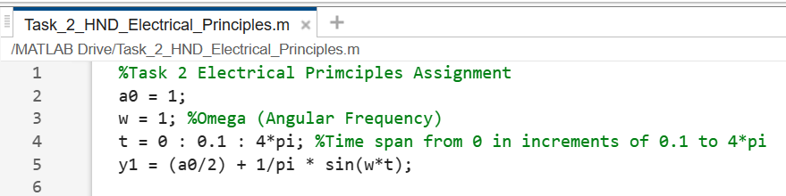

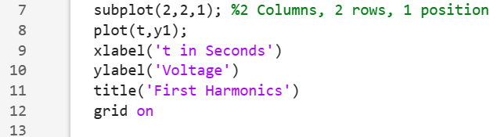

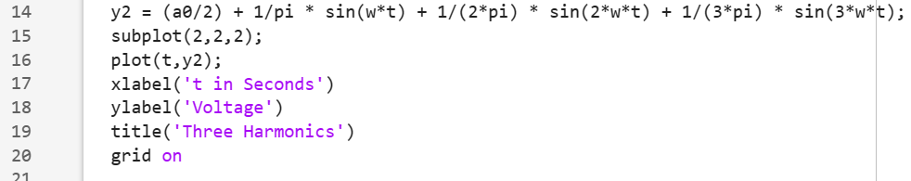

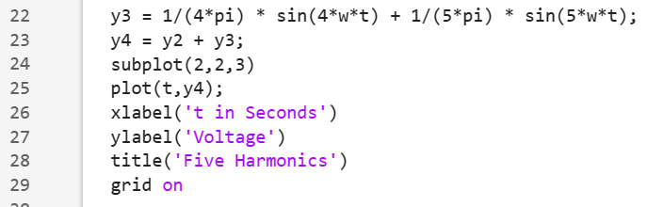

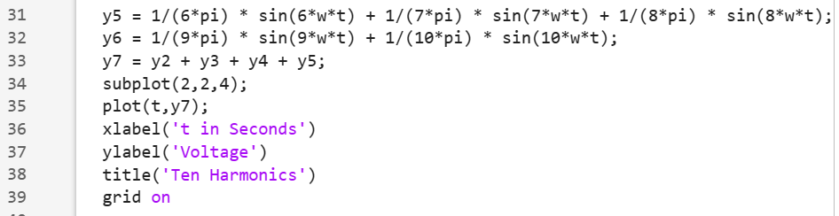
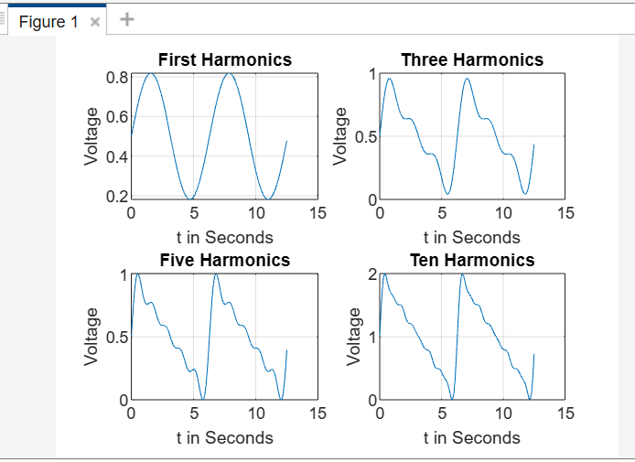

From looking at the graphs plotted, the more harmonics added will smooth out the signal.

Task 3

Task 3 – A
Show that the aperiodic signal x(t) has a Fourier Transform of

$$x\left(t\right)=\left\{\begin{aligned}1 -2≤t≤0 \\ 0 Otherwise\end{aligned}\right.$$
And
$$X\left(ⅈf\right)=\int_{-∞}^{∞}{}x\left(t\right)ⅇ^{-j2Πft}dt$$
$X\left(ⅈf\right)=\int_{-2}^{2}{1}x\left(t\right)ⅇ^{-j2Πftdt}$ $\frac{1}{-j2πf}{\left[ⅇ^{-j2Πf}\right]}_{-2}^{2}$
$X\left(ⅈf\right)$ = $\frac{1}{-j2πf}\left[ⅇ^{-j2Πf(2)}- ⅇ^{-j2Πf(-2)}\right]$
$$X\left(ⅈf\right) = \frac{1}{-j2πf} \left[ⅇ^{-j4Πf}- ⅇ^{j4Πf}\right]$$
$$X\left(ⅈf\right) = \frac{1}{πf}\left(\frac{e^{j4πf}- e^{-j4πf}}{j2}\right)$$
$$X\left(ⅈf\right) = \frac{4}{4πf}\left(\frac{e^{j4πf}- e^{-j4πf}}{j2}\right)$$
$$X\left(ⅈf\right) = \frac{4}{4πf} sin⁡(4πf)$$
Sin4$πf =$ $\frac{sin4πf}{4πf}$
$= 4$ $\frac{sin4πf}{4πf}$
$$X\left(ⅈf\right) = 4sinc⁡4πf$$

Task 3 – B
Plot X(if)=4sinc(4πf)Xif=4sinc(4𝜋f) as a real function using MATLAB.

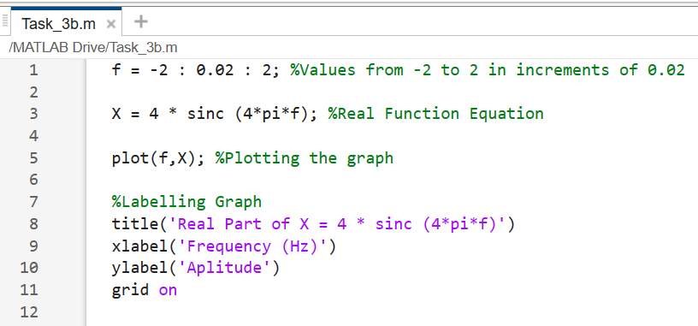

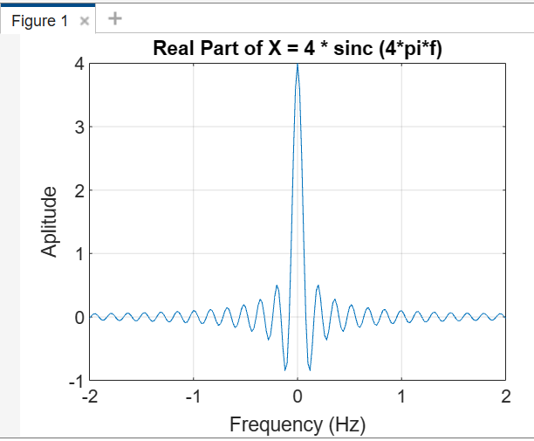

Task 3 – C
Plot the above Fourier Transforms as a complex function by plotting the amplitude and phase spectrum separately.
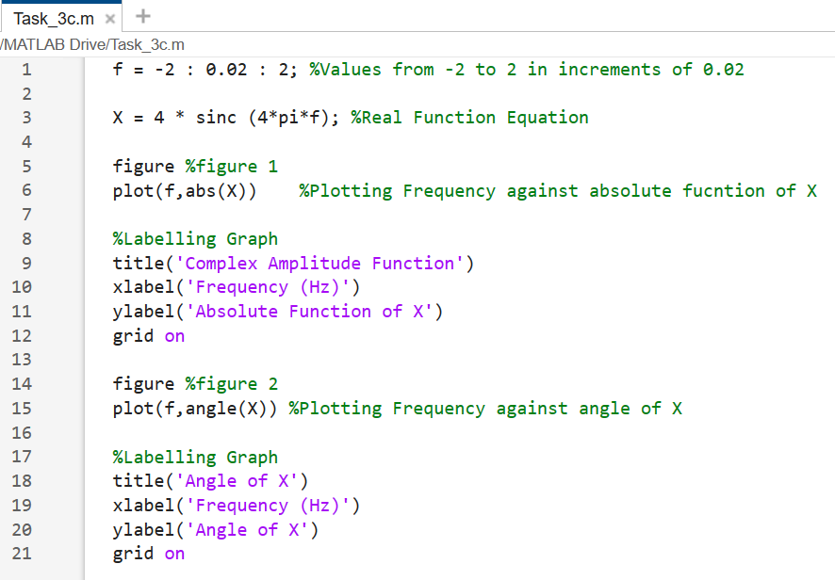
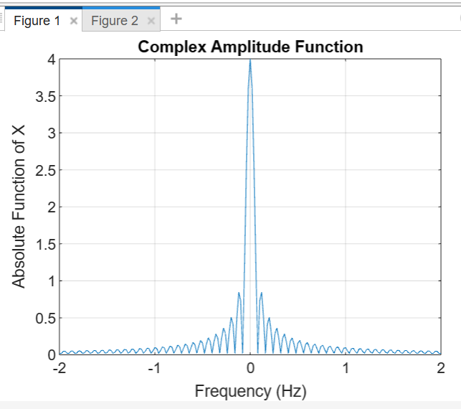
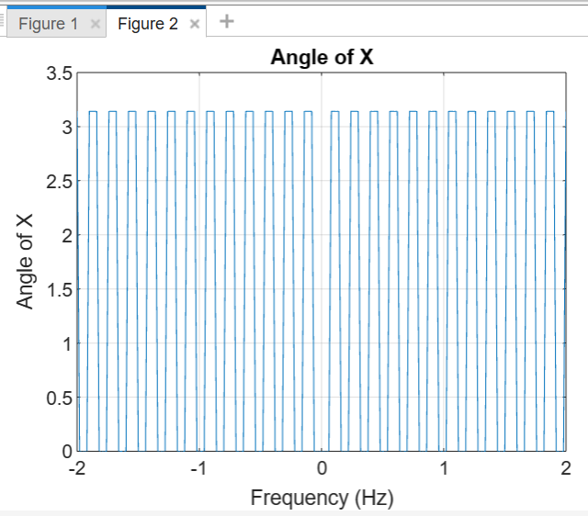

Task 3 – D
Find the Fourier Transform of the exponential signal y(t)=e−7|t| yt=e−7t, using the time Fourier Transform formula: Y(if)=∫+∞−∞y(t)e−j2πftdtYif=∫−∞+∞yte−j2𝜋ftdt

$$Y\left(if\right)=\int_{-∞}^{∞}{y{(t)e}^{-j2πft}dt}$$
$$Y\left(if\right)=\int_{-∞}^{∞}{p}ⅇ^{-7\left|t\right|} e^{-jπft}dt$$
$$Y\left(if\right)=\int_{-∞}^{∞}{p}ⅇ^{-7t-jπft}dt$$

$$Y\left(if\right)=\int_{-∞}^{0}{p}ⅇ^{7t-jπft}dt+ \int_{0}^{∞}{p}ⅇ^{-7t-jπft}dt$$

$$Y\left(if\right)=\int_{-∞}^{0}{p}ⅇ^{(7+jπf)t}dt+ \int_{0}^{∞}{p}ⅇ^{-(7+jπf)t}dt$$

$Y\left(if\right) = \frac{1}{(7+jΠf)}{\left[ⅇ^{(7+jπf)t}\right]}_{-∞}^{0}$ + $\frac{1}{(7-jΠf)}{\left[ⅇ^{-(7+jπf)t}\right]}_{0}^{∞}$

$$Y\left(if\right) = \frac{1}{(7+jΠf)}+ \frac{1}{(7-jΠf)} = \frac{\left(7-jΠf\right)+(7+jΠf)}{(7+jΠf)(7-jΠf)}$$

$$Y\left(if\right) = \frac{14}{49-7jΠf+7jΠf-(jΠ{f)}^{2}}$$

$$Y\left(if\right) = \frac{14}{49-(jΠ{f)}^{2}}$$

$$Y\left(if\right)=\frac{14}{49+{4π}^{2} f^{2}}$$

Task 3 – E + F
Perform the above integration in part (d) using the trapZ command in MATLAB
Plot the real part of the transform in part (d) over a range of frequencies.
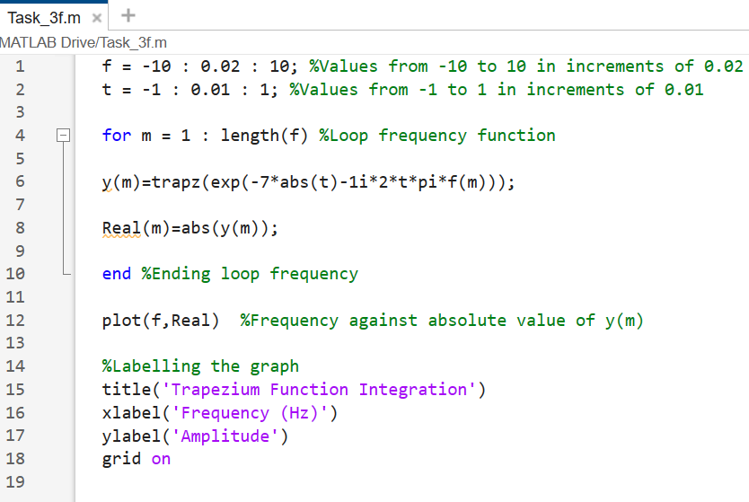
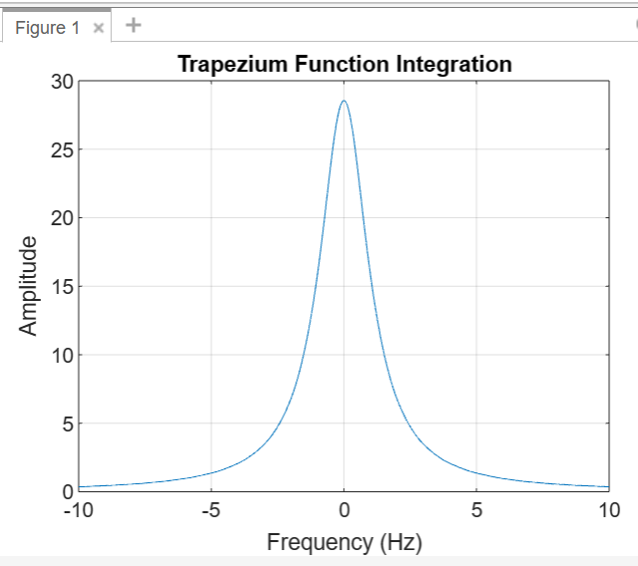

Task 4

Task 4 - A
Using MATLAB plot the amplitude spectrum of the signal below by creating a vector, x, with sampled values of the continuous time function (sample the signal every 0.0002 seconds and create a sequence of length 1000 or 0.2 sec)

x(t)=5cos(2π160t)+4cos(2π170t)+0.75cos(2π580t)+1.5cos(2π600t) xt=5cos⁡2𝜋160t+4cos⁡2𝜋170t+0.75cos⁡2𝜋580t+1.5cos⁡(2𝜋600t)

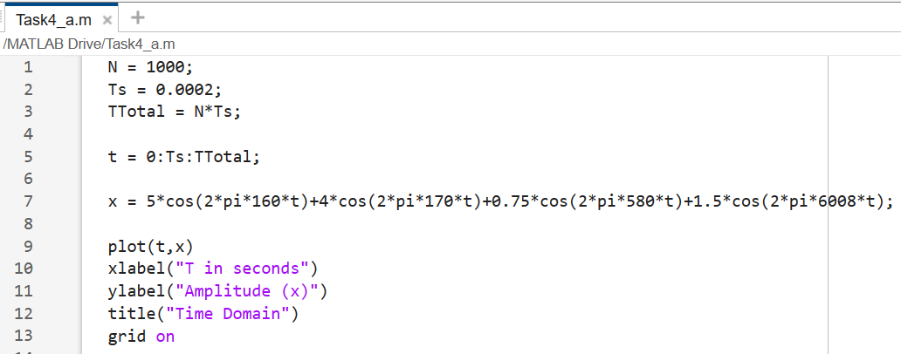

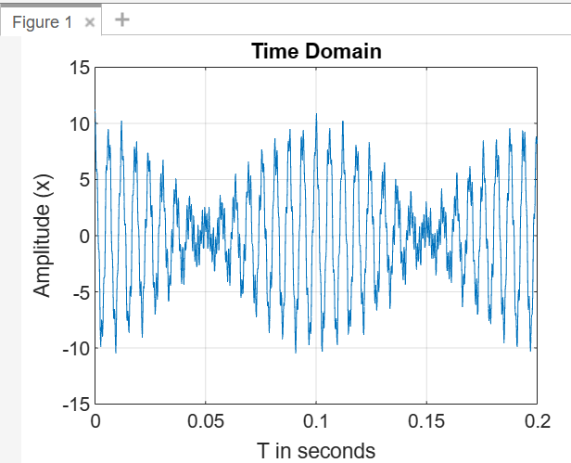

Task 4 – B
Use Fast Fourier Transform (FFT) to plot the Fourier transform of x(t) used in task 4a, by producing a sequence of samples of length N = 1000 spaced every Ts = 0.0002 seconds
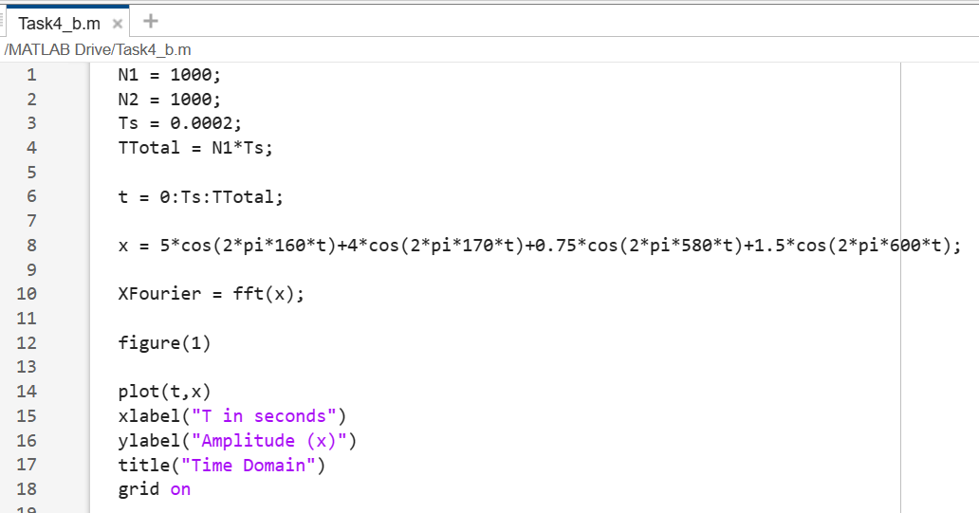
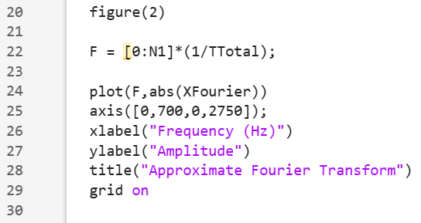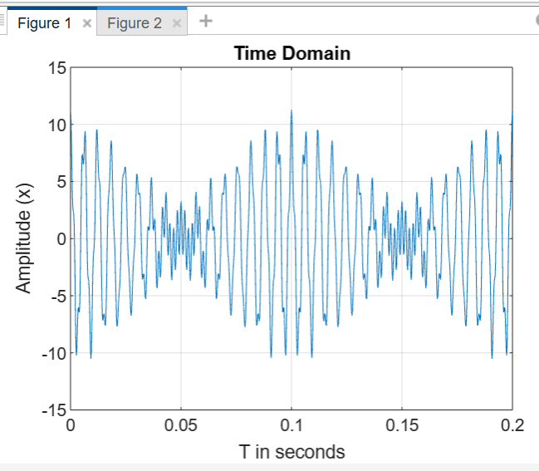
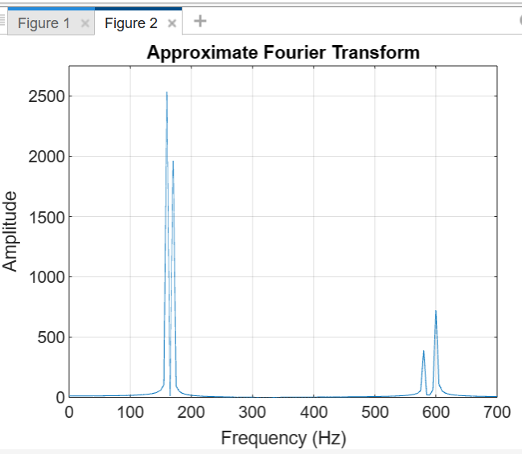

Task 4 – C + D
Apply Inverse Fourier Transform (ifft) to recover the signal from frequency domain to time domain with all frequency components. Visualise the recover signal, compare with original signal and discuss the results.
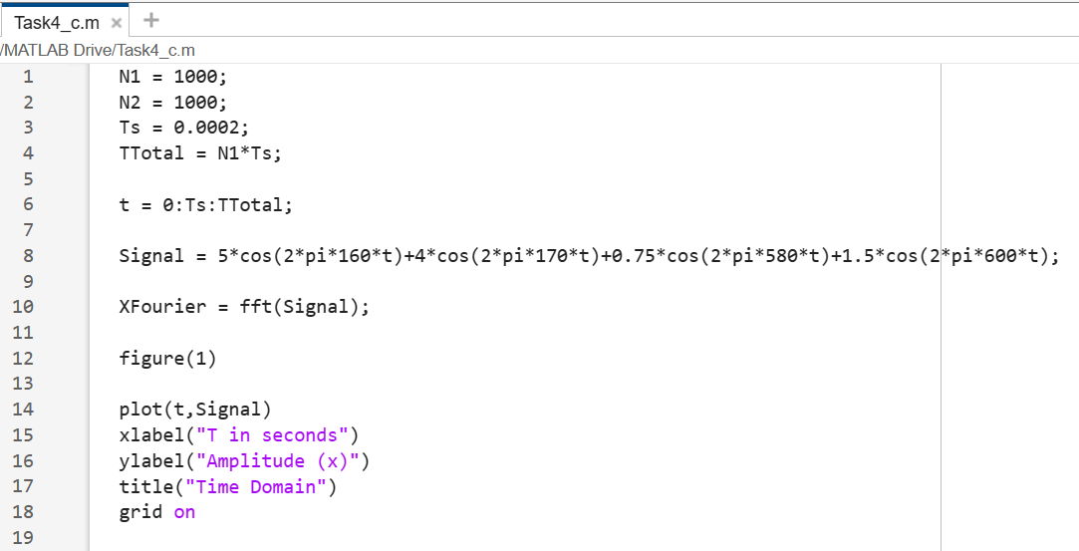
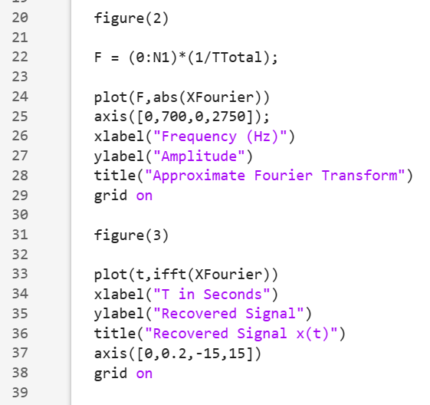

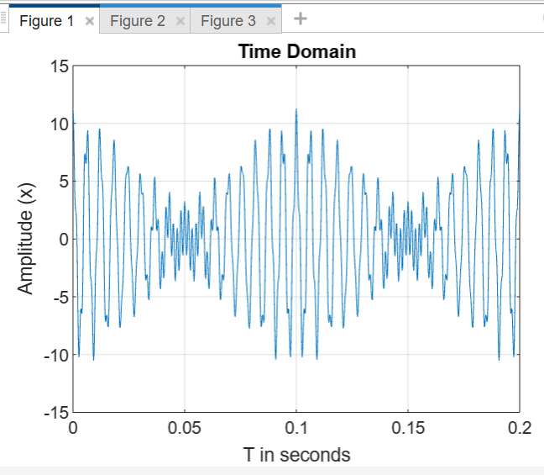

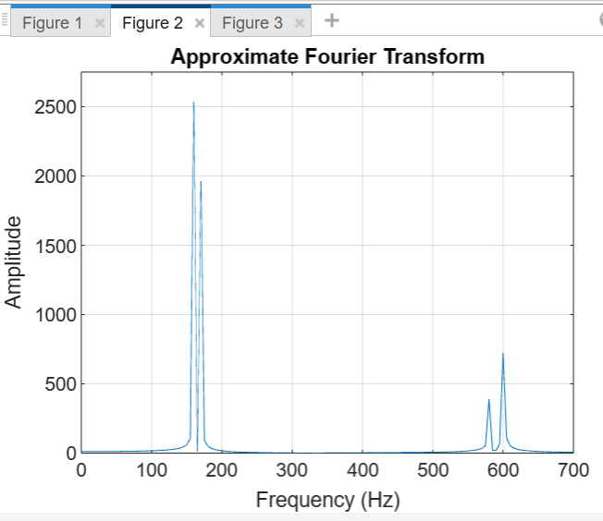
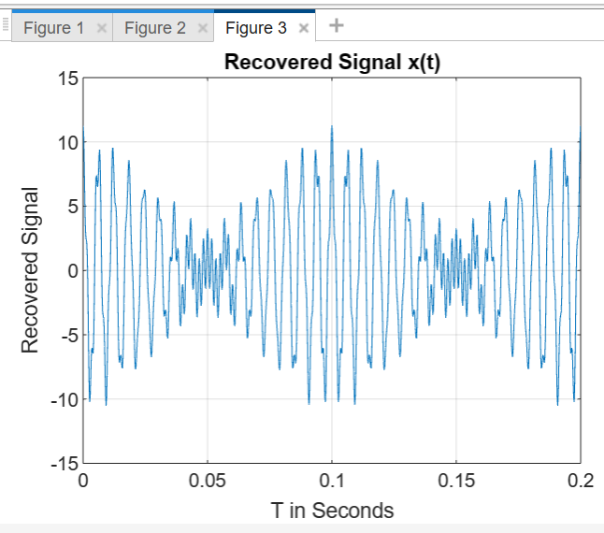

From comparing figure 1 and figure 3 where we have recovered the signal, it shows that they are identical. This shows that the process is accurate as nothing has been left out or added.

