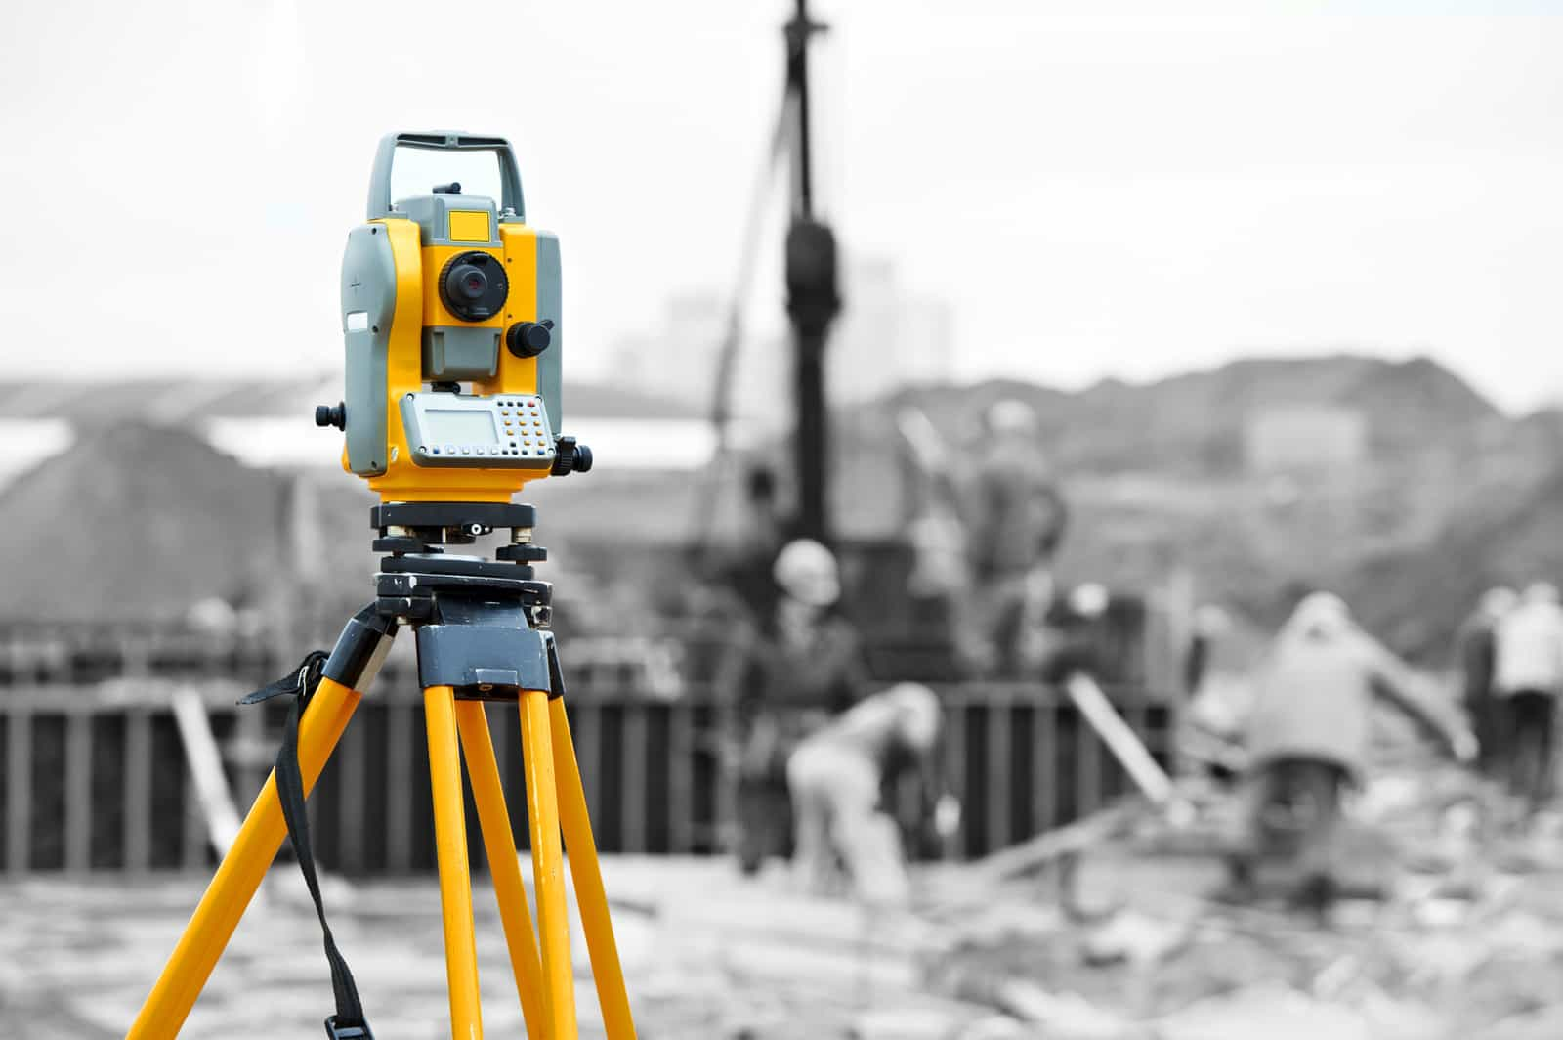  Digital Surveying | Kamran Davies - 2014508

Table of Contents
1. Introduction 1
2. Information 1
3. Overview of surveying 1
4. History of surveying 2
5. Surveying classifications (Part 1) 2
5.1 Primarily (Geodetic & Plain) 3
5.2 Purpose 4
5.3 Method 5
5.4 Equipment (Detailed) 7
6. Digital surveying technologies and listed buildings (Part 2) 10
7. Equipment in building surveying 13
8. Building survey 14
9. References 15

Introduction
There are two parts to be considered for the essay and these are to be approached in equal weighting.

Part 1
- Surveying can be classified based on different factors, outline these factors, and discuss in details different types of surveying under one of the factors.

Part 2
- Briefly describe the application of digital surveying technologies in surveying listed buildings giving examples of appropriate tools to be used and the information to be collected from the survey.

Information
Information will be sourced using online reading, websites, books and lecture notes uploaded onto Microsoft teams.

Overview of surveying
Surveying is the procedure of establishing the relative point of different features on, above or beneath the surface of the earth by means of direct or indirect dimensions. On completion of a survey being undertaken this is then represented and transferred on a sheet of paper or software to then become a plan or map. (civiltoday, 2021)
It is measuring horizontal and vertical distances between objects. Measuring angles between lines and establishing the route of the lines, and of establishing points by fixed angular and linear dimensions. (Surveying, 1999-2000)

History of surveying
As records show, surveying was initially used by the ancients during the Babylonian era (around 3,800 B.C.). Egyptians used surveying procedures during the creation of the Great Pyramids. Since then, it has advanced in both technology and a mathematical science. (Surveying, 1999-2000)

Surveying classifications (Part 1)

Primarily
(Geodetic & Plain)
Equipment
Method
Purpose

Bases

5.1 Primarily (Geodetic & Plain)
Plane surveying – Is a form of surveying in which the surface of the earth is considered as a plane and the spheroidal shape is forgotten. All triangles created by survey lines are considered as plane triangles. The level line is considered as straight, and all aligned lines are considered equal. (blog, 2020)
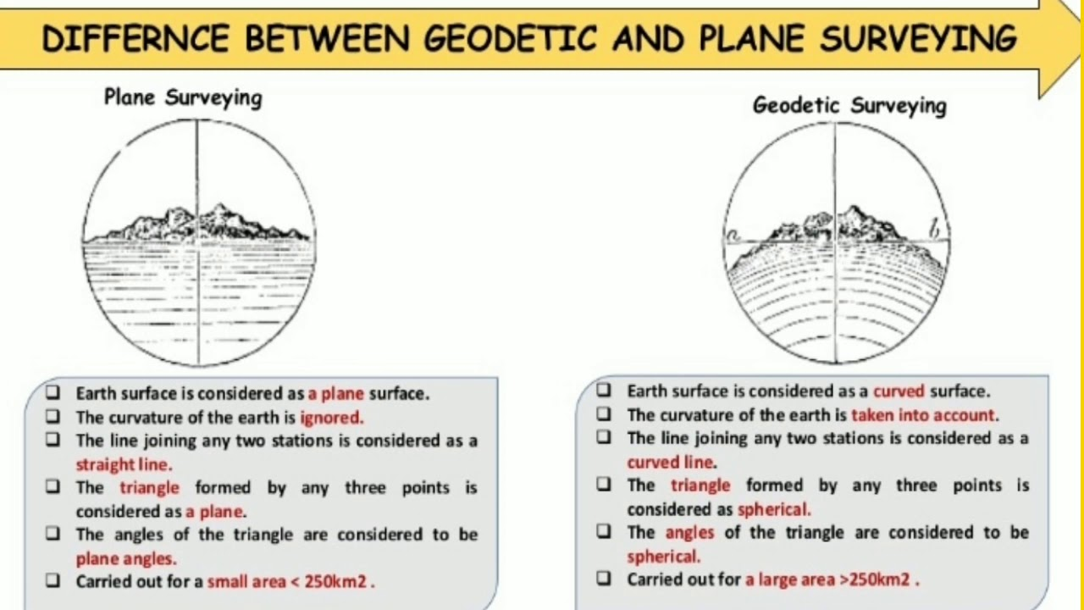
Plain Surveying
- Geodetic surveying - Is a style of surveying in which the outline of the earth is considered. All lines lying in the surface are curved lines and the triangles are spherical triangles. Consequently, it requires spherical trigonometry. (blog, 2020)
Geodetic surveying

5.2 Purpose
There are several reasons why a purpose of a survey would be undertaken. They are as follows:
- To define the relative locations of the existing futures of the ground.
- To outline a clear position of planned structures on the ground.
- To define areas, quantities and volumes.
- To plan a map of the land of detailed out location such as cities, towns, villages and major roads.
- To prepare the engineering detailed plans and sections of several segments which include roads, railways, bridges, dams and other structure.
- To prepare a topographical map showing details of hills, valleys and rivers.

(online, 2022)
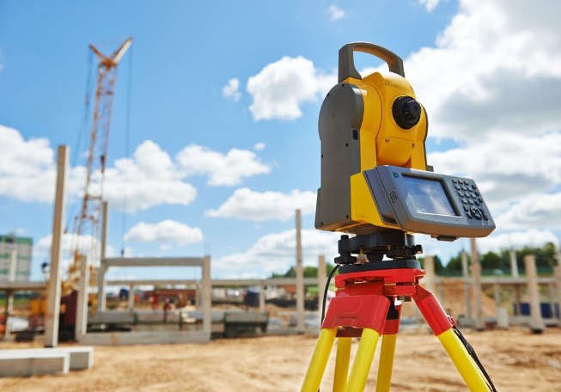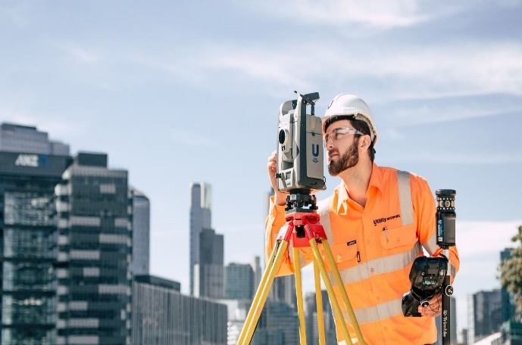
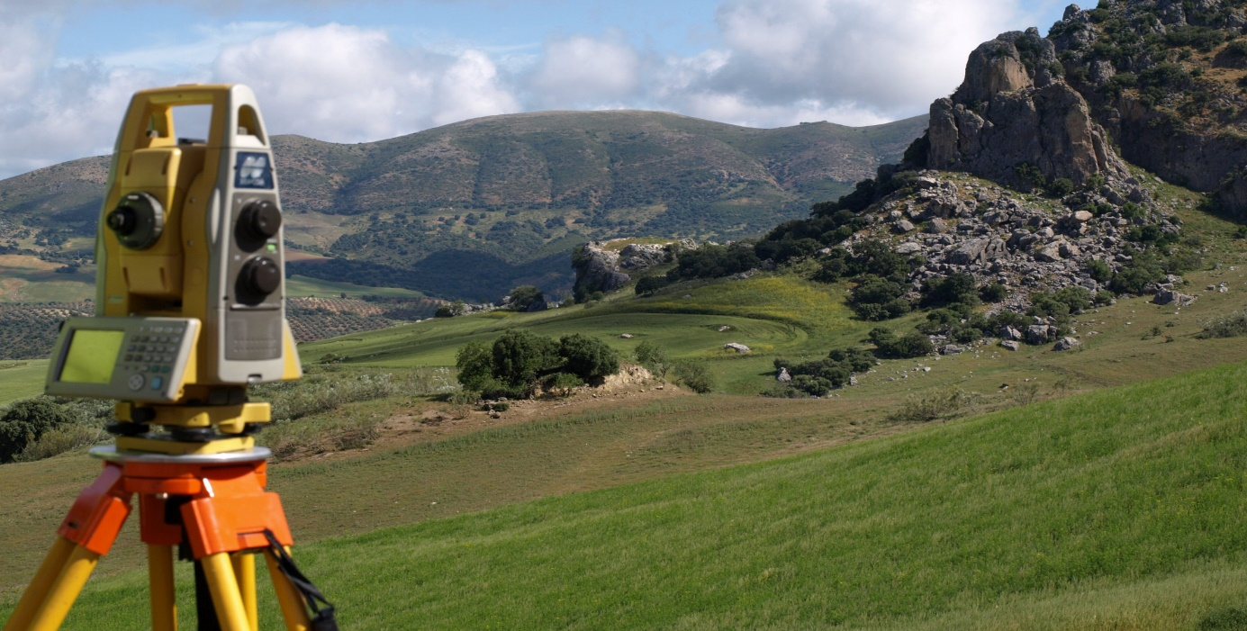

5.3 Method
Based on procedures implemented, surveying can be classified into the following three:
- Triangulation: The tracing and measurement of a succession of triangles in order to determine the distances and relative positions of points spread over an area, particularly by measuring the length of one side of each triangle and deducing its angles and the length of the other two sides by observation from this baseline. (engineers, 2018)
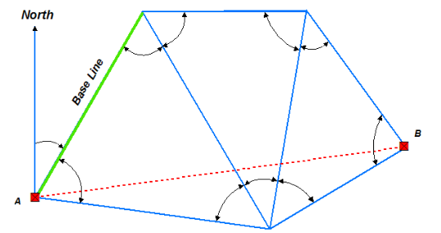
- Traversing: Is a type of survey in which several of attached survey lines form the core and the directions and sections of the survey lines are measured with the help of an angle measuring instrument and tape or chain. The types of traverse surveying are closed and open traverse. (today, 2021)
- Closed traverse: When the lines form a circuit which ends at the starting point. (today, 2021)
- Open traverse: When the lines form a circuit ends elsewhere except starting point. (today, 2021)

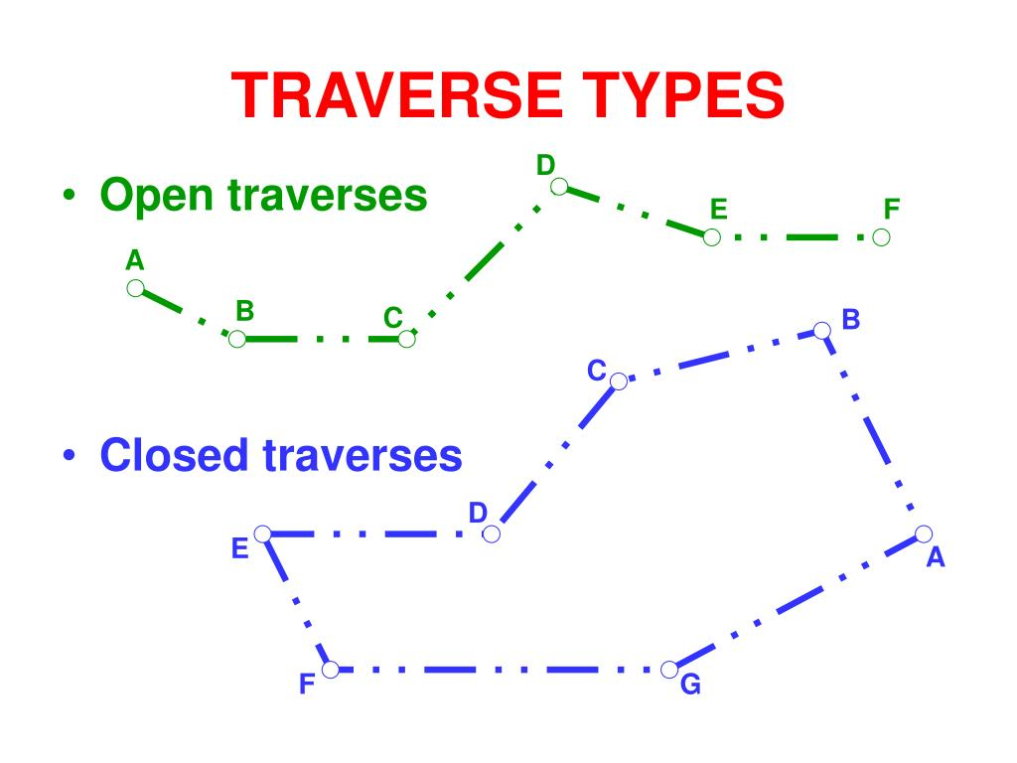
- Trilateration: In which the lengths of the sides of a triangle are measured, mostly by electronic process. From this information gathered the angles are then calculated. By creating a series of triangles next to one another, a surveyor can find additional distances and angles that would not otherwise be quantifiable. (engineers, 2018)
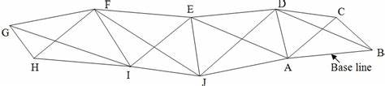

5.4 Equipment (Detailed)
A surveyor use of equipment is to make precise measurements. From defining property boundaries to preparing construction sites, surveyors rely on particular equipment to do their tasks correctly.
Below is a summary of numerous types of surveying equipment and their uses:
Chains and tapes
Taking precise measurements is one of the most vital tasks that surveyor must complete. There is a variety of tools that can be used to take measurements including tapes, rulers, chains, and laser devices. Pocket tapes are ideal for small-scale measurements while measuring wheels, nylon coated steel tape and fiberglass tape measures can be used for larger distances. (equipment, 2022)
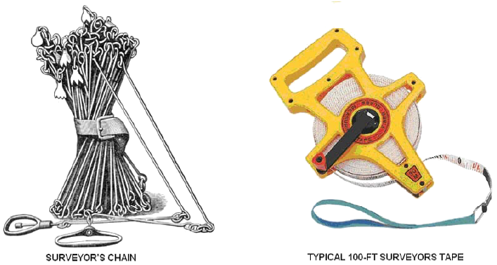
Hammer and peg
Pegs are mainly made from wood. They are used to point out the locations on the ground at station points. A hammer is used to force the peg into the ground. (concepts, 2021)
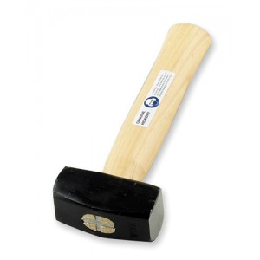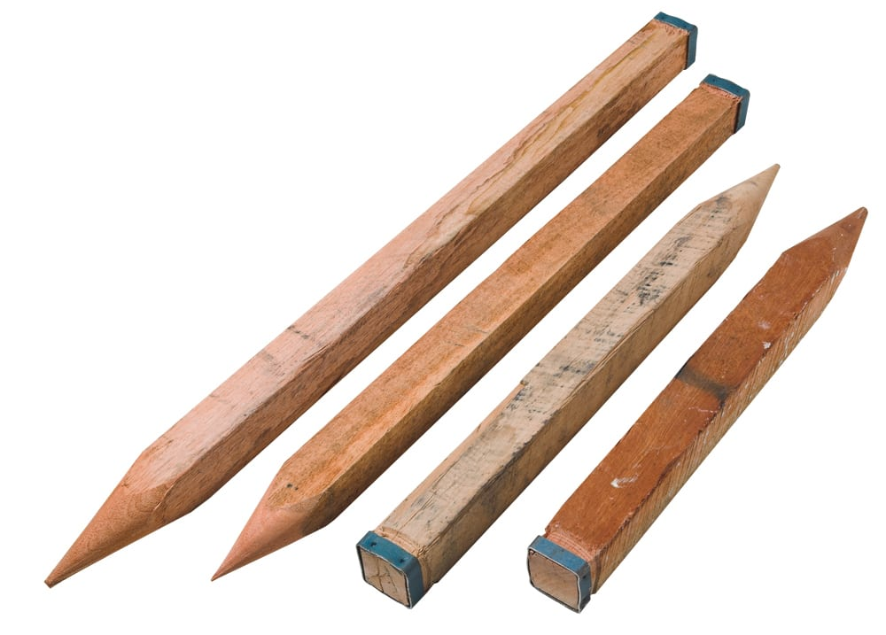

Ranging Rods
Ranging rods are 2-3 metres in length and are coated with alternative bands of two colours (red and white). Each band is kept at a length of 200mm. They are used to range an intermediate point on a survey line. (concepts, 2021)
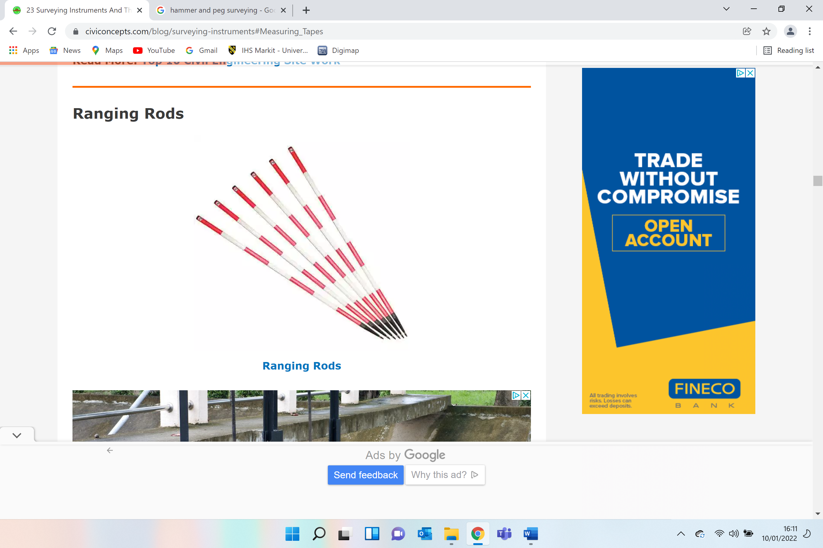
Theodolite
A surveying instrument with a rotational telescope for calculating horizontal and vertical angles to make an exact measurement of areas and triangulate the position of objects in a particular area². (pe, 2022)
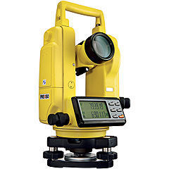

Total Stations
A theodolite that works with electronic engineering to calculate angles and distances and includes an on-board computer to collect data and execute triangulation calculations. This instrument is used to track record features in topographic surveying. (pe, 2022)
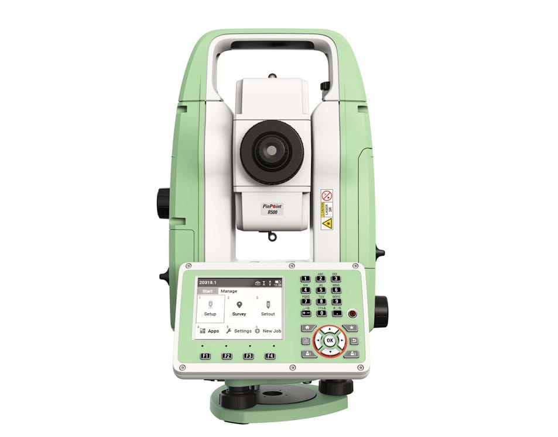
3D Scanners
A surveying instrument that can accurately measure and collect data from objects, surfaces, buildings, and landscapes. This piece of equipment collects information in the form of point cloud data, which consists of millions of 3D coordinates. These coordinates can be used to create 3D computer-aided design (CAD) models, which can then help analyse topographic features and structures. (pe, 2022)
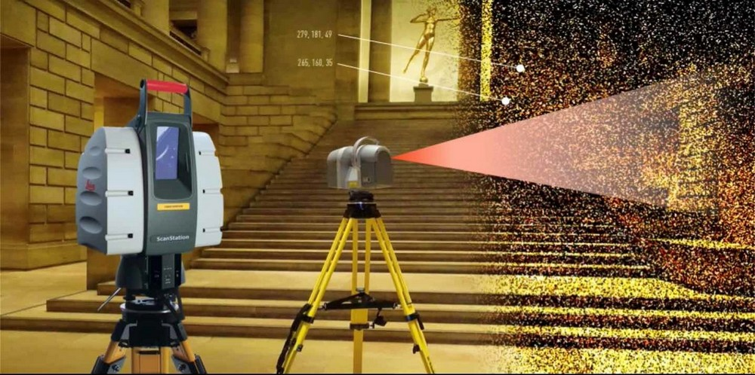

GPS/GNSS
The use of Global Positioning System signals or Global Navigation Satellite System signals via a receiver and antenna to establish the shape, boundary, position, objects or points in space relative to other forms, boundaries, or points. (pe, 2022)
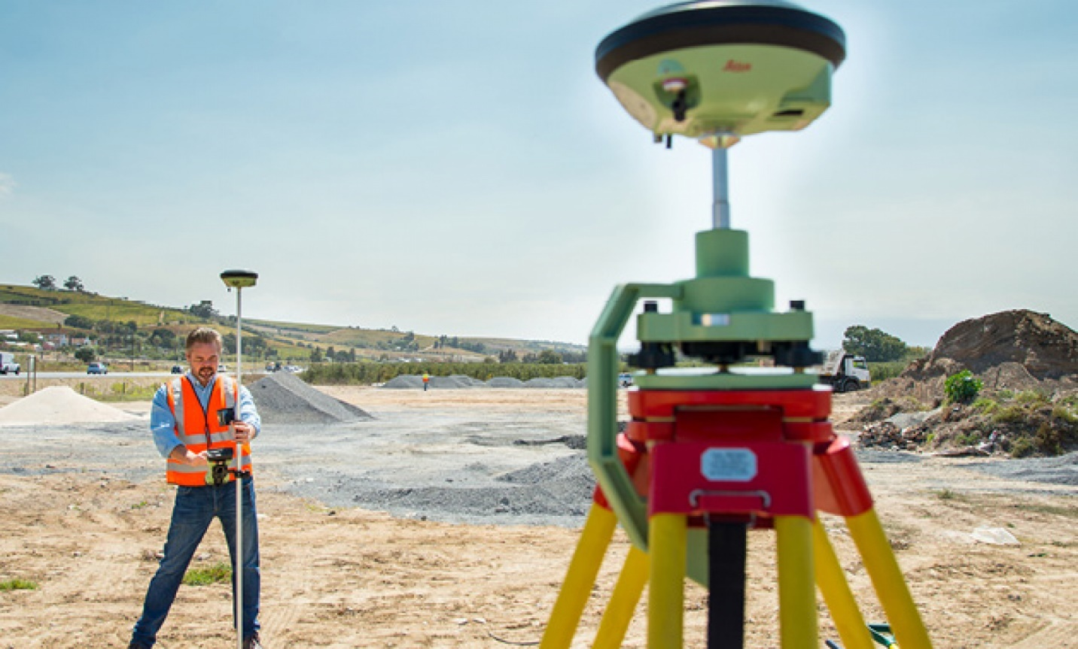

Digital surveying technologies and listed buildings (Part 2)
The planning (Listed Building and Conservation Areas) Act 1990 produces special controls for the demolition, modification or addition of buildings, objects or structures of particular architectural or historic significance.
Listed buildings are added to a register called the List of Buildings of Special Architectural or Historic Interest. There are several reasons why a building could become They are as follows:
- Architectural interest
- Historic interest
- Historic association
- Group value
(buildings, 2021)

There are three categories of listing in England and Wales.
- Grade I: Buildings of exceptional importance
- Grade 2*: Buildings of more than special interest
- Grade 2: Buildings of special interest
(buildings, 2021)
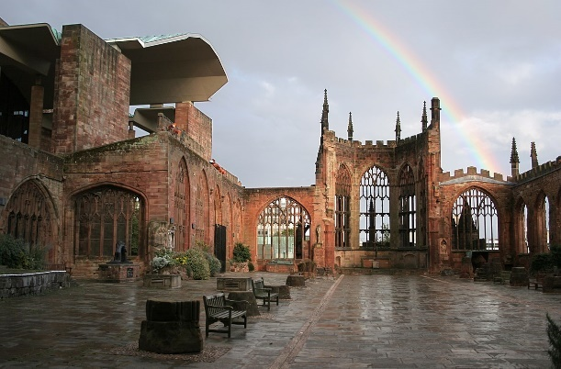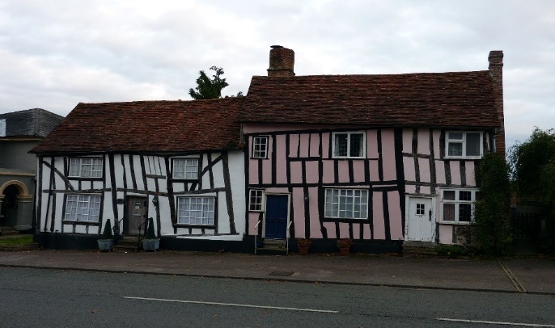
There are several reasons why a building can become listed, but as a general rule, the older a building is, the more likely it is to become listed. The age of a building will have a considerable role in whether it is listed, as this can understandably refer to its importance in regard to its history.
Predominantly, listed buildings will be those which are of special historical, educational or architectural interest or those which are of national importance and have been regarded its importance to keep safeguarded.
Likewise, every building constructed before 1700, surviving in its original condition is listed, alongside most buildings built between 1700 and 1840. As a general rule, a building has to be a minimum of 30 years old to become listed, yet properties built after 1945 will also require careful consideration before being listed.
Figures show that historic England estimates that there are currently around 500,000 listed buildings. (renovations, 2020)
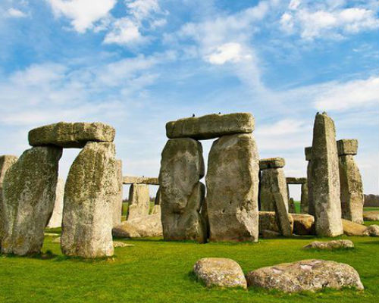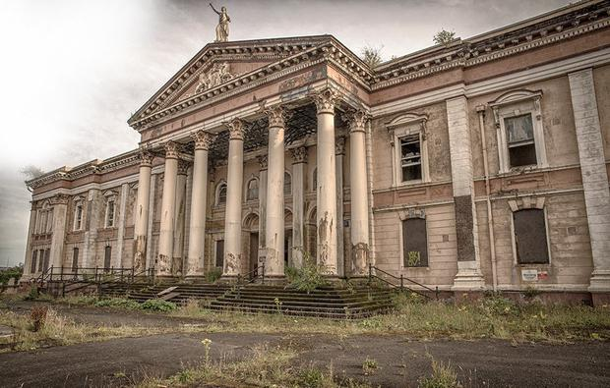

Listed building surveyors are professionals who would advise their clients regarding existing properties or historic properties. In addition, they also suggest the ones under construction. Their advice is on various disciples such as new designs available for a building and extension costs. They are also known as historic building surveyors. Because a considerable part of their work involves researching and analysing, it also includes preserving historic structures by carrying out landmark building surveys. (education, 2022)
Below is a list of the responsibilities of a listed building surveyor:
- Making sure that the construction takes place on time in the given budget
- Valuing an asset
- Scheduled meetings with clients
- Building inspection to look for any faults or damage
- Preparing relevant paperwork such as insurance assessments, tenders and legal notices.
- Advising clients on sustainability and other environmental factors. All of these might affect building designs and construction.
- Advising the health and safety issues associated with a constriction.
(education, 2022)
Below is the contents page of what you would see on a RICS building survey:
- Introduction to the report
- About the inspection
- Overall assessment and summary of condition ratings About the property
- Outside the property
- Inside the property
- Services
- Grounds (including shared areas for flats)
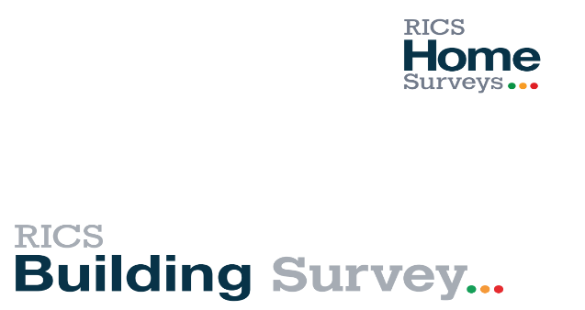
- Issues for your legal advisers
- Risks Energy efficiency
- Surveyor’s declaration
(RICS, 2012)

Equipment in building surveying
- Thermal imaging surveys involve the use of thermal imaging cameras to visually represent surface temperatures of an object in order to identify thermal irregularities that indicate possible defects. Thermographic surveys are typically required for 3 reasons:
- Commissioning of New Equipment/Buildings: Thermography can be used to identify potential defects at the earliest possible stage; enabling remedial works to be carried out before the building or equipment is handed over to the client.
- Maintenance Activities: Thermography can be used as part of a predictive maintenance or condition monitoring programme to identify defects early such that remedial works can be scheduled around business operations preventing unplanned production downtime.
- Fault Diagnosis: Where equipment is suspected of operating under faulty conditions or demonstrating evidence of poor performance, thermography can be used to provide further information which can assist in diagnosing the suspected issue.
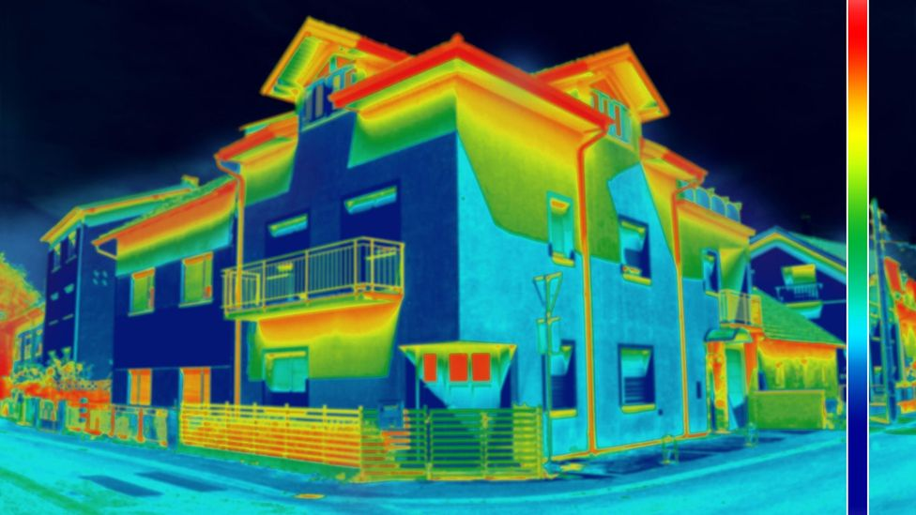
(Red-current, 2021)
- Moisture meter / Protimeter is a premium range of professional moisture measuring instruments. Protimeter is a premium range of professional moisture measuring instruments for surveyors. (Damp-meter, 2021)
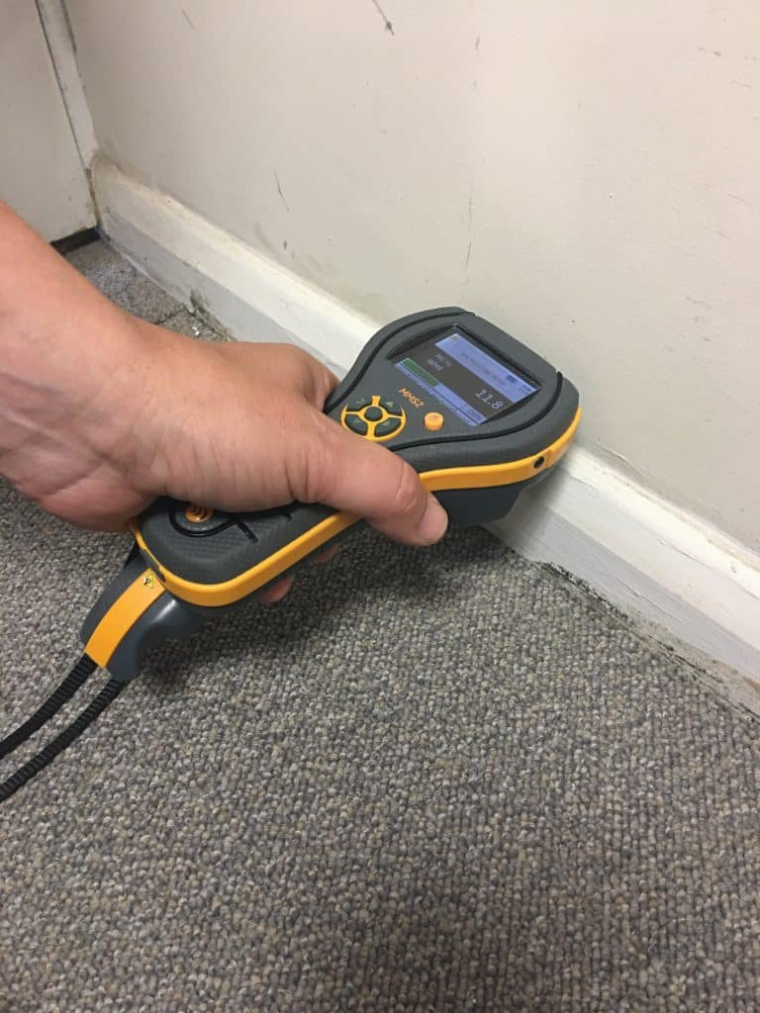

Building survey
A Structural Survey or Building Survey (otherwise known as the Level 3 RICS Survey) is an in-depth assessment of a property. It is the most comprehensive of the surveys available for residential properties and will provide a detailed evaluation of a property’s condition.
The Building Survey report will define the condition of each element of the structure and identify the property’s defects, their apparent cause, the urgency of repair, maintenance options and may also include an approximate cost of repair.
Building Surveys are performed by Building Surveyors. It's important to check that the surveyor you select is regulated by RICS, as they set the guidance for surveyors, and this will ensure that the advice you are getting is independent, professional / skilled advice from appropriately trained experts.
Building Surveys are suitable for all properties, but they are particularly appropriate for:
- Listed Buildings – a building that is on the Statutory List of Buildings of Special Architectural or Historic Interest
- Older Properties – recommended for properties over 50 years old
- Buildings constructed in an unusual way, regardless of age
- Buildings that you intend to renovate or change
- Buildings that have already been renovated or significantly altered
(moving, 2022)
When conducting a survey that the regulations provided below are followed accordingly.
- HASAWA (Health and safety at work act 1974)
- Woking at height regulations 2005
- Control of asbestos regulations 2012
- The construction (design and management) regulations 2015
(WRM, 2018)


References
blog, C. e., 2020. Civil engineering blog. [Online]
Available at: https://civilengineering.blog/2020/01/29/primary-divisions-survey-plane-surveying-geodetic-surveying/
[Accessed 30 12 2021].
buildings, D., 2021. Designing buildings. [Online]
Available at: https://www.designingbuildings.co.uk/wiki/Listed_buildings
[Accessed 10 01 2022].
civiltoday, 2021. What is surveying?. [Online]
Available at: https://civiltoday.com/surveying/13-definition-and-importance-of-surveying
[Accessed 27 12 2021].
concepts, C., 2021. Civi concepts. [Online]
Available at: https://civiconcepts.com/blog/surveying-instruments#Measuring_Tapes
[Accessed 07 01 2022].
Damp-meter, 2021. Damp-meter. [Online]
Available at: http://www.damp-meter-direct.co.uk/what-is-a-protimeter.htm#.YdyD0v7P3SI
[Accessed 10 01 2022].
education, O., 2022. One education. [Online]
Available at: https://www.oneeducation.org.uk/listed-building-surveyor/
[Accessed 10 01 2022].
engineers, W. c., 2018. we civil engineers. [Online]
Available at: https://wecivilengineers.wordpress.com/2018/09/07/classification-of-surveying/
[Accessed 02 01 2022].
equipment, B., 2022. Baseline equipment. [Online]
Available at: https://www.baselineequipment.com/surveying-equipment-types
[Accessed 05 01 2022].
moving, R., 2022. Really moving. [Online]
Available at: https://www.reallymoving.com/surveyors/guides/what-is-a-building-survey-(level-3-survey)
[Accessed 10 01 2022].
online, C. p., 2022. Civil projects online. [Online]
Available at: https://www.civilprojectsonline.com/surveying-and-levelling/purpose-of-surveying-civil-engineering/
[Accessed 2021 12 30].
pe, S. o., 2022. School of pe. [Online]
Available at: https://www.schoolofpe.com/blog/2021/07/six-of-most-common-surveying-instruments.html
[Accessed 08 01 2022].
Red-current, 2021. Red-current. [Online]
Available at: https://www.red-current.com/thermal-imaging-surveys
[Accessed 10 01 2022].
renovations, C., 2020. Concrete renovations. [Online]
Available at: https://www.concreterenovations.co.uk/news/what-are-the-differences-between-grade-i-and-ii-listed-buildings/
[Accessed 10 01 2022].
RICS, 2012. RICS. [Online]
Available at: https://www.rics.org/globalassets/rics-website/media/upholding-professional-standards/sector-standards/building-surveying/building-survey-sample-form-rics.pdf
[Accessed 10 01 2022].
Surveying, W. L., 1999-2000. Wikle Land Surveying. [Online]
Available at: http://wiklelandsurveying.com/content/history.htm
[Accessed 27 12 2021].
today, C., 2021. Civil today - Traverse surveying. [Online]
Available at: https://civiltoday.com/surveying/251-traverse-surveying
[Accessed 03 01 2022].
WRM, 2018. WRM. [Online]
Available at: https://www.workplace-rm.com/716/
[Accessed 10 01 2022].

