Hospitality & Guest Services
Programme: International Hotel Management
Module code: BMIH4003

Assignment Title: The role and importance of quality service, hospitality, and guest services within the hotel Industry

Student Name: Golam Mohammed Polash
Student ID: 2238997
Module Tutor: Charlotte Joyner
Word Count: 1300
Date of Submission: 22 October 2023

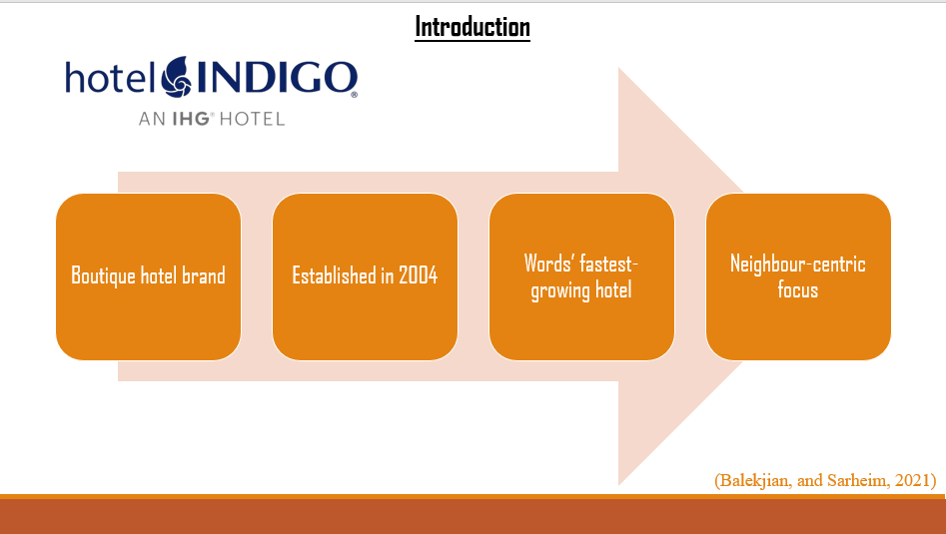
Introduction
Hotel Indigo is a boutique hotel brand that was established in 2004. The headquarters of the hotel is located in Atlanta, Georgia, United States. This is a subsidiary company owned by InterContinental Hotels Group (IHG) and has been operating its business in more than 20 countries in more than 130 locations. The hotel is one of the fastest-growing hotels in the world and has earned an operating profit of $919 million in 2022 which is higher than the pre-pandemic situation (Balekjian, and Sarheim, 2021). The hotel has developed personalised services so effectively that it differs the hotel from other largest and fast-growing hotels in the world. Additionally, a neighbour-centric focus has made the hotel popular in different regions.

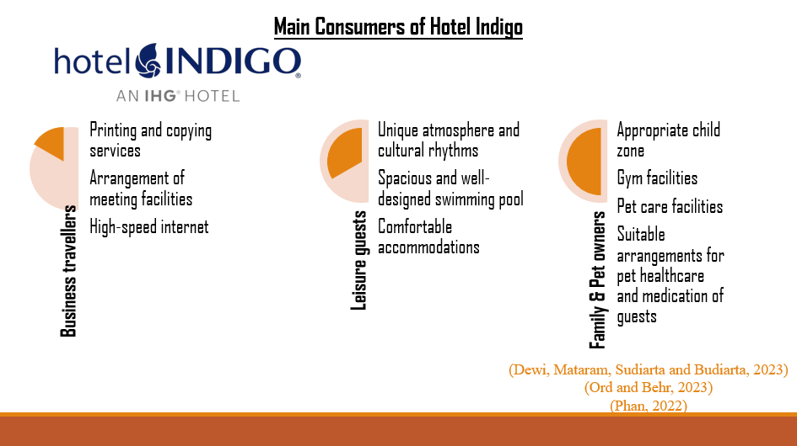

Main consumers of the hotel
Some travellers show their interest in spending their time for various reasons. The satisfaction rate of the consumers is also lucrative where 90% of guests said that they would recommend the brand to others. Among the travelling groups, business travellers are one of the key consumers or gusts. Business travellers group stay 2.5 nights on average (Dewi, Mataram, Sudiarta, and Budiarta, 2023). The hotel provides several benefits to the business travellers group including printing and copying services, arrangement of meeting facilities, high-speed internet and many more. On the other hand, leisure guests are another big group of guests. This group of guests usually stay in the hotels of Hotel Indigo at the seasonal time in different regions (Ord and Behr, 2023). They stay 3 nights on average. They come to visit to spend vacations with family and friends. The hotel is popular with leisure guests as they can experience a unique atmosphere and cultural rhythms which will not be found anywhere else. Additionally, the hotel also offers various amenities for this group of guests such as a spacious and well-designed swimming pool and gyms, comfortable accommodations, local food and beverages and many more. The hotel also provides cordial reception for pet owners and groups of guests as well. It helps enhance the customer loyalty among the pet lovers. Only 30% of hotels in the US are pet-friendly and Hotel Indigo is one of them (Phan, 2022). The solo travellers' group is another growing group for Hotel Indigo. The hotel analyses data of the different groups of guests and understands what they are looking for. The hotel personalises its offerings to make all groups satisfied. That is why the hotel has become one of the most appealing hotels to their guests.

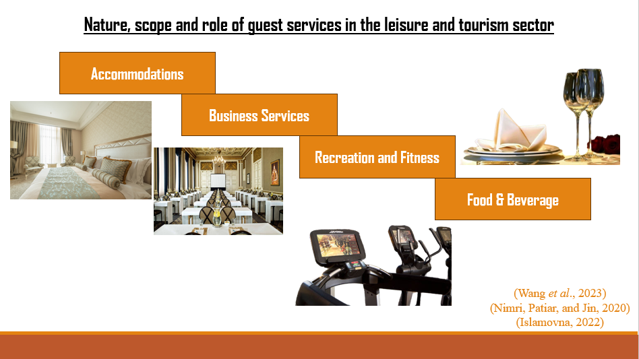Nature, scope and role of guest services in the leisure and tourism sector
The role of guest services among hotels worldwide does not satisfy the needs of different groups of guests properly. As part of this, they distinguish the needs of different groups and try to develop their Manu based on the distinguished groups. Different groups need different types of services and amenities. For example, the needs of leisure guests are not similar to the needs of business groups (Wang et al., 2023). That is why they play a vital role by distinguishing the expectations of different groups and offering them by personalising. The nature, scopes and roles vary based on the type, size, and location of the hotels. There are some common scopes of hotels which are:
Accommodations: All types of hotels try to bring some uniqueness to their room facilities including furniture, aesthetic shower rooms developed by some aesthetic shower equipment and sinks. Accommodations help the hotels to make the facilities appealing to the guests (Nimri, Patiar, and Jin, 2020).
Business services: Business services include all the facilities that satisfy the needs of business professionals for conferences, meetings and many more. Business services include suitable rooms for meeting arrangements including formal and aesthetic there.
Recreation: Most of the largest hotels in the world consider the creation and fitness of the guests. For the purpose of making recreation more effective for the guests, most of the hotels offer fitness centres and gyms which attract guests who are health conscious (Islamovna, 2022). Additionally, to enhance the recreation level among the guests, some hotels recruit local guides who are acquainted with the local visitors and creation centres.
Food and beverage: It is another interesting part of hotel guests. Most of the hotels try to keep variations in this offering.

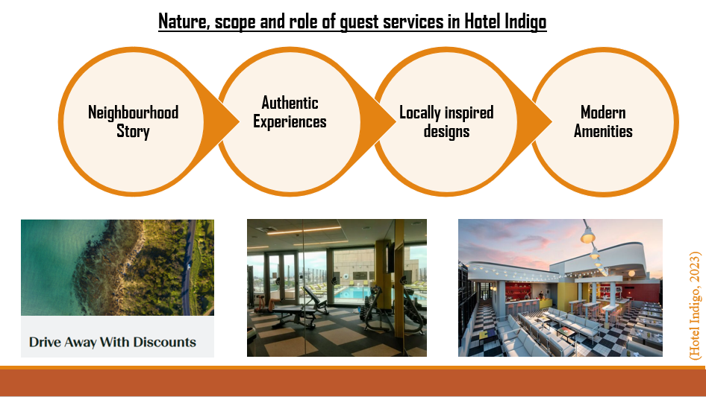Nature, scope and role of guest services in Hotel Indigo
Neighbourhood story, authentic experience and locally inspired designs are the nature of Hotel Indigo which align the purpose of the hotel with largest hotels in the world. The scopes are also different in Hotel Indigo. For example, Comfortable and stylish furniture, hardwood floors, and modern amenities have made the hotel unique in terms of accommodation (Hotel Indigo, 2023). For example, the type of spa service varies from location to location of the hotel. The hotel has fitness, gyms and spa which also attract the guests significantly. Additionally, child zone also attracts family guests. The hotel provides a secretarial room for business guests. Additionally, all the common services are available in this hotel. All the things mentioned aforesaid play a vital role for satisfying guests by meeting their demands.

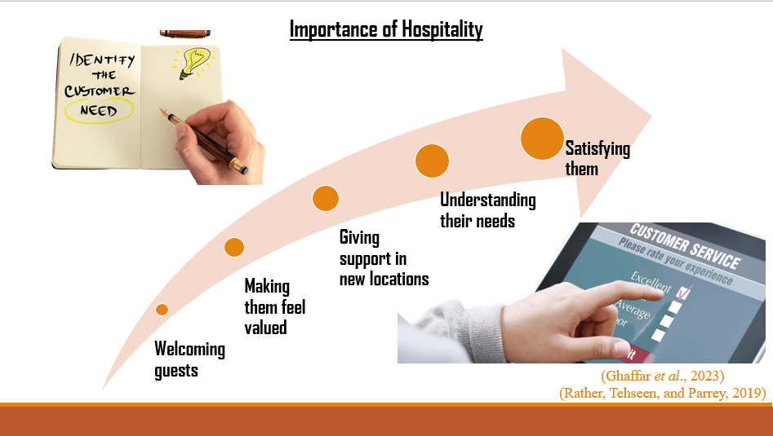Importance of Hospitality
Hospitality has a huge importance in welcoming guests and making them feel valued. When tourists or visitors go to a new location, they usually do not find anything acquainted there. The hospitality sector provides them with a warm reception and provides them fundamental support for their stay. Another importance of hospitality is to create customer satisfaction (Ghaffar et al., 2023). By identifying the various needs of various groups of visitors, the hospitality sector offers them personalised services to make them. Additionally, hospitality plays a vital role in distinguishing a hotel from others by developing some exclusive offerings (Rather, Tehseen, and Parrey, 2019). For example, Hotel Indigo provides dive-away service at a discount rate.

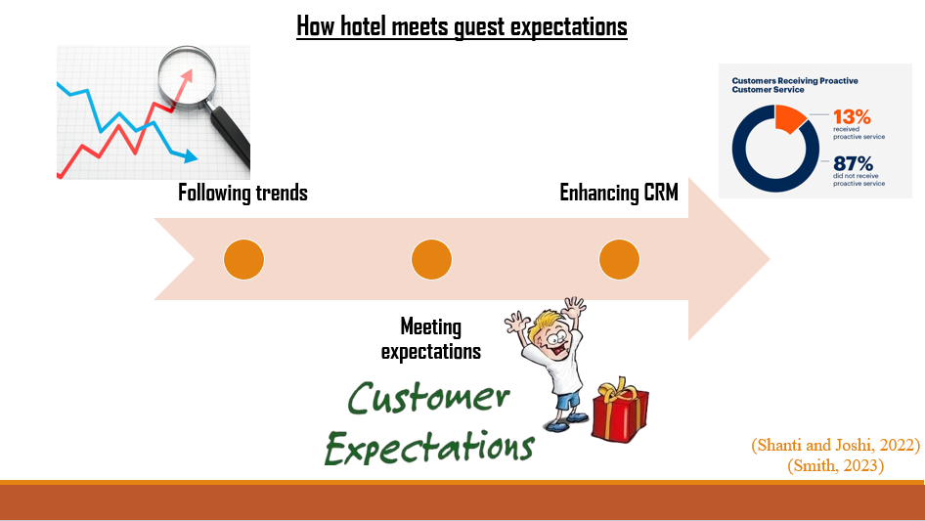

How hotel meets guest expectations
There are several ways hotels meet guest expectations. Providing excellent customer service is one of them. Customers can contact the company regarding various services and offers through the company website and hotline. Additionally, providing a comfortable environment is another one. A suitable environment is provided to different types of guests in hotels (Shanti and Joshi, 2022). Personalising the experiences for guests is also another significant way to meet the expectations of the customers. However, to meet the expectations of customers, the largest hotels in the world find out the trends of customers and design services accordingly (Smith, 2023).

Conclusion
There are various types of guests who visit various hotels and their expectations are also different. Hotels are to satisfy the customers by fulfilling their needs. That is why they categorise the group of customers and identify common expectations of each group of guests. They develop their offerings in various scopes such as accommodations, business services and many more. All of the activities play a vital role in satisfying the guests by meeting expectations.

References
Balekjian, and Sarheim, (2021). Boutique Hotels Segment. New York. HVS Global Hospitality Service.
Dewi, Mataram, Sudiarta, and Budiarta, (2023). Implementation of Green Practices in Improving Service Quality of Food & Beverage Department at Hotel Indigo Bali Seminyak Beach. International Journal of Glocal Tourism, 4(2), pp.111-122.
Ghaffar et al., (2023). Does CSR influence sustained competitive advantage and behavioral outcomes? An empirical study in the hospitality sector. Journal of Global Scholars of Marketing Science, 33(1), pp.107-132.
Hotel Indigo (2023) About us: Hotel indigo, IHG. Available at: https://www.ihg.com/hotelindigo/content/us/en/about-us (Accessed: 18 October 2023).
Islamovna, (2022). Development of tourist and recreational cluster of Samarkand region and its impact on domestic business. European Multidisciplinary Journal of Modern Science, 4, pp.39-44.
Nimri, Patiar, and Jin, (2020). The determinants of consumers’ intention of purchasing green hotel accommodation: Extending the theory of planned behaviour. Journal of Hospitality and Tourism Management, 45, pp.535-543.
Ord and Behr, (2023). Curating the music city: The accommodation sector in Glasgow’s music tourism ecology. Tourist Studies, p.14687976231177963.
Phan, (2022). Communication campaign for Rin Rin Pet Care (Doctoral dissertation, FPTU HCM).
Rather, Tehseen, and Parrey, (2019). Customer brand identification, affective commitment, customer satisfaction, and brand trust as antecedents of customer behavioral intention of loyalty: An empirical study in the hospitality sector. Journal of Global Scholars of Marketing Science, 29(2), pp.196-217.
Shanti and Joshi, (2022). Examining the impact of environmentally sustainable practices on hotel brand equity: a case of Bangalore hotels. Environment, Development and Sustainability, 24(4), pp.5764-5782.
Smith (2023) The ultimate 2023 guide to elevating guest satisfaction, Amadeus Hospitality. Available at: https://www.amadeus-hospitality.com/guest-satisfaction/ (Accessed: 18 October 2023).
Wang et al., (2023). Determinants and mechanisms driving energy-saving behaviours of long-stay hotel guests: Comparison of leisure, business and extended-stay residential cases. Energy Reports, 9, pp.1354-1365.

