Combinational Circuits
Combinational Logic Circuits are circuits in which the output at any time depends upon the combination of the input signals present at that instant only, and does not depend upon the past conditions.
Combinational logic circuits output depends only on the present input and it does not depend on the past input or output.
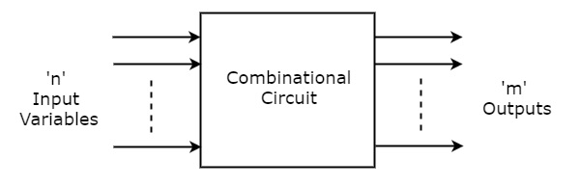
The Following are the most important Combinational Circuits
- Adders
- Subtractors
- Comparators
- Decoders
- Encoders
- Multiplexer
- Demultiplexer
- Parity Generator/ Parity Checker
- Code Converters
Procedure to design combinational Circuits.
Any combinational circuits can be designed by following the design procedure given below
- From the word description of the problem, identify the inputs and outputs and draw a block diagram
- Draw the truth table such that it completely describes the operation of the circuit for different combinations of inputs.
- Write down the switching expressions for the outputs
- Simplify the switching expressions for the outputs
- Implement the simplified expression using logic gates.

Adders
Half –Adders
The simplest combinational circuit which performs the arithmetic addition of two binary digits is called a Half –adder.
The half- adder has two inputs A and B and two outputs are Sum (S) and Carry (C)
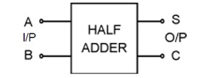
Truth table
Inputs |  | Outputs
A | B | CARRY(C) | SUM (S)
0 | 0 | 0 | 0
0 | 1 | 0 | 1
1 | 0 | 0 | 1
1 | 1 | 1 | 0
Design of half adder using K-Map
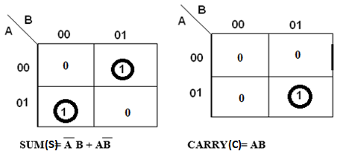

Logic Diagram
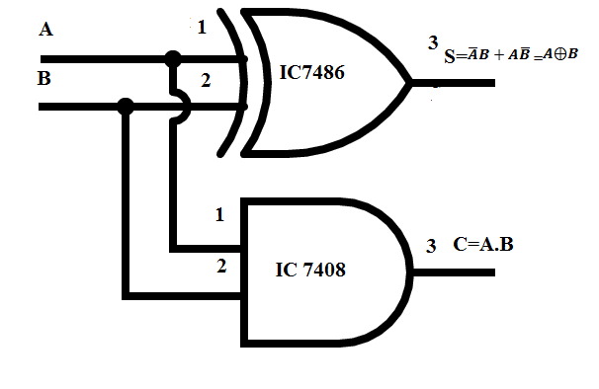
Disadvantage:
A half – adder has only two inputs and there is no provision to add a carry coming from the lower order bits when the multibit addition is performed.
Full adder:
Full adders is a combinational circuit that performs the arithmetic sum of three input bits and produces two outputs sum and carry out (C_{out}).
Logic symbol:
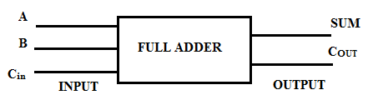
TRUTH TABLE:
INPUTS |  |  | OUTPUTS
A | B | C_{in} | C_{out} | SUM
0 | 0 | 0 | 0 | 0
0 | 0 | 1 | 0 | 1
0 | 1 | 0 | 0 | 1
0 | 1 | 1 | 1 | 0
1 | 0 | 0 | 0 | 1
1 | 0 | 1 | 1 | 0
1 | 1 | 0 | 1 | 0
1 | 1 | 1 | 1 | 1

K- Map for sum and carry
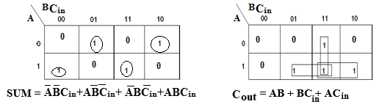
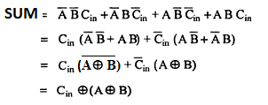
C_{out} = $AB+BC_{in}+AC_{in}$
= $AB\left(C_{in}+\overline{C_{in}}\right)+(A+\overline{A})BC_{in}+A(B+\overline{B})C_{in}$
= $ABC_{in}+AB\overline{C_{in}}+ABC_{in}+\overline{A}BC_{in}+ABC_{in}+A\overline{B}C_{in}$
= $ABC_{in}+AB\overline{C_{in}}+\overline{A}BC_{in}+A\overline{B}C_{in}$
= $ABC_{in}+AB\overline{C_{in}}+C_{in}(\overline{A}B+A\overline{B})$
= $AB{(C}_{in}+\overline{C_{in}})+C_{in}(A⊕B)$
C_{out} = $AB+C_{in}(A⊕B)$

Logic diagram
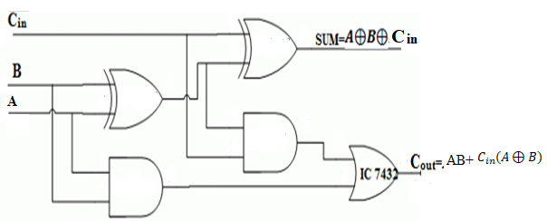
Full adder is a combination of two half adders
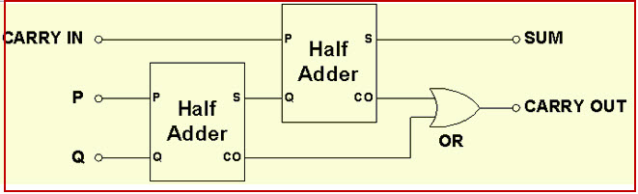

Half Subtractor
The Half –subtractor is a combinational circuit which is used to perform subtraction of two bits. It has two inputs A and B. It has two outputs Difference (D) and Borrow (B)
Logic symbol
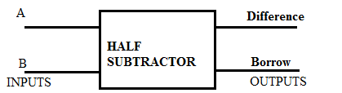

TRUTH TABLE:
INPUTS |  | OUTPUTS
A | B | BORROW | DIFFERENCE
0 | 0 | 0 | 0
0 | 1 | 1 | 1
1 | 0 | 0 | 1
1 | 1 | 0 | 0

K-Map for DIFFERENCE and BORROW:
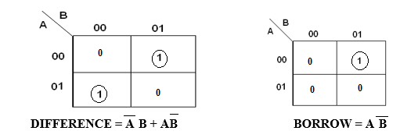
Logic diagram
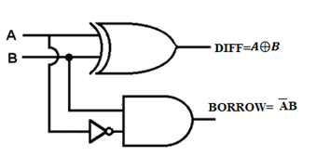
Disadvantage:
The Borrow cannot be considered while doing the second bit subtraction
Full subtractor:
Full subtractor is a Combinational Circuit that performs subtraction involving three bits, namely A, B and Borrow in (B_{in}). It has two outputs Difference (D) and Borrow out (B_{Out})
Logic symbol
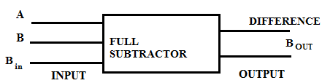
TRUTH TABLE:
INPUTS |  |  | OUTPUTS
A | B | B_{in} | B_{out} | DIFFERENCE
0 | 0 | 0 | 0 | 0
0 | 0 | 1 | 1 | 1
0 | 1 | 0 | 1 | 1
0 | 1 | 1 | 1 | 0
1 | 0 | 0 | 0 | 1
1 | 0 | 1 | 0 | 0
1 | 1 | 0 | 0 | 0
1 | 1 | 1 | 1 | 1

K-Map for Difference and borrow:
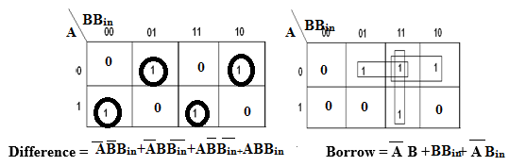
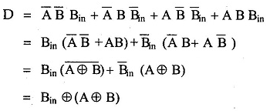
B_{out} = $\overline{A}B+BB_{in}+\overline{A}B_{in}$
= $\overline{A}B\left(B_{in}+\overline{B_{in}}\right)+(A+\overline{A})BB_{in}+\overline{A}(B+\overline{B})B_{in}$
= $\overline{A}BB_{in}+\overline{A}B\overline{B_{in}}+ABB_{in}+\overline{A}BB_{in}+\overline{A}BB_{in}+\overline{A}\overline{B}B_{in}$
= $\overline{A}BB_{in}+\overline{A}B\overline{B_{in}}+ABB_{in}+\overline{A}\overline{B}B_{in}$
= $\overline{A}BB_{in}+\overline{A}B\overline{B_{in}}+B_{in}(AB+\overline{A}\overline{B})$
= $\overline{A}B{(B}_{in}+\overline{B_{in}})+B_{in}(\overline{A⊕B})$
C_{out} = $\overline{A}B+B_{in}(\overline{A⊕B})$
Logic diagram
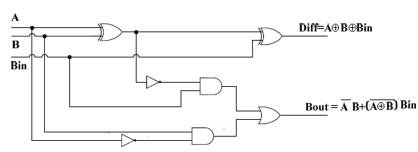
Full subtractor is a combination of two half subtractor
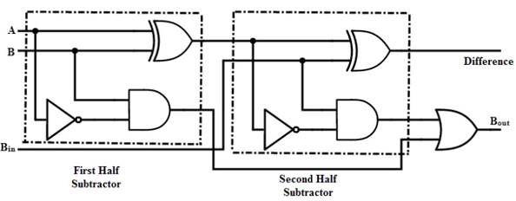
Parallel binary adder
A single full adder performs the addition of two one bit numbers and an input carry. But a Parallel Adder is a digital circuit capable of finding the arithmetic sum of two binary numbers that is greater than one bit in length by operating on corresponding pairs of bits in parallel. It consists of full adders connected in a chain where the output carry from each full adder is connected to the carry input of the next higher order full adder in the chain. A n bit parallel adder requires n full adders to perform the operation. So for the two-bit number, two adders are needed while for four bit number, four adders are needed and so on.
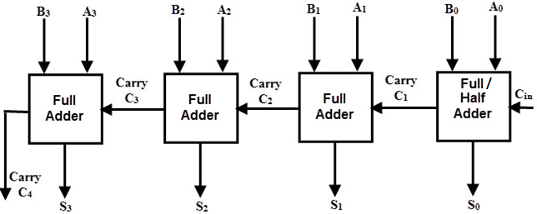

Working of parallel Adder
- As shown in the figure, first the full adder FA0 adds A0 and B0 along with the carry Cin to generate the sum S0 (the first bit of the output sum) and the carry C0 which is connected to the next adder in chain.
- Next, the full adder FA1 uses this carry bit C1 to add with the input bits A1 and B1 to generate the sum S1(the second bit of the output sum) and the carry C1 which is again further connected to the next adder.
- Next, the full adder FA2 uses this carry bit C2 to add with the input bits A2 and B2 to generate the sum S2(the third bit of the output sum) and the carry C2 which is again further connected to the next adder in chain and so on.
- The process continues till the last full adder FAn uses the carry bit Cn to add with its input An and Bn to generate the last bit of the output along last carry bit Cout.

Parallel Binary subtractor
A Parallel Subtractor is a digital circuit capable of finding the arithmetic difference of two binary numbers that is greater than one bit in length by operating on corresponding pairs of bits in parallel. The parallel subtractor can be designed in several ways including combination of full subtractors,
For designing a 4 bit parallel subtractor we need 4 full subtractors.
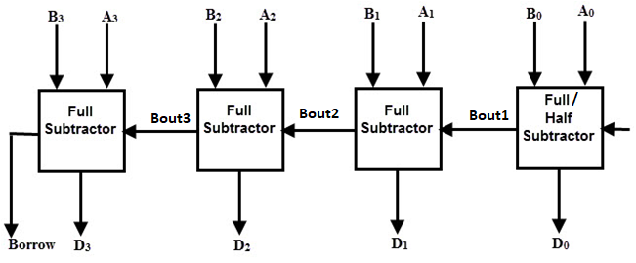
Working of parallel Subtractor –
- As shown in the figure, first the full subtractor FS0 subtracts A0 and B0 along with the Borrow (Bin) to generate the D0 (the first bit of the output Difference) and the Borrow Bout0 which is connected to the next adder in chain.
- Next, the full Subtractor FS1 uses this Borrow bit Bout1 to Subtract with the input bits A1 and B1 to generate the difference D1(the second bit of the output difference) and the Borrow Bout1 which is again further connected to the next adder.
- Next, the full Subtractor FS2 uses this Borrow bit Bout2 to Subtract with the input bits A2 and B2 to generate the difference D2(the thirs bit of the output difference) and the Borrow Bout2 which is again further connected to the next adder and so on
- The process continues till the last full subtractor FSn uses the Borrow bit Boutn to subtract with its input An and Bn to generate the last bit of the output along last Borrow bit Bout.

4 bit Parallel adder /subtractor
In Digital Circuits, a Binary Adder-Subtractor is one which is capable of both addition and subtraction of binary numbers in one circuit itself. The operation being performed depends upon the binary value the control signal holds. It is one of the components of the ALU.
Lets consider two 4-bit binary numbers A and B as inputs to the Digital Circuit for the operation with digits.
The circuit consists of 4 full adders since we are performing operation on 4-bit numbers. There is a control line K that holds a binary value of either 0 or 1 which determines that the operation being carried out is addition or subtraction. If the control input is 1, it performs Subtraction. If the control input is 0, It performs Addition (i.e, control input =1 (Subtraction) Control input =0 (Addition ).
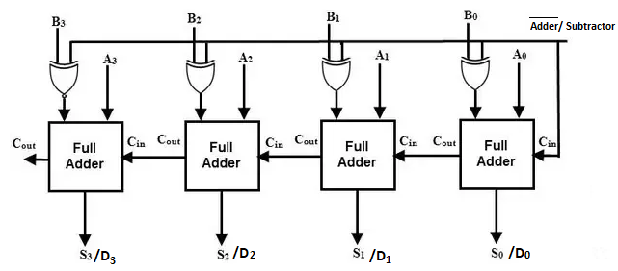
Adder (Control input =0)
If the control input is 0, it performs Binary addition.
An example is given below (1111+0001=1 0000)
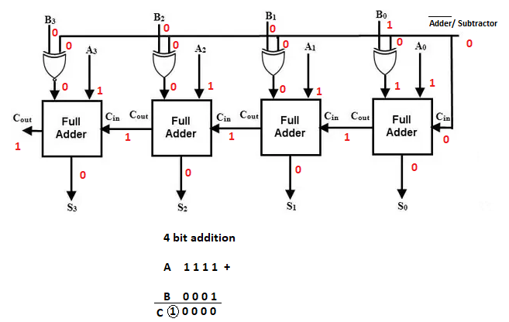
Subtractor (Control input =1)
If the control input is 1, it performs Binary Subtraction.
An example is given below (1111-0001=1110)



