Research in action ECP5006
Portfolio of competences
Reia Sigrist (2219662)

Contents
Reflective log 2
Competency one: Applied Research – Completion of Research Proposal 6
Competency Two: Applied Research – Ethical Considerations – Ethics Form Completion 15
Competency Three: Applied Research – Qualtrics Study Creation 32
Reference list 41
Appendix 43

Reflective log
As part of the Research in Action module, I had the opportunity to work as part of a research team to explore the intricacies of the Psychology of gender bias. We were tasked with designing and implementing two small-scale research studies, one quantitative and one qualitative, to delve deeper into this critical societal issue. Collaborating with my teammates, we navigated through the complexities of study design, data collection, and analysis. Our primary aim was to comprehensively understand the intricate aspects of gender bias and its psychological underpinnings. We quickly choose our study topic area of gender bias towards women in STEM (Science, Technology, Engineering and Mathematics) being a topic we had studied previously and felt confident to apply the knowledge we had gained. Throughout this experience, I gained a profound appreciation for the importance of thorough research methodologies and the significance of gender bias in our world. It was challenging yet immensely rewarding endeavour that has left me with a renewed commitment to understand and address this important topic. This reflective log serves as a thoughtful examination of our group study project by exploring personal growth, challenges faced, and lessons learned.
At the outset, I was both excited and a little anxious, uncertain about how the process would unfold. We were supported throughout the module with regular feedback and advice when needed which helped to improve our understanding and performance (London, 2014). I thoroughly enjoyed the independent learning aspect of this module and found it both a rewarding and empowering experience (Moore, 1973; Kingsbury, 2015). As we delved into designing and conducting the research studies, my feelings oscillated between moments of frustration and excitement. It was eye-opening experience that highlighted the complexities of gender bias, the importance of thorough research, and what goes into planning and implementing a research project. Working as a team allowed diverse perspectives, but it also required effective communication and compromise. In the end, the project left me with a profound sense of accomplishment, a better understanding of the subject, and an appreciation for the collaborative efforts necessary to tackle such an important issue.
Reflecting on the experience of our group project, there were both positive and challenging aspects. My main role was the organiser of our group, I took it upon myself to manage and organise our team efforts, which involved planning and scheduling, distributing tasks, and ensuring that we remained on track to meet our objectives (See appendix 1). This role allowed me to facilitate effective communication within the group, encouraging the exchange of diverse perspectives and ideas. Leading the team was rewarding and out of my comfort so challenged me, including when some members didn't stay updated on our shared document, causing confusion about their tasks (Forrester & Tashchian, 2010). We resolved this by holding weekly in-person meetings to reinforce the importance of the document as a central information source. We encountered several challenges during our project, including a team member joining late. However, we swiftly addressed this issue by helping her catch up with the work and providing necessary resources which was all on the shared document. Another significant challenge was the need to change our study multiple times, which led to the arduous task of revising proposals and ethics forms to align with the new study plan. This required a great deal of adaptability and patience, and I learned to be flexible, prioritise clear communication, and streamline the modification process to ensure that our research remained on track despite the hurdles. Yet, these challenges helped me grow as a team player and adapt to unforeseen obstacles (Driskell et al., 2006).
Analysing the situation of our group project presented a multifaceted challenge. Designing and executing the two small-scale research studies demanded meticulous planning and flexibility. It was evident that research is an ever-evolving process, requiring adjustments and iterations to align with the ever-changing dynamics of the subject matter (Gauch, 2003). Our group dynamics revolved around a multifaceted communication strategy that ensured our collaborative efforts were cohesive and efficient (Kozlowski & Ilgen, 2006). We used a shared Word document to track progress and relay important messages, allowing for structured and centralised information exchange and eventually changed to Microsoft Teams. For more immediate matters, the WhatsApp group served as a quick and convenient platform. Weekly meetings, on the other hand played a crucial role in synchronising our progress and offering support to anyone facing challenges. This constant communication system allowed us to consult each other when we encountered difficulties, fostering a sense of unity and shared responsibility in our research endeavour. Challenges emerged when members struggled to maintain consistency in their contributions, but regular check-ins and clear role assignments helped mitigate these issues (See appendix 1). The experience reinforced successful research not only depends on robust methodologies but also the ability to navigate unexpected hurdles and collaborate effectively within a team.
In conclusion, the group project was an invaluable learning experience that both challenged and bolstered me. I came to appreciate the intricate nature of research, the significance of teamwork, and the persistence needed to navigate unforeseen challenges. In retrospect, I recognise the importance of early project planning to mitigate the need for frequent revisions and better time management for a more efficient workflow. This experience not only enhanced my academic growth but also nurtured my ability to work effectively in a team, improving my communication and project management skills. This project reinforced that tackling complex societal issues requires continuous adaption and a commitment to producing rigorous research. Unexpectedly, I learned the importance of resilience and adaptability when faced with research plan changes, which strengthened my problem-solving capabilities and discovering a previously untapped aptitude for leadership, despite my lack of prior experience in such a role. Overall, this project significantly enriched my academic and personal development, equipping me with a more comprehensive toolkit for future endeavours.
In light of this experience, I’ve outlined an action plan for approaching similar situations in the future. First and foremost, I will prioritise early comprehensive project planning to reduce the need for frequent adjustments. I intend to allocate more time to thoroughly understand the intricacies of the research topic from the outset. This proactive approach will enable me to anticipate potential challenges and adjustments more effectively. Considering my unexpected proficiency in leadership, I plan to actively seek out leadership roles in future projects. My experience has shown that stepping into leadership roles can be a valuable asset, and I’m committed to embracing and refining this newfound ability in future endeavours. This project has highlighted the importance of adaptability and diligence, and I am committed to implementing these changes in my future research endeavours, ensuring a more streamlined and effective approach to complex research projects.

Competency one: Applied Research – Completion of Research Proposal



Research Proposal – Study 2 – Super Labs

Research proposal (1,000 words overall)
Student Name and University ID number: | Reia Sigrist (2219662)  The research proposal form was completed by me and another team member. We decided to split the word count down the middle with us both completing 500 words of 1000 word total. My team member completed the methodological section, and I did all other sections of the form.  Harriet Adams (2219657)  Afsana Begum (2204410)  Marisa Pinto (2203596)
Proposed Supervisor’s name: | Only complete this if you have already been in contact with a potential supervisor who has agreed to supervise you in principle.  Katie Sullivan and Paul Hutchings
Psychology Research Area (tick all that apply)
  Social Psychology | Developmental Psychology | Biological Psychology | Forensic Psychology
Health Psychology | Individual Differences | Educational Psychology | Political Psychology
Cognitive Psychology | Clinical Psychology | Counselling Psychology | Occupational Psychology
Other: indicate briefly (not included in word count)

Proposed Study Design (tick all that apply)
Quantitative | Experimental | Applied (with UWTSD students | Online Questionnaire Survey
Qualitative | Quasi Experimental | Focus Groups | Online
Mixed Methods | Applied (with external organisation) | Interviews | Lab-based study
If Applied, and involving an external organisation, please indicate your plans for gaining appropriate approvals from the organisation: (not included in the word count) |  | Other study design: indicate briefly (not included in word count)

Suggested Research Title/Area: (between 10-15 words and must reflect the essence of your proposed research question, study design and study population and should be more specific than a broad topic area).
Exploring Gender Bias: An Attitudes Towards Women Scale approach to assessing sexist behaviours and attitudes to women in STEM.
I was tasked with formulating a research title that would reflect the essence of the proposed research question succinctly. Several titles were proposed, but this title met APA standards, fulfilled criteria, and gained team approval.

Background: 250 words
Why is your study important? What theory and empirical research evidence supports your research question? (Please provide a rationale for your study including a brief review of relevant psychological literature and theory and a minimum of five references).
In recent years, there has been growing recognition of the persistent gender disparities in professional settings, particularly in Science, Technology, Engineering, and Mathematics (STEM) fields (e.g., Hill et al., 2010; Ceci et al., 2014; Moss-Rousin et al., 2012; Sheltzer et al., 2014; Beede et al., 2011; Diekman et al., 2010). Women make up just 24% of the STEM workforce in the UK (Davies., 2023) and 35% in higher educational settings (HESA., 2021). The study of “Exploring Gender Bias” embarks to unravel correlations and disparities in how individuals score statements related to sexism and assign traits to job roles. The primary purpose is to assess the extent of sexism or gender bias of women in STEM. By measuring sexism levels, researchers can understand how pervasive discriminatory attitudes and beliefs are toward women, particularly in STEM fields. The study can help identify disparities in how women are treated or perceived in STEM. Comparing masculine and feminine traits to job roles can help identify the root causes of gender bias and challenge stereotypes and misconceptions about women’s capabilities in these fields. It can provide insights into whether gender bias affects opportunities, career advancement, and access to resources in these fields. By comparing trait allocation, we can uncover stereotypes and biases that may hinder women’s participation and advancement in STEM fields (Hill et al., 2010; Leslie et al., 2015). By unravelling the complexities of sexism and attitudes toward traits and job roles the research aims to contribute empirically grounded insights that can inform policies and initiatives fostering gender diversity, equity, and inclusivity in the workforce.
There was so much empirical evidence to read regarding gender bias and STEM. I streamlined the main articles which directly influenced our study. This section of the form was challenging and was reworked several times to produce coherency.
Reference list (not included in word count):
Beede, D., Julian, T., Langdon, D., McKittrick, G., Khan, B., & Doms, M. (2011). Women in STEM: A Gender Gap to Innovation. Economics and Statistics Administration Report.
Bem, S. L. (1974). The measurement of psychological androgyny. Journal of Consulting and Clinical Psychology, 42(2), 155-162.
Blonde, J., Gianettoni, L., Gross, D., & Guilley, E. (2021). Measurement of sexism, gender identity, and perceived gender discrimination: A brief overview and suggestions for short scales. FORS working paper series, paper 2021-22. DOI:10.24440/FWP- 2021-00002
I produced the reference list in the American Psychological Association (APA) 7th publication manual (APA, 2019).
Budig, M. J., & England, P. (2001). The wage penalty for motherhood. American Sociological Review, 66(2), 204–225.
Ceci, S. J., Ginther, D. K., Kahn, S., & Williams, W. M. (2014). Women in Academic Science: A Changing Landscape. Psychological Science in the Public Interest, 15(3), 75–141.
Ceci, S. J., & Williams, W. M. (2011). Understanding current causes of women's underrepresentation in science. Proceedings of the National Academy of Sciences of the United States of America, 108(8), 3157–3162. https://doi.org/10.1073/pnas.1014871108
Cohen, J. (1988). Statistical power analysis for the behavioral sciences (2nd ed.). Lawrence Erlbaum Associates. https://books.google.co.uk/books?hl=en&lr=&id=rEe0BQAAQBAJ&oi=fnd&pg=PP1&dq=Cohen,+J.+(1988).+Statistical+power+analysis+for+the+behavioral+sciences+(2nd+ed.).+Lawrence+Erlbaum+Associates.&ots=sw0YPrSPs7&sig=ICkZT57dZONRFjXQPeo2Jx8P94I#v=onepage&q&f=false
Davies, K. R. (2023) STEM Women Whitepaper Report: Understanding the gender imbalance in STEM. STEM Women. https://www.stemwomen.com/stem-women-whitepaper
Diekman, A. B., Brown, E. R., Johnston, A. M., & Clark, E. K. (2010). Seeking Congruity Between Goals and Roles: A New Look at Why Women Opt Out of Science, Technology, Engineering, and Mathematics Careers. Psychological Science, 21(8), 1051–1057.
Duflo, E. (2012). Women's empowerment and economic development. Journal of Economic Literature, 50(4), 1051–1079.
Drydakis, N., Sidiropoulou, K., Patnaik, S., Selmanovic, S., Bozani, V. (2017). Masculine vs Feminine Personality Traits and Women’s Employment Outcomes in Britain: A Field Experiment. IZA Institute of Labor Economics. https://ftp.iza.org/dp11179.pdf
Freedman, D., Pisani, R., & Purves, R. (2007). Statistics (international student edition). Pisani, R. Purves, 4th Edn. WW Norton &amp; Company, New York.
Glick, P., & Fiske, S. T. (2001). An ambivalent alliance: Hostile and benevolent sexism as complementary justifications of gender inequality. American Psychologist, 56(2), 109–118.
HESA. (2021) Women in STEM: Percentage of Women in STEM statistics. https://www.hesa.ac.uk/data-and-analysis/students/whos-in-he
Hill, C., Corbett, C., & St. Rose, A. (2010). Why So Few? Women in Science, Technology, Engineering, and Mathematics. AAUW.
Hofstede, G. (1980). Culture's Consequences: International Differences in Work-Related Values. Sage Publications.
Leslie, S.J,. Cimpian, A., Meyer, M., Freeland, E. (2015) Expectations of brilliance underlie gender distributions across academic disciplines. Science. 16(347), 262-5. doi: 10.1126/science.1261375. PMID: 25593183.
Likert, R. (1932). A Technique for the Measurement of Attitudes. Archives of Psychology, 22(140), 1–55.
Moss-Racusin, C. A., Dovidio, J. F., Brescoll, V. L., Graham, M. J., & Handelsman, J. (2012). Science faculty’s subtle gender biases favor male students. Proceedings of the National Academy of Sciences, 109(41), 16474–16479.
Nosek, B. A., Smyth, F. L., Sriram, N., Lindner, N. M., Devos, T., Ayala, A., Bar-Anan, Y., Bergh, R., Cai, H., Gonsalkorale, K., Kesebir, S., Maliszewski, N., Neto, F., Olli, E., Park, J., Schnabel, K., Shiomura, K., Tulbure, B. T., Wiers, R. W., . . . Greenwald, A. G. (2009). National differences in gender–science stereotypes predict national sex differences in science and math achievement. PNAS Proceedings of the National Academy of Sciences of the United States of America, 106(26), 10593–10597. https://doi.org/10.1073/pnas.0809921106
Ridgeway, C. L. (2009). Framed by Gender: How Gender Inequality Persists in the Modern World. Oxford University Press.
Sen, A. (2001). The many faces of gender inequality. New Republic, 226(17), 35–39.
Sheltzer, J. M., & Smith, J. C. (2014). Elite male faculty in the life sciences employ fewer women. Proceedings of the National Academy of Sciences, 111(28), 10107–10112.
Spence, J. T., Helmreich, R., & Strapp, J. (1973). A short version of the Attitudes toward Women Scale (AWS). Bulletin of Psychonomic Society, 2, 219-220.
Stoet, G., Geary, D.C. (2018). The Gender-Equality Paradox in Science, Technology, Engineering, and Mathematics Education. Psychological Science. 29. https://www.researchgate.net/publication/323197652_The_Gender-Equality_Paradox_in_Science_Technology_Engineering_and_Mathematics_Education
UWTSD. (2022) Research Ethics & Integrity Code of Practice. University of Trinity Saint David. https://www.uwtsd.ac.uk/media/uwtsd-website/content-assets/documents/research/REICoP-July-2022.pdf

Please state the main research question(s) or hypotheses(s): (100 words max)
Research questions:
To what extent do occupational stereotypes reveal gender bias when participants rate the required masculine and feminine traits for various job roles in STEM?
From the systematic literature search (SLS) and study plan, I devised and formulated the main research questions and hypothesis for the study.
How does sexism level affect participants' ratings of the masculine and feminine traits for specific job roles in STEM?
Hypothesis:
It is hypothesised that participants with higher levels of sexism will show less favourable attitudes towards women in STEM and there will be a positive correlation between scores on the sexism scale and the allocation of masculine traits.
Methodological Details (500 words)
Please summarise the key methodological approach: (you can include copies of proposed study materials as appendices if you wish). You must include details of the following:
- Participants: Who will your participants be, how will you access and recruit them, and how many are needed?
- Design: Using appropriate terminology clearly define key elements of your design (IVs, DVs, Qual approach, expt. manipulations etc). How do you plan to analyse your main data?
- Materials: What are the main measures, scales, experimental tools or other materials required for your study?
- Procedure: How will you carry out the study – define briefly what will happen to a participant in your study from the point of consent to the study debrief.

Participants:
This study will target undergraduate students at UWTSD over the age of 18. There is no specific inclusion or exclusion criteria for participation. Initial participant recruitment will be via the University Experimental Management System (EMS) that will allow students within the university to voluntarily sign up to participate in the study. Therefore, participants will be acquired through opportunity sampling. Students will also be awarded course credits as a result of their participation. For this study, a sample size of 10-20 participants was chosen to ensure an adequate number of data points for the application of the Pearson’s correlation. A sample of this size provides meaningful analysis while minimising recruitment and data collection resources (Cohen., 1988). Although if more volunteers choose to participate then the sample size can be increased. Further recruitment of participants may be necessary to ensure a diverse group of participants.
Design:
A quantitative quasi experimental design that will consist of two sections, including a trait allocation task and a Likert scale questionnaire. The independent variable (within-subjects) will be the levels of sexism of each participant, which will be determined by using the Attitudes toward women scale (AWS; Spence et al., 1973). As this is a quasi-experiment, the independent variable will not be manipulated, only identified to test its effect on the dependent variable. The dependent variable will be the assignment of gender specific traits for certain occupations. The Pearson’s correlation parametric test will be used to measure the relationship and direction of the relationship, if any, between the sexism scale and trait allocation.
Materials:
Before the study begins, participants will be provided with an information sheet that will highlight what they are to expect during the study. This will be followed by a consent form that will allow participants to give their full participation and data usage consent. The first section includes a condensed Attitudes toward women scale (AWS; Spence et al., 1973) questionnaire that explores the participants attitudes and beliefs regarding women, sexism, and stereotypical roles. This scale consists of 25 items that asks participants to express their feelings by indicating whether they strongly agree (score of 1) to strongly disagree (score of 5) to each of the statement presented. However, some statements have been negatively worded (including 1, 4, 5, 10, 13, 14, 15 and 16) and will therefore be reverse scored (strongly agree = 5, strongly disagree = 1). The second task will include a set of 20 traits and 4 STEM specific occupations. Participants will be asked to rate how important they feel those specific traits are for each STEM specific occupation. The Likert (Likert, 1974) style slider scale will include 5 possible answers from “very high” (score of 1) to “very low” (score of 5) levels of importance. Once both tasks have been completed, participants will be provided with a debrief sheet that will share further details of the study, final options to withdraw, information regarding use of personal data and the contact details of the researchers.
Procedure:
Participants will volunteer for the study through the university EMS system. They will then complete the study within the Psychology labs. Information sheets will be provided to highlight what participants can expect throughout the study. The researchers will then provide participants with a consent form and inform them of the data collection and their right to withdraw from the study. Once full consent has been given, the participants can begin the first section of the study which will be done using the laboratory computers. The order of the study will be counterbalanced in order to avoid any bias from the participants e.g., half of the participants will complete the scale first and the other half will complete the imaging task first. They will be asked to complete the Attitudes towards women scale (AWS; Spence et al., 1973) where they will need to state how much they agree or disagree to 25 different statements. They will then move onto the second task which will ask participants to rate the levels of importance of 20 career specific traits within different 4 STEM occupations, including two male and two female dominant roles. Once they have completed both tasks, the study will conclude, and participants will be fully debriefed by researchers and also provided with a debrief form containing further information regarding the study and contact details of the researchers.

Key Ethical considerations (150 words)

In this section you are required to briefly outline any specific ethical considerations for your project. All projects will be expected to adhere to the BPS code of human research ethics, and you will need to submit a full ethics form which will document your specific processes for informed consent, debriefing, and data protection. Here you need to briefly note additional or specific key ethical considerations for your particular project e.g. potential for distress or discomfort, any deception, research with vulnerable populations or sensitive topic areas, and briefly outline how you expect to manage these risks within your project.
The British Psychological Association (BPS) ethical guidelines and the University’s (UWTSD) code of practice were adhered to throughout the study (BPS, 2014; BPS, 2018; UWTSD, 2022). All psychological research should consider ethical issues and adhere to ethical conduct and participant wellbeing. Participant protection and well-being (Psychological or otherwise) was of paramount importance.

Ethical considerations are paramount in a study examining sexism and attitudes toward women in STEM. Informed consent is crucial, ensuring participants understand the nature and purpose of the study and the potential emotional impact (BPS, 2014; BPS, 2018). Maintaining participant confidentiality and anonymity is essential, especially when exploring sensitive topics such as sexism. Participants will be informed of this prior to consenting and will be ensured their data is held strictly confidential and anonymously (UWTSD., 2022). Researchers must prioritise the well-being of participants, minimizing potential harm by employing careful language and debriefing procedures. Ethical approval from institutional review boards is mandatory, and transparent reporting should be upheld to contribute responsibly to the collective understanding of gender dynamics in professional contexts.
The BPS ethical guidelines and UWTSD Ethics and integrity code of practice were followed stringently (BPS, 2014; BPS, 2018; UWTSD, 2022).

Reference List:
British Psychological Society (2014). Code of Human Research Ethics. Leicester: Author.
British Psychological Society (2018). Code of Ethics and Conduct. Leicester: Author.
UWTSD. (2022) Research Ethics & Integrity Code of Practice. University of Trinity Saint David. https://www.uwtsd.ac.uk/media/uwtsd-website/content-assets/documents/research/REICoP-July-2022.pdf

Appendix:
Attitudes towards Women Scale (AWS) questions:
- Swearing and obscenity are more repulsive in the speech of a woman than of a man.
- Women should take increasing responsibility for leadership in solving the intellectual and social problems of the day.
- Both husband and wife should be allowed the same grounds for divorce.
- Telling dirty jokes should be mostly a masculine prerogative.
- Intoxication among women is worse than intoxication among men.
The decision to utilize the Attitudes Toward Women (AWS) short scale aimed at evaluating levels of sexism. The AWS short scale is a well-established instrument with a concise set of questions designed to capture essential dimensions of attitudes towards women. Its brevity ensures participant engagement and reduces the risk of survey fatigue, making it a practical choice for research. Additionally, the scale's focus on assessing attitudes towards women provides a targeted examination of sexism.
- Under modern economic conditions with women being active outside the home, men should share in household tasks such as washing dishes and doing the laundry.
- It is insulting to women to have the "obey" clause remain in the marriage service.
- There should be a strict merit system in job appointment and promotion without regard to sex.
- A woman should be as free as a man to propose marriage.
- Women should worry less about their rights and more about becoming good wives and mothers.
- Women earning as much as their dates should bear equally the expense when they go out together.
- Women should assume their rightful place in business and all the professions along with men.
- A woman should not expect to go to exactly the same places or to have quite the same freedom of action as a man.
- Sons in a family should be given more encouragement to go to college than daughters.
- It is ridiculous for a woman to run a locomotive and for a man to darn socks.
- In general. the father should have greater authority than the mother in the bringing up of children.
- Women should be encouraged not to become sexually intimate with anyone before marriage, even their fiancés.
- The husband should not be favoured by law over the wife in the disposal of family property or income.
- Women should be concerned with their duties of childbearing and house tending, rather than with desires for professional and business careers.
I researched gendered traits and from that came up with this list of 10 feminine and 10 masculine traits. The decision to include 10 feminine and 10 masculine traits reflects a deliberate effort to capture a broad spectrum of gender-associated characteristics. This balanced approach allowed for a nuanced exploration of how societal expectations regarding gender roles may impact occupational choices and perceptions.
- The intellectual leadership of a community should be largely in the hands of men.
- Economic and social freedom is worth fair more to women than acceptance of the ideal of femininity which has been set up by men.
- On the average, women should be regarded as less capable of contributing to economic production then are men.
- There are many jobs in which men should be given preference over women in being hired or promoted.
- Women should be given equal opportunity with men for apprenticeship in the various trades.
- The modern girl is entitled to the same freedom from regulation and control, that is given to the modern boy.
Table of masculine and feminine traits
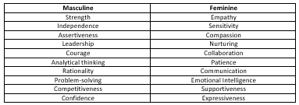
Mechanical engineer job description:
A mechanical engineer is a professional responsible for designing, analysing, and overseeing the development of mechanical systems and devices. Their role involves creating plans and specifications for mechanical components and machinery, conducting research, and using computer-aided design (CAD) software to model and test their designs. Mechanical engineers work on a wide range of projects, from designing consumer products and manufacturing equipment to developing HVAC systems and automotive components. They aim to ensure that mechanical systems are efficient, reliable, and safe, and they often work collaboratively with multidisciplinary teams to bring projects to fruition.
I wrote all the job roles to try and encompass the role in a short paragraph. Selecting STEM job roles that are predominantly occupied by either gender served to examine and expose gender biases within specific STEM roles. By choosing two STEM job roles with a predominantly female workforce and two with a predominantly male workforce, the aim was to unravel preconceived notions about gender roles and competencies in STEM.
Computer Scientist/Software Developer job description:
A computer scientist or software developer is a professional who creates, designs, and maintains software applications and computer programs. Their role involves coding, debugging, and testing to develop functional and user-friendly software. Computer scientists and software developers use programming languages and development tools to design, implement, and update software systems for various purposes, such as web applications, mobile apps, or desktop software. They work closely with software engineers and developers to turn project specifications into functional programs, ensuring that they meet the desired functionality and performance requirements. Their work is fundamental in advancing technology and providing solutions for various industries and everyday life.
Psychologist job description:
A psychologist is a healthcare professional who focuses on the study of human behaviour and mental processes. Their role involves assessing, diagnosing, and treating various psychological and emotional issues in individuals. Psychologists use therapeutic techniques and counselling to help patients cope with mental health challenges, emotional stress, and behavioural disorders. They also conduct research to gain insights into human behaviour and may specialize in areas such as clinical psychology, counselling psychology, or industrial-organizational psychology, among others. Psychologists play a critical role in promoting mental well-being and improving the lives of their patients.
Dietitian/Nutritionist job description:
A dietitian or nutritionist is a healthcare professional who specializes in the field of nutrition and dietetics. Their role involves assessing an individual's dietary needs, providing advice and guidance on nutrition and healthy eating habits, and developing personalized dietary plans to promote optimal health and well-being. Dietitians and nutritionists work in various settings, including hospitals, clinics, schools, and private practice. They play a vital role in helping individuals and communities make informed food choices, manage medical conditions through diet, and maintain a balanced and nutritious diet for better overall health.

Competency Two: Applied Research – Ethical Considerations – Ethics Form Completion

APPLICATION FOR ETHICAL APPROVAL

In order for research to result in benefit and minimise risk of harm, it must be conducted ethically. A researcher may not be covered by the University’s insurance if ethical approval has not been obtained prior to commencement.

The University follows the OECD Frascati manual definition of research activity: “creative work undertaken on a systematic basis in order to increase the stock of knowledge, including knowledge of man, culture and society, and the use of this stock of knowledge to devise new applications”. As such this covers activities undertaken by members of staff, postgraduate research students, and both taught postgraduate and undergraduate students working on dissertations/projects.
The application form for ethical approval was completed by me and another team member. We both worked through sections: A, B, and C and I completed sections: E, H, I, K, and assisted with section I.3.

The individual undertaking the research activity is known as the “principal researcher”.

Ethical approval is not required for routine audits, performance reviews, quality assurance studies, testing within normal educational requirements, and literary or artistic criticism.

Please read the notes for guidance before completing ALL sections of the form.

This form must be completed and approved prior to undertaking any research activity. Please see Checklist for details of process for different categories of application.

SECTION A: About You (Principal Researcher)
1 | Full Name: |  | Reia Sigrist  Harriet Adams  Marissa Pinto  Afsana Begum
2 | Tick all boxes that apply: |  | Member of staff: | ☐ | Honorary research fellow: | ☐
 | Undergraduate Student | ☒ | Taught Postgraduate Student | ☐ | Postgraduate Research Student | ☐

3 | Institute/Academic Discipline/Centre: | Institute of Education and Humanities/Psychology and Counselling
4 | Campus: | IQ Swansea
5 | E-mail address: | 2219662@student.uwtsd.ac.uk  2219657@student.uwtsd.ac.uk  2203596@student.uwtsd.ac.uk  2204410@student.uwtsd.ac.uk
6 | Contact Telephone Number: | NA
 | For students:
7 | Student Number: | Reia Sigrist (2219662)  Harriet Adams (2219657)  Afsana Begum (2204410)  Marisa Pinto (2203596)
8 | Programme of Study: | BSc Psychology
9 | Director of Studies/Supervisor: | Dr Katie Sullivan & Assoc Prof Paul Hutchings

SECTION B: Approval for Research Activity
1 | Has the research activity received approval in principle?  (please check the Guidance Notes as to the appropriate approval process for different levels of research by different categories of individual) |  | YES | ☒ | NO | ☐
 |  |  |  |  | Date
2 | If Yes, please indicate source of approval (and date where known): Approval in principle must be obtained from the relevant source prior to seeking ethical approval | Research Degrees Committee |  | ☐
2 |  | Institute Research Committee |  | ☐
2 |  | Other (write in):  Project supervisor  Dr Katie Sullivan |  | ☒ | 13/10/23

SECTION C: Internal and External Ethical Guidance Materials
Please list the core ethical guidance documents that have been referred to during the completion of this form (including any discipline-specific codes of research ethics, location-specific codes of research ethics, and also any specific ethical guidance relating to the proposed methodology). Please tick to confirm that your research proposal adheres to these codes and guidelines. You may add rows to this table if needed.
The UWTSD Ethics & Integrity code of practice, UWTSD Research Data Management Policy, UWTSD Data protection and Storage Protocol, BPS Code of Ethics and Conduct, BPS Code of Human Research Ethics, BPS Data Protection Regulation, and BPS Ethics Guidelines for Internet-mediated research (2018; 2021) were adhered to.
1 | UWTSD Research Ethics & Integrity Code of Practice | ☒
2 | UWTSD Research Data Management Policy | ☒
3 | UWTSD Data Protection and Storage Protocol | ☒
4 | BPS Code of Ethics and Conduct (July 2018) | ☒
5 | BPS Code of Human Research Ethics (April 2021) | ☒
7 | BPS Data Protection Regulation – Guidance for Researchers (2018) | ☒
8 | BPS Ethics Guidelines for Internet-mediated Research (June 2021) | ☒

SECTION D: External Collaborative Research Activity
If there are external collaborators, then you should gain consent from the contact persons to share their personal data with the university. If there are no external collaborators, then leave this section blank and continue to section E.
1 | Institution
2 | Contact person name
3 | Contact person e-mail address
4 | Is your research externally funded? |  | YES | ☐ | NO | ☐
5 | Are you in receipt of a KESS scholarship? |  | YES | ☐ | NO | ☐
6 | Are you specifically employed to undertake this research in either a paid or voluntary capacity? | Voluntary | YES | ☐ | NO | ☐
7 |  | Employed | YES | ☐ | NO | ☐
8 | Is the research being undertaken within an existing UWTSD Athrofa Professional Learning Partnership (APLP)? | If YES then the permission question below does not need to be answered. | YES | ☐ | NO | ☐
9 | Has permission to undertake the research has been provided by the partner organisation? | (If YES attach copy)  If NO the application cannot continue | YES | ☐ | NO | ☐

Where research activity is carried out in collaboration with an external organisation
10 | Does this organisation have its own ethics approval system? | YES | ☒ | NO | ☐
 | If Yes, please attach a copy of any final approval (or interim approval) from the organisation (this may be a copy of an email if appropriate).

SECTION E: Details of Research Activity
1 | Indicative title: | Exploring Gender Bias: An Attitudes Towards Women Scale approach to assessing sexist behaviours and attitudes to women in STEM.
2 | Proposed start date: | 25/11/2023 | Proposed end date: | 25/01/2024
Introduction to the Research (maximum 300 words per section)
Ensure that you write for a Non-Specialist Audience when outlining your response to the points below:
- Purpose of Research Activity
- Proposed Research Question
- Aims of Research Activity
- Objectives of Research Activity
Demonstrate, briefly, how Existing Research has informed the proposed activity and explain.
- What the research activity will add to the body of knowledge
- How it addresses an area of importance.
3 | Purpose of Research Activity  The purpose of this research study is to delve into the complex interplay of gender biases and stereotypes within STEM (Science, Technology, Engineering, and Mathematics) fields (e.g., Hill et al., 2010; Ceci et al., 2014; Moss-Rousin et al., 2012; Sheltzer et al., 2014; Beede et al., 2011; Diekman et al., 2010). By employing a sexism scale (Spence et al., 1973) and examining how participants allocate feminine and masculine traits to different STEM job roles this study aims to uncover the extent of gender-based preconceptions and discriminatory attitudes present in the field. The study focus is to investigate whether participants, when asked to allocate feminine and masculine traits to various STEM job roles, reveal systematic patterns of gender-based associations (Drydakis et al., 2017). This research seeks to address questions such as: To what extent do occupational stereotypes reveal gender bias when participants rate the required masculine and feminine traits for various job roles in STEM? How does sexism level affect participants' ratings of the masculine and feminine traits for specific job roles in STEM? By exploring these questions, the study seeks to provide valuable insights into the prevalence and impact of gender bias in STEM. The aims are first, to quantitively measure the presence and extent of sexism towards women, and second, to uncover how participants allocate feminine and masculine traits to different STEM job roles. The objectives are to provide rigorous assessment of the prevalence and intensity of sexism by employing a well-established sexism scale. Furthermore, to explore the potential connections between participant’s’ sexist beliefs, and their trait allocations to job roles within STEM and see if there is a correlation between the two. The ultimate goal is to provide empirical evidence regarding the prevalence of sexism and trait allocation to STEM job roles, to inform strategies, interventions, and policies that promote diversity and equal opportunities in STEM. This research addresses an area of immense importance by actively contributing to the body of knowledge needed to rectify gender disparities in STEM (Hill et al., 2010; Leslie et al., 2015).  The research questions were composed when I completed the proposal form.  The purpose of the research was detailed and was challenging to produce an introduction that was concise. I used what I wrote in the proposal form and edited it to fit the purpose of research. This took a few reworks, but I learnt a lot about being focussed on the question and being concise with limited word count. Producing concise information is an important skill for psychologists (Smyth, 2004).
4 | Research Questions  To what extent do occupational stereotypes reveal gender bias when participants rate the required masculine and feminine traits for various job roles in STEM?  The aims of the research were formulated through what the focus of our study was. I initially wrote a paragraph but again learnt the importance of writing concisely (Smyth, 2004).  How does sexism level affect participants' ratings of the masculine and feminine traits for specific job roles in STEM?
5 | Aims of Research Activity  This study proposes to explore the potential links between attitudes towards women and allocation of feminine and masculine traits to job roles within STEM.  I found the objectives section to be challenging initially because my writing lacked conciseness and focus on the specific requirements. Both Paul and Katie provided valuable feedback which helped me to stay on topic and answer the objectives (London, 2014).
6 | Objectives of Research Activity  Gender bias in STEM (Science, Technology, Engineering, and Mathematics) fields remains a pervasive issue, with women often facing obstacles in terms of representation, recognition, and opportunities for advancement.  The decision to utilize the Attitudes Toward Women (AWS) short scale aimed at evaluating levels of sexism. The AWS short scale is a well-established instrument with a concise set of questions designed to capture essential dimensions of attitudes towards women. Its brevity ensures participant engagement and reduces the risk of survey fatigue, making it a practical choice for research. Additionally, the scale's focus on assessing attitudes towards women provides a targeted examination of sexism.  Sexism level:  Individuals exhibiting high levels of sexism, as assessed through various measurements, have demonstrated a tendency to hold less favourable opinions towards women. Previous research (Glick & Fiske, 1996; Hill et al, 2010; Leslie et al, 2015) suggests that higher scores on sexism assessments correlate with a diminished regard for women, influencing attitudes and perceptions. This study aims to delve into the nuanced aspects of sexism levels, exploring how individuals with elevated sexist tendencies may unconsciously harbour more negative opinions about women.  Glick, P., & Fiske, S. T. (1996). The Ambivalent Sexism Inventory: Differentiating hostile and benevolent sexism. Journal of Personality and Social Psychology, 70(3), 491–512. https://doi.org/10.1037/0022-3514.70.3.491  Allocating masculine and feminine traits to job roles within STEM provides a framework for analysing and comparing data related to gender perceptions in STEM fields. The decision to include 10 feminine and 10 masculine traits reflects a deliberate effort to capture a broad spectrum of gender-associated characteristics. Selecting STEM job roles that are predominantly occupied by either gender served to examine and expose gender biases within specific STEM roles. By choosing two STEM job roles with a predominantly female workforce and two with a predominantly male workforce, the aim was to unravel preconceived notions about gender roles and competencies in STEM.  Hill, C., Corbett, C., & St. Rose, A. (2010). Why So Few? Women in Science, Technology, Engineering, and Mathematics. AAUW.  Leslie, S.J,. Cimpian, A., Meyer, M., Freeland, E. (2015) Expectations of brilliance underlie gender distributions across academic disciplines. Science. 16(347), 262-5. doi: 10.1126/science.1261375. PMID: 25593183.  Masculine and feminine traits for job roles:  Masculine and feminine traits in job roles continue to be significant subjects of study, particularly in the context of job roles. Traditional gender norms often associate certain traits with masculinity, such as assertiveness, independence, and competitiveness, while linking femininity to qualities like empathy, collaboration, and nurturing (Bem, 1974; Blonde et al, 2021; Stoet & Geary, 2018). In many professions, including STEM fields, these gendered expectations may influence hiring decisions, career advancement, and workplace interactions. Objectives include the identification of societal expectations associated with masculinity and femininity within STEM professions. By drawing parallels between sexism level and the allocation of gendered traits to job roles, this study seeks to unravel the intricate dynamics shaping occupational perceptions and contribute to discussions on fostering gender-inclusive workplaces.  Bem, S. L. (1974). The measurement of psychological androgyny. Journal of Consulting and Clinical Psychology, 42(2), 155-162.  Blonde, J., Gianettoni, L., Gross, D., & Guilley, E. (2021). Measurement of sexism, gender identity, and perceived gender discrimination: A brief overview and suggestions for short scales. FORS working paper series, paper 2021-22. DOI:10.24440/FWP- 2021-00002  Stoet, G., Geary, D.C. (2018). The Gender-Equality Paradox in Science, Technology, Engineering, and Mathematics Education. Psychological Science. 29. https://www.researchgate.net/publication/323197652_The_Gender-Equality_Paradox_in_Science_Technology_Engineering_and_Mathematics_Education
Proposed methods (maximum 600 words)
Developing and constructing the methodology section was challenging. Feedback from both Paul and Katie played a pivotal role, providing essential guidance to ensure clarity, precision, and adherence to the question.

1 / 2

Provide a brief summary of all the methods that may be used in the research activity, making it clear what specific techniques may be used. If methods other than those listed in this section are deemed appropriate later, additional ethical approval for those methods will be needed. You do not need to justify the methods here but should instead describe how you intend to collect the data necessary for you to complete your project.
7 | To assess [Sexism level], a validated scale will be used.  The attitudes Towards Women scale (Spence et al., 1973) will be used to collect data on sexism level in participants and will be completed on Qualtrics.. This questionnaire contains 25 items such as “Swearing and obscenity are more repulsive in the speech of a woman than of a man”. Each item is scored on a 5-point Likert scale anchored between 1 = Strongly Disagree to 5 = Strongly Agree. Total scores on the scale can range between 25 to 125, with a high score indicating a pro-feminist, egalitarian attitude while a low score indicating a traditional, conservative attitude. For the purpose of analysis, participants will be categorised into ‘low’ or ‘high’ sexism level based upon the calculated mean score once all data has been collected.  Utilising a validated scale in a research study is crucial because it ensures the reliability and validity of the measurement of sexism (King et al., 2014).  1 / 2  Implementing a randomised version of the study is essential for ensuring counterbalancing. By randomly assigning participants to different experimental condition, the likelihood of systematic biases due to the order of presentation is minimised and enhances the internal validity of the study (DePuy & Berger, 2014).  To measure trait allocation, the Qualtrics experimental programme will be used to create a task allowing participants to view and record their opinions on traits and job roles. Likert scale will be employed for traits and job roles allowing participants to rate the extent of their importance for the job role. The Likert scale will range from “very low” to “very high”, providing a continuum for respondents to express their perspectives.  An equal number of both masculine and feminine traits will be rated for each job role.  Within this part of the study, each trait and job role will be randomised within each task, and each new participant will be exposed to a randomised version to ensure appropriate counterbalancing of conditions.  Spence, J. T., Helmreich, R., & Strapp, J. (1973). A short version of the Attitudes toward Women Scale (AWS). Bulletin of Psychonomic Society, 2, 219-220.
Location of research activity
Identify all locations where research activity will take place.
8 | UWTSD IQ building - Laboratories.
Research activity outside of the UK
If research activity will take place overseas, you are responsible for ensuring that local ethical considerations are complied with and that the relevant permissions are sought. Specify any local guidelines (e.g. from local professional associations/learned societies/universities) that exist and whether these involve any ethical stipulations beyond those usual in the UK (provide details of any licenses or permissions required). Also specify whether there are any specific ethical issues raised by the local context in which the research activity is taking place, for example, particular cultural and/or legal sensitivities or vulnerabilities of participants. If you live in the country where you will do the research then please state this.
9 | N/A

10 | Use of documentation not in the public domain: Are any documents NOT publicly available? | NO | ☒
10 |  | YES | ☐
11 | If Yes, please provide details here of how you will gain access to specific documentation that is not in the public domain and that this is in accordance with the current data protection law of the country in question and that of England and Wales.

 | Does your research relate to one or more of the seven aims of the Well-being of Future Generations (Wales) Act 2015? | YES | NO
12 | A prosperous Wales | ☐ | ☒
13 | A resilient Wales | ☐ | ☒
14 | A healthier Wales | ☐ | ☒
15 | A more equal Wales | ☒ | ☐
16 | A Wales of cohesive communities  This research study is particularly pertinent in the context of the More Equal Wales Act as it seeks to explore and address gender biases, contributing directly to the Act's overarching goal of fostering greater equality within the region. | ☐ | ☒
17 | A Wales of vibrant culture and thriving Welsh language | ☐ | ☒
18 | A globally responsible Wales | ☒ | ☐
19 | If YES to any of the above, please give details:
A more equal Wales: By addressing the deeply embedded gender biases and stereotypes in STEM fields, this research aligns with the Act’s core objectives of promoting gender equity and inclusivity. It provides empirical data essential for understanding the extent of sexism in STEM, which is a crucial step toward rectifying disparities in Wales. By uncovering the roles of stereotypes in shaping career perceptions, the study contributes directly to the Act’s aim of breaking down barriers to gender equality in Wales, fostering an environment where individuals of all gender can pursue STEM career without bias or discrimination.

A globally responsible Wales: By employing methodologies such as survey, researchers can gauge explicit and implicit biases, discriminatory behaviours, and perceptions of gender roles within STEM professions. Investigation into the allocation of traits associated with specific genders in STEM job roles would shed light on persistent stereotypes and biases that affect career opportunities. Relating these findings to the objectives of the "A globally responsible Wales act" provides a nuanced understanding of how gender dynamics intersect with the pursuit of global responsibility. Such an analysis not only informs policymakers about the existing challenges but also serves as a crucial step towards aligning STEM-related policies with the broader objectives of the act. The implications of this study extend beyond academia, influencing societal norms, fostering inclusivity, and contributing to the creation of a more equitable and globally responsible workforce in Wales.
After ethics checked and returned our ethics form it was noted I had not ticked all the boxes above, an oversight on my end. I decided this study was applicable to another Act and added the information.

SECTION F: Scope of Research Activity
 | Will the research activity include: | YES | NO
1 | Use of a questionnaire or similar research instrument? | ☒ | ☐
2 | Use of interviews? | ☐ | ☒
3 | Use of focus groups? | ☐ | ☒
4 | Use of participant diaries? | ☐ | ☒
5 | Use of video or audio recording? | ☐ | ☒
6 | Use of computer-generated log files? | ☐ | ☒
7 | Participant observation with their knowledge? | ☐ | ☒
8 | Participant observation without their knowledge? | ☐ | ☒
9 | Access to personal or confidential information without the participants’ specific consent? | ☐ | ☒
10 | Administration of any questions, test stimuli, presentation that may be experienced as physically, mentally or emotionally harmful / offensive? | ☐ | ☒
11 | Performance of any acts which may cause embarrassment or affect self-esteem? | ☐ | ☒
12 | Investigation of participants involved in illegal activities? | ☐ | ☒
13 | Use of procedures that involve deception? | ☐ | ☒
14 | Administration of any substance, agent or placebo? | ☐ | ☒
15 | Working with live vertebrate animals? | ☐ | ☒
16 | Procedures that may have a negative impact on the environment? | ☐ | ☒
17 | Other primary data collection methods. Please indicate the type of data collection method(s) below. | ☐ | ☒
 | Details of any other primary data collection method:  (this box should expand as you type) | ☐ | ☒
If NO to every question, then the research activity is (ethically) low risk and may be exempt from some of the following sections (please refer to Guidance Notes).

If YES to any question, then no research activity should be undertaken until full ethical approval has been obtained.

SECTION G: Intended Participants
If there are no participants then do not complete this section, but go directly to section H.

 | Who are the intended participants: | YES | NO
1 | Students or staff at the University? | ☒ | ☐
2 | Adults (over the age of 18 and competent to give consent)? | ☒ | ☐
3 | Vulnerable adults? | ☐ | ☒
4 | Children and Young People under the age of 18? (Consent from Parent, Carer or Guardian will be required) | ☐ | ☒
5 | Prisoners? | ☐ | ☒
6 | Young offenders? | ☐ | ☒
7 | Those who could be considered to have a particularly dependent relationship with the investigator or a gatekeeper? | ☐ | ☒
8 | People engaged in illegal activities? | ☐ | ☒
9 | Others. Please indicate the participants below, and specifically any group who may be unable to give consent. | ☐ | ☒
 | Details of any other participant groups:  (this box should expand as you type) | ☐ | ☒

Participant numbers and source
Provide an estimate of the expected number of participants. How will you identify participants and how will they be recruited?
10 | How many participants are expected? | 10-20 participants will be required for this study to ensure there is an adequate number of data points to apply the Pearson’s correlation test for data analysis.  Small details were added to both these questions from ethic board comments to make the study more concise.
11 | Who will the participants be? | Students over the age of 18 who are currently studying at UWTSD University within the Psychology and Counselling Discipline.
12 | How will you identify the participants? | Students will be identified by their EMS ID when attending the study and their data will be allocated a unique study ID.

 | Information for participants: | YES | NO | N/A
13 | Will you describe the main research procedures to participants in advance, so that they are informed about what to expect? | ☒ | ☐ | ☐
14 | Will you tell participants that their participation is voluntary? | ☒ | ☐ | ☐
15 | Will you obtain written consent for participation? | ☒ | ☒
16 | Will you explain to participants that refusal to participate in the research will not affect their treatment or education (if relevant)? | ☒ | ☐ | ☐
17 | If the research is observational, will you ask participants for their consent to being observed? | ☐ | ☐ | ☒
18 | Will you tell participants that they may withdraw from the research at any time and for any reason? | ☒ | ☐ | ☐
19 | With questionnaires, will you give participants the option of omitting questions they do not want to answer? | ☒ | ☐ | ☐
20 | Will you tell participants that their data will be treated with full confidentiality and that, if published, it will not be identifiable as theirs? | ☒ | ☐ | ☐
21 | Will you debrief participants at the end of their participation, in a way appropriate to the type of research undertaken? | ☒ | ☐ | ☐
22 | If NO to any of above questions, please give an explanation
 | (this box should expand as you type)

 | Information for participants: | YES | NO | N/A
24 | Will participants be paid? | ☐ | ☒ | ☐
25 | Is specialist electrical or other equipment to be used with participants? | ☐ | ☒ | ☐
26 | Are there any financial or other interests to the investigator or University arising from this study? | ☐ | ☒ | ☐
27 | Will the research activity involve deliberately misleading participants in any way, or the partial or full concealment of the specific study aims? | ☐ | ☒ | ☐
28 | If YES to any question, please provide full details

SECTION H: Anticipated Risks

Outline any anticipated risks that may adversely affect any of the participants, the researchers and/or the University, and the steps that will be taken to address them.

If you have completed a full risk assessment (for example as required by a laboratory, or external research collaborator) you may append that to this form.
1 | Full risk assessment completed and appended? |  | Yes  All possible risks to participants, researchers and the university needed to be identified to take mitigating action to reduce the probability of risk or harm. |  | ☐
1 |  |  | No |  | ☒
2 | Risks to participants  For example: sector-specific health & safety, emotional distress, financial disclosure, physical harm, transfer of personal data, sensitive organisational information
 | Risk to participants:  - The questions asked during the research may unexpectantly induce strong emotions in participants.  - Whilst the risk of using an assessment of sexism scale, the scale being used may be negatively received by participants, and participants may decline to respond to some questions within the scale.  - Participant may have concerns regarding use and safe storage of their Data collected during this study.  Additional information was added for participant risks as highlighted by ethic board comments. While data protection policies had been followed it needed to be recorded in the potential risks and how we as researchers would mitigate the risks associated. | How you will mitigate the risk to the Participant:  - All questions used within the study will be taken from Attitudes towards Women (ATW) and will signed off by the research supervisor prior to data collection commencing. Participants will be fully informed of the purpose of the study and the procedure of the study.  - BPS Code of Human Research Ethics (2021), participants will be informed that they will be required to complete an attitudes towards women questionnaire. They will also be informed that they can decline to respond to any question they wish, and this will not affect their overall participation. If they wish to withdraw from the study once they see the questions, they will be able to do so by closing the browser and informing the researcher that they no longer wish to proceed. Additional resources will be provided within the debrief form for contact information regarding gender bias and sexism towards women for help and support.  - The researcher will provide the participants an explanation of how their data will be handled confidently and that their data will be anonymised within the information sheet for the study. The researcher will also explain the process involved in the collection, handling, and storage of their data if the participants require more detailed information. The participant will also have the chance to remove their data, at any time up to the completion of the study, at which time their data will be anonymised, and the researcher may not be able to distinguish between participants data.
3 | If research activity may include sensitive, embarrassing or upsetting topics (e.g. sexual activity, drug use) or issues likely to disclose information requiring further action (e.g. criminal activity), give details of the procedures to deal with these issues, including any support/advice (e.g. helpline numbers) to be offered to participants. Note that where applicable, consent procedures should make it clear that if something potentially or actually illegal is discovered in the course of a project, it may need to be disclosed to the proper authorities  It was important when covering what could be a sensitive topic, to not force a response from a participant. Also providing a detailed debrief on the purpose of the study for ethical transparency.
 | Participants will be informed about discrimination-related topics in the study description. They will need to provide consent and can choose not to answer uncomfortable questions. Additionally, participants will also have the chance to remove their data, at any time up to the completion of the study, at which time their data will be anonymised, and the researcher may not be able to distinguish between participants data. A debrief will be provided at the end, revealing the true study aims and offering the option to withdraw if desired.
4 | Risks to the investigator  For example: personal health & safety, physical harm, emotional distress, risk of accusation of harm/impropriety, conflict of interest
 | Risk to the investigator:  - The researcher’s email is provided in the debrief to the participants. Therefore, a potential risk could be the researcher receiving negative or unwelcome emails from a participant.  - The student researchers may find themselves being asked for information outside of their scope of knowledge as an undergraduate student.  Additional risks to investigator were added from ethic board comments to detail the physical safely of the investigator. This was something I had not considered and instead focussed on protecting the participants from what could be a sensitive topic.  - A participant may accuse a student researcher of harm if they are unhappy with an incident during the study.  - Physical safety of the researcher may be at risk with a participant who could potentially become disgruntled with the type of questions being asked. | The risk to the investigators was also considered, and appropriate mitigating action detailed in this section.  How you will mitigate the risk to the Investigator:  - Only the university student email address will be provided, and not personal ones. If the researcher does receive any unwelcomed emails from a participant, this will be reported to the research supervisor immediately.  - Any queries sent to the researchers that they are unable to deal with will be passed on to the research supervisor.  - It will be ensured that the student researcher follows all UWTSD and BPS researcher codes of conduct and research guidelines, and the study will not take place until all elements have been approved by the supervisor.  - Informed consent and transparency will be paramount in detailing the purpose of the study and study topic area. Participants will be able to withdraw at any time up to the completion of the study, at which time their data will be anonymised, and the researcher may not be able to distinguish between participants data. Additional resources will be provided within the debrief form for contact information regarding gender bias and sexism towards women for help and support.  The risk to the university was also considered. Steps to mitigate the risk to UWTSD were documented, and these steps were followed throughout the study.
5 | University/institutional risks  For example: adverse publicity, financial loss, data protection
 | Risk to the University:  - The reputation and integrity of UWTSD and discipline of Psychology could be endangered if researchers do not adhere to codes ethics and research protocols.  - Data could be exposed, leaked, or misused. | How you will mitigate the risk to the University:  - The University Ethics and Integrity Code of Practice and the BPS Code of Ethics and Conduct will be followed at every stage of the proposed study to minimise any potential risks to the Instutition from arising. Professionalism will always be exhibited by all researchers.  - The data collected will be stored in accordance with UWTSD Research Data Management (RDM) rules and only used for the intended purpose, in compliance with ethical guidelines set out by UWTSD Research Ethics & Integrity Code of Practice policy and British Psychological Society (BPS) code of ethics. To minimise any risk to UWTSD and the psychology department, all collected data will be stored securely and initially saved on the Psychology laboratories’ computers. Electronic data transfer will only occur on anonymised data.
6 | Environmental risks  For example: accidental spillage of pollutants, damage to local ecosystems
 | Risk to environment:  - Data collection will take place within the psychology labs, therefore there is the risk of spillage occurring on the equipment in this area.  - Printing of materials. | The risk to the environment was also considered, and appropriate mitigating action detailed in this section.  How you will mitigate the risk to environment:  - Participants will be reminded that no food or drink is to be taken into the lab area.  - Researchers will limit printing of materials – the information sheet and consent form will be displayed to participants via Qualtrics, and the debrief information will be displayed at the end of the task. A debrief form will be sent to participants via the EMS to keep for their own records following completion of the study.

 | Disclosure and Barring Service
 | If the research activity involves children or vulnerable adults, a Disclosure and Barring Service (DBS) certificate must be obtained before any contact with such participants. | YES | NO |  | N/A
7 | Does your research require you to hold a current DBS Certificate? | ☐ | ☐ |  | ☒
8 | If YES, please give the certificate number. If the certificate number is not available, please write “Pending”; in this case any ethical approval will be subject to providing the appropriate certificate number.

SECTION I: Feedback, Consent and Confidentiality

1 | Feedback  What de-briefing and feedback will be provided to participants, how will this be done and when?
 | Participants will be debriefed as soon as possible after their participation in the study. They will be provided a debrief form with additional information about the purpose of the study, address any concerns or misconceptions, and offer support if needed. This will also be their opportunity to ask any questions to the researchers.
2 | Informed consent  Describe the arrangements to inform potential participants, before providing consent, of what is involved in participating. Describe the arrangements for participants to provide full consent before data collection begins. If gaining consent in this way is inappropriate, explain how consent will be obtained and recorded in accordance with prevailing data protection legislation.
 | Prior to their participation, individuals will be presented with a clear and detailed explanation of the research’s purpose, procedures, potential risks, and benefits. They will be informed of their right as participants, including the assurance of anonymity and the confidentiality of their responses. This informed consent process is designed to ensure that participants engage in the study voluntarily and with comprehensive understanding of its objectives and ethical safeguards.
3 | Confidentiality / Anonymity  Set out how anonymity of participants and confidentiality will be ensured in any outputs. If anonymity is not being offered, explain why this is the case.
This section was completed by another team member, but I assisted with writing section 3 based on feedback received from Paul. Participant anonymity and confidentiality was considered and documented and adhered to throughout the study.
To ensure confidentiality the research will be anonymised. At no point will the researcher or anyone associated with the project be able to identify the participants as information collected does not contain any identifiable information. Consent forms will be kept locked away and detached from the study data to ensure confidentiality. All participant responses will be kept strictly confidential, meaning that proper safeguards will be put in place to protect the privacy of participants and their information from unauthorised access, use, disclosure, modification, loss, and theft. Physical safeguards will be implemented, making sure to lock cabinets, private lab rooms, and information stored away from the public. Any electronic data will be protected with a password, and based on the sensitivity of the information, also encrypted.

SECTION J: Data Protection and Storage

 | Does the research activity involve personal data (as defined by the General Data Protection Regulation 2016 “GDPR” and the Data Protection Act 2018 “DPA”)? | YES | NO
1 | “Personal data” means any information relating to an identified or identifiable natural person (‘data subject’). An identifiable natural person is one who can be identified, directly or indirectly, in particular by reference to an identifier such as a name, an identification number, location data, an online identifier or to one or more factors specific to the physical, physiological, genetic, mental, economic, cultural or social identity of that natural person. Any video or audio recordings of participants is considered to be personal data. | ☒ | ☐
 | If YES, provide a description of the data and explain why this data needs to be collected:
2 | Students will use their Experiment Management System (EMS) number to sign up for the study, which will then be used to identify them during their participation; however, this identifying number will not be included with the data produced from taking part in the study. Participants will also be asked to report their age and gender in order to produce descriptive statistics.  (this box should expand as you type)
 | Does it involve special category data (as defined by the GDPR)? | YES | NO
3 | “Special category data” means sensitive personal data consisting of information as to the data subjects’ –  (a) racial or ethnic origin,  (b) political opinions,  (c ) religious beliefs or other beliefs of a similar nature,  (d) membership of a trade union (within the meaning of the Trade Union and Labour Relations (Consolidation) Act 1992),  (e) physical or mental health or condition,  (f) sexual life,  (g) genetics,  (h) biometric data (as used for ID purposes), | ☐ | ☒
 | If YES, provide a description of the special category data and explain why this data needs to be collected:
4 | (this box should expand as you type)

 | Will data from the research activity (collected data, drafts of the thesis, or materials for publication) be stored in any of the following ways? | YES | NO
5 | Manual files (i.e. in paper form)? | ☐ | ☒
6 | University computers? | ☒ | ☐
7 | Private company computers? | ☐ | ☒
8 | Home or other personal computers? | ☐ | ☒
9 | Laptop computers/ CDs/ Portable disk-drives/ memory sticks? | ☒ | ☐
10 | “Cloud” storage or websites? | ☒ | ☐
11 | Other – specify: | ☐ | ☒
12 | For all stored data, explain the measures in place to ensure the security of the data collected, data confidentiality, including details of backup procedures, password protection, encryption, anonymisation and pseudonymisation:
All raw data will be collected using University computers and computer programs which will be stored electronically. Both researchers will have shared access to all documents and data, which will only be accessible through a password protected University account. However, all data will also be backed up and stored on a memory stick to ensure no data becomes damaged or lost. The memory stick will be kept within the Psychology Laboratory. Personal data such as participant names and EMS numbers will also be stored in a document that only researchers can access, although all data will remain anonymous. Participant details e.g., names and EMS number will only be necessary for gaining participant consent.
(this box should expand as you type)

 | Data Protection
 | Will the research activity involve any of the following activities: | YES | NO
13 | Electronic transfer of data in any form? | ☒ | ☐
14 | Sharing of data with others at the University outside of the immediate research team? | ☐ | ☒
15 | Sharing of data with other organisations? | ☐ | ☒
16 | Export of data outside the UK or importing of data from outside the UK? | ☐ | ☒
17 | Use of personal addresses, postcodes, faxes, emails or telephone numbers? | ☐ | ☒
18 | Publication of data that might allow identification of individuals? | ☐ | ☒
19 | Use of data management system? | ☐ | ☒
20 | Data archiving? | ☐ | ☒
21 | If YES to any question, please provide full details, explaining how this will be conducted in accordance with the GDPR and Data Protection Act (2018) (and any international equivalents, where appropriate):
The data will be collected using Qualtrics on University computers within the Psychology labs. The data will be anonymised and then downloaded onto the researcher's password protected files where both researchers can access this. The data will be also transferred and stored on a shared, password protected memory stick that will be available for both researchers to access.

(this box should expand as you type)
22 | List all who will have access to the data generated by the research activity:
Harriet Adams
Reia Sigrist
Dr Katie Sullivan
Prof Paul Hutchings
(this box should expand as you type)
23 | List who will have control of, and act as custodian(s) for, data generated by the research activity:
Both researchers (Harriet Adams and Reia Sigrist) and supervisors Dr Katie Sullivan and Prof Paul Hutchings

(this box should expand as you type)
24 | Give details of data storage arrangements, including security measures in place to protect the data, where data will be stored, how long for, and in what form. Will data be archived – if so how and if not why not.
The data collected through Qualtrics will be stored on the University lab computers using the researcher's password protected University account. All anonymous data will be stored securely and will be deleted once the study has been completed and all data has been collected. All data will be used and stored in accordance with the UWTSD Research Data Management Policy.

(this box should expand as you type)
25 | Please indicate if your data will be stored in the UWTSD Research Data Repository (see https://researchdata.uwtsd.ac.uk/ ). If so please explain. (Most relevant to academic staff)
The data will not be stored within the UWTSD Research Data Repository.
(this box should expand as you type)
26 | Confirm that you have read the UWTSD guidance on data management (see https://www.uwtsd.ac.uk/library/research-data-management/) | YES | ☒
27 | Confirm that you are aware that you need to keep all data until after your research has completed or the end of your funding | YES | ☒

SECTION K: Declaration
The information which I have provided is correct and complete to the best of my knowledge. I have attempted to identify any risks and issues related to the research activity and acknowledge my obligations and the rights of the participants.

In submitting this application I hereby confirm that I undertake to ensure that the above named research activity will meet the University’s Research Ethics and Integrity Code of Practice which is published on the website: https://www.uwtsd.ac.uk/research/research-ethics/
1 | Signature of applicant: | R.Sigrist & H.Adams | Date:  08/11/2023

For STUDENT Submissions:
2 | Director of Studies/Supervisor: | Paul B. Hutchings | Date:  13/``/23
3 | Signature: | Paul B. Hutchings | Date:  13/``/23

For STAFF Submissions:
4 | Academic Director/ Assistant Dean: |  | Date:
5 | Signature: |  | Date:

Checklist: Please complete the checklist below to ensure that you have completed the form according to the guidelines and attached any required documentation:
☒ | I have read the guidance notes supplied before completing the form.
☒ | I have completed ALL RELEVANT sections of the form in full.
☒ | I confirm that the research activity has received approval in principle
☐ | I have attached a copy of final/interim approval from external organisation (where appropriate)
☐ | I have attached a full risk assessment (where appropriate) ONLY TICK IF YOU HAVE ATTACHED A FULL RISK ASSESSMENT
☒ | I understand that it is my responsibility to ensure that the above named research activity will meet the University’s Research Ethics and Integrity Code of Practice.
☒ | I understand that before commencing data collection all documents aimed at respondents (including information sheets, consent forms, questionnaires, interview schedules etc.) must be confirmed by the DoS/Supervisor, module tutor or Academic Director.

RESEARCH STUDENTS AND STAFF ONLY
All communications relating to this application during its processing must be in writing and emailed to pgresearch@uwtsd.ac.uk , with the title ‘Ethical Approval’ followed by your name.
You will be informed of the outcome of your claim by email; therefore it is important that you check your University and personal email accounts regularly.
STUDENTS ON UNDERGRADUATE OR TAUGHT MASTERS PROGRAMMES should submit this form (and receive the outcome) via systems explained to you by the supervisor/module leader.

This form is available electronically from the Academic Office web pages: https://www.uwtsd.ac.uk/academic-office/appendices-and-forms/

Competency Three: Applied Research – Qualtrics Study Creation

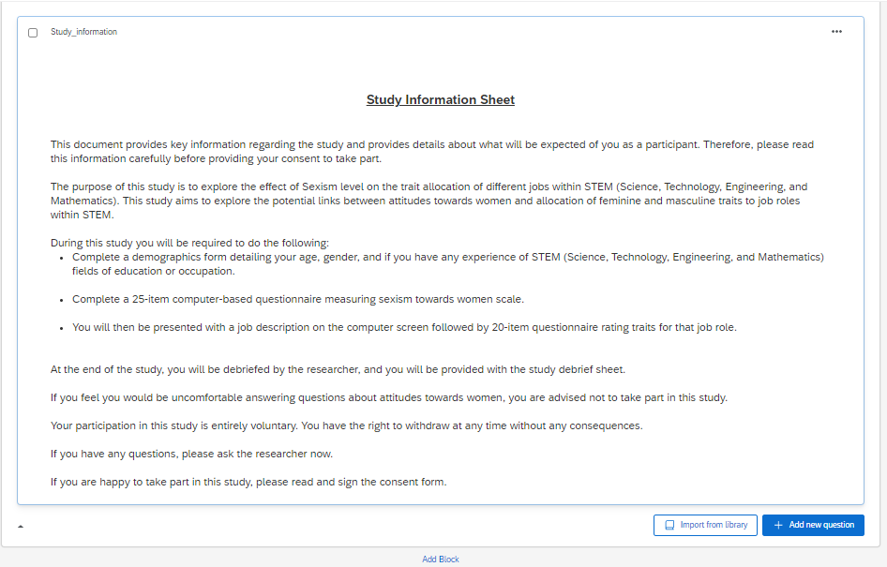
I completed the study on Qualtrics with assistance from another team member.
I developed the Study Information Sheet with the aim of clearly conveying the details of the study. Its purpose was to provide participants with the necessary information to make an informed decision and give their consent to participate.
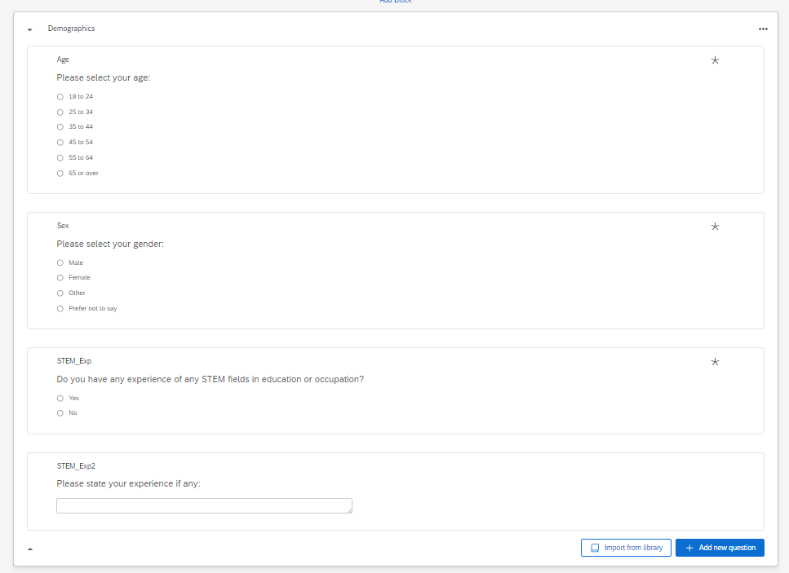
The Demographics was discussed with my team member to decide what data we would need. My team member added the open-ended question for additional data.
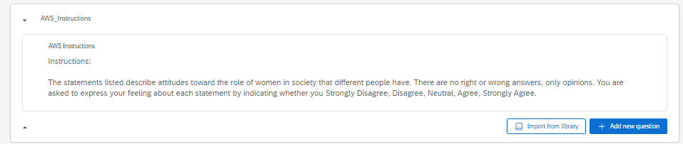
The AWS instructions are same as on the scale.
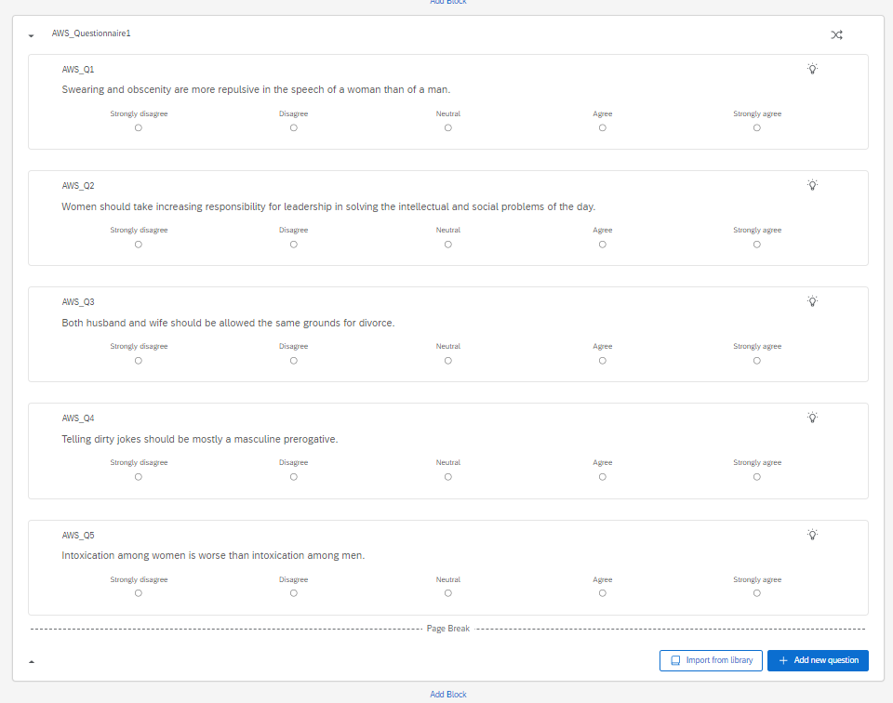
AWS scale I reworked as originally it was presented as a list of questions, which could have been overwhelming for participants, I redesigned the layout for clarity and help prevent survey fatigue. By incorporating whitespace and distributing the questions across multiple pages, I aimed to enhance readability and user-friendliness.
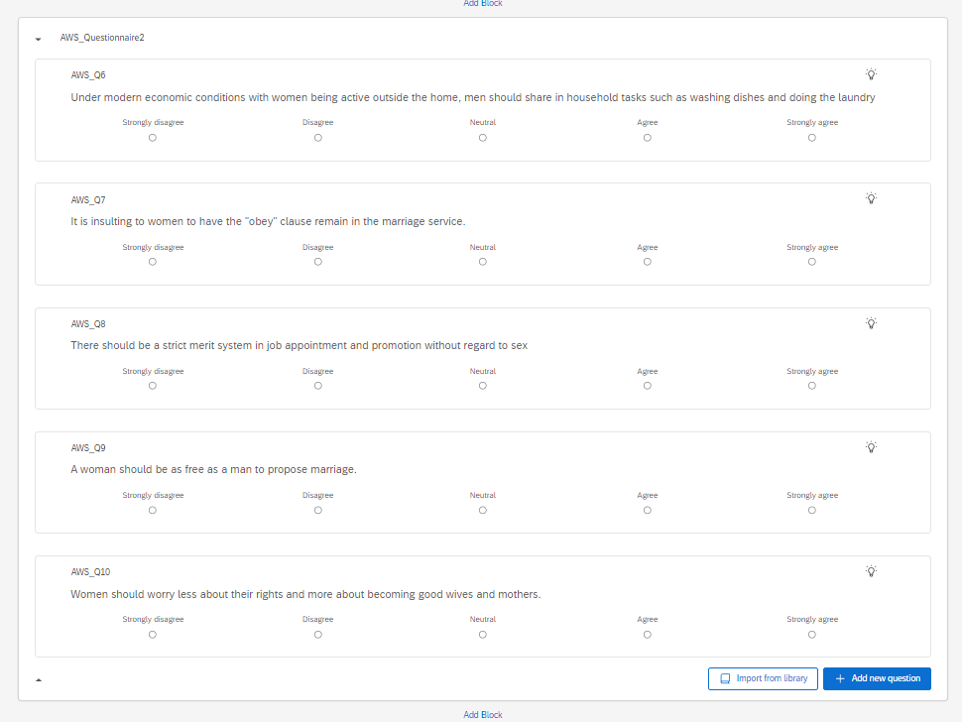
I gained valuable insights into Qualtrics and encountered challenges when page breaks failed to display. Through research, I discovered that the issue stemmed from having a randomizer on. Consequently, I had to divide the blocks to reconstruct the page breaks.
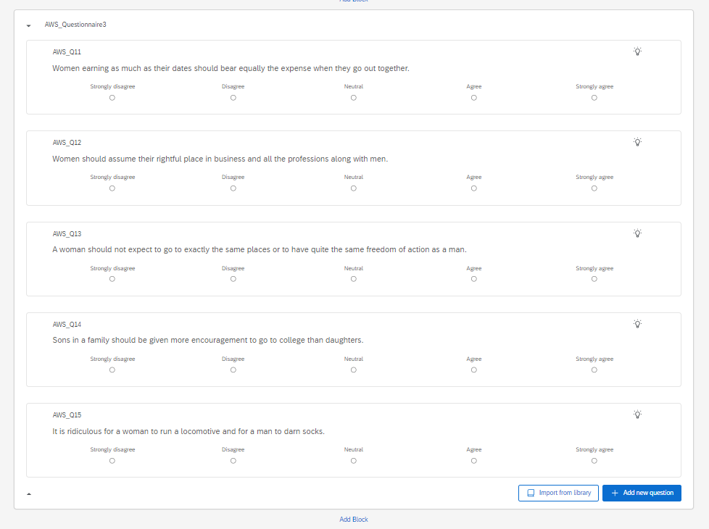
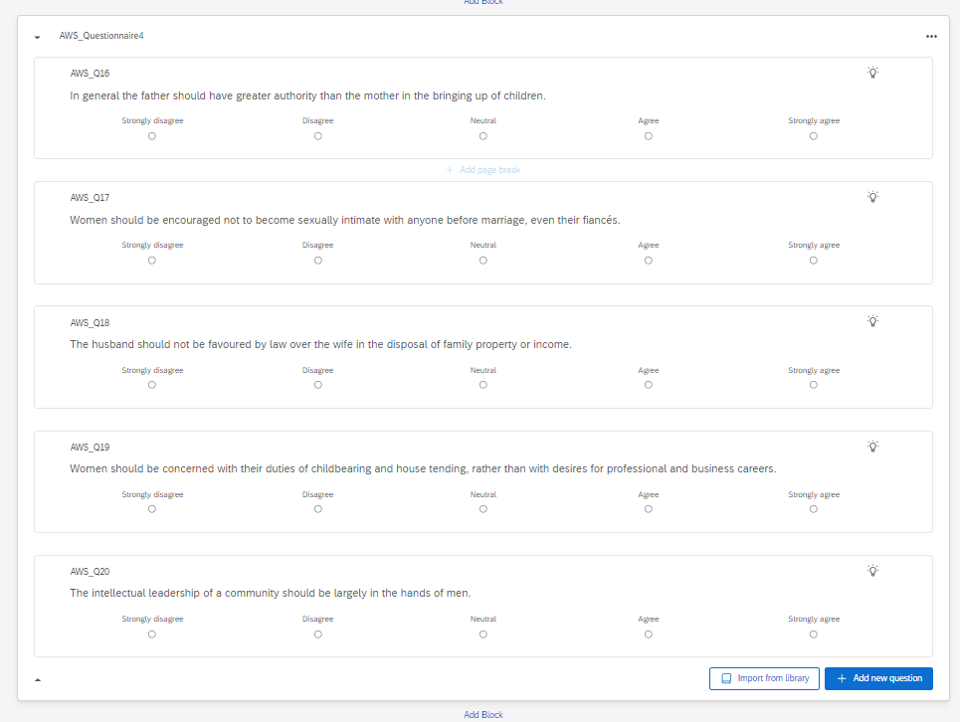
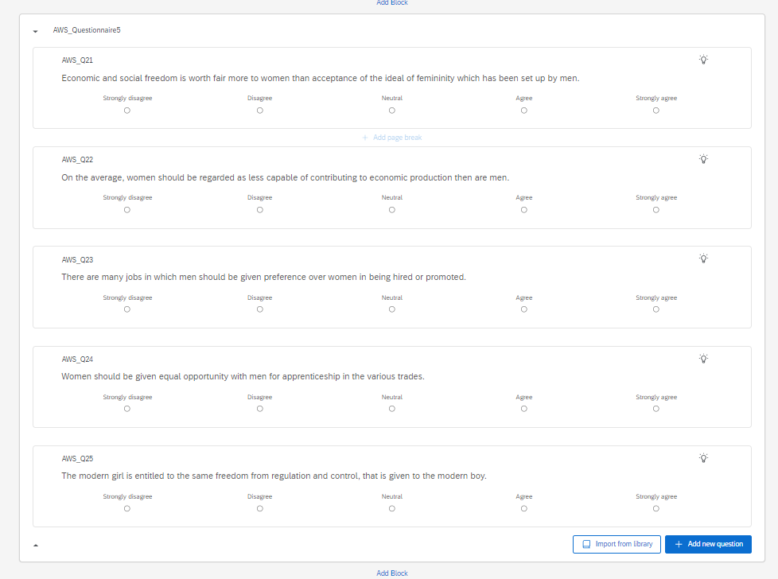
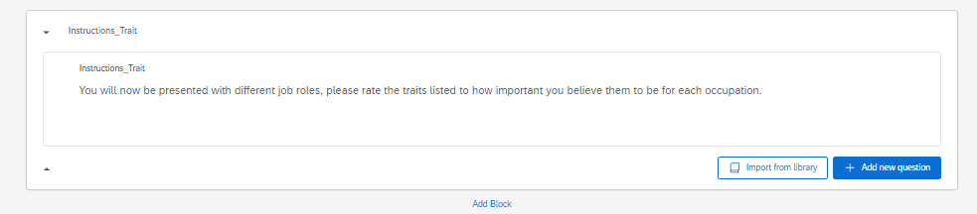
I deliberately maintained brevity and clarity in the Trait instructions, ensuring that the information provided was succinct and easily comprehensible for participants.
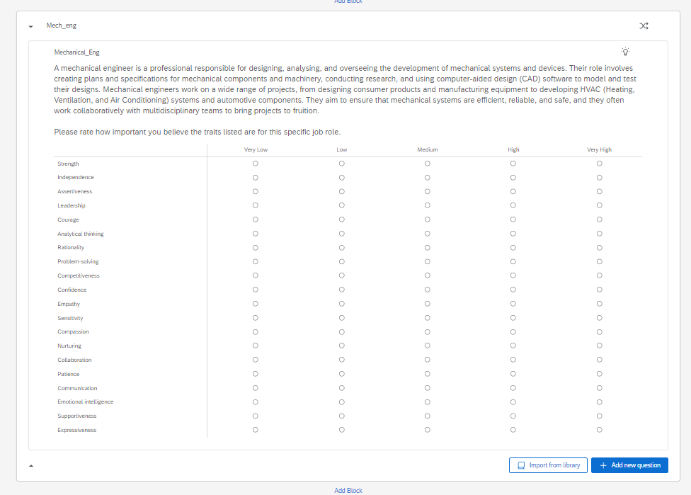
Mechanical engineers were chosen for trait allocation in this study due to the profession's gender-skewed representation. By examining the perceived masculine and feminine traits associated with mechanical engineering, the research aims to contribute insights into the gender biases and stereotypes that may influence career choices and perceptions within STEM fields.
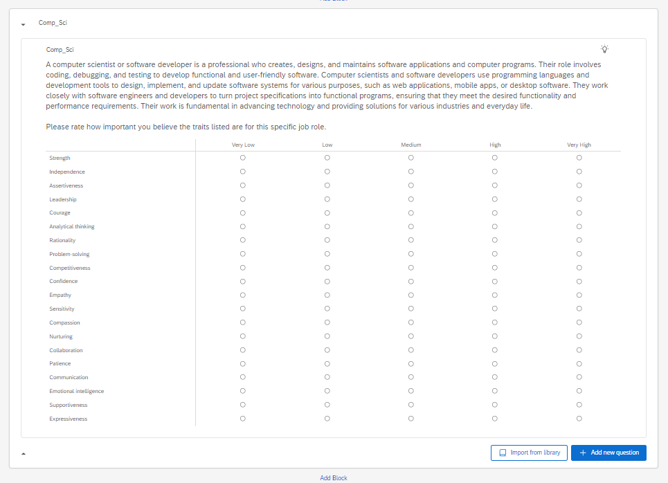
I gained valuable insights into Qualtrics and encountered challenges when page breaks failed to display. Through research, I discovered that the issue stemmed from having a randomizer on. Consequently, I had to divide the blocks to reconstruct the page breaks.

Computer scientists were selected for trait allocation in this study to investigate the gender perceptions within the field. The choice is grounded in the observable gender imbalance in computer science and technology-related professions. By analysing the association of masculine and feminine traits with computer science roles, the study aims to uncover potential stereotypes and biases that may impact career dynamics.
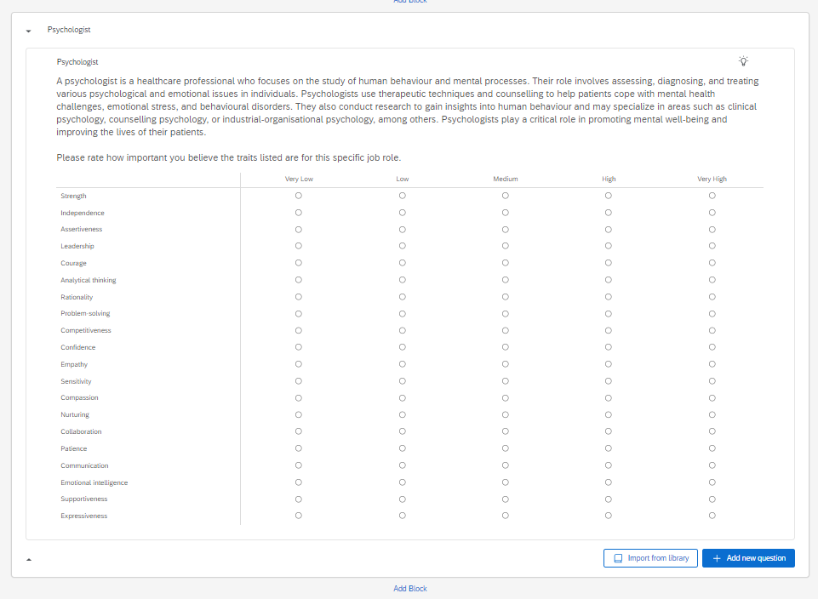
Psychologists were chosen for the opposite reason in that they have a predominantly female workforce. The selection is motivated by the diverse and multifaceted nature of psychology, which often involves the integration of both analytical and empathetic qualities. Investigating the allocation of masculine and feminine traits to psychologists aims to uncover societal attitudes and stereotypes, offering valuable insights into how gender roles may influence perceptions and expectations within the realm of psychology.
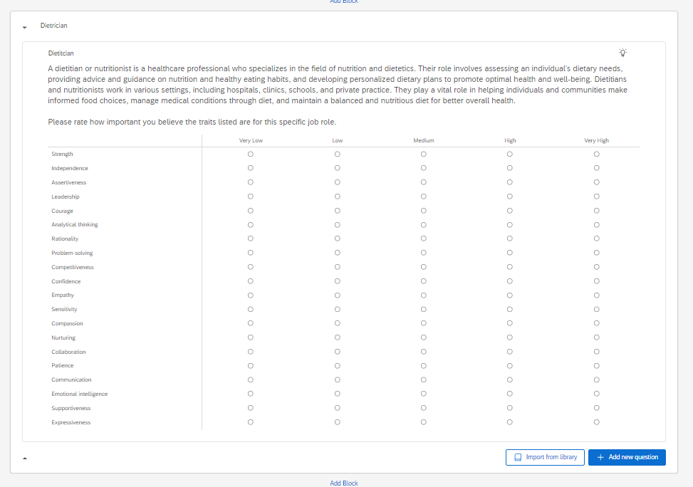
Dieticians and nutritionists were chosen for trait allocation in this study due to the profession's relevance to health and wellness, with a notable representation of a higher female workforce. Investigating the allocation of masculine and feminine traits in this context aims to shed light on societal perceptions of roles related to nutrition and dietary guidance.
The End screen was written by a team member.
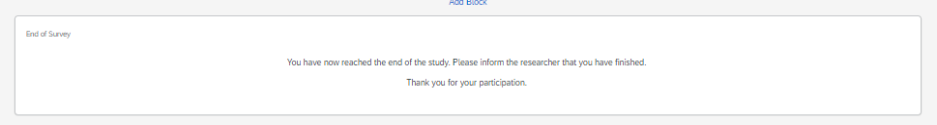
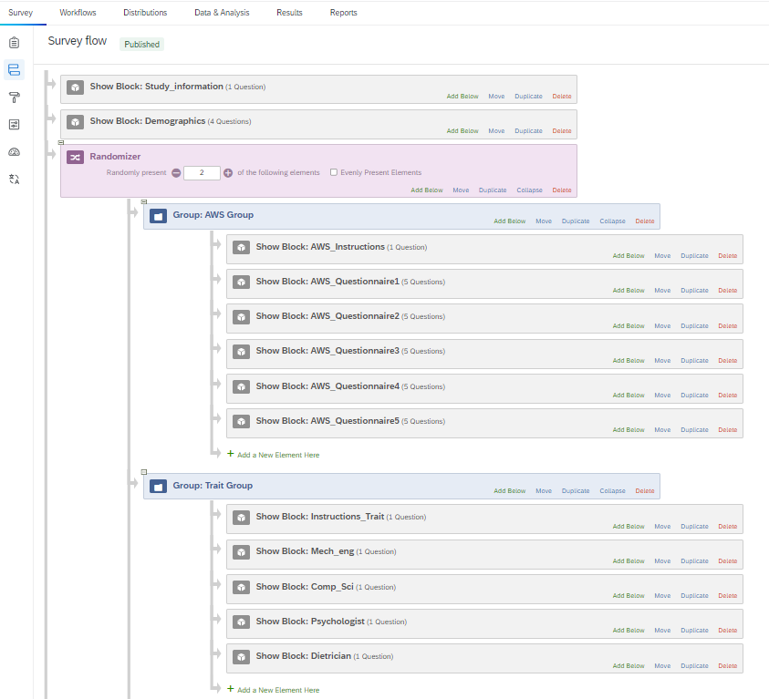
Engaging in the intricacies of survey flow, I acquired an extensive understanding of the various components and dynamics involved in structuring and organising survey instruments. Through this learning process, I gained insights into the effective arrangement of survey elements, the significance of question sequencing, and the overall impact on participant comprehension and engagement.
It required extensive research for me to grasp the implementation of a randomizer. I found the process of autonomous learning enjoyable, and I felt a sense of pride when it successfully functioned. The utilisation of a randomiser proved beneficial for counterbalancing the study.

Reference list
American Psychological Association. (2019). Publication Manual (OFFICIAL) 7th Edition of the American Psychological Association: 7th Edition, Official.
British Psychological Society (2014). Code of Human Research Ethics. Leicester: Author.
British Psychological Society (2018). Code of Ethics and Conduct. Leicester: Author.
Beede, D., Julian, T., Langdon, D., McKittrick, G., Khan, B., & Doms, M. (2011). Women in STEM: A Gender Gap to Innovation. Economics and Statistics Administration Report. Retrieved from: https://files.eric.ed.gov/fulltext/ED523766.pdf
British Psychological Society (2014). Code of Human Research Ethics. Leicester: Author.
British Psychological Society (2018). Code of Ethics and Conduct. Leicester: Author.
Ceci, S. J., Ginther, D. K., Kahn, S., & Williams, W. M. (2014). Women in Academic Science: A Changing Landscape. Psychological Science in the Public Interest, 15(3), 75–141. https://doi.org/10.1177/1529100614541236.
Coolican, H. (2014). Research methods and statistics in psychology (6th ed.). Hove, East Sussex: Psychology Press.
Davies, K. R. (2023) STEM Women Whitepaper Report: Understanding the gender imbalance in STEM. STEM Women. Retrieved from: https://www.stemwomen.com/stem-women-whitepaper
DePuy, V., & Berger, V. W. (2014). Counterbalancing. Wiley StatsRef: Statistics Reference Online.
Diekman, A. B., Brown, E. R., Johnston, A. M., & Clark, E. K. (2010). Seeking Congruity Between Goals and Roles: A New Look at Why Women Opt Out of Science, Technology, Engineering, and Mathematics Careers. Psychological Science, 21(8), 1051–1057. DOI: 10.1177/0956797610377342.
Dierdorff, E. C., Bell, S. T., & Belohlav, J. A. (2011). The power of “we”: Effects of psychological collectivism on team performance over time. Journal of Applied Psychology, 96(2), 247. https://doi.org/10.1037/a0020929
Driskell, J. E., Goodwin, G. F., Salas, E., & O'Shea, P. G. (2006). What makes a good team player? Personality and team effectiveness. Group Dynamics: Theory, Research, and Practice, 10(4), 249. https://doi.org/10.1037/1089-2699.10.4.249
Forrester, W. R., & Tashchian, A. (2010). Effects of Personality on Attitudes toward Academic Group Work. American Journal of Business Education, 3(3), 39-46. https://doi.org/10.19030/ajbe.v3i3.397
Gauch, Jr., H.G. (2003). Scientific method in practice. Cambridge, UK: Cambridge University Press.
Gibbs, G. (1988). Learning by Doing: A Guide to Teaching and Learning Methods. Further Education Unit.
HESA. (2021) Women in STEM: Percentage of Women in STEM statistics. Retrieved from: https://www.hesa.ac.uk/data-and-analysis/students/whos-in-he
Hill, C., Corbett, C., & St. Rose, A. (2010). Why So Few? Women in Science, Technology, Engineering, and Mathematics. American Association of University Women.
Iida, P. C., Ruegg, R., De Boer, M., Araki, N., & Agnello, M. F. (2020). The concise APA handbook: APA 7th edition. IAP.
Kozlowski, S. W. J., & Ilgen, D. R. (2006). Enhancing the Effectiveness of Work Groups and Teams. Psychological Science in the Public Interest, 7(3), 77-124. https://doi.org/10.1111/j.1529-1006.2006.00030.x
King, C., Phillips, C. E., Walker, K. D., & O'Toole, S. K. (2014). A reliability generalization of the attitudes toward women (AWS) scale. Race, Gender & Class, 151-168.
Kingsbury, M. (2015). Encouraging independent learning. In H. Fry, S. Ketteridge & S. Marshall (Eds.) A handbook for teaching and learning in higher education; Enhancing academic practice (4th ed., pp. 169-179). Oxon: Routledge.
Leslie, S.J,. Cimpian, A., Meyer, M., Freeland, E. (2015) Expectations of brilliance underlie gender distributions across academic disciplines. Science. 16(347), 262-5. doi: 10.1126/science.1261375. PMID: 25593183.
Moss-Racusin, C. A., Dovidio, J. F., Brescoll, V. L., Graham, M. J., & Handelsman, J. (2012). Science faculty’s subtle gender biases favor male students. Proceedings of the National Academy of Sciences, 109(41), 16474–16479. https://doi.org/10.1073/pnas.1211286109
Sheltzer, J. M., & Smith, J. C. (2014). Elite male faculty in the life sciences employ fewer women. Proceedings of the National Academy of Sciences, 111(28), 10107–10112. https://doi.org/10.1073/pnas.1403334111.
Smyth, T. R. (2004). The principles of writing in psychology. London: Palgrave Macmillan.

Spence, J. T., Helmreich, R., & Strapp, J. (1973). A short version of the Attitudes toward Women Scale (AWS). Bulletin of Psychonomic Society, 2, 219-220.

Štrukelj, E. (2018, January 3). Writing a systematic literature review [Blog post]. Retrieved from https://blog.efpsa.org/2018/01/03/writing-a-systematic-literature-review/
UWTSD. (2022) Research Ethics & Integrity Code of Practice. University of Trinity Saint David. https://www.uwtsd.ac.uk/media/uwtsd-website/content-assets/documents/research/REICoP-July-2022.pdf

Appendix
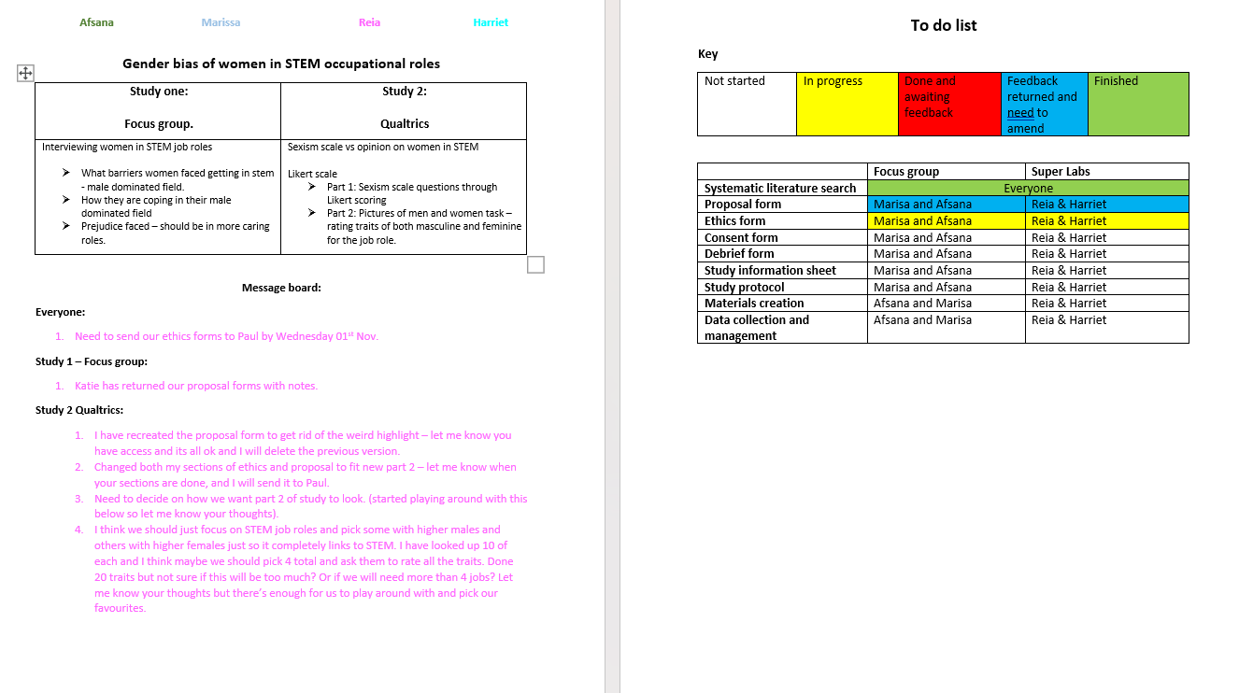
Appendix 1 Example of shared document with communication and keeping track of workload from week 5.

