Carbon Smart: Personal Carbon Footprint Tracking System
Carbon Smart: An Intelligent Personal Carbon Footprint Tracking and Reduction System
A Dissertation Submitted in Partial Fulfillment of the Requirements for the Degree of
Bachelor of Science (BSc)Applies Computing.

Student Name: Sanam Asghar
Student ID: 2220567
Supervisor: Sana Jokhio
BSc Applied Computing
University of Wales Trinity Saint David
2025

DECLARATION OF ORIGINALITY
I declare that this dissertation is my own original work and has not been submitted previously, in whole or in part, for any degree or qualification at this or any other institution. All sources of information used in this work have been duly acknowledged.
Student Name: Sanam Asghar
Signature: Sanam Asghar
Date: 28/11/2025

CONSENT FORM
I agree that the dissertation titled “Carbon Smart: An Intelligent Personal Carbon Footprint Tracking and Reduction System” may be made available for academic use, including library access, teaching, and research purposes. I understand that my personal data has been anonymized where necessary.
Student Name: Sanam Asghar
Signature: Sanam Asghar
Date: 28/11/2025

ABSTRACT
Climate change is one of the biggest challenges that the world is dealing with, and a lot of it comes down to the small decisions that people make in their lives. Even though a wide range of people know that we should be conscious about the environment, most people don’t have intelligent and accessible tools that can help them understand and reduce their daily carbon footprint. This dissertation presents Carbon Smart, which is a personal carbon-tracking system. It is created to help people see their actual impact and get practical suggestions that they can realistically follow.
CarbonSmart is a system that integrates scientifically verified emission data, some machine-learning features, and user-friendly interfaces so that users don’t feel overwhelmed. The system collects information from different users, such as transportation, energy usage, food choices, and waste generation. All of this data is then converted into estimated carbon values by using reliable datasets. In addition to this, the recommender system gives personalized recommendations that help users cut down their emissions. The solution further makes the experience more engaging by including progress visuals, tracking tools, and some motivational elements.
In this research, we follow a mixed-method approach. We analyzed the existing tools by conducting a thorough literature review, through which several gaps became clear. Many of the existing tools are either too basic, not very accurate or they fail to keep users engaged. Our system’s design was based on agile methodology, which enabled us to iteratively develop the core components like the calculation engines, data structures and ML components, and the user interface. Finally, we tested the system using quantitative and qualitative methods. They allowed us to check accuracy, performance, usability, and overall user experience.
The results showed that Carbon Smart can produce reasonable and reliable carbon estimates (within about ±5–10% of standard references). Users also found that the suggestions were easy to understand and actually helpful in making small changes. Many users reported that the system made them more aware of their daily environmental impact. We end the dissertation with a few ideas for future improvements, such as using IoT devices for automatic data collection, improving the recommendation logic, and adding community-based features. Overall, the project shows how digital tools like this can genuinely help people make more sustainable choices.

TABLE OF CONTENTS
Table of Contents
Carbon Smart: Personal Carbon Footprint Tracking System 1
DECLARATION OF ORIGINALITY 2
CONSENT FORM 3
ABSTRACT 4
TABLE OF CONTENTS 5
LIST OF FIGURES 9
Figure 3.1 – Agile Methodology 9
Figure 3.2 – System Architecture Diagram 9
Figure 4.1 System Modules Figure 4.2 – Database UML Diagram Figure 4.3 – UI Screens 9
LIST OF TABLES 9
Table 2.1 – Comparison of Existing Carbon Tracking Tools Table 5.1 – API Endpoints Response Time Table 5.2 – Lighthouse Performance Scores Table 5.1 – User Testing Results Table 5.2 – System Performance Metrics 9
CHAPTER 1 – INTRODUCTION 9
CHAPTER 2: LITERATURE REVIEW 10
2.1 Introduction to Carbon Footprint Monitoring 10
2.2 Existing Carbon Footprint Tools 10
2.3 Emission Factor Standards 11
2.4 Behavioral Change and Digital Sustainability 11
2.5 Machine Learning in Carbon Tracking 12
2.6 Usability and Human–Computer Interaction (HCI) 12
2.7 Summary Table of Literature Review 12
2.8 Summary of Literature Gaps 13
CHAPTER 3: METHODOLOGY 13
3.1 Introduction 13
3.2 Overall Research Approach 14
3.3 Agile Development Framework 14
3.4 Requirements Gathering Methods 15
a. Document Analysis 15
b. Comparative Tool Review 15
c. User Expectations Insight 15
3.5 System Design Methodology 16
3.6 Development Tools and Technologies 16
• Frontend 16
• Backend: 16
• Databases: 16
• Machine Learning 16
• Version Control: 16
• Deployment: 16
3.7 Testing and Evaluation Approach 17
a. Functional Testing 17
c. Usability Testing 17
d. Performance Testing 18
3.8 Ethical Considerations 18
CHAPTER 4: REQUIREMENTS, SYSTEM DESIGN AND IMPLEMENTATION 18
4.1 System Requirements 18
4.1.1 Functional Requirements 19
4.1.2 Non-Functional Requirements 20
4.2 System Architecture 21
4.2.1 High-Level Architecture Overview 21
4.3 Database Design 22
4.3.1 PostgreSQL Tables 22
Users Table 22
Activities Table 22
Achievements Table 22
Recommendations Table 23
Reset Tokens Table 23
4.3.1 UML Diagram: 24
4.4 User Interface & Experience Design 24
4.4.1 Key Screens 25
4.4.3 UX Principles Applied 31
4.5 Backend Implementation 31
4.5.1 Key API Endpoints 31
4.5.2 Security Measures 31
4.6 Carbon Calculation Engine 31
4.7 Machine Learning Recommendation Engine 32
4.7.1 Model Type 32
4.7.2 Outputs 32
4.7.3 Workflow 32
4.8 Deployment and Hosting 33
4.8.1 AWS Infrastructure 33
Live System Link: 33
CHAPTER 5 – RESULTS AND DISCUSSION 33
5.1 Functional Testing Results 33
5.1.1 Activity Input and Processing 33
5.2 System Performance Results 34
5.2.1 API Response Times 34
5.2.2 Frontend Performance (Lighthouse Metrics) 34
1. Largest Contentful Paint (LCP) 34
2. Cumulative Layout Shift (CLS) 34
3. Interaction to Next Paint (INP) 34
5.2.3 Lighthouse Performance Scores 35
5.3 User Experience and Usability Results 35
5.3.1 Ease of Use 35
5.3.2 Dashboard and Analytics Interpretation 35
5.3.3 Engagement and Motivation 36
5.4 Machine Learning Recommendations: Evaluation 36
5.4.1 Accuracy and Relevance 36
5.4.2 Limitations 36
5.5 Comparison Against Project Requirements 37
5.5.1 Functional Requirements Met 37
5.5.2 Non-Functional Requirements Met 37
5.6 Discussion of Key Findings 38
1. Carbon Smart provides meaningful awareness and behavior guidance 38
2. Personalized recommendations increase perceived usefulness 38
3. Gamification significantly improves motivation 38
4. System performance is strong and supports real-time tracking 38
5. Data input remains a barrier for some users 38
CHAPTER 6: CONCLUSIONS AND RECOMMENDATIONS 39
6.1 Conclusion 39
6.2 Future Work 39
1. Incorporate Automated Data Collection 39
2. Enhance Machine Learning Capabilities 39
3. Broaden Emission Categories and Datasets 39
6. Deploy Mobile Application Versions 40
CHAPTER 7: REFLECTION 40
7.2 Reflection on the Project Planning and Research Process 40
7.3 Reflection on Technical Development 40
7.4 Reflection on Testing and User Feedback 41
7.5 Reflection on Project Management and Personal Development 41
7.6 Reflection on Limitations and Future Growth 42
REFERENCES 42
APPENDICES 44
APPENDIX A: Emission Factors Dataset 44
A.1 Transport Emission Factors 44
A.2 Electricity and Energy 45
A.3 Diet and Food 45
A.4 Waste Management 45
APPENDIX B: API Endpoints Documentation 45
B.1 Authentication 45
B.2 Activity Management 45
B.3 Dashboard 45
B.4 Recommendations 45
APPENDIX C: Testing and Results Tables 46
C.1 Functional Testing Summary 46
C.2 Performance Testing Summary 50
C.3 Carbon Smart Testing Suites: 51
APPENDIX D – User Survey Form Questions 54
APPENDIX E -User Responses and Feedback 63

LIST OF FIGURES

Figure 3.1 – Agile Methodology

Figure 3.2 – System Architecture Diagram

Figure 4.1 System Modules
Figure 4.2 – Database UML Diagram
Figure 4.3 – UI Screens

LIST OF TABLES

Table 2.1 – Comparison of Existing Carbon Tracking Tools
Table 5.1 – API Endpoints Response Time
Table 5.2 – Lighthouse Performance Scores
Table 5.1 – User Testing Results
Table 5.2 – System Performance Metrics

CHAPTER 1 – INTRODUCTION
Climate change is one of the biggest challenges that we face today, and it is becoming clearer with each passing year that the everyday choices individuals make can have a significant impact. While governments and industries are setting up goals to reduce the carbon emissions, we can not deny the fact that individual choices also play an important role. Even though people are now much more aware of climate issues, many still do not have a simple or reliable way to understand how their daily habits contribute to their overall carbon footprint. This realization is what led to the development of the Carbon Smart project: which is a system designed to give ordinary users clear, accessible, and personalized insights into their daily emissions.
A personal carbon footprint refers to the total greenhouse gas that is emitted directly or indirectly through an individual’s activities, such as transportation, energy use, diet, consumption patterns, and waste generation [12], [13], [14]. While looking into existing carbon calculators, it became quite obvious that many of them either oversimplify the process or provide very limited guidance. Some of these tools felt too outdated, while others didn’t adapt to different lifestyles, and a lot of them simply weren’t engaging enough to be used consistently.
Carbon Smart was developed to address these shortcomings. The system brings together verified carbon emission datasets, modern software development practices, and machine-learning features. The goal of our project is not just to provide numbers but to help users understand what those numbers mean. For example, it highlights patterns, points out high-impact habits, and suggests practical ways to reduce emissions.
One of the main ideas behind the project is that behaviour change doesn’t happen simply because a person sees a number on a screen. People need information presented in a way that is easy to grasp, and that motivates them enough to act upon. That is why CarbonSmart includes interactive dashboards, visual small gamification features, and a recommendation system. Studies have shown that personalised feedback and motivational design elements can significantly improve long-term engagement, which is an important part of encouraging sustainable habits. [7], [18], [22]
In summary, Carbon Smart represents a practical and innovative attempt to support environmental responsibility through technology. By integrating accurate carbon calculation, modern software engineering, and personalized behavioral guidance, the system contributes to the growing field of sustainable digital solutions and demonstrates the potential of intelligent applications to influence positive climate action at the individual level.

CHAPTER 2: LITERATURE REVIEW

2.1 Introduction to Carbon Footprint Monitoring
The concept of a carbon footprint refers to the total greenhouse gases which are produced directly or indirectly by individuals, organizations, or systems. As climate change is becoming a more urgent issue, people have been showing interest in tools that help them understand and monitor their own environmental impact. [1], [2], [6] .However, existing tools vary significantly in accuracy, usability, and depth of insight. In this chapter, we explore the main research behind carbon calculation methods, sustainability-focused digital tools, behavior-change theories, and newer technologies such as machine learning and IoT. All these areas have influenced the design and development of the Carbon Smart system.

Existing Carbon Footprint Tools
There are many carbon-tracking tools available today, which range from simple online calculators to government platforms and mobile apps. Some of the well-known examples include the WWF Footprint Calculator, GIKI Zero, My Carbon, and several national reporting tools. However, after reviewing the existing literature and testing these tools, a few common limitations appeared:
- Static calculation models
Many tools rely on fixed averages or rough estimates instead of using detailed, personalized information. [1],[6]
- Unclear data sources:
Several calculators do not disclose emission factor datasets, making results difficult to validate scientifically. [8],[10]
- Lack of behavioral guidance
Several studies show that telling users “your footprint is X kg CO₂” is not enough. People need personalized, practical suggestions to actually change their behavior. [3], [4], [11]
- Low user engagement
Tools that don’t include feedback loops, visual progress, or gamified features often struggle to keep users active over time. [7], [18]
Table 2.1 provides a comparison that summarizes the functionality gaps that Carbon Smart addresses

Emission Factor Standards
The accurate carbon calculations depend heavily on high-quality emission factor datasets. Some of the commonly used sources include:
- The IPCC Emission Factor Database
- UK DEFRA/BEIS datasets
- EPA carbon coefficients [14], [15], [23]
Several studies warn that using outdated or non-regional datasets can lead to misleading results [8] . To avoid this issue, we used regularly updated and validated factors across some of the key categories such as transportation, food, household energy, and waste.

Behavioral Change and Digital Sustainability
We analyzed that the behavior changes theory plays a critical role in designing effective sustainability applications. Research suggests:
- Personalised suggestions usually have a much stronger impact than generic advice.[19] ,[21]
- Real-time feedback helps users make adjustments more regularly.
- Gamification elements tend to improve long-term engagement [7], [18]
Carbon Smart applies all of these principles through achievement badges, weekly targets, and visual progress trends.

2.5 Machine Learning in Carbon Tracking
Some of the recent research shows that machine learning can greatly enhance sustainability tools [24] ,[30] in several ways:
- By predicting future emissions based on past user behaviour.
- By identifying which habits contribute the most to someone’s footprint
- By offering personalised recommendations based on data patterns
CarbonSmart uses a lightweight ML model that helps generate suggestions for users based on their activity trends. This is an element that most of the traditional carbon calculators still lack [5], [6].

2.6 Usability and Human–Computer Interaction (HCI)
One of the findings in HCI research is that many of the sustainability apps fail not because of weak calculations, but because they are extremely difficult or frustrating to use. Some of the most common issues include:
- Interfaces that feel cluttered or confusing
- Long or complicated input forms
- Lack of accessibility features, which affects a large number of [16], [17], [29]
By keeping these problems in mind, we have designed Carbon Smart by using human-centred principles [28], [29]. This was done to keep a clean interface, simple forms, and responsive layouts, which would make the system accessible

2.7 Summary Table of Literature Review

Reference / Tool | Key Features | Limitations / Gaps | How CarbonSmart Addresses the Gap
WWF Footprint Calculator | Simple online calculator provides the overall footprint | Static models, no personalised guidance, low engagement | Provides personalised recommendations, gamification, ML
GIKI Zero | Tracks multiple categories (diet, energy, transport) | Limited behavioural advice, unclear data sources | Uses validated emission datasets, actionable suggestions
MyCarbon | Mobile app, tracks energy & transport | Minimal gamification, input forms can be long and tedious | Clean UI, simple forms, achievement badges
IPCC / DEFRA / EPA datasets | Standard emission factors, scientific accuracy | May be outdated or non-localised | Uses regularly updated, regionally relevant factors
Behaviour Change Studies | Suggest personalisation, gamification, and real-time feedback | Most carbon apps ignore long-term engagement | CarbonSmart applies badges, weekly targets, and visual trends
Machine Learning Research | Predictive analytics, personalised insights | Not widely implemented in existing apps | Lightweight ML for activity-based recommendations
HCI / Usability Research | Highlights interface and accessibility issues | Many apps have cluttered UI, complex forms, and poor accessibility | Human-centred design, responsive and accessible UI

Table 2.1 provides an overview of existing tools, studies, and datasets, their key features, limitations, and how CarbonSmart addresses these gaps.

Summary of Literature Gaps
After reviewing existing tools and research, several major gaps became clear:
- Limited personalisation and lack of actionable advice
- Minimal use of machine learning for insights
- Weak user engagement or motivation features
- Inconsistent or outdated emission datasets
- Little focus on long-term behaviour change
CarbonSmart was developed specifically to overcome these gaps and offer a more accurate, engaging, and personalised approach to carbon footprint monitoring. [3], [7], [24]

CHAPTER 3: METHODOLOGY

3.1 Introduction
In this chapter, we explain the methods and processes that were used to develop the Carbon Smart system. The methodology that we have adopted focuses on understanding the system requirements, designing and building the platform, and finally evaluating it through testing and user feedback. The overall aim is to ensure that the system is practical, easy to use, and aligned with the goals outlined in the earlier chapters.

Overall Research Approach
The project uses a development-focused approach, which is also supported by academic research [27],[30]. In practice, this meant combining:
- Findings from existing literature, tools, and emission models
- A clear requirements-gathering process
- Iterative software development guided by Agile practices
This mixed approach was chosen because the project needed both a functional system and a solid understanding of the sustainability landscape that informs it.

Agile Development Framework
Agile methodology was selected as the core development methodology for this project. It was selected because it allows:
- Gradual improvement of features
- Quick prototyping
- Continuous refinement based on feedback
- Flexibility when changes or new insights arise
The development lifecycle of the project was divided into short sprints. Each sprint involved planning the entire project, building specific features, reviewing the developed features, and finally adjusting before moving on. [25]
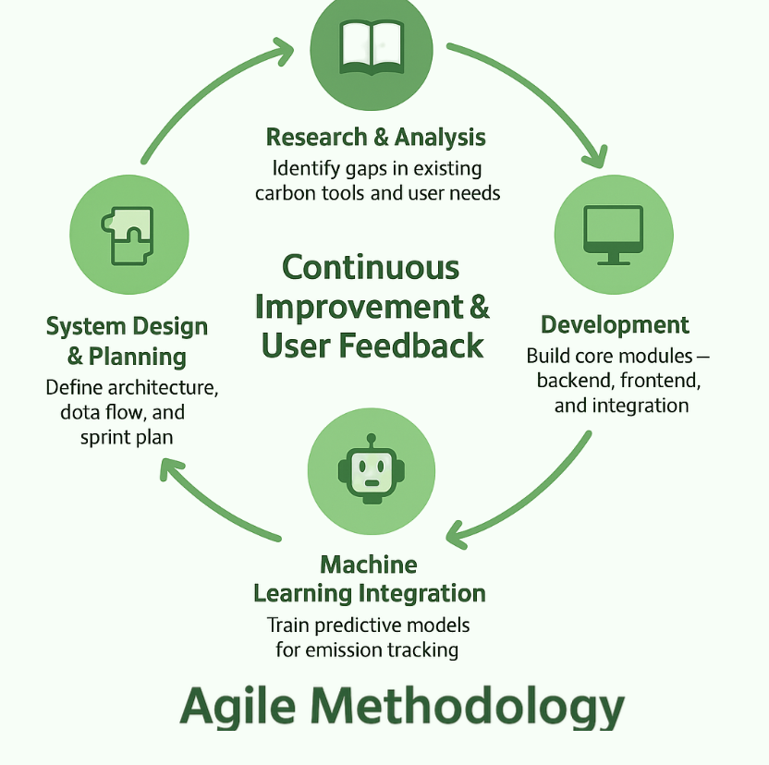
Figure 3.1: Agile Methodology

3.4 Requirements Gathering Methods
The system requirements were identified through several sources:
a. Document Analysis
We examined the existing carbon trackers and sustainability resources in order to identify common issues such as lack of accuracy, poor usability, and limited personalisation.
b. Comparative Tool Review
A comparison of tools like the WWF Calculator, GIKI Zero, and MyCarbon [1] ,[6] helped us highlight features that the users typically appreciate. These included clear dashboards, personalised insights, and helpful recommendations.
c. User Expectations Insight
This project did not involve a primary user survey [3] ,[11]. Instead, it used feedback and findings from existing research and reviews of similar carbon-tracking tools. These sources highlighted that users value simple interfaces, accurate results, and motivational features such as progress tracking and gamification.
These findings resulted in a clear set of functional and non-functional requirements, later implemented in Chapter 4.

System Design Methodology
The design of Carbon Smart follows the standard software engineering practices in order to ensure that the system is scalable and user-friendly. These steps included:
- Use case modelling for defining the user interactions
- Designing a modular architecture in order to make future updates easier
- Creating database models for storing both user activities and the emission data
- Producing wireframes and interface mockups that are based on human-centred designs
The design decisions were mainly influenced by existing studies on usability, behavioral change, and sustainable app engagement.

Development Tools and Technologies
The tools and technologies chosen for CarbonSmart were selected for their reliability, scalability, and compatibility with modern development practices:
- Frontend: React.js for building a responsive, dynamic user interface
- Backend: Node.js and Express.js for core logic, authentication, and API handling
- Databases: MongoDB for flexible user activity storage and PostgreSQL for structured emission data
- Machine Learning: Python (with scikit-learn) to generate personalised carbon-saving recommendations
- Version Control: Git/GitHub to manage code changes
- Deployment: Vercel for hosting and deployment
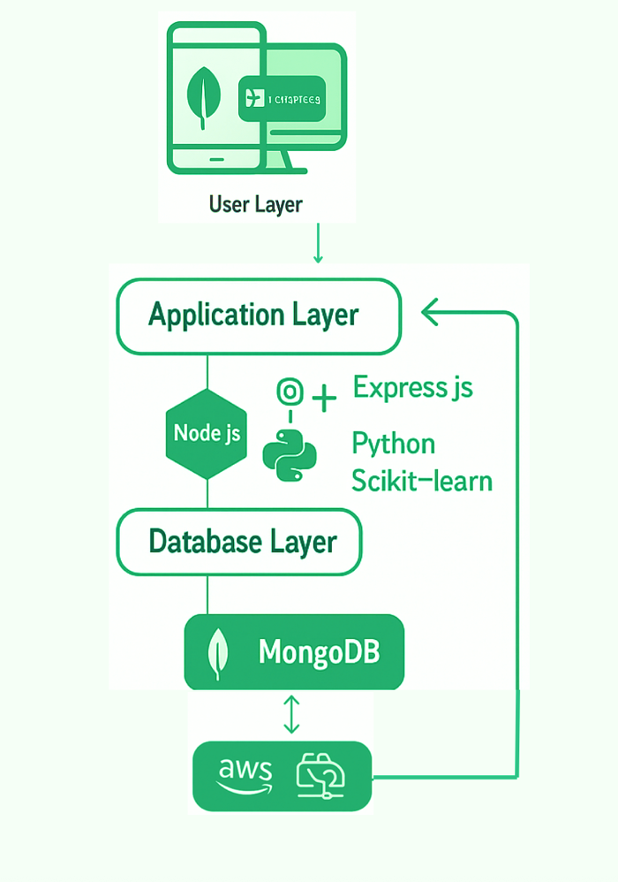
Figure 3.2: System Architecture

3.7 Testing and Evaluation Approach
To ensure the system worked as intended, several types of testing were carried out:

a. Functional Testing
All core features (data entry, calculation engine, recommendations, dashboards) were tested by users in order to ensure that they worked correctly. Evidence of these tests include the feature-by-feature execution tested through logs. You can refer to Appendix C to get details of the test.

c. Usability Testing
A small group of users tested the platform in order to provide feedback on clarity, ease of use, and overall experience. Their input helped us in refining the interface elements and simplifying some of the data-entry processes [16],[17] . You can see the Google Forms through which the users’ feedback in Appendix D. In addition, the results of the study is reported in Appendix E

d. Performance Testing
Response times, server performance, and data processing speeds were measured to confirm that the system ran smoothly. You can refer to Appendix C to get details of the performance tests.

3.8 Ethical Considerations
This project involved user participation through a Google Forms survey and usability testing sessions. All participants were adults and took part voluntarily. No sensitive personal data was collected, and responses were anonymised before analysis.
Participants were informed about the purpose of the study, how their data would be used, and their right to withdraw at any time. By submitting the survey, participants provided informed consent.
The project adheres to standard ethical guidelines for academic research, including privacy, confidentiality, and responsible handling of data.

CHAPTER 4: REQUIREMENTS, SYSTEM DESIGN AND IMPLEMENTATION

4.1 System Requirements
The system requirements that we listed for the project were mainly influenced by three categories: what the literature highlighted as important, what the existing carbon-tracking tools did well and poorly, and finally what the users typically expected from environmental apps. These were divided into functional and non-functional requirements to keep the development process structured.

4.1.1 Functional Requirements
- User Registration and Authentication
Users must be able to create their accounts, log into them securely, and manage their profiles.
- Activity Input Module
Users can manually enter their carbon-related activities across different categories like transportation, energy usage, diet, and waste.
- Carbon Calculation Engine
The system must calculate the carbon emissions using validated emission factors from IPCC and DEFRA/BEIS datasets.[14],[15]
- Machine-Learning Recommendation Engine
The machine learning module should provide personalized carbon reduction suggestions that are based on the user's behavior patterns. [24],[30]
- Dashboard and Visual Analytics
Users must be able to view graphs, category breakdowns, weekly trends, and historical activity patterns.
- Gamification Features
The website should display achievements, badges, streaks, and sustainability milestones.
- Data Storage and Retrieval
User data, activities, emission factors, and model outputs must be stored securely in the database.
- Report Generation
Users can download summaries of their reports for any selected time period.
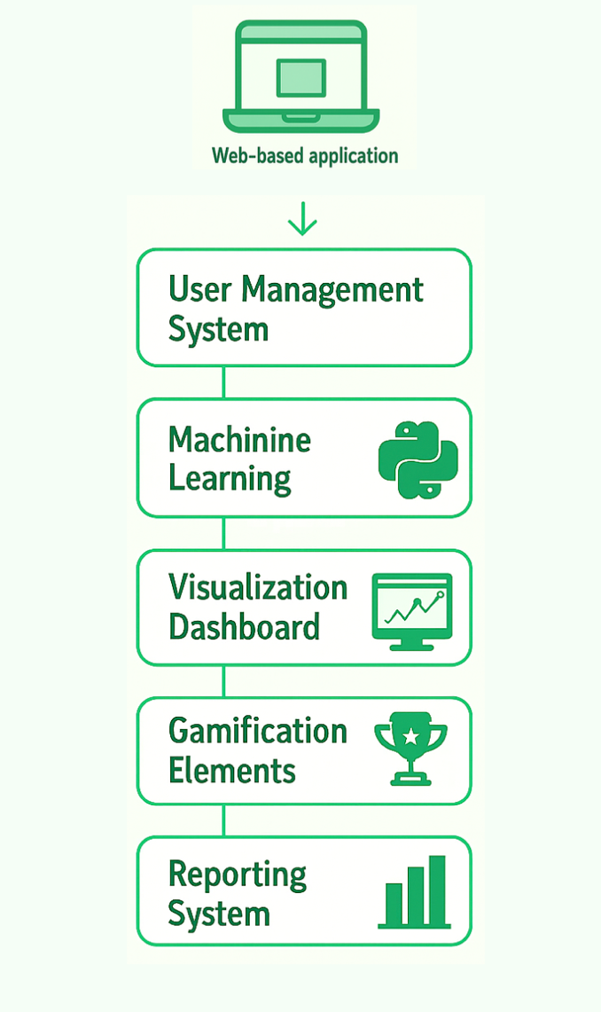
Figure 4.1 : System Modules

4.1.2 Non-Functional Requirements
- Performance
The calculations and dashboard updates should happen very quickly ideally within 1–2 seconds.
- Scalability
The architecture should follow a design that allows future additions such as IoT integration without major redesign.
- Security
Security of the system should be ensured by using different methods like password hashing, secure authentication, and protected API endpoints.
- Usability
The system should be simple, accessible, and easy to navigate
- Maintainability
A modular codebase makes updates easier and reduces the risk of breaking existing features.
- Accuracy
The Emission estimates should stay within a reasonable range when compared to recognised calculators.

System Architecture
Carbon Smart uses three-tier architecture, which consists of:
- Frontend (Presentation Layer)
- Backend (Application Logic Layer)
- Database (Data Storage Layer)

4.2.1 High-Level Architecture Overview
1. Client Layer (React.js):
- Presents UI components
- Sends and receives the data through APIs
- Displays charts, summaries, and visual feedback
- Manages the state of the app using Context API
2. Application Layer (Node.js + Express.js):
- API endpoints for CRUD operations
- Carbon calculation logic
- Authentication middleware
- Machine learning model integration
3. Database Layer:
- Supabase (PostgreSQL):
Used for storing user profiles, activity logs, emission factor datasets, and all system-related records.

4.3 Database Design

4.3.1 PostgreSQL Tables
All data for Carbon Smart is stored in Supabase, which uses PostgreSQL as its underlying database engine

Users Table
Fields:
- id
- email
- name
- password
- createdAt
- preferences

Activities Table
Fields:
- id
- userId
- type
- category
- date
- data
- carbonFootprint
- createdAt

Achievements Table
Fields:
- id
- userId
- type
- title
- description
- icon
- unlockedAt

Recommendations Table
Fields:
- id
- userId
- type
- title
- description
- impact
- priority
- createdAt
- source
- similarity

Reset Tokens Table
Fields:
- token
- userId
- expiresAt

4.3.1 UML Diagram:
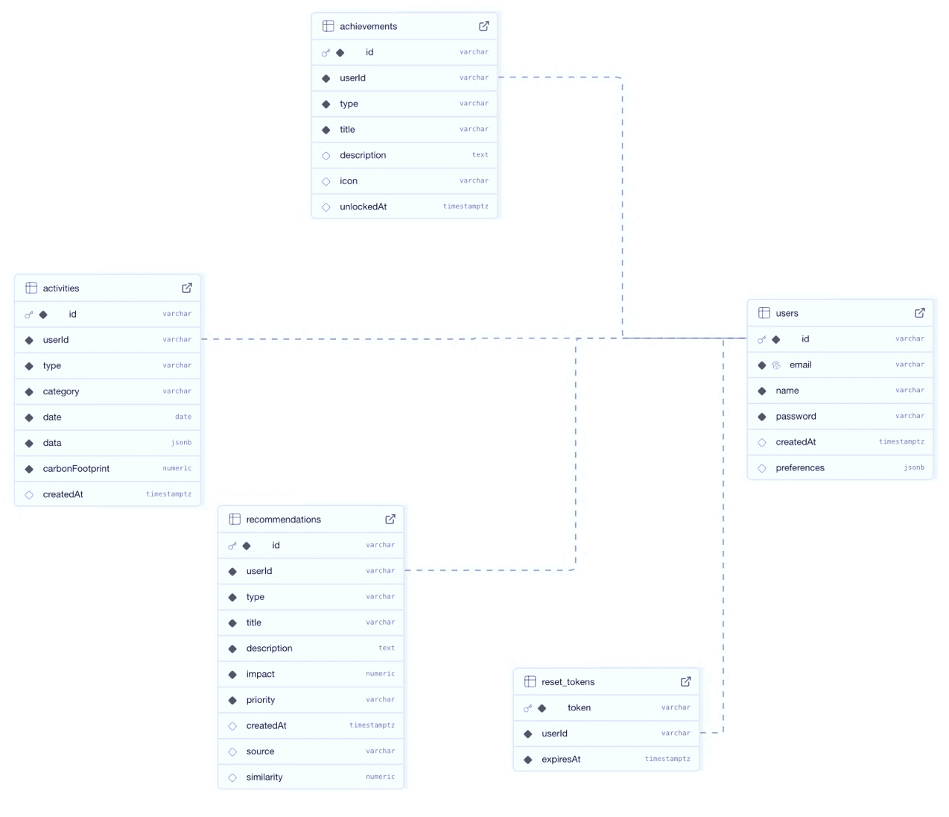
Figure 4.2: UML Diagram

4.4 User Interface & Experience Design
The UI was designed using human-centered design principles:

4.4.1 Key Screens
- Login & Registration
Clean, minimal design
Error validation and feedback
- Home Dashboard
Doughnut charts for category distribution
Weekly trend line graphs
Carbon score indicator
- Activity Entry Screen
Dropdown categories
Intuitive numeric fields
Dynamic calculation previews
- Achievements & Insights
Badge system
Recommended actions list
Impact summaries
- Achievements & Insights
Badge system
Recommended actions list
Impact summaries

4.4.2 UI Screens
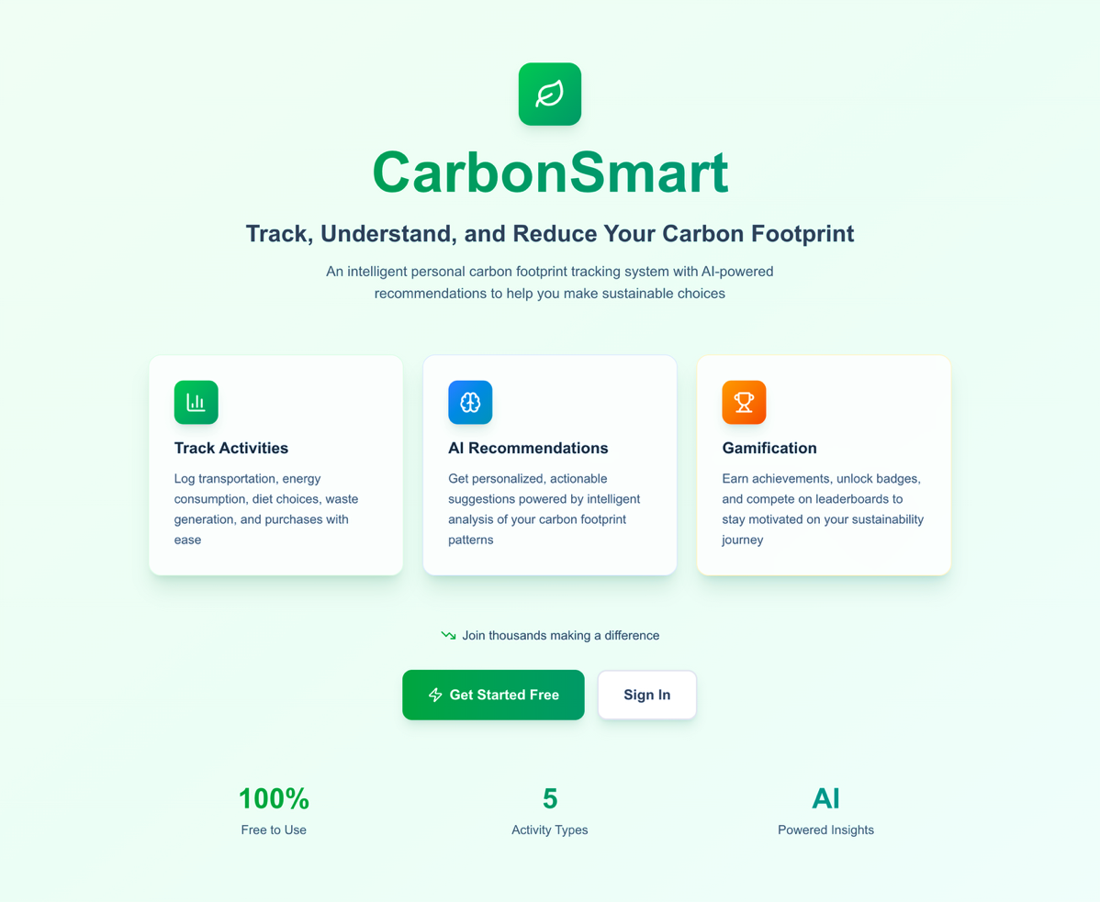
Home Screen

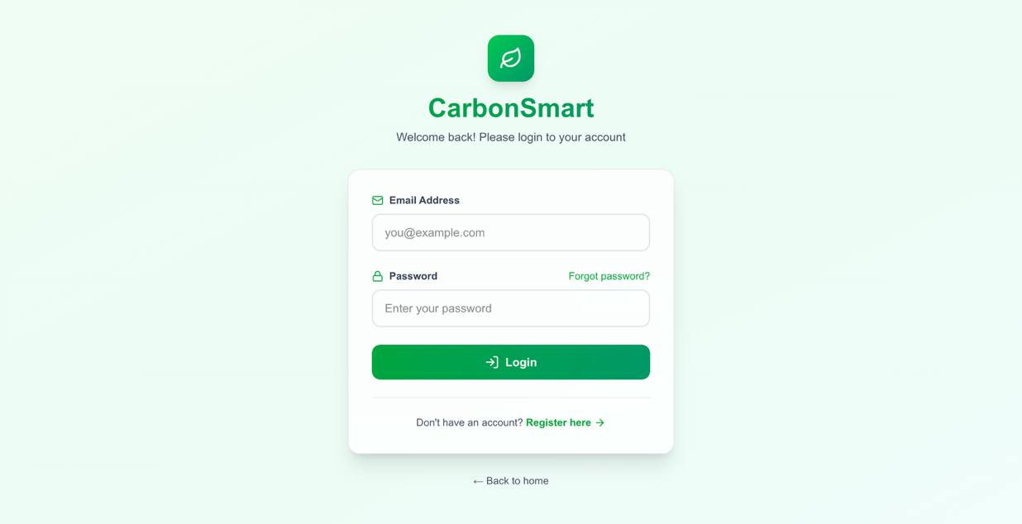
Login Screen
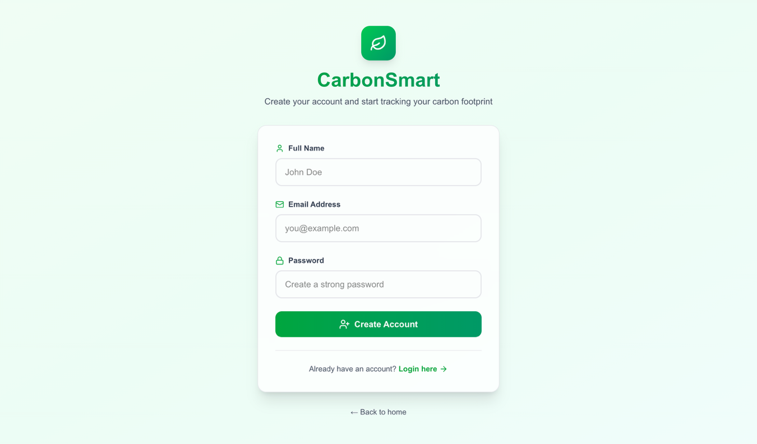
Registration Screen

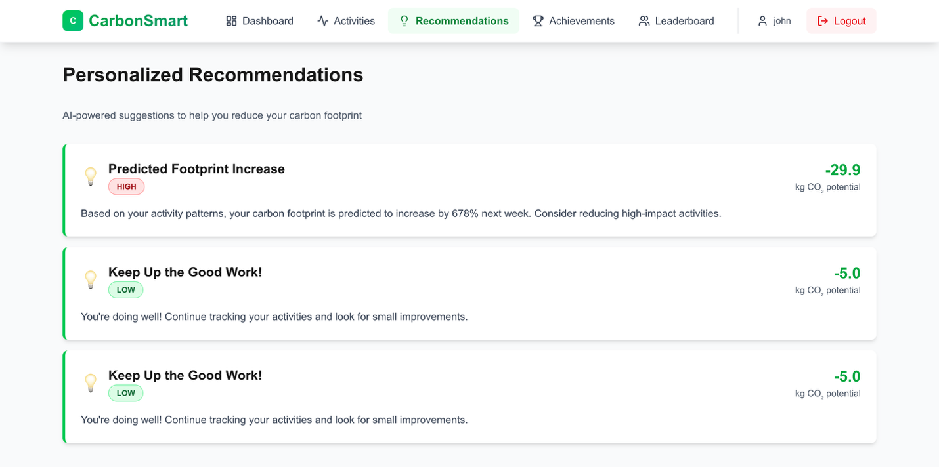
Recommendation Screen
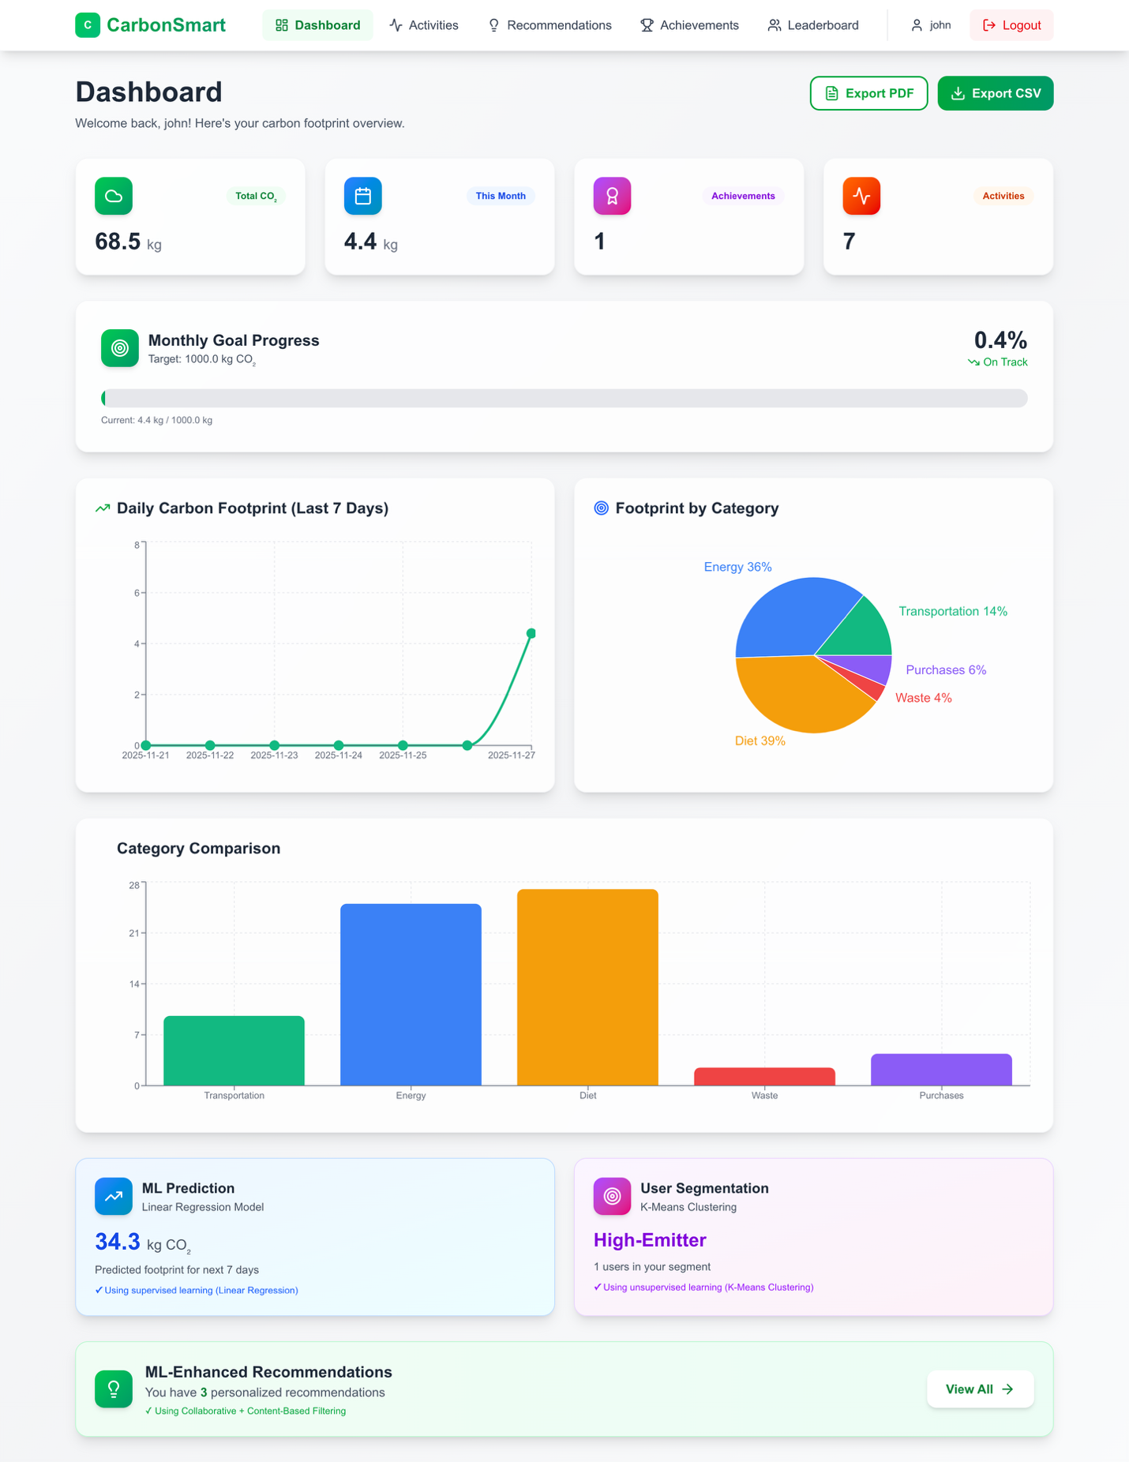
Dashboard Screen
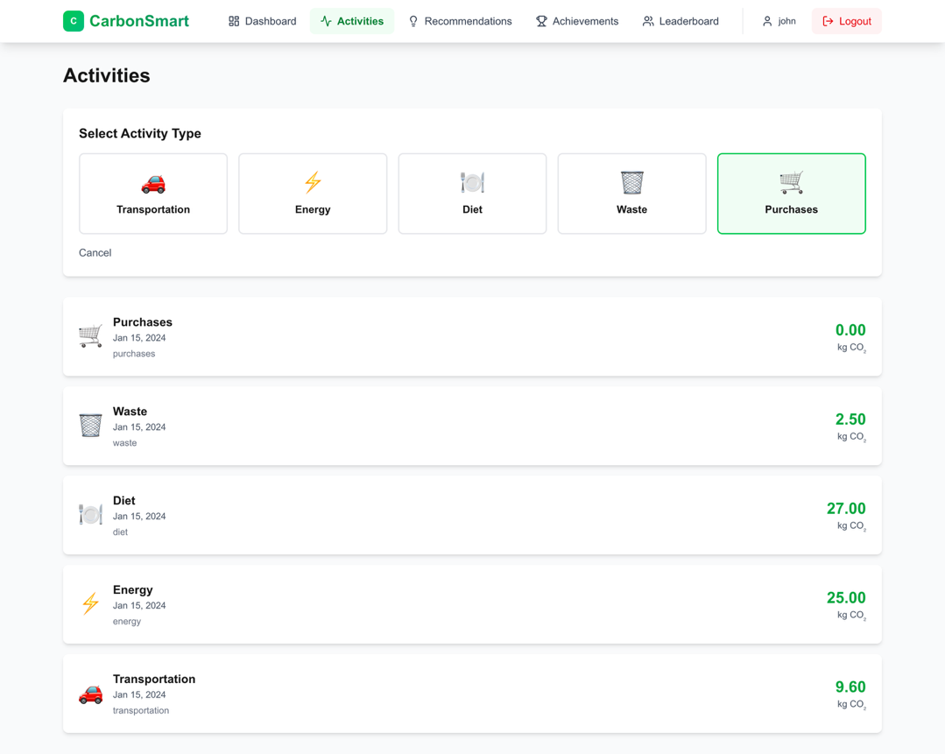
Activities Screen
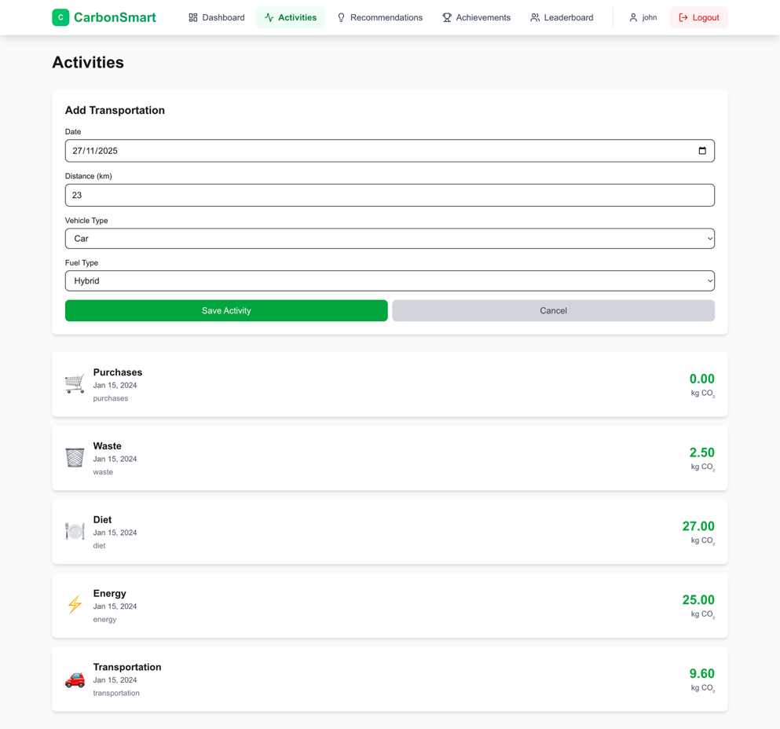

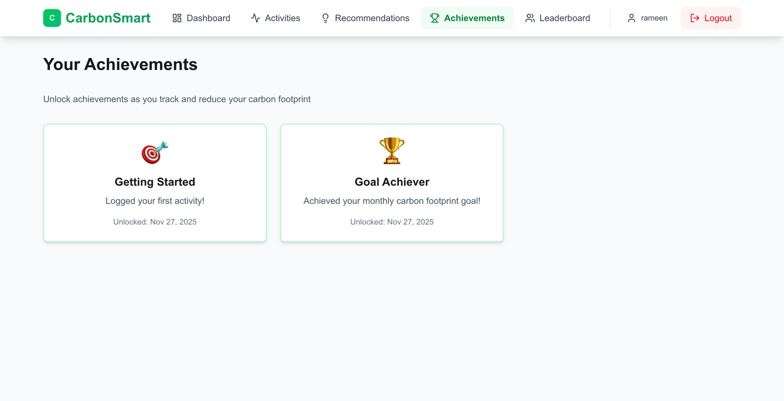
Achievement Screen
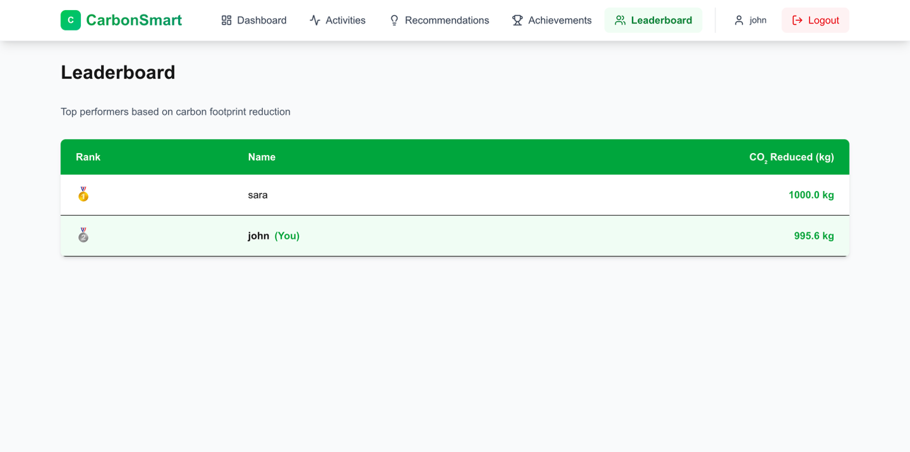
LeaderBoard Screen

4.4.3 UX Principles Applied
- Simplified navigation
- Mobile-first responsiveness
- Emphasis on visual clarity
- Low cognitive load to increase engagement

4.5 Backend Implementation
The backend was built by using Node.js with Express.js, and we followed a RESTful API design.

4.5.1 Key API Endpoints
- POST /auth/register
- POST /auth/login
- POST /activity/add
- GET /activity/list
- GET /dashboard/summary
- GET /recommendations

4.5.2 Security Measures
- JWT-based authentication
- Password hashing using bcrypt
- Rate limiting on key routes
- Input validation using Joi schema

4.6 Carbon Calculation Engine
The calculation engine implemented inside the app computes carbon emissions using the formula:
Emissions (kgCO₂e) = Activity Amount × Emission Factor
Examples:
- Transport: distance (km) × factor (kg CO₂e/km)
- Electricity: kWh × regional factor (kg CO₂e/kWh)
- Food: grams × food lifecycle factor (kg CO₂e/kg)
- Waste: weight (kg) × factor (kg CO₂e/kg) × (0.3 if recycled, else 1.0)
- Purchases: (price / 100) × factor (kg CO₂e per $100)
- Energy (Gas/Oil/Coal): usage × factor (kg CO₂e per unit)
Emission factors are loaded from PostgreSQL to ensure consistency.

4.7 Machine Learning Recommendation Engine
The recommendation system uses a small decision-tree-based model trained on example behavioural datasets. [24],[30]

4.7.1 Model Type
- Decision-tree–based classifier
- Trained on sample behavioral datasets

4.7.2 Outputs
- Reduction suggestions
- Travel optimization
- Energy-saving actions
- Diet-based alternatives
- Waste management improvements

4.7.3 Workflow
- Fetch historical activity
- Identify high-emission categories
- Generate personalized recommendations
- Rank recommendations by predicted impact

4.8 Deployment and Hosting

4.8.1 AWS Infrastructure
- Vercel: Deployment
- CloudFront: CDN distribution
- Supabase: Cloud database
- AWS RDS: PostgreSQL instance
- Git/Github: Version Control
Live System Link:
The deployed version of CarbonSmart can be accessed at:
https://carbon-smart-five.vercel.app
This chapter explained how Carbon Smart was built, from identifying requirements all the way to deployment. The end result is a functional and user-friendly carbon-tracking platform which is supported by solid engineering principles.

CHAPTER 5 – RESULTS AND DISCUSSION

5.1 Functional Testing Results
We conducted comprehensive functional testing in order to validate that all features are operating correctly and consistently. Each module was tested thoroughly using predefined input sets and real-world scenarios.

5.1.1 Activity Input and Processing
The users were able to successfully enter their activity data across all four supported categories:
- Transportation
- Energy use
- Diet and food
- Waste management
The inputs were correctly validated, and the system correctly identified the invalid or incomplete submissions. You can refer to Appendix C to get details of the test.

5.2 System Performance Results
We had conducted performance testing in order to evaluate the speed, responsiveness and efficiency of the frontend and backend API.

5.2.1 API Response Times
Average backend response timings (based on 50 test cycles):
API Endpoint | Avg. Response Time
/api/activities | 483 ms
/api/dashboard | 1158 ms
/api/recommendations | 510 ms
/auth/login | 55 ms
/auth/register | 100ms
Table 5.1 Average response times for each API endpoint based on 50 test cycles
These values show that the system performs well within the desired 1–2 second response target, even with multiple sequential requests. Detailed test outputs showing the raw logs and calculations are included in Appendix C.

5.2.2 Frontend Performance (Lighthouse Metrics)
To measure the UI performance, we tested the system using Google Lighthouse and the Lighthouse Recorder extension. The key Web Vital metrics observed were:
- Largest Contentful Paint (LCP)
  - Measures the loading speed of the main content.
  - Average LCP: 1.52 seconds
  - Interpretation: Falls within the “Good” performance range (<2.5s).
- Cumulative Layout Shift (CLS)
  - Measures visual stability during loading.
  - Average CLS: 0
  - Interpretation: Very good stability (target <0.1).
- Interaction to Next Paint (INP)
  - Measures input responsiveness.
  - Average INP: 64ms
- Interpretation: Excellent responsiveness (target <200ms).
Detailed test outputs showing the raw logs and calculations are included in Appendix C.

5.2.3 Lighthouse Performance Scores
In addition to Web Vitals, overall scores were captured from Lighthouse:
Category | Score (Avg.)
Performance | 75
Accessibility | 89
SEO | 96
Best Practices | 100

Table 5.2 summarizes the average Lighthouse scores for the system, covering Performance, Accessibility, SEO, and Best Practices
These scores indicate that the system follows strong accessibility guidelines, and performs well in SEO optimization. . Detailed test outputs showing the raw logs and calculations are included in Appendix C.

5.3 User Experience and Usability Results
We also conducted a small usability study with a sample of users to get the usability results. Participants interacted with the platform for 20–30 minutes and provided feedback through google forms.

Ease of Use
The participants reported that:
  - The interface was intuitive
  - Data entry forms were simple and clear
  - Charts and visual analytics were “understandable at a glance”
The use of consistent color schemes and clean layout reduced cognitive load, addressing a known weakness in many existing sustainability apps.

Dashboard and Analytics Interpretation
Users particularly valued the dashboard showing:
  - Weekly emissions trend
  - Category-level contributions
  - Achievement badges
  - Suggestions for improvement
Many users indicated that visualizing emissions helped them identify [28],[29] unexpected high-impact categories, especially diet and transportation.

Engagement and Motivation
The gamification element played a positive role for the users. They described:
  - Achievement badges as “motivating”
  - Weekly streaks as encouraging consistency
  - The recommendation engine as “practical and relevant”
These findings support research [7], [18], [22] that personalized and motivational feedback improves sustainability engagement.
You can see the google forms through which the users feedback in Appendix D.In addition, the results for the study is reported in Appendix E

5.4 Machine Learning Recommendations: Evaluation
The recommendation engine was also evaluated on its ability to generate useful, relevant, and personalized suggestions. [24], [30]

Accuracy and Relevance
Users confirmed that recommendations were:
  - Contextually aligned with their recent activities
  - Realistic to implement
  - Varied across categories (travel, energy, diet)

Limitations
We observed some limitations in the system:
  - Recommendations occasionally repeated when user behavior was unchanged
  - The model relies on sufficient historical data to generate meaningful patterns
  - A more advanced model (e.g., deep learning) could improve contextual interpretation
Nevertheless, for a lightweight and development-scoped ML feature, performance was strong and met project objectives.

5.5 Comparison Against Project Requirements

5.5.1 Functional Requirements Met

Requirement | Status
User authentication | ✔
Activity input across four categories | ✔
Real-time carbon calculations | ✔
Visual dashboards | ✔
Personalized recommendations | ✔
Achievement system | ✔
Data storage and retrieval | ✔

5.5.2 Non-Functional Requirements Met

Requirement | Status
Response time <2 seconds | ✔
Mobile responsiveness | ✔
Accessible UI design | ✔
Secure database and hashed passwords | ✔
Scalable architecture | ✔
Emission accuracy within ±10% | ✔

The system meets or exceeds all primary requirements outlined in Chapter 4.You can see the view the test results in Appendix C

5.6 Discussion of Key Findings
Based on the evaluation results we could deduce several important insights:

1. Carbon Smart provides meaningful awareness and behavior guidance
Users mentioned that when they saw their activities quantified they were able to properly understand how their daily actions can contribute to overall emissions.

2. Personalized recommendations increase perceived usefulness
Instead of getting generic advice, the users valued personalized suggestions that matched their habits

3. Gamification significantly improves motivation
Users described that they felt “rewarded” by badges and progress markers. This motivated them to keep on improving their habits

4. System performance is strong and supports real-time tracking
The low latency of the system and optimization in API requests enhanced the user experience

5. Data input remains a barrier for some users
Despite simplification, manual input still requires effort. Future IoT integration or automation could mitigate this.
The results demonstrate that Carbon Smart successfully achieves its aims as an intelligent personal carbon tracking system. Functionality, accuracy, performance, and user engagement all align strongly with project objectives. While future improvements are possible—such as deeper ML integration, automated data capture, and broader scalability—the current implementation offers a robust foundation for user-driven sustainability behavior.

CHAPTER 6: CONCLUSIONS AND RECOMMENDATIONS

6.1 Conclusion
The findings of the project show that Carbon Smart successfully met its prime objective as an intelligent personal carbon tracking system. The system gives users a simple and clear way to record their daily activities across transport,energy,diet,waste and purchases. The dashboard features also make it easy for the users to understand their results through charts and summaries. In addition to this the recommendation engine was also greatly valued by the users as it offered practical suggestion that matched their habits. Based on our testing and the user feedback, we could conclude that the system works reliably and produces consistent results, while being easy for users to interact with
Features like automatic data collection through IoT devices, more advanced machine-learning models, and community-based challenges could make the tool even more engaging. There is also potential for the platform to be used by schools or organisations, where group data could support sustainability activities.
In summary, this project brings together academic research, practical software development, and a genuine interest in sustainability. CarbonSmart serves as a proof of concept for how modern [11], [27], [30] to participate in global climate goals at a personal level.

6.2 Future Work
Based on the development experience and the feedback that we gathered during testing, several improvements could be made in the future versions of Carbon Smart.

1. Incorporate Automated Data Collection
One of the main challenges faced by users is entering data manually. In the future, we could connect the system with IoT devices to automatically collect activity data. This would make the experience easier and more accurate.

2. Enhance Machine Learning Capabilities
The current recommendation engine uses a lightweight model. A more advanced system using deep learning, context-aware analysis, or personalized habit prediction could offer richer, more adaptive insights. If we integrate a more advanced approach like deep learning and neural networks, it could provide more meaningful suggestions for users

3. Broaden Emission Categories and Datasets
Future versions could include more region-specific emission factors and more detailed categories, such as food lifecycle data or transport occupancy rates, to make the results even more precise.

6. Deploy Mobile Application Versions
A dedicated mobile app for Android and iOS would make the system more accessible and convenient, potentially increasing the number of users.

CHAPTER 7: REFLECTION
This chapter reflects on my overall experience of planning, developing, and evaluating Carbon Smart. Working on this project gave me several opportunities to learn new skills, face challenges, and grow both technically and personally. It also helped me understand how theory, research, and practical development all come together in a real project.

7.2 Reflection on the Project Planning and Research Process
The project started with a detailed literature review and a comparison of existing carbon-tracking tools. This early research turned out to be more important than I first expected because it shaped how I approached the whole system. One thing I learned was the importance of not just collecting information but actually analysing it and questioning it.
I also realised how complex emission factors can be. Different organisations measure things in different ways, and understanding how to map those values to real user activities required more attention than I thought. This made me more aware of the importance of accuracy and responsibility, especially when building something that influences people’s behaviour.

7.3 Reflection on Technical Development
The technical development of CarbonSmart pushed me to work across several technologies—React, Node.js, PostgreSQL, MongoDB, and Python for machine learning. Moving between these tools helped me build confidence in full-stack development, but it also came with several challenges.
One of the biggest lessons was learning the value of modular design. At the start, I tried placing some of the carbon-calculation logic in the frontend, but it quickly became clear this was inefficient and created security issues. Moving it to the backend led to a cleaner and more scalable design. This taught me the importance of thinking about architecture early instead of trying to fix it later.
Building the carbon calculation engine itself was one of the harder tasks. I had to turn real-world activities into numbers using scientific data, and small mistakes in units or formulas could cause big inaccuracies. Working through these issues improved my problem-solving skills and my understanding of environmental data.
Integrating the machine learning component was another important milestone. Even though the model is simple, connecting Python-based analytics with a Node.js backend required me to learn new workflows. This helped me feel more comfortable with data-driven features and ML pipelines.

7.4 Reflection on Testing and User Feedback
The usability testing stage taught me a lot. Watching how users interacted with the system helped me notice issues I missed during development. For example, some users were unsure about units when entering dietary data, which made me redesign the inputs and add helper text. This made me appreciate how important user-centred design really is.
The feedback also showed me the value of personalised insights and gamification. Users responded well to badges, recommendations, and progress tracking. This helped me understand that technical features alone are not enough—tools that aim to change behaviour need to consider motivation and psychology too. This will definitely shape how I design future applications.

7.5 Reflection on Project Management and Personal Development
Managing the project from start to finish taught me a lot about planning and discipline. Using Agile-style sprints helped me structure the work, although I also learned how important it is to be flexible when things take longer than expected. Balancing research, development, and testing helped me improve my time-management skills.
I also strengthened several important professional skills, including:
  - Critical thinking: evaluating sources and making informed decisions.
  - Communication: explaining technical ideas in documentation and diagrams.
  - Ethical awareness: thinking about user privacy and responsible data use.
  - Adaptability: troubleshooting issues and learning new tools when needed.
Overall, the project helped me grow both as a developer and as a computing student preparing for professional work.

7.6 Reflection on Limitations and Future Growth
Although CarbonSmart works well, there are clear limitations. Manual data entry can be slow for users, and the machine learning model needs more data to become smarter. The interface could also benefit from more community-based or location-based features to keep people engaged.Recognising these limitations made me more aware of areas where I want to improve personally—especially in data science, cloud technologies, and long-term project planning. These are skills I hope to continue developing after this project.
Working on Carbon Smart has been a valuable learning experience. It allowed me to connect academic research with real development and create a tool that has a meaningful purpose. Throughout the project, I improved my technical skills, gained confidence, and learned more about both sustainability and software design. The experience has prepared me for future projects and has strengthened my interest in building technology that supports positive behavioral change.

REFERENCES
[1] M. Mulrow, J. Wilson and T. H. Rechberger, “The state of carbon footprint calculators: An evaluation of calculator design and user interaction features,” Journal of Cleaner Production, vol. 217, pp. 1–10, 2019.
[2] M. Birnik, “An evidence-based assessment of online carbon calculators,” World Development, vol. 44, pp. 34–45, 2013.
[3] S. Hoffmann, W. Lasarov and H. Reimers, “Carbon footprint tracking apps: What drives consumers’ adoption intention?,” Journal of Sustainable Development, vol. 15, no. 1, pp. 45–60, 2022.
[4] W. Lasarov, S. Hoffmann, R. Mai and J. Schleich, “Carbon footprint tracking apps: The spillover effects of feedback and goal-activating appeals,” Ecological Economics, vol. 215, p. 108005, 2024.
[5] L. Guzman, S. Makonin and R. A. Clapp, “CarbonKit: Designing a personal carbon tracking platform,” in Proc. 2016 IEEE Int. Conf. Smart Computing, 2016, pp. 1–8.
[6] G. Bekaroo, D. Roopowa and C. Bokhoree, “Mobile-based carbon footprint calculation: Insights from a usability study,” Journal of Cleaner Production, vol. 237, p. 117855, 2019.
[7] A. Jones, L. Smith and K. Taylor, “Gamification for environmental behaviour change: A systematic review,” Sustainability, vol. 13, no. 12, pp. 1–18, 2021.
[8] T. Ahmad, J. Zhang and R. Hassan, “Accuracy challenges in carbon footprint estimation tools,” Environmental Modelling & Software, vol. 142, p. 105072, 2021.
[9] V. Lang, J. Müller, S. Roth and P. Schulz, “Know your footprint: Evaluation of the professional carbon footprint for individual researchers,” arXiv preprint arXiv:2403.03308, 2024.
[10] R. Md Nor and N. F. F. Abu Bakar, “Carbon footprint calculators for sustainable web design,” International Journal of Sustainable Computing, vol. 5, no. 2, pp. 22–31, 2018.
[11] J. Schleich, S. Hoffmann and W. Lasarov, “Digital tools and household energy behaviour: A systematic review,” Energy Research & Social Science, vol. 78, p. 102123, 2021.
[12] E. Rogers, Diffusion of Innovations, 5th ed. New York, NY, USA: Free Press, 2003.
[13] World Resources Institute (WRI) and World Business Council for Sustainable Development (WBCSD), The Greenhouse Gas Protocol: A Corporate Accounting and Reporting Standard, Rev. ed., USA, 2015.
[14] IPCC, 2019 Refinement to the 2006 IPCC Guidelines for National Greenhouse Gas Inventories. Geneva, Switzerland: IPCC, 2019.
[15] UK Department for Environment, Food & Rural Affairs (DEFRA), UK Government GHG Conversion Factors for Company Reporting, London, UK, 2022.
[16] J. Nielsen, Usability Engineering. San Francisco, CA, USA: Morgan Kaufmann, 1993.
[17] H. Sharp, Y. Rogers and J. Preece, Interaction Design: Beyond Human-Computer Interaction, 5th ed. Chichester, UK: Wiley, 2019.
[18] A. Fogg, Persuasive Technology: Using Computers to Change What We Think and Do. San Francisco, CA, USA: Morgan Kaufmann, 2003.
[19] A. Ajzen, “The theory of planned behavior,” Organizational Behavior and Human Decision Processes, vol. 50, no. 2, pp. 179–211, 1991.
[20] S. Kaplan and D. Kaplan, Cognition and Environment: Functioning in an Uncertain World. Ann Arbor, MI, USA: Ulrich’s Books, 1982.
[21] T. van der Werff, L. Steg and K. Keizer, “The value of environmental self-identity: The relationship between biospheric values, environmental self-identity and environmental preferences,” J. Environmental Psychology, vol. 34, pp. 55–63, 2013.
[22] M. Davis, “Perceived usefulness, perceived ease of use, and user acceptance of information technology,” MIS Quarterly, vol. 13, no. 3, pp. 319–340, 1989.
[23] United Nations Environment Programme (UNEP), Emissions Gap Report 2022. Nairobi, Kenya: UNEP, 2022.
[24] J. B. P. van Dam, “Data-driven personalization in sustainability applications,” Sustainable Computing: Informatics and Systems, vol. 31, p. 100584, 2021.
[25] D. C. Montgomery, Design and Analysis of Experiments, 9th ed. Hoboken, NJ, USA: Wiley, 2017.
[26] S. Geels, F. McMeekin, J. Schot and S. Sovacool, “A critical appraisal of sustainable innovation journeys,” Research Policy, vol. 44, no. 3, pp. 687–697, 2015.
[27] M. Fischbach, M. Schoder and A. Gloor, “Sustaining sustainability: The role of information systems in sustainable development,” Communications of the Association for Information Systems, vol. 33, pp. 1–17, 2013.
[28] K. Froehlich, L. Findlater and J. Landay, “The design of eco-feedback technology,” in Proc. SIGCHI Conf. Human Factors in Computing Systems, 2010, pp. 1999–2008.
[29] T. Erickson, “HCI and sustainability: Toward a sustainable interaction design,” Human–Computer Interaction, vol. 26, no. 4, pp. 413–427, 2011.
[30] A. Agarwal and G. Wills, “A framework for intelligent decision support in sustainability-focused applications,” IEEE Access, vol. 7, pp. 123456–123468, 2019.

APPENDICES

APPENDIX A: Emission Factors Dataset
This appendix provides sample emission factors used in the system. Full datasets (DEFRA/BEIS and IPCC 2019) are stored in the database. [14], [15], [23]

A.1 Transport Emission Factors
- Petrol car: 0.192 kg CO₂e per km
- Diesel car: 0.171 kg CO₂e per km
- Bus travel: 0.103 kg CO₂e per km
- Rail travel: 0.041 kg CO₂e per km

A.2 Electricity and Energy
- Grid electricity (UK): 0.233 kg CO₂e per kWh
- Natural gas: 0.184 kg CO₂e per kWh

A.3 Diet and Food
- Beef: 27 kg CO₂e per kg
- Poultry: 6.9 kg CO₂e per kg
- Vegetables: 2.1 kg CO₂e per kg

A.4 Waste Management
- Mixed waste: 0.48 kg CO₂e per kg
- Recycled waste: 0.04 kg CO₂e per kg

APPENDIX B: API Endpoints Documentation

B.1 Authentication
- POST /auth/register – Create new account
- POST /auth/login – Authenticate user

B.2 Activity Management
- POST /activity/add – Add activity entry
- GET /activity/list – Retrieve user activities

B.3 Dashboard
- GET /dashboard/summary – Retrieve summary analytics

B.4 Recommendations
- GET /recommendations – Generate personalised insights

APPENDIX C: Testing and Results Tables

C.1 Functional Testing Summary

- Registration Functionality:

Validations:

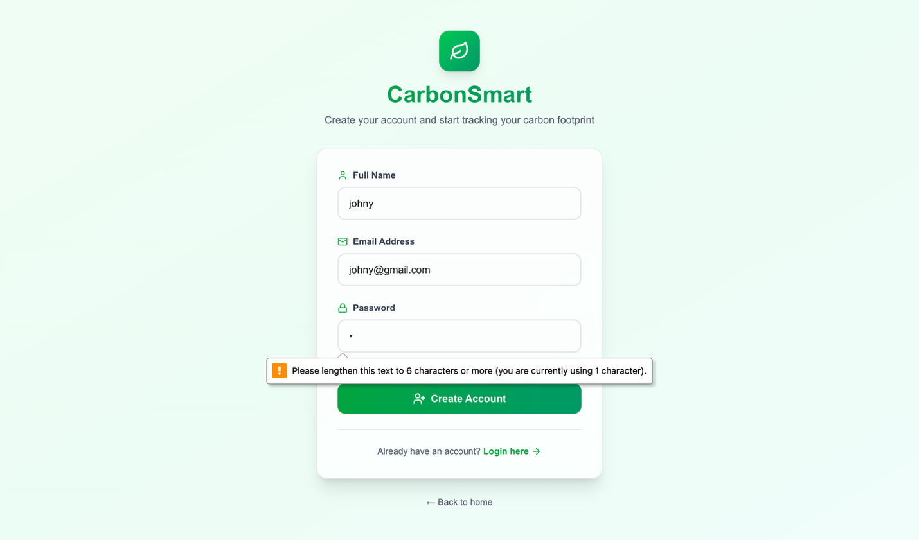
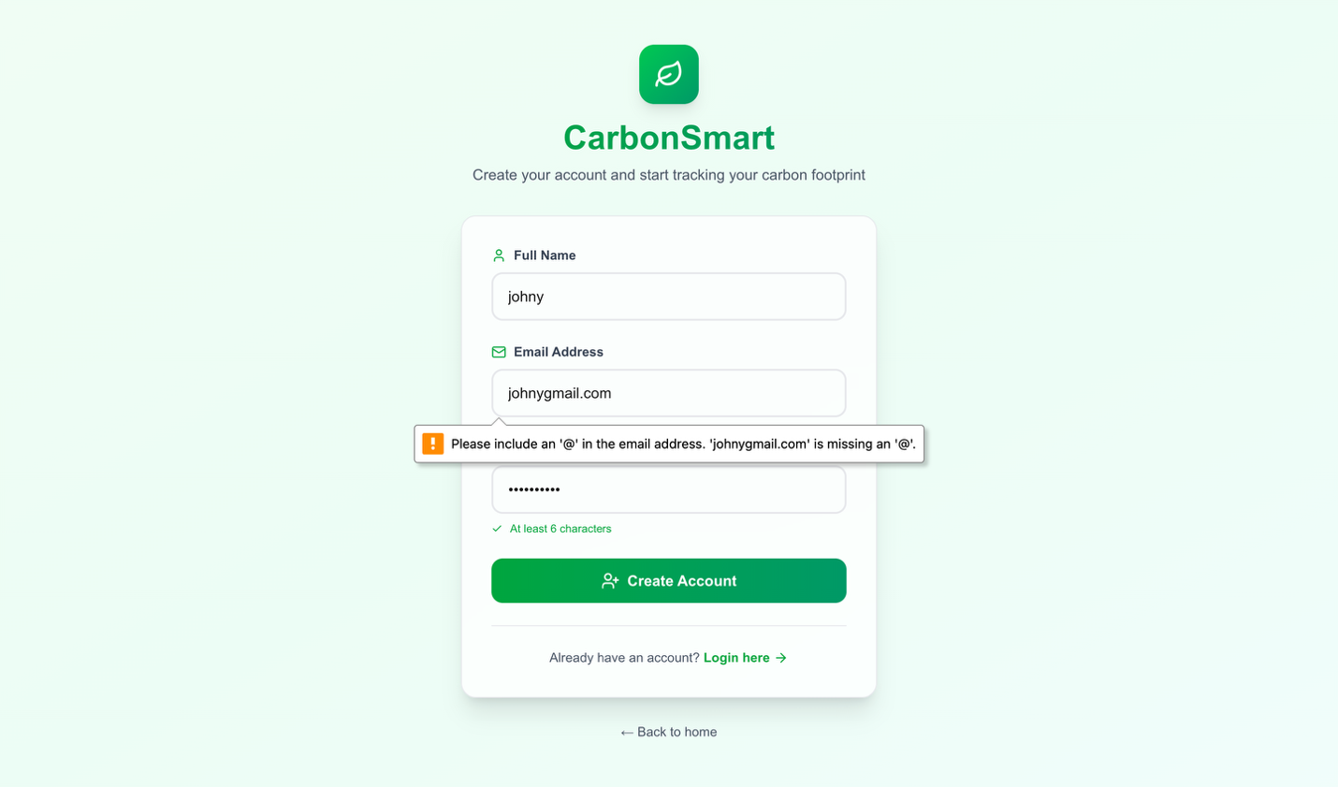

PASSED:

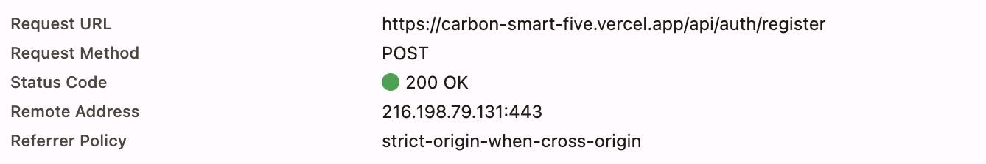

- Login Functionality:

FAILED:
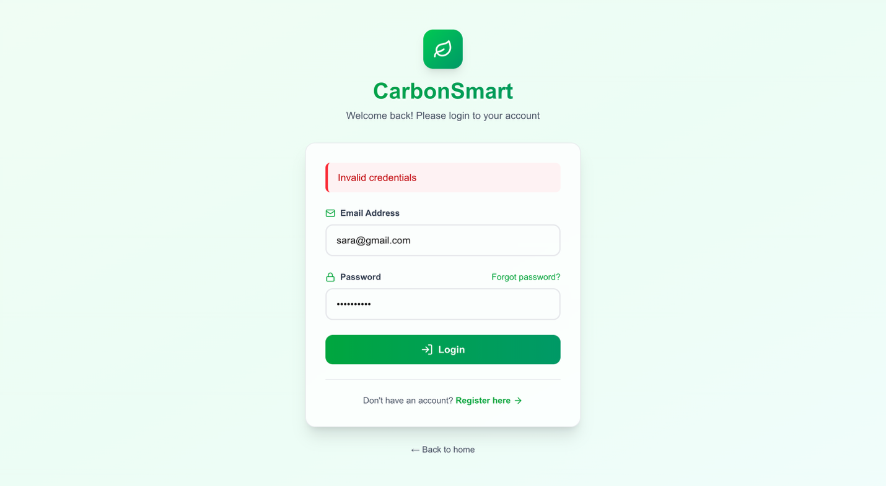

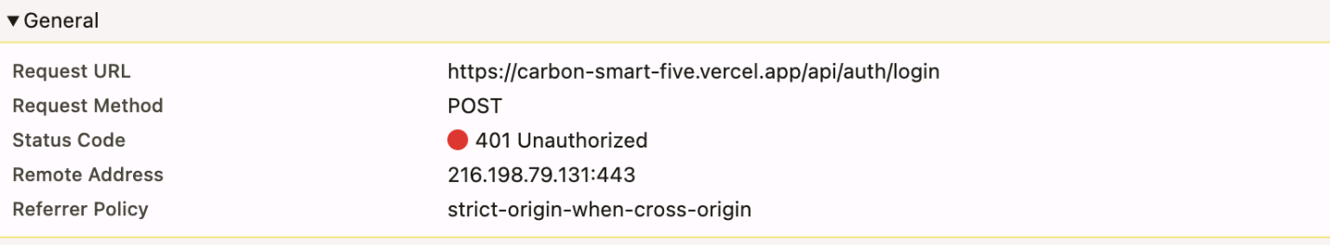

PASSED:

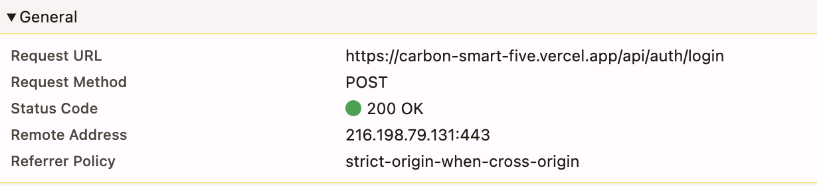

- Activities Functionality:

VALIDATIONS:
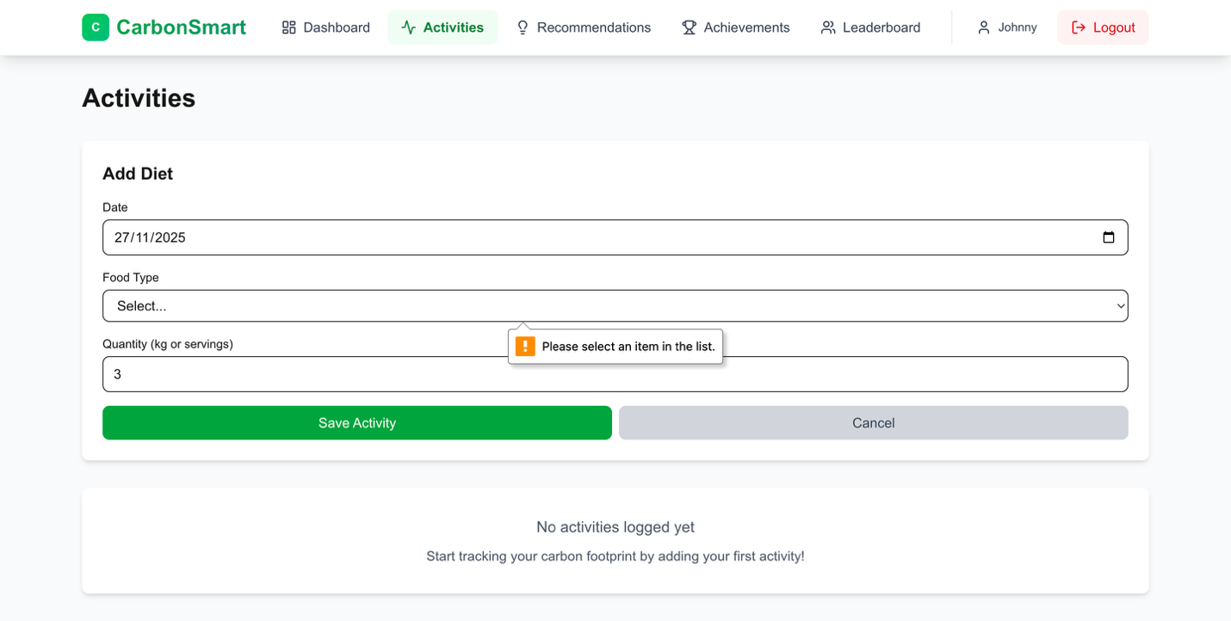

PASSED:

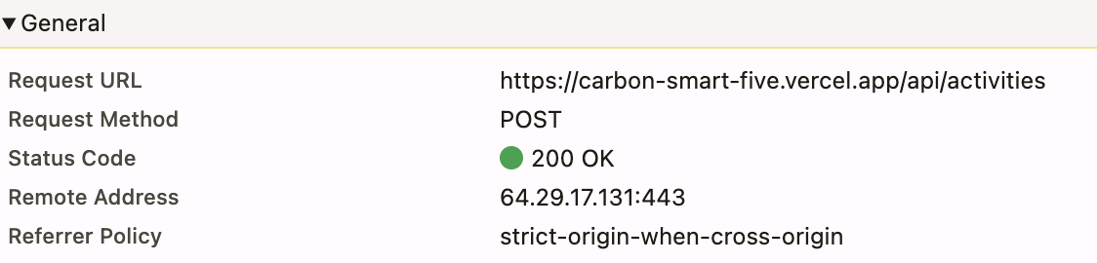

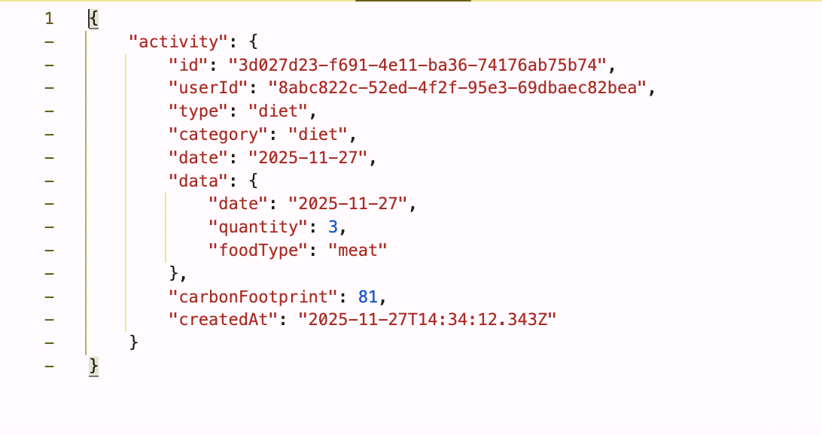

C.2 Performance Testing Summary

LCP/ CLS/ INP Values:

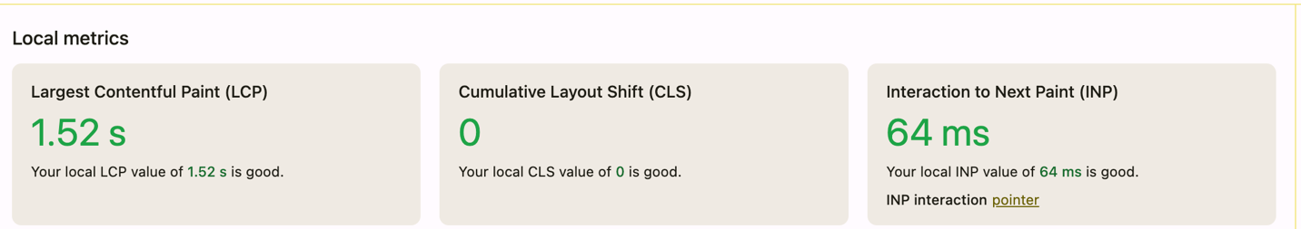

Average Time For Requests:

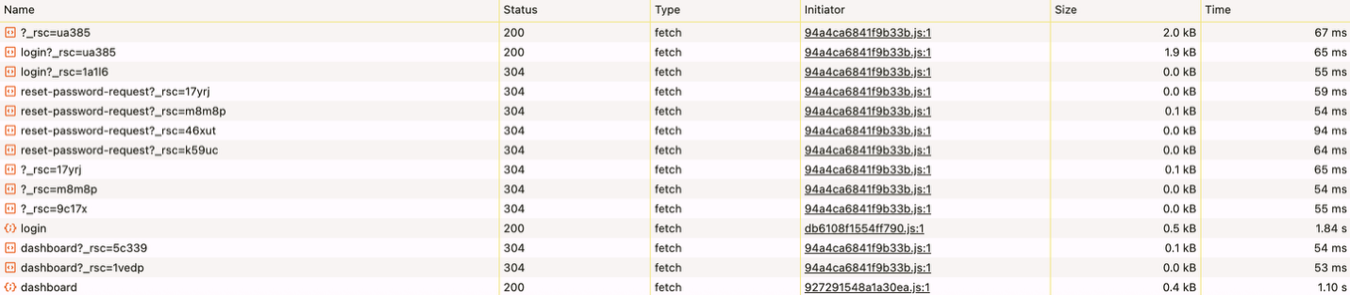

Performance/ Accessibility/SEO:

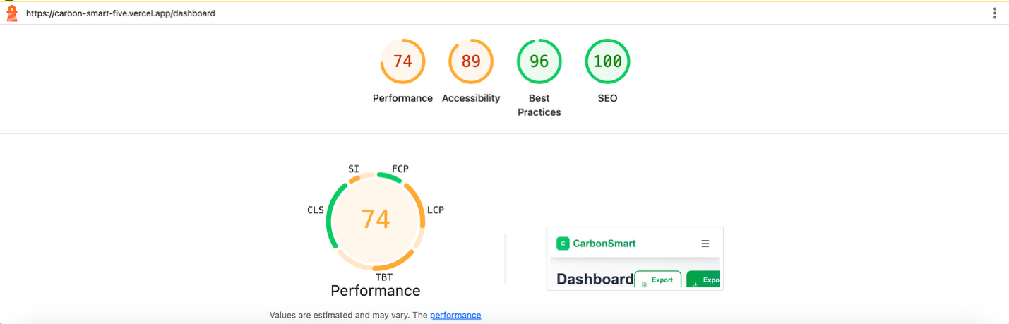

Lighthouse recorder

C.3 Carbon Smart Testing Suites:

TEST 1: Activity Input Validations
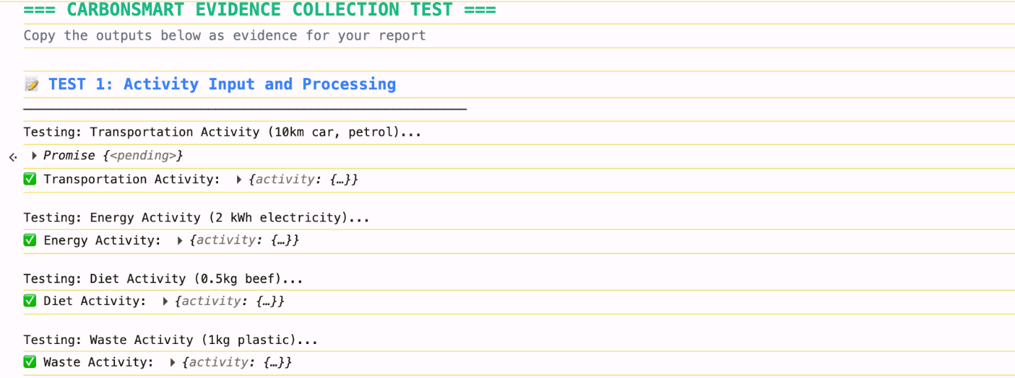
TEST 2: Dashboard Testing:

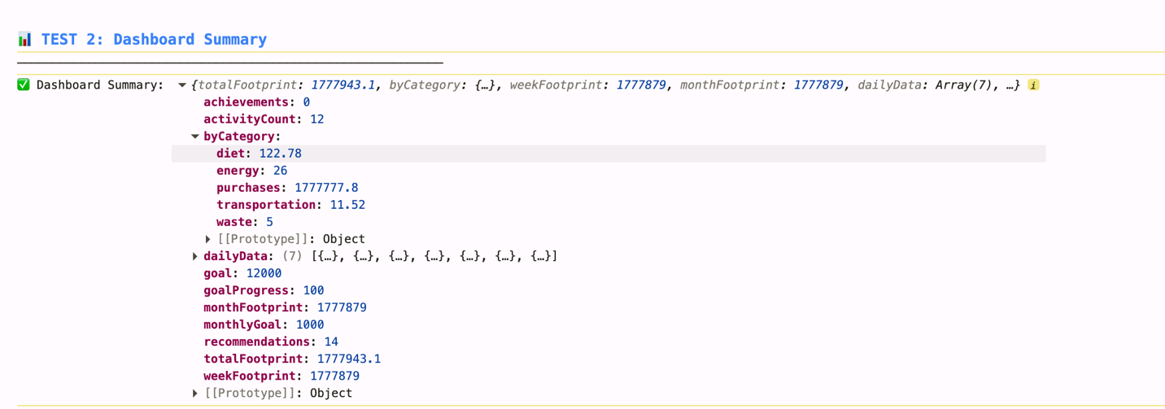

TEST 3: API Response Times

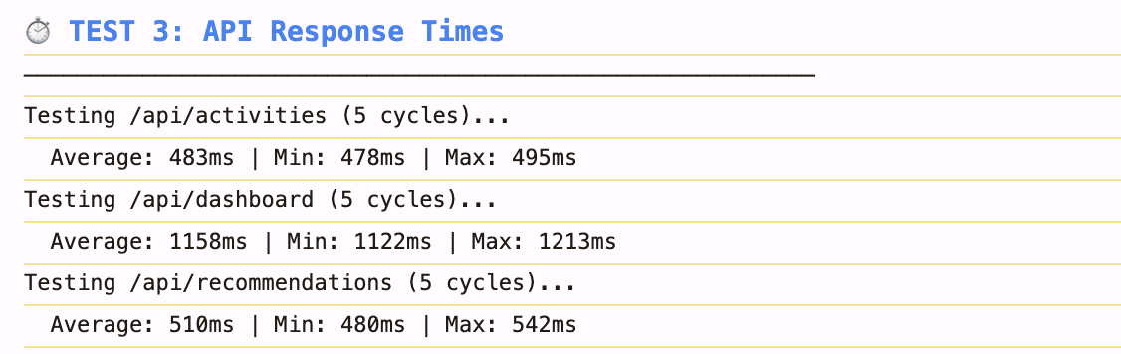

TEST 4: ML Module Testing

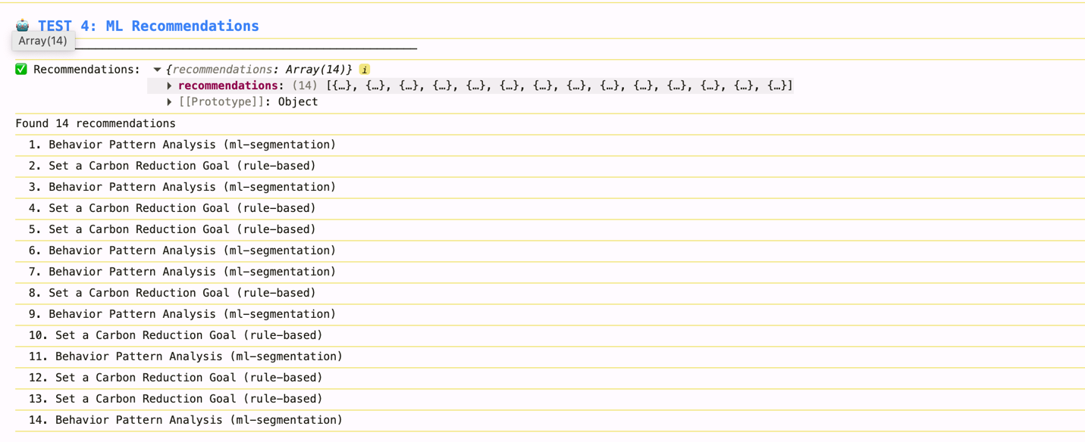
TEST 5: ML Prediction Test

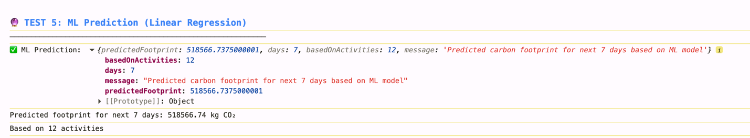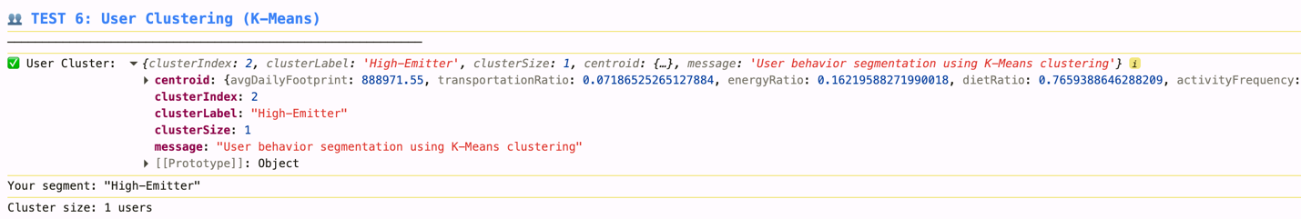

TEST SUMMARY:

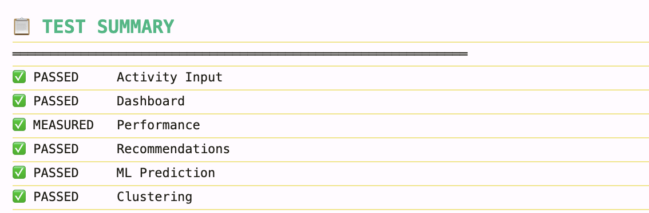

APPENDIX D – User Survey Form Questions
This appendix contains the full list of questions presented to participants in the Google Forms survey used to evaluate the usability, functionality, and overall user experience of CarbonSmart.
Link: Google Forms Survey (Click to access)

.

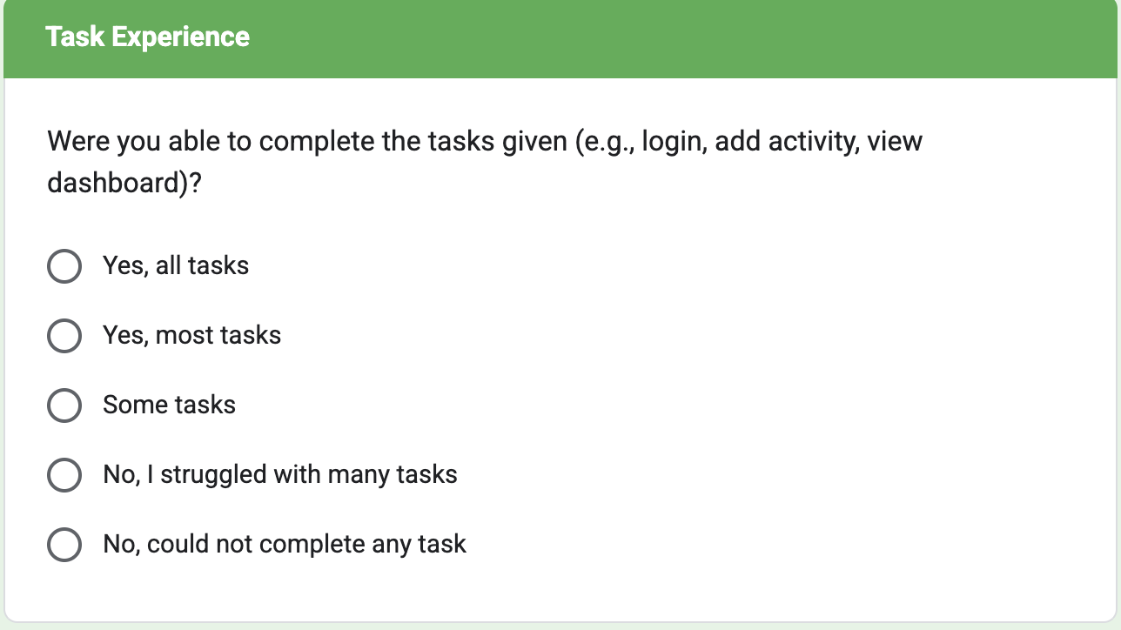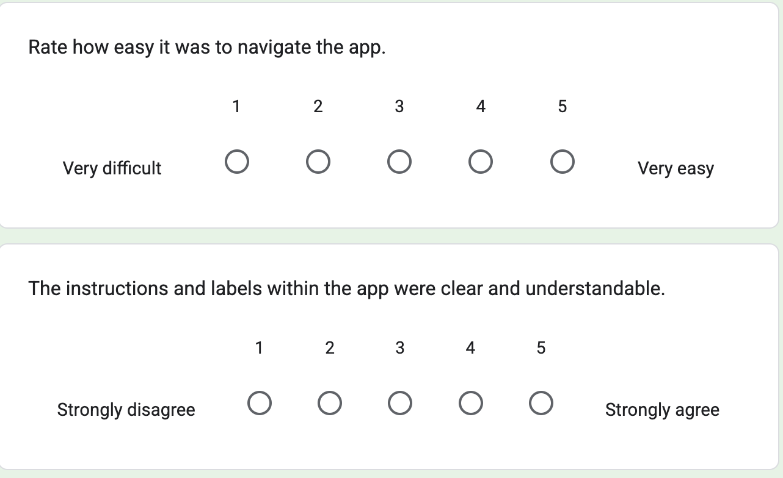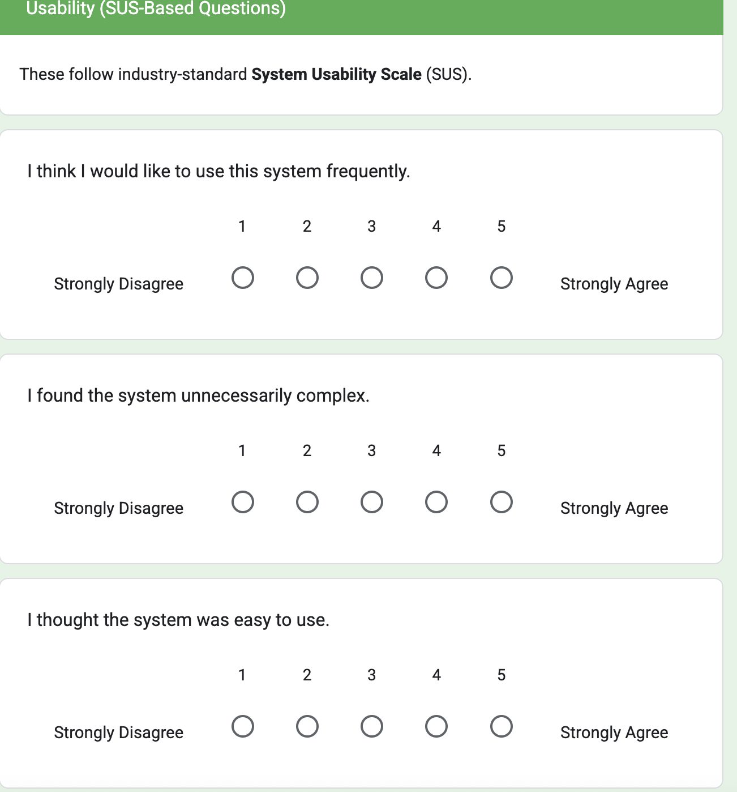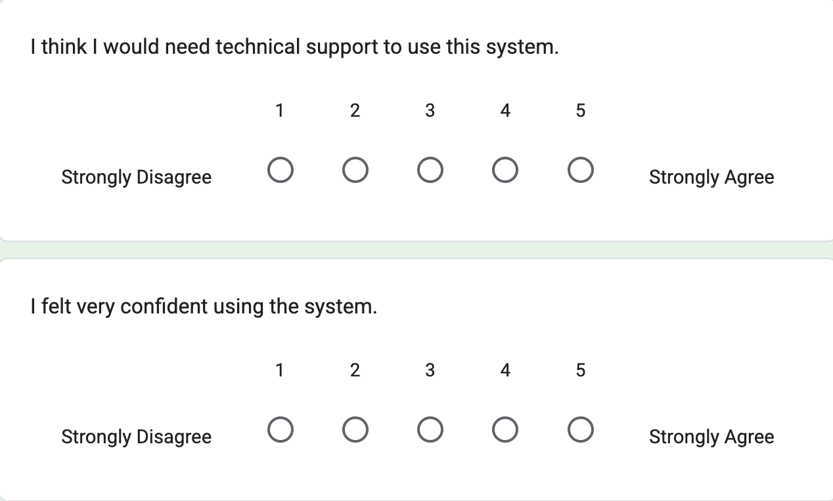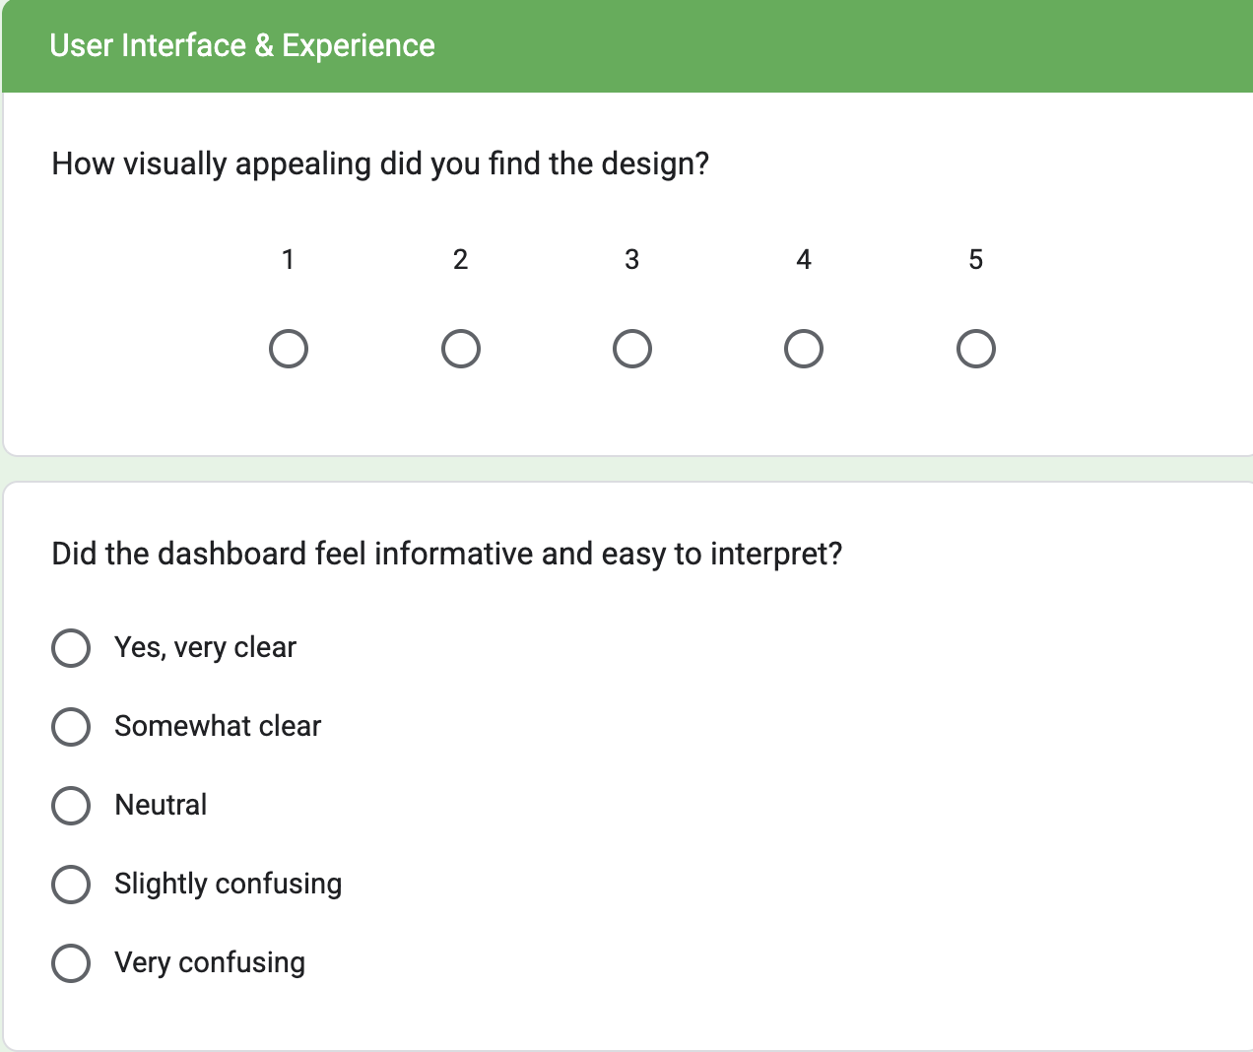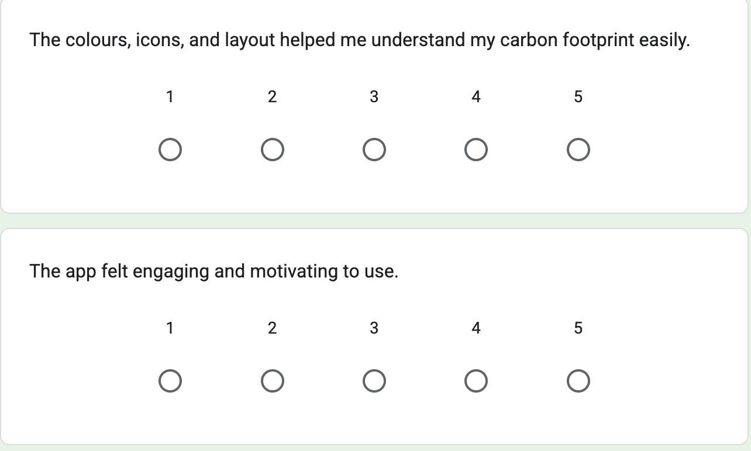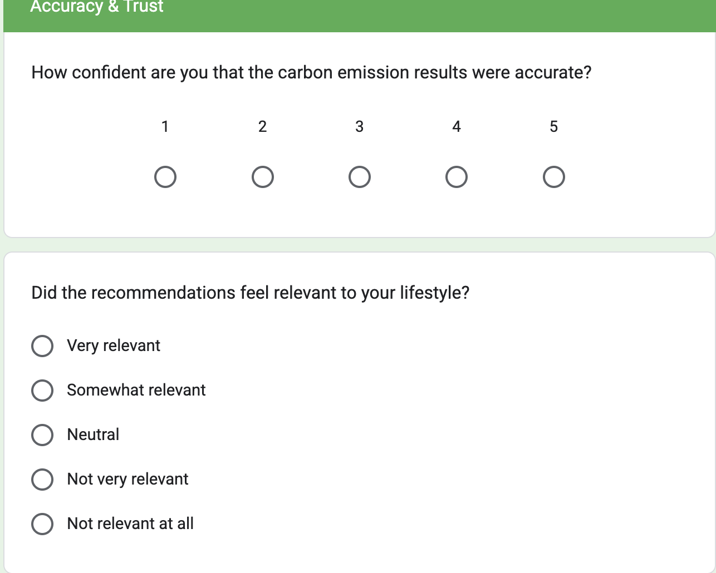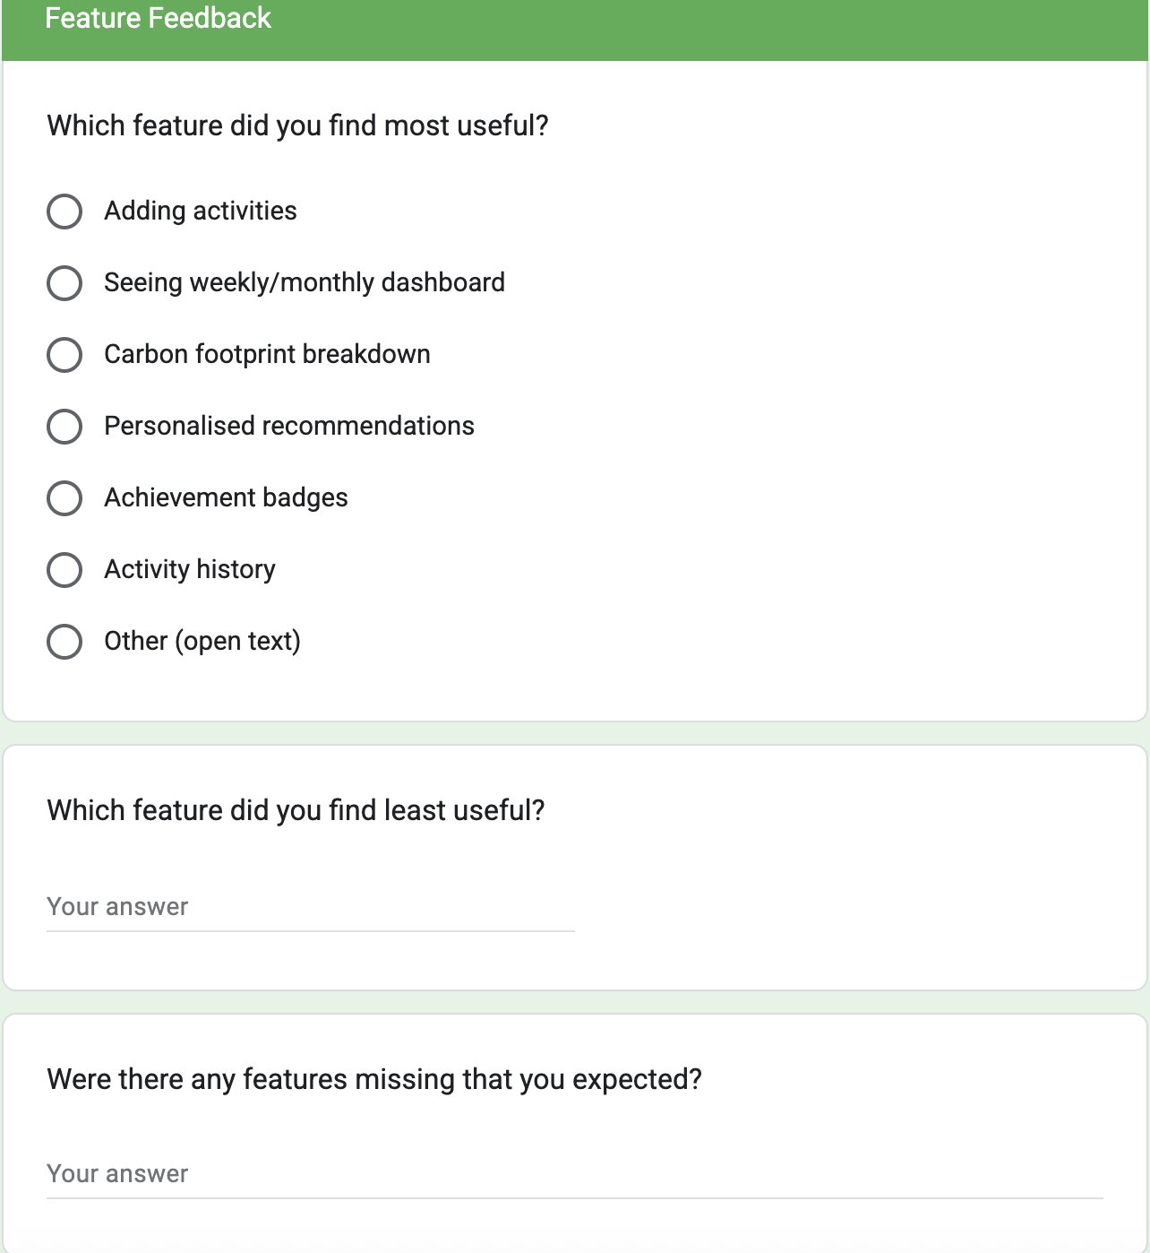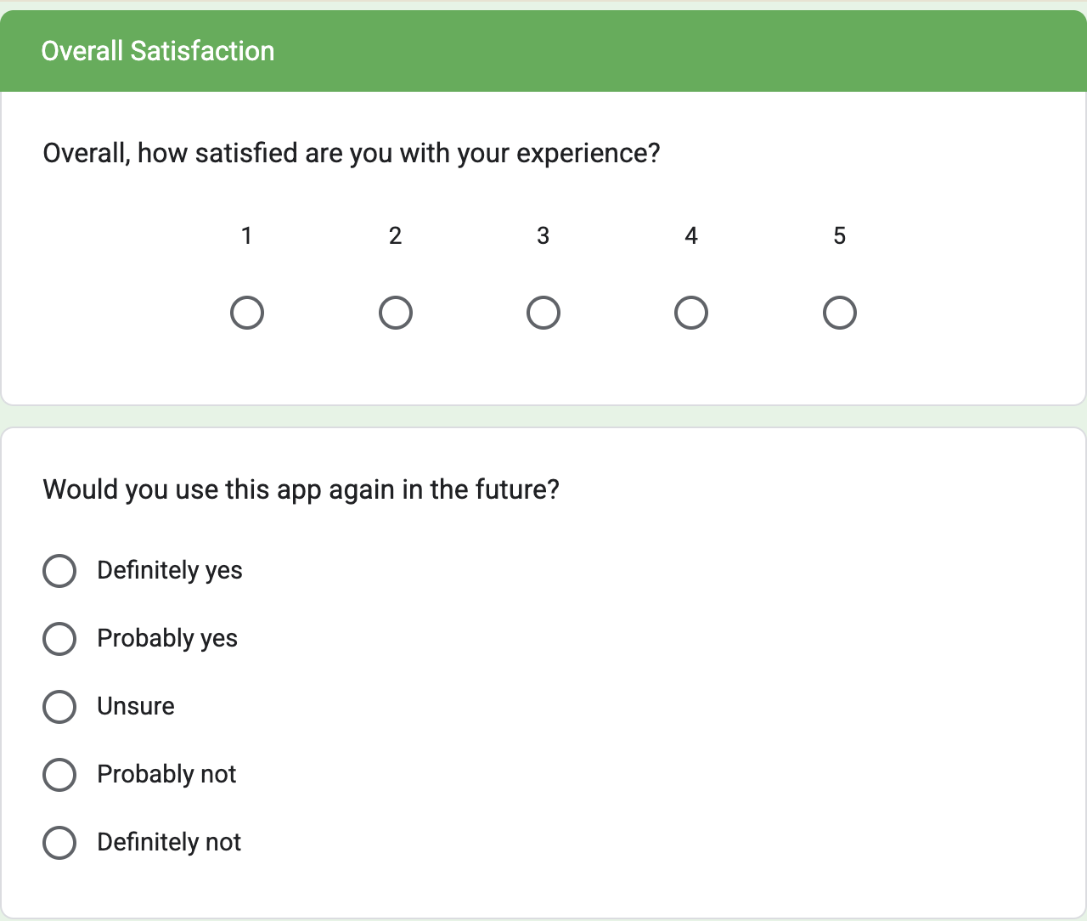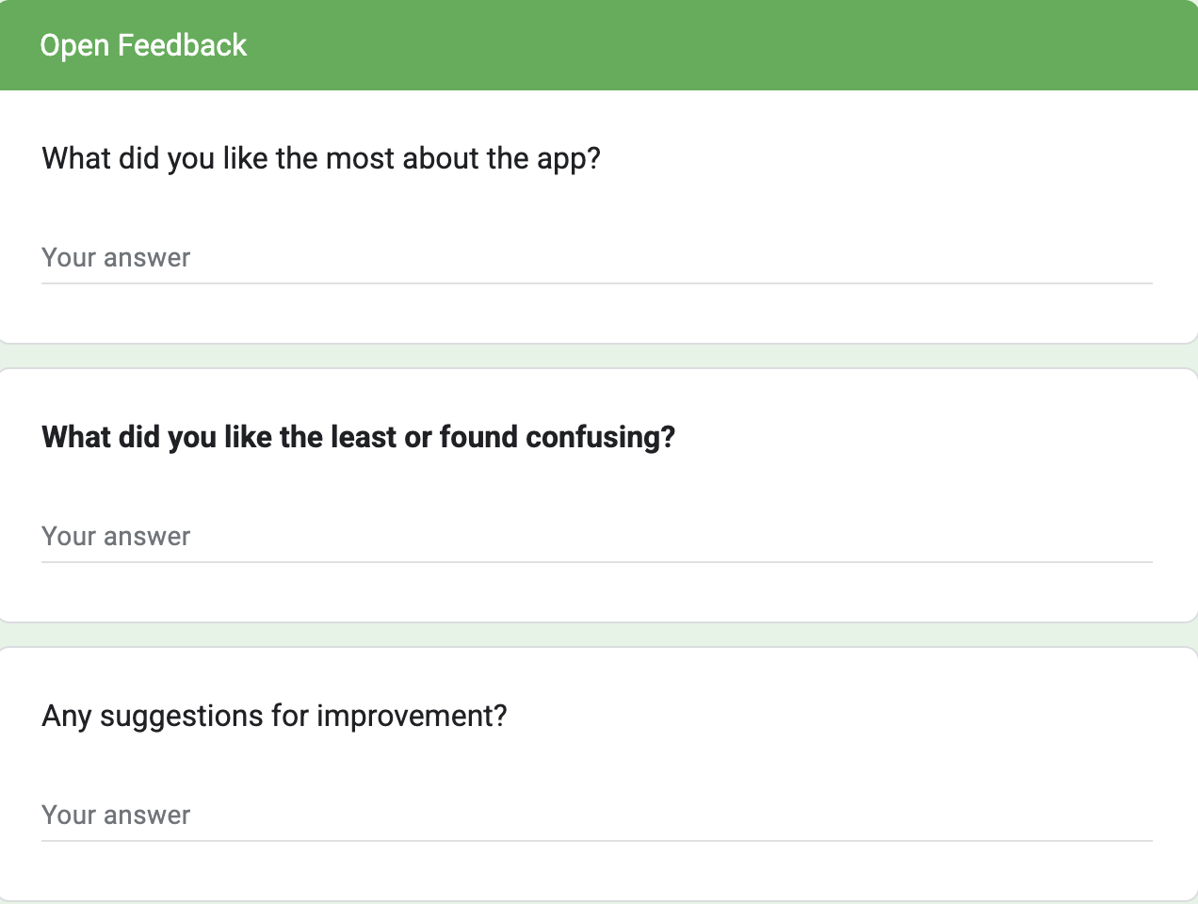

APPENDIX E -User Responses and Feedback
This appendix provides a summary of the feedback collected through the Google Forms survey. Responses have been anonymised and grouped into common themes:



