Name: Nia Davies

Student Number: 2518521
__________________________________________________________

WORKSHEET 4 – TESTING

- Original code:
numbers=[0, 1, 2, 3, 4, 5, 6, 7, 8, 9, 10, 11, 12, 13, 14, 15, 16, 17, 18, 19, 20, 21, 22, 23, 24, 25, 26, 27, 28, 29, 30, 31, 32, 33, 34, 35, 36, 37, 38, 39, 40, 41, 42, 43, 44, 45, 46, 47, 48, 49, 50]
treasureLocations = [6, 18, 29, 35, 42]
while True:
treasureGuess = int(input("Enter a number between 1 and 50 to find the treasure"))
smallestDistance=100
for treasure in treasureLocations:
if treasureGuess == treasure:
print("treasure found - 1000 coins for you")
distance=abs(treasureGuess - treasure)
if distance < smallestDistance:
smallestDistance=distance
if smallestDistance> 25:
print("freezing. Nowhere near.")
if smallestDistance >=19 and smallestDistance <=25:
print("Still cold")
if smallestDistance >=13 and smallestDistance <=18:
print("Cooler")
if smallestDistance >=8 and smallestDistance <=12:
print("Getting warmer")
if smallestDistance >=5 and smallestDistance <=7:
print("HOT - getting closer")
if smallestDistance >=3 and smallestDistance <=4:
print("Very very hot")
if smallestDistance >=1 and smallestDistance <=2:
print("So close you're on fire.")

Code Testing

First, create a test rig, so that you can see the generated numbers before testing the programme - so that you can see what you’re doing!

For each test below, run your code and enter the values provided. Provide a screenshot of what happened when the programme ran. Did the programme behave correctly, or did it do something unexpected? Fill in a box for each test below. You should present 11 separate boxes, 1 for each test. (Note: the first box is provided as a template)

Test the following:

- Guess is an exact match on the first number in the set
- Guess is an exact match on the last number in the set
- User enters their guess as -4
- User enters their guess as 55
- Within 2 of a number (below)
- Within 2 of a number (above)
- Within 5 of a number (below)
- Within 5 of a number (above)
- Within 2 of two numbers
- Within 2 or 5 of three numbers (you may need to run your program a few times to generate a suitable number set, or you can hard code the values into the test rig)
- What happens if a duplicate number is generated within the random number set?

Test:
- Guess is an exact match on first number in the set

Screenshot(s) of output:
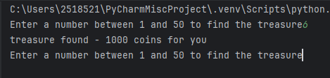
Result: Did the program behave as expected ie syntactically and logically correct?
YES
Program has worked and shown a match when input

Test:
- Guess is an exact match on the last number in the set

Screenshot(s) of output:
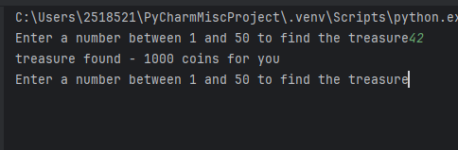
Result: Did the program behave as expected ie syntactically and logically correct?
YES
Program has worked and shown a match when input

Test:
- User enters their guess as -4

Screenshot(s) of output:
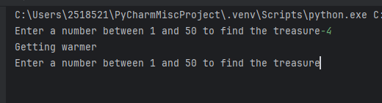
Result: Did the program behave as expected ie syntactically and logically correct?
NO
As the guess is close to one of the treasureLocations – this has shown “warmer” -- however, does not logically make sense as -4 should not be a selectable option. Further code should be written in order

Test:
- User enters their guess as 55

Screenshot(s) of output:
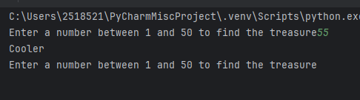
Result: Did the program behave as expected ie syntactically and logically correct?
NO - Code has been written to only show output based on proximity to the treasure location numbers. If rewritten, code should be extended to include minimum and maximum figures.

Test:
- Within 2 of a number (below)

Screenshot(s) of output:
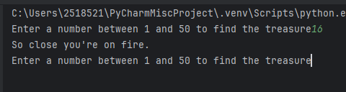
Result: Did the program behave as expected ie syntactically and logically correct?
YES – program has run correctly and shown output necessary from code, indicating user is close to treasure location.

Test:
- Within 2 of a number (above)

Screenshot(s) of output:

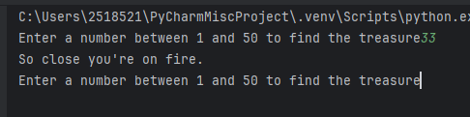
Result: Did the program behave as expected ie syntactically and logically correct?
YES – program has run correctly and shown output necessary from code, indicating user is close to treasure location.

Test:
- Within 5 of a number (below)

Screenshot(s) of output:

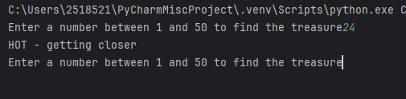
Result: Did the program behave as expected ie syntactically and logically correct?
YES – program has run correctly and shown output necessary from code, indicating user is close to treasure location.

Test:
- Within 5 of a number (above)

Screenshot(s) of output:

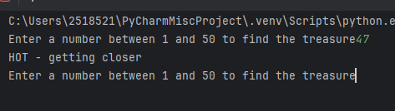
Result: Did the program behave as expected ie syntactically and logically correct?
YES – program has run correctly and shown output necessary from code, indicating user is close to treasure location.

Test:
- Within 2 of two numbers

Screenshot(s) of output:
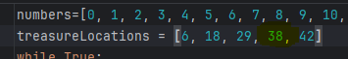

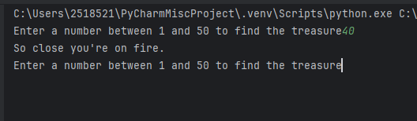
Result: Did the program behave as expected ie syntactically and logically correct?
YES – program has run correctly and shown output necessary from code, indicating user is close to treasure location.
NOTE: the hardcoded treasure location numbers were edited for this task as the existing ones did not meet the criteria for this test.

Test:
10. Within 2 or 5 of three numbers (you may need to run your program a few times to generate a suitable number set, or you can hard code the values into the test rig)

Screenshot(s) of output:
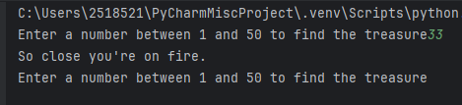
Result: Did the program behave as expected ie syntactically and logically correct?
YES – program has run correctly and shown output necessary from code, indicating user is close to treasure location. Appears to have run correctly as input (33), is closest to 32, as treasure is 1 place away – output shows “on fire” message.

NOTE: the hardcoded treasure location numbers were edited for this task as the existing ones did not meet the criteria for this test.

Test:
11. What happens if a duplicate number is generated within the random number set?

Screenshot(s) of output:

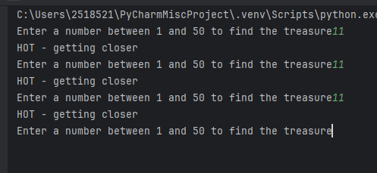
Result: Did the program behave as expected ie syntactically and logically correct?
NO – same warning is shown repeatedly. If extended – code to be reworked to only allow figures within certain parameters and should not allow duplicated guesses.

- Consider the results of the above tests and revisit your original code in order to address thetests that failed. (Note: you may not be able to solve all of the problems that were originally encountered, but solve as many as you can.)

Paste your full revised code here :

[Copy and paste your full revised code here – note, do not use a screenshot]

